Approved by OMB
3060-1122
Expires: March 31, 2021
Estimated time per response: 10-55 hours

Annual Collection of Information
Related to the Collection and Use of 911 and E911 Fees by States and Other Jurisdictions

Pursuant to OMB authorization 3060-1122, the FCC’s Public Safety and Homeland Security Bureau seeks the following specific information in order to fulfill the Commission’s obligations under Section 6(f)(2) of the NET 911 Act:

- Filing Information

- Name of State or Jurisdiction
State or Jurisdiction
State of New Jersey

- Name, Title and Organization of Individual Filing Report
Name | Title | Organization
Christopher J. Rein | State Chief Technology Officer | Office of Information Technology

- Overview of State or Jurisdiction 911 System

- Please provide the total number of active Public Safety Answering Points (PSAPs) in your state or jurisdiction that receive funding derived from the collection of 911/E911 fees during the annual period ending December 31, 2018:

PSAP Type | Total
Primary | 0
Secondary | 0
Total | 0

- Please provide the total number of active telecommunicators in your state or jurisdiction that were funded through the collection of 911 and E911 fees during the annual period ending December 31, 2018:

Number of Active Telecommunicators | Total
Full-Time | 0
Part-time | 0

- For the annual period ending December 31, 2018, please provide an estimate of the total cost to provide 911/E911 service in your state or jurisdiction.

Amount  ($) | Unknown

3a. If an amount cannot be provided, please explain why.
The State of New Jersey funds the statewide enhanced 9-1-1 infrastructure at an annual cost of approximately $14M, the operational, equipment and personnel costs are the responsibility of the PSAP and not reported to the State 9-1-1 Office.

- Please provide the total number of 911 calls your state or jurisdiction received during the period January 1, 2018 to December 31, 2018.

Type of Service | Total 911 Calls
Wireline | Not separated
Wireless | Not separated
VoIP | Not separated
Other | Not separated
Total | 9,000,000

- Description of Authority Enabling Establishment of 911/E911 Funding Mechanisms

- Has your State, or any political subdivision, Indian tribe, village or regional corporation therein as defined by Section 6(f)(1) of the NET 911 Act, established a funding mechanism designated for or imposed for the purposes of 911 or E911 support or implementation (please include a citation to the legal authority for such mechanism)? Check one.

- Yes …………………..
- No ………………..…..

1a. If YES, provide a citation to the legal authority for such a mechanism.
N.J.S.A. 52:17C

1b. If YES, during the annual period January 1, 2018 to December 31, 2018, did your state or jurisdiction amend, enlarge, or in any way alter the funding mechanism.
No

- Which of the following best describes the type of authority arrangement for the collection of 911/E911 fees? Check one.
- The State collects the fees …………………………………..
- A Local Authority collects the fees ………………………..
- A hybrid approach where two or more governing bodies
(e.g., state and local authority) collect the fees ……………..

- Describe how the funds collected are made available to localities.
Funds are not made available to localities.

- Description of State or Jurisdictional Authority That Determines How 911/E911 Fees are Spent

- Indicate which entities in your state have the authority to approve the expenditure of funds collected for 911 or E911 purposes.
Jurisdiction | Authority to Approve  Expenditure of Funds  (Check one)
 | Yes | No
State

Local
(e.g., county, city, municipality)

1b. Please briefly describe any limitations on the approval authority per jurisdiction (e.g., limited to fees collected by the entity, limited to wireline or wireless service, etc.)
Through the annual budgeting process, the Office of the State Treasurer, OMB, and the State Legislature determine how to allocate the revenue generated by the 9-1-1 System & Emergency Response Fee.

- Has your state established a funding mechanism that mandates how collected funds can be used? Check one.
- Yes …………………..
- No ………………..…..
2a. If you checked YES, provide a legal citation to the funding mechanism of any such criteria.
N.J.S.A. 52:17C-19

2b. If you checked NO, describe how your state or jurisdiction decides how collected funds can be used.
- Description of Uses of Collected 911/E911 Fees

- Provide a statement identifying with specificity all activities, programs, and organizations for whose benefit your state, or political subdivision thereof, has obligated or expended funds collected for 911 or E911 purposes and how these activities, programs, and organizations support 911 and E911 services or enhancements of such services.

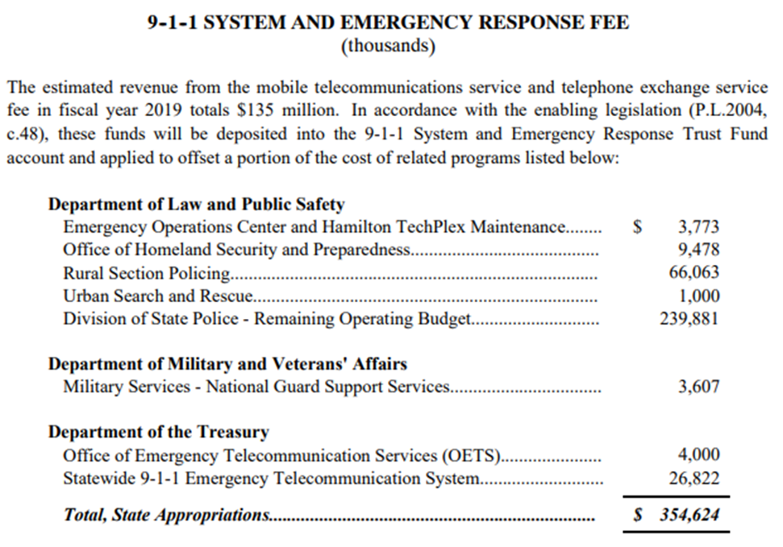

- Please identify the allowed uses of the collected funds. Check all that apply.
Type of Cost |  | Yes | No
Operating Costs | Lease, purchase, maintenance of customer premises equipment (CPE) (hardware and software)
 | Lease, purchase, maintenance of computer aided dispatch (CAD) equipment (hardware and software)
 | Lease, purchase, maintenance of building/facility
Personnel Costs | Telecommunicators’ Salaries
 | Training of Telecommunicators
Administrative Costs | Program Administration
 | Travel Expenses
Dispatch Costs | Reimbursement to other law enforcement entities providing dispatch
 | Lease, purchase, maintenance of Radio Dispatch Networks
Grant Programs |  | If YES, see 2a.
2a. During the annual period ending December 31, 2018, describe the grants that your state paid for through the use of collected 911/E911 fees and the purpose of the grant.
- Description of 911/E911 Fees Collected

- Please describe the amount of the fees or charges imposed for the implementation and support of 911 and E911 services. Please distinguish between state and local fees for each service type.
Service Type | Fee/Charge Imposed | Jurisdiction Receiving Remittance  (e.g., state, county, local authority, or a combination)
Wireline | $.90/Monthly | State
Wireless | $.90/Monthly | State
Prepaid Wireless | None | NA
Voice Over Internet Protocol (VoIP) | $.90/Monthly | State
Other | None | NA

- For the annual period ending December 31, 2018, please report the total amount collected pursuant to the assessed fees or charges described in Question F 1.

Service Type | Total Amount Collected ($)
Wireline | Not Available
Wireless | Not Available
Prepaid Wireless | NA
Voice Over Internet Protocol (VoIP) | Not Available
Other | NA
Total | $122,905,000

2a. If an amount cannot be provided, please explain why.

- Please identify any other sources of 911/E911 funding.
N.J.S.A. 52:17C-12. Expenses
a. All expenses incurred in the installation, operation and maintenance of a PSAP shall be defrayed by the municipality or county operating or controlling the PSAP.

Question | Yes | No
- For the annual period ending December 31, 2018, were any 911/E911 fees that were collected by your state or jurisdiction combined with any federal, state or local funds, grants, special collections, or general budget appropriations that were designated to support 911/E911/NG911 services? Check one.
4a. If YES, please describe the federal, state or local funds and amounts that were combined with 911/E911 fees.

- Please provide an estimate of the proportional contribution from each funding source towards the total cost to support 911 in your state or jurisdiction. | Percent
State 911 Fees | Unknown
Local 911 Fees | 0
General Fund - State | 0
General Fund - County | Unknown
Federal Grants | 0
State Grants | 0

- Description of Diversion or Transfer of 911/E911 Fees for Other Uses

Question |  | Yes | No
- In the annual period ending December 31, 2018, were funds collected for 911 or E911 purposes in your state or jurisdiction made available or used solely for the purposes designated by the funding mechanism? Check one.
1a. If NO, please identify what amount of funds collected for 911 or E911 purposes were made available or used for any purposes other than the ones designated by the funding mechanism or used for purposes otherwise unrelated to 911 or E911 implementation or support, including any funds transferred, loaned, or otherwise used for the state's general fund. Along with identifying the amount, please include a statement identifying the non-related purposes for which the collected 911 or E911 funds were made available or used.
Amount of Funds ($) | Identify the non-related purpose(s) for which the 911/E911 funds were used. (Add lines as necessary)

- Oversight and Auditing of Collection and Use of 911/E911 Fees

Question | Yes | No
- Has your state established any oversight or auditing mechanisms or procedures to determine whether collected funds have been made available or used for the purposes designated by the funding mechanism or otherwise used to implement or support 911? Check one.
1a. If YES, provide a description of the mechanisms or procedures and any enforcement or other corrective actions undertaken in connection with such auditing authority, for the annual period ending December 31, 2018. (Enter “None” if no actions were taken.)

Question | Yes | No
- Does your state have the authority to audit service providers to ensure that the amount of 911/E911 fees collected from subscribers matches the service provider’s number of subscribers? Check one.
2a. If YES, provide a description of any auditing or enforcement or other corrective actions undertaken in connection with such auditing authority, for the annual period ending December 31, 2018. (Enter “None” if no actions were taken.)

- Description of Next Generation 911 Services and Expenditures

Question | Yes | No
- Does your state or jurisdiction classify expenditures on Next Generation 911 as within the scope of permissible expenditures of funds for 911 or E911 purposes? Check one.
1a. If YES, in the space below, please cite any specific legal authority:
N.J.S.A. 52:17C

Question |  | Yes | No
- In the annual period ending December 31, 2018, has your state or jurisdiction expended funds on Next Generation 911 programs? Check one.
2a. If YES, in the space below, please enter the dollar amount that has been expended.
Amount  ($) | $175,000.00

- For the annual period ending December 31, 2018, please describe the type and number of NG911 Emergency Service IP Network(s) (ESInets) that operated within your state.
Type of ESInet | Yes | No | If Yes, Enter Total PSAPs Operating on the ESInet | If Yes, does the type of ESInet interconnect with other state, regional or local ESInets?
 |  |  |  | Yes | No
- A single, state-wide ESInet
- Local (e.g., county) ESInet
- Regional ESInets |  |  | [If more than one Regional ESInet is in operation, in the space below, provide the total PSAPs operating on each ESInet]
Name of Regional ESInet:

Name of Regional ESInet:

- Please provide a description of any NG911 projects completed or underway during the annual period ending December 31, 2018.
Internal staff and consultant services to begin the development of a RFP for the replacement of the State's legacy 9-1-1 network with a state of the art, IP based, Next Generation 9-1-1 network.

Question | Total PSAPs  Accepting Texts
- During the annual period ending December 31, 2018, how many PSAPs within your state implemented text-to-911 and are accepting texts? | Text to 9-1-1 capability became available statewide in July 2016 through 17 regional PSAPs equipped with the necessary equipment.
Question | Estimated Number of PSAPs  that will Become Text Capable
- In the next annual period ending December 31, 2019, how many PSAPs do you anticipate will become text capable? | Statewide capability exists and no additional PSAPs planned for text capability until NG9-1-1 deployed.

- Description of Cybersecurity Expenditures

Question | Check the appropriate box |  | If Yes,  Amount Expended ($)
- During the annual period ending December 31, 2018, did your state expend funds on cybersecurity programs for PSAPs? | Yes | No

Question | Total PSAPs
- During the annual period ending December 31, 2018, how many PSAPs in your state either implemented a cybersecurity program or participated in a regional or state-run cybersecurity program? | None.

Question | Yes | No | Unknown
- Does your state or jurisdiction adhere to the National Institute of Standards and Technology Framework for Improving Critical Infrastructure Cybersecurity (February 2014) for networks supporting one or more PSAPs in your state or jurisdiction?

- Measuring Effective Utilization of 911/E911 Fees

- Please provide an assessment of the effects achieved from the expenditure of state 911/E911 or NG911 funds, including any criteria your state or jurisdiction uses to measure the effectiveness of the use of 911/E911 fees and charges. If your state conducts annual or other periodic assessments, please provide an electronic copy (e.g., Word, PDF) of the latest such report upon submission of this questionnaire to the FCC or provide links to online versions of such reports in the space below.
No assessments or reports exist related to the effectiveness of the expenditures of the 9-1-1 System and Emergency Response Fee collected in New Jersey. The amount of funds collected annually of approximately $123M are used to offset over $354M in State expenditures for programs itemized in the enabling legislation N.J.S.A. 52:17C in support of emergency response.

A Primary PSAP is one to which 911 calls are routed directly from the 911 Control office. A secondary PSAP is one to which 911 calls are transferred from a Primary PSAP. See National Emergency Number Association, Master Glossary of 9-1-1 Terminology (Master Glossary), Apr. 13, 2018, at 162, available at https://cdn.ymaws.com/www.nena.org/resource/resmgr/standards/NENA-ADM-000.22-2018_FINAL_2.pdf.
A telecommunicator, also known as a call taker or a dispatcher, is a person employed by a PSAP who is qualified to answer incoming emergency telephone calls and/or who provides for the appropriate emergency response either directly or through communication with the appropriate PSAP. See Master Glossary at 192.

