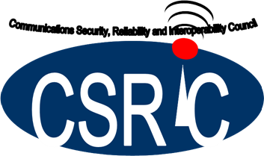
March 17, 2020

Communications Security, Reliability, and Interoperability Council VII

Report on the Current State of Interoperability in the Nation’s 911 Systems

Working Group 4: 911 Security Vulnerabilities during the IP Transition

Table of Contents

1 Results in Brief 4
1.1 Executive Summary 4
2 Introduction 5
2.1 CSRIC VII Structure 6
2.2 Working Group 4 Team Members 7
3 Objective, Scope, and Methodology 8
3.1 Objectives 8
3.2 Scope 8
3.3 Methodology 8
3.3.1 Transition Paradigm 9
3.3.2 Published Source Data 10
4 Background 11
5 Analysis and Findings 13
5.1 Analysis 13
5.1.1 Interoperability in a Legacy and Foundational State 13
5.1.2 Interoperability in a Transitional State 14
5.1.3 Interoperability in an Intermediate State NG9-1-1 environment 16
5.1.3.1 Intermediate State 16
5.1.4 Interoperability in an End State NG9-1-1 Environment 16
5.1.4.1 Jurisdictional End State 16
5.1.4.2 National End State 17
5.1.5 Progress Toward NG9-1-1 17
5.1.5.1 Select Results from the Quantitative Analysis – Quantitatively-based Indicators of Interoperability Progress 19
5.1.5.2 Select Results from the Quantitative Analysis – State “Maturity Levels” indicators of Interoperability progress 21
5.1.5.3 Summary and Salient Points Drawn from the Analysis 22
5.1.6 Progress toward Ubiquitous Interoperability 23
5.2 Findings 25
6 Conclusions 25
Appendix A – National 911 Progress Report – November 2019 Summary of Interoperability-Related Items 26
A.1 Total Potential Reporting Entities 27
A.2 State Contracts (39%) 27
A.3 Number of Operational ESInets Deployed (31%) 27
A.4 Total Number of PSAPs (5,432 reported) 27
A.5 Total Number of reported Call-Taking Positions (19,334 reported) 27
A.6 NG9-1-1 Components Procured at State Level 27
A.7 NG9-1-1 Components Procured at Sub-State Level 27
A.8 Number of Contracts Awarded and Testing Begun at State level (277 Contracts) 28
A.9 Percentage of States Who Have Systems Capable of Processing NG9-1-1 Calls for All Service Types (wireless, wireline, and VoIP) (31%) 28
A.10 Percentage of Total State Population Served by NG9-1-1 Capable Services (26%) 28
A.11 Percentage of Total State Population Served by NG9-1-1 Capable Services (27%) 28
A.12 Number of PSAPs Receiving Calls through an ESInet (includes Legacy PSAPs connected to an ESInet through an LPG) (31%) 29
A.13 Number of Operational ESInets Deployed within the States (162 ESInets) 29
A.14 Percentage of MIS to GIS Synchronization Process (GIS readiness for NG9-1-1) (36%) 29
A.15 Routing and Location Maturity Level (5%) 30
A.16 GIS Data Maturity Level (14%) 30
A.17 NG9-1-1 Core Elements Maturity Level (9%) 30
A.18 Network (ESInet) Maturity Level (4%) 30
A.19 PSAP Call Handling System and Applications Maturity Level (7%) 30
A.20 Security Maturity Level (7%) 30
A.21 Summary and Salient Points 31
Appendix B –Summary of Results from 2020 NASNA Interoperability Matrix 32
Appendix C – Full Treatment of Legacy, Foundational, and Transitional State Interoperability 69
C.1 5.1.1 Interoperability in a Legacy and Foundational State 69
C.2 Interoperability in a Transitional State 70
7 Definitions 73

Results in Brief

Executive Summary

The Commission specifically directed the Communications Security, Reliability, and Interoperability Council (CSRIC) VII to report on the security risks and best practices for mitigation in 9-1-1 systems (legacy, transitional, and next generation), measuring the risk magnitude and remediation costs within those networks. In order to accomplish those objectives, assessing the current state of 9-1-1 systems interoperability was also included in the objectives to serve as a baseline for further tasks. This initial report researched, reviewed, and analyzed existing data to determine the current state of 9-1-1 systems interoperability based upon authoritative, readily available public sources.

This report provides the observations discerned through review of independent research based upon publications from various industry groups, including:

- A National Plan for Migrating to IP-Enabled 9-1-1 Systems released in 2009 by the National E9-1-1 Implementation Coordination Office (now known as the National 911 Program)
- The Phase II Supplemental Report: NG9-1-1 Readiness Scorecard, released December 2, 2016 by FCC Task Force on Optimal Public Safety Answering Point Architecture (TFOPA)
- The National 911 Progress Report, released November 2019 by the National 911 Program
- The 2020 NASNA Interoperability Matrix, released January 2020 by the National Association of State 9-1-1 Administrators (NASNA)
- Additional data from several large Public Safety Answering Points (PSAPs) provided by the Association of Public Safety Communication Officials (APCO).

The review of the current state of interoperability entailed the analysis of legacy, transitional, and Next Generation 9-1-1 (NG9-1-1) systems. CSRIC VII, Working Group 4 looked to the six (6) TFOPA defined “maturity states” when providing observations and findings throughout this report. The progress towards NG9-1-1 documented in the report especially includes raw and analyzed data from the National 911 Progress Report, which is populated with 53 data elements essential to obtaining full interoperability. Reported at the state level, these data points help to categorize a state’s 9-1-1 operations, protocols, and progress toward a full NG9-1-1 implementation. The data and accompanying analysis can be found in Section 5.1.5 of this report.

Although the foundation for NG9-1-1 systems has been talked about within the industry for over a decade, very few of the nation’s public safety agencies have been able to move the concept forward. This hasn’t been for lack of initiative. Throughout our research, it was observed that several key missing elements are limiting full “National End State” NG9-1-1 deployment.
Full NG9-1-1 “National End State” can be achieved through the use of a Forest Guide which allows functional elements to discover call routing information outside of those defined within a jurisdiction’s Emergency Call Routing Function (ECRF) geographical dataset. No national level Forest Guide or other mechanism currently exists to facilitate or ensure nationwide End State NG9-1-1 though efforts are being explored to address the issue. As an example NENA has plans to facilitate the deployment of a Forest Guide in 2020.
Based on the recently published National 911 Progress Report (and supplemented by the 2020 NASNA Interoperability Matrix and individual PSAP data provided by APCO based on that same matrix), there are 11 states that have 100% of their population served by NG9-1-1 capable services and 11 with some transitional services available. Many states are in the Foundational Stage where NG9-1-1 feasibility studies are being performed, and Geographic Information System (GIS) data preparations are under way. Overall, the percentage of interoperability-relevant quantitative metrics taken from our analysis of the data in the National 911 Progress report reveals that, on average, 33% of 9-1-1 authorities, covered population, and geographies across the country are in some way, preparing for (or covered by), or fully prepared to serve the public (or cover the public) with, NG9-1-1 capable or compliant systems. When National 911 Program State self-reported Maturity Levels relevant to interoperability are taken into consideration, however, those percentages drop to between 5 to 10%. Overall, using this data as a baseline for analysis reveals that at the present time, NG9-1-1 interoperability is still largely in the early stages.

The report documents our observation that each stage in the maturity matrix has some limitation with regard to the ability to gain full interoperability within a defined category, whether it is related to the reliability of connectivity within their Service Provider, Computer Aided Dispatch (CAD) systems interoperability, or GIS mapping limitations.

Introduction
The transition from legacy to IP-based networks has resulted in a “hybrid” system that commingles legacy and IP network elements in the nation’s 9-1-1 infrastructure. Due to the technical nature of the transition, and the funds available to transform the system, this “hybrid” situation will exist for many years. While in this hybrid state, 9-1-1 systems will be at higher risk for operational issues, failures, and system compromise and breach, as full system protections and redundancies native to each domain (legacy and next generation) will not be fully operational. For example, this “hybrid” system may encounter challenges in ensuring interoperability with respect to 9-1-1 calls and related data. In addition, security functions (like data encryption) to protect data traversing through the IP-based networks do not function or are unavailable as the data travels through legacy network elements.

9-1-1 systems are highly interconnected, and interoperability between call-taking components and CAD components is critical. Legacy, transitioning, and fully NG9-1-1-capable systems capture and exchange potentially large amounts of data, and transferring such data between 9-1-1 systems potentially requires external data connections. The presence of such connections expands the cyber-attack surface of the network. Thus, understanding the extent and nature of interoperability between 9-1-1 systems plays an important role in cyber-protecting our public safety infrastructure.

The existence of diverse systems will put the nation’s 9-1-1 system at risk until the transition can be completed. In the world of technology, system transition phases are notoriously rife with risks that do not exist in either the beginning state or in the end state. Therefore, having in place security mechanisms to secure full system functionality during the transition phase will be essential to the well-ordered functioning of the system.

With this in mind, the FCC directed CSRIC VII to survey the current state of interoperability for the nation's 9-1-1 systems, including for legacy 9-1-1 networks, transitional 9-1-1 networks, and NG9-1-1. The FCC further directed CSRIC VII to identify security risks in legacy 9-1-1 networks, transitional 9-1-1 networks, and NG9-1-1 networks and recommend best practices to mitigate risks in these three areas. In addition, CSRIC VII will place the vulnerabilities on a scale that accounts for both risk level and remediation expense.

NOTE: Based upon guidance from the Commission, “interoperability” describes the capability of a Public Safety Answering Point (PSAP) to process and share 9-1-1 requests for emergency assistance and related data with other PSAPs and with emergency response providers, regardless of jurisdiction, equipment, device, software, service provider, or other relevant factors, and without the need for proprietary interfaces.

Milestones:
- Report on Current 9-1-1 Systems Interoperability – March 2020
- Report on Security Risks and Best Practices for Mitigation in 9-1-1 in Legacy, Transitional, and NG9-1-1 Implementations – September 2020
- Report Measuring Risk Magnitude and Remediation Costs in 9-1-1 and NG9-1-1 Networks – March 2021

CSRIC VII Structure
CSRIC VII was established at the direction of the Chairman of the FCC in accordance with the provisions of the Federal Advisory Committee Act, 5 U.S.C. App. 2. The purpose of CSRIC VII is to provide recommendations regarding ways the FCC can strive for security, reliability, and interoperability of the nation’s communications systems. CSRIC VII’s recommendations will focus on a range of public safety and homeland security-related communications matters. The FCC created informal subcommittees under CSRIC VII, known as working groups, to address specific tasks. These working groups must report their activities and recommendations to the Council as a whole, and the Council may only report these recommendations, as modified or ratified, as a whole, to the Chairman of the FCC.

Communications Security, Reliability, and Interoperability Council (CSRIC) VII
CSRIC VII Working Groups
Working Group 1: Alert Originator Standard Operating Procedures | Working Group 2: Managing Security Risk in the Transition to 5G | Working Group 3: Managing Security Risk in Emerging 5G Implementations | Working Group 4: 911 Security Vulnerabilities during the IP Transition | Working Group 5: Improving Broadcast Resiliency | Working Group 6: SIP Security Vulnerabilities
Chair:  Craig Fugate, America’s Public Television Stations | Chair:  Lee Thibaudeau, Nsight | Chair:  Farrokh Khatibi, Qualcomm | Chair:  Mary Boyd, Intrado Life & Safety | Chair:  Pat Roberts, Florida Association of Broadcasters | Chair:  Danny McPherson, Verisign
FCC Liaison:  James Wiley | FCC Liaison:  Kurian Jacob | FCC Liaison: Steven Carpenter | FCC Liaison: Rasoul Safavian | FCC Liaison: Robert “Beau” Finley | FCC Liaison: Ahmed Lahjouji
Table 1 - Working Group Structure

Working Group 4 Team Members

Name | Company
Mary A. Boyd, Chair (Alternate: Mike DeWeese) | Intrado Life & Safety
Brandon Abley | National Emergency Number Association (NENA)
Daryl Branson | Colorado Public Utilities Commission
Tom Breen | Comtech Telecommunications Corp.
Gerald “Jay” English | Association of Public Safety Communications Officials
Laurie Flaherty | U.S. Department of Transportation
Jay Gerstner (Alternate: Robert Dianda) | Charter Communications
James (Jim) Goerke (Alternate: Richard Muscat) | Texas 9-1-1 Alliance
Jeanna Green | Sprint
Stacy Hartman | CenturyLink
William (Mike) Hooker | T-Mobile USA
William (Andy) Leneweaver | Washington State 911 Coordination Office
Tim Lorello | SecuLore Solutions
Theresa Reese | Ericsson
Rasoul Safavian | FCC
Charlie Sasser | National Association of State Technology Directors
Andre Savage | Cox Communications
Dorothy Spears-Dean | National Association of State 911 Administrators
Leslie Sticht | State of Minnesota
Mark Titus | AT&T
Brian Trosper (Alternate: Bill Mertka) | Verizon
Jeff Wittek | Motorola Solutions
Jackie Wohlegemuth | ATIS

Table 2 - List of Working Group Members

Objective, Scope, and Methodology

Objectives
Report on the Current State of Interoperability in the Nation’s 9-1-1 Systems
In 2009, the National E9-1-1 Implementation Coordination Office (now known as the National 911 Program) published A National Plan for Migrating to IP-Enabled 9-1-1 Systems. In that Plan, the Office outlined potential benefits of such a migration. “PSAP Connectivity and Interoperability” was identified as a specific benefit.

NG9-1-1 has greater scalability and flexibility than the current 9-1-1 environment. NG9-1-1 also has a greater potential to increase public and responder safety through interconnectivity and interoperability than the current 9-1-1 environment. With IP-enabled 9-1-1, the physical location of a PSAP becomes immaterial. IP-enabled technology will allow callers to reach 9-1-1 call takers regardless of the PSAP location. It will allow PSAPs to transfer and share information with other call centers or response agencies more quickly and with greater accuracy by way of shared and accurate GIS based routing, regardless of location, and to deliver access to crucial data at a level rarely available today. The ability to transfer 9-1-1 calls within and among jurisdictions along with all collected data provides resilience that currently does not exist, but that may be essential in the event of call overload or PSAP damage.

IP-enabled 9-1-1 systems are now more generally referenced as the next generation of 9-1-1, or NG9-1-1. Regardless, “interoperability” continues to be in the heart of the migration’s vision. As noted above, the Commission specifically directed CSRIC VII to report on the “Current State of Interoperability in the Nation’s 9-1-1 Systems.”

Scope
The transition from legacy 9-1-1 circuit switched systems to IP-based NG9-1-1 systems provides an opportunity to assess the security vulnerabilities of these systems during that transition. As a first step in this assessment, the FCC has directed CSRIC VII to survey the current state of interoperability for the nation's 9-1-1 systems, including legacy , transitional, and NG9-1-1 implementations.

Methodology
The Commission directed CSRIC VII to “survey” the current state of interoperability for the nation's 9-1-1 systems, including for legacy 9-1-1 networks, transitional 9-1-1 networks, and NG9-1-1. This activity , however, did not entail the creation and distribution of a formal survey, but rather an examination of available data and information that would support report observations on the state of interoperability among 9-1-1 systems transitioning to the next generation of 9-1-1. That included a review of current published data on such matters, along with contributions from the 9-1-1 community provided by APCO, NASNA, and the National 9-1-1 Program.

Transition Paradigm
In assessing the interoperability of 9-1-1 systems at various points in the transition to NG9-1-1, CSRIC VII looked to the “maturity states” adopted by the FCC’s TFOPA as described below:
- Legacy State
The Legacy stage is characterized as the point in time where 9-1-1 services are provided by the traditional incumbent local exchange carrier (ILEC) with circuit-switched infrastructure and Automatic Location Identification (ALI) circuits.
- Foundational State
As the name implies, the Foundational stage is where the groundwork and planning for NG91-1 implementation is initiated. NG9-1-1 feasibility studies are performed, Geographic Information System (GIS) data preparation commences, and IP networks may be implemented. NG9-1-1 systems are not yet operational and system procurement is either planned or underway
- Transitional State
The Transitional state is the point at which services have migrated partially from the legacy environment and the 9-1-1 services are enabled by an IP infrastructure. The Emergency Services IP Network (ESInet) is in place and ESN routing is still being utilized. This is the first state in which certain Next Generation Core Service elements may be implemented. At this point, a governance model has been established. Systems in this State are said to be NG9-1-1 Transitional.
- Intermediate State
The Intermediate State is the state in which the 9-1-1 Authority has implemented and made operational all i3 Core functions within their control and all calls are routed per GIS boundaries and location information (i3 algorithms). Additionally, an i3 PSAP multimedia call handling system (terminating ESRP) is implemented. Infrastructure and applications are being refined to incorporate advanced call- and data-delivery interfaces. Business and performance elements are maturing and are reviewed in regular intervals to optimize operations. Governance agreements are in place and the model is functioning. Systems in the Intermediate State are said to be NG9-1-1 Ready.
- Jurisdictional End State
The Jurisdictional End State is the state in which PSAPs are served by i3 standards-based systems and / or elements, from ingress through multimedia "call" handling. Originating Service Providers are providing SIP interfaces and location information during call set-up time. Within the jurisdiction, ESInets are interconnected providing interoperability which is supported by established agreements, policies and procedures. Systems in the End State are NG9-1-1 Compliant.
- National End State
The National End State is the state in which PSAPs are served by i3 standards-based systems and/or elements, from ingress through multimedia "call" handling. Nationally, ESInets are interconnected providing interoperability which is supported by established agreements, policies and procedures. All systems in the End State are NG9-1-1 Compliant.
CSRIC VII made the assumption that the interoperability envisioned by fully deployed NG9-1-1 (i.e., “end state”) would vary depending upon legacy transition progress to NG9-1-1 (i.e., “maturity level”). The report’s observations and analysis are based in part upon how data reflected that progress.

Published Source Data
CSRIC VII reviewed and analyzed several sources of data, including the 2019 National 911 Progress Report, and contributions submitted by NASNA and APCO dealing specifically with the status of member-observed interoperability from state to state (NASNA) or at an individual PSAP level (APCO).
The data contributed by NASNA to support the interoperability assessment consisted of a matrix in which NASNA members were asked to rate several practical types of interoperability on a scale from “no interoperability” to “interstate interoperability” for their respective states. Members were also encouraged to provide comments for each category, as well as overall comments regarding the existence of interoperability in their state. The compiled results are attached as Appendix B.
For the National 911 Progress Report, CSRIC VII assumed that progress towards NG9-1-1 impacted, and was directly related to, the nature and state of 9-1-1 interoperability as the Commission defined it. Indeed, the survey instrument the National 911 Program utilized to gather the data from which the National 911 Progress Report was compiled included self-reported state progress toward NG9-1-1 using the same maturity states identified above. The full analysis of the Progress Report can be found in Appendix A: Summary of Interoperability-Related Items.
In addition to the data sources reviewed, CSRIC VII also wanted to raise awareness regarding the National 911 Program ongoing development of a Next Generation 911 (NG911) Interstate Playbook focused on best practices surrounding connectivity and information sharing among multiple, separate jurisdictions and states. State 9-1-1 administrators in Iowa, Minnesota, North Dakota and South Dakota are working together to determine how best to connect two or more state 9-1-1 systems in the next generation environment. The result of this collaboration is a series of chapters in the Playbook. To date, two chapters have been generated. Chapter 1, released in October 2016, provides guidance on the many issues PSAPs must consider for successful interconnectivity. It also serves as a document for modeling best practices. Building on Chapter 1, Chapter 2, released in June 2018, offers new information and elements for states to consider as they look to implement NG9-1-1.
As more states progress through the implementation of NG9-1-1, the Playbook offers a resource of lessons learned as well as templates and examples of useful documents. A third chapter is under development to continue to help states and regions throughout the country work together to advance emergency communications. Much of the content of the evolving Playbook deals with interoperability.

Background
9-1-1 and public safety have been a very high priority for the FCC since the early 1990’s. The prior CSRIC VI (2016 – 2018) focused on NG9-1-1 and the nation’s transition from legacy 9-1-1 circuit switched network call handling platforms to NG9-1-1 IP-based Emergency Services IP networks (ESInets) and core services. Its report stated, “The migration presents the opportunity to assess the reliability and resiliency of the networks and functional elements supporting the transition.” Specifically, CSRIC VI was asked to:

- Review existing Best Practices regarding overall monitoring, reliability, notifications, and accountability in preventing 9-1-1 outages in transitional NG9-1-1 environments.
- Develop additional guidance on Best Practices regarding overall monitoring, reliability, notifications, and accountability in preventing 9-1-1 outages in transitional NG9-1-1 environments.
- Identify risks associated with transitional 9-1-1 systems that could result in disruptions to 9-1-1 service.
- Make recommendations to protect the NG9-1-1 network, including recommendations for Best Practices and standards development.
- Study specific actions that originating Service Providers, 9-1-1 System Service Providers and other entities in the 9-1-1 call chain should take to detect and deter outage precursors before 9-1-1 calls are delivered to the ESInet gateway.
- Recommend actions the FCC could take to encourage the private sector to detect or deter threats to 9-1-1 before they reach the ESInet perimeter. The focus would be on Identifying tools that are already available or not burdensome to implement.
- Recommend a “NG9-1-1 readiness checklist” for small carriers analogous to the one the TFOPA developed for PSAPs.
As CSRIC VI completed its work on minimizing the risk of outages during the transition from legacy 9-1-1 to NG9-1-1, it became very apparent that cybersecurity needed to be considered as a potential risk, and this fact was document in the final report. As that report states: “the public safety community must continually identify risks and address evolving physical and cyber security requirements.” CSRIC VI noted that the rapid rate of technology advancement continued to outpace the public safety community’s ability to stay ahead of the threats.

CSRIC VI also recognized that while cybersecurity considerations are an important part of the transition to NG9-1-1, neither the charter, nor the report, had focused on cybersecurity. In reality, the topic required very specialized expertise. In the final report CSRIC VI recommended that stakeholders take deliberate steps to consider the cybersecurity implications introduced by the transition to NG9-1-1. CSRIC VI also recommended that a future CSRIC focus on NG9-1-1 related cybersecurity challenges and develop Best Practices as appropriate.

Following the CSRIC VI recommendations, the Commission structured the CSRIC VII initiative to follow the recommendations of the prior CSRIC resulting in the action items identified in Section 3.1. The FCC directive to CSRIC VII as the result of the work accomplished in CSRIC VI was as follows:

The FCC directs CSRIC VII, to:
- Survey the current state of interoperability for the nation's 9-1-1 systems, including for legacy 911 networks, transitional 911 networks, and Next Generation 911 (NG911). ( March 2020)
- Identify security risks in legacy 9-1-1 networks, transitional 9-1-1 networks, and NG9-1-1 networks and recommend best practices to mitigate risks in these three areas. (September 2020)
- In addition, CSRIC VII will place the vulnerabilities on a scale that accounts for both risk level and remediation expense. (March 2021)
These action items will be delivered to CSRIC VII starting in March 2020, with a final completion date of March 2021. The March 2020 report focuses on the findings resulting from an assessment of the current state of 9-1-1 systems interoperability, including for legacy 9-1-1 networks, transitional 9-1-1 networks, and NG9-1-1. The status of interoperability will provide a foundation for identifying security risks within the transitional 9-1-1 networks and making best practice recommendations to mitigate these risks.

Analysis and Findings

Analysis
The following sub-sections analyze interoperability based on the maturity states described in section 3.3.1. Additional considerations regarding interoperability in generic legacy, transitional, and end states is also included. A fuller treatment of legacy and transitional interoperability considerations is given in Appendix C.

Interoperability in a Legacy and Foundational State
Interoperability in a legacy E9-1-1 environment is limited by the technology that is used to support legacy E9-1-1 service. A critical element of the existing legacy E9-1-1 infrastructure is the Selective Router (SR) (also referred to as an E9-1-1 tandem). SRs are specially equipped central offices that provide the switching (i.e., “selective routing”) of 9-1-1 calls. “Selective routing” is the process by which 9-1-1 calls are routed to the appropriate PSAP (or other designated destination) based on the caller’s location. When discussing interoperability in a legacy E9-1-1 environment, it is important to consider both the ability to transfer the voice (or TTY) call as well as the ability to share critical incident data (e.g., via CAD-to-CAD interfaces) between PSAPs / public safety entities. Emergency calls that undergo alternate /overflow routing should also be considered.
When a legacy PSAP determines that it is necessary to transfer an emergency call, it sends a “flash” signal to the SR and waits for dial tone. Once the dial tone is received, the PSAP requests the transfer either by operating a key associated with a particular type of secondary PSAP (e.g., fire department), or using a speed calling feature (i.e., “*XX code” or “# + 4 digits”) to identify a particular PSAP or other transfer-to destination, or by manually dialing the 7 / 10-digit number of the desired transfer-to destination. The use of specific keys or speed calling codes limits the number of transfer-to destinations that can be identified by a PSAP in a transfer request, impacting the level of interoperability supported in a legacy E9-1-1 environment.
Another factor impacting the level of interoperability associated with a legacy E9-1-1 environment is the connectivity supported between SRs. Interoperability to support the transfer of emergency calls, as well as the delivery of alternate / overflow-routed 9-1-1 calls, is limited by the available connectivity of Signaling System 7 (SS7)-based inter-tandem trunks.
Interoperability considerations in a legacy E9-1-1 environment must also include the ability to share incident data between PSAPs/Public Safety Agencies. As noted in the responses captured in the 2020 NASNA Interoperability Matrix (as summarized in Appendix B), some PSAPs share CAD systems or have CAD-to-CAD software that allows them to transfer data between neighboring PSAPs that have the same type of CAD system. The NASNA Interoperability study also identified the use of a CAD Aggregator to facilitate the exchange of incident details between PSAPs. However, in a legacy E9-1-1 environment, interoperability in the context of incident data exchange is limited to regional shared arrangements where the PSAPs support the same type of CAD system.
During the Foundational State, planning for NG9-1-1 is underway and feasibility studies are being performed, but network/service transition has not yet been initiated. Thus, the interoperability considerations for the Legacy State are also applicable to the Foundational State.

Interoperability in a Transitional State
As described in Section 3, in a Transitional State, there is a mix of legacy and next generation components in the 9-1-1 service architecture. For example, the Transitional State assumes that an ESInet and associated NG9-1-1 Core Services (NGCS) are present in the architecture, but that the originating networks and / or PSAPs are still operating as they did in the legacy state. Gateway elements are included in the Transitional State to facilitate interoperability between the legacy and NG9-1-1 components of the service architecture. Where end offices and Mobile Switching Centers (MSCs) are still connected to legacy Selective Routers, Emergency Service Number (ESN) routing will still be performed by the Selective Router as it would in the legacy state.
However, in the Transitional State, ESN routing causes the emergency calls to be directed to a gateway (named a Legacy Selective Router Gateway, or LSRG) that is responsible for taking the information received with the 9-1-1 call delivered to it, as well as information obtained by querying a legacy Automatic Location Information (ALI) system, and generating IP-based signaling toward the ESInet that contains location, callback, and possibly other additional data, as expected by the ESInet / NGCS. Both the LSRG and the ESInet / NGCS will use location information in the form of geo-coordinates or a civic address to support GIS-based call routing.
To support interoperability in the Transitional State, where end offices and MSCs are still served by legacy Selective Routers, it will be necessary to have an LSRG on the ingress side of the ESInet to support interworking of the signaling protocols and the call information. SS7 connectivity will also be required between the end offices / MSCs and the LSRG, as well as connectivity between the LSRG and the ALI system to support data exchange. IP connectivity will be required between the LSRG and the ESInet. As in the intermediate state, the GIS-based routing performed by the LSRG and ESInet / NGCS is expected to be limited to routing defined within the jurisdiction’s GIS dataset.
Where legacy PSAPs are still served by Selective Routers, initial 9-1-1 calls will be routed to an LSRG on the egress side of the ESInet using GIS-based routing. Processing of the 9-1-1 call by the PSAP will continue as in the legacy state, with the PSAP querying an ALI system to obtain location information for the call. In this transitional architecture, the ALI will steer the location request back to the LSRG, in the same way it would steer an ALI request in a legacy environment, to obtain location and other non-location information. Interoperability in support of call and location delivery in the context of this type of transitional architecture will require an LSRG on the egress side of the ESInet to support interworking of signaling protocols and the call information.
Emergency call transfers in a Transitional State where LSRGs are present will have many of the same limitations as transfers in a legacy state, since the PSAP will use the same legacy mechanisms to request the transfer and the Selective Router will be responsible for bridging the caller, primary PSAP, and transfer-to party. Conveyance of incident data between the primary PSAP and a transfer-to destination that is accessible via the LSRG in this transitional scenario will rely on the availability of next generation conveyance mechanisms. Interoperability in the Transitional State will also be impacted by the ability to correctly interpret incident data. Standard mechanisms for formatting and conveying incident data are unlikely to be widely deployed during the Transitional State.
The Transitional State may also include scenarios where legacy PSAP call processing equipment interconnects to an ESInet / NGCS via a Legacy PSAP Gateway (LPG). In this case, the LPG looks to the legacy PSAP like a Selective Router for call delivery, and like an ALI system for location data delivery. Calls will be delivered to the legacy PSAP using the same types of Multi-Frequency (MF) trunk interfaces as those used by Selective Routers to deliver 9-1-1 calls to PSAPs in the legacy state. Likewise, PSAPs will interact with the LPG using the same types of legacy data retrieval interfaces that they use when interacting with an ALI system in a legacy state.
As in the legacy state, interoperability associated with emergency call transfers initiated by legacy PSAPs that are served by LPGs may be limited based on the use of specific keys or speed calling codes to identify the transfer-to destination in a transfer request. However, in transitional architectures involving LPGs, the caller, primary PSAP, and transfer-to destination will be bridged / conferenced using functionality in the ESInet. Interoperability associated with transferred calls will be dependent on the level of IP connectivity between the ESInet serving the primary PSAP and other ESInets/PSAPs. In addition, the ability to effectively share and interpret incident data associated with transferred calls will rely on the availability / deployment of next generation conveyance mechanisms and standard data formats which are unlikely to be widely available during the Transitional State.
The Transitional State may also include architectures where legacy originating networks interconnect with ESInets via a Legacy Network Gateway (LNG). Like a Selective Router in a legacy state, the LNG will need to be capable of receiving 9-1-1 calls over MF or SS7-supported trunks. The LNG will be responsible for taking the information received with the 9-1-1 call via MF or SS7 signaling, applying NG9-1-1-specific processing to that information to identify location and callback, and potentially other additional information for the 9-1-1 call, and generating IP-based signaling toward the ESInet that contains the identified location, callback, and other additional data. To support interoperability in a Transitional State where end offices and MSCs are connected to LNGs, MF or SS7 connectivity will be required between the end offices/MSCs and the LNG, and IP connectivity will be required between the LNG and the ESInet / NGCS.
During the Transitional State, as well as the intermediate and end states, 9-1-1 calls may be alternate / overflow / policy-routed by an ESRP in an ESInet. The logic associated with this type of routing is separate from the GIS-based routing applied by an ECRF. Interoperability during the Transitional State will therefore also be impacted by the degree to which IP connectivity exists between the ESInet that initially receives the call and the alternate destination identified by alternate/overflow/policy routing functionality at the ESRP.
Currently, the ability for any gateway systems to handle RTT or the conversion between RTT and TTY are beyond manufacture features for Commercial-Off-The-Shelf (COTS) devices used as gateways. During transition, implementations will likely handle conversions between RTT and TTY elsewhere in the architecture (e.g., in the originating network or ESInet/NGCS).
These conversion capabilities may not exist in all networks or be implemented in the same manor causing incompatibilities and a possible loss of fidelity to both RTT and TTY parties involved in an emergency call. When an RTT call is delivered to a fully NG9-1-1-capable PSAP and then is transferred to a PSAP on another ESInet or to a PSAP served by a legacy selective router, the RTT call will likely fall back to TTY by default before routing. Note that, these types of problems will not exist when RTT is supported on an end-to-end basis.

Interoperability in an Intermediate State NG9-1-1 environment

Intermediate State
As described in Section 3.3.1, the Intermediate State is the state in which the 9-1-1 Authority has implemented and made operational all National Emergency Number Association (NENA) i3 Core functions within their control and all calls are routed per GIS boundaries and location information (i3 algorithms). The ESInet and certain NGCS elements have been in place since the Transitional State, and in the Intermediate State, PSAPs are i3-capable. Originating Service Providers are not yet providing Session Initiation Protocol (SIP) interfaces to the ESInet / NGCS. Thus the architectures that support the Intermediate State include the transitional architectures where an LNG exists between the originating network and the ESInet / NGCS and architectures in which end offices / MSCs are still connected to a legacy SR which interconnects with the ESInet / NGCS via an LSRG.
In an intermediate environment, interoperability is typically limited to PSAPs whose routing instructions are defined within the jurisdiction’s Emergency Call Routing Function (ECRF) geographical dataset, which is the NGCS functional element that supports location-based routing in an NG9-1-1 environment. In addition, the interoperability considerations described in Section 5.1.2 for the LNG and ingress LSRG transitional architectures also apply during the intermediate state.

Interoperability in an End State NG9-1-1 Environment
When considering the current condition of interoperability in an End State NG9-1-1 environment, we must actually consider two environments: (1) a Jurisdictional End State and (2) a Nationwide End State. The definitions of these two environments, described in Section 3.3.1, are excerpted from the TFOPA work directed by the FCC in 2015 – 2016.

Jurisdictional End State
As described in Section 3.3.1, when the 9-1-1 system has reached a Jurisdictional End State, PSAPs are served by NENA i3 standards-based systems and / or elements and support multimedia “call” handling. Originating Service Providers support the establishment of multimedia emergency calls that are delivered to the ESInet / NGCS via SIP interfaces, with location and callback information provided during call set-up. ESInets are interconnected but only at a Local, Regional, State or Tribal Authority level. Intrastate or interstate interoperability is supported based on established agreements, policies and procedures.
In a jurisdictional End State environment, interoperability is typically limited to PSAPs whose routing instructions are defined within the jurisdiction’s ECRF geographical dataset and with whom IP connectivity exists. The implementation of different transfer methods in different ESInets will also impact interoperability for transferred calls in an End State NG9-1-1 environment. Interoperability in an End State environment will also rely on the implementation of standard data formats and conveyance mechanisms to support the sharing of incident data.

Because there are no systems today that fully meet the “end state” definition (i.e., systems that fully support multimedia call delivery / handling, as well as SIP Originating Service Provider [OSP] call delivery, location information delivered in SIP signaling, and call transfer with incident data delivery), there are currently no NG9-1-1 systems that are viewed as being in a full jurisdictional end state.

National End State
As described in Section 3.3.1, the National End State is the state in which multimedia emergency calling is supported end-to-end, and all systems are NG9-1-1 compliant. ESInets are interconnected to create a nationwide “network of networks”. Interoperability is supported by established agreements, policies and procedures.
Ubiquitous interoperability in a National End State environment requires certain systems to be in place. One way a National End State environment can be enabled is through the implementation of a Forest Guide. In the context of NG9-1-1, a Forest Guide will be responsible for keeping track of the coverage areas of the functional elements in the NG9-1-1 architecture (i.e., ECRFs) that are responsible for routing 9-1-1 calls. Like ECRFs, Forest Guides use the Location to Service Translation (LoST) protocol to process requests for routing information. Forest Guides do not, however, perform mappings from location information to routing information. Instead, a Forest Guide allows functional elements to discover call routing information outside of those defined in a jurisdiction’s ECRF geographical dataset by telling the functional elements that query it where (i.e., to which ECRF) to direct their routing queries. With the support of full NG9-1-1 functionality and the implementation of interconnected Forest Guides, National End State interoperability can be achieved. No national level Forest Guide or other mechanism currently exists to facilitate or ensure nationwide End State NG9-1-1 though efforts are being explored to address the issue. As an example, NENA has plans to facilitate the deployment of a Forest Guide in 2020.

Progress Toward NG9-1-1
As mentioned under “Methodology,” one of the ways the CSRIC VII investigated the state of current 9-1-1 interoperability was a review of existing literature / reports on the subject whose contents might shed light on the current state of affairs. One of the sources reviewed and analyzed was the most recent National 911 Progress Report, released in November 2019 by the National 911 Program. Released as an annual report over the past few years, the National 911 Progress Report summarizes the annual updates to the National 911 Profile Database maintained by the National 911 Program. The National 911 Profile Database is populated through an online survey tool comprised of 53 data elements. The data points capture details that help characterize a state’s 9-1-1 operations, protocols, and progress towards NG9-1-1 implementation. The online survey collects data from states and territories for the calendar year in question (January 1 – December 31). It provides basic demographic information on the characteristics of 9-1-1 systems nationwide and helps answer fundamental questions such as:

- How many primary public safety answering points (PSAPs) does a specific state have?
- How many of each type of 9-1-1 calls are answered per year?
- How many states have issued request for proposals (RFPs) for NG9-1-1 procurements or contracts for NG9-1-1 implementation?
- What is the progress towards NG9-1-1 for each state?
- How many PSAPS are capable of processing 9-1-1 calls using NG9-1-1 infrastructure?
- How is the capability of responding to text-to-9-1-1 calls progressing?

The information collected in the database and shared in the report seeks to provide the most complete and current information about 9-1-1 at the state level to support the development of effective policies, plans, and implementation strategies at all levels of government. The 2019 National 911 Progress Report summarizes the data provided by states and territories for the 2018 calendar year. A total of 47 reporting entities—including 1 territory and the District of Columbia—participated in the 2019 collection effort.

As part of its efforts to ascertain the current level of 9-1-1 systems interoperability across the nation, CSRIC VII quantitatively analyzed the data contained in the report. This quantitative analysis resulted in some estimated percentages regarding key measures of progress vs. a goal of 100% across 56 states and territories (total possible number of reporting entities) for those “key measures of progress.” CSRIC VII did not analyze all of the data sets in the reports, only those it regarded as being indicative of progress toward 9-1-1 interoperability. It should be noted that there is no strict “9-1-1 interoperability” metric in the report; all of the analyzed report entities are secondary, “indicative of progress toward interoperability” metrics. For example, the report metric “Number of PSAPs Receiving Calls through an ESInet” is indicative of progress towards interoperability as ESInets are standards based, and, theoretically at least, PSAPs that are already receiving calls over an ESInet should be able to interoperate with other PSAPs on that same, or different ESInets, so long as they conform to the established NENA or other ESInet standards. Entities that did not participate in filling out the survey tool had their answers counted as “zeros” in the quantitative analysis that was completed. The same logic was applied to “question mark” or other answers that fell into the “unknown” category.

The analysis not only focused on simple “percentages of progress” based upon the data supplied in the report. Since the report collected information relative to the FCC-defined NG9-1-1 “maturity states” as defined by TFOPA and subsequently adopted for use by the National 911 Program in its publications, an attempt was made to estimate national level progress toward the goal of “National End State” NG9-1-1. Some of the more optimistic statistical analyses indicating good progress toward NG9-1-1 interoperability based upon the basic quantitative data in the report look quite different when viewed through the lens of state-level “NG9-1-1 maturity” as also reported in the document. The analysis undertaken by CSRIC VII, as mentioned, looked at potential measures of progress towards interoperability from both sample sets, and drew conclusions from them.

Select results of the analysis and some of our conclusions are introduced and discussed in the following document sections. The entire completed analysis is included as Appendix A to this document.

Select Results from the Quantitative Analysis – Quantitatively-based Indicators of Interoperability Progress
The entire analysis of the National 911 Progress Report is included as Appendix A to this report. Select salient results are included in this section. They are listed in the order they appeared in the original Report.

State NG9-1-1 Contracts Awarded (39%)
- 22 of 47 states replying have a state contract in place for NG9-1-1; 22 of 47 states reporting have begun testing and installing NG9-1-1 components in full or in part.
- Percentage: 22 of 56 = 39%

Number of Operational ESInets Deployed (31 %)
- 27 states reported operating 162 ESInets
- 28 states report 1,813 PSAPs are using ESInets for call traffic
- Percentage of PSAP on ESInet: 1,813 of 5,900 = 31%

NG9-1-1 Components Procured at State Level
- ESInet – 20 of 56 = 36%
- NGCS – 18 of 56 = 32%
- CPE – 12 of 56 = 21%
- GIS – 10 of 56 = 18%

NG9-1-1 Components Procured at Sub-State Level
- ESInet – 10 of 300 = 3.3%
- NGCS – 7 of 300 = 2%
- CPE – 5 of 300 = 1%
- GIS – 2 of 300 = 0.6%

Percentage of Total State Population Served by NG9-1-1 Capable Services (26%)
11 States – 100% (CT, DE, HI, IN, IA, ME, MA, NH, ND, VT, WA)

- AL – 11.04%
- AZ – 95%
- CA – 2.66%
- IL – 4%
- KS – 62%
- MI – 30.46%
- NC – 10%
- OH – 20%
- TN – 86%
- TX – 2%
- VA – 13%
- Rest are 0% or not reporting

Average = 26%

Percentage of the Geographical Area of a State Served by NG9-1-1 Capable Services (27%)
12 States – 100% (CT, DE, HI, IN, IA, ME, MA, MN, NH, ND, VT, WA)

- AL – 17.93%
- CA – 21.49%
- IL – 19%
- KS – 86%
- MI – 52.63%
- NC – 10%
- OH – 20%
- TN – 86%
- TX – 1%
- VA – 6.7%
- Rest are 0% or not reporting

Average = 27%

Number of PSAPs Receiving Calls through an ESInet (includes Legacy PSAPs connected to an ESInet through an LPG) (31%)
- 1,813 PSAPs across the US in 28 states (8 states, have near, or over, 100 PSAPS connected to an ESInet)
- Percentage of reported PSAPs in report: = 33%
- Percentage vs. Generally accepted # of PSAPS (5,900) = 31%

Percentage of PSAPs that Process IP calls with their CPE (61%)
8 States – 100% (CT, HI, IN, ME, MA, MN, NH, VT)

- AL – 14.63%
- AZ – 73%
- CA – 1.8%
- IL – 12%
- IA – 95%
- KS – 90.59%
- KY – 46%
- LA – 8%
- MI – 26.5%
- ND – 77%
- OH – 20%
- TN – 75%
- TX – 6%
- VA – 10%
- WA – 78%
- Rest are 0% or not reporting

Average = 61%

Number of Operational ESInets Deployed within the States (162 ESInets)
- 162 Operational ESInets in 27 states
- 12 states – 2 or more
- 15 states – 1
- 14 states – 0
- Just about 50% of states and territories have at least one (1) ESInet

Select Results from the Quantitative Analysis – State “Maturity Levels” indicators of Interoperability progress
2019 National 911 Progress Report: Summary of Data Related to State “Maturity Levels” as Indicators of Interoperability Progress

 | Legacy | Foundational | Transitional | Intermediate | End State | Did not respond | Unknown
Business | 19.64% | 12.50% | 21.43% | 5.36% | 19.64% | 16.07% | 5.36%
Data | 17.86% | 25.00% | 16.96% | 8.04% | 9.82% | 16.07% | 6.25%
Applications and Systems | 20.54% | 16.96% | 23.21% | 8.93% | 8.04% | 16.07% | 6.25%
Infrastructure | 27.68% | 16.96% | 17.86% | 8.04% | 5.36% | 16.07% | 8.04%
Security | 30.36% | 16.07% | 10.71% | 12.50% | 7.14% | 16.07% | 7.14%
Operations | 26.79% | 17.86% | 12.50% | 8.93% | 10.71% | 16.07% | 7.14%

Routing and Location Maturity Level (5%)
- Intermediate – 4 (CT, ME, NH, RI)
- Jurisdictional End State – 3 (DE, MA, TN)
- Readiness – Best case, 13%, Realistic case, 5%
At best, 7, more likely 3, states are potentially interoperable in terms of routing and location (i.e., doing location-based call routing). As we mentioned, if they aren’t actually connected, interoperability is a “moot point.”

GIS Data Maturity Level (14%)
- Intermediate – 5 (HI, IA, OH, RI, WA)
- Jurisdictional End State – 8 (CT, DE, KS, ME, MA, NH, TN, VT)
- Readiness – Best case, 23%, Realistic case, 14%
At best, 13 states, more likely 8, have GIS data that “match” up at jurisdictional boundaries. Same point as above; if actual cross-border map coordination is not in place, interoperability is “moot,” but theoretically, it can take place if action is taken.

NG9-1-1 Core Elements Maturity Level (9%)
- Intermediate – 7 (AL, CT, HI, IN, ID, MI, RI)
- Jurisdictional End State – 5 (ME, MA, NH, TN, VT)
- Readiness – Best case, 21%, Realistic case, 9%
At best, 12 states, more likely 5, have NGCS that is complete and fully interoperable, subject, again, to connections and interconnect agreements being in place.

Network (ESInet) Maturity Level (4%)
- Intermediate – 4 (IA, ME, NH, TN)
- Jurisdictional End State – 2 (MA, MI)
- Readiness – Best case, 11%, Realistic case, 4%
At best, 6, more likely 2, states are ready for Network-level interoperability.

PSAP Call Handling System and Applications Maturity Level (7%)
- Intermediate – 3 (HI, IA, NH)
- Jurisdictional End State – 4 (CT, DE, ME, MA)
- Readiness – Best case, 13%, Realistic case, 7%
At best, 7, more likely 3, states have interoperable CPE (this number is likely higher, given reporting earlier on IP-capable CPE, but sticking to the self-reported maturity level rankings from the states themselves, this number comes out lower here).

Security Maturity Level (7%)
- Intermediate – 7 (DE, HI, IA, KS, NH, RI, WA)
- Jurisdictional End State – 4 (ME, MA, MI, VT)
- Readiness – Best case, 20%, Realistic case, 7%
At best, 11, more likely 4, states are ready for interoperability with regard to network and information security. Given we have to focus on security later in our process, this information is presented for information purposes, but was not used in to derive the summary conclusions below.

Summary and Salient Points Drawn from the Analysis

While the data documented in the National 911 Progress Report is not ideally suited for drawing definitive, verifiable conclusions regarding 9-1-1 systems interoperability across the nation (since the data was not collected with that purpose in mind), some conclusions can be made regarding the national state of NG9-1-1 interoperability based upon it. The report does offer strong evidence of “interoperability readiness” in some reporting entities, notably in the Northeastern region of the country.

Across 56 reporting entities, there are documented in this year’s report (with 47 of the 56 entities reporting):
- 5,432 PSAPs
- 19,334 Call Taking Positions
- 162 Operational ESInets
Overall percentage of NG9-1-1-relevant quantitative measures indicative of various existing levels of interoperability come out to around 30 – 33% (1/3) of all reporting entities. This may mean that, on average, 33% of 9-1-1 authorities, covered population, and geographic coverage across the country are in some way, preparing for (or covered by), or more or less fully prepared to serve the public (or cover the public) with NG9-1-1 capable (if not 100% NG9-1-1 compliant) systems. This is not the same thing as being interoperable in any sense of that word, but it is indicative of interoperability potential across jurisdictions, covered population, and / or geographic coverage.

When National 911 Program States Self-Reported Maturity Levels relevant to interoperability are taken into consideration, percentages drop to between 5 to 10%. Overall, using this data as a baseline for analysis reveals that at the present time, NG9-1-1 interoperability is still largely in the early stages. Some states, notably in the Northeast, are largely ready to interoperate should they chose to do so. Outside this region, the situation is less developed.

Progress toward Ubiquitous Interoperability
While nationwide implementation of NG9-1-1 will bring with it a ubiquitous platform for interoperability between public safety answering points, some interoperability has already been achieved in the legacy 9-1-1 environment, as well. Therefore, to understand and gauge the progress that has been made toward full interoperability of 9-1-1 systems, it is necessary to apply measures of interoperability against specific types of communication content, rather than asking what technology is being used to provide the interoperability.

With this in mind, NASNA conducted a data collection exercise with its members to assess the level of interoperability in each responding state for several categories of content. NASNA has provided the results of this exercise to the public and the results of this analysis are presented here.

Thirty-seven (37) states responded to NASNA’s data request. No territories or tribal entities responded. The states that did respond are distributed relatively evenly across the United States.

Each respondent was asked to rate their state’s level of interoperability in several categories type of communication content:
- voice 9-1-1 calls
- location data
- additional incident data
- text-to-9-1-1 (using means other than the 9-1-1 network for delivery)
- text-to-9-1-1 (using the 9-1-1 network for delivery)
- multimedia emergency services (MMES)
- 9-1-1 to TTY
- computer assisted dispatch (CAD) data
- mapping data
- other systems

For each of these categories, respondents were requested to rate the category by level of interoperability:
- No interoperability - No PSAPs in the state have this level of interoperability with any other PSAPs.
- Low interoperability - Some PSAPs have this level of interoperability with some other PSAPs on a limited basis (such as with immediate neighbors).
- Moderate interoperability - Most PSAPs have this level of interoperability with most other PSAPs in the state, although there are some non-compliant PSAPs.
- Statewide interoperability - Every PSAP in the state has this level of interoperability with every other PSAP.
- Interstate interoperability - This state’s PSAPs have this level of interoperability with PSAPs in one or more neighboring states. For states with international borders, each was asked to identify any existing international interoperability.
.

The results were provided by each respondent in a matrix format, and respondents were encouraged to add comments to provide context to their responses. The graph below depicts the overall responses from the matrix.

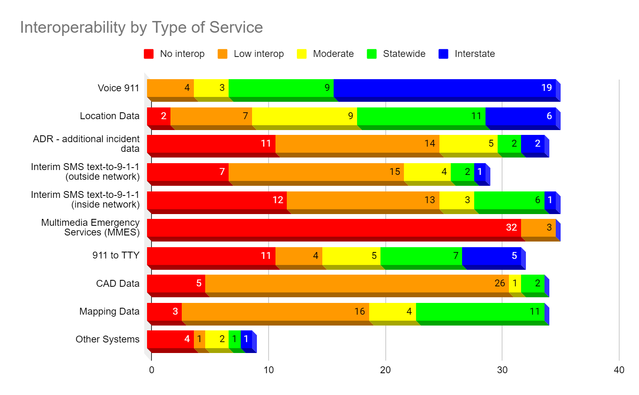

Perhaps not surprisingly, “voice 9-1-1” has the highest level of interoperability, with 28 of the 37 respondents indicating that they have statewide or interstate voice 9-1-1 interoperability. Perhaps also not surprising is that very few respondents indicated any level of interoperability regarding multimedia emergency services (MMES), given that very few PSAPs nationwide are currently accepting multi-media content via 9-1-1.

Another interesting finding is that 26 of the respondents indicate a low level of CAD Data interoperability. A review of the comments provided indicate that this is primarily due to local PSAPs sharing CAD systems on a case-by-case basis with neighboring PSAPs.

One general conclusion that can be made from the both the quantitative and qualitative results of the interoperability matrix is that statewide and interstate operability optimally requires state-level coordination of interoperability efforts, but that in the absence of such coordination, local interoperability will often occur due to the operational necessities of neighboring PSAPs whether or not state-level coordination is in place or encouraged.

Findings

CSRIC VII sought data from various national-level resources and received support from two nationwide programs that provided a current overview of 9-1-1 interoperability for the United States as well as some data on individual PSAP efforts provided by APCO. The primary data sources, as identified in this report, were the National 911 Program and NASNA.

NASNA reported from responding State 911 Program Offices that voice 9-1-1 was the highest level of interoperability among the PSAPs. However, the technologies used to manage the incident after initial receipt and through dispatch of emergency response field personnel had a lower level of interoperability. The more advanced technologies used day to day by the general public such as multi-media services had a very low level of respondents indicating interoperability.

The key findings of the November 2019 National 911 Progress Report indicate that 39% of participants have awarded a statewide NG9-1-1 contract and 31% of PSAPs have implemented an ESInet. This result is a leading indicator in assessing the current state of 9-1-1 interoperability as the establishment of the ESInet IP network infrastructure is a critical prerequisite in achieving PSAP interoperability.

It is important to note that while CSRIC VII is primarily focused on identifying cybersecurity threats and mitigation strategies to be employed by public safety during the transition to NG9-1-1, a key baseline to completing this activity is to ascertain the state of current 9-1-1 interoperability. The greater the state of current interoperability, the greater the immediate need for cybersecurity threat identification and mitigation technologies and strategies. The content of this report was meant to determine the baseline state of 9-1-1 interoperability and serve as a basis for the subsequent tasks / reports to be completed by CSRIC VII.

Conclusions
The United States needs to continue to move forward with the deployment of NG9-1-1, with a strong focus on achieving interoperability, as defined in this report, which includes industry standards-based solutions. The quicker these solutions can be implemented and tested, the quicker the country will meet the goals of the Commission and experience the benefits of full-scale interoperability.

Appendix A – National 911 Progress Report – November 2019 Summary of Interoperability-Related Items

Contents
Total Potential Reporting Entities | 3
State Contracts (39%) | 3
Number of Operational ESInets Deployed (31%) | 3
Total Number of PSAPs (5,432 reported) | 3
Total Number of reported Call-Taking Positions (19,334 reported) | 3
NG9-1-1 Components Procured at State Level | 3
NG9-1-1 Components Procured at Sub-State Level | 3
Number of Contracts Awarded and Testing Begun at State level (277 Contracts) | 4
Percentage of States Who Have Systems Capable of Processing NG9-1-1 Calls for All Service Types (wireless, wireline, and VoIP) (31%) | 4
Percentage of Total State Population Served by NG9-1-1 Capable Services (26%) | 4
Percentage of Total State Population Served by NG9-1-1 Capable Services (27%) | 4
Number of PSAPs Receiving Calls through an ESInet (includes Legacy PSAPs connected to an ESInet through an LPG) (31%) | 5
Number of Operational ESInets Deployed within the States (162 ESInets) | 5
Percentage of MIS to GIS Synchronization Process (GIS readiness for NG9-1-1) (36%) | 5
Routing and Location Maturity Level (5%) | 6
GIS Data Maturity Level (14%) | 6
NG9-1-1 Core Elements Maturity Level (9%) | 6
Network (ESInet) Maturity Level (4%) | 6
PSAP Call Handling System and Applications Maturity Level (7%) | 6
Security Maturity Level (7%) | 7
Summary and Salient Points | 7

A.1 Total Potential Reporting Entities
- 50 states
- DC
- 5 territories
- 56 total reporting entities

A.2 State Contracts (39%)
- 22 of 47 states replying have a state contract in place for NG9-1-1; 22 of 47 states reporting have begun testing and installing NG9-1-1 components in full or in part.
- Percentage: 22 of 56 = 39%

A.3 Number of Operational ESInets Deployed (31%)
- 27 states reported operating 162 ESInets
- 28 states report 1,813 PSAPs are using ESInets for call traffic
- Percentage of PSAP on ESInet: 1,813 of 5,900 = 31%

A.4 Total Number of PSAPs (5,432 reported)
- Reported Primary PSAPs – 4,505
- Secondary – 927
- TOTAL – 5,432 (Not ALL states reporting)
- 38 states report 60 DoD PSAPs
- 31 states report 4 DoI PSAPs

A.5 Total Number of reported Call-Taking Positions (19,334 reported)
- 19,334 across 34 states reporting
- 20,000 appears to be a good number for total across 56 states and territories

A.6 NG9-1-1 Components Procured at State Level
- ESInet – 20 of 56 = 36%
- NGCS – 18 of 56 = 32%
- CPE – 12 of 56 = 21%
- GIS – 10 of 56 = 18%

A.7 NG9-1-1 Components Procured at Sub-State Level
- ESInet – 10 of 300 = 33%
- NGCS – 7 of 300 = 2%
- CPE – 5 of 300 = 1%
- GIS – 2 of 300 = 0.6%

A.8 Number of Contracts Awarded and Testing Begun at State level (277 Contracts)
- 277 across 36 states
- 22 of 56 have begun statewide testing

A.9 Percentage of States Who Have Systems Capable of Processing NG9-1-1 Calls for All Service Types (wireless, wireline, and VoIP) (31%)
14 States – 100% (CT, DE, HI, IN, ME, MD, MA, MI, NH, ND, RI, TN, VT, VA)

- AL – 14.63%
- AZ – 82%
- CA – 8.39%
- IL – 14%
- KS – 80%
- KY – 59%
- TX – 0.07%
- WA – 73%

Rest are 0% or not reporting
Average = 31%

A.10 Percentage of Total State Population Served by NG9-1-1 Capable Services (26%)
11 States – 100% (CT, DE, HI, IN, IA, ME, MA, NH, ND, VT, WA)

- AL – 11.04%
- AZ – 95%
- CA – 2.66%
- IL – 4%
- KS – 62%
- MI – 30.46%
- NC – 10%
- OH – 20%
- TN – 86%
- TX – 2%
- VA – 13%

Rest are 0% or not reporting
Average = 26%

A.11 Percentage of Total State Population Served by NG9-1-1 Capable Services (27%)
12 States – 100% (CT, DE, HI, IN, IA, ME, MA, MN, NH, ND, VT, WA)

- AL – 17.93%
- CA – 21.49%
- IL – 19%
- KS – 86%
- MI – 52.63%
- NC – 10%
- OH – 20%
- TN – 86%
- TX – 1%
- VA – 6.7%

Rest are 0% or not reporting
Average = 27%

A.12 Number of PSAPs Receiving Calls through an ESInet (includes Legacy PSAPs connected to an ESInet through an LPG) (31%)
1,813 PSAPs across the US in 28 states (8 states, have near, or over, 100 PSAPS connected to an ESInet)
Percentage of reported PSAPs in report: = 33%
Percentage vs. Generally accepted # of PSAPS (5,900) = 31%
Percentage of PSAPs the Process IP calls with their CPE (61%)
8 States – 100% (CT, HI, IN, ME, MA, MN, NH, VT)

- AL – 14.63%
- AZ – 73%
- CA – 1.8%
- IL – 12%
- IA – 95%
- KS – 90.59%
- KY – 46%
- LA – 8%
- MI – 26.5%
- ND – 77%
- OH – 20%
- TN – 75%
- TX – 6%
- VA – 10%
- WA – 78%

Rest are 0% or not reporting
Average = 61%

A.13 Number of Operational ESInets Deployed within the States (162 ESInets)
162 Operational ESInets in 27 states
- 12 states – 2 or more
- 15 states – 1
- 14 states – 0
Just about 50% of states and territories have at least one (1) ESInet

A.14 Percentage of MIS to GIS Synchronization Process (GIS readiness for NG9-1-1) (36%)
13 States – 100% (CT, DC, HI, IN, KS, ME, MD, MA, NH, RI, TN, VT, VA)

- ID – 55%
- IL – 20%
- IA – 99%
- MN – 2%
- NE – 20%
- NY – 12%
- ND – 60%
- OH – 90%
- OR – 80%
- SC – 95%
- SD – 95%
- TX – 19%
- WA – 99%

Rest are 0% or not reporting
Average = 36%

A.15 Routing and Location Maturity Level (5%)
- Intermediate – 4 (CT, ME, NH, RI)
- Jurisdictional End State – 3 (DE, MA, TN)
- Readiness – Best case, 13%, Realistic case, 5%
At best, 7, more likely 3, states are potentially interoperable in terms of routing and location (i.e., doing location-based call routing). As we mentioned, if they aren’t actually connected, interoperability is a “moot point.”

A.16 GIS Data Maturity Level (14%)
- Intermediate – 5 (HI, IA, OH, RI, WA)
- Jurisdictional End State – 8 (CT, DE, KS, ME, MA, NH, TN, VT)
- Readiness – Best case, 23%, Realistic case, 14%
At best, 13 states, more likely 8, have GIS data that “match” up at jurisdictional boundaries. Same point as above; if actual cross-border map coordination is not in place, interoperability is “moot,” but theoretically, it can take place if action is taken.

A.17 NG9-1-1 Core Elements Maturity Level (9%)
- Intermediate – 7 (AL, CT, HI, IN, ID, MI, RI)
- Jurisdiction End State – 5 (ME, MA, NH, TN, VT)
- Readiness – Best case, 21%, Realistic case, 9%
At best, 12 states, more likely 5, have NGCS that is complete and fully-interoperable, subject, again, to connections and interconnect agreements being in place.

A.18 Network (ESInet) Maturity Level (4%)
- Intermediate – 4 (IA, ME, NH, TN)
- Jurisdiction End State – 2 (MA, MI)
- Readiness – Best case, 11%, Realistic case, 4%
At best, 6, more likely 2, states are ready for Network-level interoperability.

A.19 PSAP Call Handling System and Applications Maturity Level (7%)
- Intermediate – 3 (HI, IA, NH)
- Jurisdiction End State – 4 (CT, DE, ME, MA)
- Readiness – Best case, 13%, Realistic case, 7%
At best, 7, more likely 3, states have interoperable CPE (this number is likely higher, given reporting earlier on IP-capable CPE, but sticking to the self-reported maturity level rankings from the states themselves, this number comes out lower here).

A.20 Security Maturity Level (7%)
- Intermediate – 7 (DE, HI, IA, KS, NH, RI, WA)
- Jurisdiction End State – 4 (ME, MA, MI, VT)
- Readiness – Best case, 20%, Realistic case, 7%
At best, 11, more likely 4, states are ready for interoperability with regard to network and information security. Given we have to focus on security later in our process, this information is presented for information purposes, but was not used in to derive the summary conclusions below.

A.21 Summary and Salient Points
Across 56 reporting entities, there are:
- 5,432 PSAPs
- 19,334 Call Taking Positions
- 162 ESInets
Overall percentage of NG9-1-1-relevant quantitative measures come out to around 30 – 33% (1/3) of all reporting entities. This may mean that, on average, 33% of 9-1-1 authorities, covered population, and geographic coverage across the country are in some way, preparing for (or covered by), or more or less fully prepared to serve the public (or cover the public) with NG9-1-1 capable (if not 100% NG9-1-1 compliant) systems. This is NOT the same thing as being interoperable in any sense of that word, but it IS indicative of interoperability potential across jurisdictions, covered population, and / or geographic coverage.

When National 911 Program Office Self-reported Maturity Levels relevant to interoperability are taken into consideration, percentages drop to between 5 to 10%.
Overall, there are MANY inconsistencies’ in the data, but using it as a baseline reveals that at the present time, NG9-1-1 interoperability is in its INFANCY. Some states, notably in the Northeast, ARE largely ready to interoperate should they chose to do so. Outside this region, the situation is less “rosy.”

The group will have to make a “judgement call” as to which set of figures is a better indicator of “interoperability readiness,” since, on the basis of the National 911 Progress Report ALONE, no definitive, verifiable conclusions can be made regarding the national state of NG9-1-1 interoperability. That said, however, the report does offer strong evidence of “interoperability readiness” in some reporting entities, again, notably in the Northeastern region of the country.

Appendix B –Summary of Results from 2020 NASNA Interoperability Matrix

Response Rate

37 states responded. 13 states did not respond, and none of the 6 territories responded. States were also asked to fill one out for any tribal entities they had that were not part of their state 9-1-1 system, but no tribal responses were received.

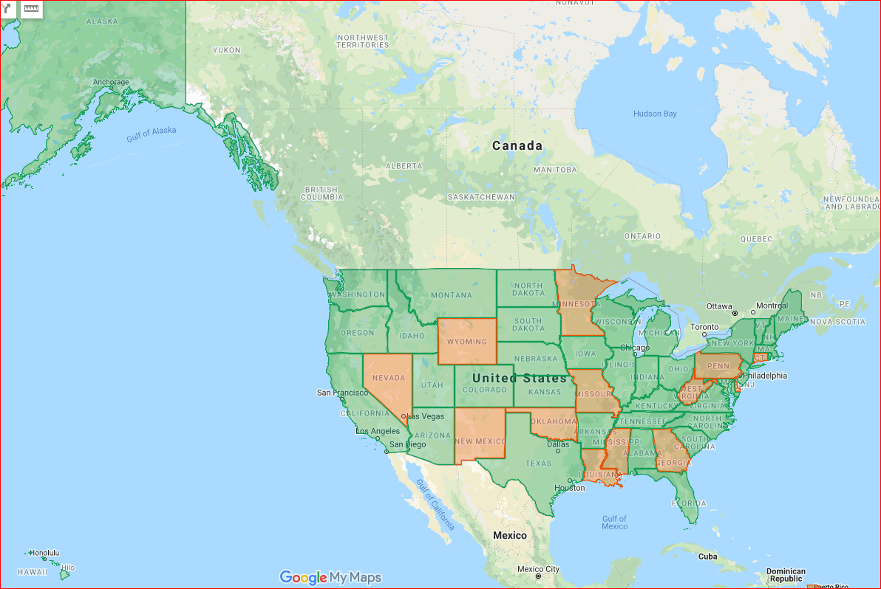
Map: Responses received in green. Click the map to zoom in.

Overall Responses

Responses to all of the categories are represented in this graph.

No interoperability - No PSAPs in the state have this level of interoperability with any other PSAPs.

Low interoperability - Some PSAPs have this level of interoperability with some other PSAPs on a limited basis (such as with immediate neighbors).

Moderate interoperability - Most PSAPs have this level of interoperability with most other PSAPs in the state, although there are some non-compliant PSAPs.

Statewide Interoperability - Every PSAP in the state has this level of interoperability with every other PSAP.

Interstate Interoperability - This state's PSAPs have this level of interoperability with PSAPs in one or more neighboring states. For states with international borders please identify.

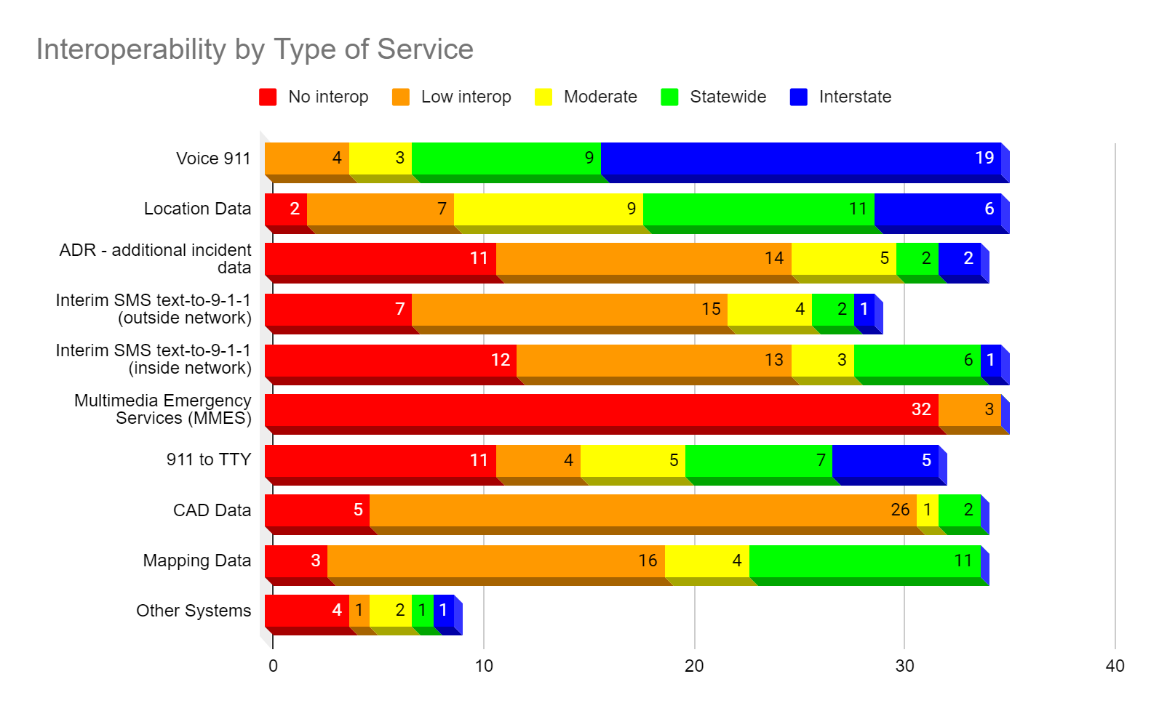

Voice Interoperability:

Shows the level of ability to transfer voice 9-1-1 calls from one PSAP to another.

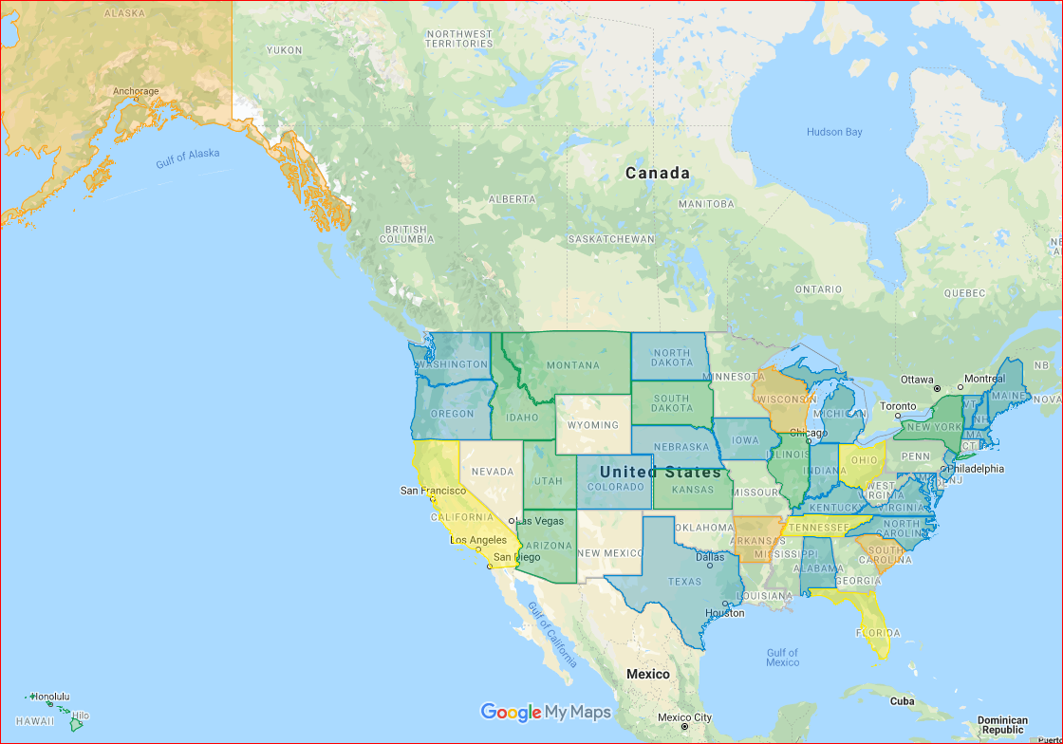
Click on the map to zoom in.

Legend:
Blank - State did not participate.
Gray - State participated but left this question unanswered.
Red - No interoperability.
Orange - Low interoperability.
Yellow - Moderate interoperability.
Green - Statewide interoperability.
Blue - Interstate interoperability.

Voice 911 Call Interoperability
State | Level | Comments
Alabama | Interstate | All voice calls can be transferred from one PSAP to any other PSAP in the state. Additionally, voice calls can be transferred out of the state on PSTN.
Alaska | Low | Some urban PSAPs have this level with their immediate neighbors
Arizona | Statewide
Arkansas | Low | Currently low. Most (if not all) have the ability to transfer calls on a limited basis to neighboring PSAPs. PSAPs that have moved to a hosted solution have the ability to transfer to other PSAPs on the hosted network.
California | Moderate | The only limitation that we have is the number of selective routers. We have 45 SR and transfers are only supported where we have "normal" transfers. When a "special" transfer is needed, we may not have the circuits to support.
Colorado | Interstate | All voice calls can be transferred from one PSAP to any other PSAP in the state. In some cases, PSAPs bordering Utah, Wyoming, etc., they also have the ability transfer to PSAPs in the neighboring states.
Connecticut | No Response
Delaware | No Response
Florida | Moderate
Georgia | No Response
Hawaii | Statewide
Idaho | Statewide | ID PSAPs can transfer voice 9-1-1 inside PSAP to PSAP.
Illinois | Statewide | All voice calls can be transferred from one PSAP to any other PSAP in the state. In some cases, PSAPs bordering Missouri and Indiana also have the ability transfer to PSAPs in the neighboring states.
Indiana | Interstate | Michigan, Ohio, Kentucky
Iowa | Interstate
Kansas | Statewide
Kentucky | Interstate
Louisiana | No Response
Maine | Interstate | New Hampshire, Canada--transfer voice; working on data with NH
Maryland | Interstate | Transfers done via selective router or 10-digit.
Massachusetts | Interstate | Voice only. MA is "rebidding/dipping" one out of State PSAP's ESRK's for Wireless calls.
Michigan | Interstate | All voice calls can be transferred from one PSAP to any other PSAP in the state. In some cases, PSAPs bordering Utah, Wyoming, etc., they also have the ability transfer to PSAPs in the neighboring states.
Minnesota | No Response
Mississippi | No Response
Missouri | No Response
Montana | Statewide
Nebraska | Interstate | Nebraska PSAPs have the ability to transfer calls with bordering PSAPS in Iowa
Nevada | No Response
New Hampshire | Interstate
New Jersey | Interstate | PSAPs in the counties within proximity to New York City can transfer to and from NYC's PSAC.
New Mexico | No Response
New York | Statewide | xfer on 911 system to immediate neighbors and to other PSAP's to 10-digit
North Carolina | Interstate | All voice calls can be transferred from one PSAP to any other PSAP in the state. In some cases, PSAPs bordering Virginia, South Carolina, etc., they also have the ability transfer to PSAPs in the neighboring states.
North Dakota | Interstate | Interoperability only exists with MN.
Ohio | Moderate | Most interoperability at this point is with neighboring counties, etc.
Oklahoma | No Response
Oregon | Interstate | All PSAPs in the State of Oregon have this capability due to the fact that Oregon still uses legacy selective routers and all 6 that serve the state are connected through an inter tandem connections.
Pennsylvania | No Response
Rhode Island | Interstate | Voice can be transferred to Mass. And CT..
South Carolina | Low | Most PSAPs have this level with their immediate neighbors
South Dakota | Statewide | PSAPs that border other states do 10-digit transfers; no other data sharing. Will work on Interstate Agreements with MN and ND on the CenturyLink network once we are completed with the implementation phase since we are all on the CenturyLink ESInet.
Tennessee | Moderate | The current ESI Net can transfer calls. The new ESI Net will have expanded capabilities; anticipated complete by end of 2020.
Texas | Interstate | All PSAPs can transfer using 10-digit transfer via the PSTN.PSAPs on regional ESInets can transfer "on-net" to PSAPs within their network. PSAPs along the Texas/Mexico border transfer across the border using international PSTN dial codes.
Utah | Statewide | All UT PSAPs can transfer voice 9-1-1 inside PSAP to PSAP.
Vermont | Statewide | Voice calls can be transferred from one PSAP to any other PSAP in the state. Voice transfers can be made with bordering States like New York, Massachusetts and New Hampshire using the PSTN.
Virginia | Interstate | Transfer in some instances may need to take place over an admin trunk rather than a 9-1-1 trunk
Washington | Interstate | PSAPs bordering Oregon, Idaho, and British Columbia routinely transfer calls back and forth. WA PSAPs perform transfers utilizing our ESInet's NGCS.
West Virginia | No Response
Wisconsin | Low | There are six providers serving PSAPs in the state. If neighboring PSAPs have the same provider, they likely have transfer capabilities. In the event of call transfers where interop is not established, calls are manually forwarded to admin lines in most cases.
Wyoming | No Response

Location Data:

Shows the level of ability to transfer location data for 9-1-1 calls from one PSAP to another.

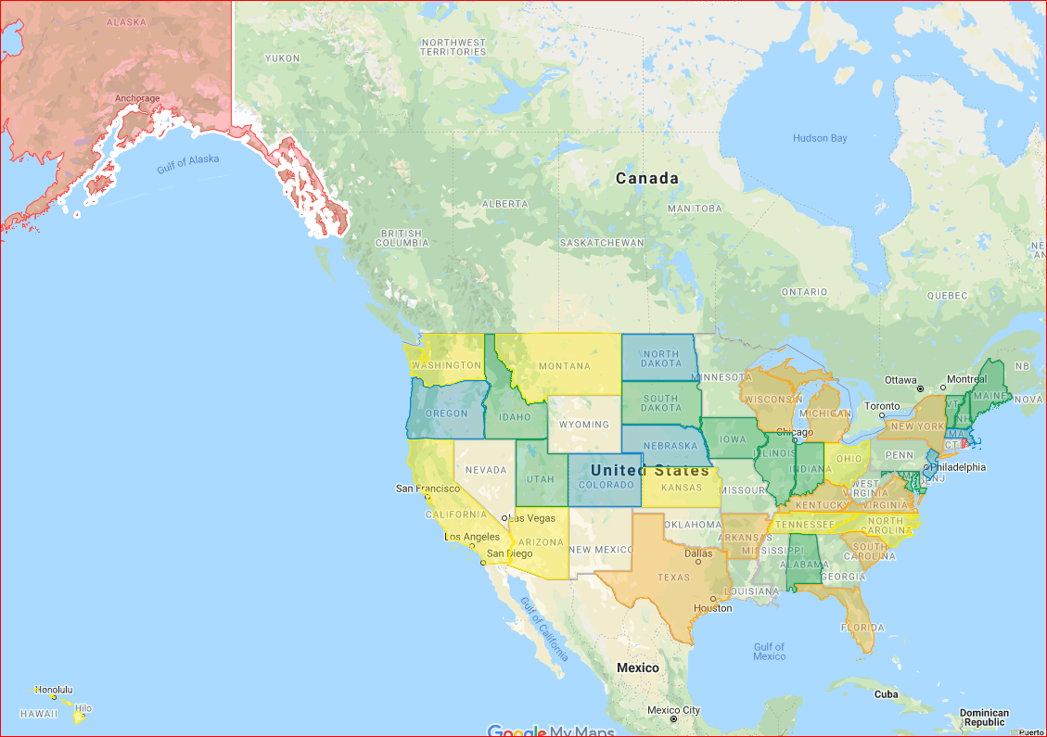
Click on the map to zoom in.

Legend:
Blank - State did not participate.
Gray - State participated but left this question unanswered.
Red - No interoperability.
Orange - Low interoperability.
Yellow - Moderate interoperability.
Green - Statewide interoperability.
Blue - Interstate interoperability.

Location Data Interoperability
State | Level | Comments
Alabama | Statewide | All ALI data can be transferred from one PSAP to another within the state.
Alaska | None
Arizona | Moderate
Arkansas | Low | Currently low. Most (if not all) have the ability to transfer calls on a limited basis to neighboring PSAPs. PSAPs that have moved to a hosted solution have the ability to transfer to other PSAPs on the hosted network.
California | Moderate | The only limitation that we have is the number of selective routers. We have 45 SR and transfers are only supported where we have "normal" transfers. When a "special" transfer is needed, we may not have the circuits to support.
Colorado | Interstate | All voice calls can be transferred from one PSAP to any other PSAP in the state. In some cases, PSAPs bordering Utah, Wyoming, etc., they also have the ability transfer to PSAPs in the neighboring states.
Connecticut | No Response
Delaware | No Response
Florida | Low
Georgia | No Response
Hawaii | Moderate
Idaho | Statewide | ID PSAPs can transfer location information from PSAP to PSAP.
Illinois | Statewide | Location data is transferred from one PSAP to any other PSAP in the state. In some cases, PSAPs bordering Missouri and Indiana also have the ability transfer data to PSAPs in the neighboring states.
Indiana | Statewide | Michigan, Ohio, Kentucky
Iowa | Statewide
Kansas | Moderate
Kentucky | Low | Location data is only transferable between PSAPs within the same ILEC footprint or connected to the same Host CHE.
Louisiana | No Response
Maine | Statewide
Maryland | Statewide | ALI data is transferable within LATA or with RapidSOS.
Massachusetts | Interstate | Voice only. MA is "rebidding/dipping" one out of State PSAP's ESRK's for Wireless calls.
Michigan | Low
Minnesota | No Response
Mississippi | No Response
Missouri | No Response
Montana | Moderate
Nebraska | Interstate
Nevada | No Response
New Hampshire | Statewide | We do have three state borders and one international border (Canada) where cross border transfers are performed. We are currently working with the vendors in those jurisdictions to develop true interoperability between the states.
New Jersey | Interstate | PSAPs in the counties within proximity to New York City can transfer to and from NYC's PSAC.
New Mexico | No Response
New York | Low
North Carolina | Moderate | North Carolina PSAPS can transfer ALI to other PSAPs within the state as long as the functionality is set up between the transferring PSAP and receiving PSAP. Transfers to adjoining states can be accomplished if the transferring PSAP and receiving PSAP are within the same LATA.
North Dakota | Interstate | Interoperability only exists with MN.
Ohio | Moderate | Most can send ALI data with the transfer, but there are also places where it is voice call only at this point.
Oklahoma | No Response
Oregon | Interstate | All PSAPs in the State of Oregon have this capability due to the fact that Oregon still uses legacy selective routers and all 6 that serve the state are connected through an intertandem connection. As you know when a call is transferred, the call is transferred through the selective router and therefore a query to the ALI database is initiated again.
Pennsylvania | No Response
Rhode Island | None
South Carolina | Low | Most PSAPs have this level with their immediate neighbors
South Dakota | Statewide
Tennessee | Moderate | The current ESI Net can transfer calls. The new ESI Net will have expanded capabilities; anticipated complete by end of 2020.
Texas | Low | There are 3 ALI database providers within the state covering approximately 600 PSAPs so visibility to this functionality is limited. In generic terms, calls that are transferred via the PSTN (10-digit) do not include the ALI record and have to be "re-bid". Calls that are transferred "on-net" to PSAPs using the same database provider do include the ALI record.
Utah | Statewide | All UT PSAPs can transfer location information from PSAP to PSAP.
Vermont | Statewide | Vermont has this ability technically, but it’s not utilized due to operational impact and procedures.
Virginia | Low | In most cases, PSAPs are not able to transfer data across LATAs
Washington | Moderate | Currently transfers to/from PSAPs in Oregon, Idaho, and British Columbia are being done via 10-digit transfer. Because of this ANI cannot be sent so caller location data cannot be queried. Our ESInet/NGCS vendor is working on using the Oregon & Idaho Selective Routers for this, thus allowing ANI to be shared.
West Virginia | No Response
Wisconsin | Low | There might be some with this capability if they have full transfer capability with their neighbor.
Wyoming | No Response

Additional Incident Data:

Shows the level of ability to share additional incident data from one PSAP to another.

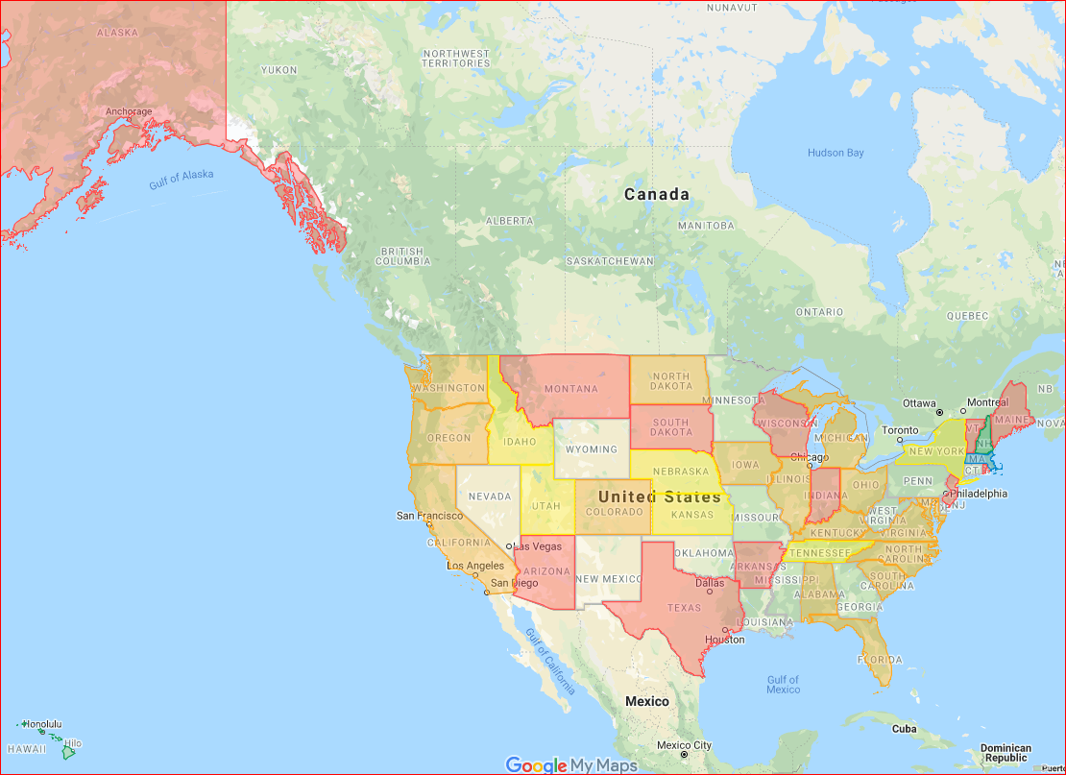
Click on the map to zoom in.

Legend:
Blank - State did not participate.
Gray - State participated but left this question unanswered.
Red - No interoperability.
Orange - Low interoperability.
Yellow - Moderate interoperability.
Green - Statewide interoperability.
Blue - Interstate interoperability.

Additional Incident Data Interoperability
State | Level | Comments
Alabama | Low | Some PSAPs share CAD systems, and can transfer information via CAD to their neighbors.
Alaska | None
Arizona | None | Use supplemental data
Arkansas | None
California | Low
Colorado | Low | Some PSAPs share CAD systems, and can transfer information via CAD to their neighbors.
Connecticut | No Response
Delaware | No Response
Florida | Low
Georgia | No Response
Hawaii | Statewide
Idaho | Moderate | Those PSAPs with the same CAD are able to push that to another PSAP that shares the CAD to CAD connection.
Illinois | Low | Several PSAP's share CAD Data but that is the exception and not the rule.
Indiana | None
Iowa | Low
Kansas | Moderate
Kentucky | Low
Louisiana | No Response
Maine | None
Maryland | Low
Massachusetts | Interstate | RapidSOS deployed through the State. Fully integrated into the map and NG911 CPE.
Michigan | Low | Some PSAPs share CAD systems, and can transfer information via CAD to their neighbors.
Minnesota | No Response
Mississippi | No Response
Missouri | No Response
Montana | None
Nebraska | Moderate
Nevada | No Response
New Hampshire | Statewide
New Jersey | None
New Mexico | No Response
New York | Moderate | incident data can be shared via Mutualink installed at each county level PSAP. County level PSAP's can share incident data with PSAP's in other states via Mutualink
North Carolina | Low | Some PSAPs share CAD systems or have CAD to CAD software, and can transfer information via CAD to their neighbors.
North Dakota | Low
Ohio | Low | Variable.
Oklahoma | No Response
Oregon | Low | There are few PSAPs within Oregon that connect to RapidSOS.
Pennsylvania | No Response
Rhode Island | None
South Carolina | Low | Most PSAPs have this level with their immediate neighbors
South Dakota | None
Tennessee | Moderate | ADR is available via over-the-top solutions. ADR will be available over the new ESI Net when complete.
Texas | None | not used
Utah | Moderate | Those PSAPs with the same CAD are able to add detailed incident information and push that to another PSAP that shares the CAD to CAD connection. We do have 2 different CADs connected by a CAD Aggregator that can push the incident details from PSAP to PSAP as well.
Vermont | None
Virginia | Low | Outside of some regional and shared services CAD projects, this data is not widely available
Washington | Low
West Virginia | No Response
Wisconsin | None | Unknown but unlikely
Wyoming | No Response

Text-to-911 (outside network):

Shows the level of ability to text-to-911 calls from one PSAP to another using methods other than the 9-1-1 network itself.

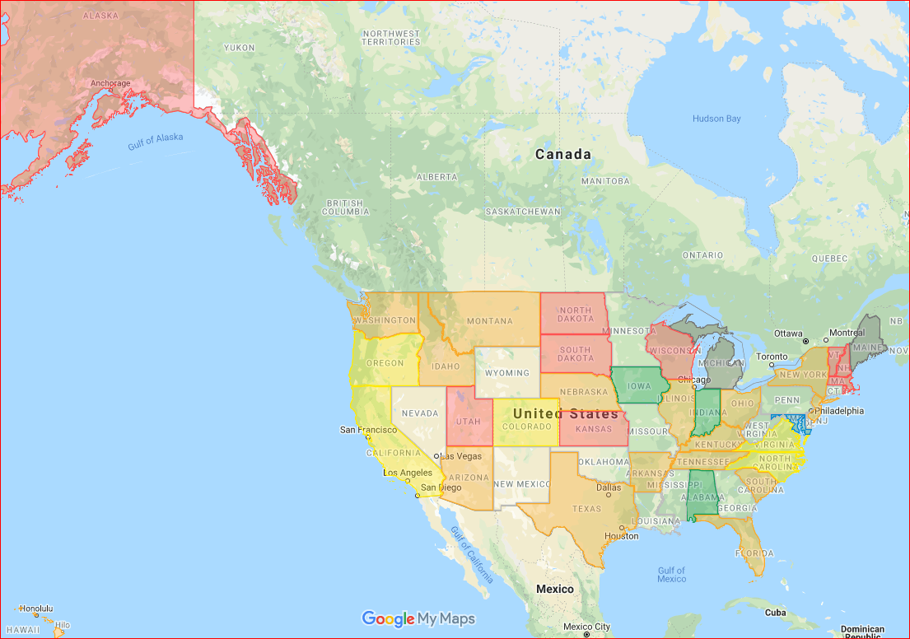
Click on the map to zoom in.

Legend:
Blank - State did not participate.
Gray - State participated but left this question unanswered.
Red - No interoperability.
Orange - Low interoperability.
Yellow - Moderate interoperability.
Green - Statewide interoperability.
Blue - Interstate interoperability.

Text-to-911 Interoperability (Outside Network)
State | Level | Comments
Alabama | Statewide | All text sessions that originate in Alabama can be transferred to other neighboring PSAPs in the state.
Alaska | None
Arizona | Low
Arkansas | Low | Currently very low. Only a small percentage of PSAPs have deployed text-to-911 service.
California | Moderate
Colorado | Moderate | Roughly 70% of Colorado's PSAPs have interim text-to-911, can transfer from one PSAP to another. PSAPs that do not have text-to-911 are unable to either transfer or receive text sessions.
Connecticut | No Response
Delaware | No Response
Florida | Low
Georgia | No Response
Hawaii | Low
Idaho | Low | In ID we have 3 different ways PSAPs are getting text. Those that have the CPE type of solution can share with others that have the same CPE and CPE solution.
Illinois | Low | In ID we have 3 different ways PSAPs are getting text. Those that have the CPE type of solution can share with others that have the same CPE and CPE solution.
Indiana | Statewide
Iowa | Statewide
Kansas | None
Kentucky | Low | Only available for PSAPs using the same OTT solution and/or on the same TCC.
Louisiana | No Response
Maine | Blank | All PSAPs in Maine are within the network
Maryland | Interstate | MD using TCC that can transfer text sessions between PSAPs
Massachusetts | None
Michigan | Blank
Minnesota | No Response
Mississippi | No Response
Missouri | No Response
Montana | Low
Nebraska | Low
Nevada | No Response
New Hampshire | None | MD using TCC that can transfer text sessions between PSAPs
New Jersey | Low
New Mexico | No Response
New York | Low
North Carolina | Moderate | Approximately 90% of North Carolina's PSAPs have text-to-911, some can transfer from one PSAP to another. PSAPs that do not have text-to-911 are unable to either transfer or receive text sessions. All PSAPs will have text to 911 and be able to transfer by June 30, 2020
North Dakota | None | All inbound 9-1-1 text calls handled within 911 network.
Ohio | Low | Only 1/4 of the state has Text-to-9-1-1.
Oklahoma | No Response
Oregon | Moderate | Most PSAPs in the State utilize the same Text-to-9-1-1 product, therefore they are able to transfer to one another.
Pennsylvania | No Response
Rhode Island | None
South Carolina | Low | Most PSAPs have this level with their immediate neighbors
South Dakota | None | We plan to deploy Text-to-9-1-1 later in 2020 after we complete the implementation phase
Tennessee | Low
Texas | Low | Limited visibility to this functionality from a state perspective
Utah | None | The only PSAPs in UT that are currently getting SMS text is utilizing the 911 network to transfer.
Vermont | None
Virginia | Moderate | In Virginia, there is a legislative mandate for all localities to deploy this service by July 1, 2020
Washington | Low
West Virginia | No Response
Wisconsin | None | With only 12 PSAPs (out of 122) that have text capability, it is unlikely that any are transferring.
Wyoming | No Response

Text-to-911 (inside network):

Shows the level of ability to text-to-911 calls from one PSAP to another via the same network used to deliver voice 9-1-1 calls.

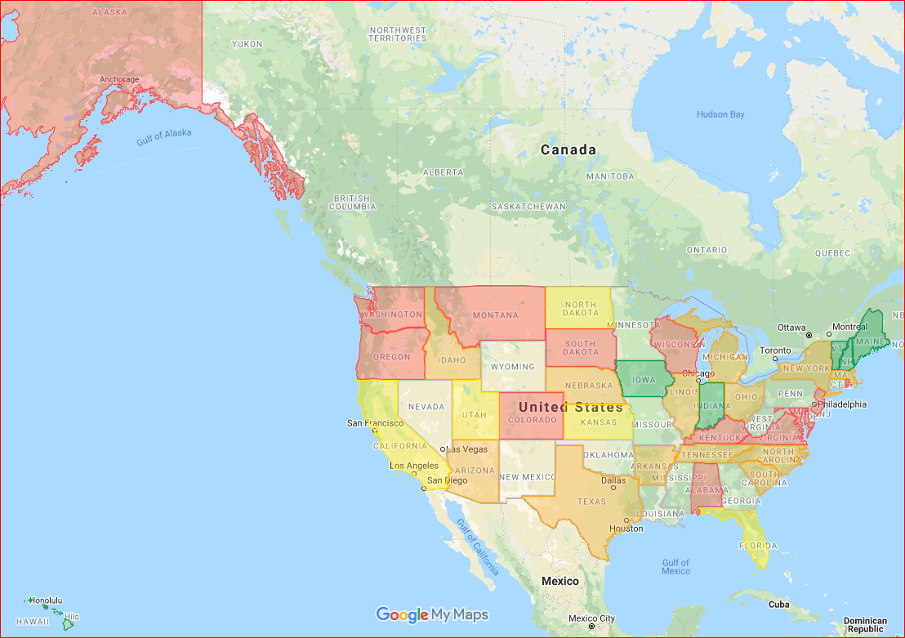
Click on the map to zoom in.

Legend:
Blank - State did not participate.
Gray - State participated but left this question unanswered.
Red - No interoperability.
Orange - Low interoperability.
Yellow - Moderate interoperability.
Green - Statewide interoperability.
Blue - Interstate interoperability

Text-to-911 Interoperability (Inside Network)
State | Level | Comments
Alabama | None | Texts are delivered out of band via a web portal on the public internet.
Alaska | None
Arizona | Low
Arkansas | Low | Currently very low. Only a small percentage of PSAPs have deployed text-to-911 service.
California | Moderate
Colorado | None | We do not have text-to-911 delivery via the 9-1-1 network at this time.
Connecticut | No Response
Delaware | No Response
Florida | Moderate
Georgia | No Response
Hawaii | Statewide
Idaho | Low | In ID we have 3 different ways PSAPs are getting text. Those that have the CPE type of solution can share with others that have the same CPE and CPE solution.
Illinois | Low
Indiana | Statewide
Iowa | Statewide
Kansas | Moderate
Kentucky | None
Louisiana | No Response
Maine | Statewide
Maryland | None | As PSAPs implement NG911, this functionality will be done within the ESInet.
Massachusetts | Low | Voice relay for misrouted text messages. Text solution fully integrated into the NG911 call handling system.
Michigan | Low | Almost 70% of the state's PSAPs have Text-to-911 and can transfer calls between PSAPs
Minnesota | No Response
Mississippi | No Response
Missouri | No Response
Montana | None
Nebraska | Low | About half of the PSAPs in Nebraska have text-to-911. Those that do have the ability to transfer.
Nevada | No Response
New Hampshire | Statewide | Only between the 2 geographically separated primary PSAP locations, not between the PSAP and secondary PSAPS
New Jersey | None | Not until NG
New Mexico | No Response
New York | Low
North Carolina | Low | As we implement NG911 text to 911 sessions can be transferred. At this time, we have 33 PSAPs on the NG911 network.
North Dakota | Moderate | Text-to-911 service is statewide but some PSAPs handle texts for others who are not capable of receiving texts directly. Some PSAPs are able to transfer to MN ESInet.
Ohio | Low | Only 1/4 of the state has Text-to-9-1-1.
Oklahoma | No Response
Oregon | None | N/A
Pennsylvania | No Response
Rhode Island | None
South Carolina | Low | Most PSAPs have this level with their immediate neighbors
South Dakota | None | We plan to deploy Text-to-9-1-1 later in 2020 after we complete the implementation phase
Tennessee | Low | A few TN PSAPs have SMS capabilities through an interim solution. Full deployment is pending with the new ESI Net.
Texas | Low | Limited visibility to this functionality from a state perspective
Utah | Moderate | There are a few PSAPs that don't have SMS, those that do can transfer sessions to each other within the state.
Vermont | Statewide
Virginia | None | Text-to-9-1-1 is a NG9-1-1 core service and will be available through the network by the end of calendar year 2021
Washington | None | This capability is currently dependent upon multiple PSAPs accepting the integrated delivery of Text-to-911, and is expected to be available by End-Of-CY 2020
West Virginia | No Response
Wisconsin | None | The state is unaware of any integrated text solutions in the state. The state does not have an ESInet at this time.
Wyoming | No Response

Multimedia Emergency Services (MMES):

Shows the level of ability to multimedia emergency services (MMES) data from one PSAP to another.

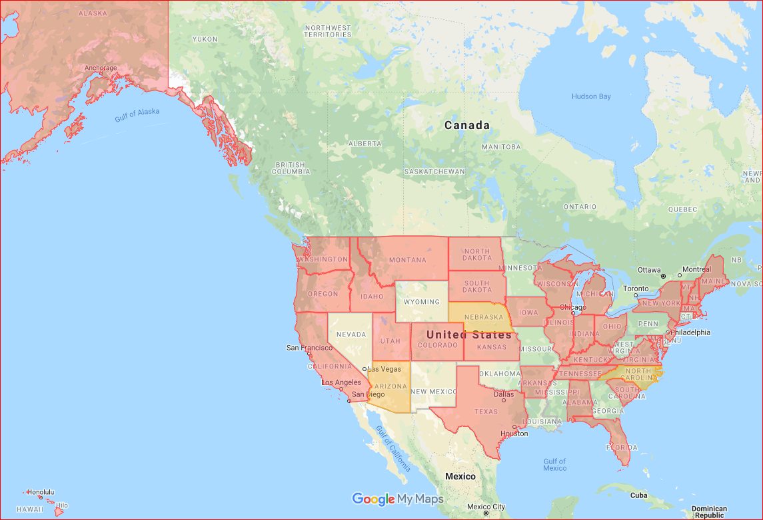
Click on the map to zoom in.

Legend:
Blank - State did not participate.
Gray - State participated but left this question unanswered.
Red - No interoperability.
Orange - Low interoperability.
Yellow - Moderate interoperability.
Green - Statewide interoperability.
Blue - Interstate interoperability

Multimedia Emergency Services (MMES)
State | Level | Comments
Alabama | None | Two PSAPs have the ability to receive video - Morgan and Chilton. They cannot transfer the video to one another.
Alaska | None
Arizona | Low | Century Link states their network can transfer video when carriers send
Arkansas | None | No interoperability at this time.
California | None
Colorado | None | None of our PSAPs currently support MMES at this time.
Connecticut | No Response
Delaware | No Response
Florida | None
Georgia | No Response
Hawaii | None
Idaho | None | Not available in ID YET.
Illinois | None | There is no interoperability.
Indiana | None
Iowa | None
Kansas | None
Kentucky | None
Louisiana | No Response
Maine | None | Only receiving text at this time and can transfer between PSAPs
Maryland | None
Massachusetts | None | Piloting live streaming in April 2020.
Michigan | None | None of our PSAPs currently support MMES at this time.
Minnesota | No Response
Mississippi | No Response
Missouri | No Response
Montana | None
Nebraska | Low
Nevada | No Response
New Hampshire | None | NH does not currently accept MMS services (RTT, Video, Pictures) into the PSAP
New Jersey | None
New Mexico | No Response
New York | None | All PSAP's in State are E911 Legacy State WPH2 capable. County Level PSAP's only via Mutualink(above)
North Carolina | Low | Currently only one PSAP can receive videos and pictures.
North Dakota | None | It's our understanding that no standards-driven solution for this service exists so we have not pursued.
Ohio | None
Oklahoma | No Response
Oregon | None
Pennsylvania | No Response
Rhode Island | None
South Carolina | None
South Dakota | None | No plans in place yet for MMES sessions other than Text-to-9-1-1
Tennessee | None | Pending deployment of new ESI Net.
Texas | None | There are no active MMS services enabled in the state.
Utah | None | No PSAPs in UT have the capability of receiving video or pictures through their CPE.
Vermont | None | Vermont is not currently receiving RTT. voice, pictures, and or video from the TCCs.
Virginia | None | This service is not currently available in Virginia
Washington | None | This is a contract requirement of our NGCS vendor, but WA is not currently accepting MMES
West Virginia | No Response
Wisconsin | None | No PSAPs are receiving MMES outside of basic text.
Wyoming | No Response

911 to TTY:

Shows the level of ability to transfer TTY calls from one PSAP to another.

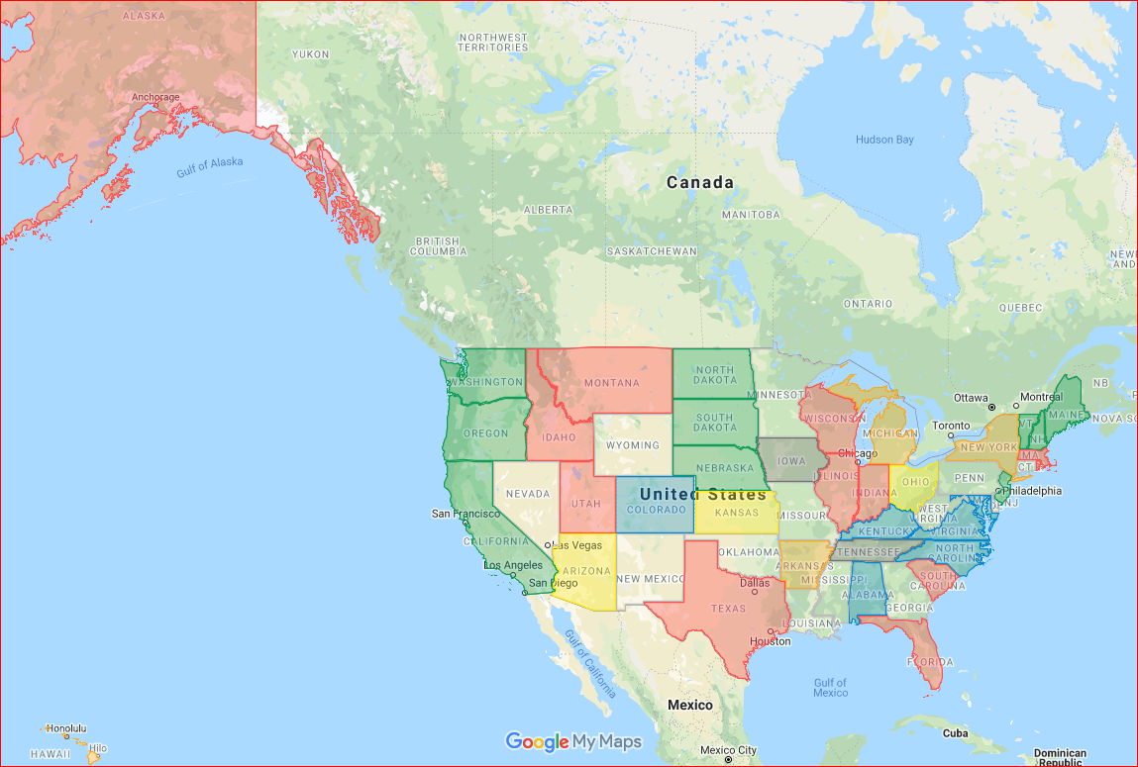
Click on the map to zoom in.

Legend:
Blank - State did not participate.
Gray - State participated but left this question unanswered.
Red - No interoperability.
Orange - Low interoperability.
Yellow - Moderate interoperability.
Green - Statewide interoperability.
Blue - Interstate interoperability

911 to TTY
State | Level | Comments
Alabama | Interstate
Alaska | None
Arizona | Moderate
Arkansas | Low | Low interoperability
California | Statewide
Colorado | Interstate | All voice calls can be transferred from one PSAP to any other PSAP in the state. In some cases, PSAPs bordering Utah, Wyoming, etc., they also have the ability transfer to PSAPs in the neighboring states. TTY calls are handled by the network in the same fashion as voice calls.
Connecticut | No Response
Delaware | No Response
Florida | None
Georgia | No Response
Hawaii | Low
Idaho | None
Illinois | None | There is no interoperability for TTY calls.
Indiana | None
Iowa | Blank | Unknown. Use of TTY is very low.
Kansas | Moderate
Kentucky | Interstate
Louisiana | No Response
Maine | Statewide
Maryland | Interstate | TTY calls are received on voice trunks, and can be transferred in the same manner as voice call.
Massachusetts | None
Michigan | Low
Minnesota | No Response
Mississippi | No Response
Missouri | No Response
Montana | None
Nebraska | Statewide
Nevada | No Response
New Hampshire | Statewide
New Jersey | Statewide
New Mexico | No Response
New York | Low | xfer to adjacent PSAP's only
North Carolina | Interstate | All voice calls can be transferred from one PSAP to any other PSAP in the state. In some cases, PSAPs bordering South Carolina, Virginia, Tennessee and Georgia also have the ability to transfer to PSAPs in the neighboring states unless limited by LATA boundaries. TTY calls are handled by the network in the same fashion as voice calls. TTY call transcripts cannot be transferred.
North Dakota | Statewide
Ohio | Moderate
Oklahoma | No Response
Oregon | Statewide | Still using legacy CAMA trunks to deliver calls. Able to transfer TTY Calls
Pennsylvania | No Response
Rhode Island | None
South Carolina | None
South Dakota | Statewide | The TTY calls can be transferred, but the data from the previous conversation cannot be transferred
Tennessee | Blank | No data.
Texas | None | TTY calls cannot be transferred
Utah | None
Vermont | Statewide
Virginia | Interstate
Washington | Statewide | ...as long as the caller or originator is sending via TTY
West Virginia | No Response
Wisconsin | None | Unknown but unlikely
Wyoming | No Response

CAD Data:

Shows the level of ability to share Computer Aided Dispatch (CAD) data from one PSAP to another.

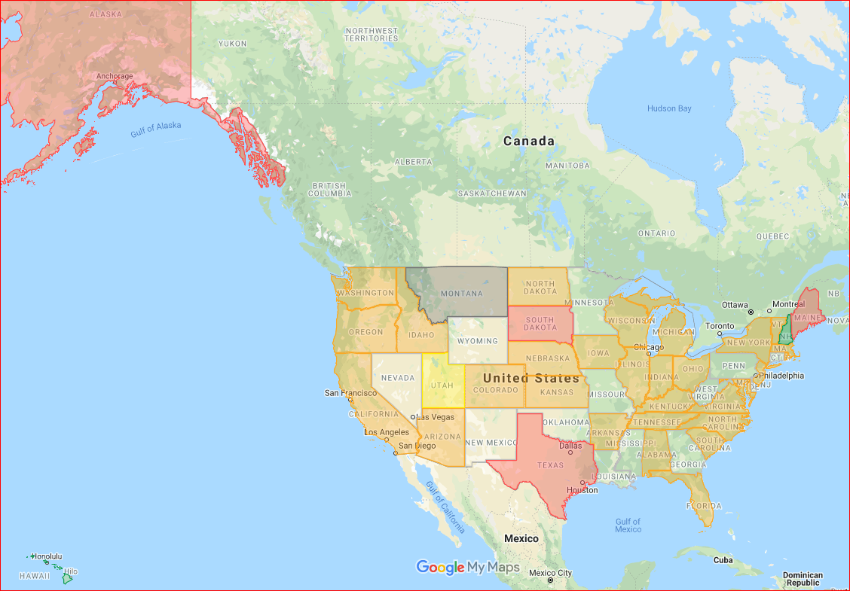
Click on the map to zoom in.

Legend:
Blank - State did not participate.
Gray - State participated but left this question unanswered.
Red - No interoperability.
Orange - Low interoperability.
Yellow - Moderate interoperability.
Green - Statewide interoperability.
Blue - Interstate interoperability

CAD
State | Level | Comments
Alabama | Low | Approximately five PSAPs have the ability to transfer CAD records between each other.
Alaska | None
Arizona | Low | Depending on PSAPs CAD System
Arkansas | Low | Low Interoperability. Many Arkansas PSAPs still do not have CAD
California | Low | Very limited ability in this category.
Colorado | Low | Some PSAPs share CAD systems, and can transfer information via CAD to their neighbors.
Connecticut | No Response
Delaware | No Response
Florida | Low
Georgia | No Response
Hawaii | Statewide
Idaho | Low | A few PSAPs have CAD to CAD, or a shared CAD server amongst their neighboring agencies.
Illinois | Low | Several PSAP's share CAD Data but that is the exception and not the rule.
Indiana | Low
Iowa | Low
Kansas | Low | In 2020, we will be implementing RapidDeploy Nimbus across all Kansas PSAPs so that CAD data may be shared amongst all PSAPs in the State
Kentucky | Low | Capability limited to PSAPs operating the same CAD solution and operating on the same IP network.
Louisiana | No Response
Maine | None
Maryland | Low | PSAPs in National Capitol Region using CAD-to-CAD transfer
Massachusetts | Low | MA State 911 does not track this but is aware of some PSAPS having this capability.
Michigan | Low | Some PSAPs share CAD systems, and can transfer information via CAD to their neighbors.
Minnesota | No Response
Mississippi | No Response
Missouri | No Response
Montana | Blank
Nebraska | Low | Some PSAPs have a shared CAD platform and have interoperability.
Nevada | No Response
New Hampshire | Statewide | NH Provides the CAD to each secondary PSAP to transfer information and CAD data specific to a call
New Jersey | Low | A few counties have this ability.
New Mexico | No Response
New York | Low | Capability only in one three county shared CAD
North Carolina | Low | Some PSAPs share CAD systems or have CAD to CAD software, and can transfer information via CAD to their neighbors.
North Dakota | Low
Ohio | Low | Highly dependent on systems right now - variable depending on neighbors’ system.
Oklahoma | No Response
Oregon | Low | There are approximately 5-6 PSAPs in the Portland metro area that share the same CAD and are able to transfer records to one other.
Pennsylvania | No Response
Rhode Island | Low | There are several towns in RI who have CAD-to-CAD interfaces
South Carolina | Low
South Dakota | None
Tennessee | Low | A few PSAPs/districts utilize standard CAD solutions.
Texas | None | Because CAD has no standards CAD systems are not interoperable therefore records cannot be transferred
Utah | Moderate | Most PSAPs have CAD to CAD, or a shared CAD server amongst their neighboring agencies. There are some PSAPs that need to get it to minimize transfers-UT is working on this now through standards and legislation for 2020, we are possibly looking at either a statewide CAD aggregator or statewide CAD- not sure yet.
Vermont | Low | There are two main CAD systems in Vermont and some PSAPs use one system, while others use the alternate. To my knowledge they can only push a call on the same system.
Virginia | Low | PSAPs that are participating in regional and shared services CAD projects can transfer these records, but this is not a widespread capability
Washington | Low | There are several Counties/PSAPs in WA who either share a CAD system, have CAD-to-CAD interfaces, or have some other method of CAD interoperability. Several Counties/PSAPs have CAD interoperability projects as part of their Grants.
West Virginia | No Response
Wisconsin | Low | There are some PSAPs operating on the same CAD which may provide this capability.
Wyoming | No Response

Mapping Data:

Shows the level of ability to share mapping data from one PSAP to another.

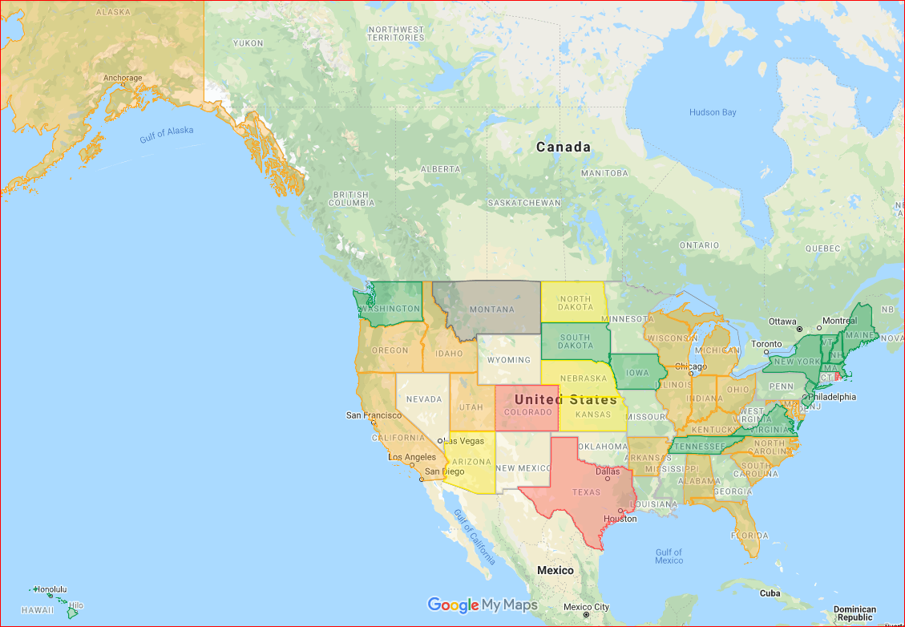
Click on the map to zoom in.

Legend:
Blank - State did not participate.
Gray - State participated but left this question unanswered.
Red - No interoperability.
Orange - Low interoperability.
Yellow - Moderate interoperability.
Green - Statewide interoperability.
Blue - Interstate interoperability

Mapping
State | Level | Comments
Alabama | Low | There are some PSAPs operating on the same CAD which may provide this capability.
Alaska | Low | Some PSAPs have this level with their immediate neighbors
Arizona | Moderate
Arkansas | Low | Low interoperability - available for some PSAPs on hosted solutions.
California | Low
Colorado | None | None of our PSAPs share mapping data at this time.
Connecticut | No Response
Delaware | No Response
Florida | Low
Georgia | No Response
Hawaii | Statewide
Idaho | Low | Starting to get GIS shared amongst the 6 regions in ID. Two of 6 have shared GIS data currently.
Illinois | Low | This is a work in progress as we are preparing for NG911 and geo-spatial routing.
Indiana | Low
Iowa | Statewide
Kansas | Moderate
Kentucky | Low | Some PSAPs share mapping information as needed through multiple methods. We are moving to a centralized statewide system.
Louisiana | No Response
Maine | Statewide
Maryland | Low | Regionally. MD is implementing a statewide database for PSAP GIS data sharing.
Massachusetts | Statewide
Michigan | Low | We have a GIS Repository that the majority of PSAPs participate in and can see mapping data.
Minnesota | No Response
Mississippi | No Response
Missouri | No Response
Montana | Blank
Nebraska | Moderate | Many of Nebraska PSAPs have a shared mapping solution.
Nevada | No Response
New Hampshire | Statewide | And is shared with the secondary PSAPs / Communications centers
New Jersey | Statewide | State Office if GIS make mapping data available to PSAPs and their vendors.
New Mexico | No Response
New York | Statewide | Statewide GIS program in which every county uploads data to allows all counties and municipalities to access
North Carolina | Low | Some PSAPs share mapping data with their adjoining PSAPs due to mutual aid responses or if the PSAP is serving as a backup center to their neighboring county. As I3 migration continues in NC, all PSAPs will have the ability to share GIS data.
North Dakota | Moderate
Ohio | Low | Variable
Oklahoma | No Response
Oregon | Low | There are approximately 5-6 PSAPs in the Portland metro area that share the same CAD and are able to transfer records to one other. Those agencies use the same mapping applications.
Pennsylvania | No Response
Rhode Island | None
South Carolina | Low | Some PSAPs have this level with their immediate neighbors
South Dakota | Statewide
Tennessee | Statewide | TN uses a standard GIS solution available to all districts/PSAPs.
Texas | None | GIS data is not shared and is not standardized across the state.
Utah | Low | UT AGRC (Automated Geographic Reference Center) works with most PSAPs for aerial imagery mapping-Information can be shared PSAP to PSAP but it would have to be loaded manually and requested from the neighboring PSAPs.
Vermont | Statewide | There are two main CAD systems in Vermont and some PSAPs use one system, while others use the alternate. To my knowledge they can only push a call on the same system.
Virginia | Statewide | This capability is supported by the Virginia Base Mapping Program
Washington | Statewide | Washington State has one state-wide set of GIS data, which each County provides the data for, and this data is located in our ESInet. Every County/PSAP has access to every other County's GIS Data. There are also plans for the 911 GIS Data to become the statewide GIS Data source for other then 911. In addition, the 911 GIS Data has been deemed "Authoritative" by the State's Boundary Commission, making it easier for Counties to settle boundary disputes.
West Virginia | No Response
Wisconsin | Low | The state is aware of two PSAPs that can share mapping data but there may be a few others.
Wyoming | No Response

Other Systems:

Shows the level of ability to share data from systems not described in other categories from one PSAP to another.

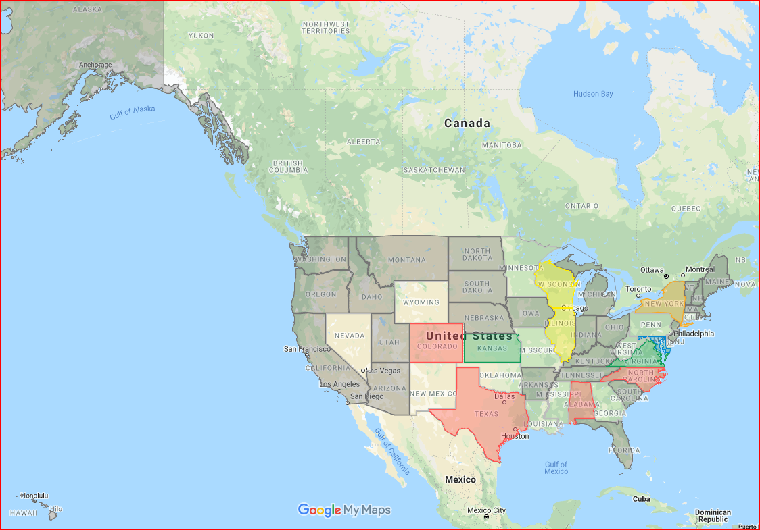
Click on the map to zoom in.

Legend:
Blank - State did not participate.
Gray - State participated but left this question unanswered.
Red - No interoperability.
Orange - Low interoperability.
Yellow - Moderate interoperability.
Green - Statewide interoperability.
Blue - Interstate interoperability

Other
State | Level | Comments
Alabama | None | N/A
Alaska | Blank
Arizona | Blank
Arkansas | Blank
California | Blank
Colorado | None | N/A
Connecticut | No Response
Delaware | No Response
Florida | Blank
Georgia | No Response
Hawaii | Blank
Idaho | Blank
Illinois | Moderate | The Statewide radio system (STARCOM21) is utilized by the State Police as well as several County's and municipalities operating throughout the State.
Indiana | Blank
Iowa | Blank
Kansas | Statewide | Statewide interoperable LMR system available to all PSAPs in the state.
Kentucky | Blank
Louisiana | No Response
Maine | Blank
Maryland | Interstate | LMR
Massachusetts | Blank | One ESINET with redundant carriers at all 228 PSAPs. Same call handling system at all PSAPs. Same standard level of base training. Selective routers and ALI database replaced with NG911 LDB and connections to three Data Centers. We geospatial route every 911 call with point data. Statewide GIS.
Michigan | Blank
Minnesota | No Response
Mississippi | No Response
Missouri | No Response
Montana | Blank
Nebraska | Blank
Nevada | No Response
New Hampshire | Blank
New Jersey | Blank | NA
New Mexico | No Response
New York | Low | LMR- Regional P25 systems in three areas of the state allow first responders in multiple counties to communicate seamlessly
North Carolina | None | NA
North Dakota | Blank
Ohio | Blank
Oklahoma | No Response
Oregon | Blank
Pennsylvania | No Response
Rhode Island | Blank
South Carolina | Blank
South Dakota | Blank
Tennessee | Blank
Texas | None
Utah | Blank
Vermont | Blank
Virginia | Statewide | Statewide analytics data is available
Washington | Blank
West Virginia | No Response
Wisconsin | Moderate | Wisconsin's TIME system (law enforcement database for NCIC, CJIS, etc.) has a connection at most PSAPs in the state. Not sure if that classifies as interoperability though.  Most PSAPs in the state also maintain a dispatch console that has access to the statewide interoperable radio system (WISCOM) which can be used for dispatching when CAD is not interoperable.
Wyoming | No Response

General Comments

In addition to commenting on each type of technology category, respondents were also provided with space to provide general comments about their overall interoperability. These are the responses:

General Comments
State | Comments
Alabama | Alabama is in the process of ESInet build-out; all PSAPs should be on the network by the end of Q2 2020.
Alaska | Most PSAP's in AK are still phase 0 with no caller ID coming with the call.
Arizona | Participated, but did not provide any general comments.
Arkansas | Participated, but did not provide any general comments.
California | We are currently deploying NG 9-1-1 and will have 100% capability in all the areas above by the end of 2022.
Colorado | Colorado is currently in the process of migrating its PSAPs to an ESInet. Additional interoperability functionality will be added at a future date.
Connecticut | Did not participate in the data collection.
Delaware | Did not participate in the data collection.
Florida | Participated, but did not provide any general comments.
Georgia | Did not participate in the data collection.
Hawaii | Participated, but did not provide any general comments.
Idaho | Participated, but did not provide any general comments.
Illinois | Participated, but did not provide any general comments.
Indiana | Indiana elected to use INdigital and AT&T to build two ESInet networks. In the event one fails the other will have the capability to process the calls. The Statewide 911 Board has also installed MEVO phones in all PSAPs that currently serve as a backup.
Iowa | Participated, but did not provide any general comments.
Kansas | Participated, but did not provide any general comments.
Kentucky | Participated, but did not provide any general comments.
Louisiana | Did not participate in the data collection.
Maine | Participated, but did not provide any general comments.
Maryland | LMR - MD is heavily invested in the sharing of system keys and talkgroups for interoperable communications. MD has a statewide 700 MHz system that jurisdictions use for interoperability.
Massachusetts | Participated, but did not provide any general comments.
Michigan | Michigan is currently in the process of migrating its PSAPs to an ESInet. Additional interoperability functionality will be added at a future date.
Minnesota | Did not participate in the data collection.
Mississippi | Did not participate in the data collection.
Missouri | Did not participate in the data collection.
Montana | Participated, but did not provide any general comments.
Nebraska | Participated, but did not provide any general comments.
Nevada | Did not participate in the data collection.
New Hampshire | New Hampshire is a single PSAP model (two geographically separate PSAP locations, connected with an ACD over an ESINET). We are connected to 67 secondary PSAPS (Communications Centers) to transfer ANI/ALI and GIS Data as well as EMD determinants related specifically to the 9-1-1 call.
New Jersey | Participated, but did not provide any general comments.
New Mexico | Did not participate in the data collection.
New York | LMR- Base stations on National Interoperability Channels deployed at tower sites statewide allow communications between first responders on these channels and on local channels via patching
North Carolina | North Carolina is currently in the process of migrating its PSAPs to a statewide ESInet. At this time, there are 33 of 127 PSAPs on the ESInet. Additional interoperability functionality will be added at a future date. By June 30, 2021, all PSAPs will have migrated their GIS data to the i3 standard and migrated to the ESInet.
North Dakota | Participated, but did not provide any general comments.
Ohio | Pilot counties on "pre-ESInet" are capable of line items above. NG9-1-1 Core Services contract will be soon and adjust the above chart accordingly as the implementation take place in 2021/2022.
Oklahoma | Did not participate in the data collection.
Oregon | Participated, but did not provide any general comments.
Pennsylvania | Did not participate in the data collection.
Rhode Island | Participated, but did not provide any general comments.
South Carolina | South Carolina is in the final stages of procuring a vendor for a statewide NG9-1-1 system with NG Core functionality. Development of such a system may begin as early as the spring of 2020 and first stages of incorporating PSAPs into the system in early 2021. The new network will allow full deployment of i3 solutions, including text, ANI/ALI over the network, ADR and other features, including interoperability with bordering states when those entities come online.
South Dakota | 28 out of the 32 PSAPs in the state are part of the NG9-1-1 statewide deployment. The remaining 4 PSAPs are tribal and we have no interoperability with them, nor do they with one another.
Tennessee | TN's first ESI Net (NetTN) was originally deployed in 2011 and the core systems have reached end-of-life. The state is migrating to the AT&T/Intrado Nationwide ESI Net product. Completion of deployment is anticipated by the end of 2020. The new network will allow full deployment of i3 solutions, including text, ANI/ALI over the network, ADR and other features, including interoperability with bordering states when those entities come online.
Texas | NG9-1-1 operational ESInets are just now turning up in the State of Texas. Implementation will continue over the next 3 years. Interoperability will become an issue as soon two adjacent ESInets turn up with services provided by disparate managed service providers. Work has begun on the development of interoperability and interconnectivity standards that will be used throughout the state as the multiple ESInets are deployed and the legacy telco infrastructure (SRs) are decommissioned.
Utah | Participated, but did not provide any general comments.
Vermont | Participated, but did not provide any general comments.
Virginia | Virginia has begun the implementation of NG9-1-1. Our current schedule anticipates the deployment of this service to 124 PSAPs to be completed by the end of calendar year 2021.
Washington | Participated, but did not provide any general comments.
West Virginia | Did not participate in the data collection.
Wisconsin | Wisconsin is currently procuring an ESInet system with PSAP migration expected to begin in late 2020. PSAPs are not statutorily required to interconnect with the ESInet at this time which may pose further interoperability issues in the future.
Wyoming | Did not participate in the data collection.

Appendix C – Full Treatment of Legacy, Foundational, and Transitional State Interoperability

5.1.1 Interoperability in a Legacy and Foundational State
Interoperability in a legacy E9-1-1 environment is limited by the technology that is used to support legacy E9-1-1 service. A critical element of the existing legacy E9-1-1 infrastructure is the Selective Router (SR) (also referred to as an E9-1-1 tandem). SRs are specially equipped central offices that provide the switching (i.e., “selective routing”) of 9-1-1 calls. “Selective routing” is the process by which 9-1-1 calls are routed to the appropriate PSAP (or other designated destination) based on the caller’s location. For emergency calls that originate in legacy wireline networks, the caller’s location is represented by their 10-digit telephone number or Automatic Number Identification (ANI). For emergency calls that originate in legacy wireless networks, selective routing is done based on a 10-digit location key that represents the cell site and sector that the caller is calling from. In addition to providing selective routing functionality, SRs control the delivery of voice calls to the PSAP, as well as emergency call transfer and certain maintenance functions for each PSAP.
Today, SRs typically receive emergency calls over dedicated Multi-Frequency (MF) or Signaling System No. 7 (SS7) trunk groups from wireline end offices and Mobile Switching Centers (MSCs). SRs use information received in incoming signaling (e.g., the caller’s ANI or location key) to identify the PSAP that serves the area in which the call originated. SRs deliver the emergency call to the PSAP, typically over traditional Centralized Automatic Message Accounting (CAMA)-like or Enhanced MF interfaces, with an ANI / location key that allows the PSAP to query an Automatic Location Identification (ALI) database for the caller’s location information. This location information, and other incident information received by the PSAP in incoming signaling or by interacting with the emergency caller may subsequently be used to facilitate the dispatch of emergency personnel when entered into the CAD system. CAD systems provide a user interface that can be used to enter and/or validate incident-related information. They are then responsible for routing the incident data to the appropriate dispatchers so that resources can be assigned and dispatched while call takers continue collecting other incident information from reporting parties. In addition to dispatch, CAD systems are responsible for supporting call status maintenance, event notes, resource unit status and tracking, and call resolution and disposition. Many CAD systems have an internal messaging system that supports workstation-to-workstation messaging.
When discussing interoperability in a legacy E9-1-1 environment, it is important to consider both the ability to transfer the voice (or TTY) call as well as the ability to share critical incident data (e.g., via CAD-to-CAD interfaces) between PSAPs / public safety entities. Emergency calls that undergo alternate /overflow routing should also be considered.
When a legacy PSAP determines that it is necessary to transfer an emergency call, it sends a “flash” signal to the SR and waits for dial tone. Once the dial tone is received, the PSAP requests the transfer either by operating a key associated with a particular type of secondary PSAP (e.g., fire department), or using a speed calling feature (i.e., “*XX code” or “# + 4 digits”) to identify a particular PSAP or other transfer-to destination, or by manually dialing the 7 / 10-digit number of the desired transfer-to destination. The use of specific keys or speed calling codes limits the number of transfer-to destinations that can be identified by a PSAP in a transfer request, impacting the level of interoperability supported in a legacy E9-1-1 environment.
Another factor impacting the level of interoperability associated with a legacy E9-1-1 environment is the connectivity supported between SRs. Based on NENA 03-003, which describes recommendations for internetworking via tandem-to-tandem trunking, it is a common practice in current E9-1-1 network architectures to use dedicated trunking facilities to transport 9-1-1 calls, both within and between legacy Emergency Services Networks. While dedicated trunking is recommended, the SS7 signaling used on these trunks is identical to the signaling used on non-dedicated trunks. Interoperability to support the transfer of emergency calls, as well as the delivery of alternate/overflow-routed 9-1-1 calls, is limited by the available connectivity of SS7-based inter-tandem trunks.
Interoperability considerations in a legacy E9-1-1 environment must also include the ability to share incident data between PSAPs/Public Safety Agencies. As noted in the responses captured in the 2020 NASNA Interoperability Matrix, some PSAPs share CAD systems or have CAD-to-CAD software that allows them to transfer data between neighboring PSAPs that have the same type of CAD system. The NASNA Interoperability study also identified the use of a CAD Aggregator to facilitate the exchange of incident details between PSAPs. However, in a legacy E9-1-1 environment, interoperability in the context of incident data exchange is limited to regional shared arrangements where the PSAPs support the same type of CAD system.
During the Foundational State, planning for NG9-1-1 is underway and feasibility studies are being performed, but network/service transition has not yet been initiated. Thus, the interoperability considerations for the Legacy State are also applicable to the Foundational State.

Interoperability in a Transitional State
As described in Section 3, in a Transitional State, there is a mix of legacy and next generation components in the 9-1-1 service architecture. For example, the Transitional State assumes that an Emergency Services IP Network (ESInet) and associated NG9-1-1 Core Services (NGCS), such as the Emergency Services Routing Proxy (ESRP) and Emergency Call Routing Function (ECRF), are present in the architecture, but that the originating networks and/or PSAPs are still operating as they did in the legacy state. Gateway elements are included in the Transitional State to facilitate interoperability between the legacy and NG9-1-1 components of the service architecture. Specifically, where end offices and MSCs are still connected to legacy Selective Routers or where legacy PSAPs are still served by legacy Selective Routers, Legacy Selective Router Gateways (LSRGs) may exist between those Selective Routers and the ESInet/NGCS. Legacy PSAPs that are no longer served by Selective Routers may interconnect to the ESInet/NGCS via Legacy PSAP Gateways (LPGs). Wireline end offices and MSCs that are no longer connected to legacy Selective Routers may interconnect to ESInets/NGCS via Legacy Network Gateways (LNGs).
Where end offices and MSCs are still connected to legacy Selective Routers, Emergency Service Number (ESN) routing will still be performed by the Selective Router as it would in the legacy state. However, in the Transitional State, ESN routing causes the emergency calls to be directed to the LSRG, as if the LSRG were another Selective Router, via tandem-to-tandem trunk groups. The LSRG will be responsible for taking the information received with the 9-1-1 call delivered to it over SS7-supported trunks, as well as information obtained by querying a legacy ALI system, and generating IP-based signaling toward the ESInet that contains location, callback, and possibly other additional data, as expected by the ESInet/NGCS. Both the LSRG and the ESInet/NGCS will use location information in the form of geo-coordinates or a civic address to support GIS-based call routing. To support interoperability in the Transitional State, where end offices and MSCs are still served by legacy Selective Routers, it will be necessary to have an LSRG on the ingress side of the ESInet to support interworking of the signaling protocols and the call information. SS7 connectivity will also be required between the end offices/MSCs and the LSRG, as well as connectivity between the LSRG and the ALI system to support data exchange. IP connectivity will be required between the LSRG and the ESInet. As in the intermediate state, the GIS-based routing performed by the LSRG and ESInet/NGCS is expected to be limited to routing defined within the jurisdiction’s GIS dataset.
Where legacy PSAPs are still served by Selective Routers, 9-1-1 calls will be delivered to an LSRG on the egress side of the ESInet using GIS-based routing within the ESInet/NGCS. Again, the LSRG will be responsible for applying interworking functionality and delivering the 9-1-1 call to the Selective Router via SS7-based tandem-to-tandem trunk groups. The Selective Router will use destination routing to deliver the call via MF trunks to the appropriate PSAP, along with the ANI information available in the legacy state. Processing of the 9-1-1 call by the PSAP will continue as in the legacy state, with the PSAP querying an ALI system to obtain location information for the call. In this transitional architecture, the ALI will steer the location request back to the LSRG, in the same way it would steer an ALI request to a Mobile Positioning Center (MPC) in a legacy environment, to obtain location and other non-location information. Interoperability in support of call and location delivery in the context of this type of transitional architecture will require an LSRG on the egress side of the ESInet to support interworking of signaling protocols and the call information, as well as IP connectivity between the LSRG and the ESInet, SS7 connectivity between the LSRG and the Selective Router, and connectivity between the ALI and the LSRG to support data exchange.
Emergency call transfers in a Transitional State where LSRGs are present will have many of the same limitations as transfers in a legacy state, since the PSAP will use the same legacy mechanisms to request the transfer and the Selective Router will be responsible for bridging the caller, primary PSAP and transfer-to party. SS7 connectivity will be less of an issue for transferred calls since the transfer-leg of the call will only traverse SS7 trunks back to the LSRG, but IP connectivity to the transfer-to destination may be limited during the Transitional State. Conveyance of incident data between the primary PSAP and a transfer-to destination that is accessible via the LSRG in this transitional scenario will rely on the availability of next generation conveyance mechanisms. Interoperability in the Transitional State will also be impacted by the ability to correctly interpret incident data. Standard mechanisms for formatting and conveying incident data are unlikely to be widely deployed during the Transitional State.
As described above, the Transitional State may also include scenarios where a legacy PSAP interconnects to an ESInet/NGCS via an LPG. In this case, the LPG looks to the legacy PSAP like a Selective Router for call delivery, and like an ALI system for location data delivery. 9-1-1 calls directed to LPGs by the ESInet/NGCS will be GIS-routed by the ESInet/NGCS to the LPG, and will then be destination-routed by the LPG to the legacy PSAP. As in the LSRG-based transitional architecture and in the intermediate state, the GIS-based routing performed by the ESInet/NGCS is expected to be limited to routing defined within the jurisdiction’s GIS dataset. Calls will be delivered to the legacy PSAP using the same types of MF trunk interfaces as those used by Selective Routers to deliver 9-1-1 calls to PSAPs in the legacy state. Likewise, PSAPs will interact with the LPG using the same types of legacy data retrieval interfaces that they use when interacting with an ALI system in a legacy state.
As in the legacy state, interoperability associated with emergency call transfers initiated by legacy PSAPs that are served by LPGs may be limited based on the use of specific keys or speed calling codes to identify the transfer-to destination in a transfer request. However, in transitional architectures involving LPGs, the caller, primary PSAP, and transfer-to destination will be bridged/conferenced using functionality in the ESInet. Interoperability associated with transferred calls will be dependent on the level of IP connectivity between the ESInet serving the primary PSAP and other ESInets/PSAPs. The specification of multiple transfer methods in various standards related to NG9-1-1 will also be a factor in supporting interoperability for transferred calls in transitional, intermediate, and end-state NG9-1-1 environments. In addition, the ability to effectively share and interpret incident data associated with transferred calls will rely on the availability/deployment of next generation conveyance mechanisms and standard data formats which are unlikely to be widely available during the Transitional State.
The Transitional State may also include architectures where legacy originating networks interconnect with ESInets via an LNG. Like a Selective Router in a legacy state, the LNG will need to be capable of receiving 9-1-1 calls over MF or SS7-supported trunks. The LNG will be responsible for taking the information received with the 9-1-1 call via MF or SS7 signaling, applying NG9-1-1-specific processing to that information to identify location and callback, and potentially other additional information for the 9-1-1 call, and generating IP-based signaling toward the ESInet that contains the identified location, callback, and other additional data. For legacy wireless 9-1-1 calls, the LNG will need to interact with an MPC (or Geographic Mobile Location Center [GMLC]) to acquire location information for use in responding to location requests from PSAPs. Both the LNG and the ESInet/NGCS will use location information in the form of geo-coordinates or a civic address to support GIS-based call routing. To support interoperability in a Transitional State where end offices and MSCs are connected to LNGs, MF or SS7 connectivity will be required between the end offices/MSCs and the LNG, and IP connectivity will be required between the LNG and the ESInet/NGCS. The LNG will need to support interworking of the signaling protocols and the call information between the legacy and NG9-1-1 environments. It will also need to support connectivity to MPCs/GMLCs in legacy wireless networks. As in the intermediate state, the GIS-based routing performed by the LNG and ESInet/NGCS is expected to be limited to routing defined within the jurisdiction’s GIS dataset.
During the Transitional State, as well as the intermediate and end states, 9-1-1 calls may be alternate/overflow/policy-routed by an ESRP in an ESInet. The logic associated with this type of routing is separate from the GIS-based routing applied by an ECRF. Interoperability during the Transitional State will therefore also be impacted by the degree to which IP connectivity exists between the ESInet that initially receives the call and the alternate destination identified by alternate/overflow/policy routing functionality at the ESRP.
Currently, the ability for any gateway systems to handle RTT or the conversion between RTT and TTY are beyond manufacture features for COTS devices used as gateways. During transition, implementations will likely handle conversions between RTT and TTY elsewhere in the architecture (e.g., in the originating network or ESInet/NGCS).
These conversion capabilities may not exist in all networks or be implemented in the same manor causing incompatibilities and a possible loss of fidelity to both RTT and TTY parties involved in an emergency call. When an RTT call is delivered to a fully NG9-1-1-capable PSAP and then is transferred to a PSAP on another ESInet or to a PSAP served by a legacy selective router, the RTT call will likely fall back to TTY by default before routing. Note that, these types of problems will not exist when RTT is supported on an end-to-end basis.

Definitions

The following definitions are based on and/or are consistent with NENA’s “Master Glossary of 9-1-1 Terminology.”

Term | Description
ADR (Additional Data Repository) | A data storage facility for Additional Data. The ADR dereferences a request from the NGCS or PSAP to return additional information about the call, caller or location.
ALI (Automatic Location Identification) | The automatic display at the PSAP of the caller’s telephone number, the address/location of the telephone and supplementary emergency services information of the location from which a call originates.
ANI (Automatic Number Identification) | Telephone number associated with the access line from which a call originates.
APCO (Association of Public Safety Communications Officials) | The world’s oldest and largest professional organization dedicated to the enhancement of public-safety communications. APCO International serves the professional needs of its 15,000 members worldwide by creating a platform for setting professional standards, addressing professional issues and providing education, products and services for people who manage, operate, maintain, and supply the communications systems used by police, fire, and emergency medical dispatch agencies throughout the world.
ATIS (Alliance for Telecommunications Industry Solutions) | A U.S.-based organization that is committed to rapidly developing and promoting technical and operations standards for the communications and related information technologies industry worldwide using a pragmatic, flexible and open approach. www.atis.org
CAD (Computer Aided Dispatch) | A computer-based system, which aids PSAP Telecommunicators by automating selected dispatching and record keeping activities.
Caller Location | Location information, in the form of a civic address or geo-coordinates, obtained by a PSAP to support the dispatch of emergency personnel.
COTS (Commercial-Off-The-Shelf) | As defined by Webopedia, an adjective that describes software or hardware products that are ready-made and available for sale to the general public.
CPE (Customer Premises Equipment) | Communications or terminal equipment located in the customer’s facilities – Terminal equipment at a PSAP.
CSRIC (Communications Security, Reliability and Interoperability Council) | The Communications Security, Reliability and Interoperability Council's mission is to provide recommendations to the FCC to ensure, among other things, optimal security and reliability of communications systems, including telecommunications, media, and public safety.
ECRF (Emergency Call Routing Function) | An NGCS functional element which is a LoST protocol server where location information (either civic address or geo-coordinates) and a Service URN serve as input to a mapping function that returns a URI used to route an emergency call toward the appropriate PSAP for the caller’s location or towards a responder agency.
Enhanced-MF (Enhanced Multi-Frequency)  AKA: E-MF | The Enhanced MF signaling protocol, used on the E9-1-1 tandem-to-PSAP interface, is based on the Feature Group D protocol and supports the delivery of up to two 10-digit numbers, the first of which is preceded by two ANI information digits (i.e., ANI “II” digits).
ESInet (Emergency Services IP Network) | A managed IP network that is used for emergency services communications, and which can be shared by all public safety agencies. It provides the IP transport infrastructure upon which independent application platforms and core services can be deployed, including, but not restricted to, those necessary for providing NG9-1-1 services.
ESN (Emergency Service Number) | A 3-5 digit number that represents an Emergency Service Zone. It is stored in the Master Street Address Guide and is returned from an ALI query.
ESRK Emergency Services Routing Key) | A 10-digit North American Numbering Plan number that uniquely identifies a wireless emergency call, is used to route the call through the network, and used to retrieve the associated ALI data.
ESRP (Emergency Service Routing Proxy) | An i3 functional element which is a SIP proxy server  that selects the next hop routing within the ESInet  based on location and policy. There is an ESRP on  the edge of the ESInet. There is usually an ESRP at  the entrance to an NG9-1-1 PSAP. There may be  one or more intermediate ESRPs between them.
Forest Guide | The Forest Guide keeps track of the coverage regions for all ESInets, and thus is a resource to help determine the next appropriate ESInet to route a 9-1-1 call. Forest Guides can, in principle, be operated by anybody, including voice service providers, Internet access providers, dedicated services providers, and enterprises. The authoritative owners of the GIS data are responsible to arrange for their coverage regions to be provisioned in such Forest Guides.
GIS (Geographic Information System) | A system for capturing, storing, displaying, analyzing and managing data and associated attributes which are spatially referenced.
i3 | “i3” refers to the NG9-1-1 system architecture defined by NENA, which standardizes the structure and design of Functional Elements making up the set of software services, databases, network elements and interfaces needed to process multi-media emergency calls and data for NG9-1-1.
ILEC (Incumbent Local Exchange Carrier) | A telephone company that had the initial telephone company franchise in an area.
IP (Internet Protocol) | The method by which data is sent from one computer to another on the Internet or other networks.
LNG (Legacy Network Gateway) | An NG9-1-1 Functional Element that provides an interface between a non-IP originating network and an NGCS-enabled network.
LoST (Location to Service Translation) | A protocol that takes location information and a  Service URN and returns a URI. Used generally for  location-based emergency call routing. In NG9-1-1, used as the  protocol for the ECRF and the Location Validation Function.
LPG (Legacy PSAP Gateway) | The Legacy PSAP Gateway is a signaling and media interconnection point between an ESInet/NGCS and a legacy PSAP.  See the NENA Master Glossary for more details.
LSRG (Legacy Selective Router Gateway) | The LSRG provides an interface between a 9-1-1 Selective Router and an ESInet/NGCS, enabling calls to be routed and/or transferred between Legacy and NG networks. A tool for the transition process from Legacy 9-1-1 to NG9-1-1.
MF (Multi-Frequency) | A type of in-band signaling used on analog interoffice and 9-1-1 trunks.
MMES (Multi-Media Emergency Services) | Per ATIS-0700015.v004:  MMES are next generation emergency services utilizing real-time session-based text and other multimedia, including voice, that are based on trusted applications in support of non-voice communications between citizens and Public Safety.
MMS (Multi-Media Service) | A standard way to send messages that extends the core SMS (Short Message Service) capability to include multimedia content to and from a mobile phone over a cellular network
MPC/GMLC | The Mobile Positioning Center/Global Mobile Location Center (MPC/GMLC) is a Functional Entity that provides an interface between the wireless originating network and the Emergency Services Network to provide a caller’s call back number and location. See the NENA Master Glossary for more details.
MSC (Mobile Switching Centers) | The wireless equivalent of a Central Office, which  provides switching functions from wireless calls.
NASNA (National Association of State 9-1-1 Administrators) | An association that represents state 9-1-1 programs in the field of emergency communications. www.nasna911.org.
NENA (National Emergency Number Association) | NENA serves the public safety community as the only professional organization solely focused on 9-1-1 policy, technology, operations, and education issues. With more than 12,000 members in 48 chapters across North America and around the globe, NENA promotes the implementation and awareness of 9-1-1 and international three-digit emergency communications systems. See http://www.nena.org/page/aboutfaq2017 for more details.
NG (Next Generation) | As used herein, NG refers to NG9-1-1 (Next Generation 9-1-1).  NG9-1-1 is an Internet Protocol (IP)-based system comprised of managed Emergency Services IP networks (ESInets), functional elements (applications), and databases that replicate traditional E9-1-1 features and functions and provides additional capabilities.  See the NENA Master Glossary for more details.
NGCS (NG9-1-1 Core Services) | The base set of services needed to process a 9-1-1  call on an ESInet. Includes the ESRP, ECRF, Location Validation Function, Border Control Function, Bridge, Policy Store, Logging Services and typical IP services such as DNS and DHCP. The  term NG9-1-1 Core Services includes the services  and not the network on which they operate. See  Emergency Services IP Network.
OSP (Originating Service Provider) | Specifically, in this Report, an OSP routes the 9-1-1 calls placed by its customers to the appropriate Emergency Services Network.
PSAP (Public Safety Answering Point) | An entity responsible for receiving 9-1-1 calls and processing those calls according to a specific operational policy.  See the NENA Master Glossary for more details.
PSTN (Public Switched Telephone Network) | The network of equipment, lines, and controls assembled to establish communication paths between calling and called parties in North America
Routing Location | Location information, in the form of a civic address or geo-coordinates, used by routing elements in the NG9-1-1 architecture to route an emergency call.  See the NENA Master Glossary for more details.
RTT (Real Time Text) | Characters entered via keyboard, drawing, speech recognition, or other text creation method on terminal A and rendered in real time on the display of terminal B. The flow is time-sampled so that no specific action is needed from the user to request transmission resulting in text communication that is perceived by the user as being a real-time view of the text entry.
SIP (Session Initiation Protocol) | A protocol specified by the IETF (RFC3261) that defines a method for establishing multimedia sessions. Used as the call signaling protocol in Voice over IP, NENA i2, NENA i3 and IP Multimedia Subsystem.
SMS (Short Message Service) | A store-and-forward service typically provided by mobile carriers that sends short (160 characters or fewer) complete messages to an  endpoint. SMS is often fast, but is not real time.
SR (Selective Router) | The Central Office element (sometimes called a 9-1-1 tandem switch) that provides the switching of 9-1-1 calls. It controls delivery of the voice call with ANI to the PSAP and provides Selective Routing, Speed Calling, Selective Transfer, Fixed Transfer, and certain maintenance functions for each PSAP.
SS7 (Signaling System 7) | An out-of-band signaling system used to provide  basic routing information, call set-up and other call  termination functions. Signaling is removed from the  voice channel itself and put on a separate data  network.
TFOPA (Task Force on Optimal Public Safety Answering Point Architecture) | The FCC's Task Force on Optimal Public Safety Answering Point (PSAP) Architecture (Task Force or TFOPA) was directed to study and report findings and recommendations on structure and architecture in order to determine whether additional consolidation of PSAP infrastructure and architecture improvements would promote greater efficiency of operations, safety of life, and cost containment, while retaining needed integration with local first responder dispatch and support
TTY | A device or application used to send or receive  character by character communication using Baudot  signaling.  Also known as: TDD (Telecommunications Device  for the Deaf)
URI (Uniform Resource Identifier) | A URI is an identifier consisting of a sequence of characters that enables uniform identification of resources via a set of naming schemes.
URL (Uniform Resource Locator) | A type of URI, specifically used for describing and  navigating to a resource (e.g., http://www.nena.org)

See the NENA Master Glossary of 9-1-1 Terminology for details on acronyms & terms used in this Report. https://www.nena.org/page/Glossary
Task Force on Optimal Public Safety Answering Point Architecture (TFOPA), Working Group 2, “Phase II Supplemental Report: NG9-1-1 Readiness Scorecard,” p13, December 2, 2016, https://transition.fcc.gov/pshs/911/TFOPA/TFOPA_WG2_Supplemental_Report-120216.pdf. This report in turn based their NG9-1-1 maturity states descriptions on the National 911 Program’s report on a national NG9-1-1 cost study underway at that time. See: National 911 Program, https://www.911.gov/project_nextgeneration911coststudy.html The URL for the actual PDF is: https://www.911.gov/pdf/Next_Generation_911_Cost_Estimate_Report_to_Congress_2018.pdf
National 9-1-1 Program, “2019 National 911 Progress Report,” November 2019. See: https://www.911.gov/pdf/National-911-Program-Profile-Database-Progress-Report-2019.pdf
More information on the NG911 Interstate Playbook can be found at: https://www.911.gov/project_nextgeneration911interstateplaybook.html
TTY calls are handled by the network in the same way as voice calls are handled in a legacy environment, although transcripts of TTY calls cannot be transferred.
A state-by-state summary of the NASNA interoperability matrix is also available at https://drive.google.com/file/d/1Y4O90aMHqUz1dDHcLcETpVNj3JQHAEmV/view.
The data comprising the 2019 National 911 Progress Report are subject to limitations. Of the 56 states and territories, the data were submitted by 45 states, the District of Columbia and 1 territory . In addition, the data were self-reported by the submitting jurisdictions.
“Summary of Results from 2020 NASNA Interoperability Matrix,” January 2020. https://drive.google.com/file/d/1GS2-SWlfK36vvIf1mF3OoX1VFW6aGkkN/view
TTY calls are handled by the network in the same way as voice calls are handled in a legacy environment, although transcripts of TTY calls cannot be transferred.
NENA 03-003, NENA Recommendation for the implementation of Inter-Networking, E9-1-1 Tandem to Tandem (February 2000).
“NENA Master Glossary of 9-1-1 Terminology,” National Emergency Number Association (NENA), revised January 2020. See: https://www.nena.org/page/Glossary

