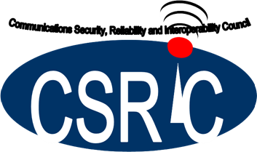

March 17, 2020

Communications Security, Reliability, and Interoperability Council VII

# 

Report on Best Practices for Broadcast Resiliency During Major Storms and Disasters

*Working Group 5: Improving Broadcast Resiliency*

Table of Contents

1 Executive Summary 3

2 Introduction 4

2.1 CSRIC VII Structure 4

2.2 Working Group 5 Members 5

3 Objective, Scope, and Methodology 6

3.1 Objective 6

3.2 Scope 6

3.3 Methodology 7

4 Background 8

5 Analysis and Best Practices 8

Analysis 8

5.1 Broadcast Stations 8

5.1.1 Emergency Management Partnership 14

5.1.2 Other Critical Private Sector Partners, including Wireless and Cable 15

5.2 Recommendations and Best Practices 19

6 Conclusions 21

7 Appendix A 22

8 Appendix B 27

8.1 Summary of Comcast Disaster Response Structures and Processes 27

8.1.1 Example: Hurricane 28

8.1.2 Overview 30

8.1.3 UNC-TV Public Media North Carolina Governance 31

8.1.4 Public Safety Partnerships 31

8.2 Federal Agencies 31

8.3 State Agencies and Affiliated Organizations 31

8.4 Not for Profit Organizations 32

8.5 For Profit Organizations 32

8.5.1 UNC-TV Public Media North Carolina Broadcast Infrastructure 32

8.5.2 Broadcast Infrastructure Challenges 33

8.5.3 North Carolina Public Safety Communications Challenges 34

8.5.4 Hurricane Florence 2018 35

# Executive Summary

The Federal Communications Committee (FCC or Commission) has made clear the importance of local broadcasters’ (radio and television stations) service to their communities during times of disaster. The FCC served as coordinator between with the Department of Homeland Security (DHS) and Federal Emergency Management Agency (FEMA) to ensure that broadcasters and the local disaster areas can be listed as a priority provider of critical information before, during and after a disaster.

According to the National Association of Broadcasters (NAB), in emergency situations Americans turn to broadcast radio and television above all other media (NAB, 2020). When broadcasters suffer considerable damage to their towers and transmission capabilities, as well as to their studios and/or control rooms during major storms, their ability to serve their communities as first informers is threatened. While there has been progress in making communications infrastructure more resilient in emergencies, cable and Internet service is often disrupted in disasters, and cell phone networks can become overwhelmed by increased usage during a disaster. Cable internet and cable services have become increasing important resources for broadcasters for distributing information. Unlike communications infrastructure that requires wired connections over a broad area, or numerous short-range towers and repeaters, broadcast stations just need an upright tower or tall building for their antenna, fuel for their generator, and access for their employees. That resilience in extreme conditions—and the ubiquity of radios and TVs—is critical in emergencies. (Flick, 2018)

The FCC established the Communications Security, Reliability and Interoperability Council (CSRIC) “…to provide recommendations to the FCC regarding ways the FCC can strive for security, reliability, and interoperability of communications systems ." As part of that mission, the Commission tasked CSRIC VII with a variety of issues to examine and provide recommendations. To achieve that goal, CSRIC VII formed six "Working Groups" under it, each to address one of the topics .

The FCC tasked CSRIC VII, with recommending best practices for how broadcasters should prepare for natural disasters and develop additional ones that, if implemented, would improve the resiliency of broadcast infrastructure and allow for more rapid recovery. CSRIC VII in turn delegated this issue to which it assigned to Working Group 5 (WG5). WG5 divided into three subcommittees to cover the issue before it: 1) local radio and television broadcasters, 2) emergency management, and 3) other critical private sectors including wireless and cable.

The Report highlights recommendations and best practices to ensure broadcasters can stay on the air and active in times of a disaster. The Report provides specific best practices and recommendations for industry and for the FCC. The Report also includes a helpful checklist from NAB, “Ten Steps to Disaster Preparation and Recovery,” in Appendix A.

With this report, the FCC will have the opportunity to consider CSRIC VII’s findings and recommendations and how they can help radio and television stations be better prepared before a disaster occurs.

# Introduction

This final report documents the efforts undertaken by the CSRIC VII WG5. With all the community information needs before, during and after a disaster, broadcasters are the common denominator stepping up when their communities need them most. This is the time we see broadcasters doing what they do best—saving lives by providing critical information to their communities. It is essential for radio and television stations to keep on transmitting before, during and after a disaster. The risks to viewers and listeners are too grave. As we are seeing, a disaster can strike at any moment, and the communities need their broadcasters to stay on air.

When it is also considered that the number of declared major disasters nearly doubled in the 1990’s compared to the previous decade, preparedness becomes an even more critical issue. Though each situation is unique, any station can be better prepared if it plans carefully, puts emergency procedures in place, and practices for all kinds of emergencies. (Centeno, 2016)

This CSRIC VII Report is the product of several months of thoughtful and detailed conference calls and subcommittee work. This report benefited from cooperative consideration, and a strong motivation to improve the resiliency of broadcast stations.

## CSRIC VII Structure

CSRIC VII was established at the direction of the Chairman of the FCC in accordance with the provisions of the Federal Advisory Committee Act, 5 U.S.C. App. 2. The purpose of CSRIC VII is to provide recommendations to the FCC regarding ways the FCC can strive for security, reliability, and interoperability of communications systems. CSRIC VII’s recommendations will focus on a range of public safety and homeland security-related communications matters. The FCC created informal subcommittees under CSRIC VII, known as working groups, to address specific tasks. These working groups must report their activities and recommendations to the Council as a whole, and the Council may only report these recommendations, as modified or ratified, as a whole, to the Chairman of the FCC.

|  |  |  |  |  |  |
| --- | --- | --- | --- | --- | --- |
| Communications Security, Reliability, and Interoperability Council (CSRIC) VII | | | | | |
| CSRIC VII Working Groups | | | | | |
| Working Group  1: Alert  Originator  Standard  Operating  Procedures | Working Group 2:  Managing Security  Risk in the  Transition to 5G | Working Group  3: Managing  Security Risk in  Emerging 5G  Implementations | Working  Group 4: 911  Security Vulnerabilities during the IP Transition | Working Group 5:  Improving Broadcast  Resiliency | Working  Group 6: SIP  Security  Vulnerabilities |
| Chair:  Craig Fugate,  America’s Public  Television  Stations | Chair:  Lee Thibaudeau,  Nsight | Chair:  Farrokh Khatibi,  Qualcomm | Chair:  Mary Boyd,  West Safety  Services | Chair:  Pat Roberts,  Florida  Association of  Broadcasters | Chair:  Danny  McPherson,  Verisign |
| FCC Liaison:  James Wiley | FCC Liaison:  Kurian Jacob | FCC Liaison:  Steven  Carpenter | FCC Liaison:  Rasoul  Safavian | FCC Liaison:  Robert “Beau”  Finley | FCC Liaison:  Ahmed  Lahjouji |

Table 1 - Working Group Structure

## Working Group 5 Members

Working Group 5 consists of the members listed below.

|  |  |
| --- | --- |
| Fred Engel | UNC-TV Public Media North Carolina |
| Dana Golub | PBS |
| Brian Lawlor | EWScripts Corp |
| Jeff Littlejohn | iHeartMedia Inc. |
| Robert Gessner | ACA Connects |
| Mark Hess | Comcast |
| Michael Raap  (alternate - Harrison (Jay) Naillon) | T-Mobile |
| Mark D. Annas | OEM |
| Wade Buckner | International Association of Fire Chiefs |
| Sulayman Brown | OEM, Fairfax County, VA |
| Craig Fugate | APTS |
| Antwane Johnson | FEMA |
| Chandra Kotaru | AWARN Alliance |
| Michelle Mainelli-McInerney | National Weather Service |
| Alex McHaddad | Blue Mountain Translator District (OR) |
| Francisco Sanchez Jr. | OHSEM, Harris County TX |
| John Williamson | Nez Perce Tribal Police Department |
| Matthew Straeb | Global Security Systems, LLC |
| Pat Roberts (Chair) | Florida Association of Broadcasters |

Table 2 - List of Working Group Members

# Objective, Scope, and Methodology

## Objective

The FCC directs CSRIC VII to update current best practices for how broadcasters should prepare for natural disasters and develop additional ones that, if implemented, would improve the resilience of broadcast infrastructure and allow for more rapid recovery.

## Scope

This document addresses the request for broadcast resiliency best practices by addressing the following scope:

*“The Working Group will recommend best practices for broadcasters to help identify the risks they face before, during and after a natural disaster, and how broadcasters can improve or be prepared when their towers or transmission sites are compromised. The Working Group will pay particular attention to how broadcasters can be prepared in the unfortunate case of a natural disaster. The Working Group will keep in mind the importance of broadcast resiliency, as local broadcasters serve as their communities first informers.*

Members of the WG5 subgroup relied on input shared with us by stakeholders with experience in broadcast resiliency before, during and after a major disaster. Members of WG5 or other stakeholders include the following areas of expertise:

* *Emergency Management Members*
* *EAS State Emergency Communications Committee (SECC) Chairs and Members*
* *Radio and TV Broadcasters*
* *Cable TV Providers*
* *Wireless Providers*
* *NOAA / NWS Members*
* *FEMA / FCC Representatives*

## Methodology

In general, this report is not based on new quantitative research, instead, subject matter experts have reviewed and discussed best practices and/or recommendations to improve broadcast resiliency before, during, and after a disaster. It should be noted that WG5 did not conduct or commission formal research, some members did conduct discussions with relevant stakeholders including radio and TV broadcasters, and professionals in the emergency management, wireless and cable fields.

The WG5 met through conference calls in 2019 and 2020. ATIS, an online collaboration portal, was also used by the WG5 participants. The portal is accessible to all Working Group members throughout the duration of their work on behalf of the CSRIC VII. ATIS allowed WG5 to share ideas, resources, and collaborate on common documents, including this Final Report. Given the disparate locations from which the WG5 members originated, having an online collaboration tool was instrumental to the successful completion of the Working Group’s final product. A wide range of topics were discussed, and available public data were reviewed, moderated and documented by Chairman, Pat Roberts.

It should be noted that the members of WG5 have extensive expertise, much of which is based on experiences and capacity in their current or previous professional roles. This report was compiled based on information from the working group members.

# Background

When a disaster occurs, citizens depend upon local broadcasters for access to lifesaving public safety and emergency information and announcements. Radio and television broadcasters are the primary source of critical information to the public in the event of disasters such as tornadoes, hurricanes, tropical storms, floods, wildfires, earthquakes, tsunamis, solar storms, terrorist violence, mass transportation accidents, and industrial or technological catastrophes. Given the strength of the broadcast infrastructure, broadcasting is often the only communications outlet available during disasters.

CSRIC VII recognizes the important role of local broadcasters in helping federal, state, and local officials provide the general public with advanced notification of and instruction before, during and after disasters and emergencies. Improving broadcast resiliency will better ensure that broadcasters will be able to serve their communities, providing them with the critical updates and information from reliable and credible sources during emergencies.

# Analysis and Best Practices

## Analysis Broadcast Stations

Broadcast facilities need reliable, stable power to fulfill their mission to inform the public. Often, sophisticated electrical power systems are employed to provide uninterrupted service to critical systems.

Businesses are often dependent on electricity, gas, telecommunications, sewer and other utilities. Plan ahead for extended disruptions during and after a disaster. Carefully examine which utilities are vital to your business’s day-to-day operation. Speak with service providers about potential alternatives and identify back-up options such as generators to power the vital aspects of your business in an emergency.

Broadcasters often face electrical service issues for a host of natural and manmade incidents. These can range from power line damage due to storms, earthquakes, and fires, and also to equipment failure, accidents and sabotage. With these concerns, it is recommended that broadcasters do a risk assessment and implement the necessary designs to mitigate power outages. Community service needs, federal and state emergency notification requirements and financial concerns all weigh in on the extent of the final design and implementation.

Assuming the broadcaster wishes to provide a resilient, reliable electrical power system to maintain “five 9’s” of service, there are a number of areas recommended to be reviewed and considered.

The simplest electrical power design utilizes a service drop from the utility, a correctly sized power transformer to step the incoming voltage down to the required level, and necessary disconnects, circuit breakers and grounding systems. A clean, well designed electrical system buildout, adhering to the local building codes will provide good service to any broadcaster.

To provide a high level of confidence and capability, broadcasters should consider multiple utility power sources when available for both studio and transmitters. Ideally this would consist of two separate utility feeds to the facility, coming in from diverse paths, distinctively separate circuits from the utility company, fed by two separate sub-stations, and switched via an automatic throw-over switch. To accomplish this task will take a significant amount of coordination with the local utility company and will likely be costly. Engineering of this work will be critical to make sure that each path to the facility is diverse and avoids any means of “arc-over” between the two circuits. And, it may be of value to consider what quantity of the electrical service lines from the utility are on poles or buried.

Backup power generators at both studio and transmitter sites have proven invaluable in maintaining broadcast operations when disasters strike. One critical item to keep in mind, in addition to properly sizing the generator and matching load requirements, is ensuring that there is sufficient fuel stored on site to maintain operations for a reasonable duration. Of course, duration is determined by load and fuel capacity, however, generator reliability and maintenance are key factors when operating in emergency backup mode.

Mission critical facilities have emergency backup power systems in place to restore power in a short period of time when a utility outage is sensed.

Most facilities that address this need do so with a single emergency power generator sized appropriately for the electrical load of the facility. Determining the load is the key step for the initial design of the system. What life safety systems in the building need to be powered (emergency lights, fire suppression systems, alarms, etc.)? What broadcast business systems are critical for operation and need to be powered? If you are located in either hot or cold climates (or both), what types of HVAC systems need to be functional during an outage to maintain broadcast operations? What building security systems need to remain functional? If a TV broadcaster, how much studio lighting is necessary to do live broadcasts? What power needs will there be for staff required to stay at the facility during a long outage?

The National Fire Protection Association has some excellent resources focusing on design considerations for emergency power systems. Specifically, NFPA 110 (National Fire Protection Association , 2019), is an excellent resource.

Another key question to be answered is how long you can run on your emergency power generator with the fuel supply present (assuming it was full at the beginning of the incident) and what your plan is to refuel (addressed below).

For mission critical applications, broadcasters may want to consider dual-power generation systems. These solutions provide added redundancy and, depending on configuration, could provide a doubling of run time.

Key concerns for any emergency power generation system include:

1. Generator placement
   1. Avoid low lying areas
   2. Avoid close proximity to other structures and vegetation
   3. Ensure generator exhaust does not enter work center HVAC system
   4. Secure location
   5. Easy, fenced access
2. Generator fuel supply
   1. Identify multiple fuel suppliers prior to an emergency
   2. Regular testing and “polishing” of fuel
3. Generator maintenance
   1. Regular load testing
   2. Preventative Maintenance Schedule for all hoses, belts, fluids and batteries
   3. Physical inspection of all electrical connections
4. Installation of a “three-way bypass” switch that would allow for a portable generator to be rolled up during long maintenance windows of primary emergency power generator.

Where and when possible, having a facility utility power service system or uninterruptible power supply (UPS) is preferred to keep critical systems operational during the time of a power outage and the emergency power generator coming to speed. Facility UPS systems offer additional benefits including power conditioning to help eliminate surges and spikes that might damage equipment. And, they also temper “dirty switching” from the ATS switching.

Facility UPS systems typically come in two forms. One is a system that uses a large number (depending on the facility electrical load) of batteries that provide power to the plant during the switchover time to generator power. Battery systems are reliable but require maintenance and replacement and due to their chemistry can be an environmental hazard. They also need to be well ventilated to remove potential buildup of harmful gasses.

The other system is based on flywheel technology where a heavy, balanced circular wheel spins at a high velocity and power is generated from it during the switchover time. Flywheel UPS systems are very reliable as well. They have a benefit of not needing to have their storage refreshed every 3-5 years like battery systems and don’t have the environmental concerns of battery UPS systems. Flywheel systems do require regular maintenance and must have their bearings replaced every few years. The annual maintenance costs are likely higher than battery systems, but you are not faced with the battery plant replacement which can be quite expensive. Both systems should be evaluated for the specific needs of individual broadcasters.

Of course, small UPS systems can be used to keep small loads operational, but these will not keep a facility functioning during an outage. These small units need to be regularly monitored and have their batteries replaced on a regular schedule.

It is recommended that appropriate measures be taken to “harden” the broadcast facilities, studios and transmitter sites, particularly in areas prone to sever weather or natural disasters. Broadcasters should consider the importance of the broadband systems in use, and appropriate measures should be taken to provide alternate ways to access your services in the event of an emergency situation.

Physical security such as a fence augmented by security personnel and/or video surveillance is recommended at all sites critical to the broadcast operation (including studios/newsrooms, satellite transmit and receive sites and antenna/transmitter sites).

It is important to recognize if the broadcast studio or transmitter sites are in a flood risk area, or if there are any obvious natural hazards that may affect these sites. Having a site assessment conducted periodically is helpful to identify any structural and/or natural conditions that could pose a threat in the event of a disaster. In this continuity planning, or risk assessment, it is important to assess how your company functions, both internally and externally, to determine which staff, locations materials, procedures and equipment are absolutely necessary to stay on the air. It is very important to establish procedures for succession of engineering and operations.

Continuity planning should include all departments within the radio or television station. A team should be put together to develop an emergency plan, including staff from all levels, as well as active members of local emergency management, first responders, community organizations and utility providers. Those with expertise vital to basic broadcast functions are ideal. These will likely include people with technical skills as well as on-air personnel and managers. Identify key suppliers, resources and other businesses you must interact with on a daily basis. It is helpful to develop professional relationships with more than one company in case your primary contractor cannot service your needs. This is especially important for suppliers such as generator service companies and fuel delivery. A disaster that shuts down a key supplier can be devastating to your operation.

Internal regularly scheduled drills could provide useful to be best prepared in times of disaster. These drills should then be put into practice with local and state emergency management officials, and local law enforcement as well as your employees. It is suggested that these drills be practiced at least once a year. This would help build a better relationship before any type of disaster might affect their market. They should also reach out to any state local emergency management staff that operated in their area or region.

Your employees and co-workers are your business’s most important and valuable asset. Effectively communicating with your staff is critical before, during and after a disaster. Work with station management to create and distribute emergency preparedness information in newsletters, on the company intranet, periodic employee emails, and other internal communications tools.

Consider setting up a telephone calling tree, a password-protected page on the company website, an email alert or a call-in voice recording to communicate with employees in an emergency. Designate an out of town phone number where employees can leave a message in a catastrophic disaster. Satellite telephones have proved invaluable in times of emergency. Hardware and service costs have dropped considerably over the years making this method of disaster communication much more affordable. (Centeno, 2016)

A comprehensive list of nonperishable food supplies as well as water should be kept on premise for time of disaster. These supplies can be obtained well ahead of an emergency and added to over time to develop a healthy stock that will be able to sustain all personnel for the duration of the emergency. It is important to keep in mind that many staff personnel will be on site twenty-four hours a day. It would be advisable to have at minimal five days of supplies. Other non-food items should also be kept in good working order and available if disaster strikes. Such items would include things like batteries, flashlights, tarps, coolers, cots, inflatable mattresses, blankets/sleeping bags, etc.

Broadcasters with local news origination should ensure they have robust and redundant ways to communicate to external news services and remote news teams. Broadcasters should have backup signal feeds to their primary satellite transmit and reception sites. These back up signal feeds should support any broadband distribution requirements. Plan what you will do if your building or studio is not accessible. A backup studio facility in a geographically diverse area from the primary site may assure continued operation during and after a disaster.

It is important to reach out to other broadcasters in your area and collaborate with them to create cooperative redundancy and geographic diversity. If you operate a television station contact a radio station to partner within times of emergency. It is critically important to have these partnerships because of the potential power outage due to local utility and generators. Another thing to consider is when the residents in the affected media market lose power, it is difficult for them to view television broadcast. They then have to rely on radio stations for the information they need. In most cases they have larger and broader news staff, and therefore can make sure all-important information is delivered to the residents in the market.

Additionally, consider satellite communications services. Some services are available on a full-time basis or on- demand. VSAT service is available globally and can be a reasonable solution for your communications needs, including email and other internet services, in an emergency. (Centeno, 2016)

The Disaster Information Reporting System (DIRS), is a useful system set up by the FCC to allow voluntary reporting of operational status of Broadcast stations. This information is compiled to give the FCC an idea of the immediate needs of broadcasters in an area that has suffered a disaster. Broadcast stations can also request assistance through DIRS. DIRS is a voluntary system that each station must sign up for in order to be informed of when the system is activated. The FCC along with FEMA decide when to activate the system. It is a good idea for broadcasters as well as all communications providers to take advantage of this program so that when disaster does strike you will have a direct form of communication with the federal government and it allows them to assess the severity and immediate needs to be able to restore communication to the community more rapidly.

Broadcasting is never more important than during an emergency. Make sure you can deliver the news even if your station goes down. Have a plan in place to carry programming from another local station or simulcast on another station. Have a plan for continuous closed captioning service. Make plans to stream programming online during an emergency. Appendix A includes NAB’s “Ten Steps to Disaster Preparation and Recovery.” It is recommended that in the aftermath of recent storms and disasters, this working group, along with the FCC, work with NAB on developing an updated checklist. NAB is the most appropriate group to distribute and educate broadcasters on best practices on an ongoing basis.

In today’s world, using digital social media is also just as important when a disaster occurs. For television stations it is pertinent to make sure they have a closed captioning plan in place to serve the hearing impaired in their community. Foreign language stations should plan to provide news over another local station. In the media markets where they have a significant minority population that speaks a different language, it is important that the broadcasters in the area have planning meetings to make sure they address the needs if foreign language stations go off the air. In addition, it is important for local and state emergency management offices to have plans in place to provide not only English EAS messages, but foreign language messages for the impacted areas.

### Emergency Management Partnership

It is important for the local broadcasters to have a close and personal relationship with their local and state emergency management teams, as well as local law enforcement. These cooperative relationships can be strengthened through active participation with state/local broadcasters associations and state/local emergency communications committees. The lines of communication need to be open and productive before, during and after a disaster. This will lead to a more productive and respectful relationship that will ease potential tensions within the community the broadcaster is serving.

These relationships will allow the flow of timely, pertinent and accurate information to be delivered. Some challenges to these relationships are things like causing more panic, being in the way of first responders, yourself becoming a victim, and possibly bringing more people into the devastated area than are necessary thus hindering relief efforts.

Local broadcasters are effective at getting the message focused as to the local effects of the community. This is helpful and important when people are looking at other forms of media that can be incorrect due to the fact that they are not even based in the community they are covering.

Critical communication between local broadcasters and emergency management officials is important during times of disasters to make sure broadcasters are at the right place, at the right time to obtain and distribute the latest news and updates as they become available. This is something that should be worked out ahead of a disaster. There should be clear primary and secondary locations where broadcasters can set up and be given the most current information. With this in place there will be less confusion and a faster response time.

### Other Critical Private Sector Partners, including Wireless and Cable

During times of disasters, broadcasters rely on other key business partners to be able to provide accurate, fast, and reliable information to their residents. These include, the wireless providers of cellular and internet, as well as their cable partners, and social media platforms. Therefore, it is important that broadcasters have planning meetings with these various partners on a regular basis, and prior to any anticipated disasters so they have a strong working relationship.

Hurricane Michael, a Category 5 storm which hit the Florida panhandle in October 2018, had a serious impact on cellular service in the area which affected local broadcast stations’ ability to communicate and relay important information. Broadcasters who experienced Hurricane Michael, some of whom sit on CSRIC VII, WG5, determined that broadcasters should ask the FCC to consider adding broadcasters as a primary source for the FCC Wireless Priority Service. This would help ensure broadcasters’ ability to gather information and distribute it to their communities before, during and after a disaster.

Wireless carriers should consider the full range of natural and man-made hazards that could impact employees, customers, operations, and assets across the country. Wireless carriers should consider conducting on-going site threat assessments in an effort to identify potential impacts to critical sites and properties to plan for threats accordingly. For times when impacts are unavoidable, it is recommended to have a fleet of rapid response equipment (Generators, COWs & Satellite technology) situated across the country to facilitate expeditious recovery. Even when there’s no active disaster or outage, it is recommended to regularly test & drill emergency response teams across the nation to be able to help stay ahead of any situation that arises.

Recommended Primary Components of Business Continuity Programs:

* *Enterprise Business Continuity Project Initiation and Oversight*
* *Risk Evaluation and Controls*
* *Business Impact Assessment and Analysis*
* *Business Continuity and Disaster Recovery Strategic Direction*
* *Business Continuity Plan Development, Maintenance, and Exercising*
* *Awareness and Training Programs*
* *Public Relations and Crisis Response and Resumption*
* *Coordination with External Agencies*
* *Incident Command Structure integrated into each Engineering team nationwide*

It is recommended that broadcasters, cable, wireless, and other partners consider utilizing these planning tools. When wireless carriers become aware of an upcoming event (such as a hurricane or storm), it is recommended that organizations seek to take action before a disaster strikes.

Before a Disaster Strikes, Preparations May Include:

* *Analyze official forecasts and warnings when severe weather conditions are anticipated.*
* *Top off fuel and test backup generators in possible areas of impact.*
* *Have portable generators, Cell-On-Wheels (COWs) and Cell -On-Light-Truck, (COLTS) on standby nationwide.*
* *Establish a command center that will mobilize teams of technicians and engineers as conditions permit.*
* *Engage national vendors to provide bulk fuel, generators, technicians, staging yards, security, accommodations and, catering, so teams can focus on the tasks at hand.*
* *Create staging areas for incoming equipment and personnel. Have teams on standby from neighboring areas.*
* *Coordinate with local and state officials, DHS, FEMA, State EOCs and the FCC as appropriate.*
* *Monitor evacuation efforts and routes and take steps to increase wireless capacity in those priority areas (shelters, transport hubs, arenas, etc...).*

During and After a Disaster, Response Actions May Include:

* *Deploy portable generators, COWs, satellite or microwave as needed.*
* *Focus on top priority site recoveries based on location (hospitals) or site traffic (evacuation*
* *centers).*
* *Communicate status reports to local and state OEMs and government affairs as appropriate.*
* *Set-up Wi-Fi calling and charging stations.*

It is recommended that wireless carriers maintain backup and alternate power sources at mission-critical locations such as Mobile Switching Centers and Data Centers. Mobile Switching Centers should have permanent, on-site emergency backup power for use in the event of a momentary or extended power failure. They should also be protected by FM 200 or Pre-action Dry Fire Systems or similar systems and be equipped with spare equipment inventory for all critical network elements. Cell sites should be generally equipped to accommodate back-up power sources as needed (e.g., batteries, fixed generators, portable generator connectors). Business Continuity Plans should be housed in a centralized redundant online repository, accessible to employees in the office and remotely through a web browser. Additionally, hard copies of plans should be available at multiple sites throughout an enterprise.

Where appropriate and if available, wireless carriers should consider installing fixed generators at key cell sites throughout the network to further strengthen network resiliency and reliability. In addition to enhancing the power resiliency of the network it is recommended that wireless carriers invest in rapid response vehicles, including COLTs, COWs, Mobile Command Centers & customized Jeeps, to help provide satellite service in the worst conditions.

People rely on their mobile internet access to get up to date information during times of disaster. They count on their local outlets to keep their digital assets current with the latest important accurate information. Timely accuracy in the social and digital space is critical before, during and after a disaster.

Including Cable Companies in planning and communications prior to disasters is also critical. Service providers, broadcasters power companies and federal state and local authorities need to share recovery plans, plant maps showing critical infrastructure and facilities will help recovery crews. This should help ensure these facilities are not damaged during recovery efforts.

It should be noted that cable infrastructure is now critical for delivery of communications data and information services as well as video services and their restoration need to be a high priority in recovery efforts. Work crews need to be aware of this as they work to restore services and clear debris so that further damage to cable plant in those efforts. Cable providers dispatch repair crews immediately after the disaster, and they also leverage their national workforce to bring crews in from all over the country. To that end it is critical that these crews are not denied access to recovery areas to enable rapid restoration of services.

Cable providers go to great lengths to ensure standby power is available for all critical facilities and endeavors to ensure they have adequate supplies prior to any disaster. In the event additional fuel is needed for power generators or for the crews in the area, it is critical that cable companies have access to fuel supplies made available during recovery.

Cable providers make every effort to provide alternative services for the community during recovery. Residents are provided free access to available Wi-Fi service. Cloud based video services (Xfinity stream) are also made available at no additional cost. This cloud-based service includes local broadcast channels and is available on mobile phones, iPad and other devices.

Cable companies often have direct feeds from local broadcast channels to their origination facilities. Upfront planning with broadcasters and working with them to ensure these connections are supported by standby power and redundant deliver paths should help these services to be more quickly restored to service providers. These services would also then be available on alternative delivery services like Xfinity stream.

Many broadcast stations are also growing their reach with their digital assets. These assets also allow people that may have evacuated or family and friends out of market to receive up to date critical information.

Working with the large social digital firms on a national level to create agreements that would benefit disaster affected areas would be helpful to all broadcasters. With these agreements’ broadcasters would be able to direct the flow in information based on geo fencing to push timely and accurate information to affected areas without filtering.

Local, state, and federal government, the broadcast community, local fire and police, and partners who have a platform to amplify emergency messages provide a valuable service to the public. With the growth and popularity of social media sites and applications, more communities and the general population are gravitating to those sources for information. While increasing the number of coordination and delivery services during an emergency provides redundant paths to access information, the potential for inconsistencies in messaging can result. Through a collaborative approach by the stakeholders, these potential inconsistencies can be mitigated, and overall broadcast reliability can be improved.

## Recommendations and Best Practices

The following are CSRIC VII’s recommendations for best practices for broadcasters to improve broadcast resiliency before, during and after a disaster to help a community respond and recover:

1. Broadcasters should do a risk assessment and implement the necessary designs to mitigate power outages.
2. Broadcasters should consider multiple utility power sources when available for both studio and transmitters. Ideally this would consist of two separate utility feeds to the facility, coming in from diverse paths, distinctively separate circuits from the utility company, fed by two separate sub-stations, and switched via an automatic throw-over switch.
3. Broadcasters should consider maintaining backup power generators at both studio and transmitter sites.
   1. Determining the load is the key step for the initial design of the system, properly sizing the generator and matching load requirements,
   2. Ensure that there is sufficient fuel stored on site to maintain operations for a reasonable duration and have a plan to refuel
   3. Ensure the emergency power system is placed correctly.
   4. Ensure regular maintenance for the system.
4. Broadcasters should consider dual-power generation systems for mission critical applications. These solutions provide added redundancy and, depending on configuration, could provide a doubling of run time.
5. Broadcasters should, when possible, have a facility utility power service system (UPS) to keep critical systems operational during the time of a power outage and the emergency power generator coming to speed. Facility UPS systems offer additional benefits including power conditioning to help eliminate surges and spikes that might damage equipment. And, they also temper “dirty switching” from the ATS switching.
6. Broadcasters should take appropriate measures to “harden” the broadcast facilities, studios and transmitter sites, particularly in areas prone to severe weather or natural disasters.
7. Broadcasters should consider the importance of the broadband systems in use, and appropriate measures should be taken to provide alternate ways to access your services in the event of an emergency situation.
8. Broadcasters should ensure physical security such as a fence augmented by security personnel and/or video surveillance for all sites critical to the broadcast operation.
9. Broadcasters should have a site assessment conducted periodically to identify any structural and/or natural conditions that could pose a threat in the event of a disaster.
10. Broadcasters continuity planning should include all departments within the radio or television station as well as members of local emergency management, first responders, community organizations and utility providers.
11. Broadcasters should identify key suppliers, resources and other businesses they need to interact with on a daily basis. This is especially important for suppliers such as generator service companies and fuel delivery.
12. Broadcasters should hold internal, regularly scheduled drills so that they will be prepared in times of disaster. These drills should then be put into practice with local and state emergency management officials, and local law enforcement as well as employees. These drills should be run at least once a year.
13. Broadcasters should work with station management to create and distribute emergency preparedness information in newsletters, on the company intranet, periodic employee emails, and other internal communications tools.
14. Broadcasters should set up a telephone calling tree, a password-protected page on the company website, and an email alert or a call-in voice recording to communicate with employees in an emergency. Designate an out-of-town phone number where employees can leave a message in a catastrophic disaster. Satellite telephones have proved invaluable in times of emergency.
15. Broadcasters should keep a comprehensive list of nonperishable food supplies as well as water on premise for time of disaster, keeping in mind that many staff personnel will be on site twenty-four hours a day. It would be advisable to have a minimal five days of supplies. Other non-food items should also be kept in good working order and available if disaster strikes, such as batteries, flashlights, tarps, coolers, cots, inflatable mattresses, blankets/sleeping bags, etc.
16. Broadcasters should ensure they have robust and redundant ways to communicate to external news services and remote news teams, including backup signal feeds to their primary satellite transmit and reception sites.
17. Broadcasters should reach out to other broadcasters in your area and collaborate with them to create cooperative redundancy and geographic diversity
18. Broadcasters should consider purchasing satellite communications services. Some services are available on-demand. VSAT service is available globally and can be a reasonable solution for your communications needs, including email and other internet services, in an emergency.
19. CSRIC VII recommends that all broadcasters sign up to DIRS to allow reporting of operational status of broadcast stations. This will ensure broadcasters a direct form of communication with the federal government and allow them to assess the severity and immediate needs to be able to restore communication to the community more rapidly.

The following are CSRIC VII’s recommendations for the FCC to help improve broadcast resiliency before, during and after a disaster to help a community respond and recover:

1. CSRIC VII recommends that the FCC work with NAB, other broadcast groups, and members of this working group to update and revise NAB’s Disaster and Preparedness Outline Plan[1] for broadcast stations.
2. CSRIC VII recommends the FCC should consider adding broadcasters as a primary source for the FCC Wireless Priority Service which would help ensure their ability to gather information and distribute it to their communities before, during and after a disaster.
3. CSRIC VII recommends the FCC continue to work closely with DHS and FEMA to provide access letters[2] to help broadcast stations be able to identify themselves as first informers. This will ensure they can get to their transmitter sites and studios to stay on the air and operate their generators, fuel supply, as well as their news staff who can provide crucial information as first informers for the residents of their media market.
4. CSRIC VII recommends the FCC consider the same access letters be granted to wireless providers, cable providers and other groups critical to providing information to their communities
5. CSRIC VII recommends the FCC to continue to work closely with DHS and FEMA to encourage a working relationship between broadcasters and their local and state emergency management officials.
6. CSRIC VII recommends the FCC encourage social media organizations such as Google, Facebook and Twitter implement algorithms that detect what areas are being impacted by an emergency and prioritize related instructions, impacts, and decision support services to appear at the top of the feeds.

# Conclusions

The members of CSRIC VII, WG5 thank all those who have contributed research and perspective to this CSRIC VII report and look forward to supporting continued collaboration in best practices and recommendations to broadcast resiliency in the unfortunate time of disaster.

In times of crisis, we hope these recommendations can help local broadcasters to always be there – wherever “there” may be. Increasing broadcast resiliency will help ensure that broadcasters stay the most trusted source of news and emergency updates, and ultimately get the information they need to keep safe in times of a disaster.

# Appendix A

National Association of Broadcasters Ten Steps to Disaster Preparation and Recovery (National Association of Broadcasters, 2018).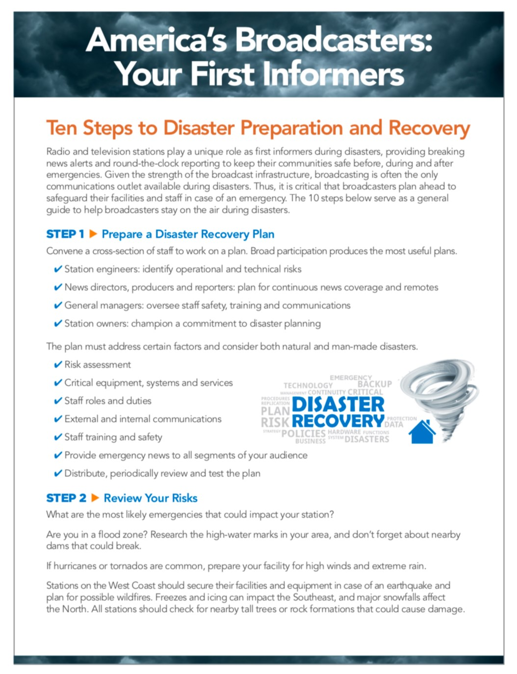018)

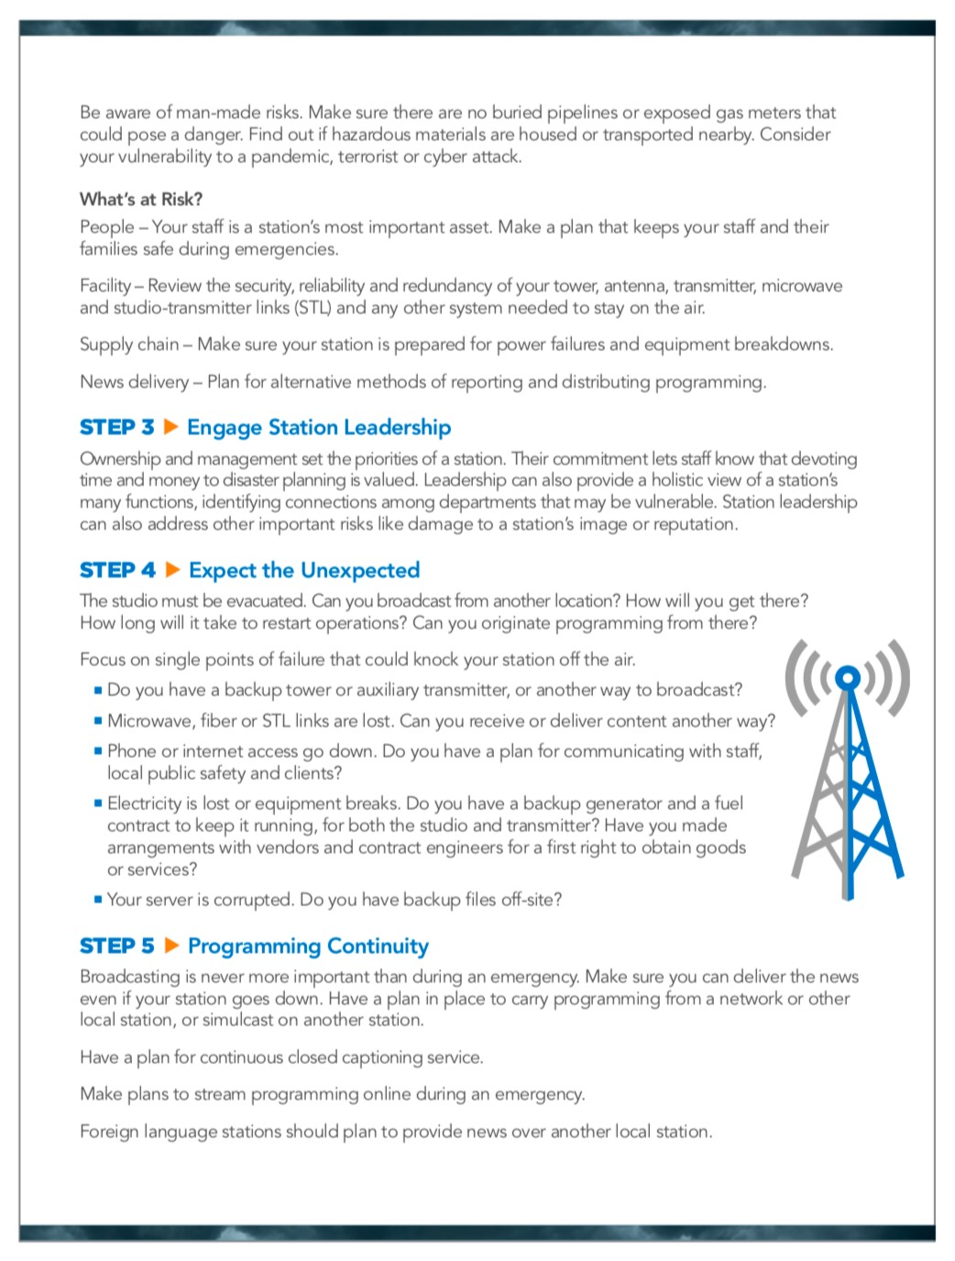

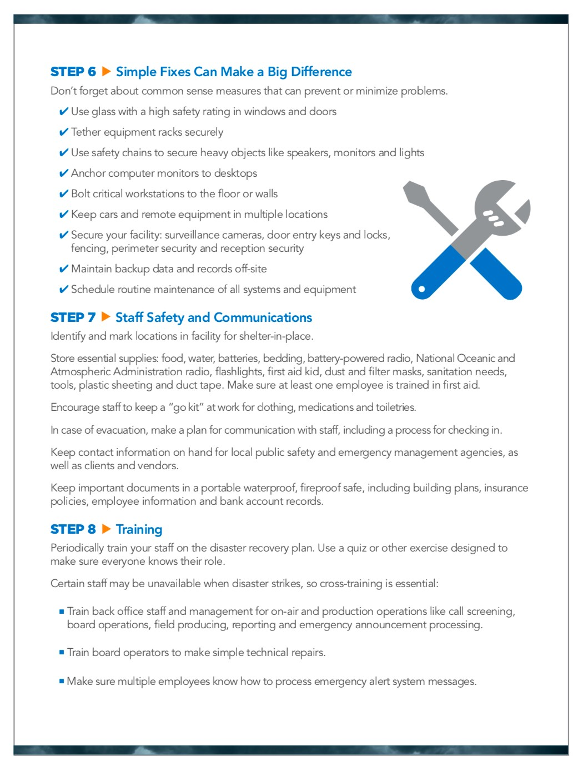

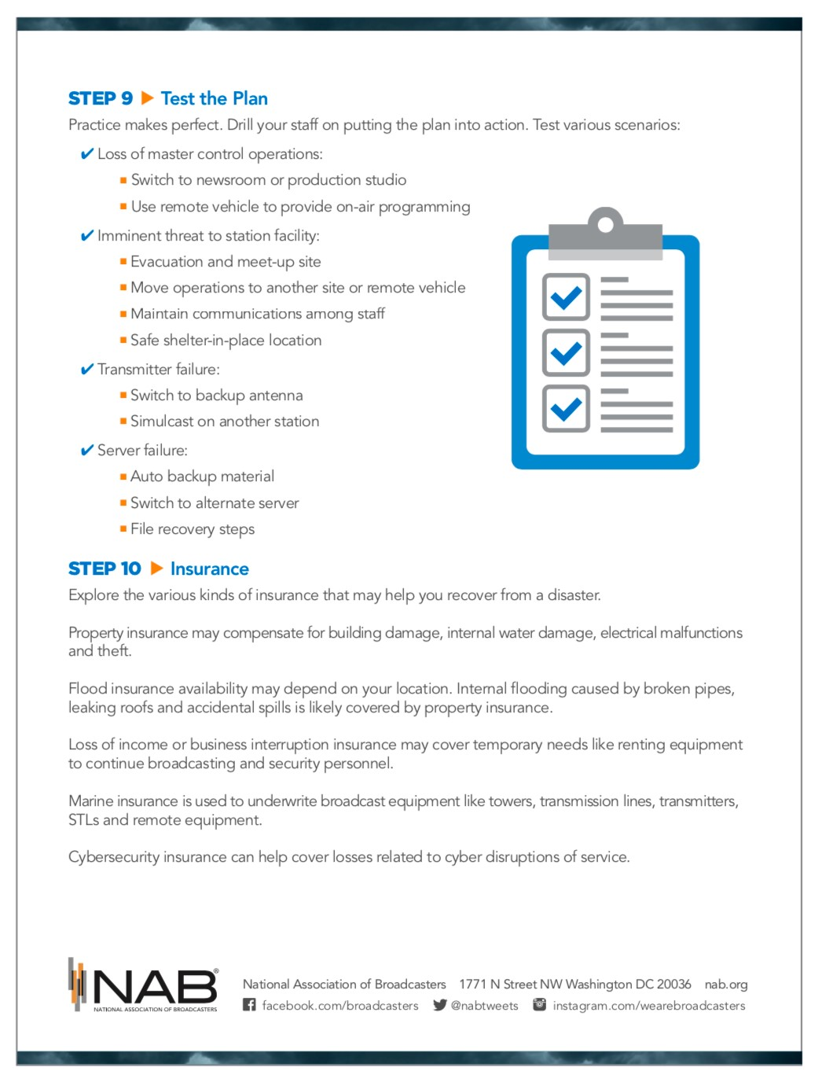

# Appendix B

Comcast Disaster Response

## Summary of Comcast Disaster Response Structures and Processes

As a national company, Comcast’s disaster response processes begin at the local level with Regional Incident

Management Teams (RIMTs). Comcast’s Regional Incident Management Teams are based upon the FEMA

Incident Command Structure (ICS), with some customizations to accommodate the specifics of Comcast’s business. These teams are in each of Comcast’s sixteen Regions and follow similar plans and processes. The teams monitor weather, natural disasters, and other types of disruptions and activate response plans and processes at the level appropriate for the severity of the event. Initial Activation Teams (IATs) decide whether to stand up the full RIMT structure and determine which additional teams and partners need to be engaged.

Incident

Commander

Operations

Planning

Logistics

Administration

Commun

ications

Safe

ty Lead

Most events are managed at the Regional level; however, some broad-based events require a larger geographic response. For example, large hurricanes may cross Regional

boundaries and impact more than one Region simultaneously. In these situations, the Divisional Incident Management Teams (DIMTs) help to coordinate cross-Regional resources and responses. Corporate and National Technology Teams also participate in major natural disasters and disruptions to ensure that the Regions and Divisions have the support that they need to recover and restore services to communities as quickly as possible. Incident Management Plans (IMPs) are designed to ensure that Comcast manages incidents at the lowest appropriate level, yet provide structure, organization and processes that can quickly escalate to manage complex or broad-ranging impacts. The plans include roles and responsibilities for key players in incident response, processes and checklists to ensure key tasks are completed, and support the protection of company personnel, assets, and services. Each Region updates their IMP and conducts table top exercises on an annual basis to ensure that stakeholders understand their roles and responsibilities.

IMP objectives include:

* Preserving the safety of all employees
* Providing a pre-planned structure for managing key decisions prior to, during and following an incident
* Ensuring internal and external communications are fact based, relevant and timely Enforcement of Comcast policies regarding employees and their families
* Maintaining the confidence of customers, business partners, and employees
* Maintaining good relations with law enforcement, regulatory, and other governmental agencies by complying with all applicable laws, regulations and reporting requirements
* Ensuring that Comcast is a good community partner throughout an event
* Providing for the safe and orderly resumption of Comcast business operations and services to customers and critical business partners.

### Example: Hurricane

Comcast begins monitoring tropical storms at their earliest stages. Once a clear trajectory is established, Regional Incident Management Teams will begin daily coordination calls. If the storm is projected to cross multiple Regional boundaries, the relevant Divisional Incident Management Teams are also activated. All Incident Management Teams track the progress of the storm, identify facilities that may be in the path, and take proactive measures to prepare personnel and facilities. Depending upon the location, these proactive measures may include

communications to customers, pre-staging generators at locations susceptible to loss of commercial power, topping off fuel, moving vehicles in potential flood areas to higher ground, securing loose objects around buildings, and ensuring that warehouses have sufficient material for potential repair needs after the storm.

For our employees, these protective measures include communications from HR and Environmental Health and Safety regarding safety precautions, and resources if an employee is unable to come to work or is otherwise impacted by the storm. Employees are reminded of policies and procedures that may impact them during a hazardous situation. As necessary, resources are stocked at local facilities in case employees need to shelter-in-place for a prolonged period of time.

As the impacts of a storm are felt, Incident Management Teams at the Regional, Divisional, and National levels closely monitor impacts to facilities, plants, and utilities. Routine reports provide updates on loss of commercial power, impacts to locations, impacts to customers, and strategies for office closures. Comcast also coordinates communications to customer care and support teams that interact directly with impacted customers.

National Teams track core infrastructure, technology, and services that may be impacted. These teams assess risks and develop strategies, as necessary, to shift traffic or fail applications out of potentially impacted data centers. The coordination between Regional, Divisional, and National Teams helps to ensure that Comcast maintains a common operating picture.

Safety is always paramount as teams assess whether employees can come to work and when repairs can begin. Comcast updates employees on any potential office closures and monitors weather conditions to ensure the safety of employees. Mangers establish needed schedule flexibility and identify core staff that need to be present during the event. Hotlines are used to ensure employees can easily determine the work status of their location. Comcast also utilizes mass notification tools, when necessary, to communicate safety messages broadly to large populations of employees.

At the community level, Comcast engages closely with local emergency responders and government agencies to coordinate resources and response efforts. Comcast often opens up wireless hotspots to the public during natural disasters to ensure that impacted individuals have access to critical information. Comcast often sponsors WIFI and televisions at evacuation centers to help those most impacted get the information they need and stay connected with concerned loved ones. Once the situation is stabilized and it is safe to do so, Comcast quickly deploys teams to help with restoration and repair efforts. Comcast strives to restore services as quickly as possible; however, following a natural disaster there are often external constraints regarding utility services, ability to access certain communities, and impacts to infrastructure that may prolong restoration in some areas.

**9. Appendix C**

UNC-TV’s experience dealing with the Hurricane Florence.

### Overview

UNC-TV Public Media North Carolina is the statewide Public Television Broadcast network providing enriching educational and cultural content. It is also the only network covering the 100 counties in North Carolina. The robust network consists of 12 full power, UHF transmitters and 24 lower power translators, and a microwave radio network that also serves as a portion of the backbone for the critical North Carolina State Highway Patrol VIPER two-way radio network.

UNC-TV has a presence on 63 tower sites in North Carolina. Of those, 31 are operated by UNC-TV, 10 of which are the Full Power UHF Transmission sites (two FP UHF’s are on leased towers). The other 32 sites carry microwave radio, translators or both.

UNC-TV provides statewide and national feeds from the North Carolina Department of Public Safety before, during and after major emergency events. These briefing streams, generated for broadcast television, radio, and web stream, come from the NC Emergency Operations Center in Raleigh, NC. Typically, these involve the Governor describing the event and having several of the emergency management team giving updates on the preparation or reaction to an event. The majority of these briefings are related to weather related events (hurricanes, tropical storms, winter ice/snow). UNC-TV has a team committed to make these broadcast/web streams available to the public. Included in those efforts is to make sure they are closed captioned and signed for the hearing impaired and soon to be available in Spanish in both voice and captioning.

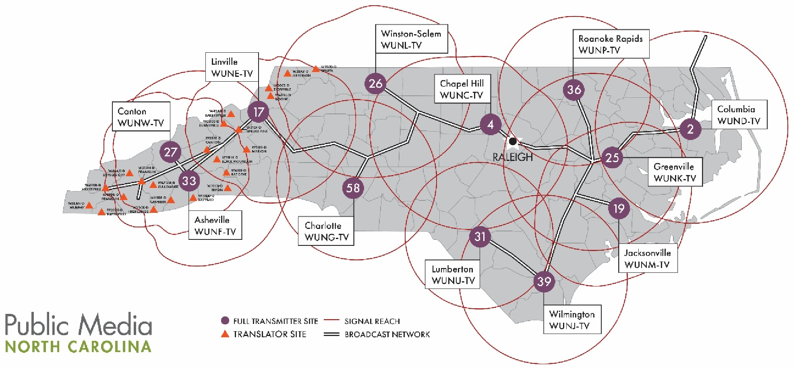

*Figure 1 – UNC-TV Public Media North Carolina Transmission Map*

### UNC-TV Public Media North Carolina Governance

UNC-TV is an affiliate of the University of North Carolina System. The UNC System consists of 17 academic institutions including UNC-Chapel Hill and North Carolina State University.

The non-commercial educational broadcast licenses granted to UNC-TV are held by the University of North Carolina System.

UNC-TV funding comes from the State of North Carolina secondary educational funding plan through the UNC System Office. Additional funding comes from the Corporation for Public Broadcasting, grants and the benevolence of North Carolinians through their generous support.

### Public Safety Partnerships

UNC-TV has over 40 Federal, State, and Local Public Safety communications systems or commercial communications systems on 20 of its tower sites. Those providers include:

## Federal Agencies

* Bureau of Alcohol, Tobacco, Firearms, and Explosives
* Department of Homeland Security
* Federal Bureau of Investigation
* Internal Revenue Service
* National Oceanic and Atmospheric Administration -National Weather Service
* United States Air Force Auxiliary Civil Air Patrol

## State Agencies and Affiliated Organizations

* Department of Agriculture –

North Carolina Forest Service

* Department of Public Safety – Division of Emergency Management

Highway Patrol

* Department of Environment and Natural Resources – Marine Fisheries

Parks & Recreation (State Parks)

Wildlife Resources Commission

* Department of Health and Human Services –

Division of Health Service Regulation –

Office of Emergency Medical Services

* Department of Justice –

State Bureau of Investigation

* Department of Transportation • UNC Healthcare –

UNC Carolina Air Care

* University of North Carolina at Chapel Hill –

North Carolina Public Radio (WUNC-FM & WUND-FM)

* University of North Carolina at Greensboro – WUAG-FM

Counties & Local Municipalities

* Avery County
* Cabarrus County
* Chatham County
* City of Raleigh
* Clay County
* Columbus County
* Halifax County
* Haywood County
* Mecklenburg County
* Mitchell County
* Robeson County
* Swain County
* Town of Clyde
* Town of Farmville
* Town of Waynesville
* Tyrrell County

## Not for Profit Organizations

* Acme-Delco-Riegelwood Fire Rescue, Inc.
* Amateur Radio Clubs
* Blue Ridge Electric Membership Corporation
* Collettsville Volunteer Fire Department, Inc.
* MCNC
* Piedmont Electric Membership Corporation
* South Orange Rescue Squad
* Student Educational Broadcasting, Inc. (WXYC-FM)
* Triple Community Fire Department, Inc.
* Western North Carolina Public Radio, Inc. (WCQS-FM)

## For Profit Organizations

* Capitol Broadcasting, Inc. (WILM-TV)
* Raycom America, Inc. (WECT-TV)
* Sinclair Broadcast Group (WLOS-TV)

### UNC-TV Public Media North Carolina Broadcast Infrastructure

UNC-TV’s vast broadcast infrastructure includes the aforementioned tower facilities. For the Full Power UHF transmission facilities this includes main and standby transmitters, main and auxiliary antenna systems, tall towers, and single thread emergency power systems.

**Towers -** Many of the UNC-TV Full Power UHF sites have towers well exceeding 1000’ in height. These are regularly inspected and meet the current ANSI/TIA-222-G specifications. It should be noted that ANSI/TIA-222-H is just around the corner and tall towers that are in potential high wind locations may need to be re-assessed and modified to meet this upcoming specification.

Towers are required to have lighting systems to meet to meet FAA requirements. In the case of UNC-TV, there is a mix of flash and LED technology systems in place, all old and unreliable. It is likely this is a concern for many other broadcasters in areas where lightning is a continual issue.

At all but one site UNC-TV has two television broadcast antennas. The main antenna is located at or near the top of the towers, the auxiliary antenna is typically located about at 70% of the height of the tower structure. On these towers are the microwave radio dishes utilized for the distribution network connecting all sites. The dishes are securely mounted and rarely move due to weather.

At many sites there are additional antenna systems utilized by the aforementioned Federal, State, Local or communications providers. These antenna systems are typically protected from ice fall with metal structures above them.

**Transmitters –** UNC-TV is fortunate that due to the FCC Mandated Broadcast Spectrum Auction that 11 of 12 full power transmission sites will have new main and standby transmitters. This work will be largely completed in 2020. The new transmitters are of solid-state design, there will no longer be any high-power vacuum tube transmitters in the fleet.

**Microwave Communications network –** UNC-TV’s broadcast network connecting all Full Power sites consists of over 100 microwave radios and antennas on dozens of sites throughout the state. The network carries three DS-3 45 Mbit/sec channels of communication. Two of the DS-3’s are used by UNC-TV for programming delivery to the transmission sites and for monitor and control. The third is critical for Public Safety as it carries the North Carolina State Highway Patrol “VIPER” two-way radio network. The VIPER system is used statewide and is the primary means of daily communications for a number of connected entities.

**Transmission facilities –** Each UNC-TV transmission facility consists of a structure, fencing and security (access control), multiple HVAC systems and a single emergency power generator. Access to sites can be challenging due to some having road access compromised by flooding (coastal areas), tree fall (entire state), road washout (mountain areas) and snow events.

### Broadcast Infrastructure Challenges

Challenges – There are a number of challenges that concern staff related the resiliency of the overall network. They are listed and described below:

* Emergency power – single thread emergency power generator, limited fuel storage, no Uninterruptable Power Supply capability
* Distribution network – single thread communications network (Microwave radio)
* Site security
* Tower integrity and lighting
* Site access

**Emergency power** – There are a number of specifications/recommendations for emergency power systems at Mission Critical facilities. These need to be reviewed and it needs to be determined what the appropriate implementation should be for facilities.

For UNC-TV we believe, at the minimum, that there should be a pair of emergency power generators, each capable of powering the entire transmission plant, and configured to operate should one fail. Having two generators provides added redundancy and would allow for double the fuel capacity for the site, thereby effectively doubling run time.

Another key element is having a facility wide Uninterruptable Power Supply (UPS) system to keep the plant operational between the time of a utility failure and the emergency power generator run up. A common cause of electronic component failure is the sudden surge of power to equipment caused by an automatic transfer switch moving from utility to generator power. That switching event is often “dirty” and can cause significant damage to component. The UPS would prevent that surge. Also, modern UPS systems provide constant power conditioning of incoming utility power to “clean” it before distribution. Many of the UNC-TV broadcast sites are located at the end of a utility power circuit. These are often susceptible to surges caused by weather or other.

Finally, an ideal power scenario would be to have the dual emergency power generators and UPS systems AND having dual utility circuits coming to the facility via diverse paths. This may not be practical but maybe an option at some locations.

**Distribution network –** UNC-TV utilizes a robust microwave radio network to communicate between towers. It works well but subject occasionally to fade. An ideal solution would to create a fiber based statewide IP backbone that would become the primary means of connectivity to the broadcast sites. There are a number of advantages and possibilities to do have this capability as the extra bandwidth could offer more localized alerting to the public and public safety communications officials, NEXTGEN TV, and other applications.

**Site Security –** When broadcast facilities become mission critical facilities site security cannot be ignored. UNCTV’s facilities are all fenced with access control. We have a limited number of cameras at each location and minimal recording capabilities. Having increased IP bandwidth (mentioned above) would allow for a much higher level of recording and reviewing capabilities centralized to one location but viewable across the network. **Tower Integrity and lighting** – As mentioned, UNC-TV’s fleet of towers meets the current ANSI-TIA specifications. However, with a new standard around the corner we will need to review it and determine the path to upgrade.

For UNC-TV the larger issue is the mix of lighting systems we have in place. They are old and unreliable which ends up with us having several NOTAM’s issued to the FAA to let them communicate to the aviation industry of issues we are having. Tower lighting systems are expensive and when you have as many as we do it becomes a huge budget issue.

**Site access –** A concern for UNC-TV and likely many other broadcasters is site access to remote transmission sites. Often the roads are not well maintained, they can be difficult to navigate, and often simply impassable. This has been a big issue during recent tropical events in North Carolina.

### North Carolina Public Safety Communications Challenges

North Carolina is regularly greatly affected by severe weather include the active tropical/hurricane storm season in summer and fall. Hurricanes, in particular, are slow moving and often very unpredictable in size, speed, and direction.

Since 2016 North Carolina has been affected by four Hurricanes including Matthew (2016), Florence (2018), Michael – which was downgraded to a tropical storm (2018) and Dorian (2019).

In each of these storms there was concern for UNC-TV about emergency power, fuel needs and access.

### Hurricane Florence 2018

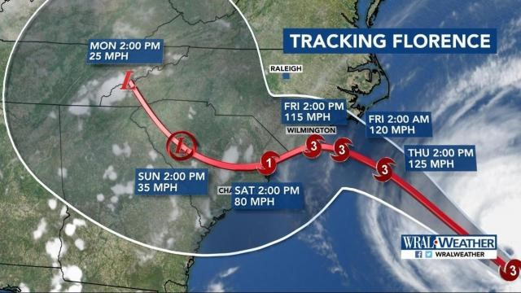

Hurricane Florence in 2018 was devastating to North Carolina causing drastic loss of life and billions of dollars of damage. Broadcasters were especially hard hit as over 20 radio and several TV broadcasters went of air due to flooding or loss of emergency power due to running out of fuel. In addition, according to the voluntary FCC DIRS system, 50% or more the cellular systems in affected counties along the coast were down at the high point of the storm.

Prior to the storm UNC-TV reached out to the public safety communications providers on our towers to let them know that we might have difficultly getting access and fuel to the sites. With that excellent relationship we were able to keep our Wilmington transmitter site functional even though it ran on utility power for 9 continuous days.

Below is a narrative from one our team members regarding his efforts during Florence. It is quite a read. From Casey Jennings, Field Operations Manager UNC-TV, September 2018:”

*“Chad and I staged in Fayetteville on Wednesday, September 12. On Thursday we travelled to WUNJ*

*(Wilmington) to fuel the generator to take a look around to make sure the site was hurricane ready and hide a key for the fuel vendor access the site. While we there the site experienced a brief power interruption that caused the main transmitter to go down. Fortunately, we were on site so Butch and Stan were able to walk us through the process to bring it back up, since it wasn’t responding to remote commands.*

*On Friday the first real effects of the storm were starting to be experienced. We travelled down to WUNU (Lumberton) to fuel the generator and inspect the freshly repaired roof for signs of leaking, and strategically placing a tarp over equipment just in case the contractor’s efforts were unsuccessful.*

*While on the way back to Fayetteville, we came to a long line of stopped traffic on I-95 North. The line was too long to see what the cause was so Chad hopped out and ran ahead to see if it was something we could assist with. He came running back and yelled “chainsaw”, so I retrieved the brand-new chainsaw I had stashed in the utility of my truck and headed toward the front of the line. When I got up there, I found a very large pine tree that had uprooted and fallen across the road, smashing the guard rail and blocking both northbound lanes of I-95. There was a man with lopping shears trying to cut some limbs off, but it was a totally futile effort. With the help of a couple of truck drivers moving brush, we got the giant pine tree cleared in about 5 minutes. As we were finishing a state trooper arrived on scene and asked us if we could cut up the remains of another large tree that had fallen and was on the shoulder just beyond the white line. (1st pic)*

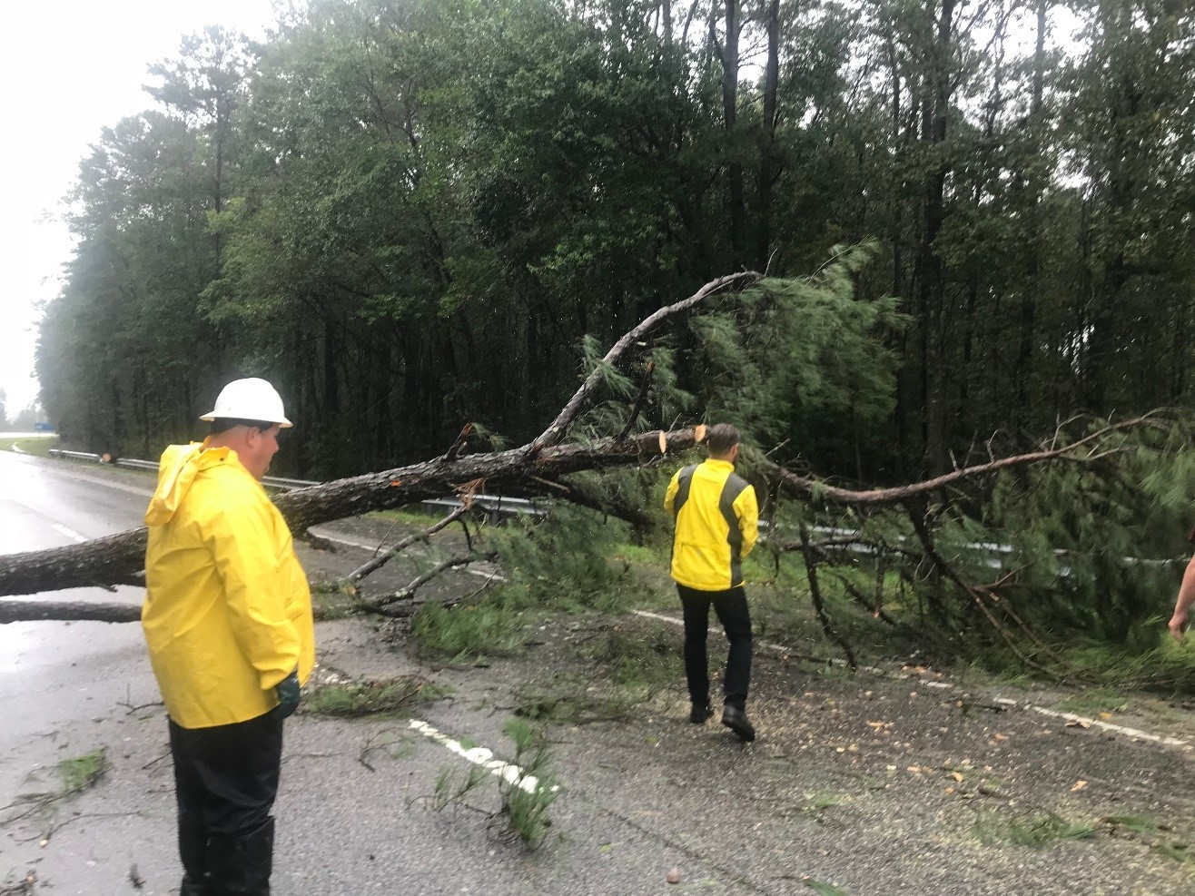

*Pic 1*

*When we returned to our hotel, it turned that a few folks staying there were hung up in the traffic jam. After that when we would walk in to get breakfast in the mornings, we’d be greeted by folks exuberantly calling out “Chainsaw!”. Folks seemed appreciative.*

*On Saturday we went back to WUNJ to refuel the generator since it had been running for a while. We put all the fuel we had in it and headed to Lumberton to check in and see how things were holding up, particularly the recently repaired roof. When we got there, we found another very large tree that had fallen across the road blocking access.*

*We cut it up and removed it, entered the site and found no leaking and everything behaving like it was supposed to. Sunday afternoon I got a call from the EMS folks in Robeson county telling me that the county solid waste department was there to refuel the generator. Definitely made me glad we’d gone in there the evening before and opened up the road. (2nd pic)*

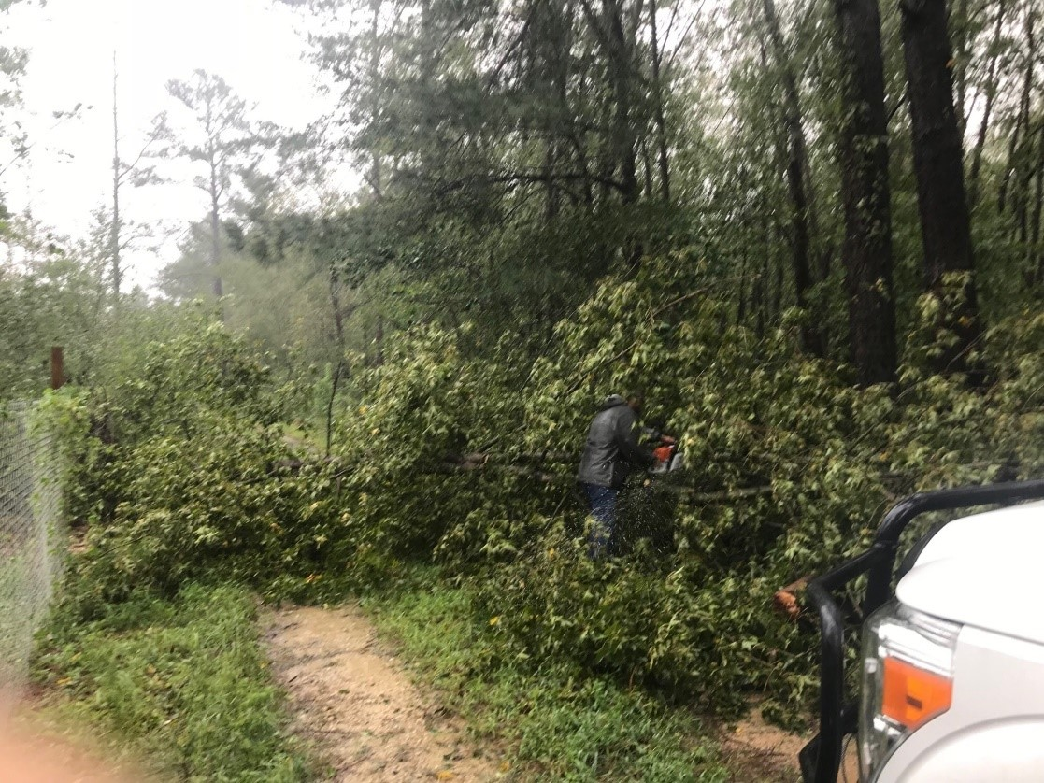

*Pic 2*

*After finding fuel at one of the only open stations in Cumberland county on Sunday morning, we headed back to WUNJ. Getting there was an adventure in itself as many roads were flooded. HWY 87 in Rieglewood was under water in several places, some up to 5’ deep. We were able to find some back roads that were flooded but still open that led us to the site. My guess is there weren’t enough local officials available to man each of the places that needed to be shut down so only the major thoroughfares were closed.*

*When we finally got to HWY 74 East we came upon the EMS director for Columbus County at a flooded section of road. He was glad to see us and thanked us for staying on top of the fuel situation, since they are dependent on our tower and electrical service for communication. We drove through about half a mile of road with deep water running across it. There were cars sitting on the road that had been abandoned due to being overcome with water. (3rd pic)*

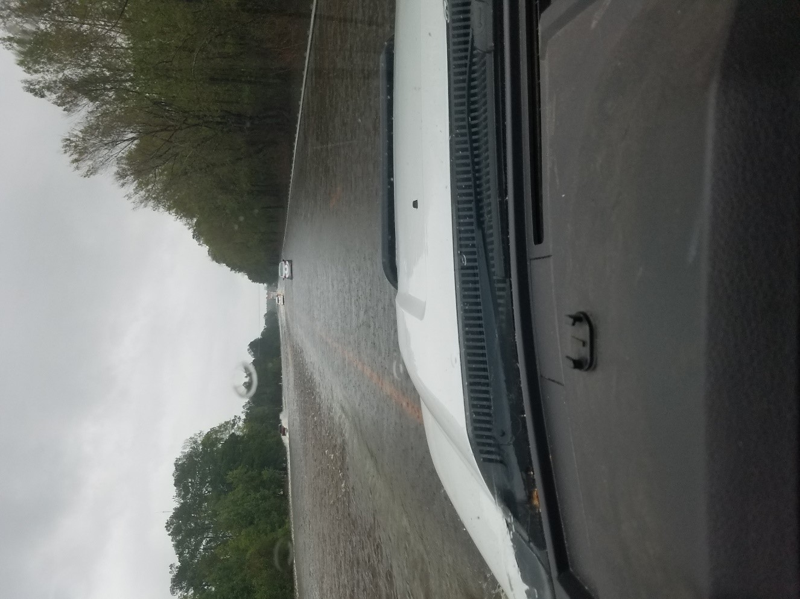

*Pic 3*

*When we got there, we found out that our fuel pump motor had gotten water in it and was inoperable. We tried to use the smaller pump from my small fuel cell, but it wasn’t possible to connect it to the large tank with what we had. We ended up elevating the fuel trailer about a foot and a half and using the 5/8” drain on the bottom and a garden hose to put about 400 gallons of fuel into the generator. It didn’t fill it up, but it bought us about another day of operation. Draining all that fuel through a small hole with gravity feed took a long time so when it was finished, we hurried to get things buttoned up so we could get out while it was daylight and the roads were still (hopefully) passable. (4th pic)*

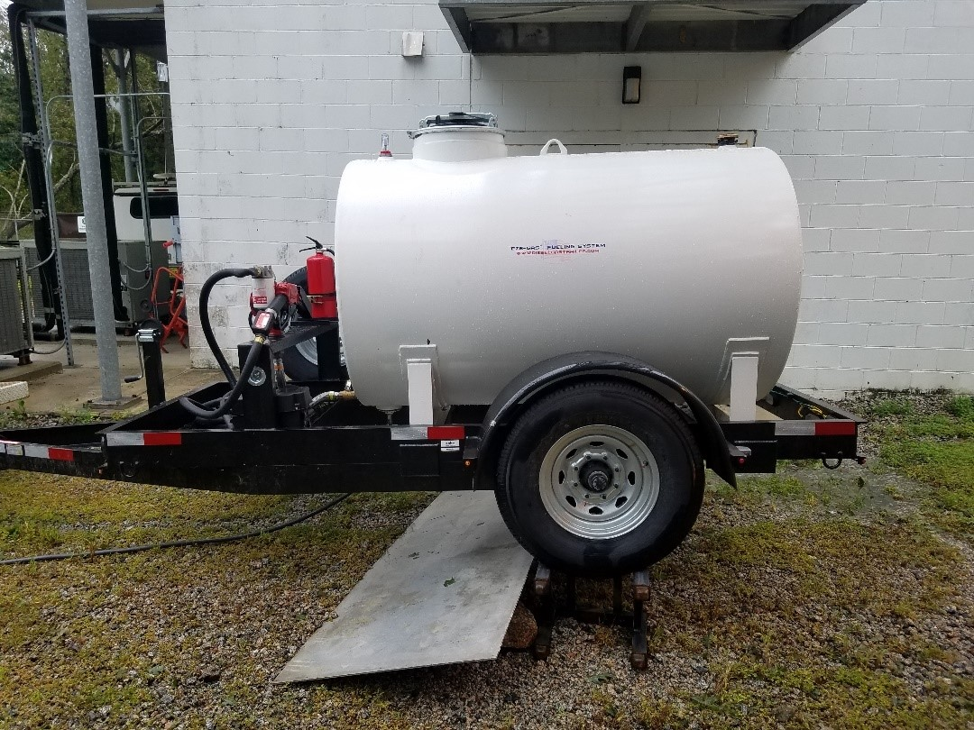

*Pic 4*

*Driving out on the same flooded backroads we drove in on, we came across another line of stopped traffic. There was a power line draped across the road about 4’ – 6’ above the blacktop. Folks were apparently paying attention to the instructions that are given during storms – “don’t go near downed power lines and don’t drive through flooded roads”- because no one was going near it. Having done distribution line work before coming to UNC-TV, I recognized that the line was A.) insulated wires that carry secondary voltage and B.) dead (there was a tree down that brought down the entire 3 phase circuit that line was tapped off of). We also saw that a truck carrying a US Coast Guard high water rescue team and pulling a tall trailer with rafts in it was stuck behind the downed line. The blocked road was the only way from Hwy 87 to Hwy 74, so they were pretty much sitting ducks. Chad and I got out and put together a quick plan. I asked a lady if I could cut a small tree from the wood line on her property to build a field expedient prop and Chad enlisted the help of the Coast Guard guys. They were more than willing to help once they found out the power line wasn’t a danger to them. I dropped a small tree and cut a fork in it. We placed the power line in the fork and raised the forked tree, sticking it in a ditch to hold it upright. That raised the power line to 13’ or 14’ above the road. The road was then open, and the Coast Guard sped off to get back to the business of high-water rescue, and the rest of us were able to go wherever it was we needed to go. (5th pic)*

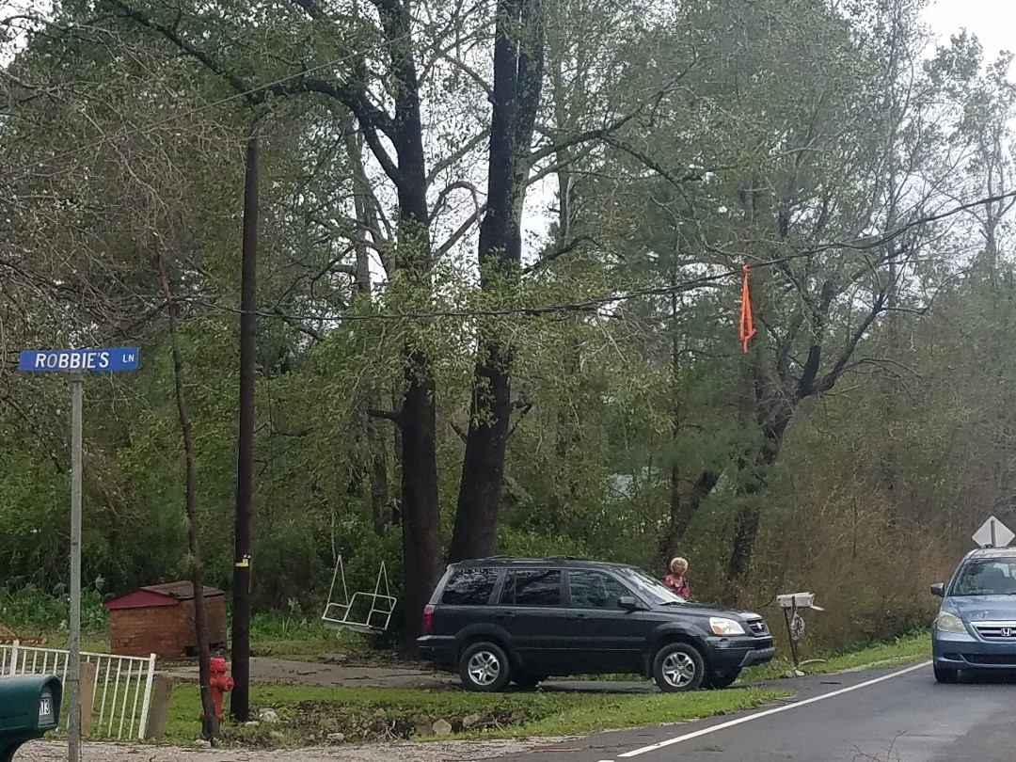

*Pic 5*

#### 10. Appendix D

NEXTGEN TV system or ATSC 3.0

As the CSRIC VII WG 5 develops guidelines to improve broadcaster resiliency before, during and after major emergencies, it is also makes sense to look at emerging broadcast technologies that may enhance emergency alerting.

Background

As you know, Television Broadcasting has been around for decades. The analog broadcasting standard was the method of delivering a single program stream to homes. But as technology had rapidly evolved it became clear exciting new means of delivery and quality were within reach.

The Advanced Television Systems Committee (ATSC) began working on a digital television broadcast system in the early 1990’s. In the late 1990’s the FCC approved, and broadcast televisions began adding digital delivery transmission systems designed to enhance the viewer experience. High Definition video, surround audio, and multiple program delivery in a single broadcast TV channel were all features that have been adopted throughout the United States. Television broadcasters were allocated a second TV channel in their markets to carry these digital services. Analog and digital transmissions ran in unison throughout the county until June of 2009 when analog broadcast services were terminated.

It was clear in the early 2000’s that although the Digital TV (DTV) standard (now referred to as “ATSC 1.0”) was a great improvement in quality there were concerns it was a “locked” standard that did not allow for any innovation or significant improvements in receptibility. ATSC 2.0 was introduced to improve mobile reception but it proved to be inefficient and was not widely adopted.

In 2011 the ATSC began having discussions about the next generation of over-the-air television broadcasting. In March of 2013, they announced a call for proposals from the industry to address this. A system was agreed up on and the Federal Communications Commission in February of 2017 issued a Notice of Proposed Rulemaking that allowed the deployment of “ATSC 3.0” in the United States.

ATSC 3.0 (now identified by the consumer electronics industry as “NEXTGEN TV”) offers broadcasters several significant enhancements over the current system. It is IP based and has the ability to upgrade and add new standards and features. It uses a different modulation system, Orthogonal frequency-division multiplexing (OFDM), that provides for robust reception capability, particularly for mobile applications. The video coding system used for ATSC 3.0 is far, far more efficient than the current system. With improved modulation system that increases the overall data-throughput and the new coding system that uses far less data, ATSC 3.0 has room for many, many features beyond just television programming.

UNC-TV, North Carolina’s public television network, an affiliate of the University of North Carolina System, began looking closely at ATSC 3.0’s in 2016. They focused specifically on the increased data-capacity of ATSC 3.0 as well as the robust modulation system. Working with the North Carolina Public Safety Communications community they wrote a white paper that focused on a specific problem facing the first responders, their continued use of analog voice pagers. This paging system, though very reliable, is based on technology developed in the 1960’s and has not had significant improvements. It is based on a cueing system where each emergency is stacked in sequence for delivery. The dispatch announcements often take over a minute, for each individual announcement, and delivers the next one only after the previous is completed. In a time of multiple emergencies, it can take minutes from the time the 911 call is received until the information is delivered to the first responders. UNC-TV and its Public Safety Communications partners proposed using ATSC 3.0 as a transmission method to deliver 911 dispatch information to first responders in a digitally delivered method. 911 call information is typically keyed into a Computer Aided Dispatch system. This data would then be delivered to the ATSC 3.0 transmitter and then decoded and displayed on a First Responder receiver device.

In laboratory tests, UNC-TV has concluded that these dispatches can delivered in a second or less, not minutes.

This will save lives.

UNC-TV submitted this concept to the 2017 National Association of Broadcasters Pilot Innovation Challenge grant competition. 150 national and international submissions were made for this grant and UNC-TV’s was the overall winner.

This is just one example of how ATSC 3.0 broadcast technology could be used to improve First Responder communications. There are many other applications for both public and non-public facing emergency communications that are being explored.

#### 11. Works Cited

Centeno, M. (2016). *Project Manager.* Washington, DC: National Public Warning System (NPWS) DHS, Federal Emergency Management Agency.

Flick, S. R. (2018, September 11). Retrieved from COMMLAWCENTER: https://www.commlawcenter.com/2018/09/broadcasters-prepare-to-meet-their-obligations-as-firstinformers-in-hurricane-florence.html

NAB. (2020, January 25). *We Are Broadcasters.* Retrieved from https://www.wearebroadcasters.com/whoWeAre/firstInformers.asp

National Association of Broadcasters. (2018). *Ten Steps to Disaster Preparation and Recovery.* Retrieved from https://www.nab.org/eyeOfTheStorm/Ten_Steps.pdf

National Fire Protection Association . (2019). *NFPA 110 - Standard for Emergency and Standby Power Systems.* Retrieved from National Fire Protection Association : https://www.nfpa.org/codes-and-standards/all-codesand-standards/list-of-codes-and-standards/detail?code=110

1. *See* Appendix A for the current National Association of Broadcasters Ten Steps to Disaster Preparation and Recovery (National Association of Broadcasters, 2018).
2. The FCC, working with DHS, has been very helpful in providing letters to broadcasters in potential areas to be impacted by major hurricanes and/or disasters. The access letters request local and state authorities to allow broadcast employees and vehicles to gain access to their transmitter sites and studios.