Federal Communications Commission
Emergency Alert System (EAS) Test Reporting System (ETRS) User Manual
Version 1
July 13, 2016

Table of Contents
1. Log in 4
1.1 New User 4
1.2 Returning User 4
1.3 Security Banner 4
1.4 Reset Your Password 5
1.5 Main User Menu 7
1.6 Update Your Profile 8
1.7 User Roles & Privileges 9
2. Actions 10
2.1 Overview 10
2.2 Create New EAS Test Record (Form 1) 11
2.2.1 Auto-populate by Facility ID 16
2.2.2 Auto-populate by CUID 18
2.3 Submit New Batch Filing 19
3. Records 20
3.1 Overview 20
3.2 EAS Participants 20
3.2.1 List View 20
3.2.2 EAS Participant Details 21
3.2.3 Related Actions 22
3.3 EAS Test Record 23
3.3.1 Test record Details 24
3.3.2 Related Actions 27
3.4 ETRS Test Cycle Record 30
3.4.1 List View 31
3.4.2 EAS Test Cycle Record Details 31
3.5 Users Record 32
3.5.1 List View 32
3.5.2 User Details 33
3.5.3 Related Actions 34
4. Reports 34
4.1 Overview 34
4.2 EAS Tests 35
5. Tasks 37
5.1 Overview 37
5.1.1 Assigned to Me 37
5.1.2 Sent by Me 38
5.1.3 Starred 38
5.1.4 ETRS Homepage 38
6. News 39
6.1 Overview 39

Log in

New User
New Emergency Alert System (EAS) Test Reporting System (ETRS) users may sign up for inputter accounts at https://www.fcc.gov/eform/submit/etrs-registration.

Returning User
There are two methods to access the ETRS log-in interface:
- Go to www.fcc.gov
Select “ETRS” under the E-Filing menu, or
- Go to fcc.appiancloud.com

Security Banner
Once the page loads, the following security banner will be displayed:
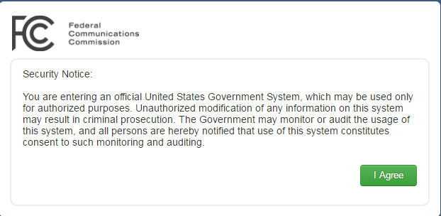

In order to proceed to the site, you must agree to the conditions stated in the banner. After you accept the terms, input your username and password.
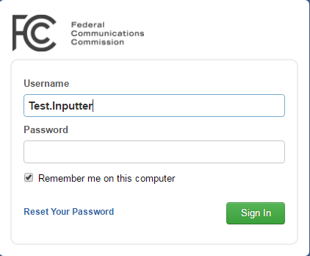

Reset Your Password
At the log-in interface, you may reset your password. If you click the “Reset Your Password” link, you will be redirected to a new page to enter your username.
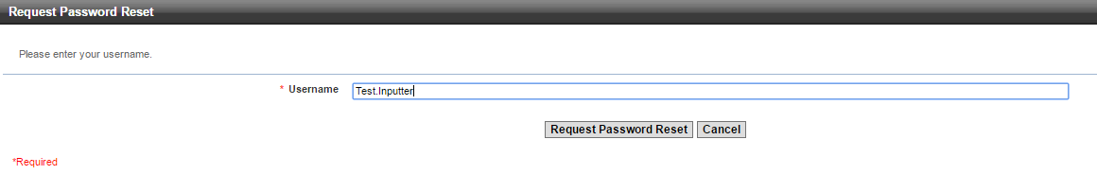
If the username exists, an email is sent to the email address associated with your username. All account passwords are automatically reset every 90-days.

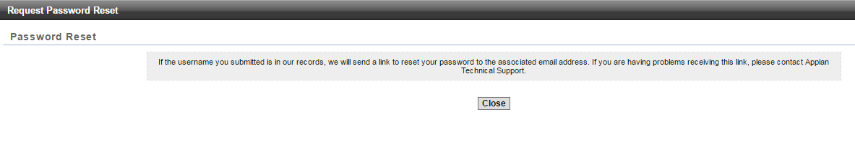

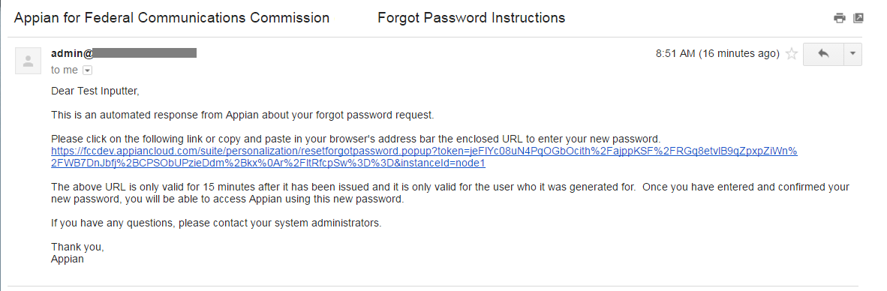

Follow the link in the email you received to reset your password. The link will expire after 15 minutes.
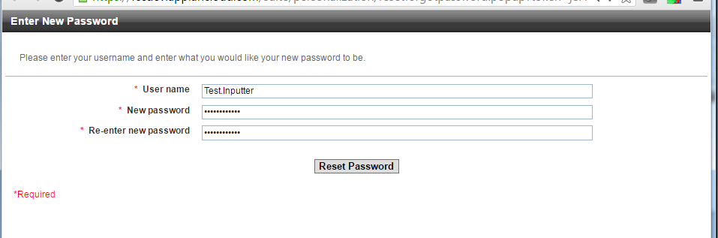

Main User Menu
When you first log in, you will see the ETRS homepage. This page summarizes details your profile, as well as actions and test records that you can access. See ETRS Homepage for details. At the top of the page, there are five tabs: News, Tasks, Records, Reports, and Actions. Depending on your role, you will be able to access different objects within these five tabs. User Roles and Privileges for details.
News provides a summary of recently created or edited records and a link that connects you directly to the record’s details. Commission releases related to a nationwide EAS test may also be provided here.
Tasks alerts you of any tasks assigned to you or to a group of which you are a member. The ETRS homepage is listed as a dashboard under this tab.
Records provide you to a collection of records (i.e. information filed in Forms One, Two and Three) relevant to your account. Depending on the record, there may be a related action to update that record.
Reports allows you to search for a collection of test records based on search criteria you input.
Last, Actions allows you to create new test records (i.e. file Form One). If you are a coordinator, you may also submit a batch filing.
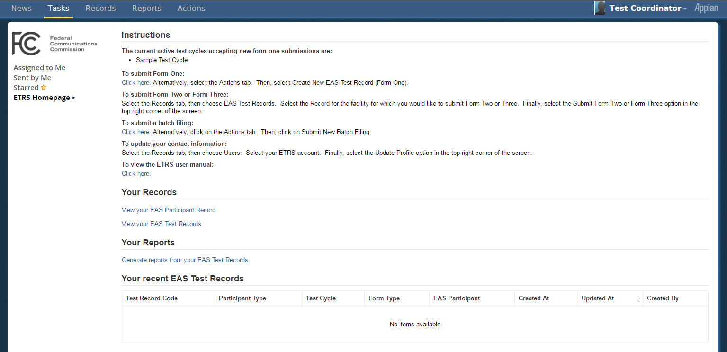

Update Your Profile
To change your user settings, click on your name in the top right corner. Select Profile.
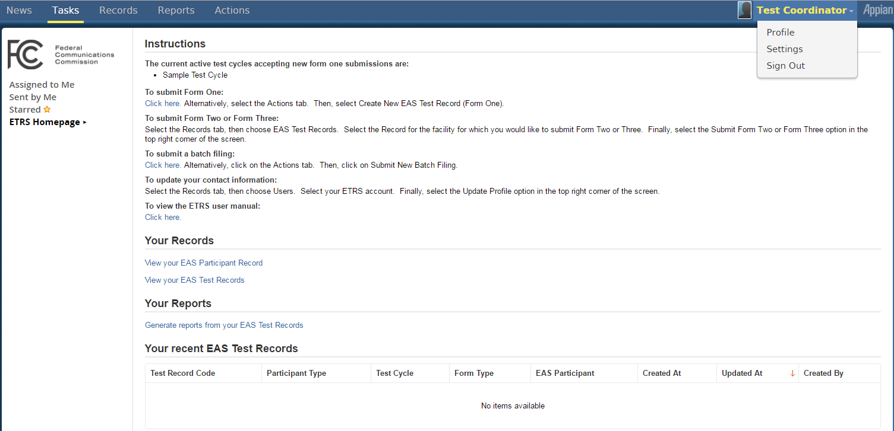

Go to the FCC User Information view in the left pane.
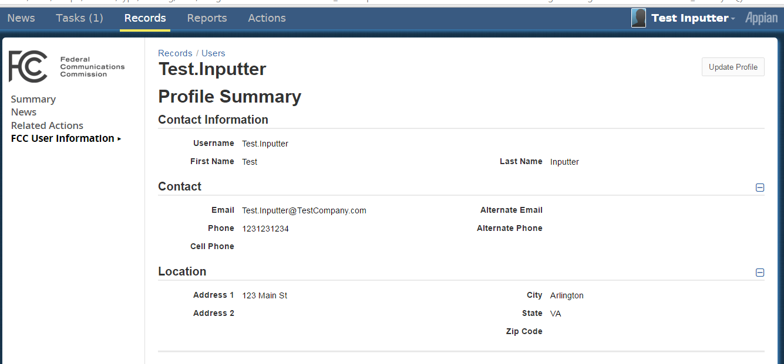
1. Select the “FCC User Information” view
2. Select this button to update your profile.
Select Update Profile in the top right corner.
Edit your information accordingly in the “Update Profile” form. The select Submit to save.
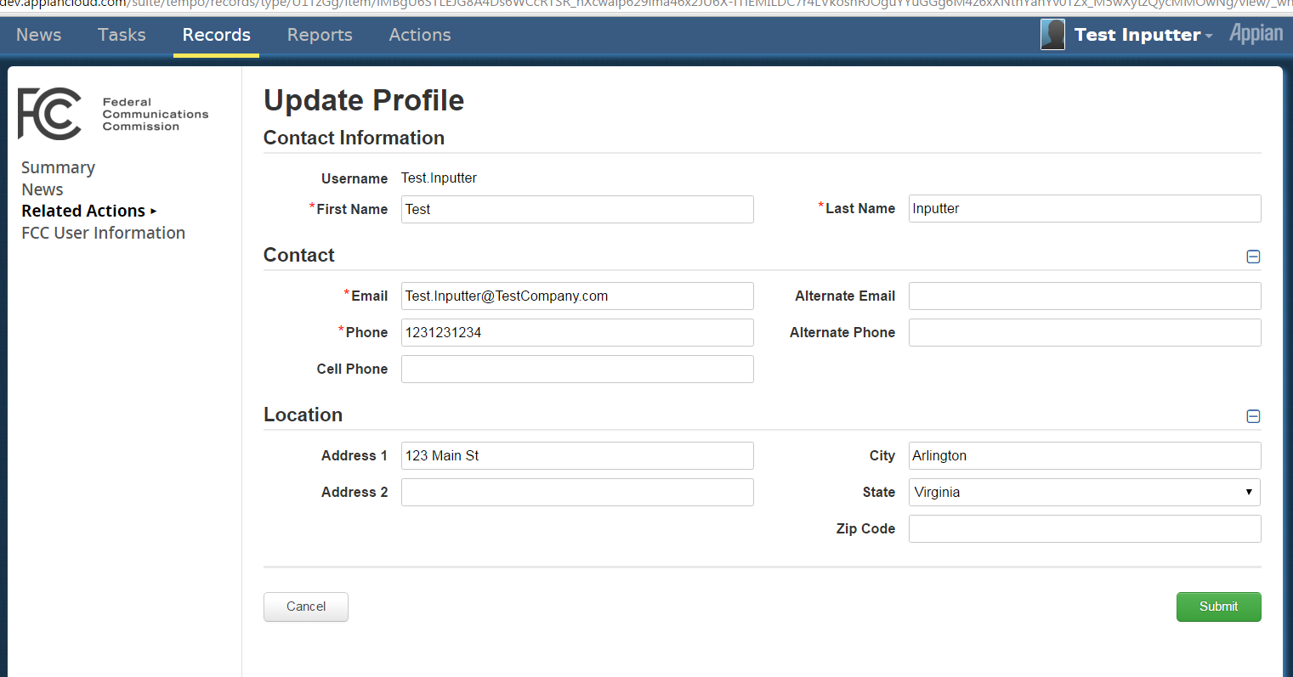
Your contact information saved here will be used to auto-populate forms throughout this application.
The “Summary,” “News,” “Related Actions,” and “FCC User Information” views you see in the left pane will be explained in detail at User Records.

User Roles & Privileges
All ETRS users are considered ETRS filers. Multiple ETRS filers may file on behalf of an EAS Participant. Most ETRS filers are inputters. New inputters have the immediate task of filling out Form One for each of its EAS Participant’s facilities. Some ETRS filers will be coordinators, which have the ability to submit batch filings for several of their EAS Participants’ facilities. To become a coordinator, ETRS inputters should e-mail a request to ETRS@fcc.gov.
Each role has different privileges, outlined below. Differences in each role are underlined.

ETRS inputters
News | - View posts generated from test records they created  - View posts or messages from groups  - View Kudos they received or gave
Records | - View test records they submitted  Related Actions: “Update Form 1,” “Submit Form 2,” “Submit Form 3”  - View all test cycles  - View your own profile  Related Actions: “Update Profile”
Reports | - Search and view a collection of test records you have submitted
Actions | - Create New EAS Test Record (Form One)

ETRS coordinators
News | - View posts generated from test records submitted by any filer associated with the EAS Participant  - View posts or messages from groups  - View Kudos they received or gave
Records | - View test records submitted by any filer associated with the EAS Participant  Related Actions: “Update Form 1,” “Submit Form 2,” “Submit Form 3”  - View all test cycles  - View profiles of any filer associated with the EAS Participant  Related Actions: “Update Profile”
Reports | - Search and view a collection of test records submitted by any filer associated with the EAS Participant
Actions | - Create New EAS Test Record (Form One)  - Submit New Batch Filing

Actions

Overview
Actions will allow a user to input data for an EAS Participant’s facilities.
Related Actions are actions that you can take on an existing record—such as editing an EAS Participant name or updating a form. Related actions are explained in the relevant views of each record.
There are links in the left pane of the window.
- The “Starred” link will show a short-list of actions that you “star.” You may “star” by clicking the white star next to the action name. Once you click it, it will change to an orange star.
- If you are a member of multiple applications, you will see the application names listed under “Applications”.
  - User Test Coordinator is a member of one application, “ETRS.”
  - The “(2)” you see next to “ETRS”, indicates that Test Coordinator has access to two actions within ETRS.
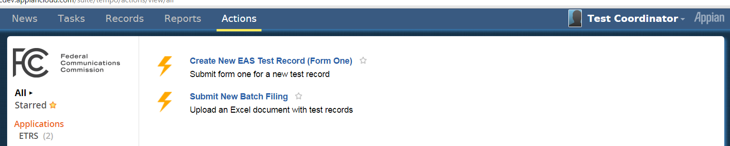
When you select an option in the left pane menu, the selected option will be made bold and a small triangle will appear next to that selection.
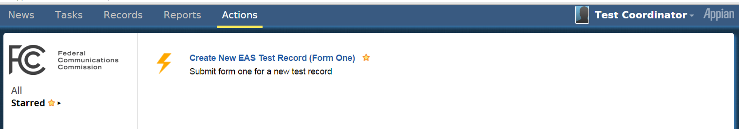

Create New EAS Test Record (Form 1)
ETRS inputters and coordinators may access the Create New Test Record action.
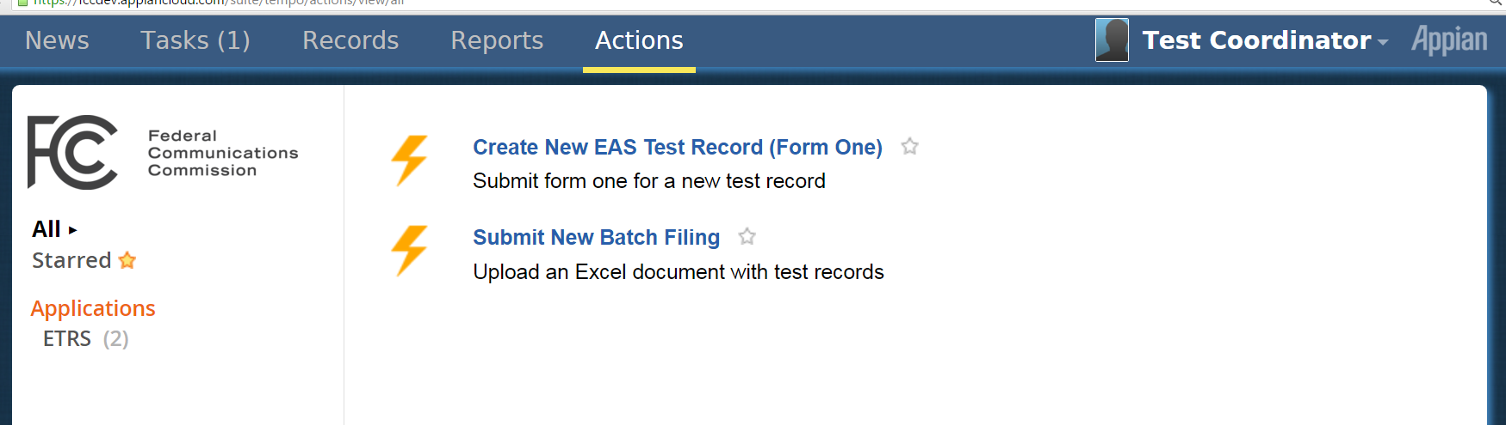

When you select Create New Test record action, you directed to the following form:
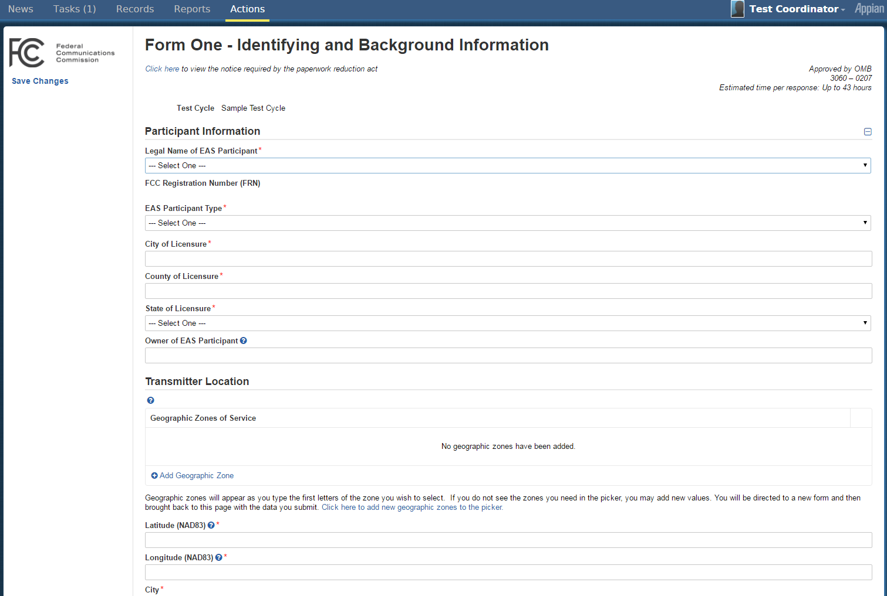

If there are multiple test cycles open, select a test cycle from a dropdown menu. If there is only one test cycle available, that test cycle will be pre-set in the form.
Depending on the “EAS Participant Type” you choose, you will be required to fill in different fields.
Throughout the form, red asterisks are used to indicate required fields that you must fill out. If the fields are not completed, you will remain on the same page even after you Submit and confirm to continue; the required fields which are not correctly filled in will be highlighted with red text.
To submit, update all the fields highlighted with red text with a valid value then press tab. The red validation messages will clear and you may submit the notification.

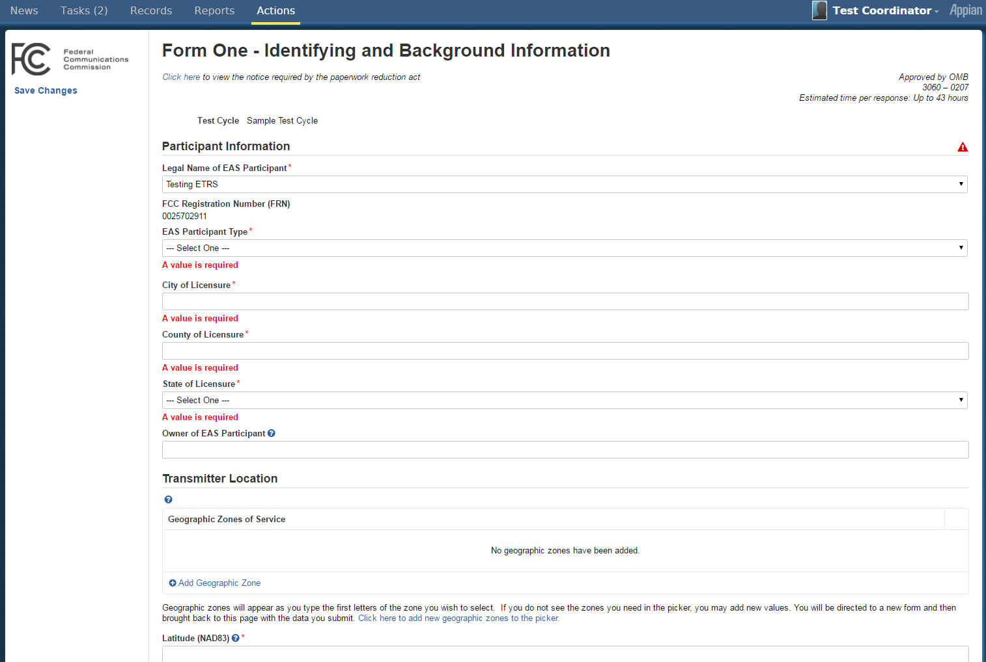
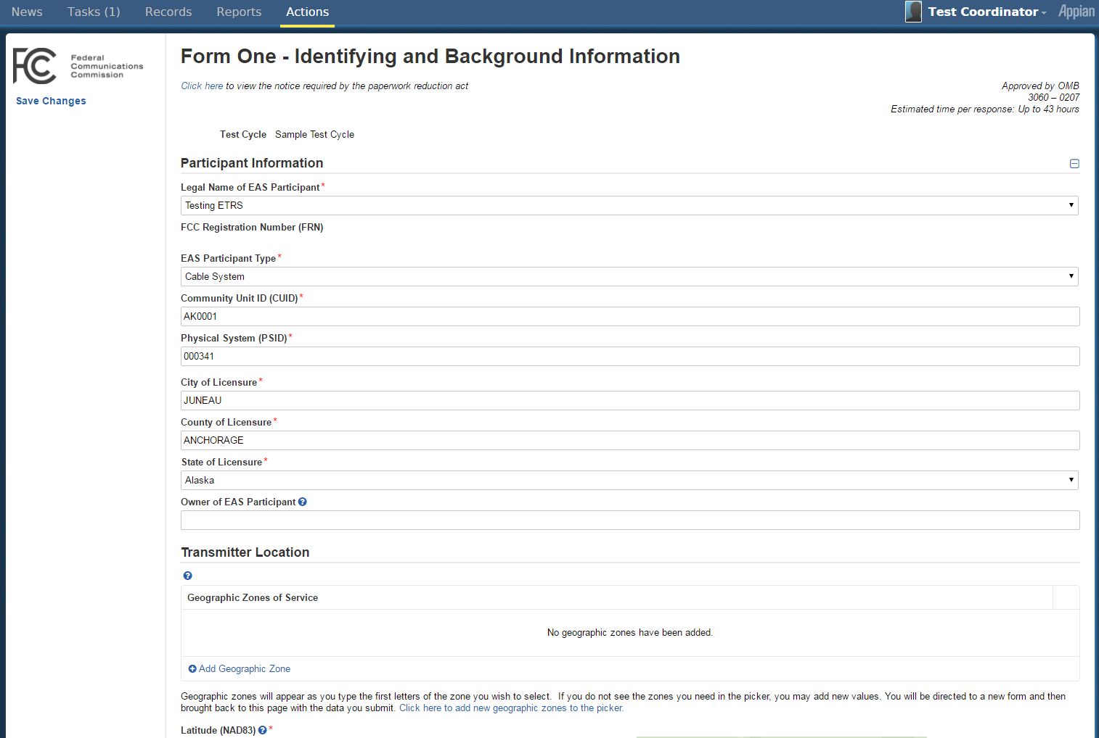

Prior to submitting the form, you may press Save Changes on the left panel to save the values you have entered so that they appear when you return to the form.
You may cancel from this action any time. If you do not cancel but instead click on a different tab, this action will be tracked in your task queue until it times out, after sixty minutes after you first clicked the Create New EAS Test Record (Form One) action.
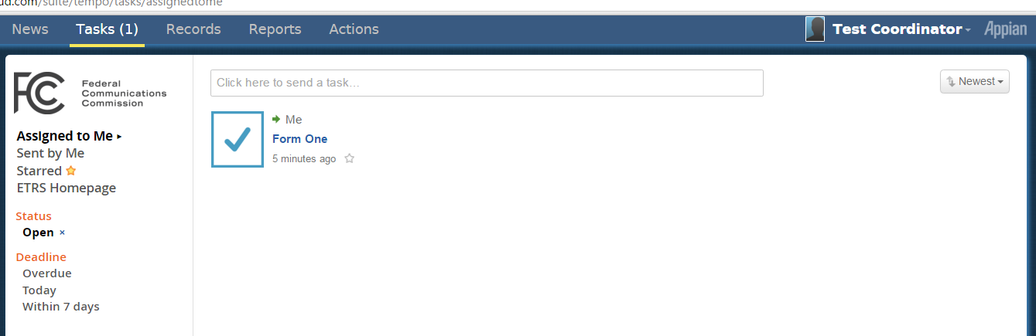
After you select Continue, you will be asked to confirm your submission.
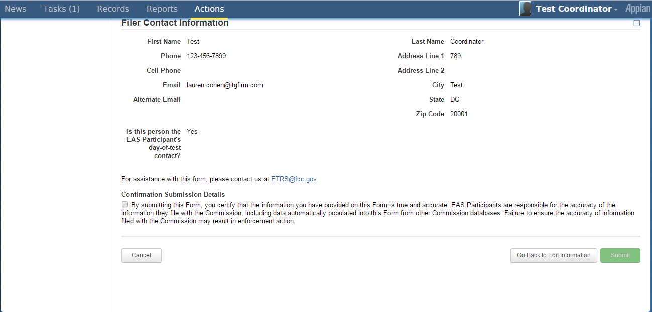
Check this box to submit.

After you verify all the inputs and check the checkbox, the Submit button will be activated, allowing you to submit.
When the new test record is successfully created, you will see a confirmation page with a link to the newly created record. See Records to learn more about records.

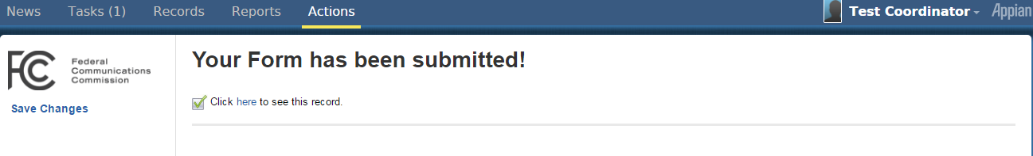

When this record is created, an email notification is sent out to the ETRS inputter who created the test record and the coordinator of the relevant EAS Participant.
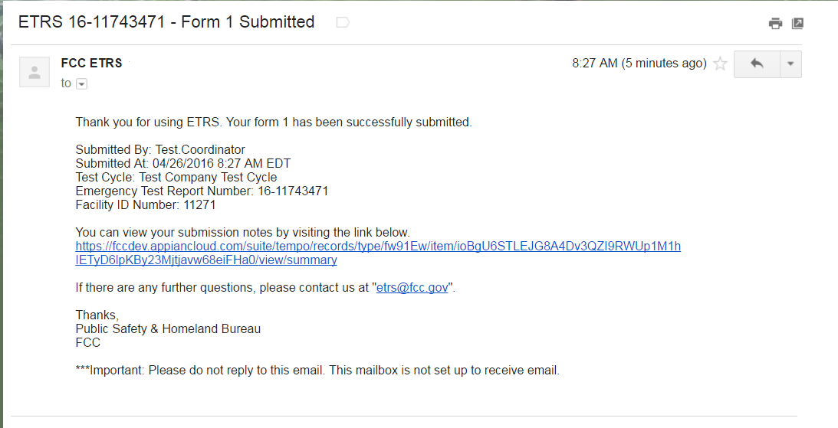

Auto-populate by Facility ID
Radio Broadcaster, Television Broadcaster, Direct Broadcast Satellite, and Satellite Digital Audio Radio Service EAS Participant types have a Facility ID search feature which assists users in auto-populating the call sign, longitude, latitude, city, and state fields.
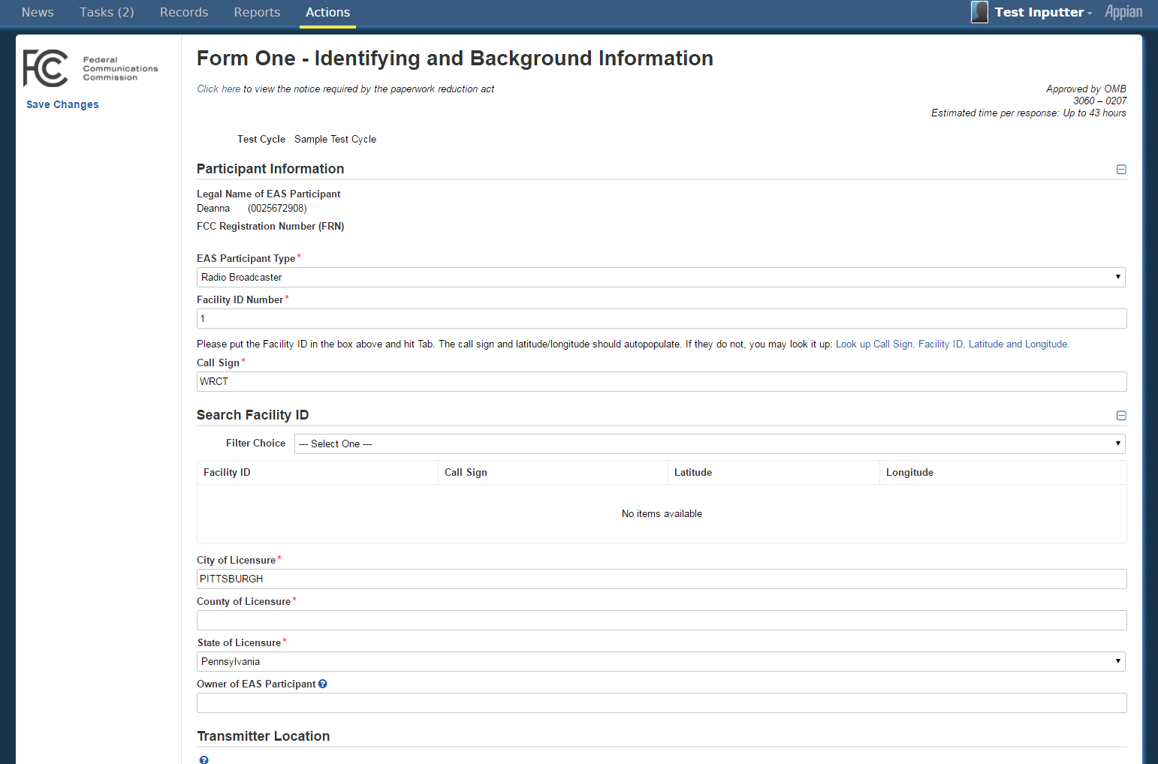

Use this feature by:
- Typing an existing facility ID into the Facility ID field. If you type a facility ID that does not exist, the other fields will not be auto-populated.
- Select “Look up Call Sign, Facility ID, Latitude and Longitude.” This opens up a “Search Facility ID” section where you can filter for call signs by type of service, call sign, city, or state. Select the facility ID to auto-populate the form.
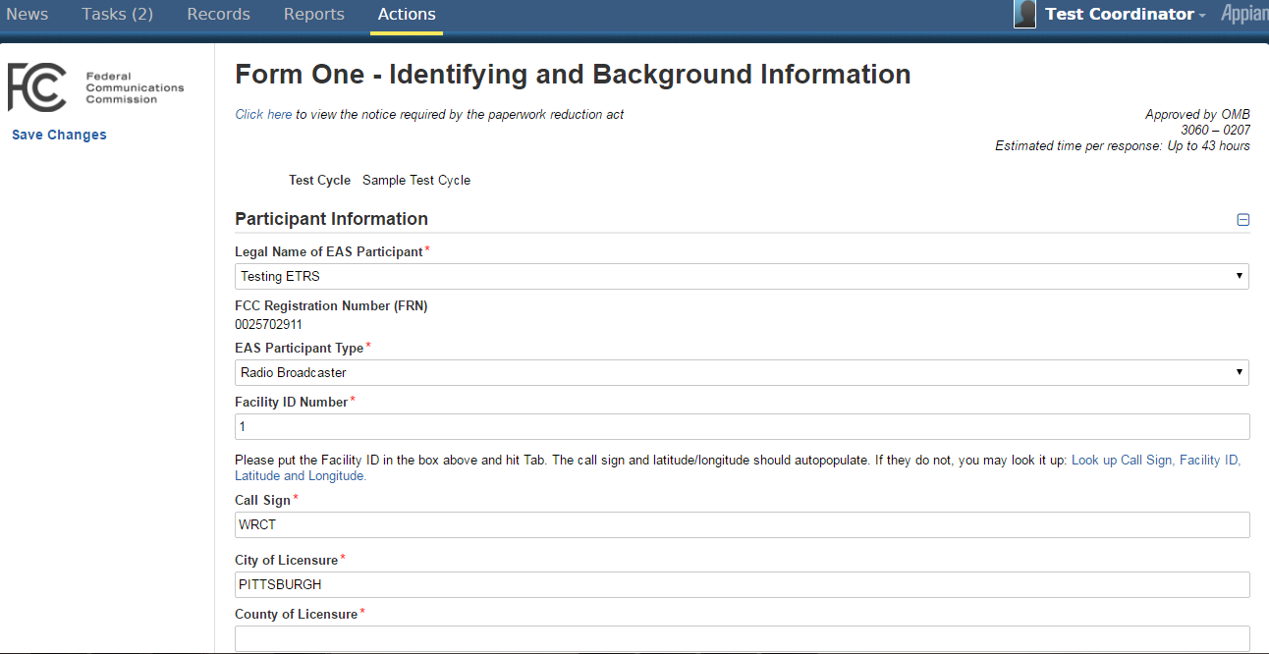
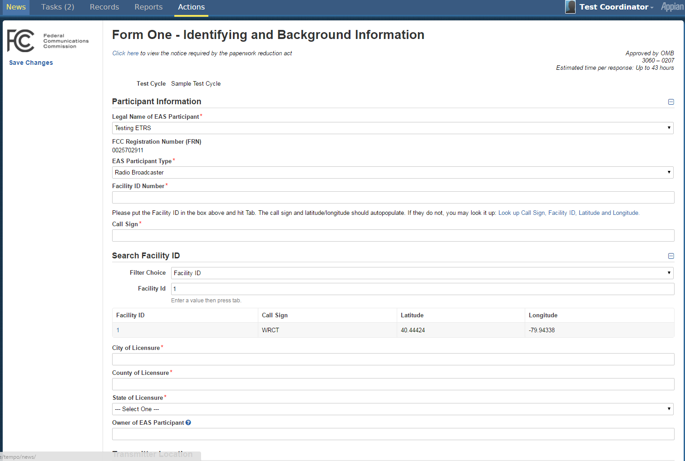

Auto-populate by CUID
Cable System and Wireless Cable System EAS Participant types have a CUID search feature which assists users in auto-populating the PSID, city, county, and state fields.
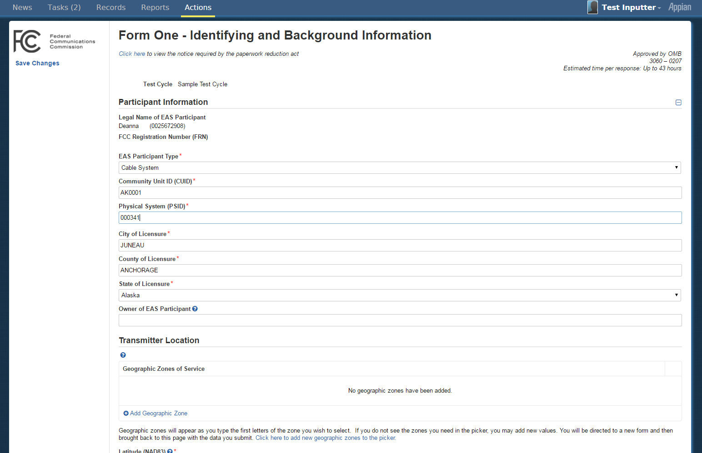

Use this feature by typing an existing CUID into the CUID field. If you type a CUID that does not exist, the other fields will not be auto-populated.

Submit New Batch Filing
The Upload Bulk Notifications action allows ETRS Coordinators to quickly edit or create new test records using spreadsheets. Download the spreadsheet template from the interface to create new test records. Alternatively, export existing records to edit from EAS Test report.
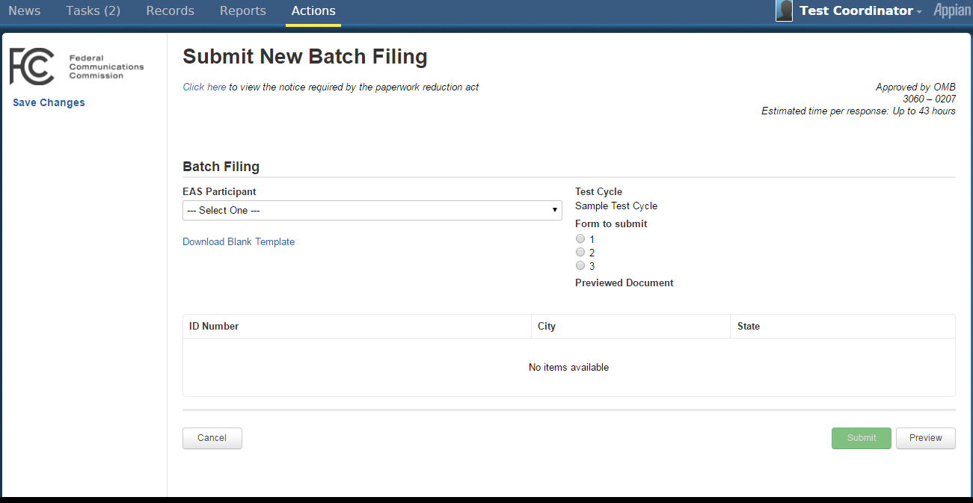
Click this link to download the excel template
Select the relevant test cycle. The form you may submit will be available if the submission and update dates for that test cycle is open. If it is open, a “Choose File” button will appear, allowing you to upload your excel file.
Select Preview to load the test records.
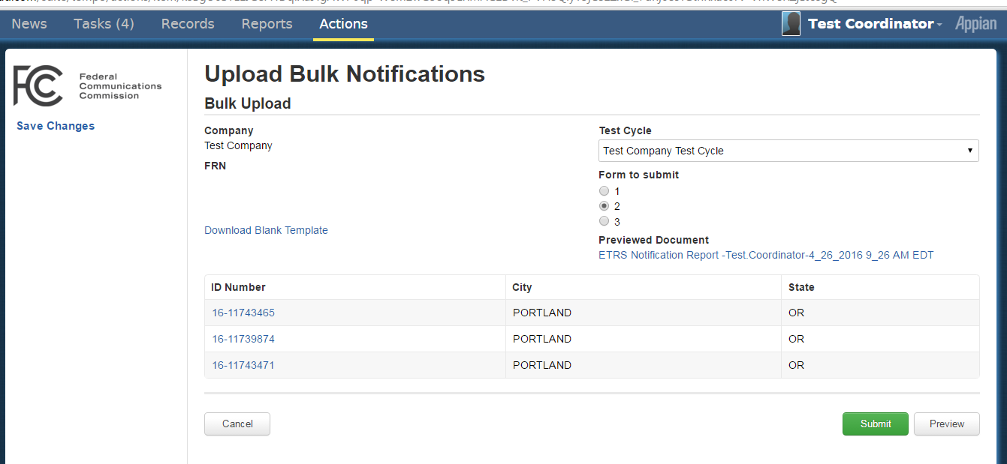
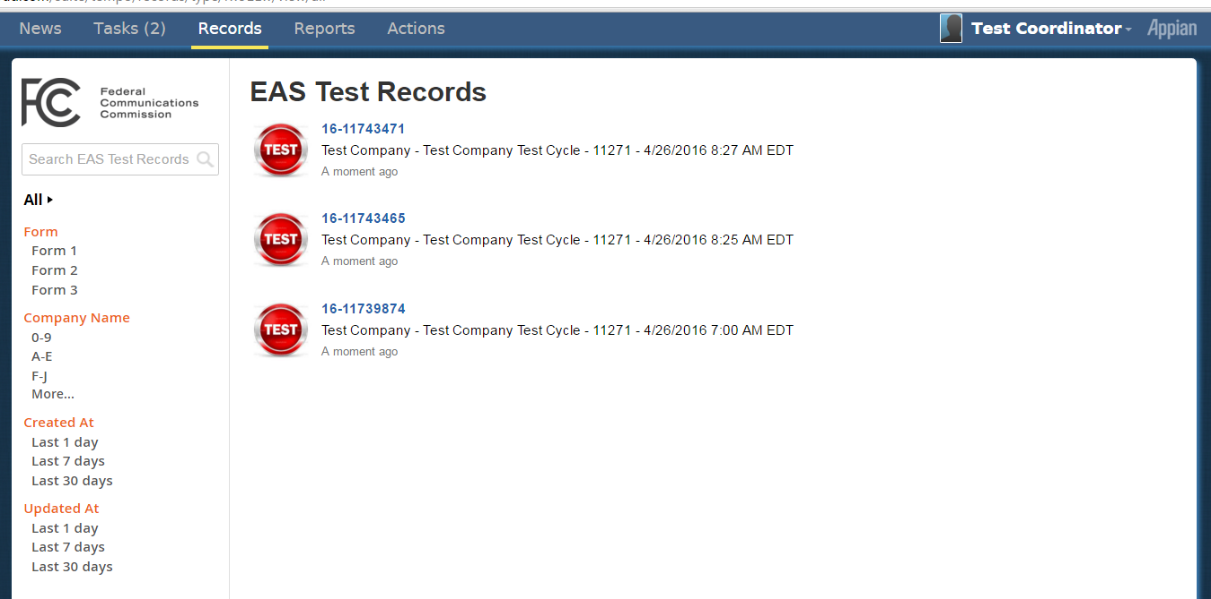

Records

Overview
The Records tab brings together all data within your application so you may easily view and take action on specific records.
Altogether, there are four different record types: EAS Test Records, ETRS Test Cycles, and Users. ETRS Coordinators also have access to EAS Participants.
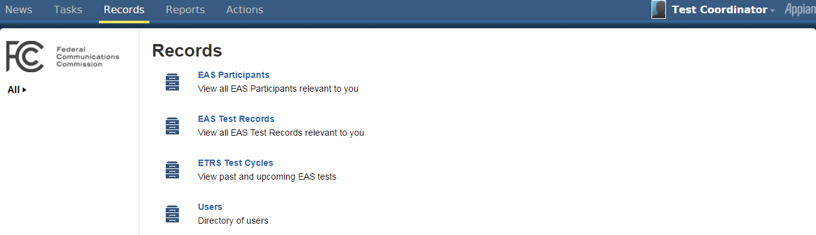

EAS Participants
The EAS Participant record provides details on ETRS inputters, ETRS coordinators, and the test records submitted by users of that EAS Participant.

List View
The list view provides a summary of the number of ETRS inputters and coordinators for each EAS Participant, as well as when the EAS Participant record was last updated.
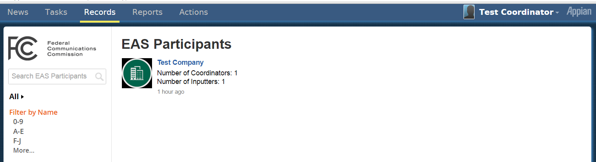
A quick overview of the number of ETRS inputters & coordinators in this EAS Participant and when it was last updated

EAS Participant Details
There are three views available in the left pane: Summary, News, and Related Actions.
In the Summary View, the specific members of the EAS Participant and the test records filed are listed. Click on the member name or the notification code to view details for that record.
The News view is empty because no news feeds are generated or updated when an EAS Participant is added to the database.
In the Related Actions view, we see the two related actions which were also in the top right corner of the Summary view, Edit EAS Participant, and Manage EAS Participant Members.
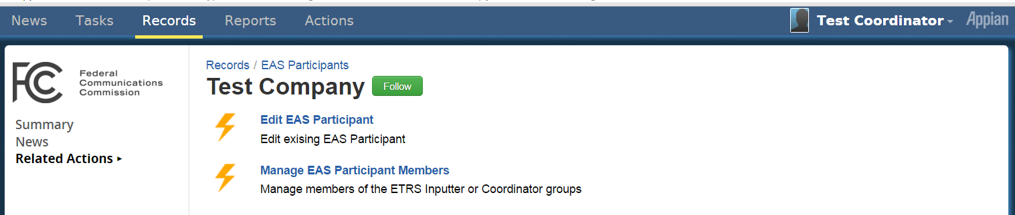

Related Actions
Using related actions, ETRS coordinators may edit EAS Participant names or downgrade/remove/upgrade EAS inputters and coordinators.

Edit EAS Participant
Select this related action to change the EAS Participant name.
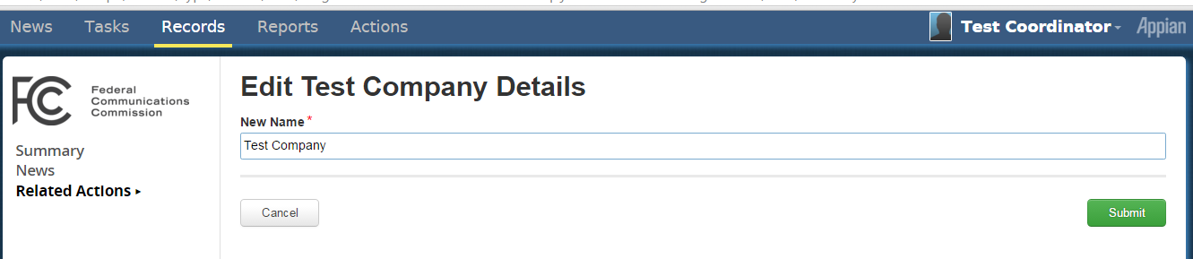

Manage EAS Participant Members
Use the Manage EAS Participant Members action to Remove, Downgrade, or Upgrade existing ETRS inputters and coordinators. Select the group you wish to modify.

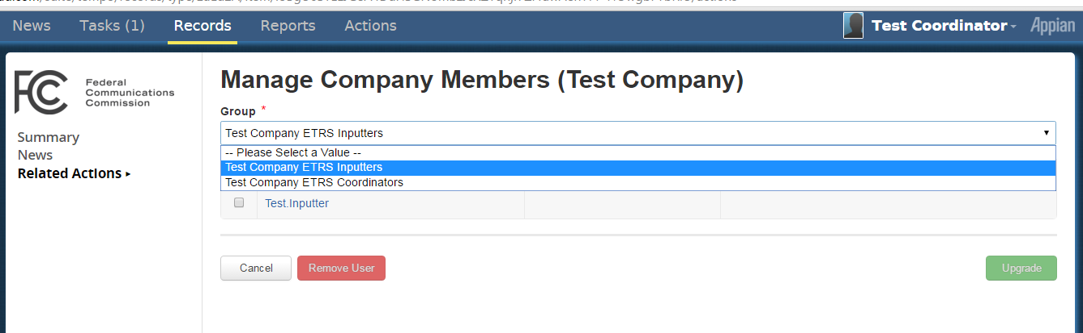
A Coordinator may remove or upgrade any ETRS inputter. Once an ETRS inputter is removed, an administrator may add the inputter back. The upgrade action allows the coordinator to set the ETRS inputter as a coordinator.
The EAS Coordinators may also Remove or Downgrade other coordinators. When a coordinator is Downgraded, (s)he is added a member to the ETRS inputter group for this EAS Participant.

EAS Test Record
The EAS Test Records record is available to all users. However, users may only view the filings that are relevant to them, as described in 1.6 User Roles & Privileges.
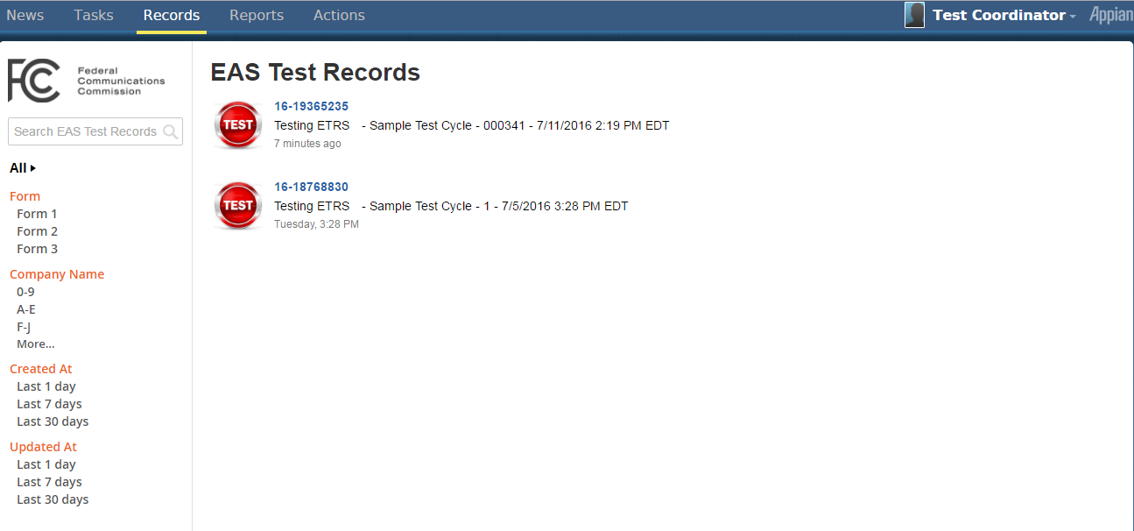

This record allows you to search for specific test record by report code, test cycle, or EAS Participant in a search box. Alternatively, you may use the “Form,” “EAS Participant Name,” “Created At,” and “Updated At” search filters to refine your search.

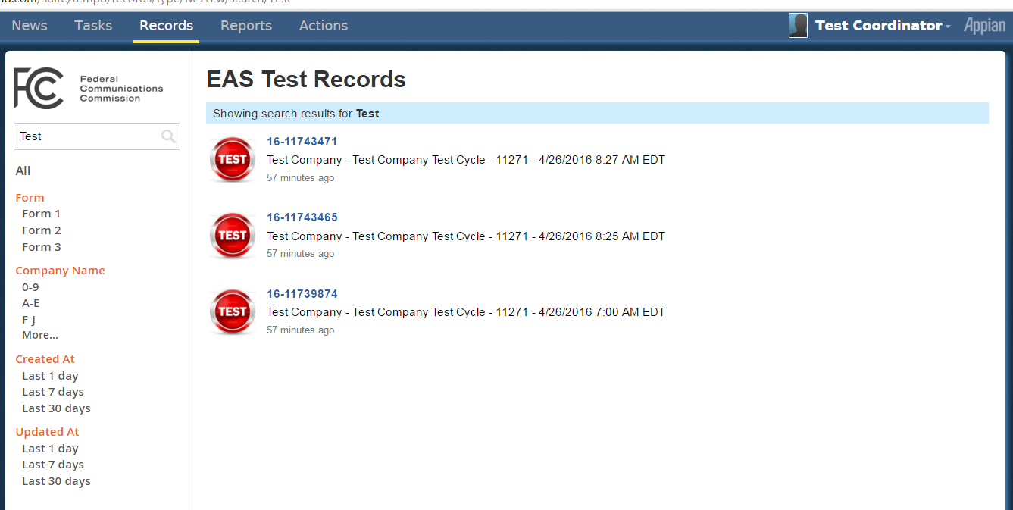
search filters
search box
To view all the details of a particular test record, click on the blue notification code in the list view.

Test Record Details
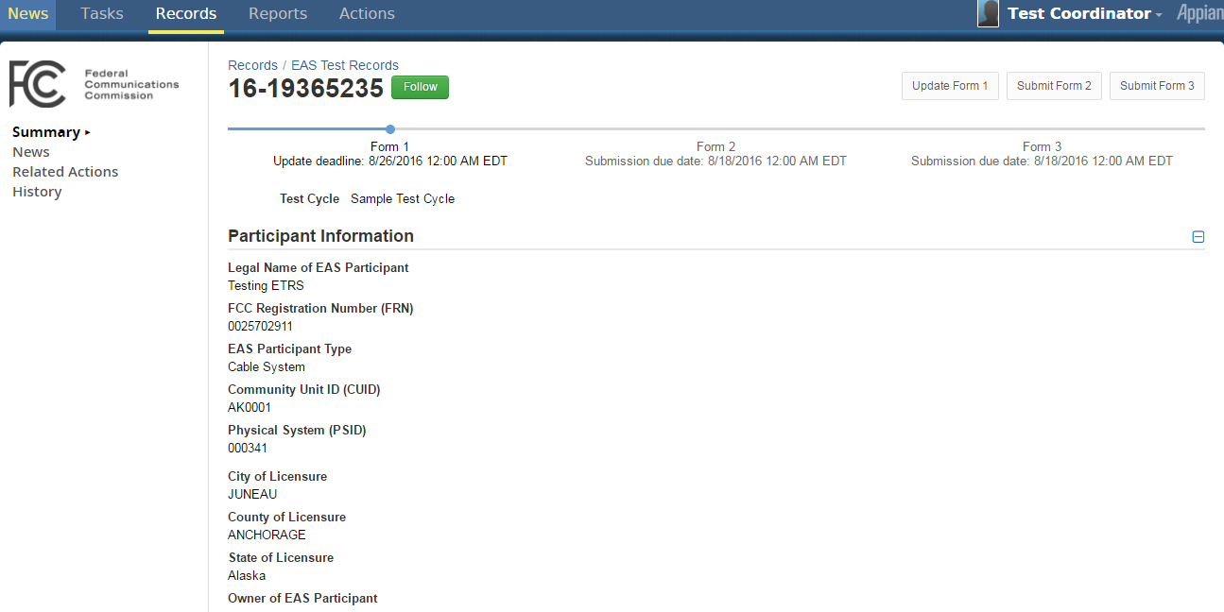
Related Actions available for this record
Different views
When you select a specific record, you are automatically redirected to the Summary View. Notice how “Summary” is bold in left pane with a triangle next to it.
The News view is a summary of news posts related to this record.
The Related Actions view is a list of actions you may take on this record. These actions are also shown in the top right corner of the “Summary” & “Related Actions” views.
The History view allows ETRS inputters and coordinators to view different versions of each form that were updated and saved.

Summary View
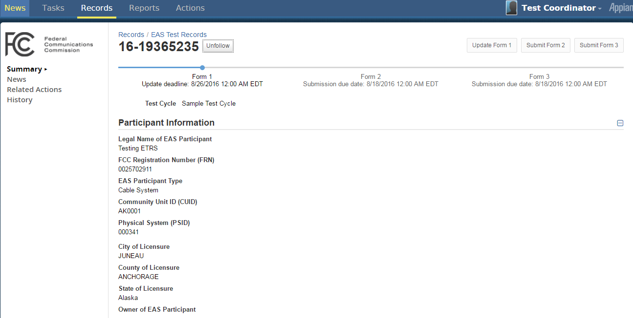
Milestone bar with due dates for each form.

The Summary View summarizes the due dates for each form in the milestone bar at the top of the window.
If you are particularly interested in updates made to a particular record, you may Follow it. By following a record, you be guaranteed to see any news posts relevant to this record in your News feeds if you are not already subscribed to the ETRS Events feed. Follow a record by clicking the green Follow button beside the ID number.
If you are already following a particular record, you’ll see a white Unfollow button.
Related Actions for this record are available in the top right corner of the summary view. This provides a streamlined design so you can view the record directly then take action to update this record. These actions are also available in the Related Actions view in the left.

News View
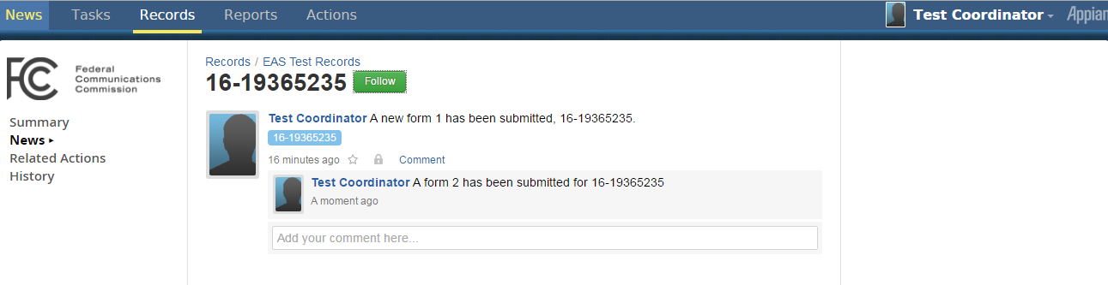
This view displays all the news feeds and comments related to this record. This news feed is also posted in the “News” tab.
A news feed is generated when a new test record notification is submitted. The feed is then updated with comments when Forms 2 and 3 are also submitted. At any point, any user may add additional comments to this news feed. Anyone who subscribes to the ETRS events news feed or who follows this particular record will see the updated comments in their News tab.
Here we see the coordinator submitted Form 1 and 2, but not Form 3.

Related Actions
Related Actions are actions that users can take on existing records. They can be found on records in the Records tab. Related Actions are different from Actions, which are used to create new records and are available only through the Actions tab.

Update Form 1
The Update Form 1 related action is available to ETRS inputters and coordinators from when the initial Form One is first submitted until the update deadline of the related test cycle. In the example below, the Form 1 update deadline expires 4/29/2015. The due dates for each form can also be found on the Test Cycle Record.
The Update Form 1 related action above is available until the Form One Update deadline listed in the milestone.

The Update Form 1 form is identical to the form in Create New EAS Test Record.

Submit/Update Form 2
If Form 2 was already submitted and the update window for Form 2 is still open, the related action will say Update Form 2 rather than Submit Form 2. In the example below, Form 2 has not yet been submitted.

When you select Submit/Update Form 2, you will be directed to the following form: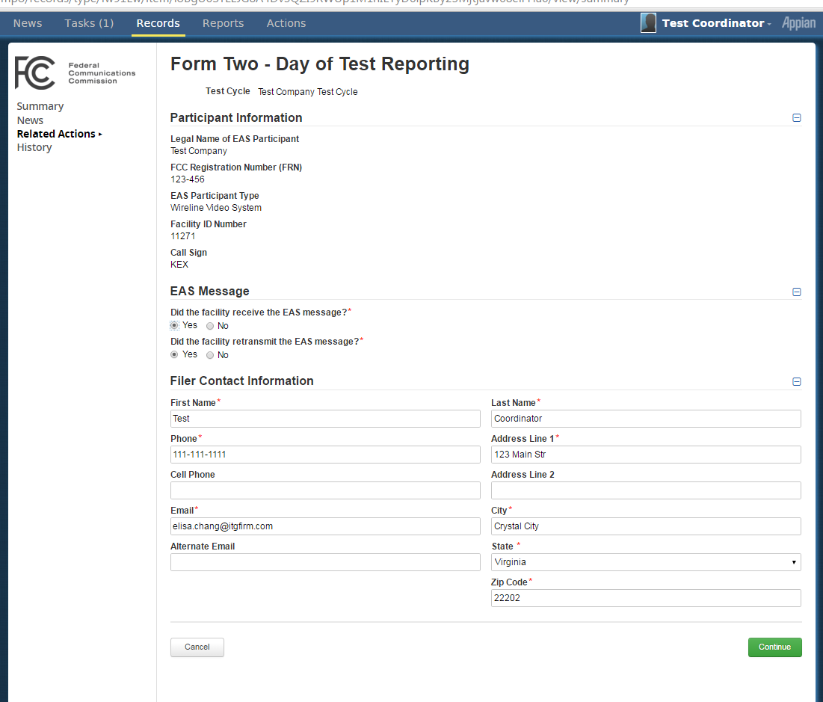

Submit/Update Form 3
Similar to the Submit Form 2 related action, Submit Form 3 will change to Update Form 3 after the form is submitted and if the update Form 3 window is open. Check the milestone bar in the Summary View for the due dates.
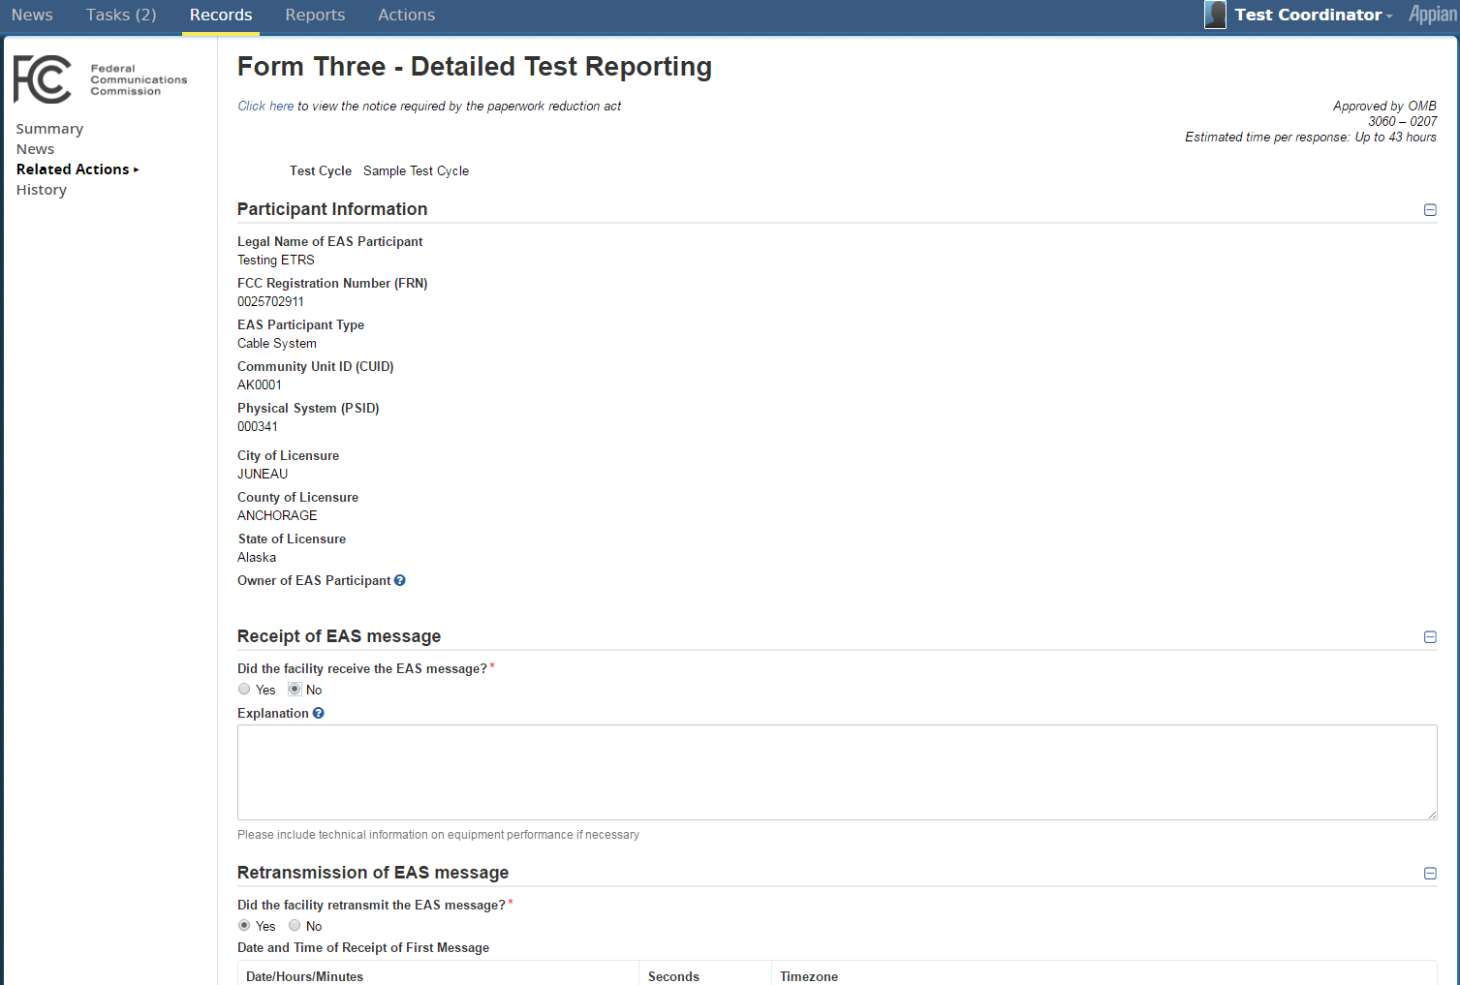

When you submit each form, you will be asked to confirm the accuracy of the information. Select the checkbox to submit.
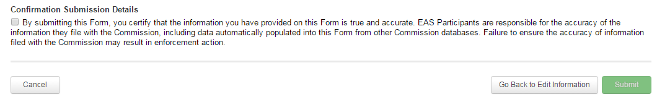

ETRS Test Cycle Record
ETRS inputters and coordinators may view test cycle details through the ETRS Test Cycles record.

List View
The list view allows inputters and coordinators to search for a specific test cycles by name. The list view quickly summarizes when each submission window opens.
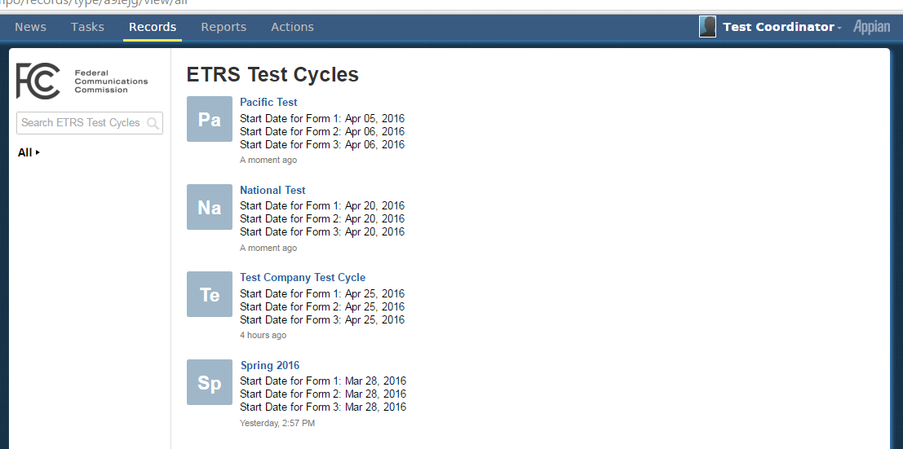

EAS Test Cycle Record Details
The Summary View highlights the submission and update period for each form for the selected test cycle.
The New view shows the news posts related to this test cycle. When a new test cycle is created, it is posted to the ETRS Events newsfeed which all ETRS inputters and coordinators are automatically subscribed to.
The Related Actions view is empty because there are no related actions available for this record available to ETRS inputters and coordinators.
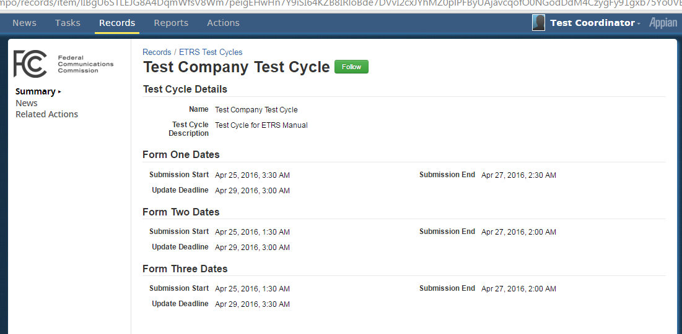

Users Record
The Users record allows users to view and update their own profile, or the profile of other users they are allowed to view.
Review User Roles and Privileges to view which profiles users can access.

List View
The list view summarizes user details in a grid. Select the Username to view details of that user.

User Details

Summary View
The summary view allows the user to personalize their accounts by adding a profile picture, a cover picture, or a blurb. To make any of these changes, simply hover over the image/section you wish to change.
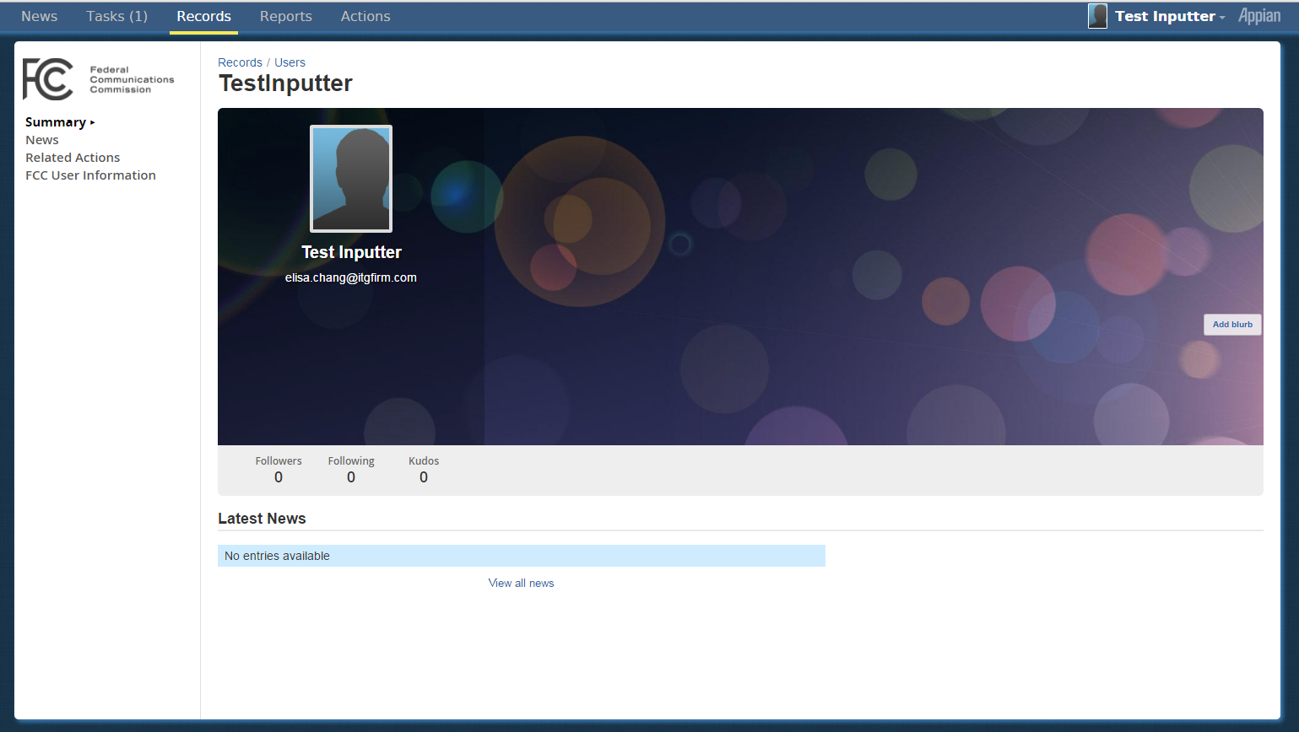

FCC User Information View
The FCC User Information View allows users to view and update the contact information they have saved. The contact information saved here will be used to auto-populate contact details of Report Test records the user submits.
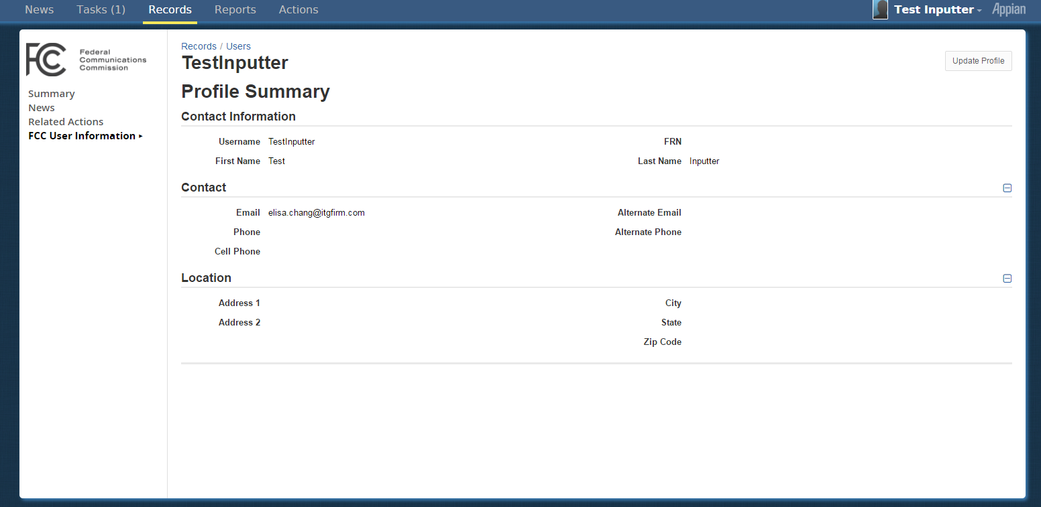

Related Actions

Update Profile
Outlined earlier in Update Your Profile, this related action allows users to set their contact info. Coordinators may view or update the profiles of ETRS inputters and other coordinators of their EAS Participant. This action is available in the top right corner of the FCC User Information View or on the Related Actions View.

Reports

Overview
ETRS reports are useful for quickly surveying a group of EAS test records.
EAS Tests report allows ETRS inputters and coordinators search for specific records or a set of EAS test records.

EAS Tests
The test records report allows the user to filter for records using the following fields: created date or last updated date, test cycle, report/test cycle type, EAS Participant name, and ID number.
Once you input your search criteria, the Search button will be enabled, allowing you to search existing records. You may view additional fields for each of these reports by selecting the Email Data in Excel button.
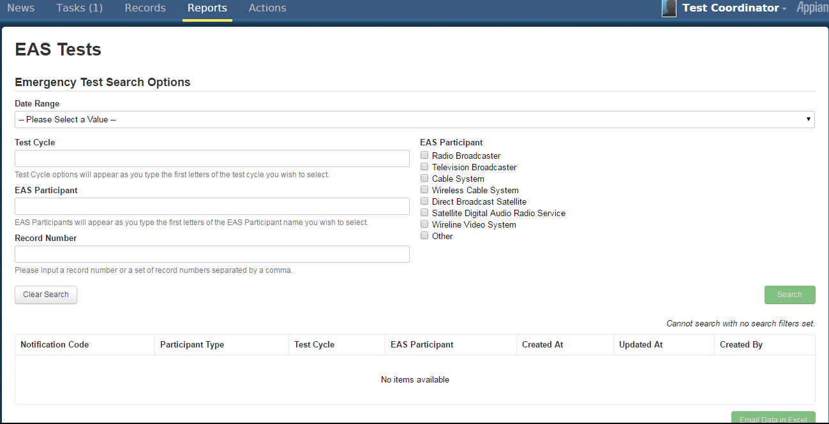

The Email Data in Excel button will send two emails and a task reminder. This may take a few minutes.
- Task: Your tasks will increment by one. You may view this task to download the excel export directly from the web browser. This task reminder will expire after 5 minutes and you will no longer see it in your task queue.
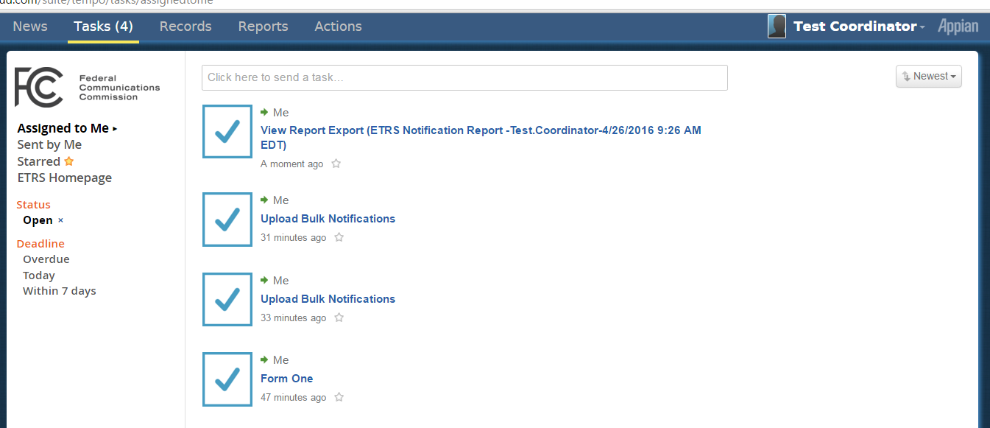
- Emails:
  - One of the emails alerts you of the new task in your Task tab
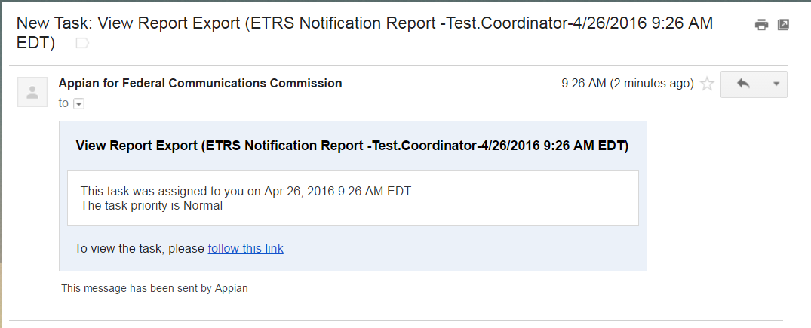

  - The second email contains an excel attachment which is the identical excel export available from the Task tab.
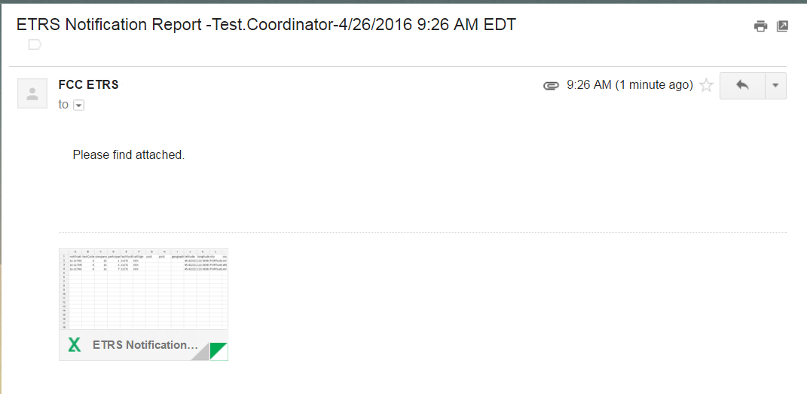

Tasks

Overview
The Tasks tab provides users with a simple interface to keep track of their existing tasks. The number in parenthesis to the right of Tasks indicates how many tasks are remaining.
When a new task is assigned to a user a group, the users/groups will receive an email notification, like the example in Reopen Reports or Email Data in Excel.

Assigned to Me
This view shows outstanding tasks assigned to you.
There is one unfinished task.
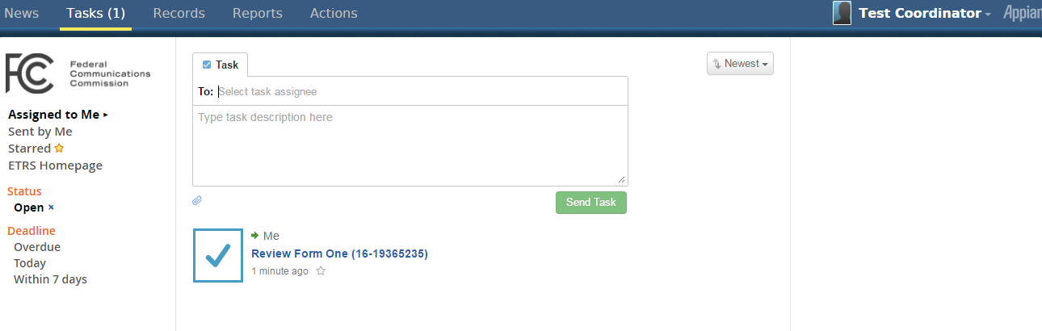

Sent by Me
ETRS allows users to track tasks users assigned to each other with the Sent by me view. This view shows tasks you assigned to other users.

Starred
This view shows tasks which you starred.

ETRS Homepage
This view is a summary view of all the actions, records, and reports you have access to. When you first log in, you are directed to this page.
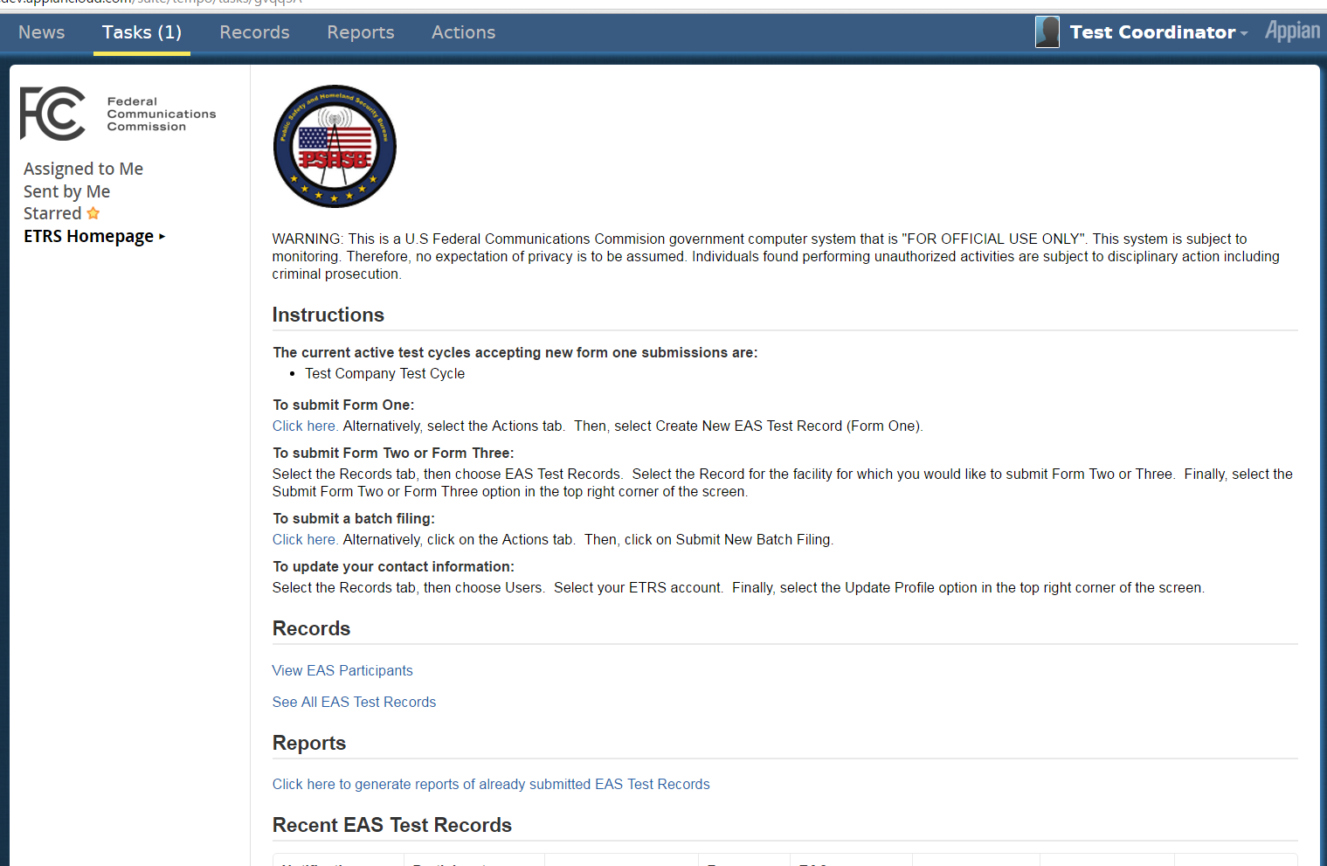

News

Overview
The News tab displays an ongoing list of entries created by fellow users, system administrators, and internal business processes.
Through the newsfeed, users may:
- View newly created or updated records
- Participate in group chats or post messages to news feed groups
- Send other users a Kudos
- Send other users tasks
- Star specific newsfeeds to view more easily later
- Comment on a newsfeed
- Connect to any test record through the blue record tag.
You are automatically subscribed to the “ETRS Events” news feed. You may “unsubscribe” by hovering to the top right corner of the news feed and selecting the orange “x.”
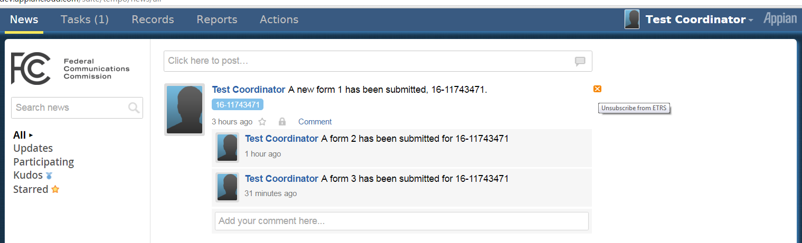
Alternatively, you may also edit your subscription to the ETRS Events news feed through your profile settings.
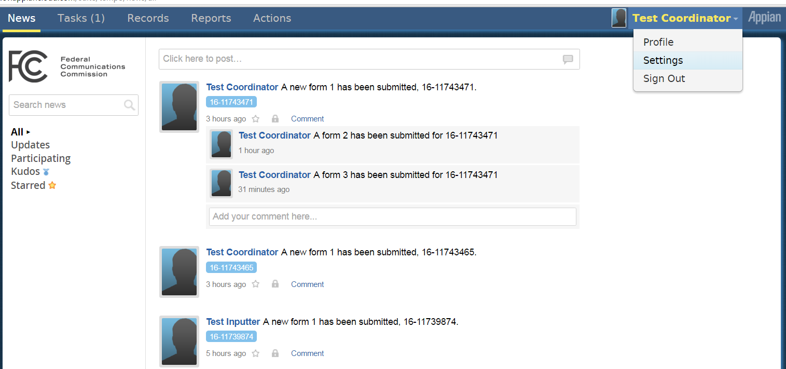
Select the News view in the left pane. And select All if you are not already subscribed. If you are, select Unsubscribe to stop receiving ETRS Events news in your News.
