**2018 Urban Rate Survey – Fixed Broadband Service Analysis**

**Introduction**

Every year, the Wireline Competition Bureau (Bureau) conducts a survey of residential standalone Internet access service rates “to help ensure that universal service support recipients offering fixed voice and broadband services do so at reasonably comparable rates to those in urban areas.” [1] The Bureau adopted the general methodology for surveying terrestrial fixed broadband providers in 2013. This document shows how the fixed broadband reasonable comparability benchmark was calculated for 2018.

The 2018 Urban Rate Survey for fixed broadband services had several notable changes from the 2017 survey to allow the Bureau to calculate reasonable comparability benchmarks for Alaska and for a larger range of download speeds.

1. The 2018 Urban Rate Survey added Alaska strata and high bandwidth (>=500 Mbps) strata to obtain representative data from Alaska[2] and from higher bandwidth services currently offered to consumers. The 2018 sample size allocation for each stratum is also modified to reflect changes in sample design.[3]
2. To account for the nonresponse, the 2018 Urban Rate Survey added an additional 10% supplemental samples (50 samples) to the total sample size.[4]
3. The 2018 fixed broadband service benchmark introduced a more flexible rate model to estimate average rate for different combinations of download bandwidths, upload bandwidths, and monthly capacity allowances to better approximate the nonlinear relationship between prices and speeds at this large range of speeds in the current market.

Because of these changes, the 2018 Urban Rate Survey is able to produce benchmarks for services with download bandwidths up to 1000 Mbps and benchmarks for Alaska based on Alaska samples. The 2018 reasonable comparability benchmarks for fixed broadband services are higher than the 2017 reasonable comparability benchmarks because the 2018 data contain higher rate variation from wider range of fixed broadband services.

**Sample Design and Selection**

The sampling unit for the 2018 fixed broadband survey was a service provider census tract pair. The frame[5] for the survey was the set of sampling units of providers offering terrestrial fixed broadband service to residential customers in urban census tracts. The frame consisted of 148,271 sampling units, encompassing 1,278 service providers and 58,050 census tracts. The likelihood of a service provider census tract pair receiving a survey is based on the number of potential subscribers for that provider in that census tract.

For each sampling unit other than the terrestrial fixed wireless providers, the number of potential subscribers is calculated as:

*Number of potential subscribers = Provider Presence Ratio x (Number of households in the sampling unit’s census tract)*

Provider Presence Ratio was calculated as the fraction of housing units in the census tract for which the provider offered fixed broadband service.

We calculated the number of potential subscribers differently for the terrestrial fixed wireless providers because the number of potential customers for such services is limited by geographic and technological factors. Many terrestrial fixed wireless providers serve suburban areas that are of moderate population density. Also, the number of housing units in these areas is likely higher than fixed wireless providers have capacity to serve. Accordingly, for each sampling unit of these providers, the number of potential subscribers is calculated as: [6]

*Number of potential subscribers = 2 x (Number of residential subscribers in the sampling unit’s census tract).*

The number of potential subscribers was not allowed to exceed the number of households in the sampling unit’s census tract.

The 2018 Urban Rate Survey added Alaska strata and high bandwidth (>=500 Mbps) strata to obtain representative data from Alaska and from higher bandwidth services currently offered to consumers. The frame was divided into strata to take into account the differing rate variability in each stratum.

The strata included in the 2018 Urban Rate Survey are listed below. There are 25 strata: 13 strata for services with download bandwidth less than 500 Mbps, 10 strata for services with download bandwidth greater than or equal to 500 Mbps (high bandwidth strata), and two Alaska strata.[7]

* Service download bandwidth < 500 Mbps
  + AT&T (AT&T Services, Inc.)
  + CenturyLink (CenturyLink, Inc., CenturyLink Communications, LLC)
  + Charter (Charter Communications, Inc.)[8]
  + Comcast (Comcast Cable Communications, INC.)
  + Cox (Cox Communications)
  + CSC Holdings (CSC Holdings LLC)
  + Frontier (Frontier Communications Corporation)
  + Verizon (Verizon New York Inc., Verizon Pennsylvania LLC, Verizon New Jersey Inc., Verizon California Inc., Verizon New England Inc., Verizon Virginia LLC, Verizon Maryland LLC, Verizon Florida LLC, Verizon Delaware LLC, GTE Southwest Incorporated dba Verizon Southwest, Verizon Washington, DC Inc.)
  + WideOpenWest (Knology, WideOpenWest, and Wiregrass Telcom)
  + Windstream (service providers identifying Windstream as their holding company)
  + Terrestrial fixed wireless providers
  + Major[9]
  + Minor
* Service download bandwidth >= 500 Mbps (high bandwidth strata)
  + AT&T
  + CenturyLink
  + Comcast
  + Cox
  + Verizon
  + WideOpenWest
  + Windstream
  + Terrestrial Fixed Wireless
  + Major
  + Minor
* Alaska
  + Fixed wireline services
  + Terrestrial fixed wireless

The table below presents the sampling plan including the sample size for each stratum. Sampling units were selected randomly from each stratum, with unequal selection probability proportional to providers’ number of potential subscribers in a given tract.[10] The sample sizes for each stratum are a reflection of the estimated number of potential subscribers in the stratum and the estimated variability of offered rates from last year’s Urban Rate Survey.

|  |  |  |  |  |  |  |  |  |
| --- | --- | --- | --- | --- | --- | --- | --- | --- |
|  | Frame | | | | Sample | | | |
| Stratum | Units | Providers | Census Tracts | Number of Potential Subscribers | Units | Providers | Census Tracts | Number of Potential Subscribers |
| Overall | 148,271 | 1,278 | 58,050 | 192,724,234 | 550 | 182 | 538 | 845,878 |
| AT&T Services, Inc. | 22,299 | 1 | 22,299 | 31,345,212 | 5 | 1 | 5 | 10,570 |
| CenturyLink | 6,964 | 1 | 6,964 | 10,326,507 | 8 | 1 | 8 | 15,175 |
| Charter | 20,941 | 1 | 20,941 | 32,021,038 | 95 | 1 | 95 | 188,186 |
| Comcast Cable Communications, LLC | 21,394 | 1 | 21,394 | 32,940,759 | 14 | 1 | 14 | 23,068 |
| Cox | 4,985 | 1 | 4,985 | 7,083,440 | 5 | 1 | 5 | 7,016 |
| CSC Holdings LLC | 2,884 | 1 | 2,884 | 4,161,729 | 5 | 1 | 5 | 10,308 |
| Frontier | 6,548 | 1 | 6,548 | 8,967,717 | 6 | 1 | 6 | 10,792 |
| Verizon | 11,958 | 8 | 11,958 | 17,608,408 | 5 | 4 | 5 | 7,226 |
| WideOpenWest | 70 | 5 | 69 | 75,953 | 5 | 3 | 5 | 11,612 |
| Windstream | 1,666 | 39 | 1,477 | 1,314,306 | 5 | 5 | 5 | 12,232 |
| Terrestrial Fixed Wireless | 11,995 | 564 | 8,569 | 789,827 | 59 | 49 | 59 | 26,288 |
| Major | 6,621 | 361 | 5,516 | 10,967,836 | 39 | 31 | 39 | 73,769 |
| Minor | 8,691 | 596 | 7,466 | 2,495,493 | 15 | 13 | 15 | 7,621 |
| AT&T Services, Inc. (>= 500 Mbps) | 5,110 | 1 | 5,110 | 9,279,269 | 5 | 1 | 5 | 8,312 |
| CenturyLink (>= 500 Mbps) | 2,253 | 1 | 2,253 | 3,931,003 | 5 | 1 | 5 | 6,762 |
| Comcast Cable Communications, LLC (>= 500 Mbps) | 4,074 | 1 | 4,074 | 6,155,316 | 5 | 1 | 5 | 7,098 |
| Cox (>= 500 Mbps) | 271 | 1 | 271 | 410,540 | 5 | 1 | 5 | 9,356 |
| Verizon (>= 500 Mbps) | 1,106 | 8 | 1,106 | 2,004,589 | 5 | 4 | 5 | 13,105 |
| WideOpenWest (>= 500 Mbps) | 2,104 | 2 | 2,104 | 2,700,179 | 5 | 2 | 5 | 5,609 |
| Windstream (>= 500 Mbps) | 188 | 6 | 188 | 292,957 | 5 | 4 | 5 | 10,786 |
| Terrestrial Fixed Wireless (>= 500 Mbps) | 331 | 42 | 330 | 52,740 | 5 | 5 | 5 | 8,311 |
| Major (>= 500 Mbps) | 3,800 | 150 | 3,659 | 6,664,364 | 165 | 59 | 165 | 324,712 |
| Minor (>= 500 Mbps) | 1,786 | 165 | 1,693 | 849,979 | 40 | 31 | 40 | 23,762 |
| Alaska Wireline | 174 | 3 | 87 | 269,365 | 5 | 2 | 5 | 8,587 |
| Alaska TFW | 58 | 4 | 51 | 15,707 | 34 | 4 | 29 | 15,615 |

**Survey Response**

The table below presents the number of responses, the number of different service providers, and the number of different census tracts requested, received, and received with rates in the 2018 Urban Rate Survey for fixed broadband service.

|  |  |  |  |
| --- | --- | --- | --- |
| Survey Status | Responses | Service Providers | Census Tracts |
| Requested | 550 | 182 | 538 |
| Received | 543 | 159 | 536 |
| Service Provided | 531 | 152 | 524 |

The next table presents the number of responses, the number of different service providers, the number of different census tracts, and the number of rates for each technology among responses received with rates as of September 2017 for the 2018 benchmark.

|  |  |  |  |  |
| --- | --- | --- | --- | --- |
| Technology | Responses | Service Providers | Census Tracts | Rates |
| Cable | 282 | 42 | 282 | 1240 |
| DSL | 115 | 36 | 115 | 750 |
| FTTH[11] | 85 | 50 | 85 | 442 |
| Fixed Wireless | 131 | 66 | 131 | 709 |

A total of 3,141 rates were provided at a variety of service levels as of September 2017 for the 2018 benchmark. Several rates were excluded from the analysis for the reasons described in the Appendix A, resulting in a total of 3,030 rates available for the analysis. The table below presents the number of responses, the number of different service providers, the number of different census tracts, and the number of rates for each technology among responses received with rates available for the analysis.

|  |  |  |  |  |
| --- | --- | --- | --- | --- |
| Technology | Responses | Service Providers | Census Tracts | Rates |
| Cable | 282 | 42 | 282 | 1240 |
| DSL | 115 | 36 | 115 | 750 |
| FTTH | 85 | 50 | 85 | 410 |
| Fixed Wireless | 130 | 65 | 130 | 630 |
| All | 530 | 151 | 523 | 3030 |

**Monthly Rates and Rate Spreads**

Monthly rates were treated as unique for a combination of census tract, FCC Registration Number (FRN), service name, technology, download bandwidth, upload bandwidth, and capacity allowance. The following average monthly rate was used if the service provider offered multiple rates in the census tract for each unique combination:

* Minimum Rate = Minimum Monthly Charge + Minimum Other Mandatory Charge + Minimum Surcharge
* Maximum Rate = Maximum Monthly Charge + Maximum Other Mandatory Charge + Maximum Surcharge
* Average Rate = (Minimum Rate + Maximum Rate)/2
* Rate Spread = Maximum Rate - Minimum Rate

The following average monthly rate was used if the service provider did not offer multiple rates in the census tract:

* Average Rate = Minimum Monthly Charge + Minimum Other Mandatory Charge + Minimum Surcharge
* Rate Spread = 0

**Weights**

Weights are required to ensure the contributions of each response properly represent the offers that consumers possibly receive nationwide. Weights are also used to ensure that a service provider’s rates do not exert extra influence on the estimate only because the provider offers different services using multiple technologies instead of one.

The 2018 survey weight construction is consistent with the 2017 survey weight construction. Each rate was assigned a weight:

*Weight = Sampling Weight x Nonresponse Weight x Same Rate Weight x Service Level Weight x Number of Potential Subscribers*

*Sampling Weight* is the inverse of the selection probability for each sample unit. The selection probability is determined by the total number of units in each strata, the sample size in each strata, and the units’ number of potential subscribers described in the sample selection section earlier. Each sample is assigned a sampling weight to reflect its selection probability.

*Nonresponse Weight* is assigned to each stratum in order to compensate for unit nonresponse in each stratum. It is the total number of potential subscribers sampled over the total number of potential subscribers in the sampled census tracts of a given provider who has provided rate responses in each stratum.

*Same Rate Weight* is assigned to the respondents who provided i) multiple service levels or ii) equal service levels via different technologies for the same rate in the same census tract.[12] In such cases, the rate was assigned a Same Rate Weight equal to 1/R, where R is the number of rate responses provided by a service provider at the same rate in the census tract.

*Service Level Weight* is assigned to the respondents who provided multiple rates for the same service level offered via different technologies and/or service names. Each rate was assigned a Service Level Weight equal to 1/L, where L is the number of responses with different rates provided by a service provider for the same service plan (same download bandwidth, upload bandwidth, and monthly capacity allowance) in the census tract.

*Number of Potential Subscribers* is the estimated number of potential customers to whom the providers advertise their service.

The final weight is the product of Sampling Weight, Nonresponse Weight, Same Rate Weight, Service Level Weight, and the Number of Potential Subscribers.

**Average Rate Model**

The 2018 Urban Rate Survey shows that broadband rate is nonlinear in proportion to download bandwidth and upload bandwidth (see Appendix B). To estimate an average rate for every possible bandwidth tier combination, we applied a weighted Generalized Additive Model (GAM), which allows maximum flexibility in our estimation,[13] to all terrestrial fixed broadband services with download bandwidths between 2 and 1000 Mbps, inclusive.[14]

This sub-sample of the data consisted of 2,894 rates from 529 responses encompassing 150 different providers in 522 different census tracts. The table below presents the number of responses, the number of different service providers, the number of different census tracts, and the number of rates for each technology used for constructing the average rate model.

|  |  |  |  |  |
| --- | --- | --- | --- | --- |
| Technology | Responses | Service Providers | Census Tracts | Rates |
| Cable | 282 | 42 | 282 | 1240 |
| DSL | 115 | 36 | 115 | 651 |
| FTTH | 84 | 49 | 84 | 387 |
| Fixed Wireless | 130 | 65 | 130 | 616 |
| All | 529 | 150 | 522 | 2894 |

The rates in this sub-sample ranged from $14.95 to $605.00 with a weighted standard deviation of $43.08. The rates vary widely across technologies. The following table shows the rate range, the weighted rate mean, the weighted rate standard deviation and the weighted download bandwidth mean for different technologies in this sub-sample.

|  |  |  |  |  |  |
| --- | --- | --- | --- | --- | --- |
|  | min | max | Weighted rate mean | Weighted rate standard deviation | Weighted download bandwidth mean |
| Cable | 14.95 | 252.98 | 77.83 | 37.39 | 166.05 |
| DSL | 23.34 | 149.00 | 68.17 | 20.06 | 29.63 |
| Fixed wireless | 19.95 | 605.00 | 87.13 | 77.74 | 17.85 |
| FTTH | 15.00 | 445.00 | 116.78 | 62.94 | 271.66 |

We undertook a weighted GAM based on the following form:[15]

Average Monthly Rate ($) = b0 + bAK AK + bA A + bDSLIDSL + bFixIFix + bFTTHIFTTH + sD(D) + sU(U)

where D is download bandwidth in Mbps, U is upload bandwidth in Mbps, A is the inverse of usage allowance in GB, AK is the Alaska indicator with a value 0 (US) or 1 (Alaska), IDSL, IFix, and IFTTH, are technology indicators (with a value 0 or 1),[16] and sD(D) and sU(U) denote to smooth functions describing relationships between rates and download bandwidths and between rates and upload bandwidths.[17]

For the US average monthly rate, we estimated the coefficients as:[18]

US Average Monthly Rate ($) =

69.9982 - 77.1871 A + 17.9820 IDSL + 42.3999 IFix + 18.5092 IFTTH + sD(D) + sU(U)

The weighted pseudo R Squared was 0.80. The plot below shows how the model fits the raw data. The closer the dots are to the 45 degree line, the better the fit. The size of the circles represents the weights of the sample rates.

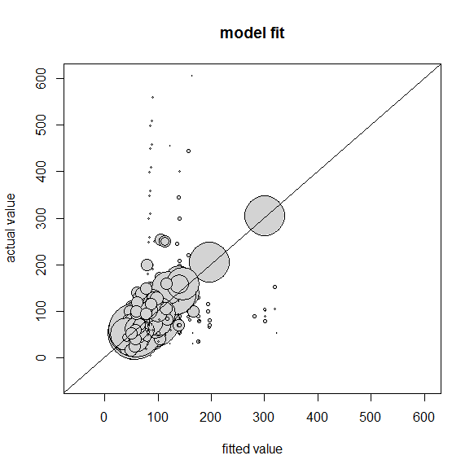

**US reasonable comparability benchmark**

Under the methodology previously adopted by the Bureau, the reasonable comparability benchmark is the estimated average monthly rate plus twice the standard deviation of rates for terrestrial fixed broadband service plans with download bandwidths of 10 Mbps or greater, upload bandwidths of 1 Mbps or greater, and usage allowance of 170 GB or greater. The root weighted mean squared residual (RWMSR) [19] is an estimate of the standard deviation of rates for service plans meeting the reasonable comparability benchmark criteria.

The 2018 Urban Rate Survey broadband average rate model approximates rate per download bandwidth and upload bandwidth closely. Therefore, the RWMSR of rates does not show a trend by download bandwidth and upload bandwidth. For the 2018 Urban Rate Survey, we calculate the RWMSR by technology. The table below shows the RWMSR by technology.

|  |  |
| --- | --- |
|  | RWMSR |
| Cable | 21.0343 |
| DSL | 14.5693 |
| Fixed wireless | 77.6271 |
| FTTH | 18.4589 |

The equation to calculate the US reasonable comparability benchmark is the following:

US reasonable comparability benchmark ($) =

69.9982 - 77.1871 A + 17.9820 IDSL + 42.3999 IFix + 18.5092 IFTTH + sD(D) + sU(U) + 2 (RWMSRDSL IDSL + RWMSRFix IFix + RWMSRFTTH IFTTH + RWMSRCable (1-IDSL+ IFix+ IFTTH))

This equation can be re-written as:

69. 9982 - 77.1871 A + 47.1206 IDSL + 197.6541 IFix + 55.4270 IFTTH + 42.0686 (1-IDSL+ IFix+ IFTTH) + sD(D) + sU(U)

Finally, the equations are further simplified by substituting the current market share of different technologies[20] for the indicator variables to derive a general benchmark estimator:

US reasonable comparability benchmark ($) = 116.5943 - 77.1871 A + sD(D) + sU(U)

The sD(D) and sU(U) in the above equation are calculated precisely from the model fit for those services with download bandwidth up to 100 Mbps to allow maximum details for different combinations of download bandwidth, upload bandwidth, and monthly capacity allowance. To avoid the risk of overfitting due to lack of data from all possible combinations of services with download bandwidth above 100 Mbps, the sD(D) and sU(U) for those services with download bandwidth above 100 Mbps are interpolated among the model fit for services with most raw data points, which are 200/10, 250/25, 500/50, and 1000/1000.

**Alaska reasonable comparability benchmark**

For the Alaska reasonable comparability benchmark, the average rate model is calculated as follows:

AK Average Monthly Rate ($) = b0 + bAK AK + bA A + bDSLIDSL + bFixIFix + bFTTHIFTTH + sD(D | AK = 1) + sU(U | AK = 1)

where sD(D) and sU(U) are estimated only using Alaska data.

The coefficient estimations for the Alaska average monthly rate are:

AK Average Monthly Rate ($) =

69.9982 + 22.4457 AK - 77.1871 A + 17.9820 IDSL + 42.3999 IFix + 18.5092 IFTTH + sD(D | AK = 1) + sU(U | AK = 1)

The equation can be rewritten as:

AK Average Monthly Rate ($) =

92.4439 - 77.1871 A + 17.9820 IDSL + 42.3999 IFix + 18.5092 IFTTH + sD(D | AK = 1) + sU(U | AK = 1)

The AK reasonable comparability benchmark is the Alaska average monthly rate plus two RWMSR and the equation is the following:

AK reasonable comparability benchmark ($) = 92.4439 - 77.1871 A + 17.9820 IDSL + 42.3999 IFix + 18.5092 IFTTH + sD(D | AK = 1) + sU(U | AK = 1) + 2 (RWMSRDSL IDSL + RWMSRFix IFix + RWMSRFTTH IFTTH + RWMSRCable (1-IDSL+ IFix+ IFTTH))

This equation can be re-written as:

92.4439 - 77.1871 A + 47.1206 IDSL + 197.6541 IFix + 55.4270 IFTTH + 42.0686 (1-IDSL+ IFix+ IFTTH) + sD(D | AK = 1) + sU(U | AK = 1)

Finally, the equations are further simplified by substituting the current market share of different technologies[21] for the indicator variables to derive a general benchmark estimator:

AK reasonable comparability benchmark ($) = 139.6721 - 77.1871 A + sD(D | AK = 1) + sU(U | AK = 1)

**Reasonable comparability benchmark results**

The table directly below provides examples of reasonable comparability benchmarks (rounded up to the nearest cent) for several service plan levels. The equations may also be used if a reasonable comparability benchmark is needed for lower download bandwidths (greater than or equal to 4 Mbps) and up to download bandwidths of 1000 Mbps.

|  |  |  |  |  |
| --- | --- | --- | --- | --- |
| **Download Speed (Mbps)** | **Upload Speed (Mbps)** | **Capacity Allowance (GB)** | **2018 US** | **2018 AK** |
| 4 | 1 | 170 | 85.54 | 109.89 |
| 4 | 1 | Unlimited | 86.00 | 110.34 |
| 10 | 1 | 170 | 87.68 | 110.94 |
| 10 | 1 | 250 | 87.83 | 111.08 |
| 10 | 1 | Unlimited | 88.13 | 111.39 |
| 25 | 3 | 250 | 94.01 | 114.70 |
| 25 | 3 | Unlimited | 94.32 | 115.01 |
| 25 | 5 | 250 | 94.36 | 115.66 |
| 25 | 5 | Unlimited | 94.67 | 115.97 |
| 50 | 5 | Unlimited | 106.52 | 120.68 |
| 100 | 10 | Unlimited | 126.42 | 133.85 |
| 100 | 20 | Unlimited | 127.89 | 138.61 |
| 250 | 25 | Unlimited | 168.02 | 220.26 |
| 500 | 50 | Unlimited | 203.71 | 304.76 |
| 1000 | 100 | Unlimited | 217.43 | 296.02 |

**APPENDIX A**

**Rates Modified or Excluded for the Analysis**

Respondents stated that 111 service plans were for business data users and thus were ineligible for the Urban Rate Survey. Providers offering these plans are Blue Spring Broadband, Desert Winds Wireless LLC, DigitalPath, Inc, EPB Fiber Optics, Gtek Computers & Wireless L.L.C., Hotwire Communications, Ltd., PogoZone Internet Solutions, and Razzo Link, Inc.

**APPENDIX B**

The 2018 Urban Rate Survey sampled rates by download speed and by upload speed. Over this large range of speeds, the rates are not linear functions of download speed and upload speed. The size of the circles in the plots below represent the weights of the sample rates. Sampled rates represent common services provided to the customers and do not include all possible combinations of download bandwidth, upload bandwidth, and monthly capacity allowance.

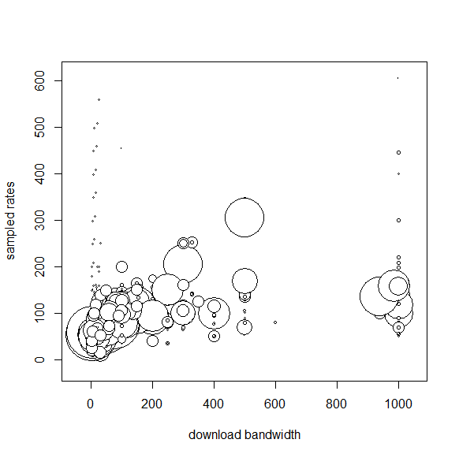 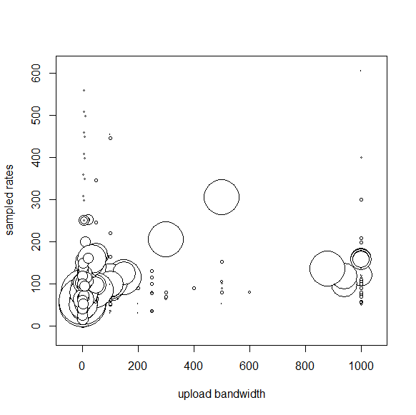

1. *Connect America Fund*, WC Docket No. 10-90, Order, 28 FCC Rcd 4242 (WCB/WTB 2013).
2. The Alaska strata are established to develop Alaska-specific benchmarks for the Alaska rate-of-return carriers. *See* *Connect America Fund, Report and Order and Further Notice of Proposed Rulemaking,* WC Docket No.10-90, et al., 31 FCC Rcd 10139, 10149, para 28 (2016).
3. The 2018 sample size allocation for each stratum is based on 2017 standard deviations for service plans with download bandwidths of at least 2 Mbps.
4. The average nonresponse rate for Urban Rate Survey is approximately 10%.
5. A frame is an inventory that lists all sampling units from which we select our samples.
6. The number of potential subscribers for the terrestrial fixed wireless providers is calculated as 2 x number of residential subscribers, assuming that such providers could no more than double their number of existing residential customers within a few months. The estimated number of potential subscribers of a given provider could not be greater than the total number of occupied housing units in the service area. The number of residential subscribers is the providers’ reported number of residential subscribers in Form 477.
7. The frame was divided into 15 strata in 2017 Urban Rate Survey.
8. Bright House Networks, LLC, Time Warner Cable Inc., and Charter Communications, Inc. are now merged and named Charter Communications, Inc.
9. The Major and Minor strata are divided based on the number of potential subscribers, the number of occupied housing units to which the provider offers service, and the Provider Presence Ratio. The algorithm used to divide the sampling units into the Major and Minor strata is “Partitioning Around Medoids.” Partitioning Around Medoids is a type of cluster analysis to identify data clusters based on dissimilarities between clusters. Medoids are the medians for multi-dimensional data. *See* Kaufman, L. and Rousseeuw, P.J. 1990. Finding Groups in Data: An Introduction to Cluster Analysis. Wiley, New York; Park, H.S. and C.H. Jun. 2009. A simple and fast algorithm for K-medoids clustering. Expert Systems with Applications. 36(2):3336–3341.
10. The selection probability of a Probability Proportional to Size (PPS) sampling is a function of measure of “size.” Measure of size is the number of potential subscribers from a provider in a given tract. The selection probability is higher for sampling units with higher number of potential subscribers.
11. FTTH stands for fiber to the home.
12. Such a situation could arise when a provider uses different technologies to provide similar services to customers in different parts of a census tract.
13. Ideally, we would calculate directly the weighted means and the weighted standard deviations of rates for all services. However, our samples do not cover all possible combinations of services provided to consumers nationwide. Therefore, we use a statistical model to estimate rates for all possible services.
14. The 2017 broadband linear regression analysis included data with download bandwidths between 2 and 50 Mbps.
15. The average rate model based on a weighted GAM for the 2018 Urban Rate Survey allows nonlinearity in rate per download bandwidth and rate per upload bandwidth. The GAM framework assumes that the relationships between the independent variables and the dependent variable follow smooth patterns, which can be linear or nonlinear. These smooth relationships can be estimated through arbitrary smooth functions and the prediction is simply the sum of these smooth relationships. More information about GAM can be found in the following references:

    Hastie, T. J.; Tibshirani, R. J. (1990). Generalized Additive Models. Chapman & Hall/CRC. ISBN 978-0-412-34390-2; Wood, S. N. (2017). Generalized Additive Models: An Introduction with R (2nd ed). Chapman & Hall/CRC. ISBN 978-1-58488-474-3.
16. For a cable service, IDSL = 0, IFix =0, and IFTTH = 0. For a DSL service, IDSL = 1, IFix =0, and IFTTH = 0; for a fixed wireless service, IDSL = 0, IFix =1, and IFTTH = 0. For a FTTH service, IDSL = 0, IFix =0, and IFTTH = 1.
17. We used the R package “Mixed GAM Computation Vehicle with GCV/AIC/REML smoothness estimation and GAMMs by REML/PQL (mgcv)” to perform model fitting. The smoothing parameter estimation was based on the Generalized Cross Validation criterion or an Un-Biased Risk Estimator criterion when the scale parameter was known. Multiple models were constructed and compared. Our final model was selected based on best performance of combinations of Akaike Information Criterion (AIC), deviance explained, and cross-validation results.
18. The coefficients for smooth functions are not specified here because these coefficients do not have the same meaning as the coefficients for the linear portion of the model. The relationships between rates and download bandwidth and between rates and upload bandwidth are described by nine additive smooth terms separately. For the US average rate, the AK indicator equals 0. Therefore, the term, bAK AK is removed. This means the model is estimated based on all US data. For the Alaska average rate, the AK indicator equals 1.
19. RWMSR is the square root of the weighted average of the square of residuals (observed rate minus average rate as defined by the Average Monthly Rate equation) plus the square of the spreads divided by 12.
20. As of June 2016, 61.66% of the US residential terrestrial fixed high bandwidth subscribers used cable, 26.33% used DSL, 10.89% used fiber, and 1.12% used terrestrial fixed wireless. *See* https://www.fcc.gov/reports-research/reports/internet-access-services-reports/internet-access-services-reports.
21. As of June 2016, 64.42% of the Alaska residential terrestrial fixed high bandwidth subscribers used cable, 32.26% used DSL, 1.15% used fiber, and 2.17% used terrestrial fixed wireless.