North American Numbering Council (NANC)
Meeting Minutes
Wednesday, June 28, 2023

Hon. Karen Charles, Chairwoman
Bridget Alexander White, Vice Chairwoman
Christi Shewman, Designated Federal Officer

Contact: NANC@fcc.gov

Contents:

- NANC Councilmember Attendance Record
- Meeting Agenda with Final Vote Record
- Meeting Presentations and Reports

A recording of the full meeting is available at https://www.fcc.gov/about-fcc/advisory-committees/general/north-american-numbering-council.
NANC Councilmember Meeting Attendance – 2023

In attendance yes/no:
Councilmember – Organization/Representative | Feb. 28 | June 28
Chairwoman – NARUC – Massachusetts Dept. of Cable and Telecommunications  - Commissioner Karen Charles | Y | Y
Vice Chairwoman – Highline – JSI  - Bridget Alexander White | Y | Y
10x People, LLC  - Lisa Marie Maxson  - John Nakamura | Y | Y
800 Response Information Services, LLC  - Heather Barrows | Y | Y
ACA Connects – America’s Communications Association  - Michael Jacobs  - Brian Hurley (Alt) | N | Y
Ad Hoc Telecommunications Users Committee  - Susan Gately | Y | Y
Alliance for Telecommunications Industry Solutions (ATIS)  - Jackie Wohlgemuth  - Thomas Goode (Alt) | Y | Y
AT&T Inc.  - Dr. Ola Oyefusi  - George Guerra (Alt) | Y | Y
Bandwidth  - Greg Rogers  - Lisa Jill Freeman (Alt) | Y | Y
Charter Communications  - Glenn Clepper (Alt) | Y | Y
Comcast Corporation  - Beth O’Donnell | Y | Y
Competitive Carriers Association (CCA)  - Alexandria May | Y | Y
CTIA – The Wireless Association  - Amy Bender  - Sarah Leggin (Alt) | Y | Y
Electronic Privacy Information Center (EPIC)  - Mr. Chris Frascella | Y | Y
Google LLC  - Craig Lennon | N | Y
INCOMPAS  - Chris Shipley | Y | Y
Inteliquent  - Bryan Bethea | N | N
Lumen  - Phil Linse | Y | Y
Maine Public Utilities Commission  - Chairman Philip L. Bartlett, II | N | N
National Association of Attorneys General (NAAG)  - Ms. Tracy Nayer  - Amanda Wentz | Y | Y
National Association of State Utility Consumer Advocates – NASUCA  - Robert B. Nelson | Y | Y
Nevada Public Utilities Commission  - Commissioner Tammy Cordova | Y | N
NTCA – The Rural Broadband Association  - Brian Ford  - Tamber Ray (Alt) | Y | Y
Peerless Network, Inc.  - Julie Oost  - Patrick Phipps (Alt) | Y | Y
Public Service Commission of District of Columbia  - Lara Howley Walt | Y | Y
SIP Forum  - Rich Shockey | Y | Y
T-Mobile USA, Inc.  - Rosemary Leist  - Scott Freiermuth (Alt) | Y | Y
TDS Telecommunications LLC  - Paul Nejedlo | Y | Y
Telnyx  - David Casem  - Sarah Halko (Alt) | Y | Y
USTelecom  - John Bercu | Y | Y
Verizon  - Dana Crandall | Y | Y
Vonage  - Colin Brown | Y | N
West Virginia Public Service Commission  - Ms. Terri Blake | Y | Y

Special Members (Non-Voting)
iconectiv LLC  - Chris Drake  - Cathy McMahon (Alt) | Y | Y
Somos, Inc.  - Joel Bernstein  - Florence Weber (Alt) | Y | Y

North American Numbering Council (NANC) Meeting
Wednesday, June 28, 2023

FINAL VOTE RECORD
A recording of the full meeting is available at
https://www.fcc.gov/about-fcc/advisory-committees/general/north-american-numbering-council.

2:00 PM Call to Order and Welcome
Honorable Karen Charles, NANC Chairwoman
Christi Shewman, NANC Designated Federal Officer (DFO)

2:05 PM Opening Remarks
Jessica Rosenworcel, Chairwoman
Federal Communications Commission

2:15 PM Roll Call, Announcements, and Recent News
Christi Shewman, NANC DFO
Honorable Karen Charles, NANC Chairwoman

2:30 PM Secure Telephone Identity Governance Authority (STI-GA)
Report to the NANC
Brent Struthers, Alliance for Telecommunications Industry Solutions (ATIS),
Director – STI-GA
[Vote: Not Applicable]

2:45 PM North American Portability Management (NAPM), LLC
Report to the NANC
Teresa Patton, Co-Chair, NAPM, LLC
[Vote: Not Applicable]

3:00 PM Numbering Administration Oversight Working Group (NAOWG)
Numbering Administration Performance Review
Philip Linse, Co-Chair, NAOWG
[Vote: Pass]

3:10 PM Report of the North American Numbering Plan Billing and Collection Agent
Heather Bambrough, Welch LLP
[Vote: Not Applicable]

3:20 PM NAOWG Report and Recommendations to the NANC for the North American Numbering Plan Fund Size Projections and Contributions Factor
Philip Linse, Co-Chair, NAOWG
[Vote: Pass]

3:30 PM Public Comment and Participation
Honorable Karen Charles, NANC Chairwoman

3:45 PM Wrap-Up
Honorable Karen Charles, NANC Chairwoman

4:00 PM Adjourn

NANC Combined Slide Deck – Presentations and Reports

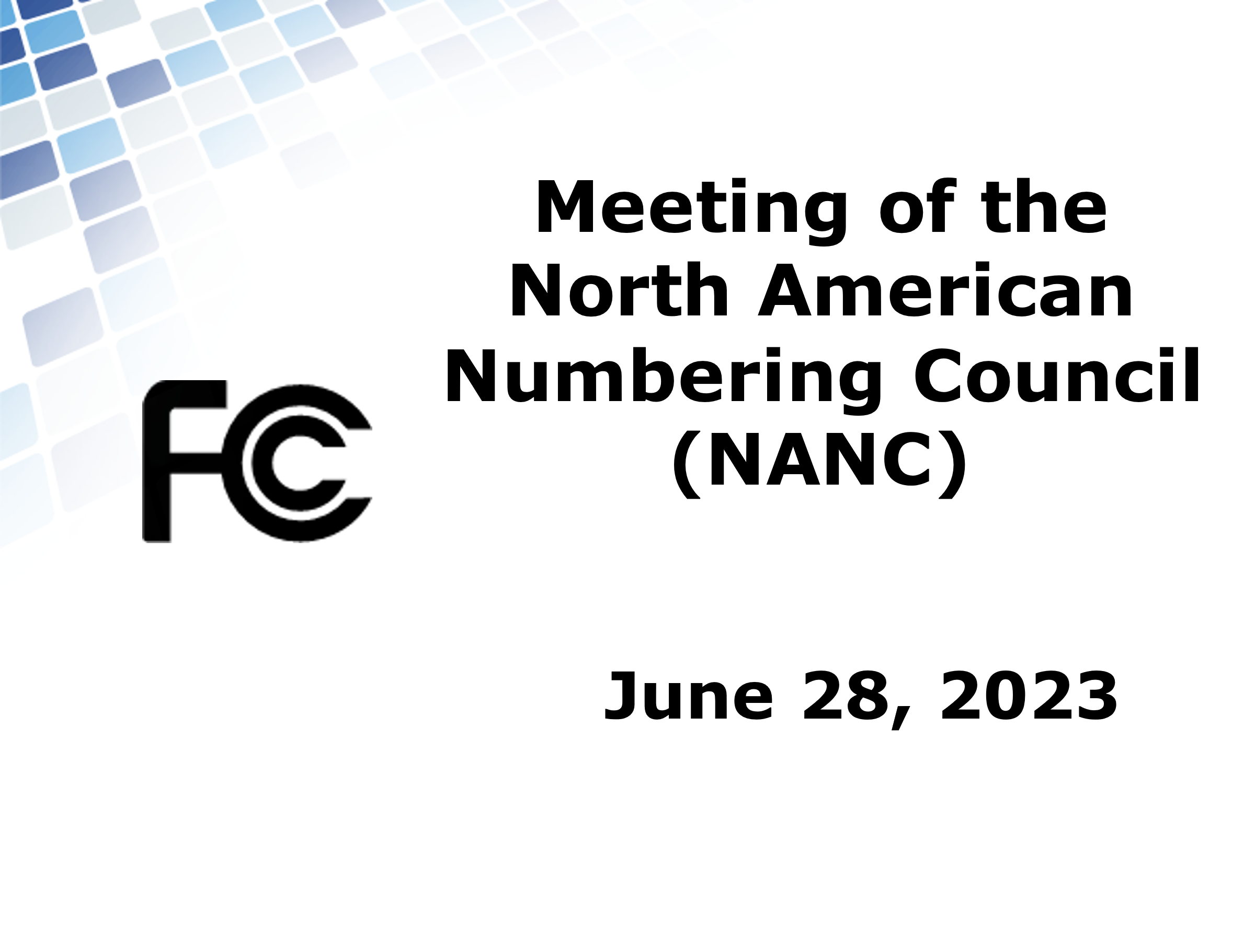

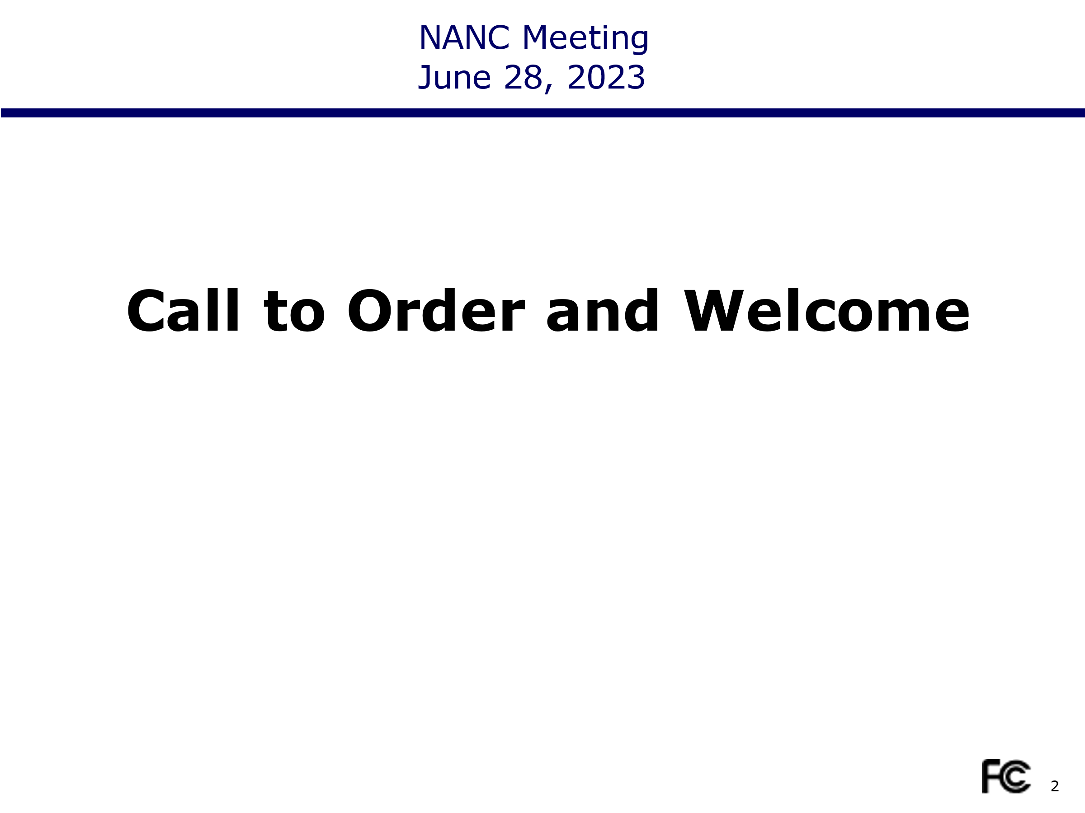
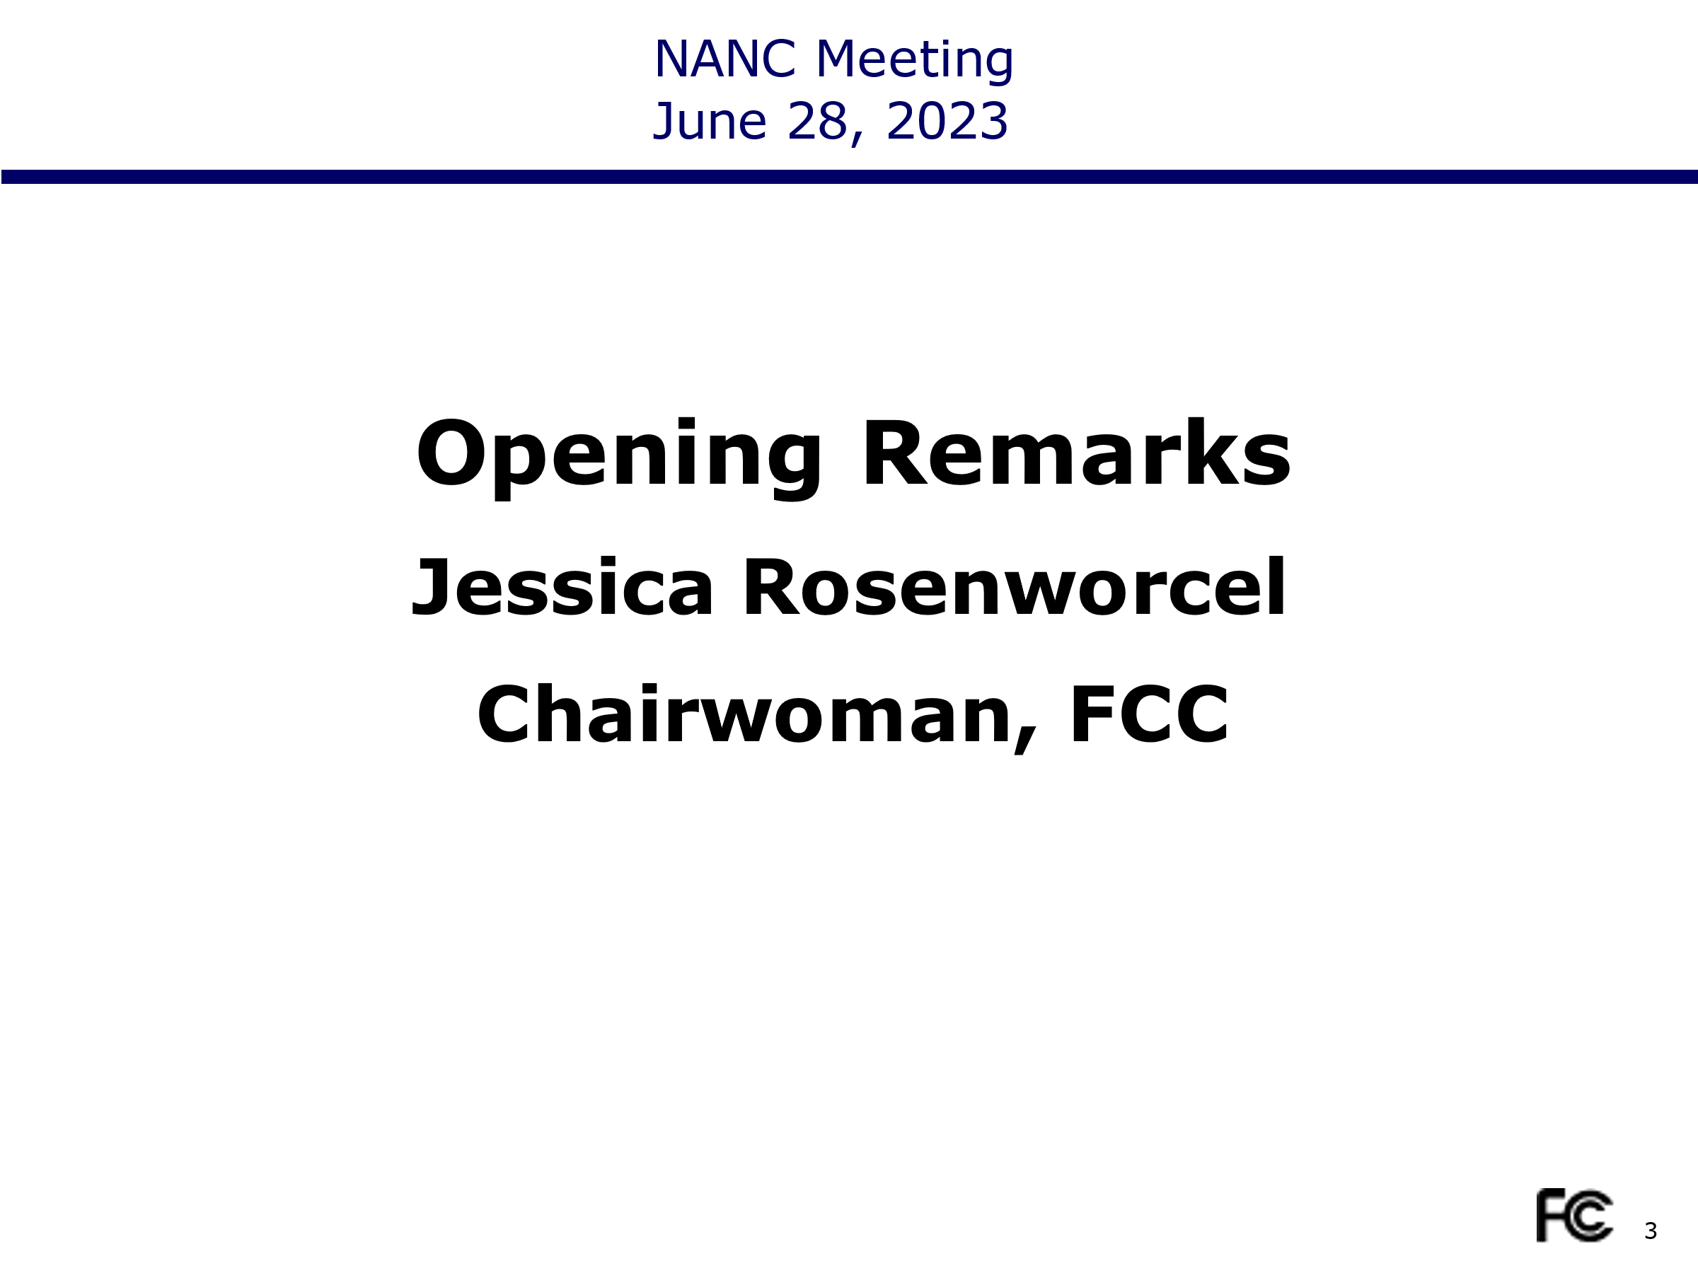
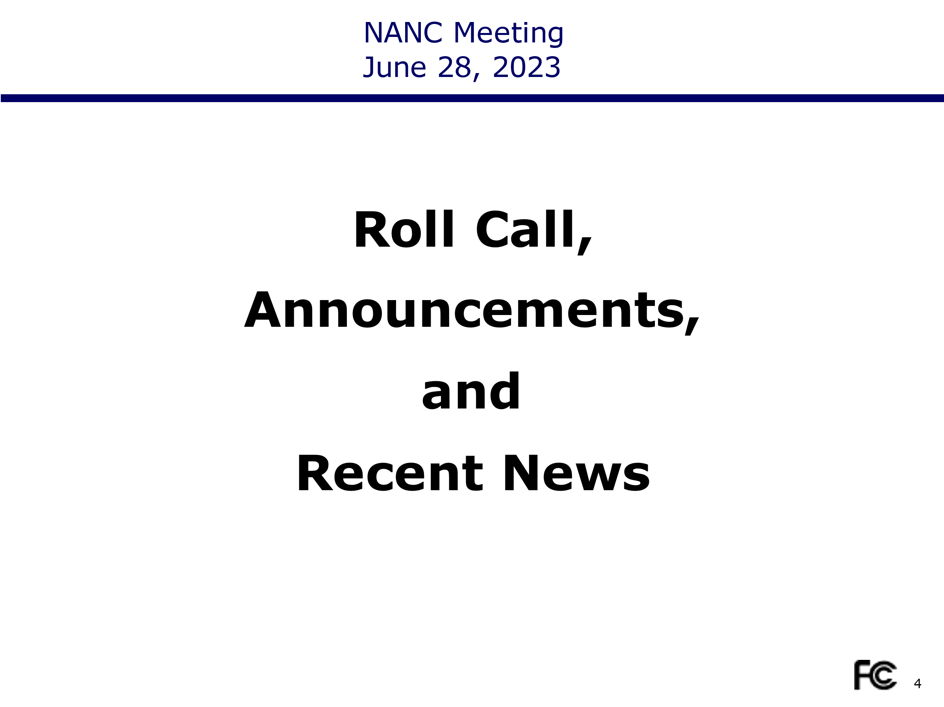
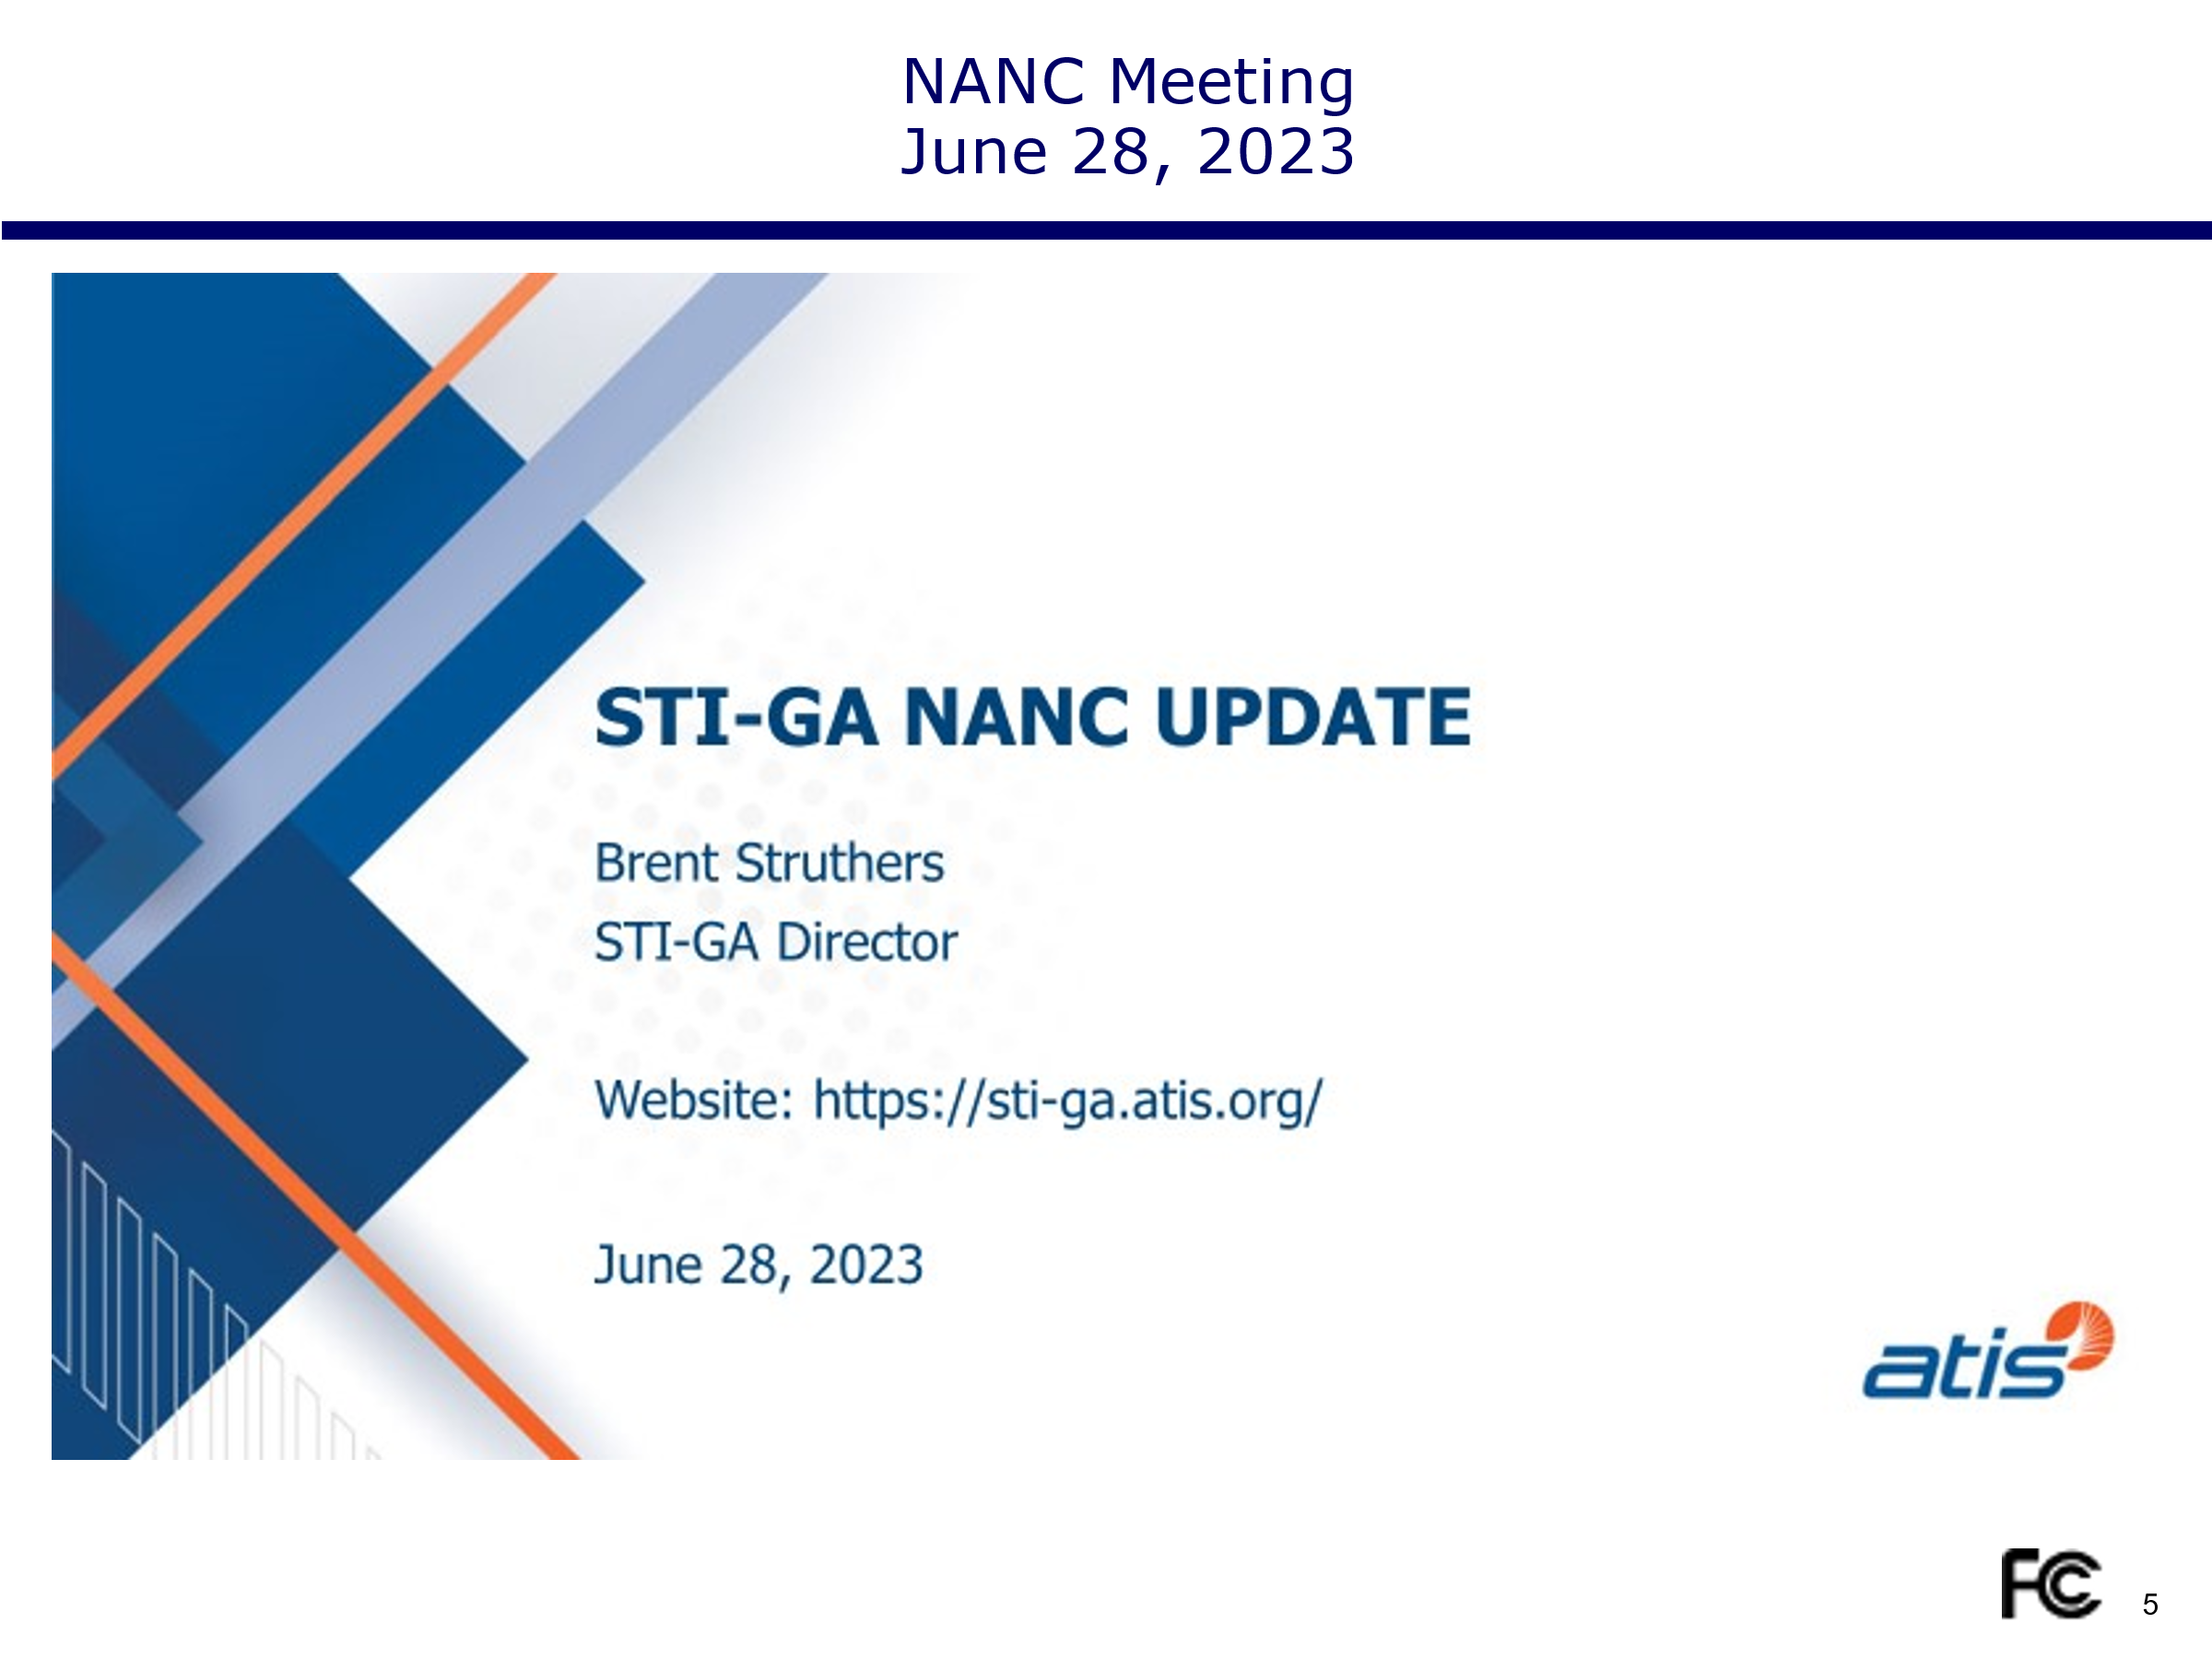
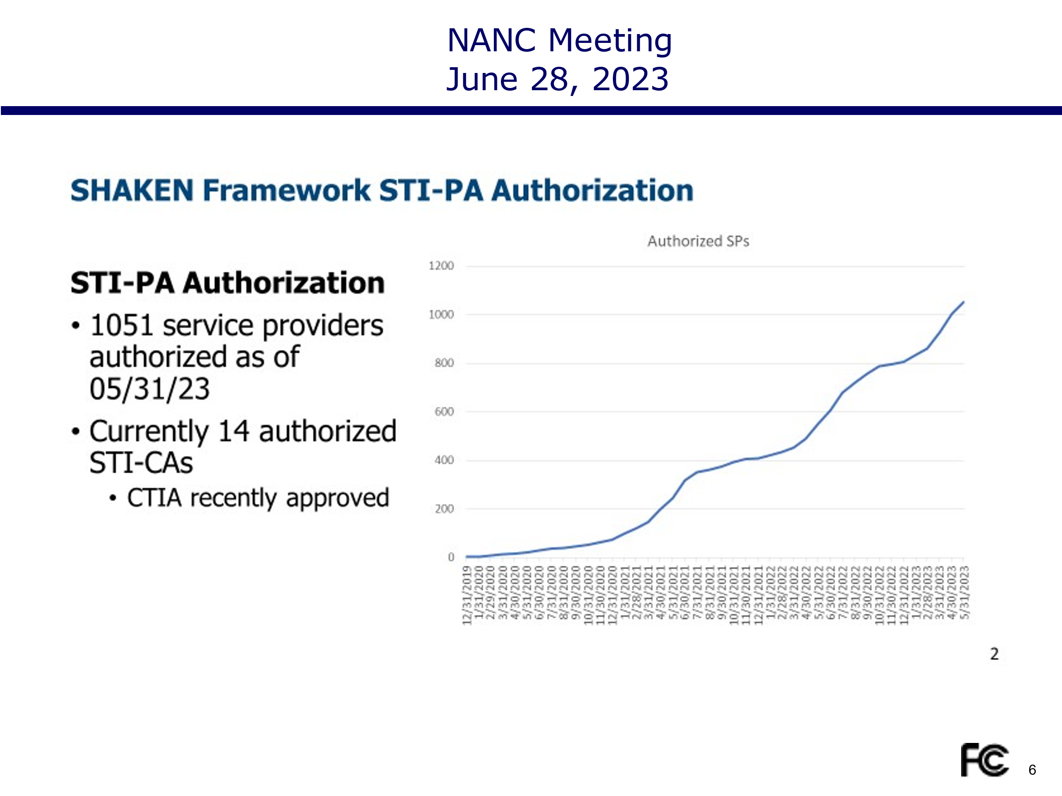
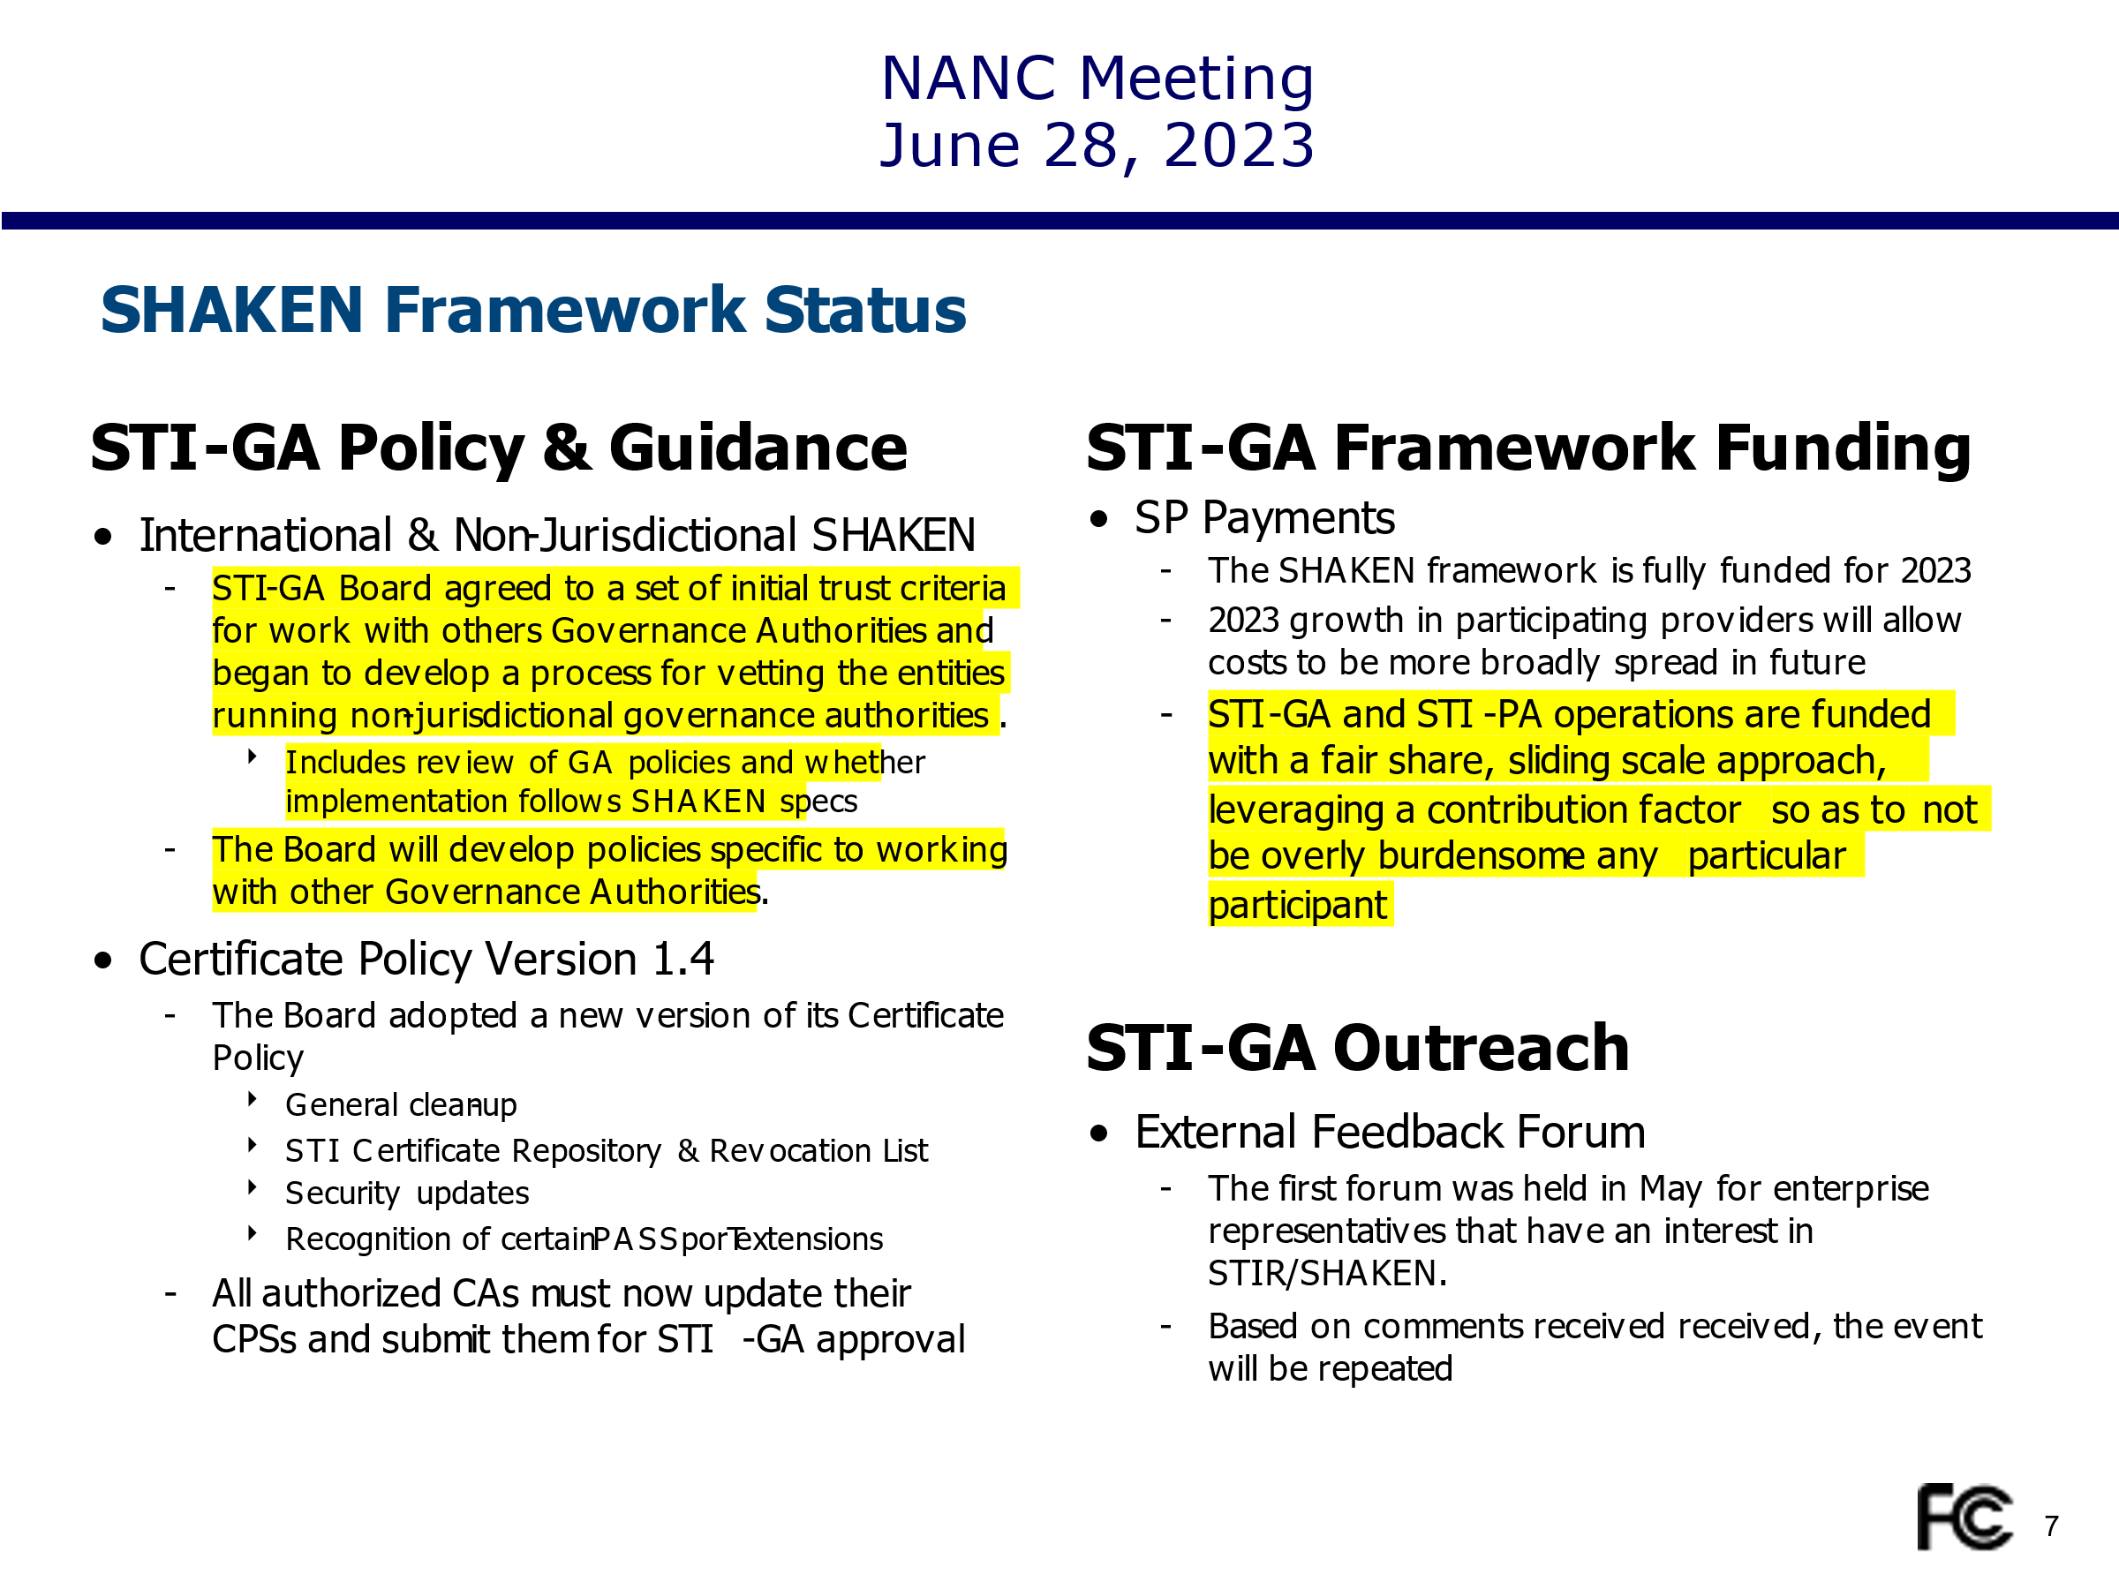
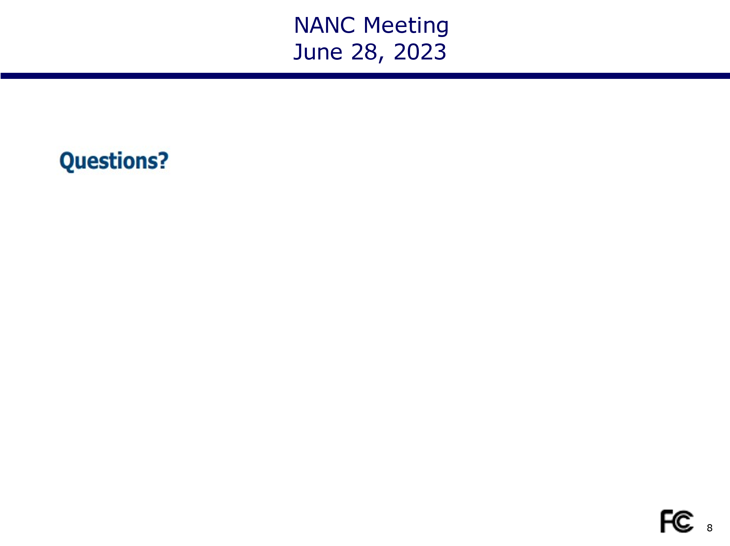
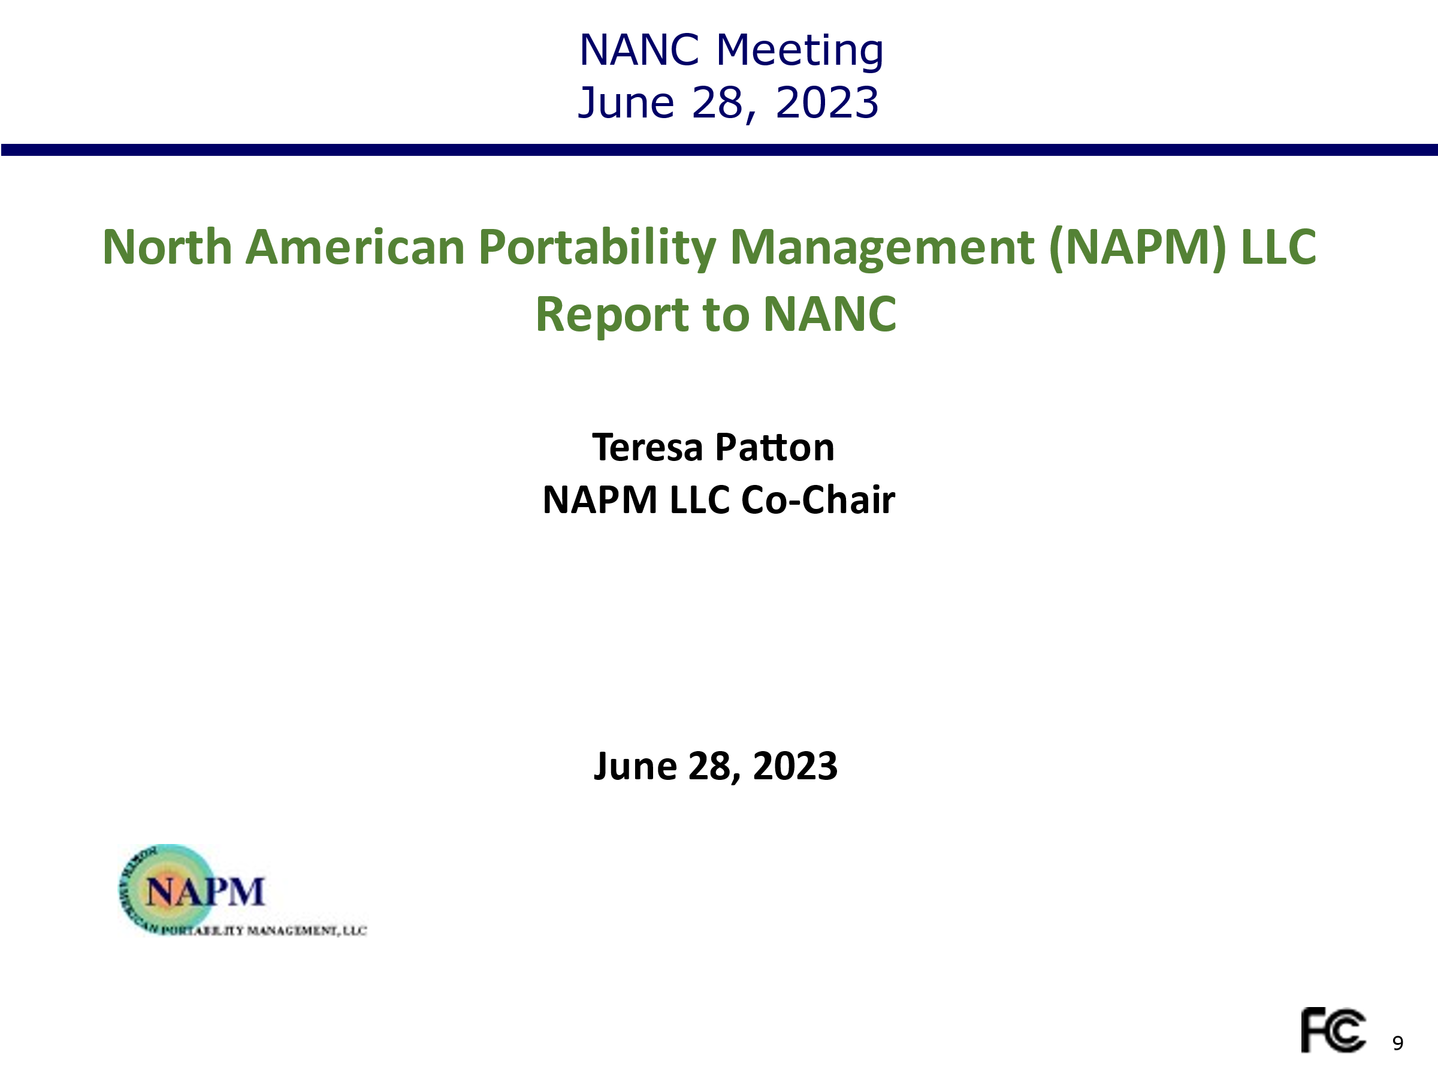
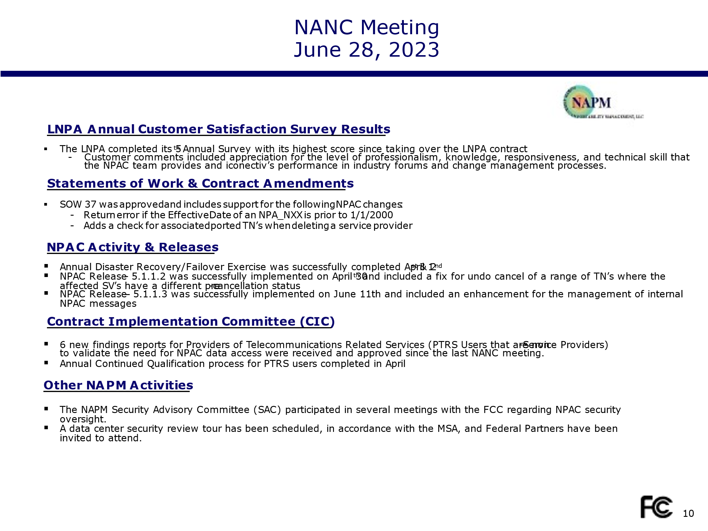
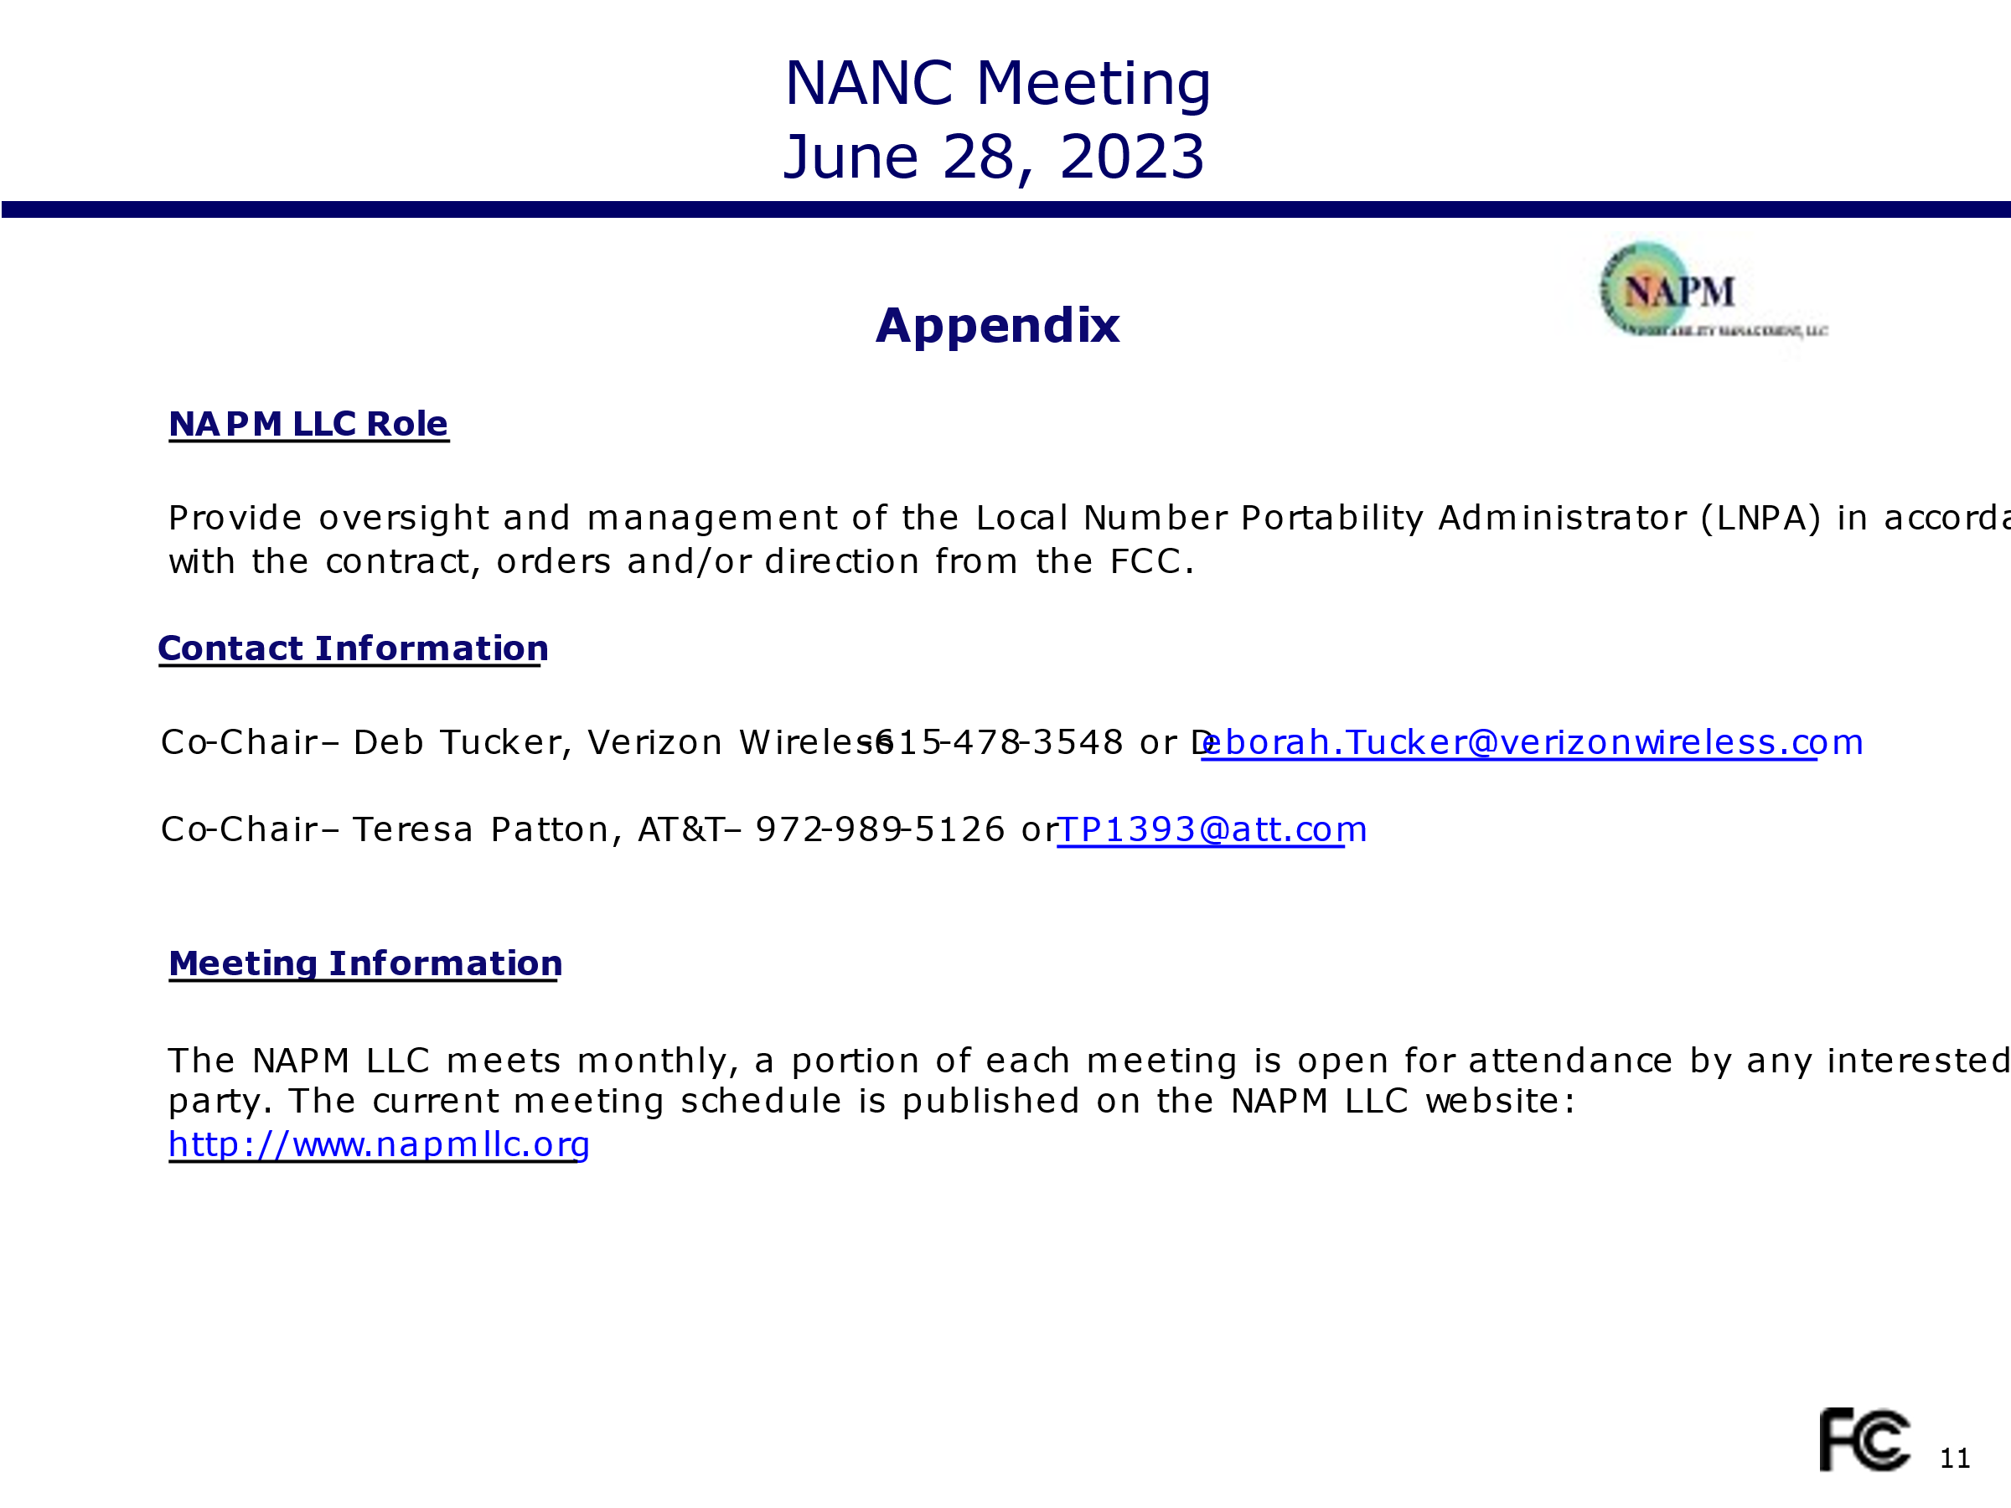
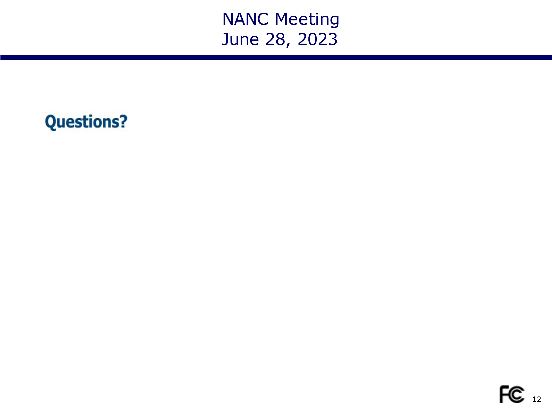
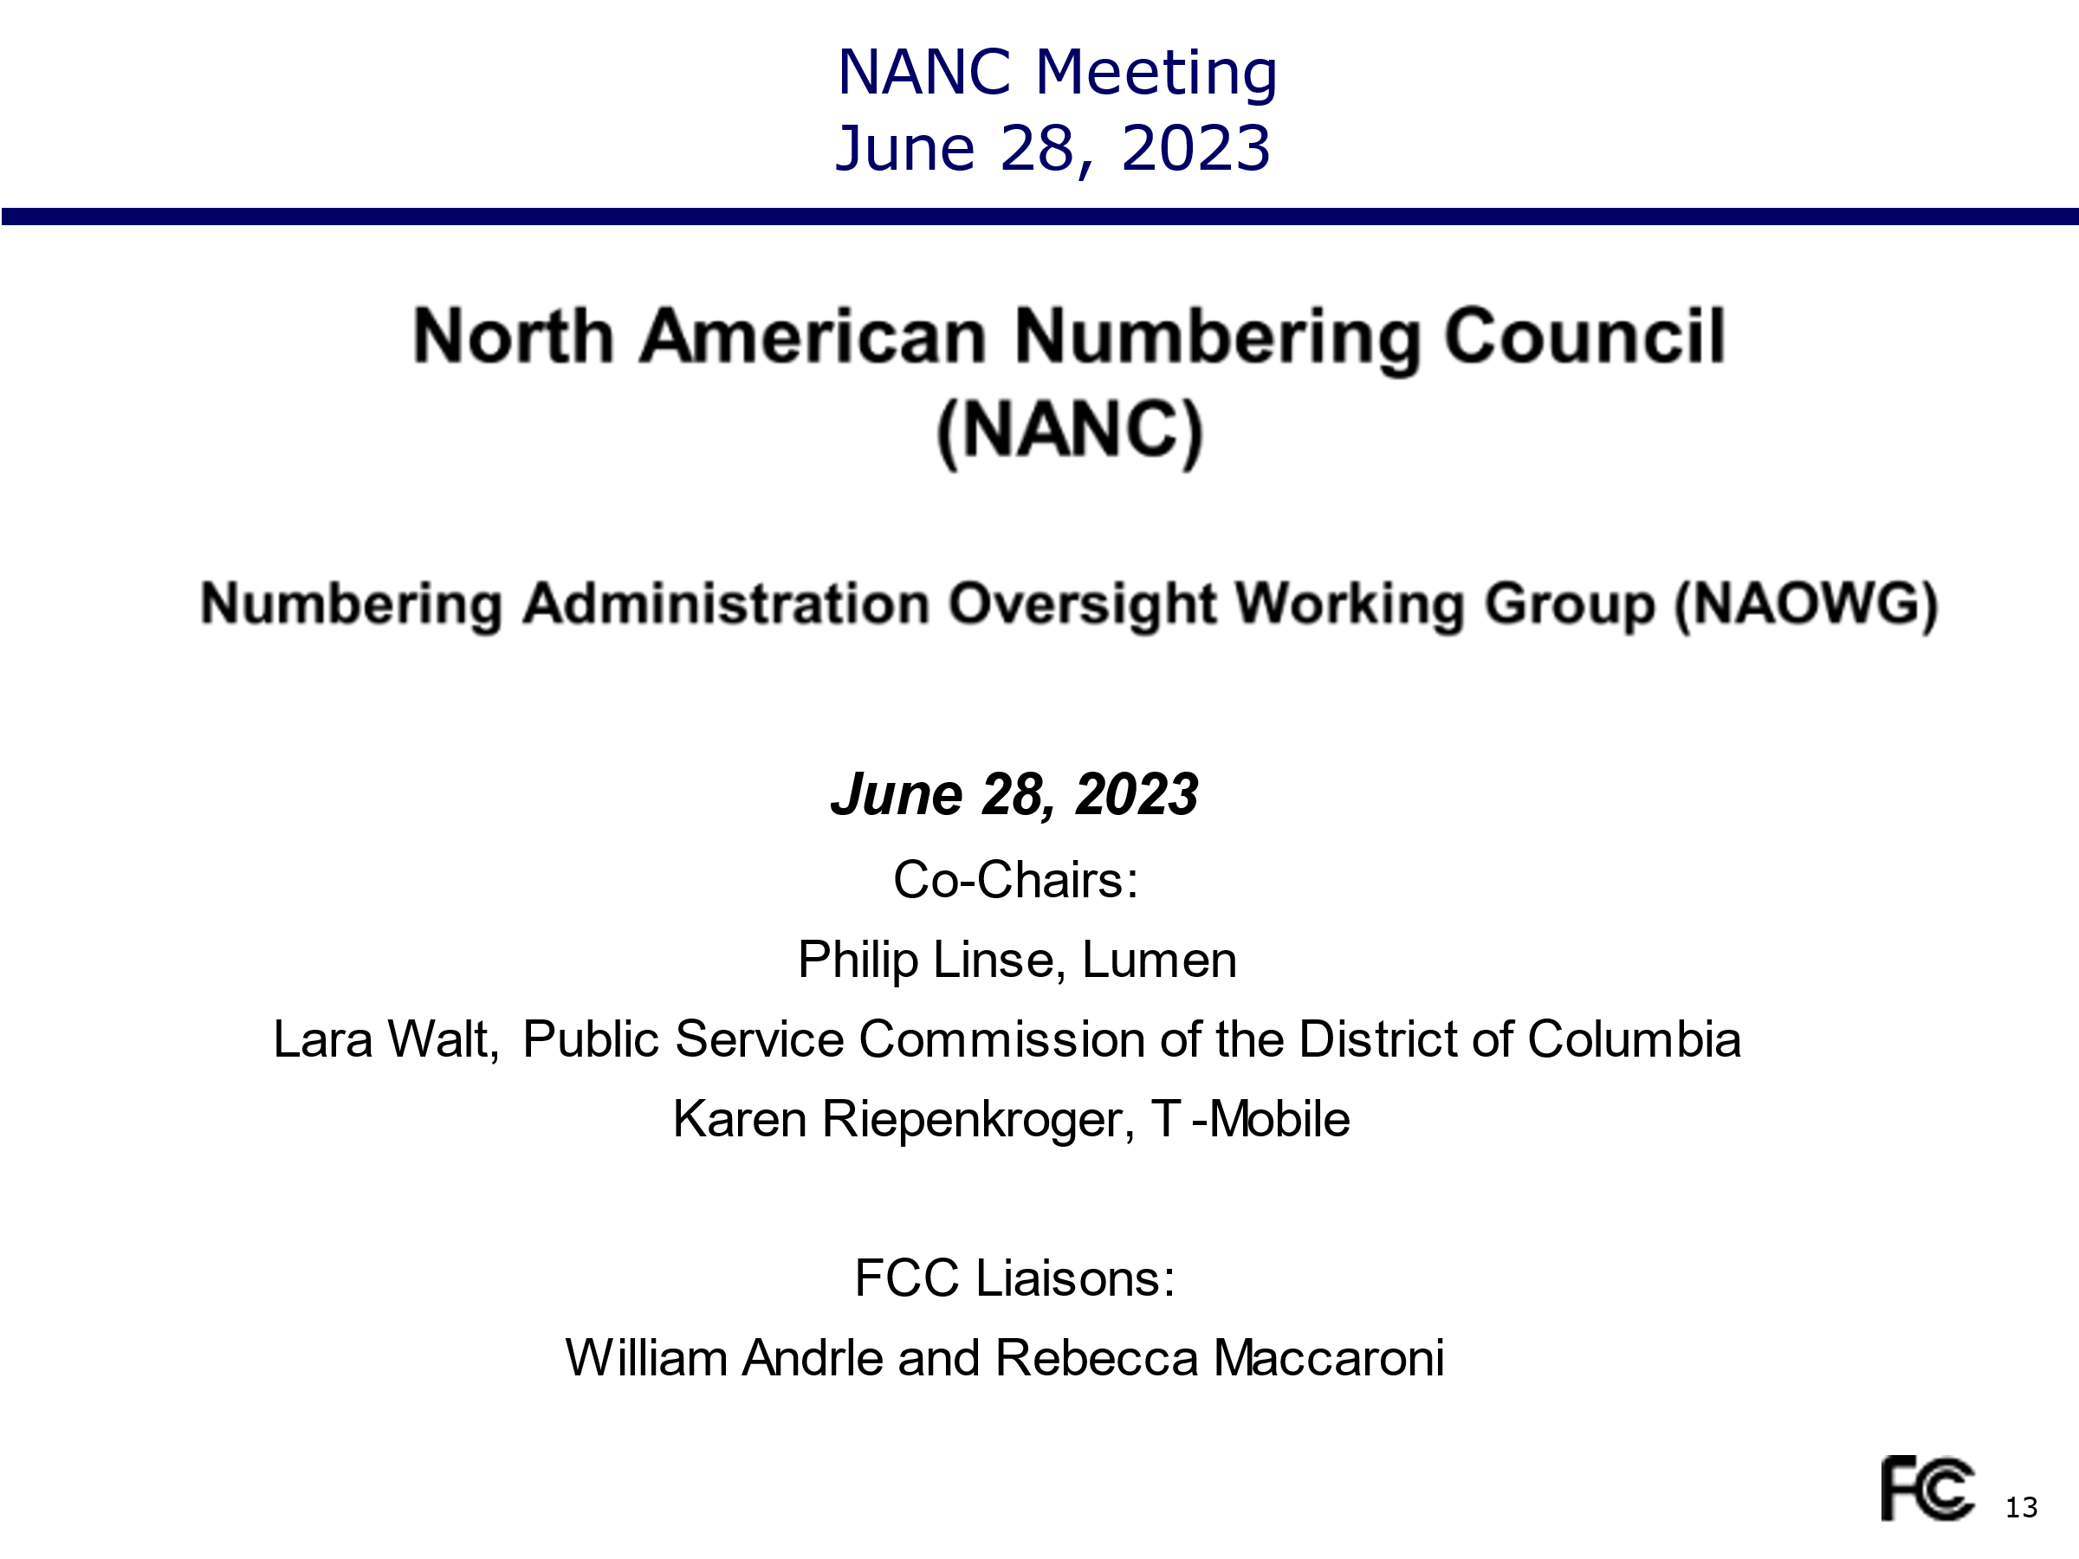

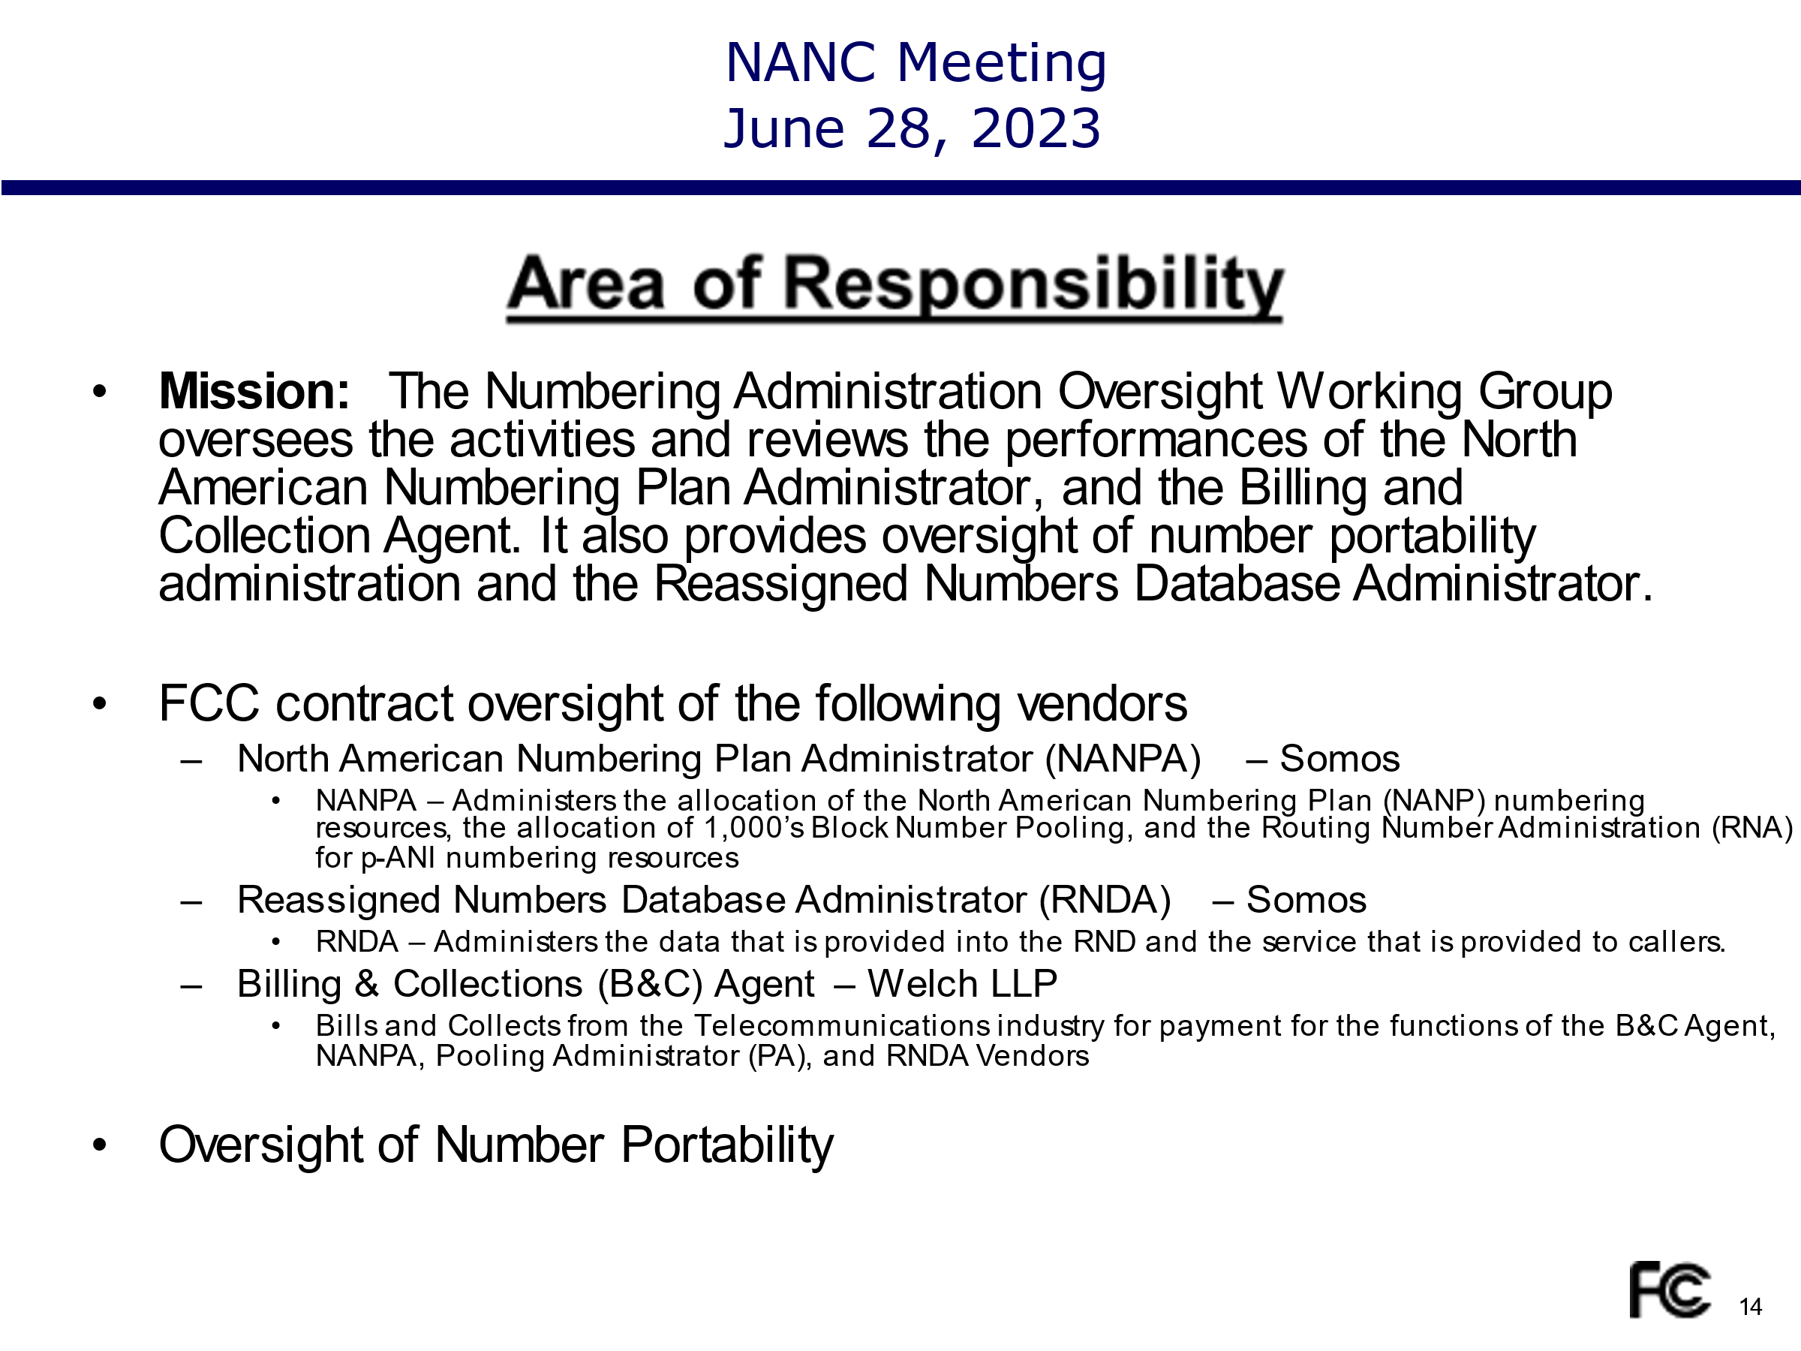

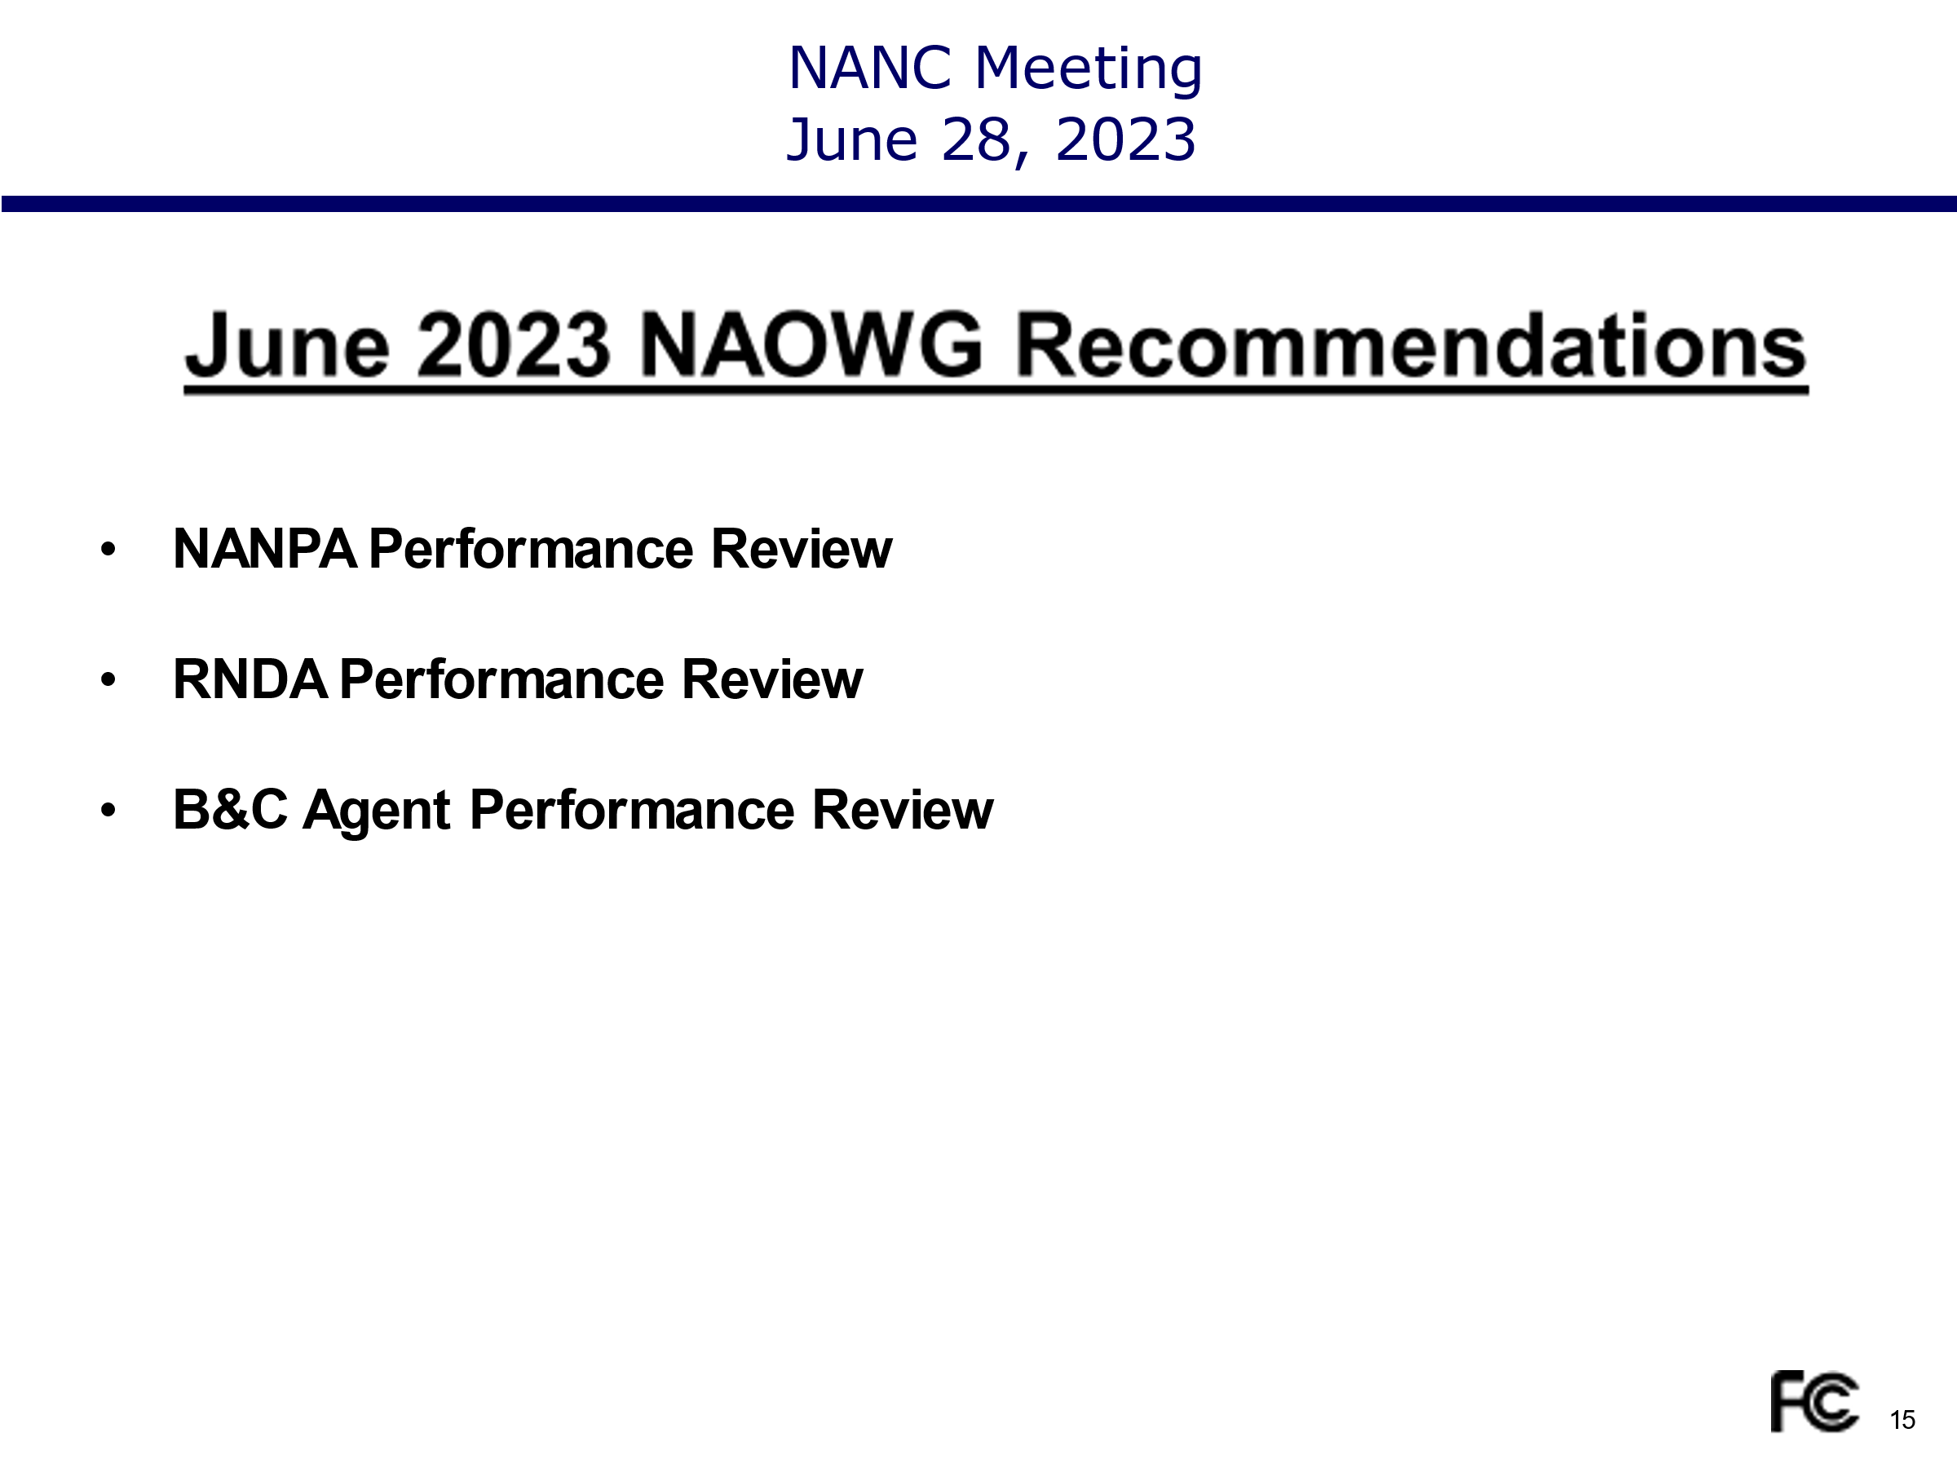
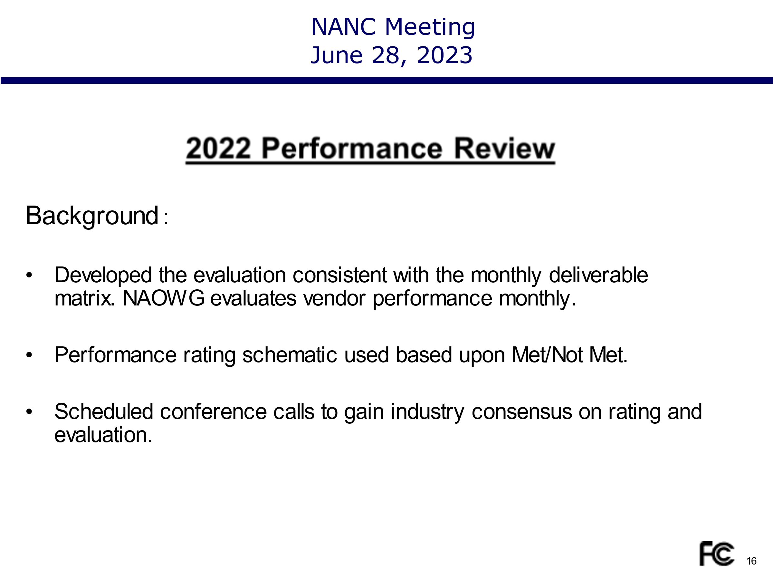
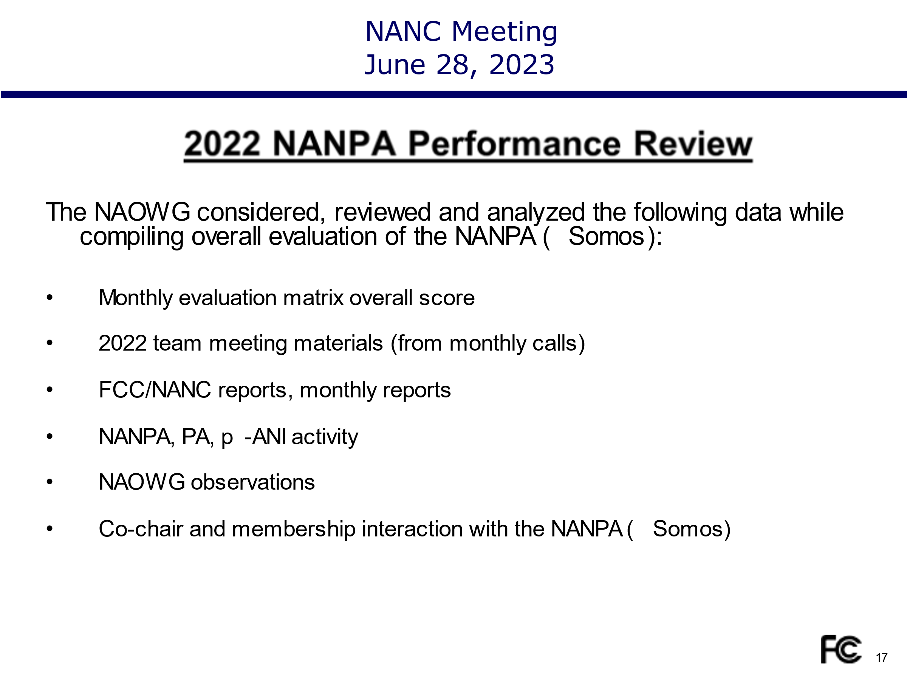
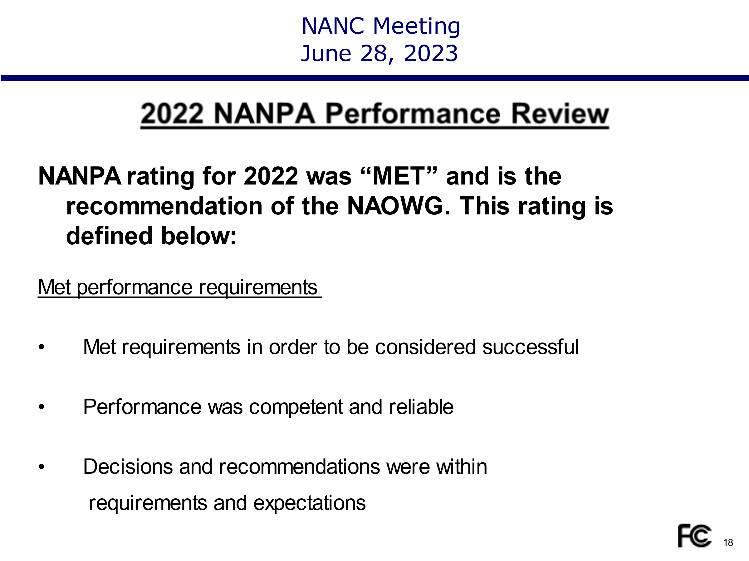
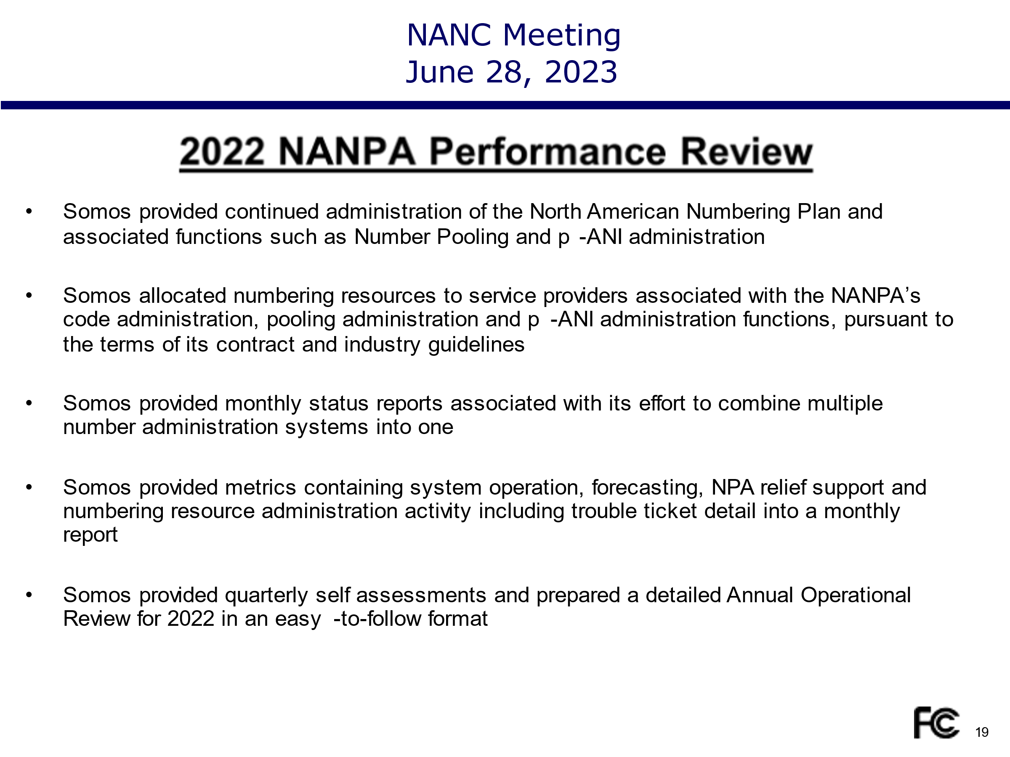
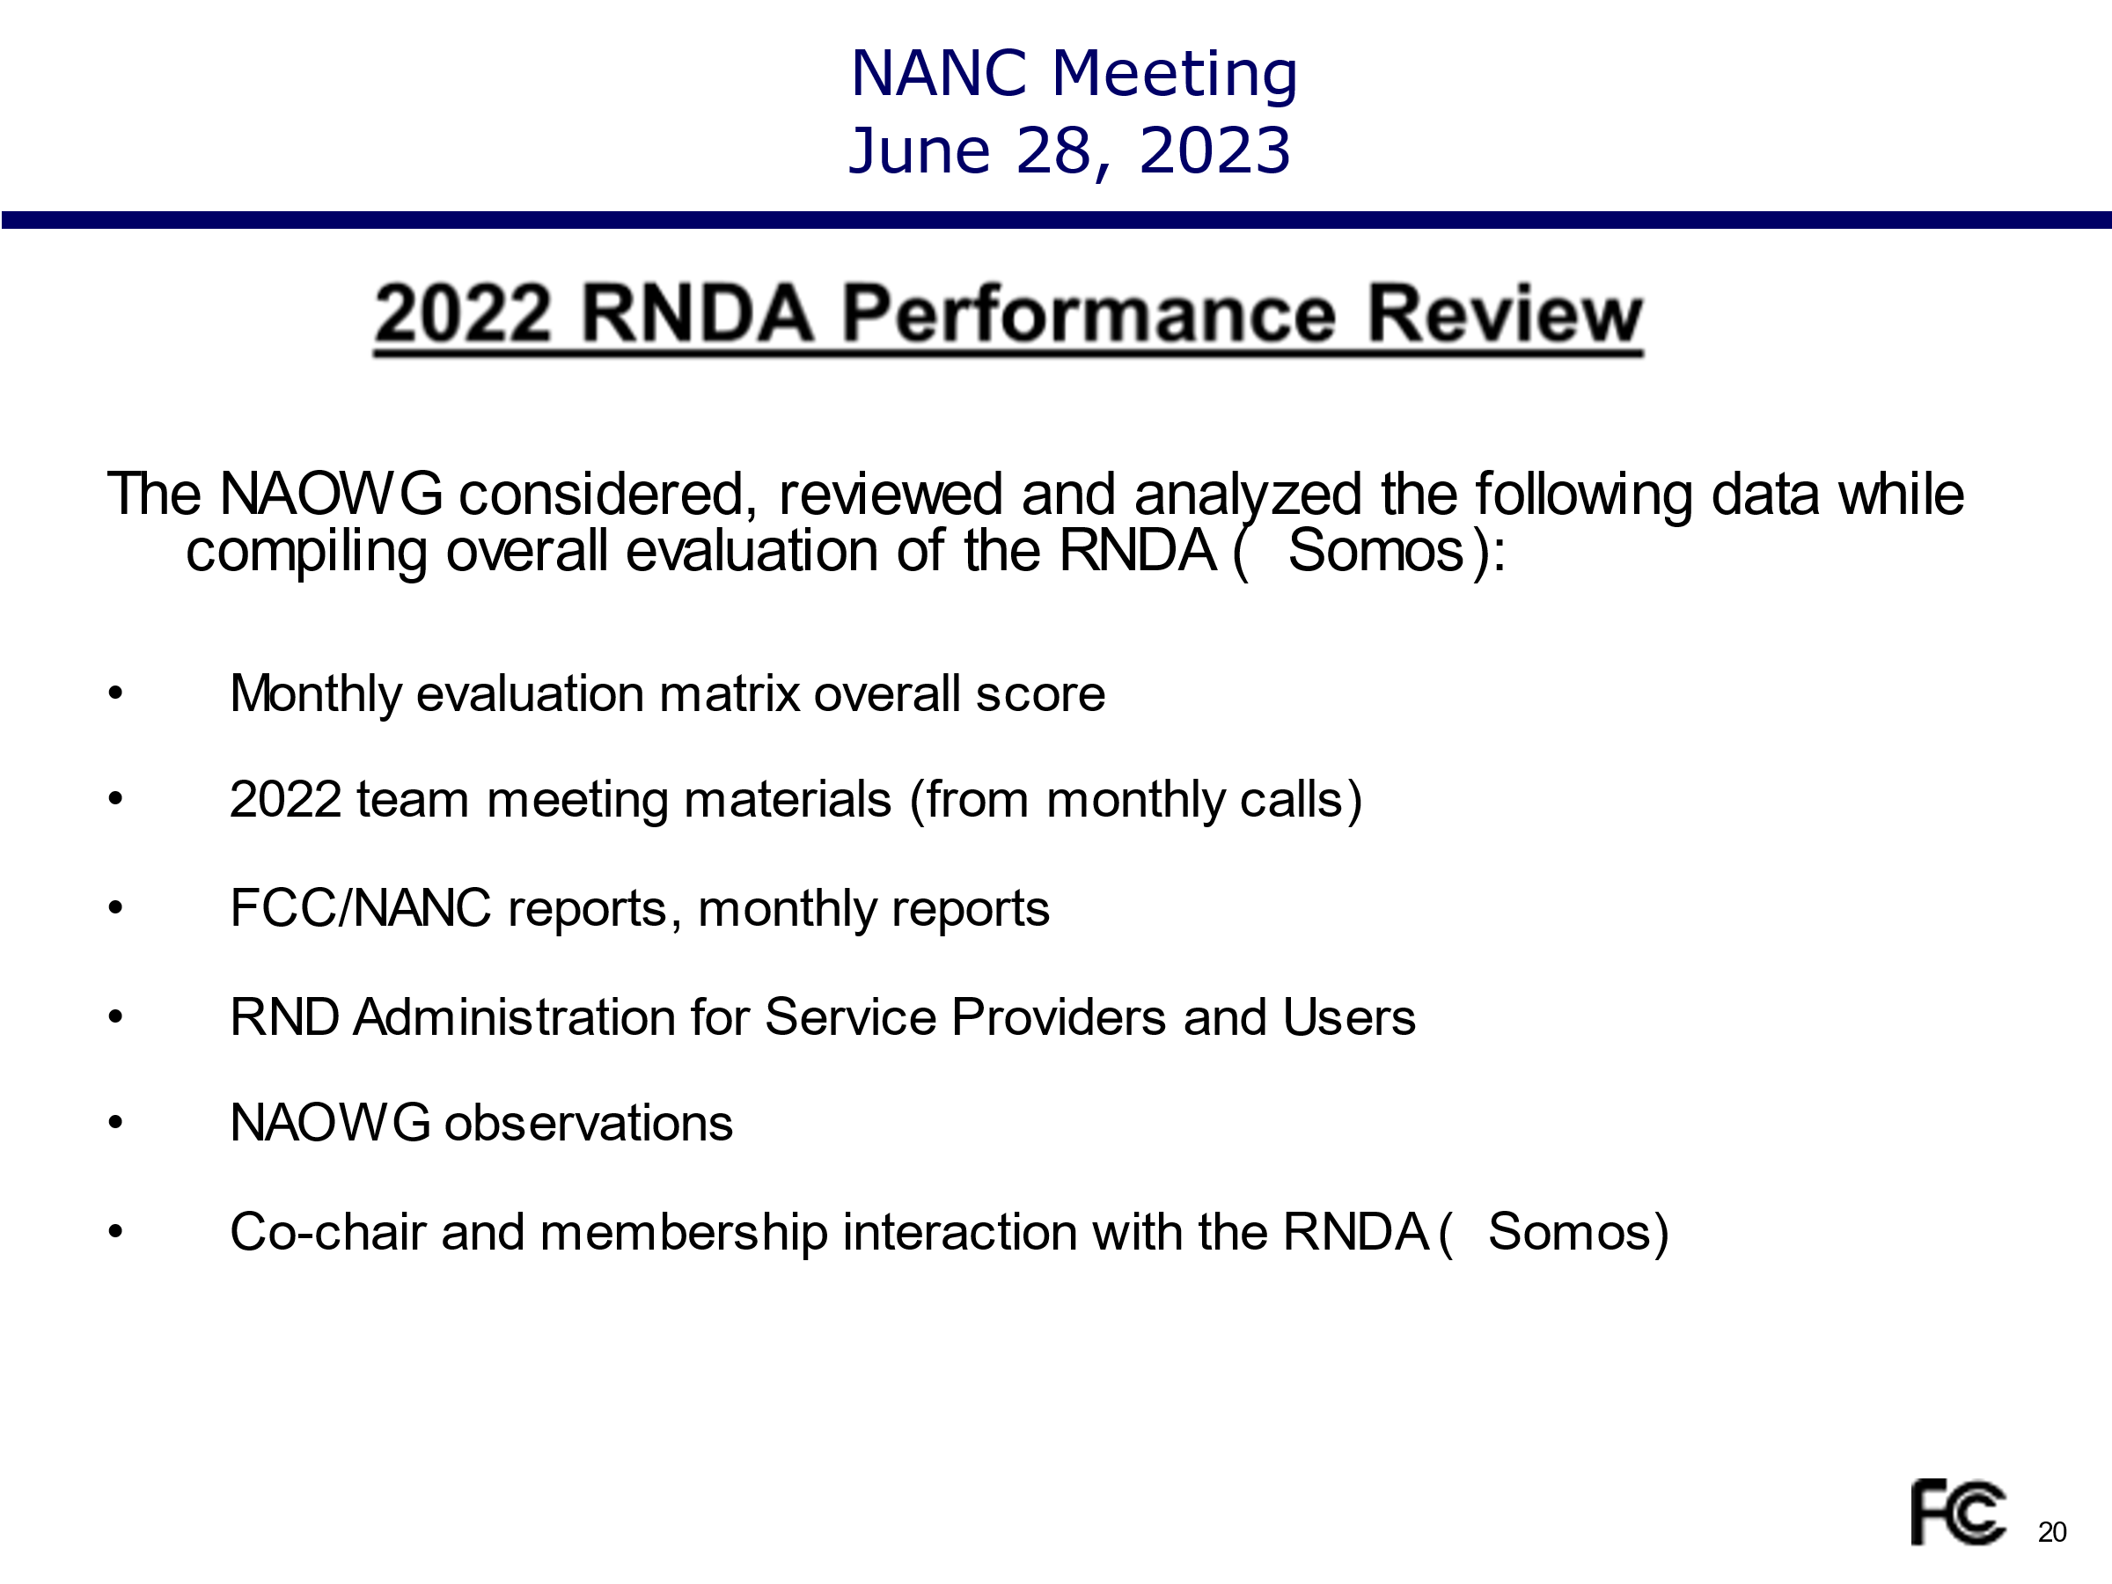
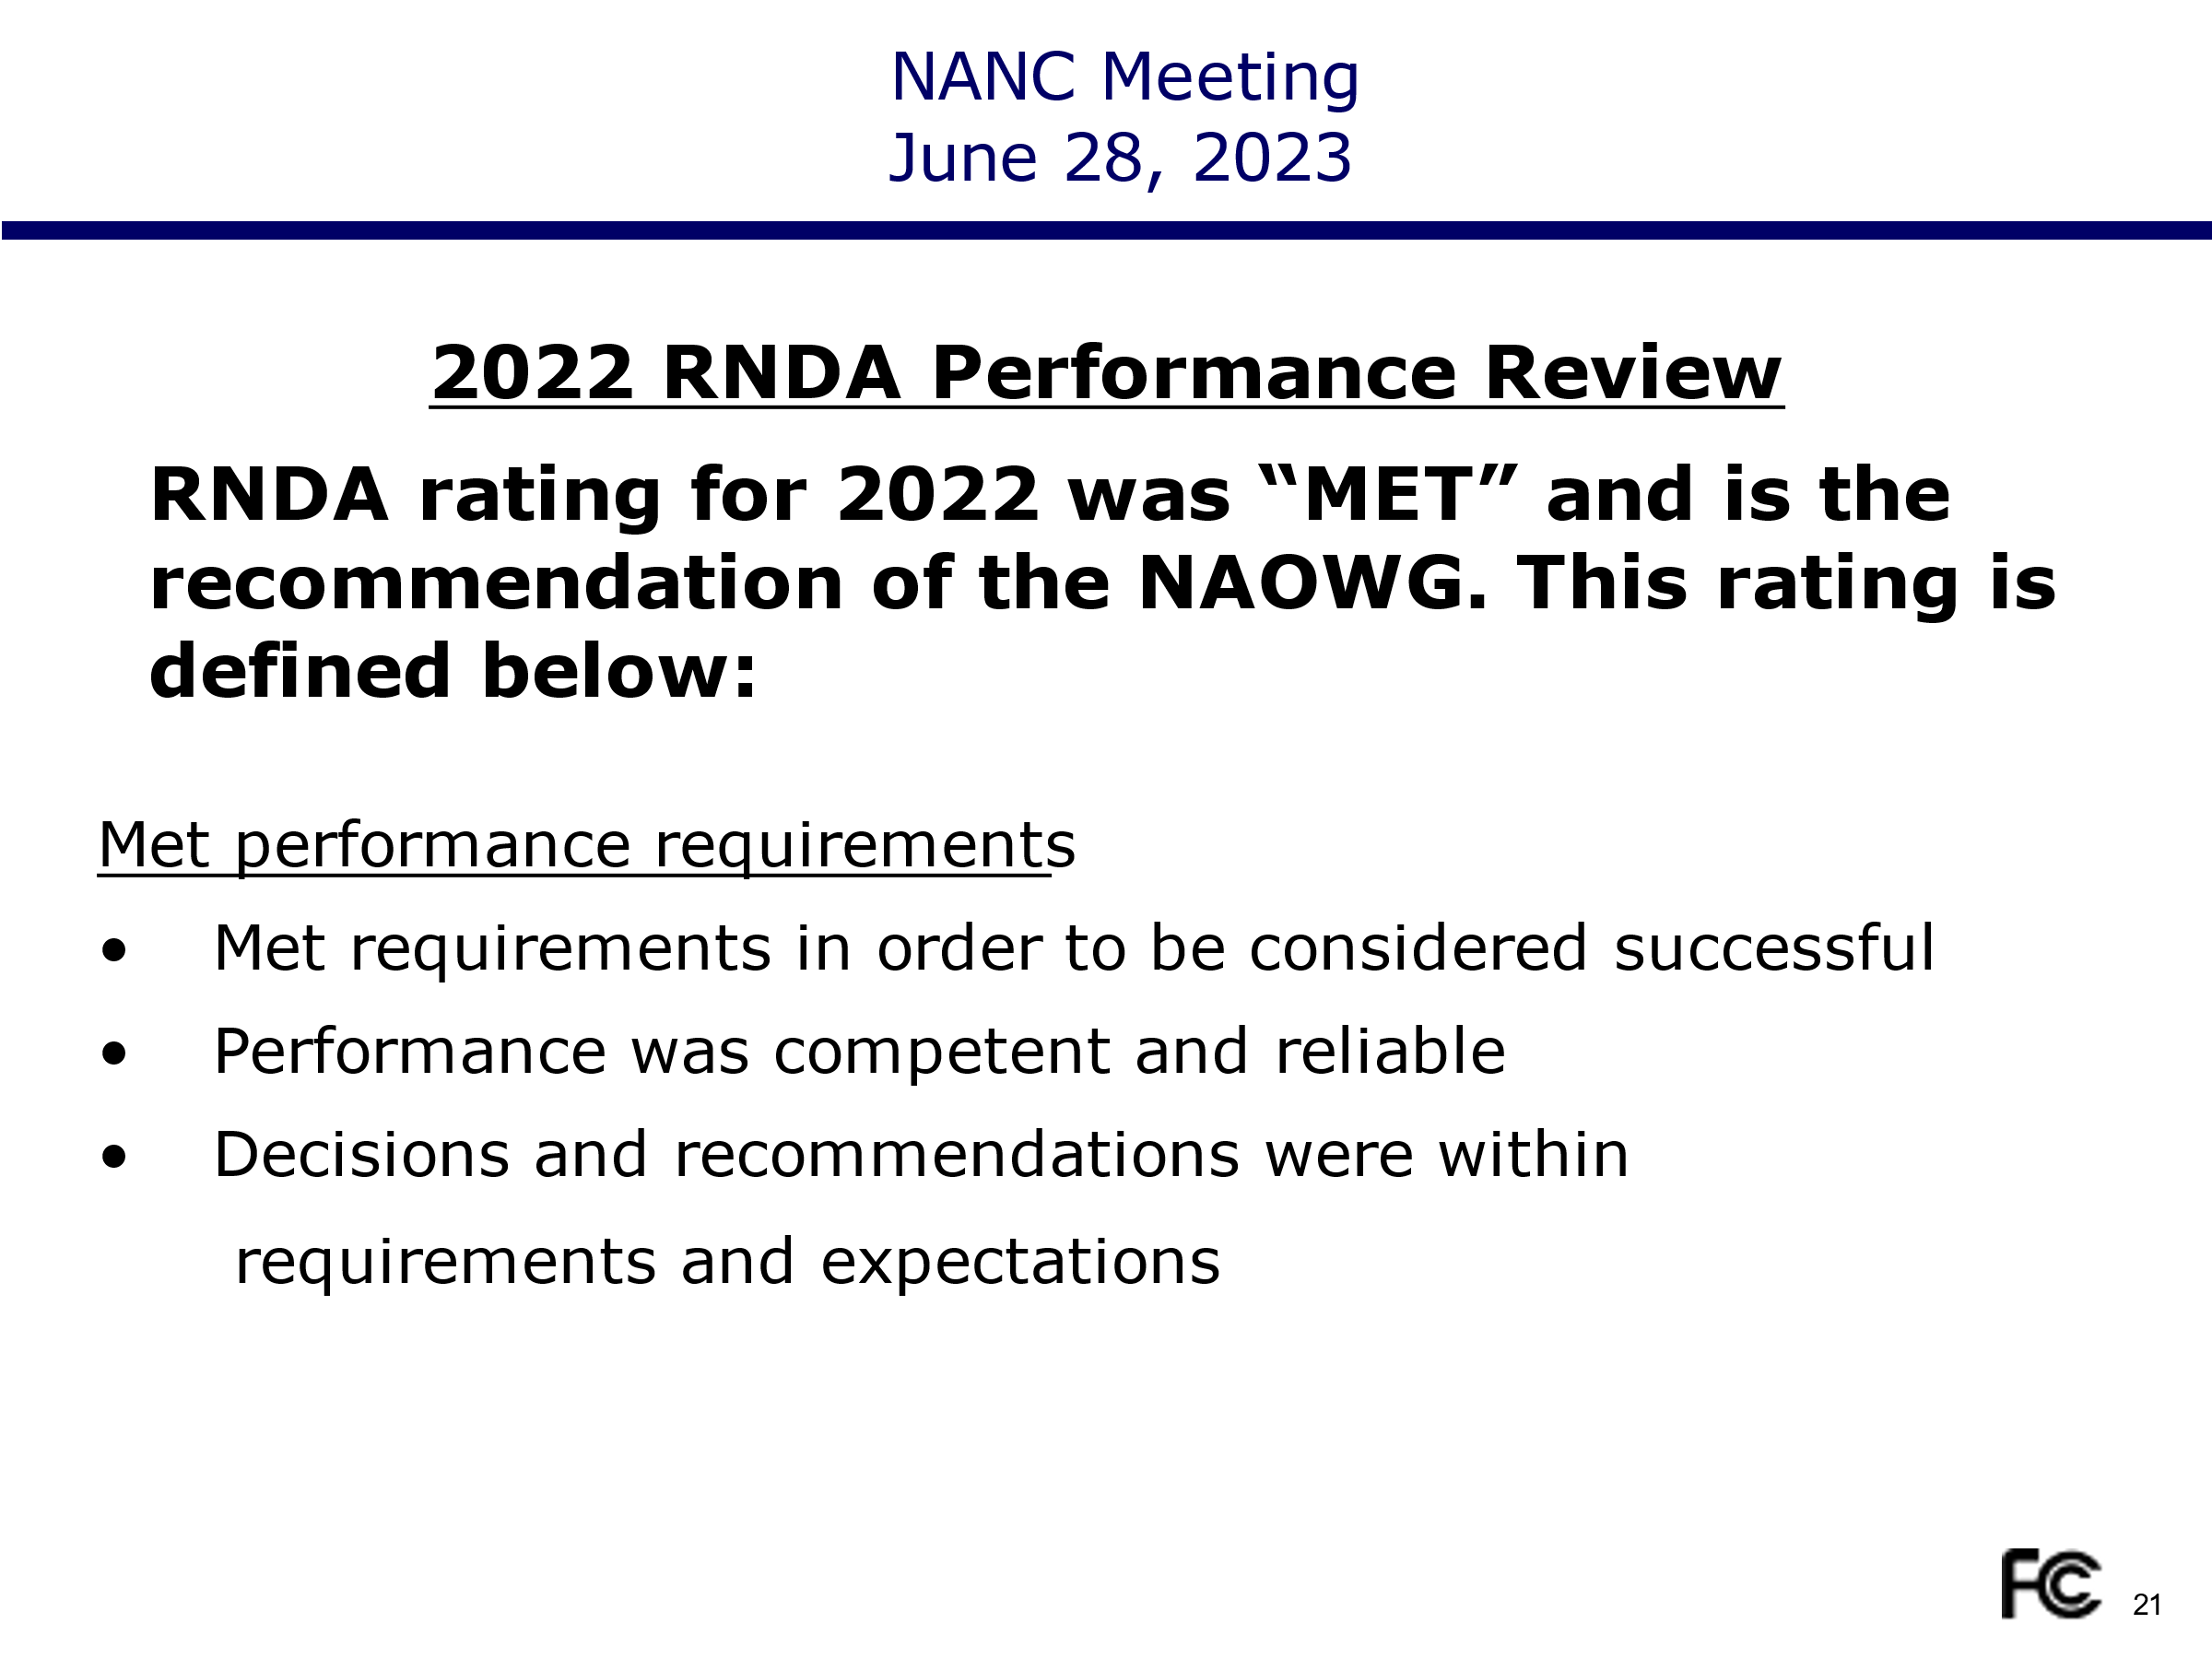
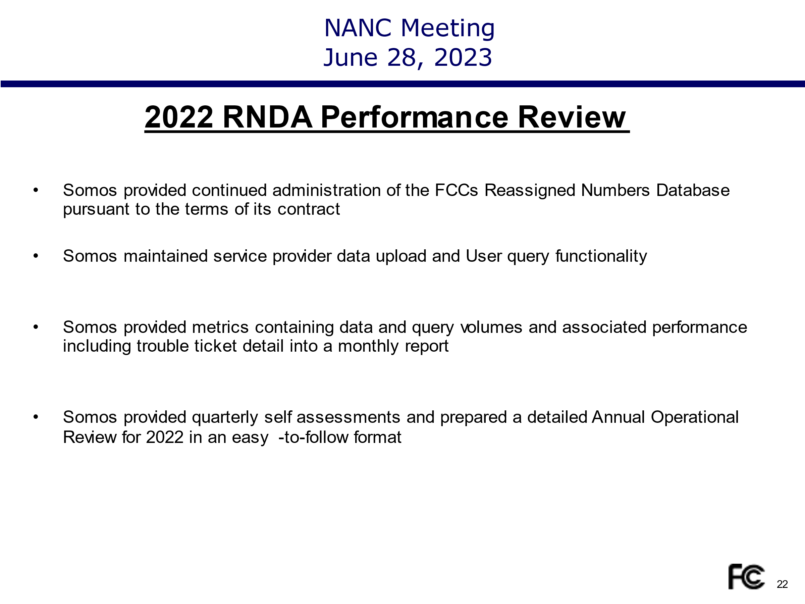
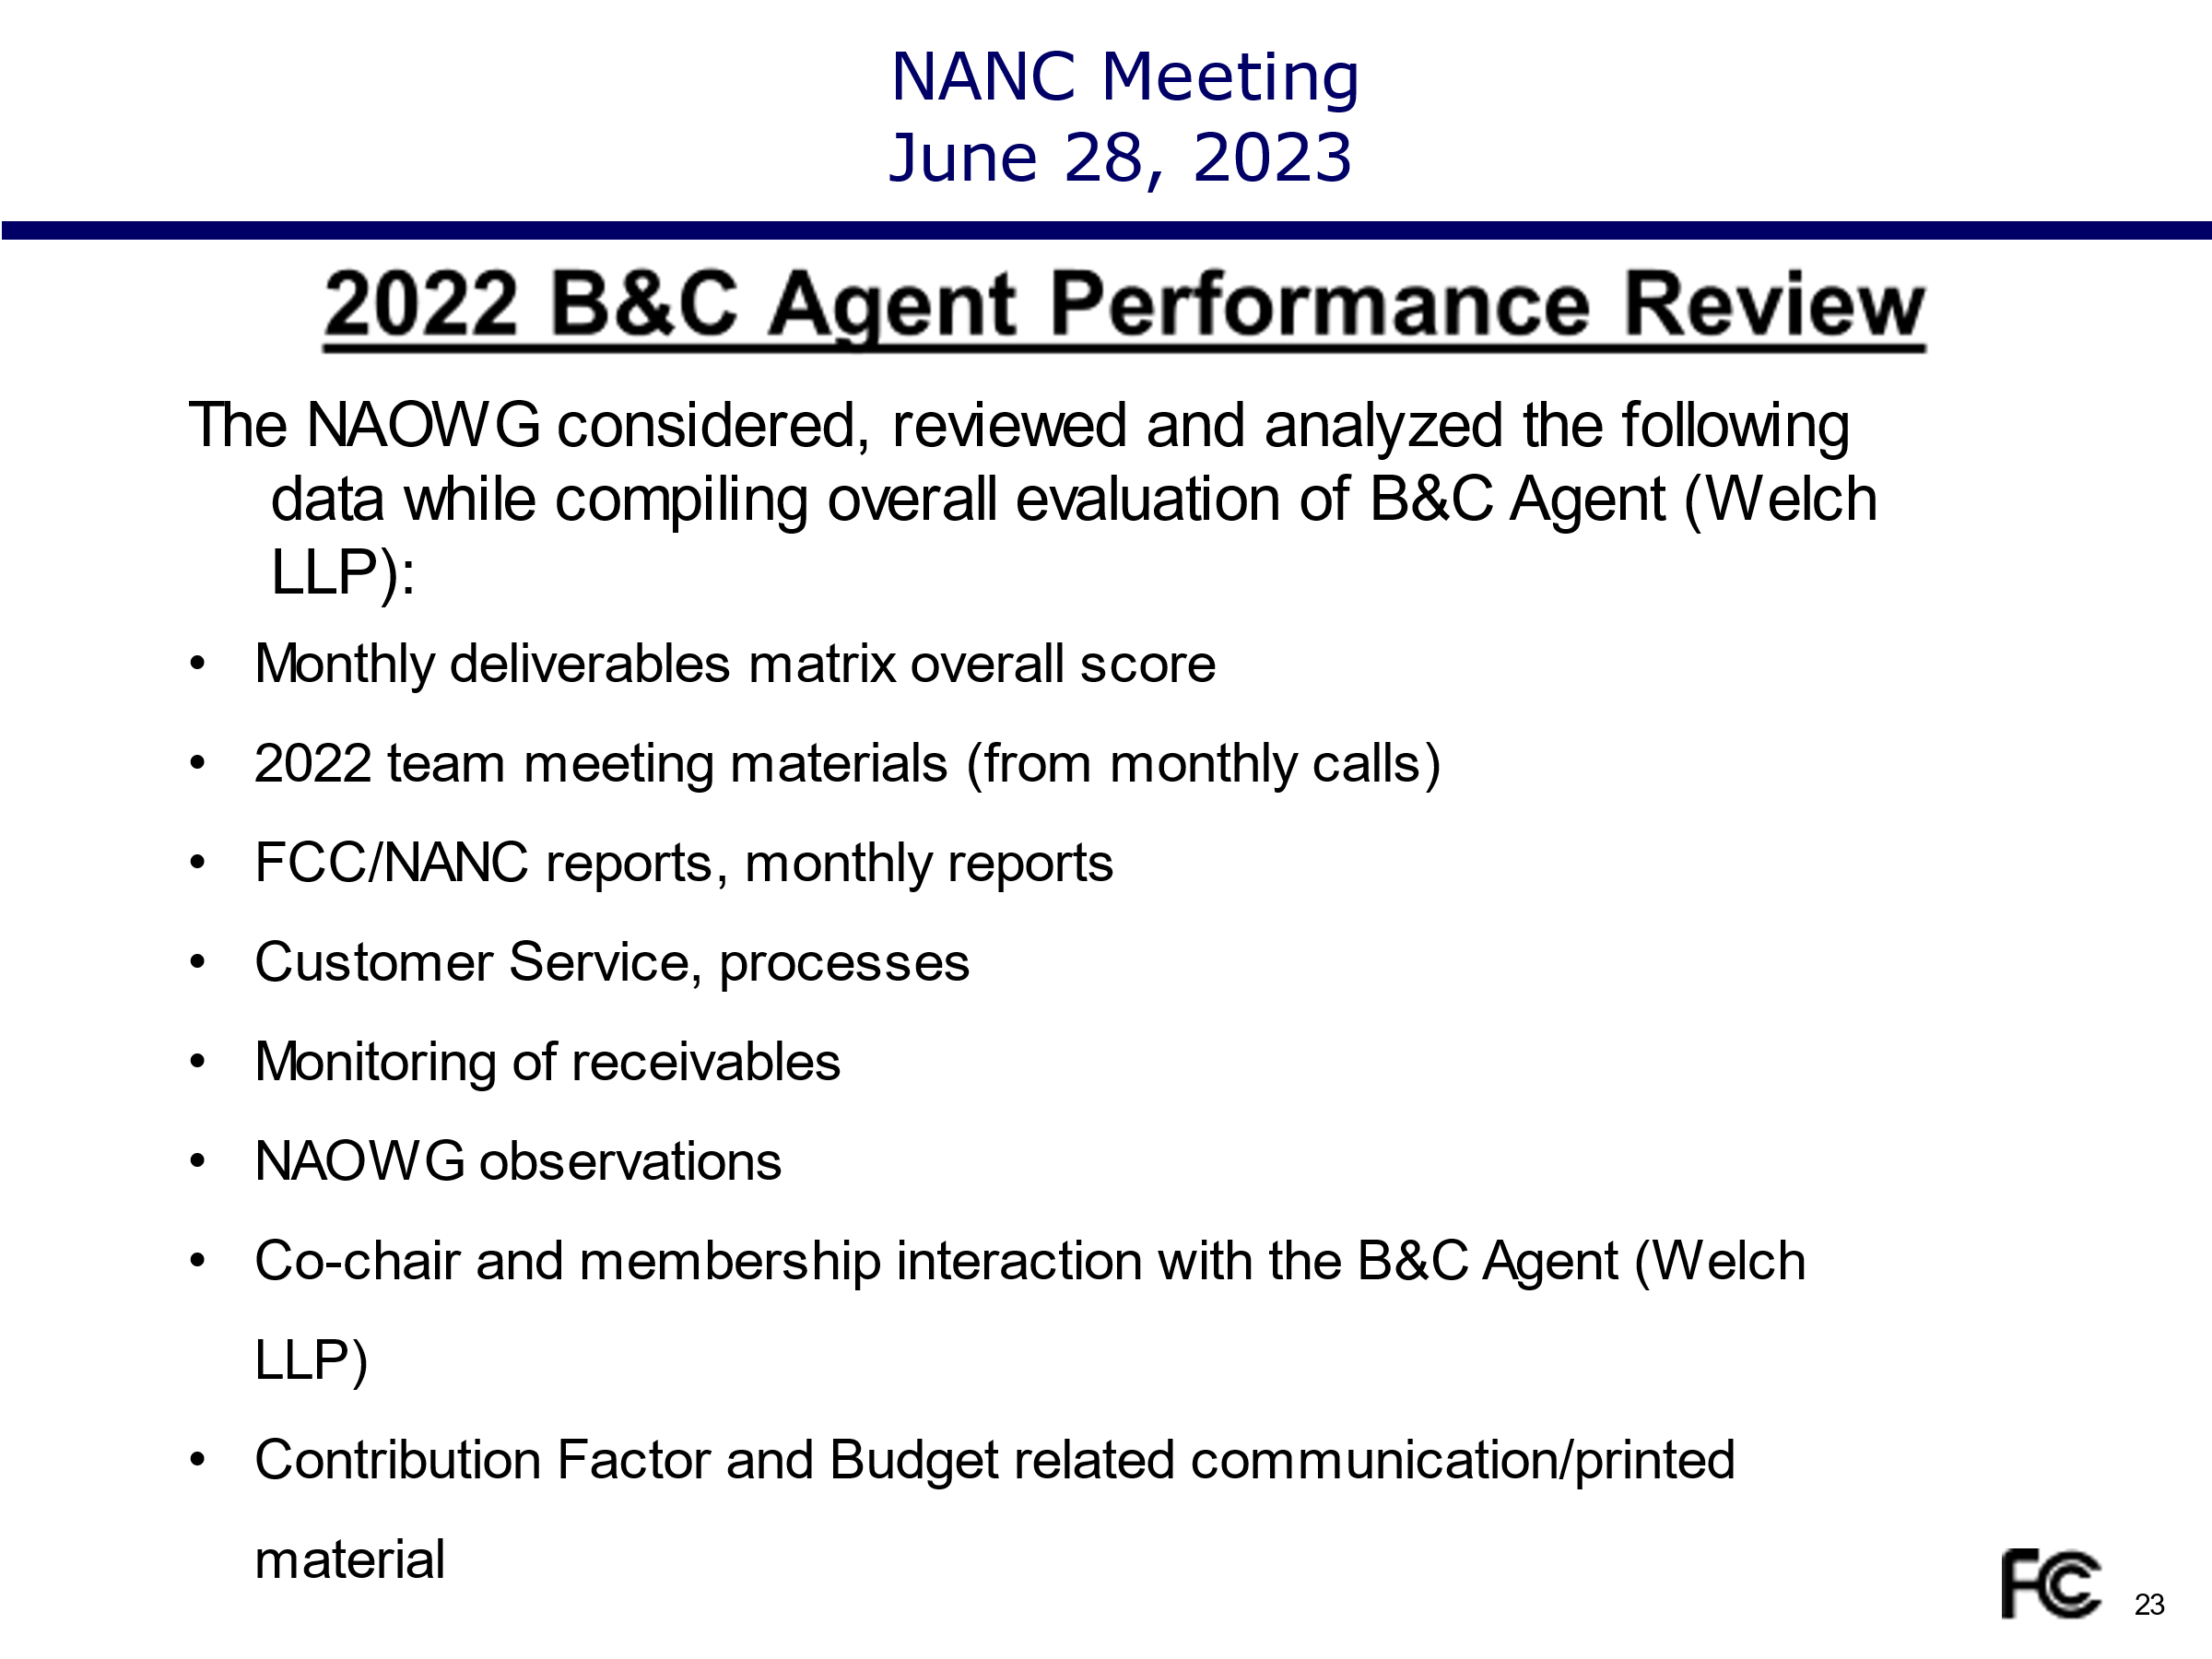

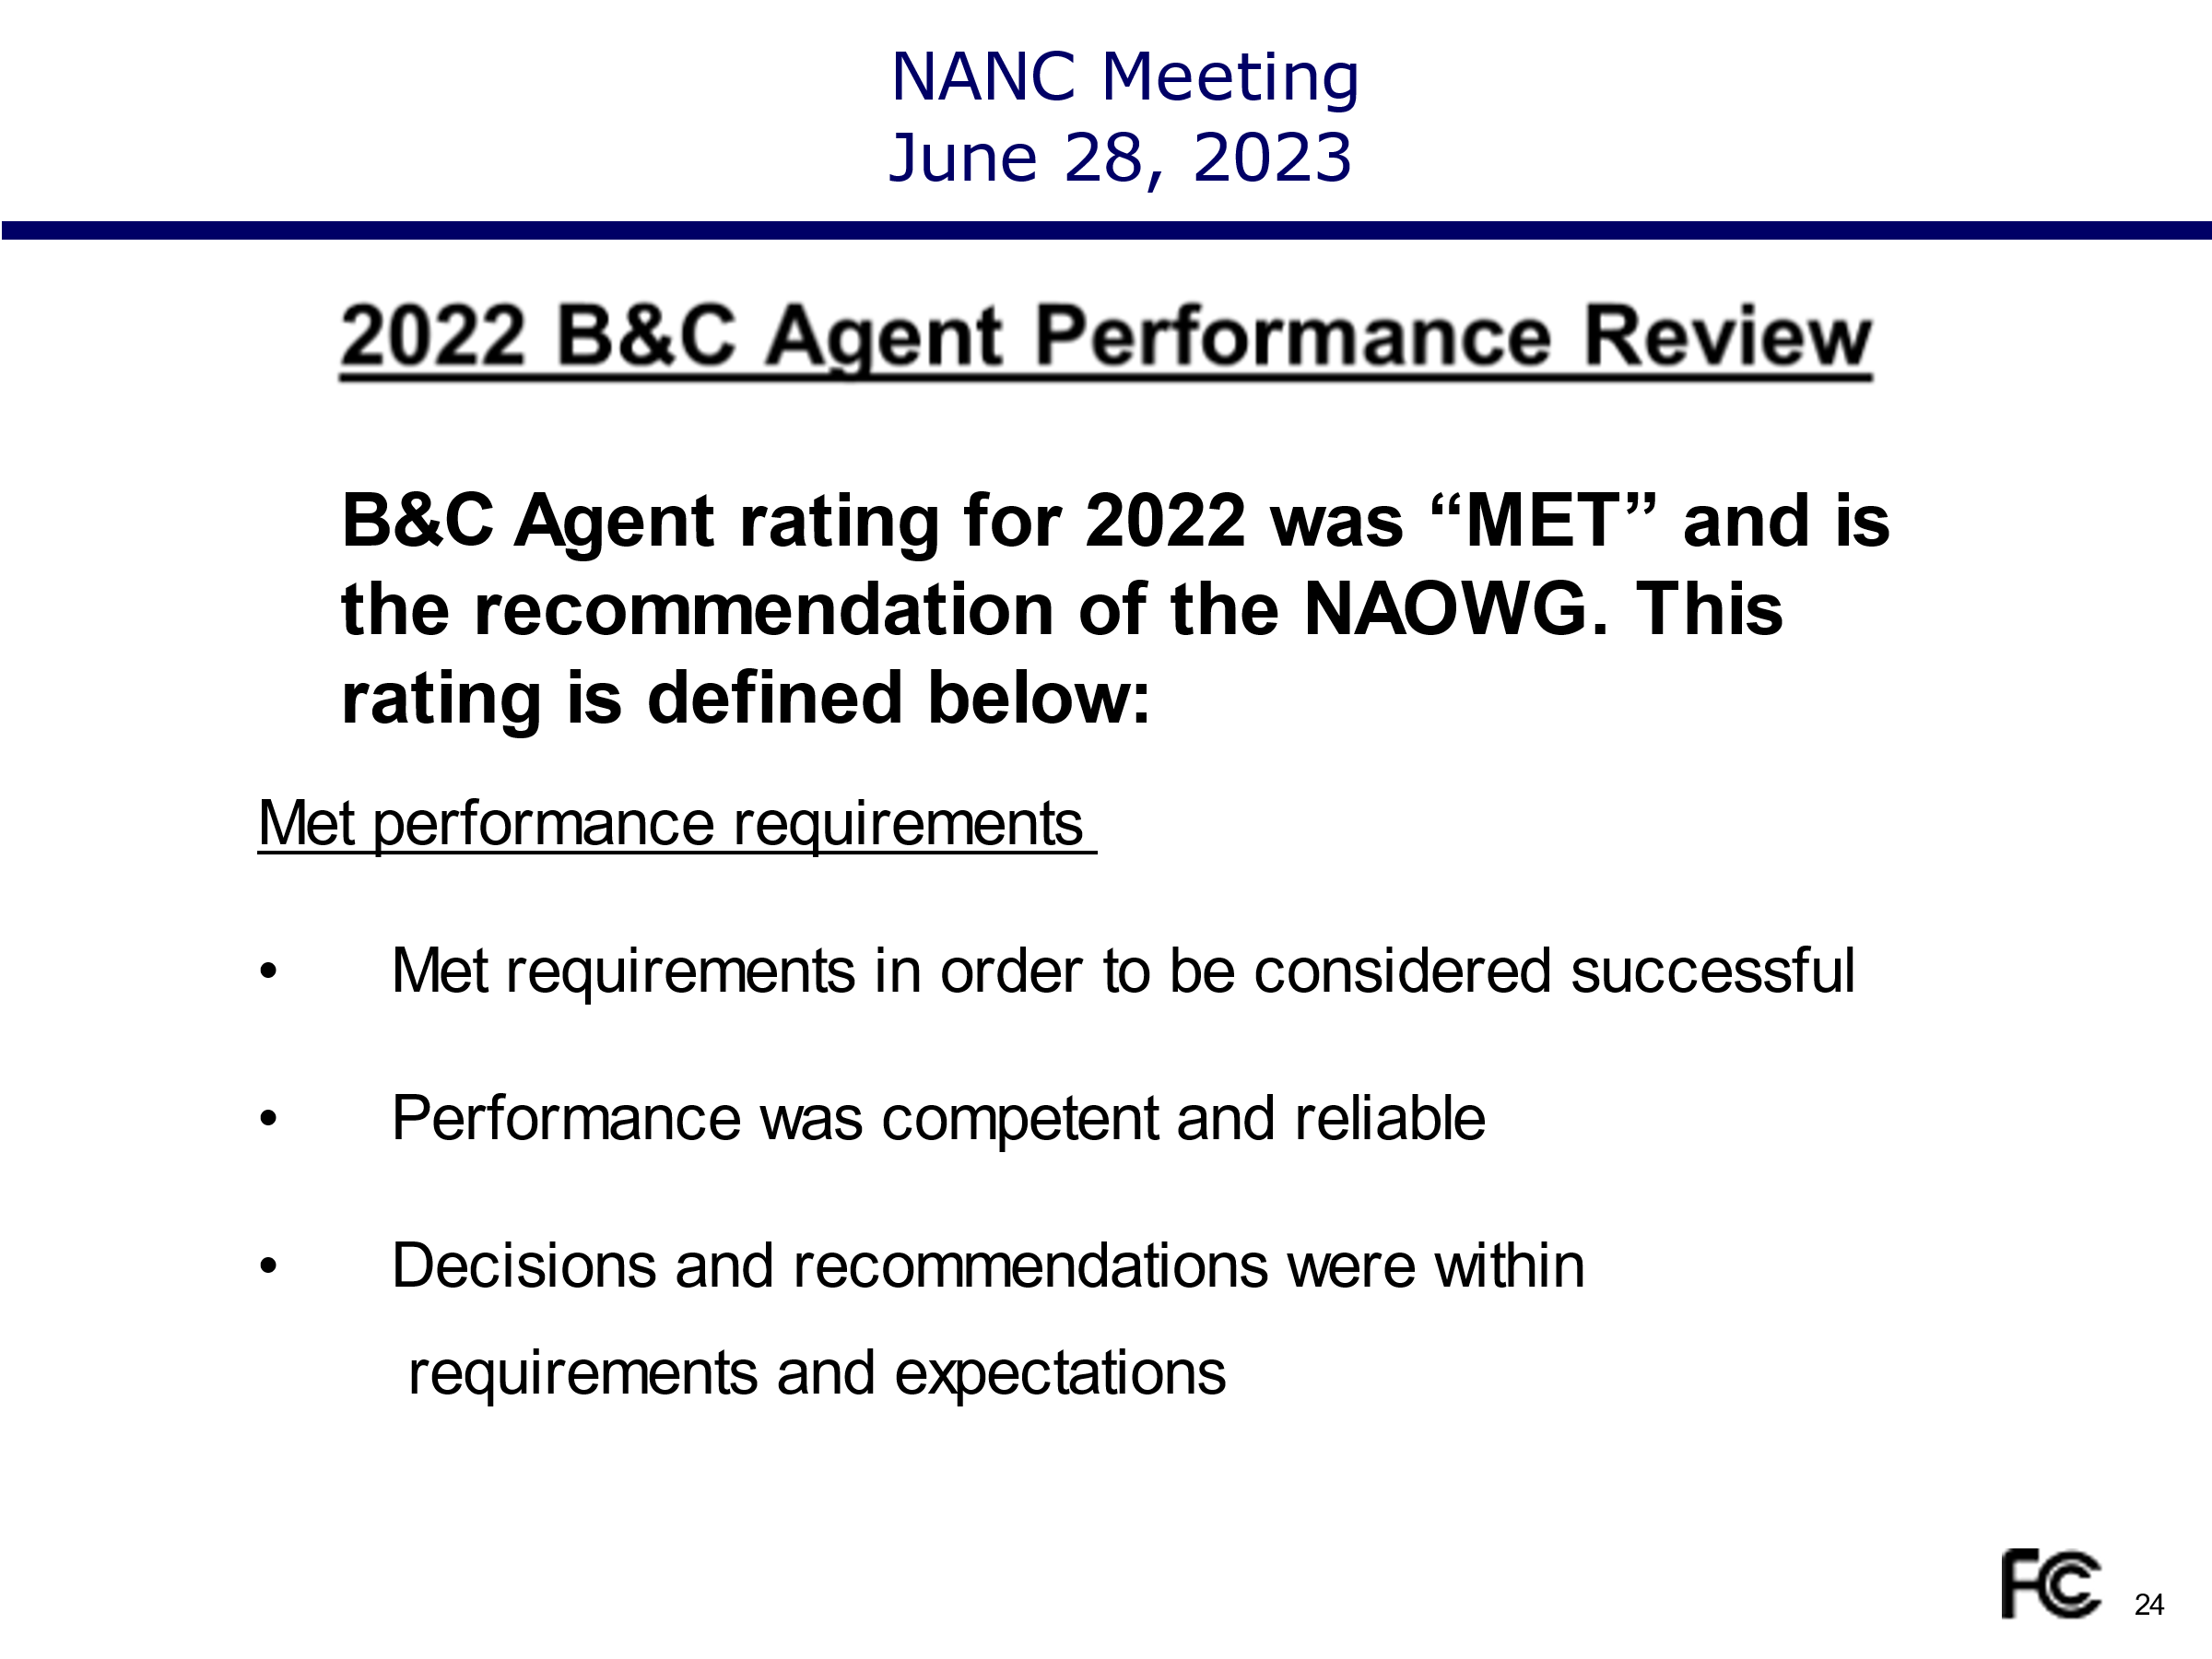
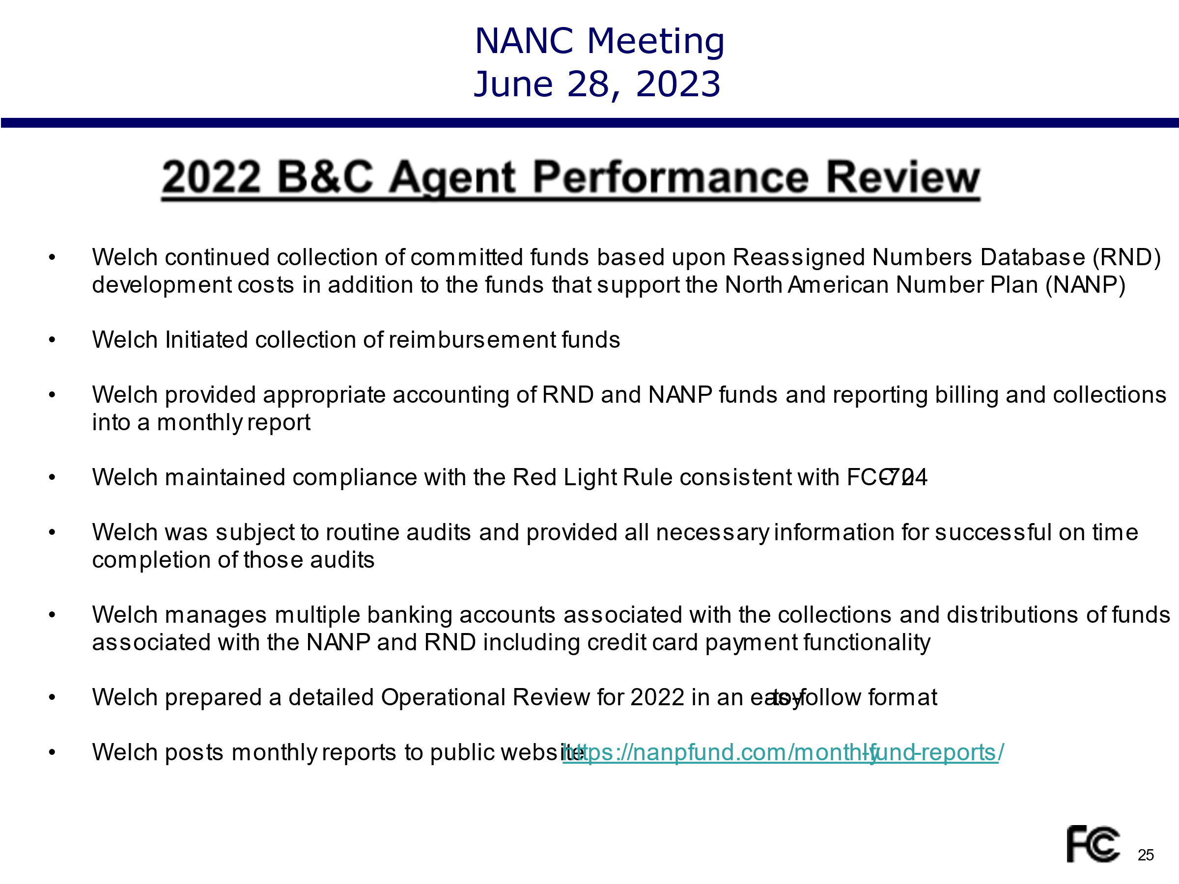
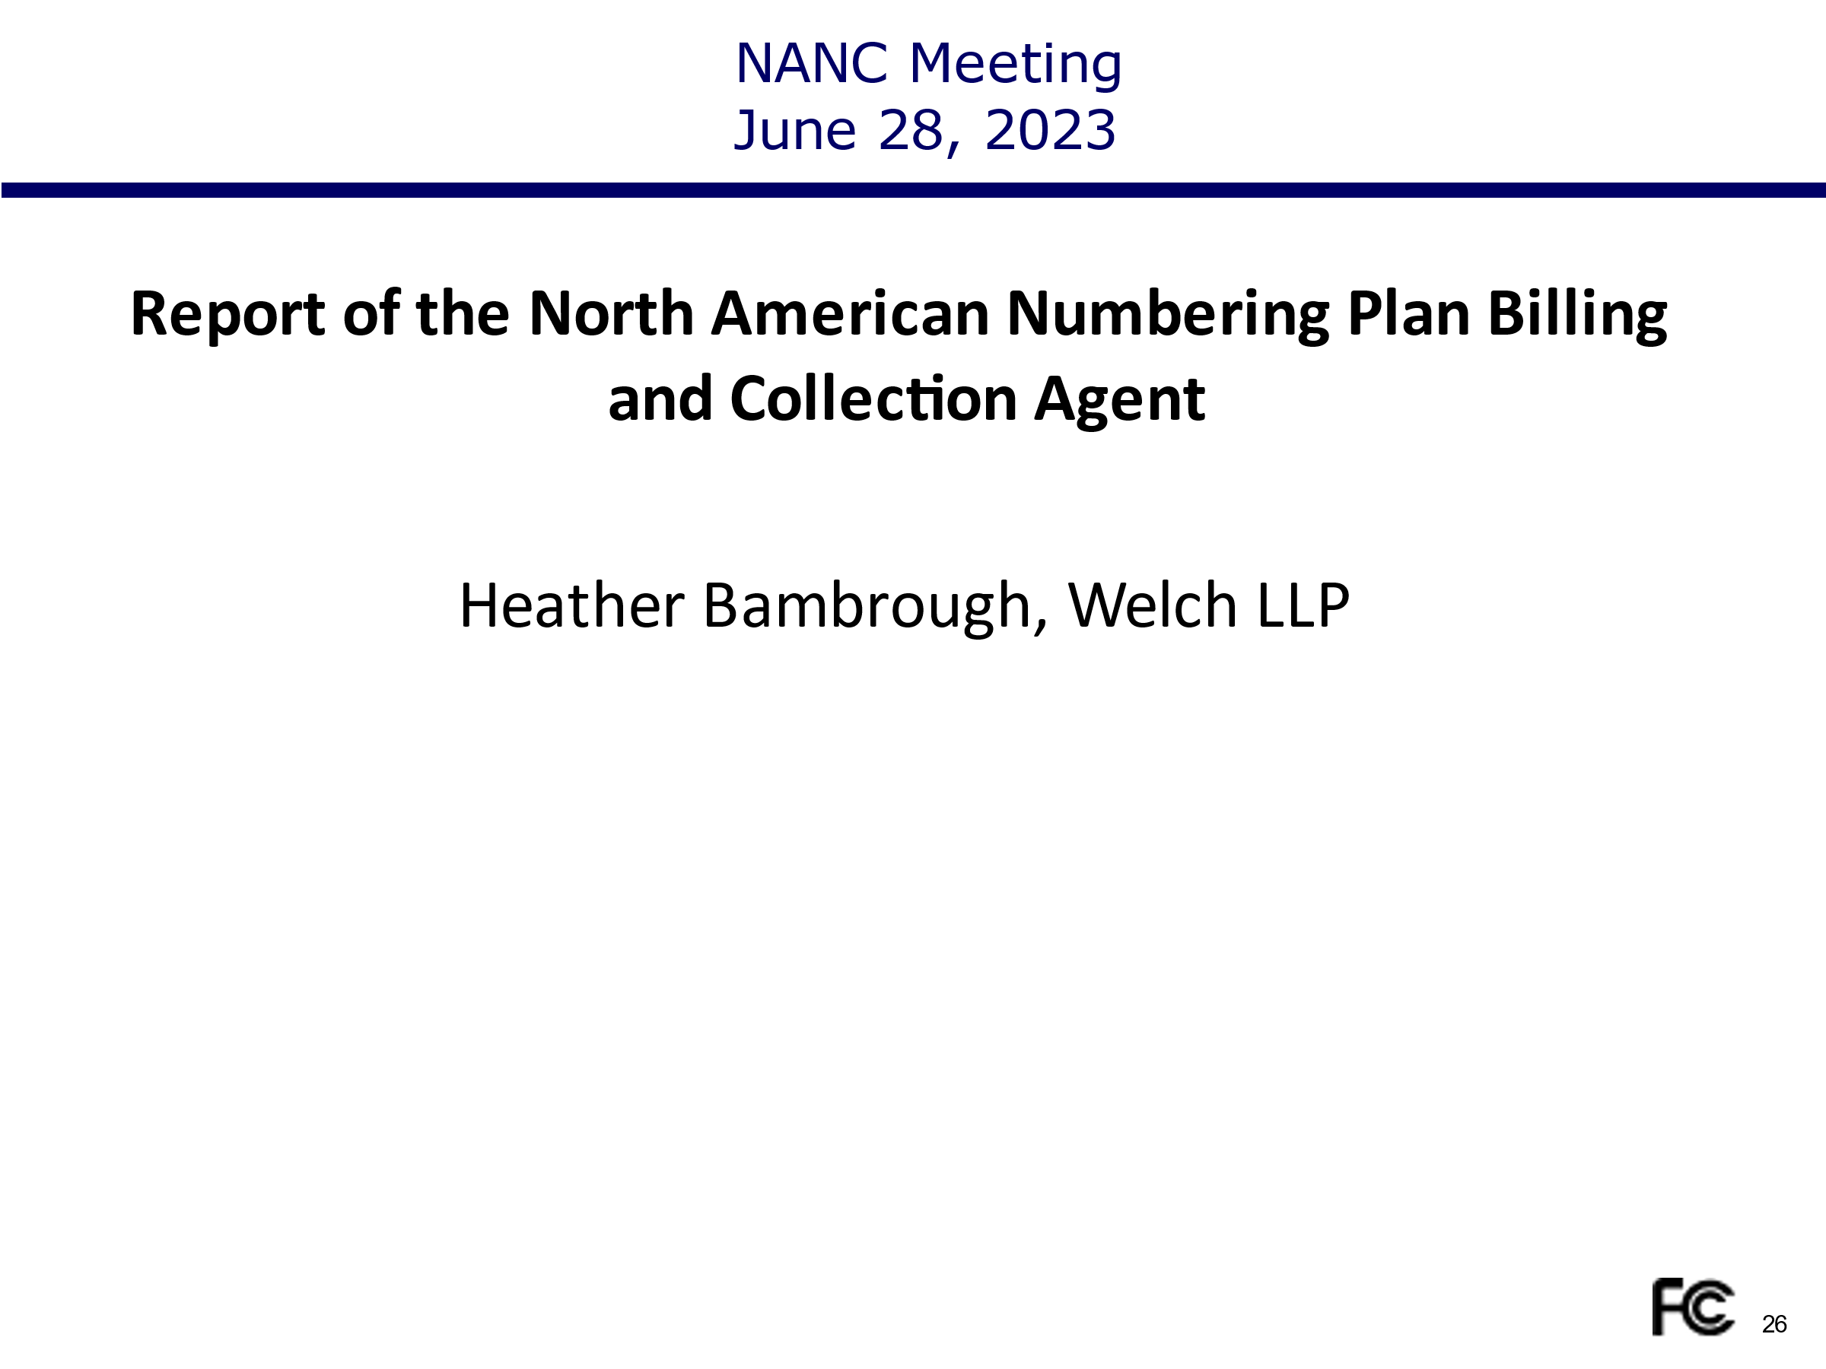
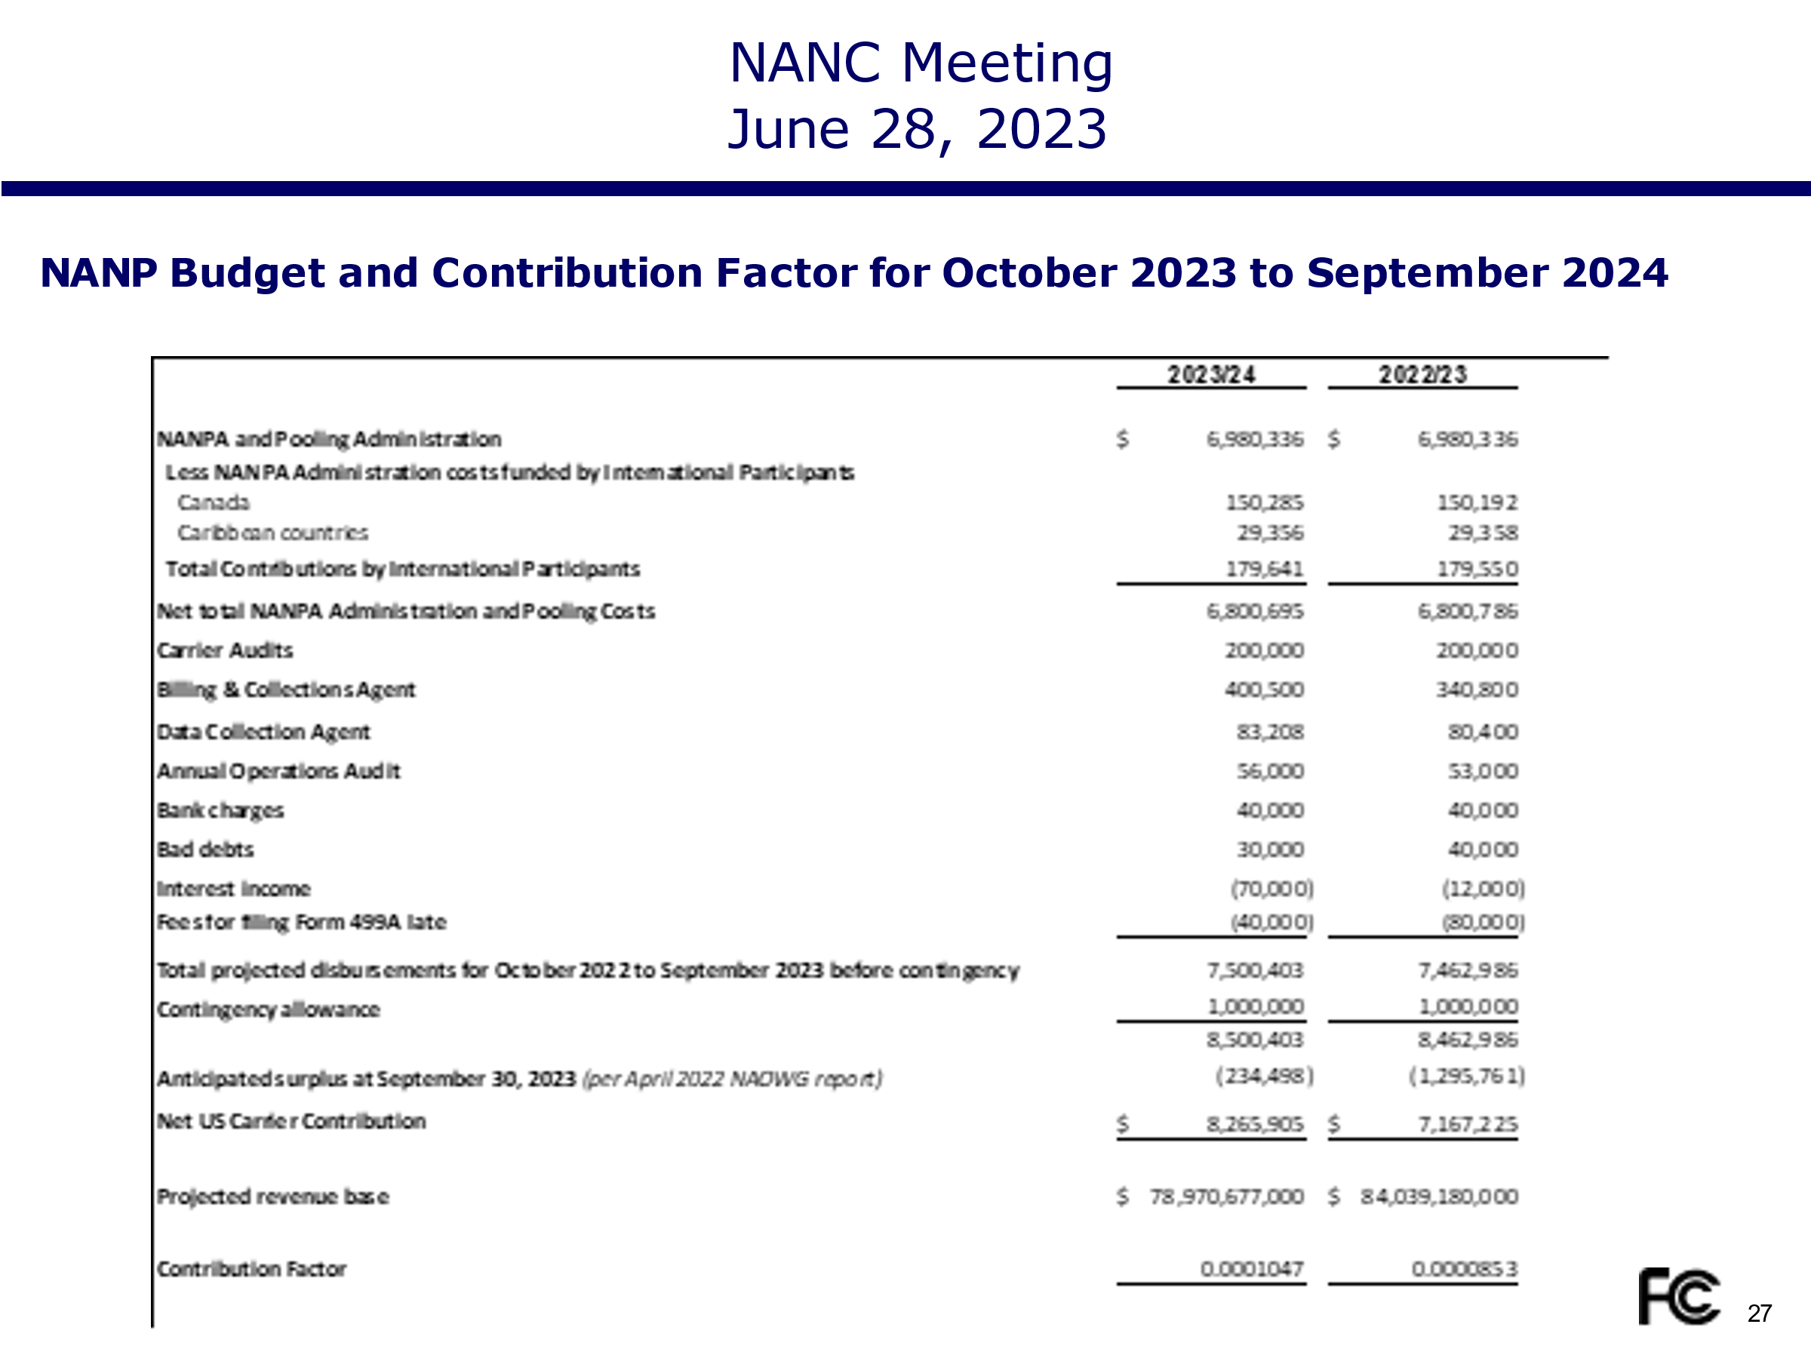

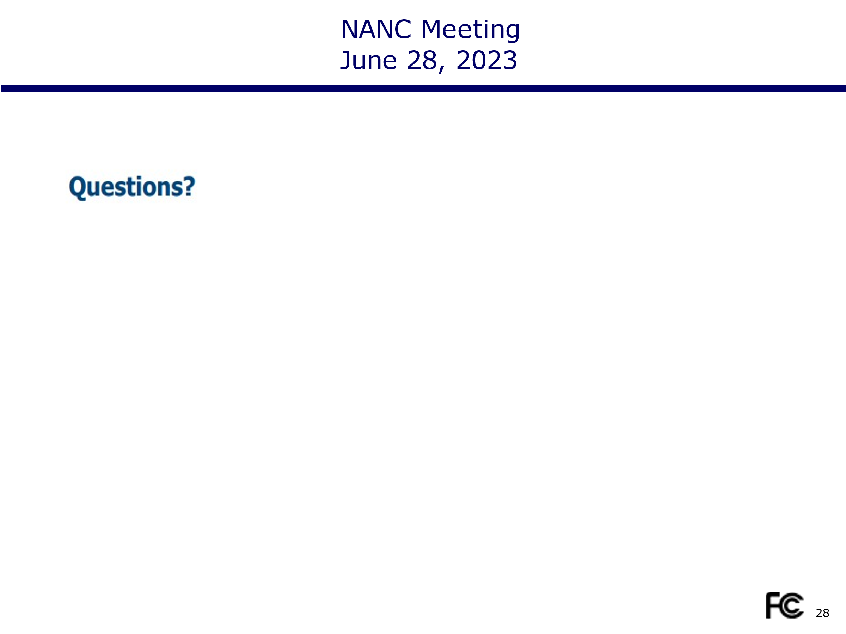
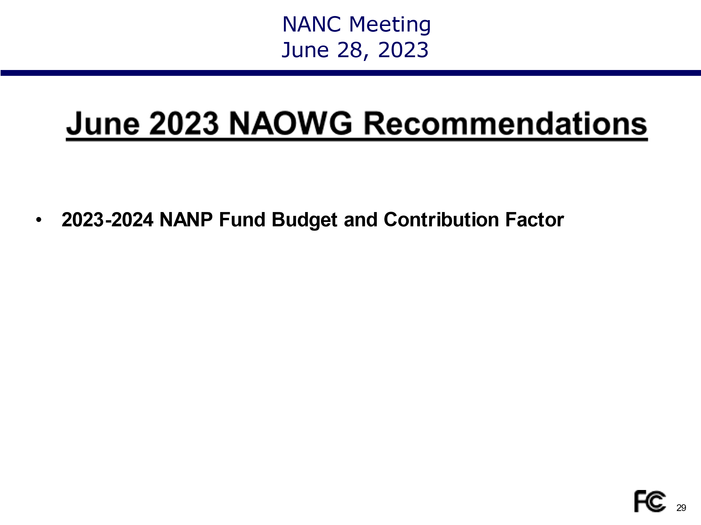
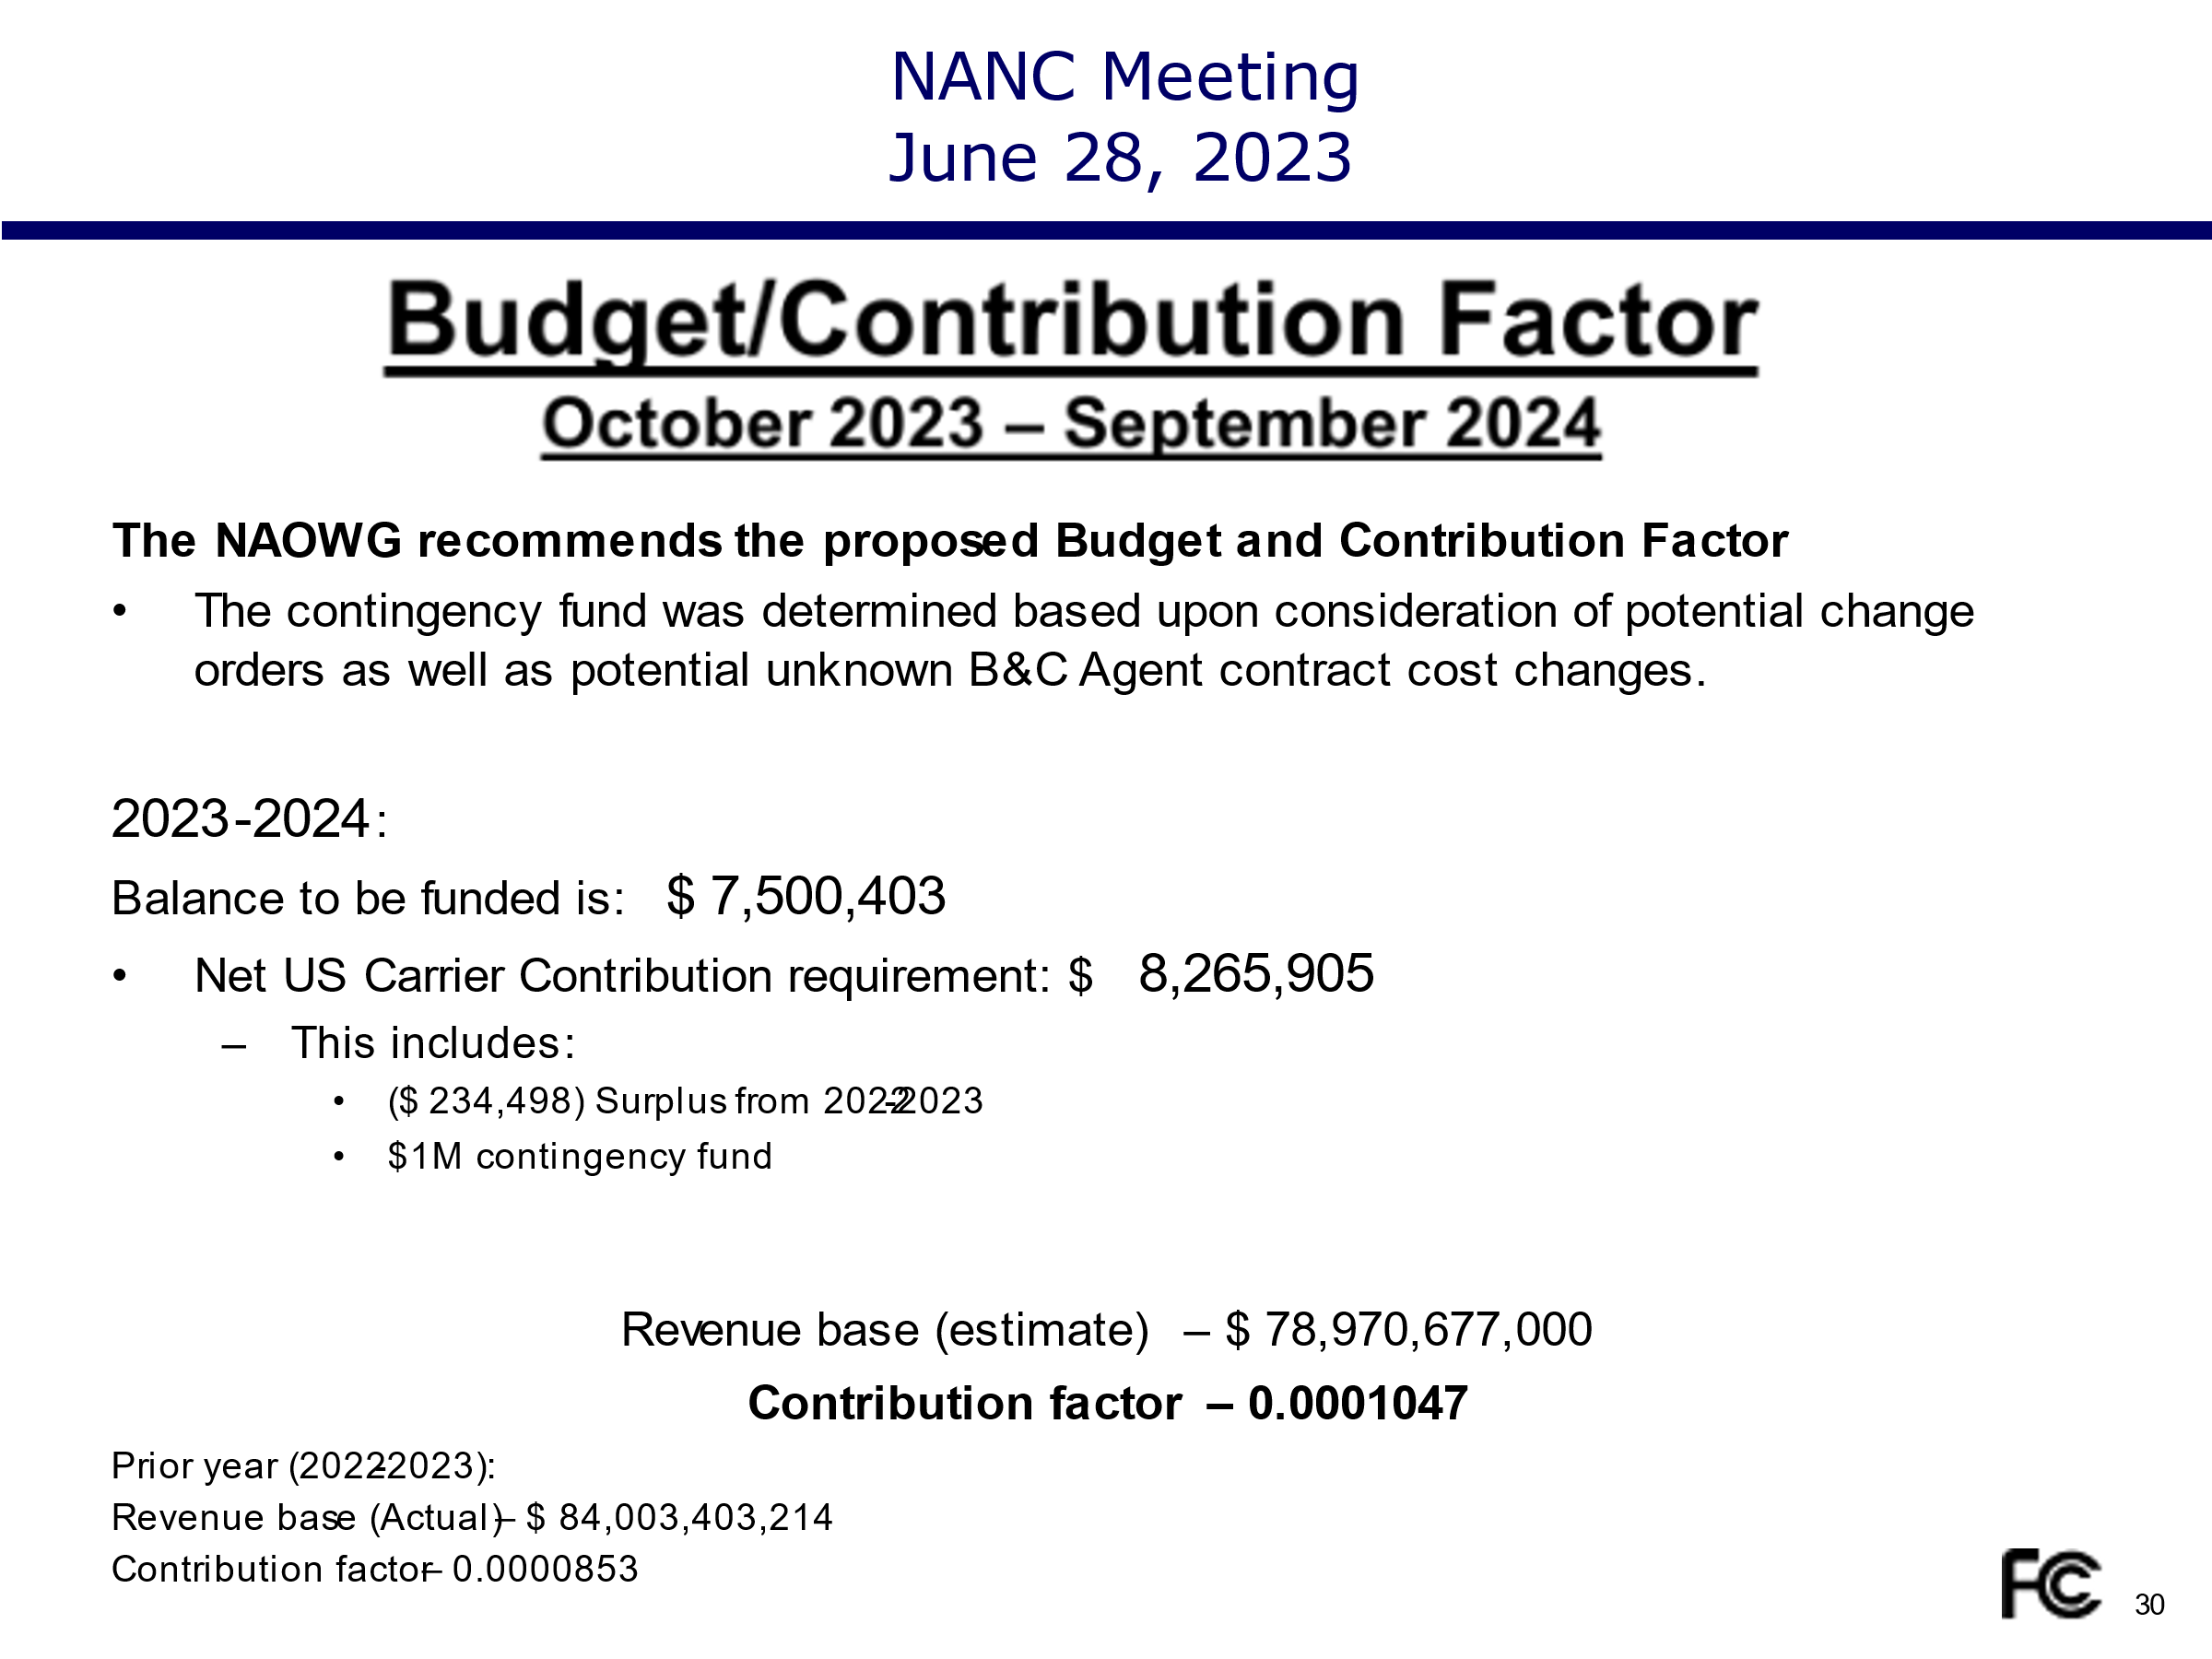
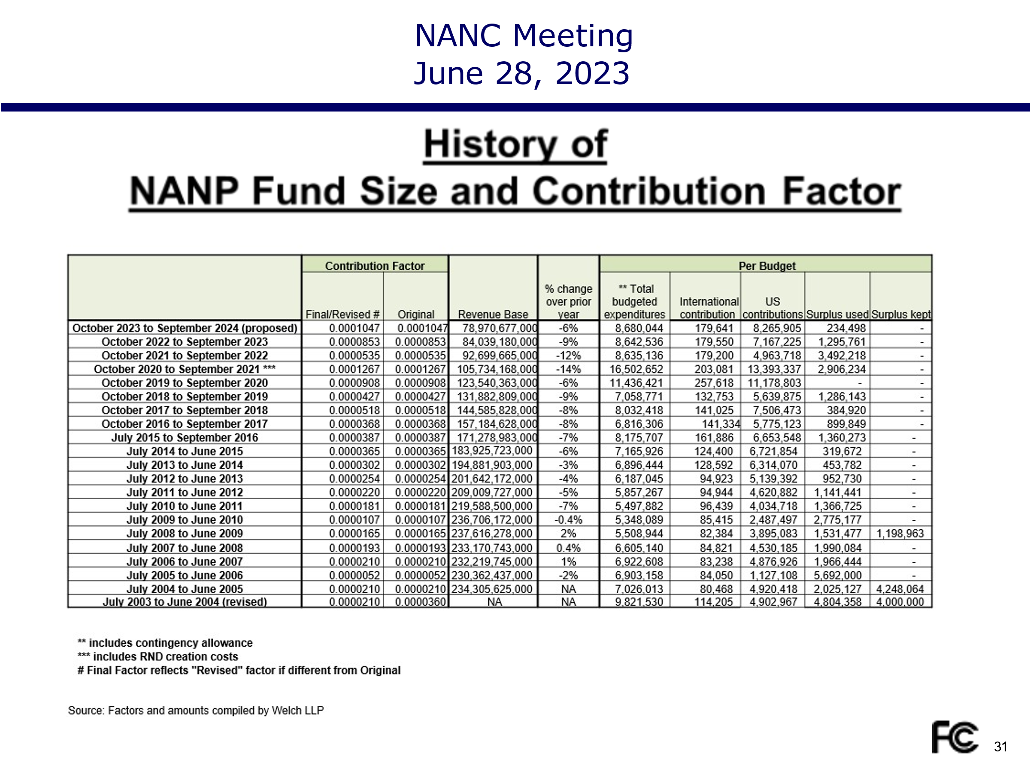

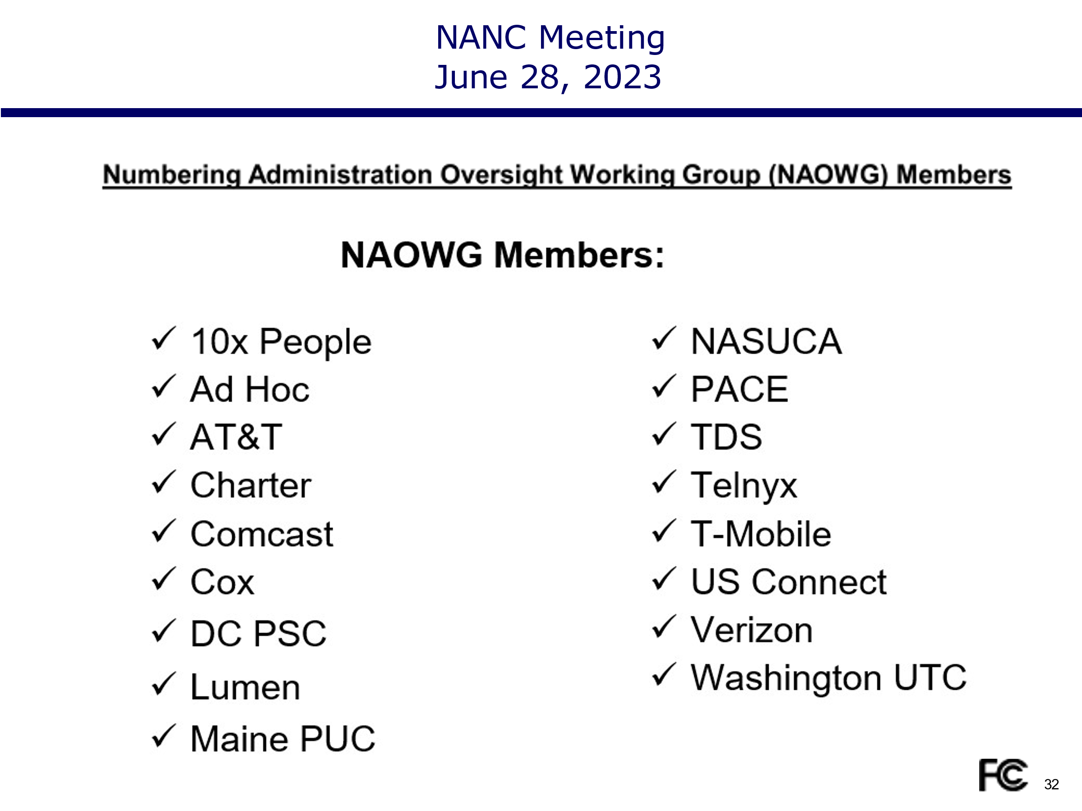
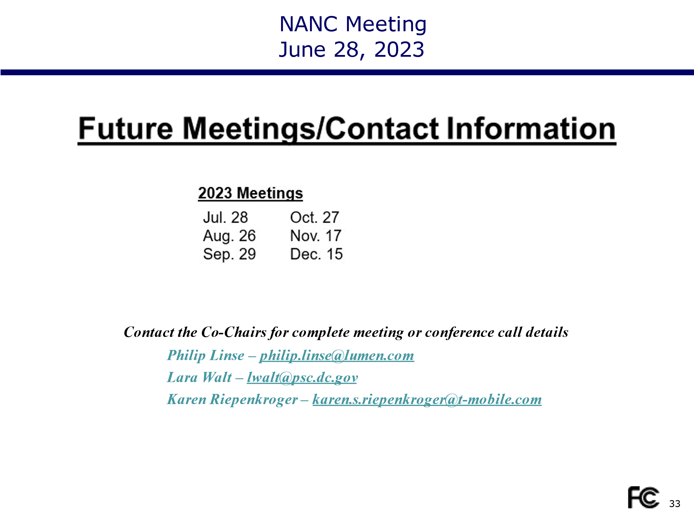
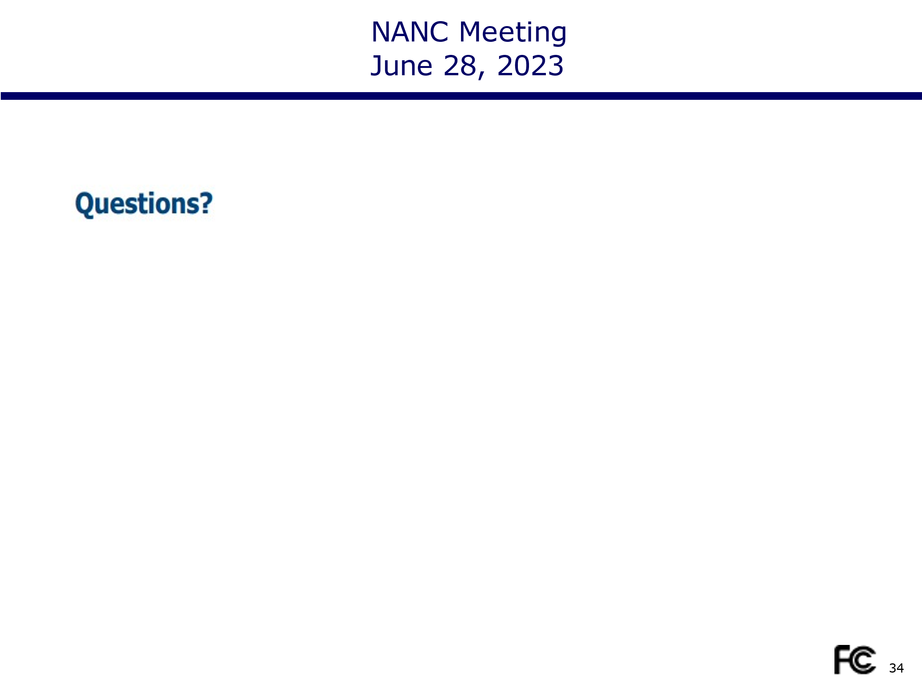
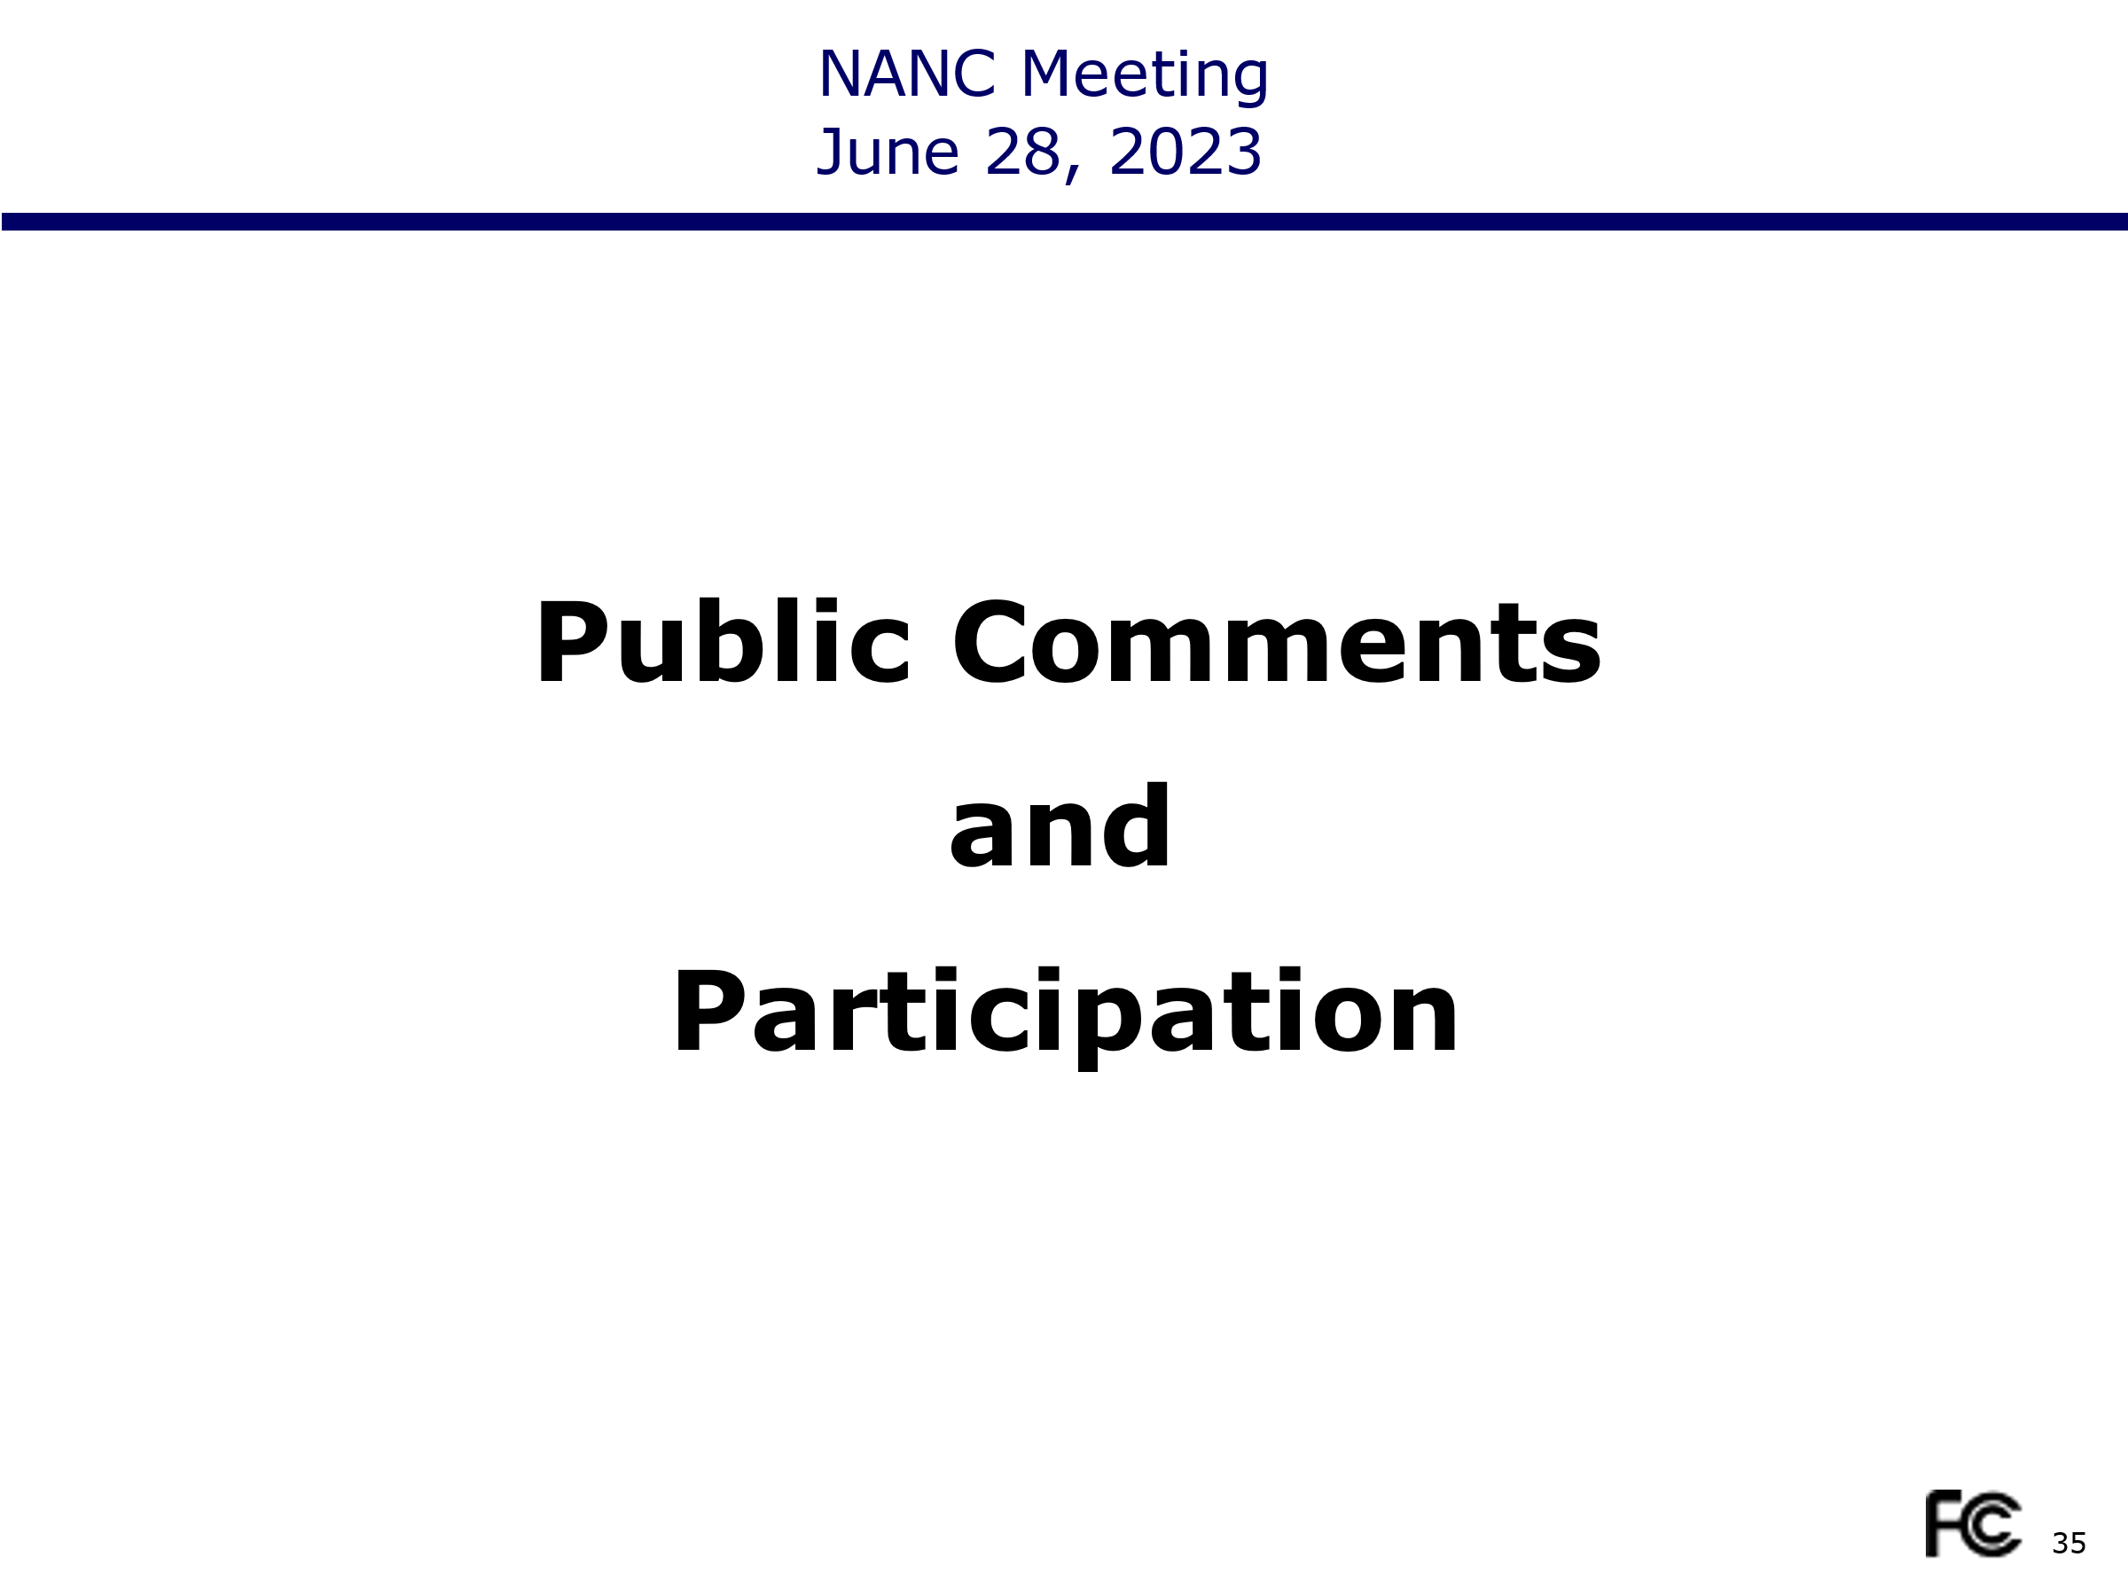
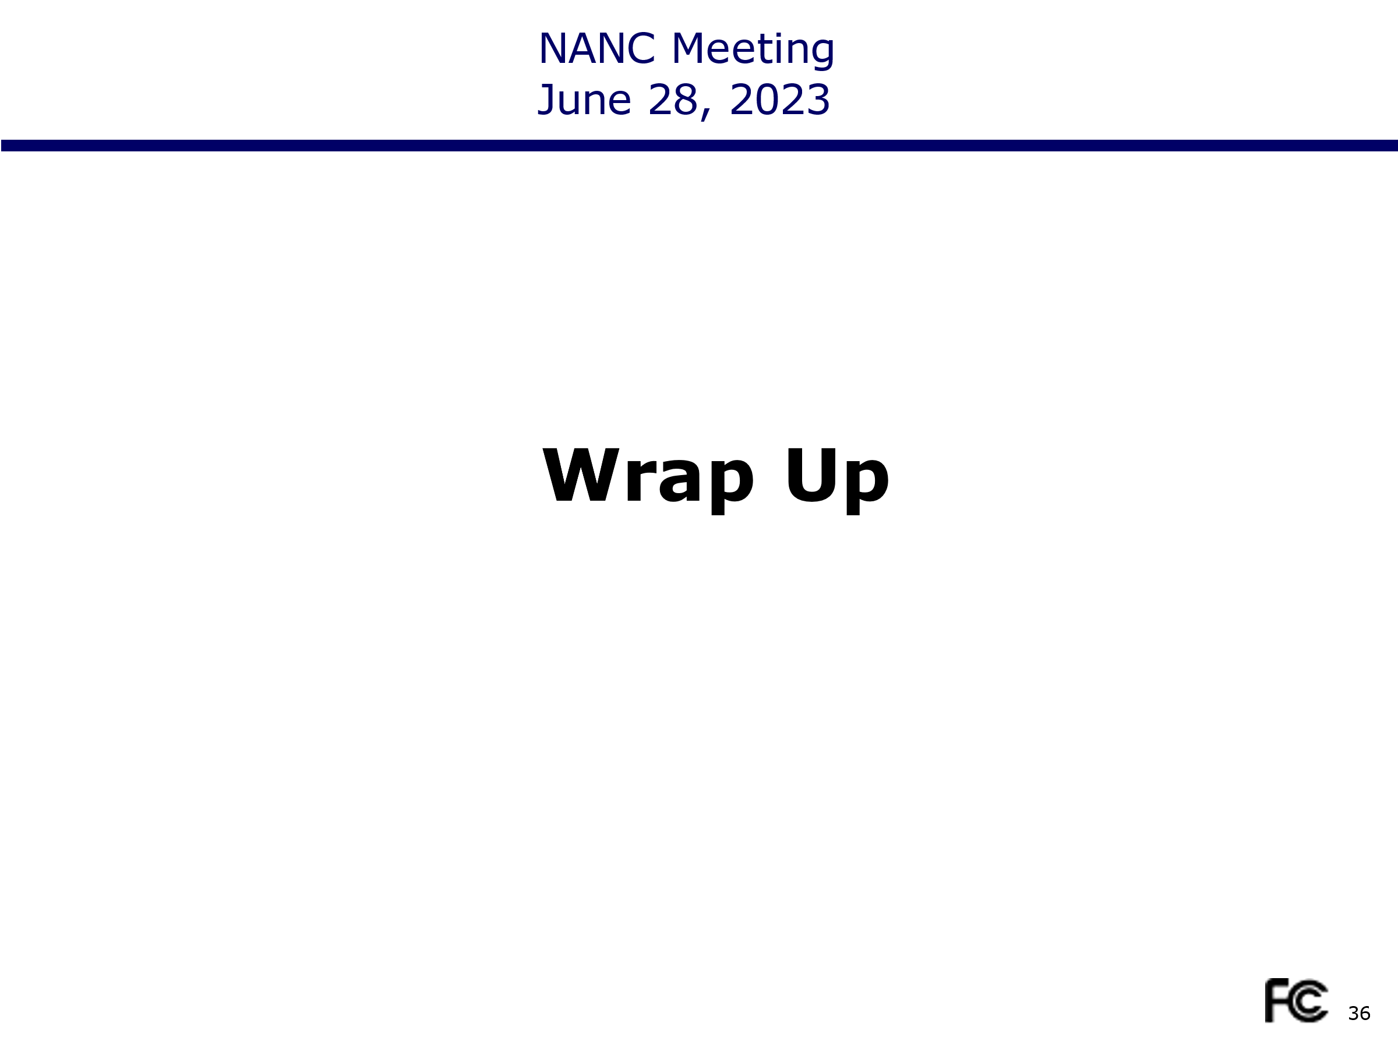
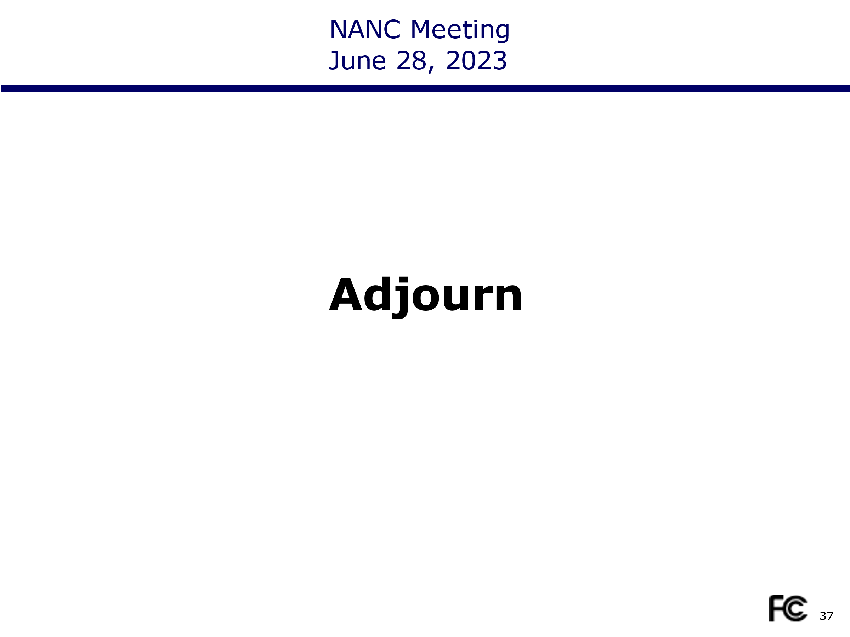

Certification of Minutes for Meeting of the North American Numbering Council

I, Karen Charles, Chairwoman of the North American Numbering Council, state that the above minutes are true and accurate, to the best of my knowledge and belief. Additional details of the meeting also may be found in the recorded videotape, available at https://www.fcc.gov/about-fcc/advisory-committees/general/north-american-numbering-council .

_________________________ ________________
Karen Charles Date
Chairwoman
North American Numbering Council

