FCC - Disaster Information Reporting System (DIRS)

Upload API Guide

Last Updated: September 25, 2023

Contents

1. Overview 3

2. Upload API 3

3. Preparing Data for Upload 5

CompanyID 5

UserID 6

DisasterID 7

Disaster Information Reporting System (DIRS) - Upload API

Target Audience: External Customers (Outside FCC Network)

# Overview

DIRS provides communications providers with a single, coordinated, consistent process to report their communications infrastructure status information during disasters.

# Upload API

The Upload API allows for the bulk upload of data without having to use the DIRS system GUI.

File uploads on DIRS are allowed via Basic Authentication. First, you will need to create an external user (non-FCC email) on CORES and <https://dirs.fcc.gov>

**Note**: Inputters are not allowed to upload a file, so please make sure you request to upgrade your user role to Coordinator.

Once your DIRS account has the Coordinator role, you can upload a file with the following process:

1. Use this endpoint: URL is POST <https://api-proxy-mulesoft.fcc.gov/dirs-batch-proxy/v1/files/uploadFile>. The endpoint uses Basic Authorization, so you will use the same Username and Password that you use to log in to the App.

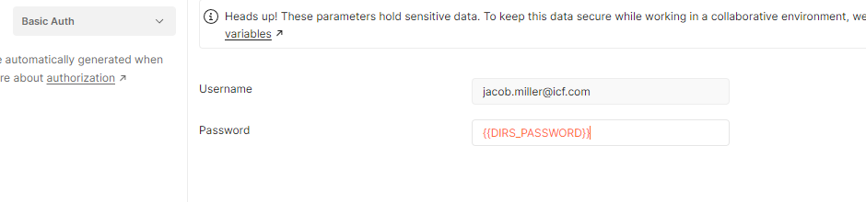

1. For this endpoint, you will be supplying form data rather than JSON in the request body. Be sure to specify the file you wish to upload. You must also supply the UserId, CompanyId and DisasterId in the request body.

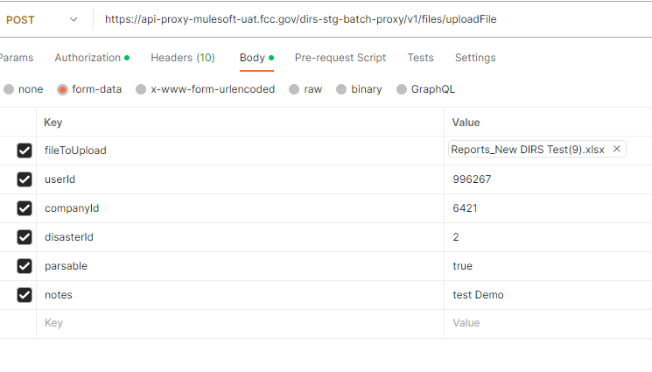

1. Feel free to make changes around UserId, CompanyId, DisasterId, etc..

(Note that UserId in the parameters mean “uploaded on behalf”. It can be different from the login user. Coordinators cannot upload a file outside of their company. )

1. Send the request.
2. If you see “File upload initiated” message this means your file upload started successfully.

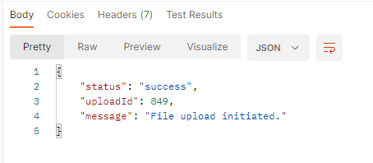

1. It will take a few minutes for the file to arrive and process in DIRS.

**\*\*Note** The file goes through a validation process after upload begins. The data in the file will only be added to the database if the file passes validation. You can track the status of the upload by logging into <https://dirs.fcc.gov> with same credentials you used to upload the file.

# Preparing Data for Upload

In order to use the API correctly, the Coordinator user will need to provide the following IDs, and should use the following steps to locate the correct IDs.

CompanyID

1. Navigate to the Company page for the company that is doing the reporting
   1. From the left navigation go to “Company & Users” > “Update Company Profile”

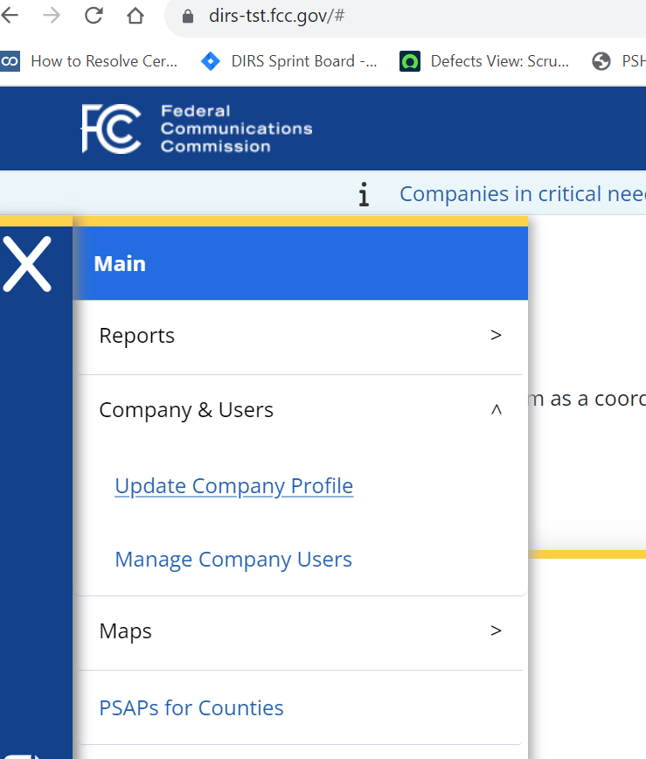

1. In the URL capture the company ID that follows the “…/company/”

UserID

1. Navigate to the top right of the screen and select the icon with your user initials in it. Example in the screenshot below is for a user “Jacob Miller” with initials of “JM”:

* 1. Click on the icon
  2. Click on Modify Profile

1. In the URL capture the User ID that follows the “…/user/”

DisasterID

1. Navigate to the Reports Chart disaster drop down.
   1. Locate the Disaster ID following the Disaster Name in the dropdown.

For any additional questions on using DIRS, please contact [DIRSHelp@fcc.gov](mailto:DIRSHelp@fcc.gov).