Federal Communications Commission (FCC)

  
  
  
Disaster Information Reporting System (DIRS)  
User Guide

**December 2023**  
Version 2.1

Revision History

|  |  |  |  |
| --- | --- | --- | --- |
| **Version** | **Date** | **Author** | **Change Description** |
| 1.0 | 05/04/2023 | P. Crawford, BA | Initial Draft |
| 1.1 | 10/04/2023 | K. Simon, ICF Tech Writer | Initial Revisions   * Features added 05/04 – 10/04/23 * Added details and images |
| 1.2 | 10/29/2023 | K. Simon, ICF Tech Writer | Secondary Revisions   * Updates from SME feedback * Added process overview graphic * Added updated images |
| 2.0 | 11/2/2023 | K. Simon, ICF Tech Writer | Final Revisions   * Updates from SME and client feedback |
| 2.1 | 11/13/2023 | K. Simon, ICF Tech Writer | Additional Revisions   * 508 compliance updates |

Table of Contents

1. Overview 5

2. Introduction to DIRS 6

3. Process Overview 7

4. User Roles in DIRS 8

5. Getting Help 10

5.1. Requesting General Information About DIRS 10

5.2. Submitting a Critical Need Request 10

6. Accessing DIRS 12

6.1. Creating a CORES Account 12

6.2. Creating a DIRS Account 15

6.3. Signing in to DIRS 19

7. Navigating Your DIRS Home Page 21

7.1. Viewing Your Notifications 21

7.2. Updating Your Profile Information 22

7.3. Updating Your Password 22

7.4. Switching Your Company View 23

7.5. Logging Out of DIRS 24

8. Adding and Updating Companies and Users 25

8.1. Adding a Company to DIRS 25

8.2. Updating Company Information 25

8.3. Updating User Information 26

9. Adding and Updating Provider Data 29

9.1. Manually Adding New Provider Data into DIRS 29

9.2. Bulk Uploading New Provider Data into DIRS 32

9.2.1. Major Equipment Template Worksheet 33

9.2.2. Remote Aggregation Devices Template Worksheet 34

*9.2.3.* Wireline PSAP Template Worksheet 35

9.2.4. Interoffice Facilities – TSP Template Worksheet 36

9.2.5. IXC Blocking Template Worksheet 37

9.2.6. Wireless MSC-STP-Voice Template Worksheet 37

9.2.7. Wireless Cell Site by County Template Worksheet 38

9.2.8. Broadcast Template Worksheet 39

9.2.9. Cable System Template Worksheet 40

9.2.10. Satellite Template Worksheet 41

9.3. Manually Updating Provider Data 42

9.4. Bulk Updating Provider Disaster Data 44

10. Generating and Downloading Reports and Lists 47

10.1. Generating and Downloading a Summary Report 47

10.2. Generating a Report List 48

10.3. Generating and Download a County PSAP List 50

10.4. Generating and Downloading a City List 51

11. Generating, Downloading, and Uploading Maps 53

11.1. Generating and Downloading a Disaster Map 53

11.2. Uploading and Downloading Wireless Coverage Maps 54

11.2.1. Uploading a Wireless Coverage Map 54

11.2.2. Downloading a Wireless Coverage Map 56

## Overview

This guide describes how to use the Federal Communications Commission (FCC) Disaster Information Reporting System (DIRS). DIRS is a web-based system used to collect situational awareness information from communications providers and to track restoration efforts during major disasters and recovery efforts. The system provides a single, coordinated, and consistent process for communications providers to report their communications infrastructure status information and request assistance.

The guide includes instructions for completing the following tasks in DIRS:

* Adding and updating communication provider data.
* Submitting critical need requests.
* Viewing, adding, and updating disaster reports.
* Viewing, uploading, and downloading disaster maps.
* Adding and updating company/user information.

## Introduction to DIRS

The Disaster Information Reporting System (DIRS) is a web-based system that communications providers (e.g., wireless, wireline, broadcast, and cable providers) can use to report communications infrastructure status and situational awareness information during times of crisis.

Because the information that communications companies enter into DIRS is sensitive for national security and/or commercial reasons, DIRS filings shall be treated as confidential upon filing. To improve the utility of DIRS and facilitate Federal restoration efforts, the Commission will disseminate aggregated DIRS information to other Federal agencies that are authorized participants on the Emergency Support Function-2 (ESF-2) team, and to authorized participants in the Commission’s Information Sharing program (see <https://www.fcc.gov/outage-information-sharing>) .

When DIRS is activated, the FCC may send a courtesy email to registered DIRS communication providers (i.e., Coordinators and Inputters) to notify them that a disaster has been activated. The email includes the geographic regions of the disaster and instructions for providers on submitting their status information. If you are a provider, you may find the following online county/zip code sites useful in determining which network infrastructure is in counties that are part of the declared disaster area.

Sites which can provide lists of zips within a given county include:

* <http://www.getzips.com/county.htm>
* <http://www.melissadata.com/lookups/countyzip.asp>
* <http://www.zip-codes.com/search.asp> .

Sites which can provide the county for a given zip include:

* <http://www.getzips.com/zip.htm>
* <http://www.melissadata.com/lookups/zipcityphone.asp>
* <http://www.zip-codes.com/search.asp>
* [www.zipinfo.com/search/zipcode.htm](http://www.zipinfo.com/search/zipcode.htm)

## Process Overview

The activation of a disaster in the Disaster Information Reporting System (DIRS) typically precedes an anticipated major emergency (e.g., major storms, hurricanes), but can also follow an unpredicted disaster. The following figure illustrates the basic DIRS process:

Graphic that describes basic DIRS process steps:
1. Disaster is anticipated, in progress, or has occurred.
2. FCC staff activate a disaster in DIRS and notify DIRS participants.
3. Participating communication network providers enter network status data into the system daily.
4. FCC staff aggregate and compile DIRS data to produce comprehensive disaster reports.
5. Emergency officials leverage DIRS reports for disaster management, recovery efforts, and emergency planning.

**Process Overview**

1. A major disaster is anticipated, in progress, or has occurred.
2. An FCC DIRS Administrator activates a disaster in DIRS by entering disaster details.
3. An FCC DIRS Administrator announces disaster activation to registered DIRS participants via courtesy email, including the counties affected, reporting instructions, and contact information.
4. Participating communication network providers (e.g., wireline, wireless, broadcast, cable, interconnected VoIP, and broadband service providers) enter their network status data into the DIRS system daily.
5. FCC staff compile and aggregate the network status data in DIRS to produce comprehensive disaster status and recovery reports.
6. FCC staff share disaster status and recovery reports with federal emergency management officials, DIRS participants, Information Sharing participants, and the public.
7. Emergency officials leverage DIRS reports to inform disaster response and recovery efforts and to plan for future disasters.

## User Roles in DIRS

|  |
| --- |
| **USER ROLE DETAILS:**   * **Coordinators can assign Coordinator or Inputter roles to their own company’s users.** |

Your user role in DIRS determines your capabilities in the system. When you create your DIRS account, you are assigned the Inputter role by default. You have the option of requesting a different role in the Desired User Type field on the Create a New Account page. Refer to the following User Role Descriptions table provided below for information on your role’s system capabilities.

| **User Role** | **Descriptions** |
| --- | --- |
| Person's silhouette representing the First, Second, or Third Reviewer role.  **Coordinator (Prescreen User)**  **Home Page Navigation Menu**Screenshot of the Coordinator Home page Navigation Menu in DIRS. | Communication provider staff who coordinate their company’s participation in the DIRS reporting and disaster management process. A Coordinator may be affiliated with multiple companies.  **Capabilities**:   * View/Add/Update/Download *their own company’s* information and users. * View/Add/Update/Download *their own company’s* disaster data/reports. * View/Add/Update/Download *their own company’s* equipment information. * View/Download disaster and wireless coverage maps * View/Download PSAPs and City lists. |
|  |  |
| Person's silhouette representing the First, Second, or Third Reviewer role.  **Inputter**  **Home Page Navigation Menu**Screenshot of the Inputter Home page Navigation Menu in DIRS. | Communication provider staff who assist Coordinators with data input for their own company. An Inputter can be affiliated with multiple companies.  **Capabilities**:   * Add data/reports *for their own company*. * Add network and equipment status information *for their own company*. * View/Update/Download network and equipment status information *they previously provided for their own company*. * View/Update/Download reports *they previously provided for their own company.* * View/Download PSAPs. |
|  |  |
| Image representing the Final Reviewer role.  **Participating Agencies User** (Fed/State/Tribal)  **Home Page Navigation Menu**Screenshot of the Participating Agencies User Home page Navigation Menu in DIRS. | Members of participating Information Sharing agencies (e.g., states, the District of Columbia, U.S. territories, federal government, and Tribal Nations) that have approved access.  **Capabilities**:   * View/Download (read-only) all reports *for their own agency or state*. |
|  |  |

## Getting Help

You can contact DIRS Administrators to request general assistance with non-urgent DIRS questions by email or calling DIRS support. However, if you need critical assistance before, during, or after a disaster activation you should submit a Critical Need Request to the FCC. A Critical Need banner available on the DIRS website and pages includes the link for submitting a request.

### Requesting General Information About DIRS

|  |
| --- |
| **USER ROLE DETAILS: Anyone can request help with DIRS.** |

Anyone with general questions about the Disaster Information Reporting System (DIRS) can email [DIRS Help](mailto:FCC-Disaster@fcc.gov?subject=FCC%20Disaster) ([DIRSHelp@fcc.gov](mailto:DIRSHelp@fcc.gov)) or call/email one of the FCC numbers listed below.

* Michael Caiafa (202) 418-1311 michael.caiafa@fcc.gov
* John Healy (215) 8094 john.healy@fcc.gov
* Ryan Hedgpeth (202) 664-9952 ryan.hedgpeth@fcc.gov
* David Ahn (202) 418-0853 [david.ahn@fcc.gov](mailto:david.ahn@fcc.gov)
* FCC Operations Center (202) 418-1122 fccops@fcc.gov

### Submitting a Critical Need Request

|  |
| --- |
| **USER ROLE DETAILS: Anyone can submit a Critical Need Request** |

Anyone who has critical questions, requires critical assistance, or wants to quickly alert federal authorities about critical infrastructure that is damaged or under threat, can submit a Critical Need Request to the FCC. A Critical Need banner, which includes a link for submitting a Critical Need Request, is available on the DIRS website and pages.  
  
**Note**: DIRS Administrators are notified via email when you submit a Critical Need Request and will coordinate the response and follow-up.

Use the following steps to submit a Critical Ne, ed Request:

1. Navigate to the [external DIRS website](https://dirs.fcc.gov/) - <https://dirs.fcc.gov/>, and, after viewing the System Usage pop-up notification, select **I Accept**.
2. Select ***click here*** on the Critical Need banner.  
   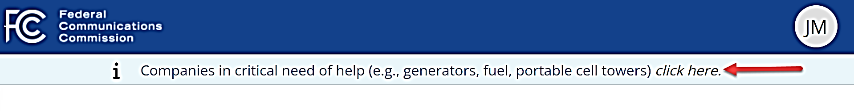
3. Enter your contact information in the Critical Need Request form fields, then click **Submit**. The required fields have an asterisk.  
   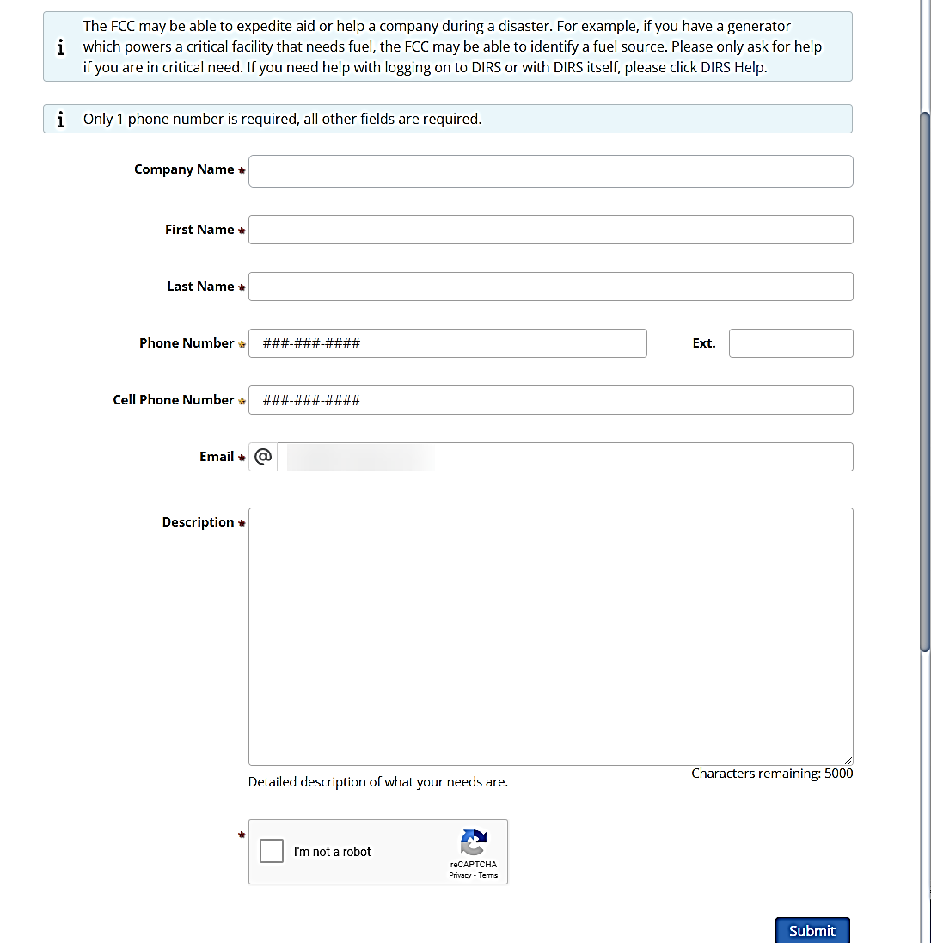

## Accessing DIRS

|  |
| --- |
| **USER ROLE DETAILS: Anyone can access DIRS.** |

New Users must register with the FCC by creating an FCC Commission Registration System (CORES) account before accessing DIRS. Current DIRS users without an existing account in CCORES will need to create a CORES account prior to accessing DIRS. Current DIRS users with an existing CORES account will not need to create a new DIRS account. New DIRS users will first need to register in CORES, and then create new DIRS account. The Username and Password you establish in CORES *is also used* for DIRS.

### Creating a CORES Account

Users must create an FCC CORES Username account *before* you can create a DIRS account. If you already have an FCC CORES account skip to Section 6.2 Creating a DIRS Account.

Use the following steps to create a CORES account:

1. Navigate to the [external DIRS website](https://dirs.fcc.gov/) (non-FCC users) and, after viewing the System Notification pop-up, select **I Accept**.
2. Select Create Account on the DIRS Welcome page.  
   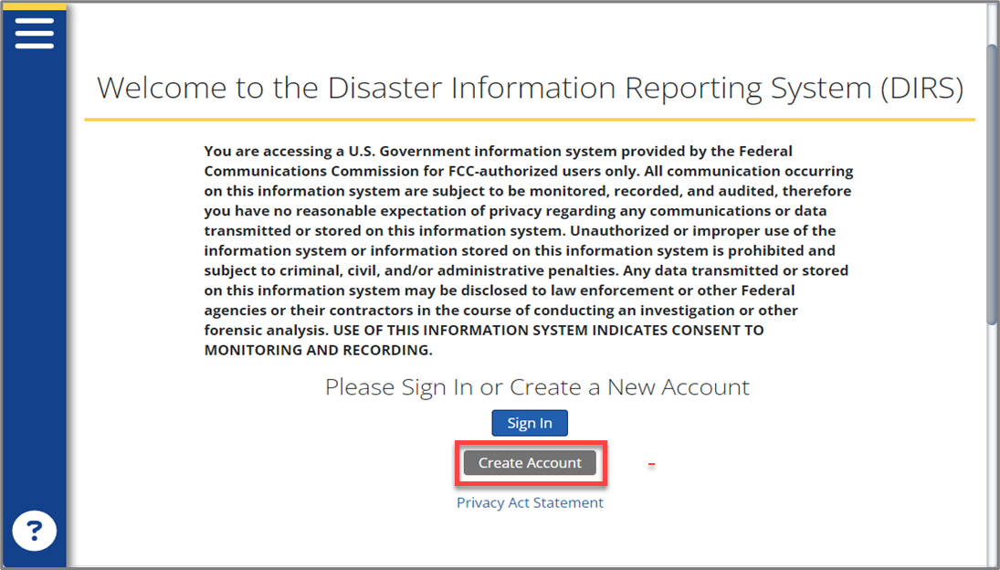
3. Click **Create a CORES Account** on the Create a New Account information page to open the FCC CORES website.  
   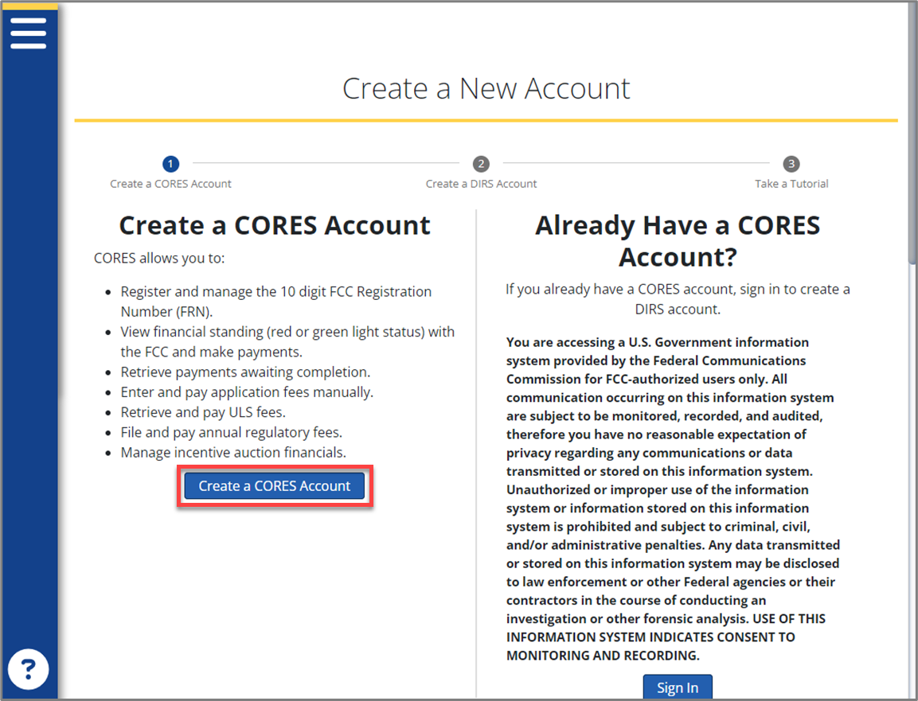
4. Click **Register** in the Need a Username tile on the FCC CORES website.  
   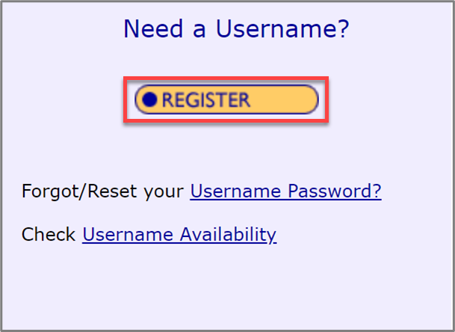
5. Enter a **Username** and **Password** in the Create New Account page fields, following the instructions on the form, then select **Create Account**. The email address you use to register *must not* be an FCC email address. The required fields have an asterisk.   
   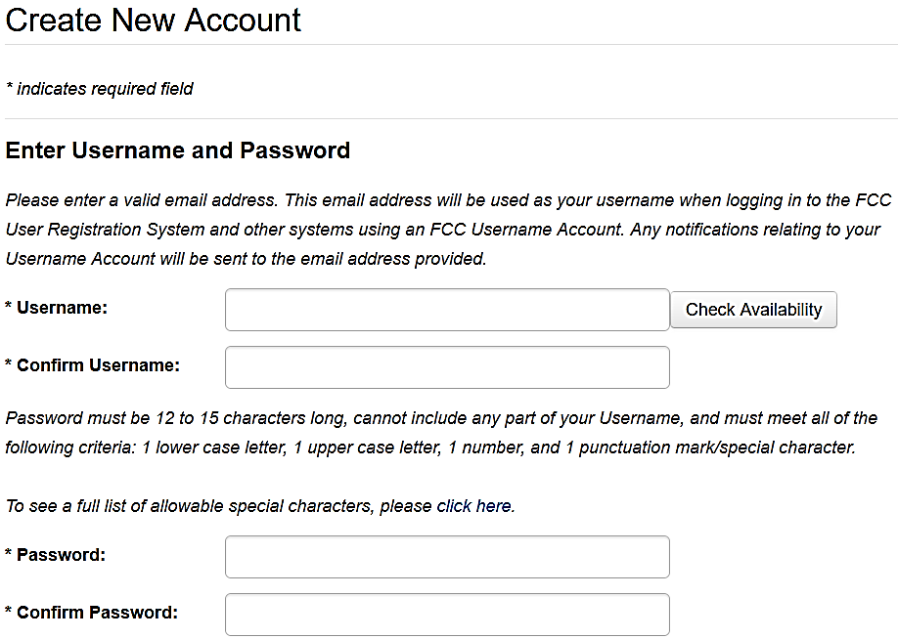
6. Verify your email address by following the instructions in the FCC CORE Registration Confirmation email you receive. Your CORES account will be activated after you verify your email address.

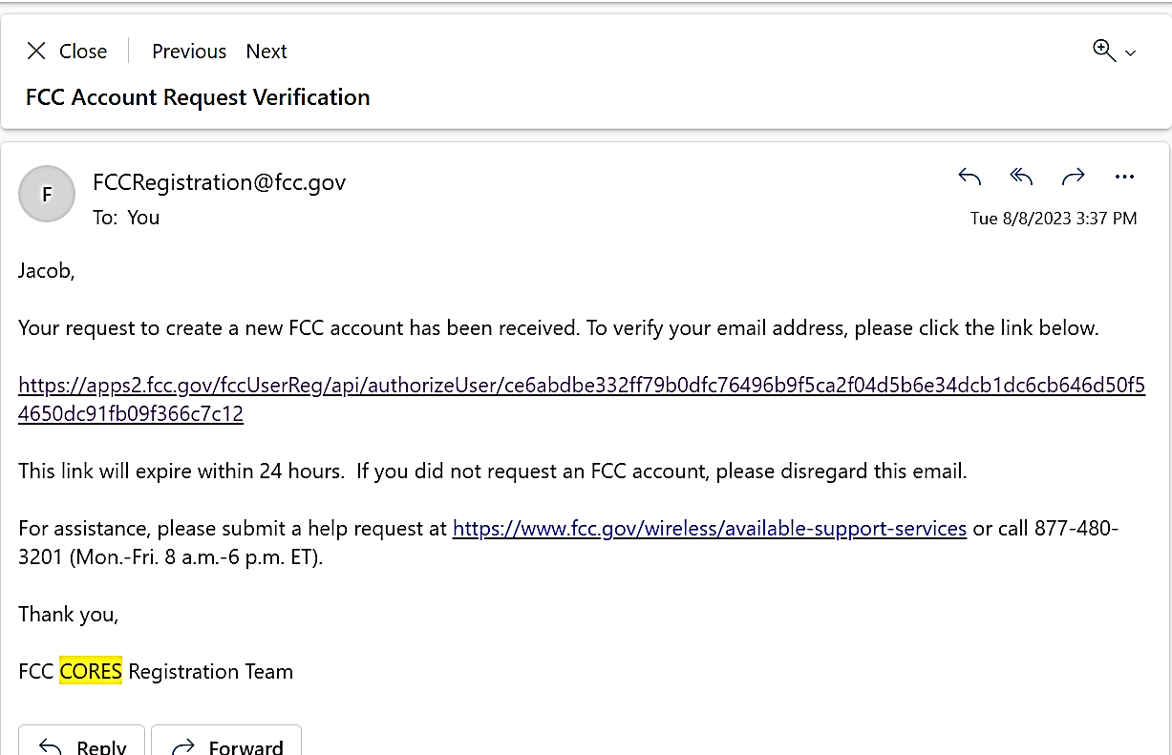

User

### Creating a DIRS Account

Use the following steps to create a DIRS account:

1. Navigate to the [external DIRS website](https://dirs.fcc.gov/) (non-FCC users) and, after viewing the System Usage pop-up notification, select **I Accept**.  
   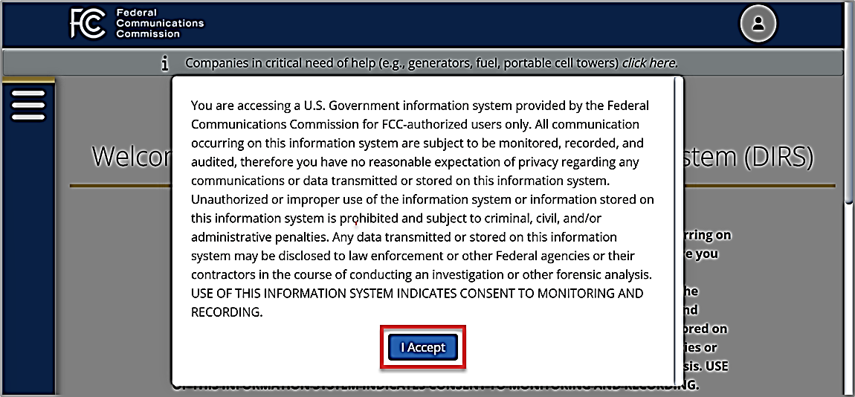
2. Click **Create Account** on the DIRS Welcome page.  
   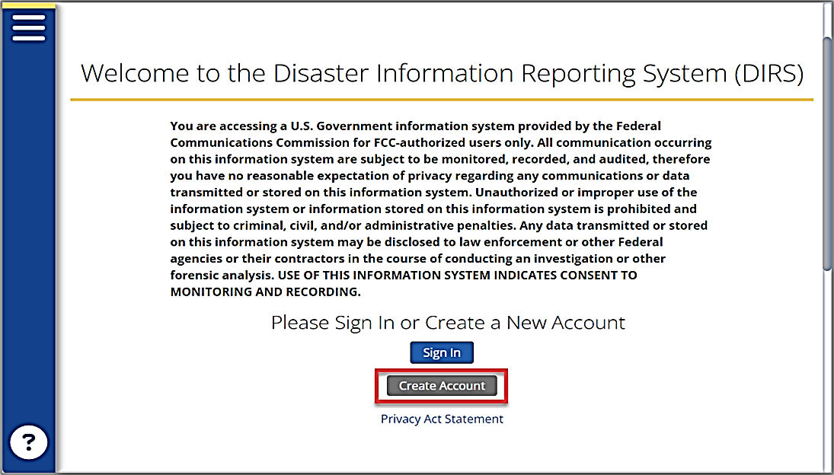
3. Click **Sign In** on the Create a New Account Information page.  
   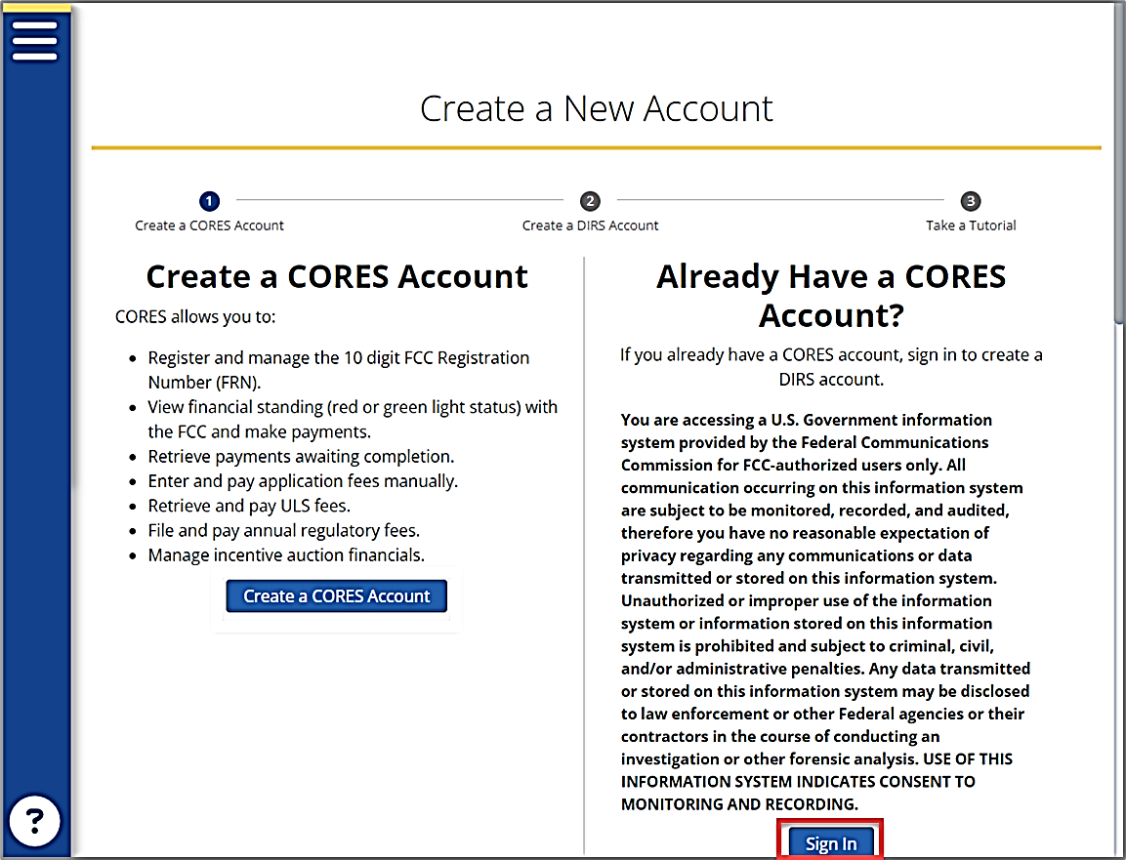
4. Enter your FCC CORES **Username** and **Password**, then click **Sign In** on the DIRS sign in form. 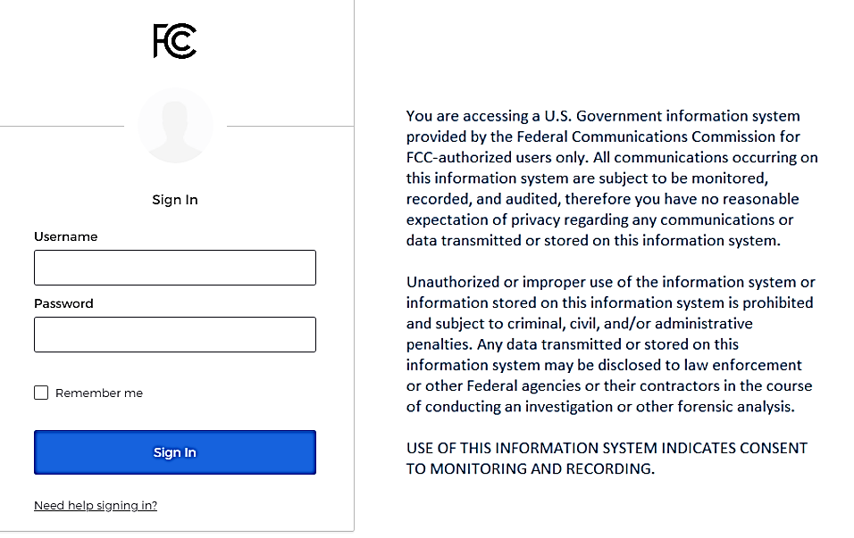
5. Click in the **Company Name** field on the Create a New Account form to select from a drop-down list of companies in DIRS or enter a new **Company Name**.  
   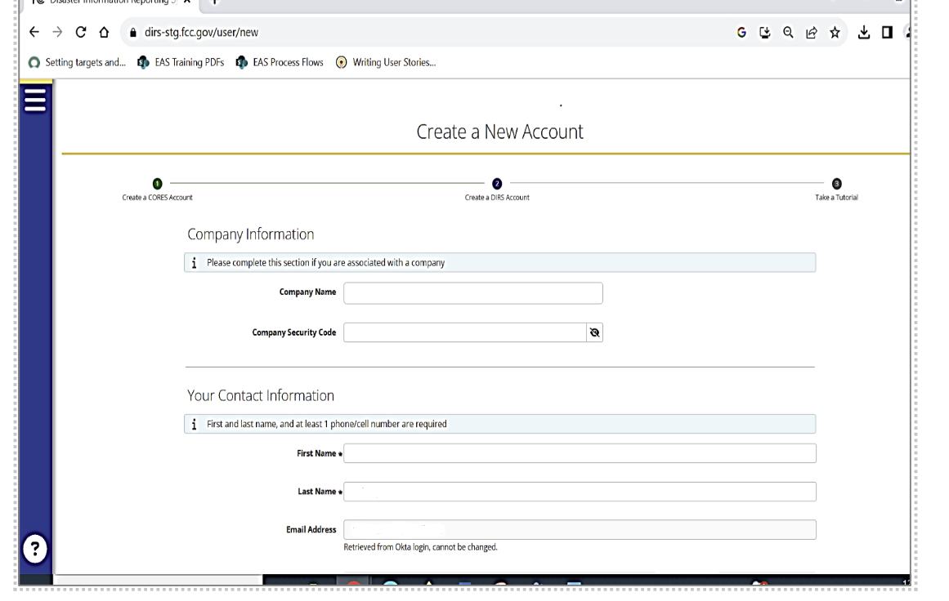
6. To complete the Company Security Code field, do one of the following:
   * If you entered an existing company in the Company Name field, enter its existing **Company Security Code**. Your company’s Coordinator has access to the code in DIRS.
   * If you entered a new company in the Company Name field, enter a new 8-digit security code in the **Company Security Code** field.
7. Enter your contact information in the form fields, then click **Submit**. The required fields have an asterisk.
8. A **Congratulations!** Banner displays when your DIRS account is created. The banner has the following options:
   * Click **Read The Tutorial** to see a brief tutorial about DIRS.
   * Click **Landing Page** to open your DIRS Landing Page.



### Signing in to DIRS

After you have created a DIRS account, you can sign in and begin using DIRS.

Use the following steps to sign in to DIRS:

1. Navigate to the [external DIRS website](https://dirs.fcc.gov/) (non-FCC users) and, after viewing the System Usage pop-up notification, select **I Accept**.  
   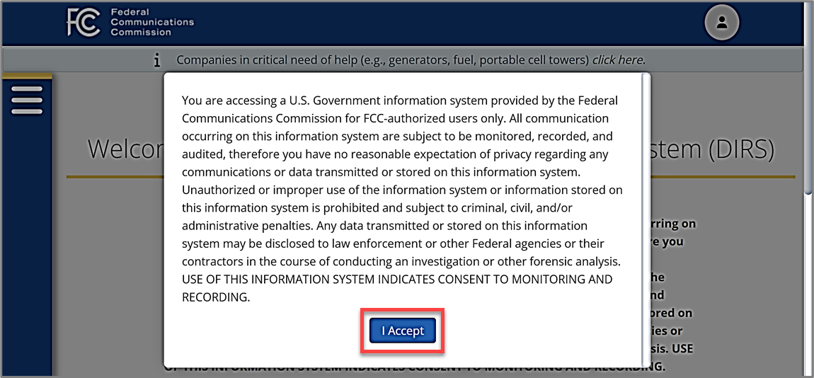
2. Click **Sign In** on the DIRS Welcome page.  
   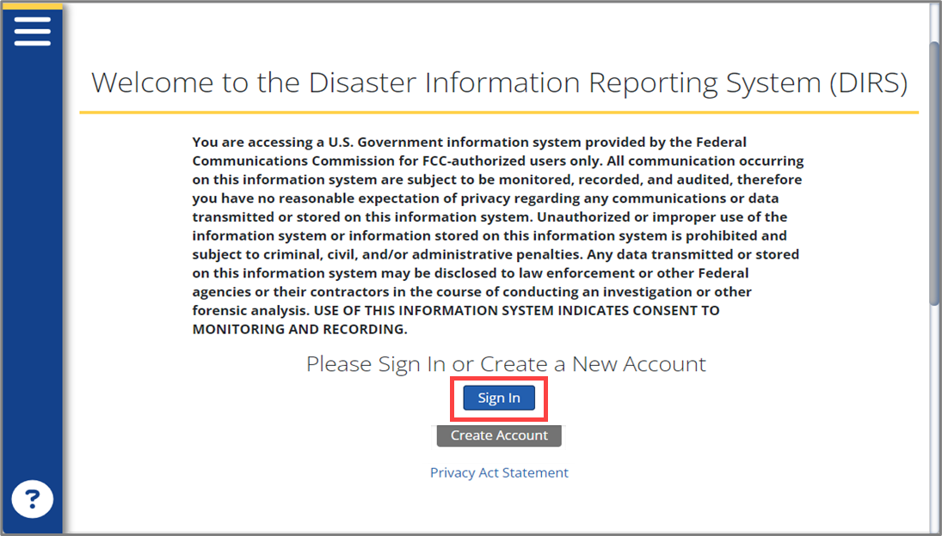
3. Enter your FCC DIRS (and CORES) **Username** and **Password**, then click **Sign In** on the DIRS Sign In form.  
   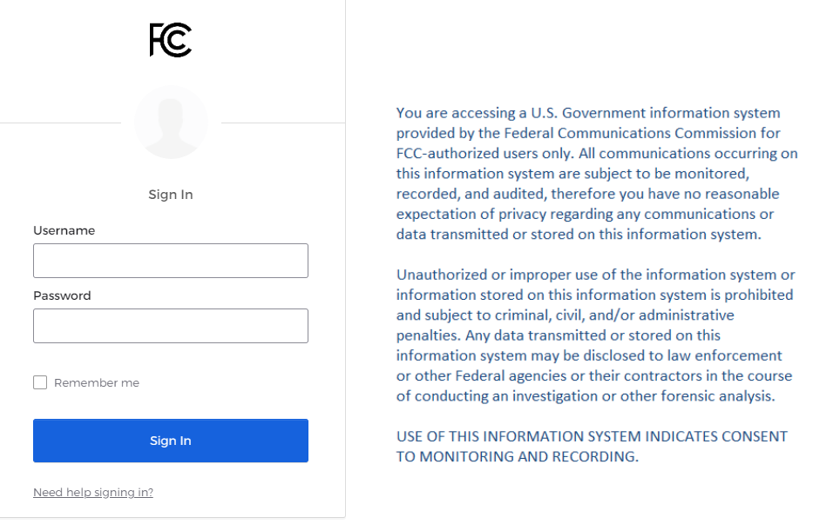

## Navigating Your DIRS Home Page

|  |
| --- |
| **USER ROLE DETAILS: All DIRS users** |

When you sign in to DIRS, your Home page displays. The features and content on your Home page vary based on your user role. Your assigned role is included in the page Greeting section.  
  
  
Your Home page consists of a Main pane and a Navigation Menu. Your Main pane includes links to your role’s frequently used options, and your Navigation Menu includes links to your user role’s *full set* of options.   
  
All Home pages include the following features:

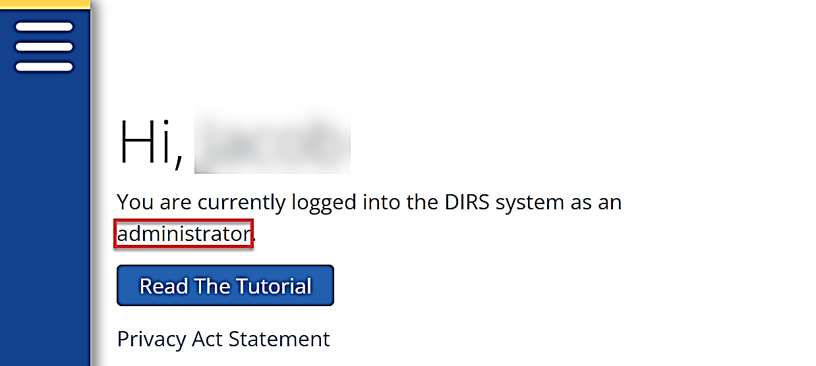

inputter

* **Header** – an FCC logo (Home page link) and your Profile icon
* **Critical Need Banner** – a link to submit Critical Need Requests to the FCC
* **Greeting** – your name and user role.
* **Navigation Menu** – all available content and options for your user role
* **Quick Links** – frequently used options for your user role
* **Help Icon** – links to a DIRS tutorial and the DIRS User Guide
* **Privacy Act Statement** – link to a Privacy Act statement

Home pages may also include the following features, *depending on your user role*:

* **Company & Users** – company and user update links
* **Maps –** easy access to disaster maps and wireless coverage maps
* **Reports** – a filterable graph with your report statistics

### Viewing Your Notifications

|  |
| --- |
| **USER ROLE DETAILS: All DIRS users** |

DIRS system notifications are displayed above your Home page header. Use the **Notification** toggle (gray handle) to hide/display the notification(s). Clear each notification by clicking the **X** icon in its row or clear them all at once by clicking **Clear All Notifications**.  
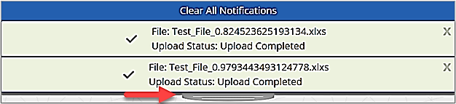

### Updating Your Profile Information

|  |
| --- |
| **USER ROLE DETAILS: All DIRS users** |

You can update your DIRS profile contact information as needed.

Use the following steps to update your profile contact information:

1. Click on your **Profile** icon in your Home page header and select **Modify Profile** from the drop-down list.  
   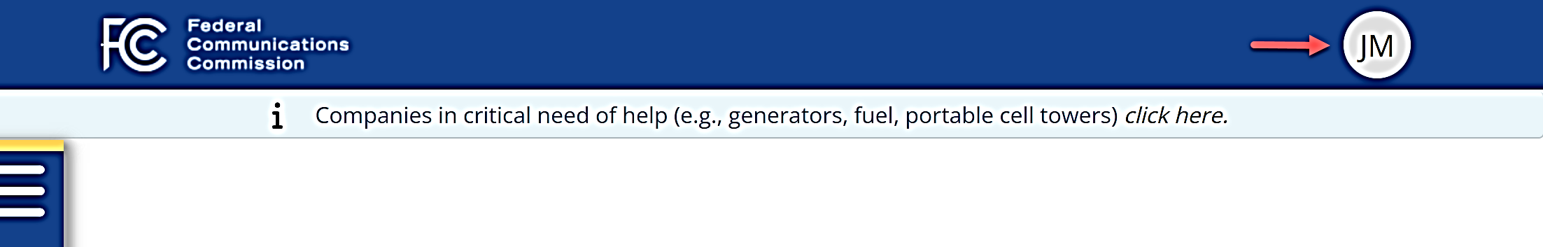
2. Update your First Name, Last Name, or phone numbers in the **Modify Profile** form, then click **Submit**.  
   **Note**: To update your Email or Role in DIRS, contact your Coordinator or a DIRS Admin. 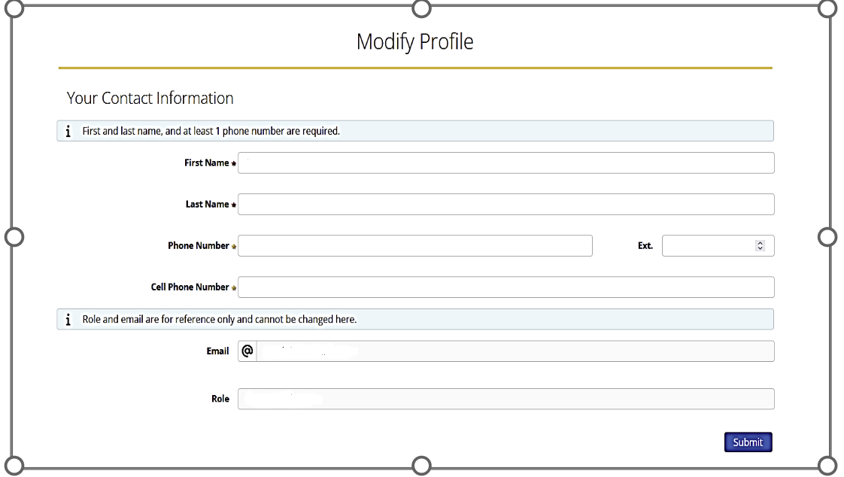

### Updating Your Password

|  |
| --- |
| **USER ROLE DETAILS: All DIRS users** |

Use the following steps to update your password:

1. Click on your **Profile** icon in your Home page header and select **Modify Password** from the drop-down list to open the FCC CORES website.
2. Follow the instructions on the FCC CORES website to reset your password.

### Switching Your Company View

|  |
| --- |
| **USER ROLE DETAILS: DIRS users with multiple company affiliations** |

If your DIRS user account is associated with multiple companies, you can switch your view from one company to another by selecting **Switch Company** in your Profile drop-down list.

Use the following steps to switch your company view:

1. Click on your **Profile** icon in your Home page header and select **Switch Companies** from the drop-down list.  
   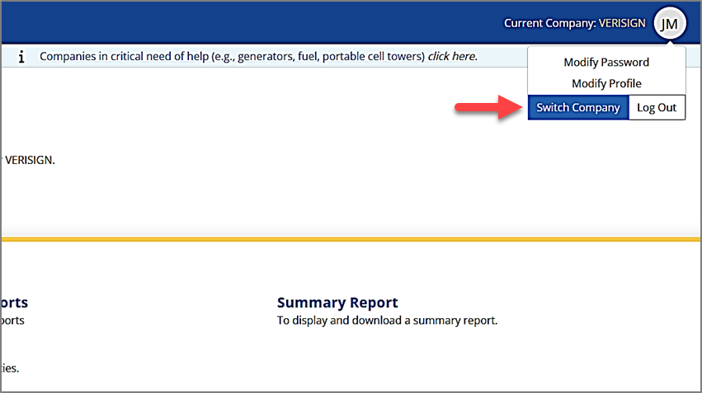
2. Select a company from the **Switch Company** pop-up to change your view to a different company’s data.

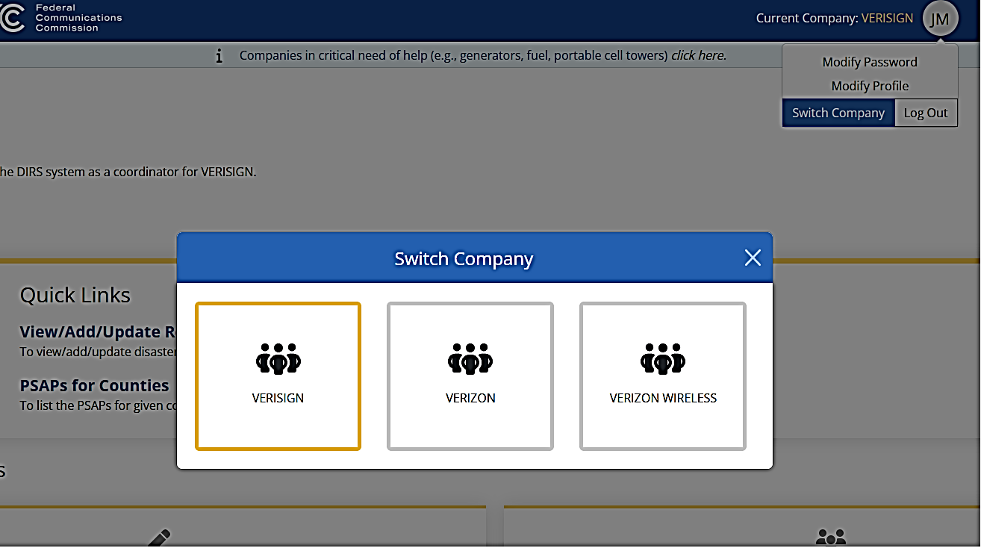

Comp A

Comp B

Comp C

### Logging Out of DIRS

|  |
| --- |
| **USER ROLE DETAILS: All DIRS users** |

You should always log out of DIRS to close your work session. Click on the **Profile** icon in your Home page header and select **Log Out** from the drop-down list to log out.  
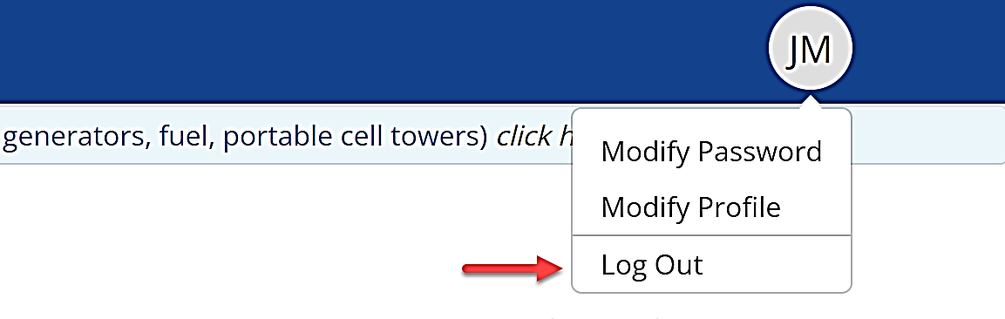

## Adding and Updating Companies and Users

DIRS company and user information can be added or updated as needed.

### Adding a Company to DIRS

|  |
| --- |
| **USER ROLE DETAILS:**   * **New DIRS users can add their own company when creating their DIRS account.** |

New companies are added to DIRS using the following method:

* New DIRS users can add a new Company Name and Company Security Code in the Create a New Account form *when creating their own DIRS account*. Refer to guide Section 6.2 Creating a DIRS Account for additional information on this method.

### Updating Company Information

|  |
| --- |
| **USER ROLE DETAILS:**   * **Coordinators can update their own company’s information.** |

Use the following steps to update company information:

1. Navigate to the [external DIRS website](https://dirs.fcc.gov/) (<https://dirs.fcc.gov/>) and sign in to DIRS.
2. Click **Update Company Profile** (Coordinators) on your Home page or Navigation Menu.
3. **Coordinators:**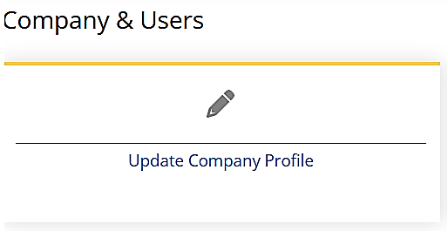
4. Find the company you want to update on the Company table and click on its **Company Name** to open its Update Company form.
5. Edit the **Update Company** form fields as needed, then select **Update** to save your updates. The required fields have an asterisk. Refer to the Company Field Descriptions table in Section 8.1 as needed.

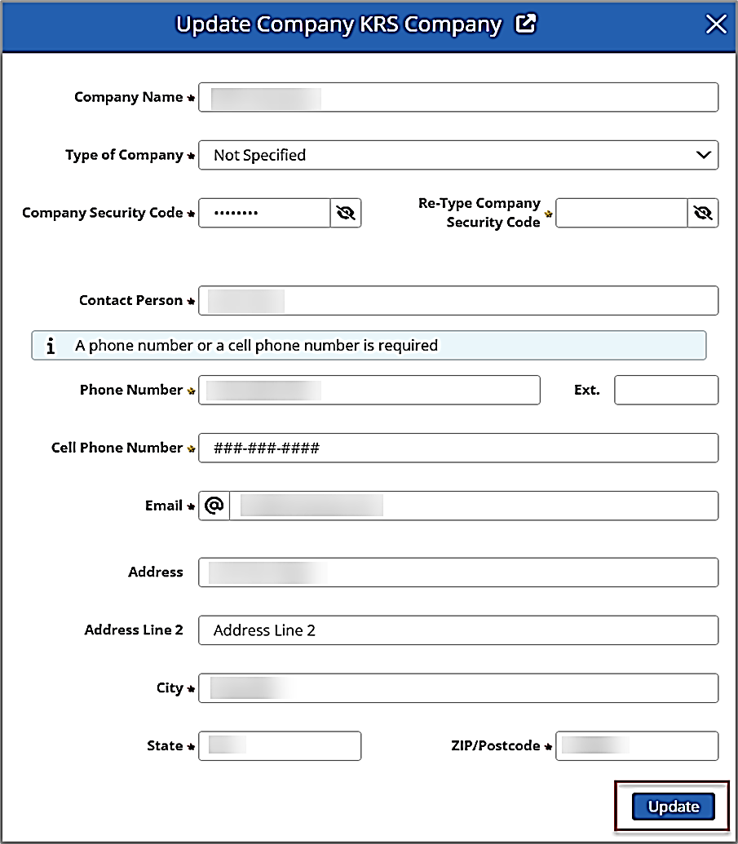

### Updating User Information

|  |
| --- |
| **USER ROLE DETAILS:**   * **Coordinators can update their own company’s user information.** |

All users can update their own contact information by selecting Modify Profile on their Home page Profile menu. Only a Coordinator can update other user information.

Use the following steps to update user information in DIRS:

1. Navigate to the [external DIRS website](https://dirs.fcc.gov/) (<https://dirs.fcc.gov/>) and sign in to DIRS.
2. Click **Manage Company Users** (Coordinator) on your Home page or Navigation Menu.  
   A picture containing text

   Description automatically generated
3. Edit the **Manage Company Users** (Coordinators) form fields as needed, then select **Update** to save your updates. The required fields have an asterisk. Refer to the User Field Descriptions table provided below.

**Coordinators:**

| **User Field Descriptions** | | |
| --- | --- | --- |
| **Field Name** | **Required** | **Description** |
| **Deactivate** |  | Click checkbox to deactivate a user. |
| **Role** | X | Click the field to select a User Role from a drop-down list.  **Notes**:   * Coordinators can only change their own users, and only to the Inputter or Coordinator roles. * Default role, assigned during account creation, is Inputter. |
| **Companies** (Admins Only) | X | Enter or add a company name. |
| **First Name** | X | Enter a first name. |
| **Last Name** | X | Enter a last name. |
| **Phone Number** | X (See Note) | Enter a phone number. **Note:** This field, **OR** Cell Phone Number is required. |
| **Ext** |  | Enter a phone extension. |
| **Cell Phone Number** | X (See Note) | Enter a cell phone number. **Note:** This field, **OR** Phone Number is required. |
| **Email** (Admins Only) | X | Enter an email address. |
| **Notify by Email** |  | Select checkbox to receive notifications via email. |

## Adding and Updating Provider Data

After the FCC activates a disaster in DIRS, communication providers (e.g., wireline, wireless, broadcast, cable, interconnected VoIP, broadband and satellite providers) can add their disaster related infrastructure status information to DIRS. The data can be directly entered into DIRS as reports, or bulk uploaded into DIRS using an Excel Data Template.

### Manually Adding New Provider Data into DIRS

|  |
| --- |
| **USER ROLE DETAILS:**   * **Coordinators and Inputters can add provider data for their own company(s).** |

You can add your communication provider disaster data into DIRS manually as reports by completing and submitting report forms in DIRS.

Use the following steps to *manually* add or update your communication provider disaster data:

1. Navigate to the [external DIRS website](https://dirs.fcc.gov/) (<https://dirs.fcc.gov/>) and sign in to DIRS.
2. Click **View/Add/Update Reports** in the Quick Links section on your Home page, or in your Navigation menu to open the Reports page.  
   Text

   Description automatically generated with medium confidence
3. Click in the **Report Type** field in the Filter data pane on the Reports page and **select** the type of report you would like to create.   
   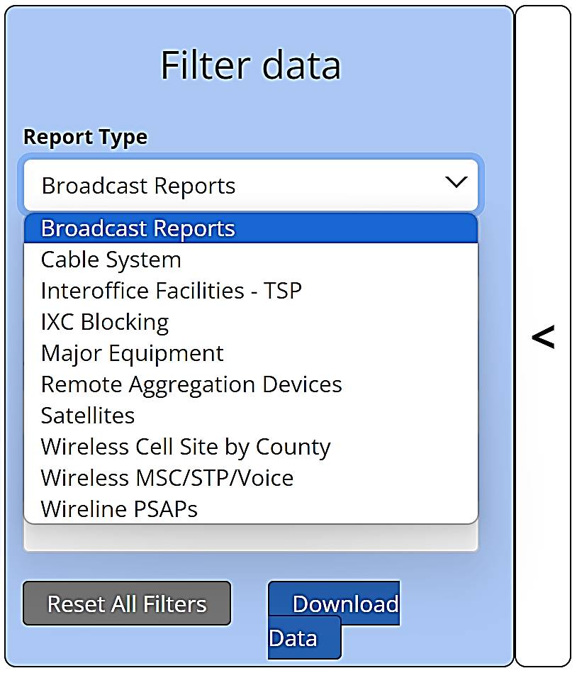
4. Click in the **Disaster**, **Company**, and **Date Range** fields in the Filter data pane to select criteria for your new data report from field drop-down lists or calendars.  
   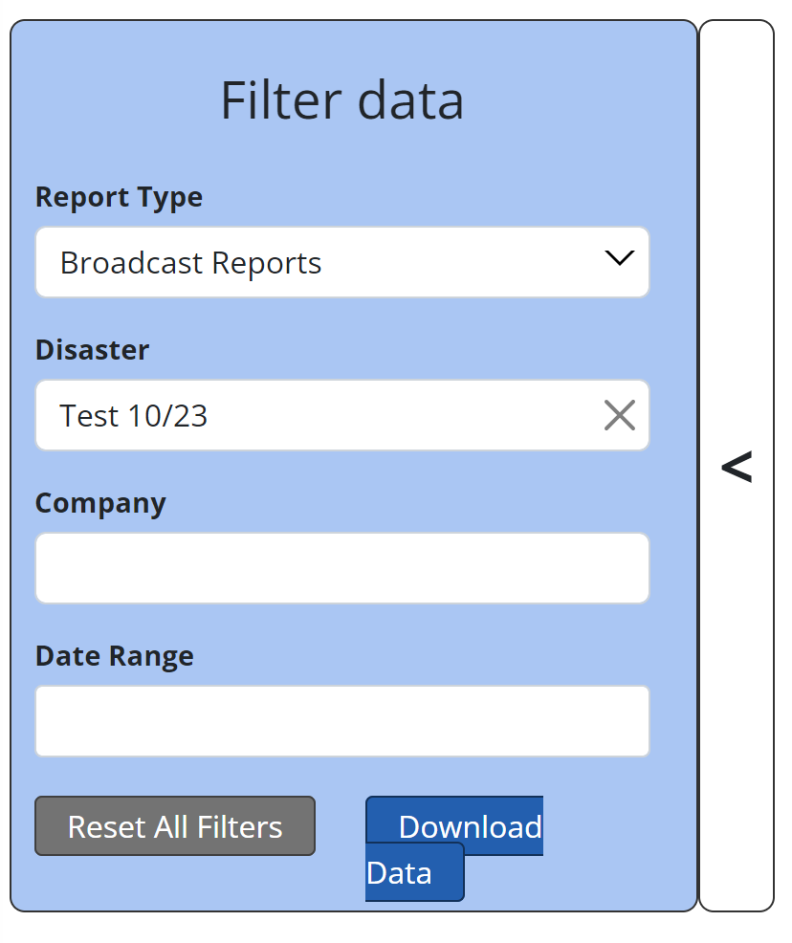
5. Click **Add New Report** on the Reports page to open the New [*report type*] Report form for the type of report you selected.  
   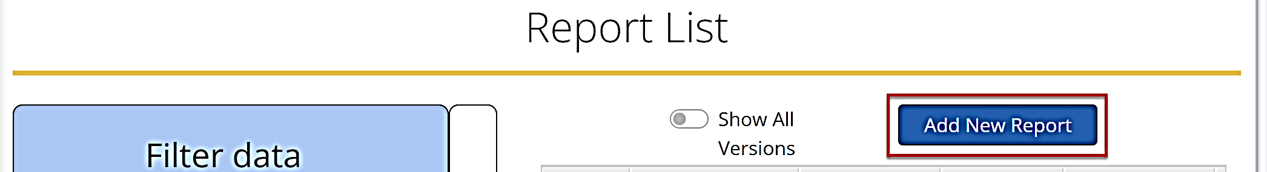
6. Enter your provider disaster data in the New [*report type*] Report form fields, then click **Submit**. The following example is the form for a Broadcast Report Type. The required fields have an asterisk. Refer to the Broadcast Template Worksheet Field Descriptions table in guide section 11.2.8 for Broadcast Report form field information.  
   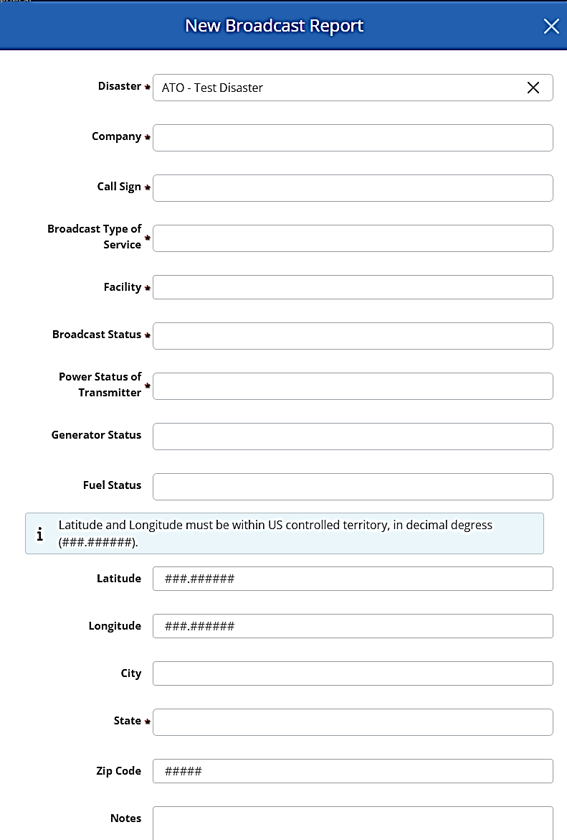

Repeat steps 3-5 above for each report type you want to add to DIRS. The Report Type form fields vary by type. Refer to the Template Worksheet Field Descriptions provided in guide sections 11.2.1 to 11.2.10 for field information.

### Bulk Uploading New Provider Data into DIRS

|  |
| --- |
| **USER ROLE DETAILS:**   * **Coordinators can bulk upload data for their own company(s).** |

If you are a coordinator, you have the option of bulk uploading your communication provider disaster data into DIRS using an Excel Data Template. The template includes nine worksheets (tabs), one for each of nine different data/report types.

Use the following steps to *bulk* add or update your communication provider disaster data:

1. Navigate to the [external DIRS website](https://dirs.fcc.gov/) (<https://dirs.fcc.gov/>) and sign in to DIRS.
2. Click **View/Add/Update Reports** in the Quick Links section on your Home page, or in your Navigation menu to open the Reports page.  
   Text

   Description automatically generated with medium confidence
3. Click **Download Excel Template** in the Batch Reports section to download the Excel Data Template to your local Download folder.  
   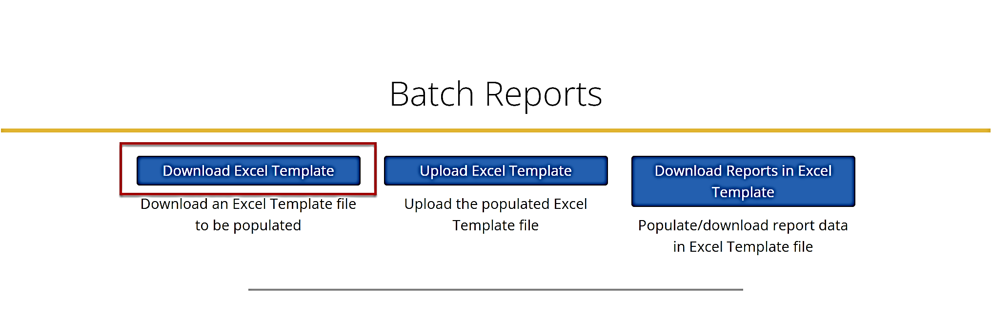
4. Enter your communication provider disaster data into your local copy of the Excel Data Template workbook. The workbook contains a worksheet with instructions and nine Data Type worksheets. Refer to the Worksheet Field Descriptions tables in guide sections 11.2.1 through 11.2.10.
5. When you have added all your data to your local Excel Data Template, re-open your Reports page in DIRS and click **Upload Excel Template** in the Batch Reports section.  
   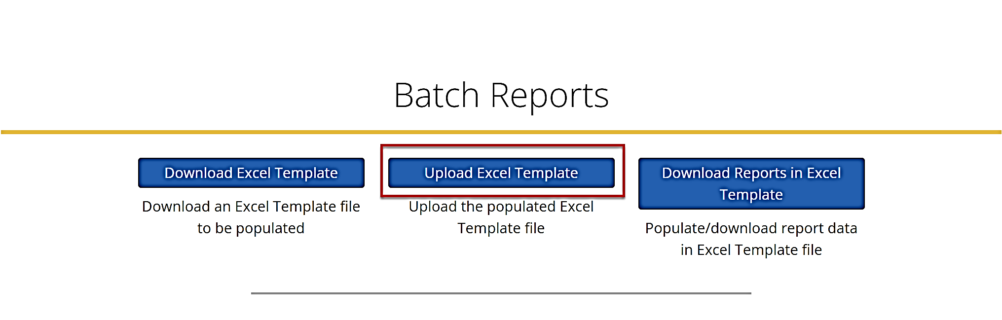
6. Click in the **Choose** file field, attach your completed Excel Data Template, then click **Submit**. Your data then uploads into the DIRS system and becomes available for viewing. The upload may take several minutes.

#### Major Equipment Template Worksheet

To provide your Major Equipment status information to the FCC, you must first enter the data on the appropriate worksheet in your local template copy. The following Major Equipment Worksheet Field Descriptions table describes information you can provide in the Excel worksheet.

| **Major Equipment Worksheet Field Descriptions** | | |
| --- | --- | --- |
| **Field Name** | **Required** | **Description** |
| **Report Number** | X (See Note) | **Note**: A Report Number is required if you are providing updated data. |
| **Type of Equipment (*Major Equipment Type)*** | X | Select an equipment type from the drop-down menu. |
| **CLLI** | X | Enter a Common Language Location Identifier Code. **Examples**: CHHLWA01 or CNBHOR64DS0 |
| **Status (*Equipment Status*)** | X | Select a status from the drop-down menu. |
| **Number of Access Lines** |  | Enter the number of access lines. |
| **Number of Working Numbers** | X (See Note) | Enter the number of working numbers. **Note**: This field, **OR** Number of Broadband Access Users is required. |
| **Number of Working Numbers Down** | X (See Note) | Enter the number of working numbers down. **Note**: This field, **OR** Number of Broadband Access Users Down is required. |
| **Number of VoIP Subscribers** |  | Enter the number of VoIP subscribers. |
| **Number of VoIP Subscribers Down** |  | Enter the number of VoIP subscribers down. |
| **Number of Video Subscribers** |  | Enter the number of video subscribers. |
| **Number of Video Subscribers Down** |  | Enter the number of video subscribers down. |
| **Number of Broadband Access Users** | X (See Note) | Enter the number of broadband access users. **Note**: This field, **OR** Number of Working Numbers is required. |
| **Number of Broadband Access Users Down** | X (See Note) | Enter the number of broadband access users down. **Note**: This field, **OR** Number of Working Numbers Down is required. |
| **Power Status** | X | Select a power status from the drop-down menu. |
| **Generator Available (*Generator Status*)** |  | Select if a generator is available. |
| **Latitude** | X (See Note) | Enter a latitude value. 45.89213 is an example latitude. **Notes**:   * This field, **OR** Address, City, and State is required. * Must be within US controlled territory. |
| **Longitude** | X (See Note) | Enter a longitude value. -123.962 is an example longitude. **Notes**:   * This field, **OR** Address, City, and State is required. * Must be within US controlled territory. |
| **Address** | X (See Note | Enter an address. **Note**: This field, OR Latitude/Longitude is required. |
| **City** | X (See Note) | Select a city from the drop-down menu. **Note**: This field, OR Latitude/Longitude is required. |
| **State** | X (See Note) | Select a state from the drop-down menu. **Note**: This field, OR Latitude/Longitude is required. |
| **Notes** |  | Enter any notes. |

#### Remote Aggregation Devices Template Worksheet

To provide your Remote Aggregation Devices status information to the FCC, you must first enter the data on the appropriate worksheet in your local template copy. The following Remote Aggregation Devices Worksheet Field Descriptions table describes the information you can provide in the Excel worksheet

| **Remote Aggregation Devices Worksheet Field Descriptions** | | |
| --- | --- | --- |
| **Field Name** | **Required** | **Description** |
| **Report Number** | X (See Note) | **Note**: A Report Number is required if you are providing updated data. |
| **Service Affected** |  | Select an equipment type from the drop-down menu. |
| **CLLI of Switch/Geographic Area** | X | Enter the Common Language Location Identifier Code (CCLI) of a switch/geographic area. |
| **Number of RAD Down** |  | Enter the number of RAD down. |
| **Number of Working Numbers Served** | X | Enter the number of working numbers served. |
| **Number of Working Numbers Down** | X | Enter the number of working numbers down. |
| **State** |  | Select a state from the drop-down menu. |
| **Notes** |  | Enter any notes. |

#### Wireline PSAP Template Worksheet

To provide your Wireline PSAP status information to the FCC, you must first enter the data on the appropriate worksheet in your local template copy. The following Wireline PSAP Worksheet Field Descriptions table describes the information you can provide in the Excel worksheet.

| **Wireline PSAP Worksheet Field Descriptions** | | |
| --- | --- | --- |
| **Field Name** | **Required** | **Description** |
| **Report Number** | X (See Note) | **Note**: A Report Number is required if you are providing updated data. |
| **PSAP Name** | X | Enter a PSAP name. **Examples**: HAMPTON CITY or League City PD |
| **Status (*Status Of PSAP*)** |  | Select a status from the drop-down menu. |
| **Reason for PSAP Out or Rerouted** |  | Select a reason for the PSAP Out or Rerouted from the drop-down menu. |
| **Restoral Time (Projected or Actual)** |  | Enter the restoral time. |
| **Area Served (e.g., County)** | X | Enter an area served. |
| **Address** |  | Emter an address. |
| **City** |  | Enter a city. |
| **State** |  | Select a state from the drop-down menu. |
| **Zip Code** |  | Enter a zip code. |
| **Number Of Customers Served by PSAP** | X | Enter the number of customers served by PSAP. |
| **Latitude** |  | Enter a latitude value. **Example**: 45.89213 **Note**: Must be within US controlled territory. |
| **Longitude** |  | Enter a longitude value. **Example**: -123.962 **Note**: Must be within US controlled territory. |
| **Address** |  | Enter an address. |
| **City** |  | Enter a city. |
| **State** |  | Select a state from the drop-down list. |
| **Zip Code** | X | Enter a zip code. |
| **Notes** |  | Enter any notes. |

#### Interoffice Facilities – TSP Template Worksheet

To provide your Interoffice Facilities status information to the FCC, you must first enter the data on the appropriate worksheet in your local template copy. The following Interoffice Facilities – TSP Worksheet Field Descriptions table describes the information you can provide in the Excel worksheet.

| **Interoffice Facilities – TSP Worksheet Field Descriptions** | | |
| --- | --- | --- |
| **Field Name** | **Required** | **Description** |
| **Report Number** | X (See Note) | **Note**: A Report Number is required if you are providing updated data. |
| **Number of DS3s Affected (Down)** | X | Enter the number of DS3s affected (down). |
| **Number of TSP Circuits Down** |  | Enter the number of TSP circuits down. |
| **State** |  | Select a state from the drop-down menu. |
| **Notes** |  | Enter any notes. |

#### IXC Blocking Template Worksheet

To provide your IXC Blocking status information to the FCC, you must first enter the data on the appropriate worksheet in your local template copy. The following IXC Blocking Worksheet Field Descriptions table describes the information you can provide in the Excel worksheet.

| **IXC Blocking Worksheet Field Descriptions** | | |
| --- | --- | --- |
| **Field Name** | **Required** | **Description** |
| **Report Number** | X (See Note) | **Note**: A Report Number is required if you are providing updated data. |
| **State** | X | Select a state from the drop-down menu. |
| **Time Period** | X | Enter a period of time. **Example**: 24 (24-hour time period) |
| **Calls Blocked in Time Period** | X | Enter the calls blocked in a time period. |
| **Historical Calls Blocked in 24 Hours** | X | Enter the historical calls blocked in 24 hours. |
| **Notes** |  | Enter any notes. |

#### Wireless MSC-STP-Voice Template Worksheet

To provide your Wireless MSC-STP-Voice status information to the FCC, you must first enter the data on the appropriate worksheet in your local template copy. The following Wireless MSC-STP-Voice Worksheet Field Descriptions table describes the information you can provide in the Excel worksheet.

| **Wireless MSC-STP-Voice Worksheet Field Descriptions** | | |
| --- | --- | --- |
| **Field Name** | **Required** | **Description** |
| **Report Number** | X (See Note) | **Note**: A Report Number is required if you are providing updated data. |
| **Type of Equipment (Wireless Type of Equipment)** |  | Select an equipment type from the drop-down menu. |
| **CLLI** | X | Enter a Common Language Location Identifier Code. **Examples**: CHHLWA01 or CNBHOR64DS0 |
| **Status** |  | Select a status from the drop-down menu. |
| **Power Status** |  | Select a power status from the drop-down menu. |
| **Generator Available** |  | Select if a generator is available. |
| **Latitude** | X (See Note) | Enter a latitude value. **Example**: 45.89213 **Notes**:   * This field, **OR** Address, City, and State is required. * Must be within US controlled territory. |
| **Longitude** | X (See Note) | Enter a longitude value. **Example**: -123.962 **Notes**:   * This field, **OR** Address, City, and State is required. * Must be within US controlled territory. |
| **Address** | X (See Note) | Enter an address. **Note**: This field, **OR** Latitude/Longitude is required. |
| **City** | X (See Note) | Enter a city. **Note**: This field, **OR** Latitude/Longitude is required. |
| **State** | X (See Note) | Select a state from the drop-down menu. **Note**: This field, **OR** Latitude/Longitude is required. |
| **Notes** |  | Enter any notes. |

#### Wireless Cell Site by County Template Worksheet

To provide your Wireless Cell Site by County status information to the FCC, you must first enter the data on the appropriate worksheet in your local template copy. The following Wireless Cell Site by County Worksheet Field Descriptions table describes the information you can provide in the Excel worksheet.

| **Wireless Cell Site by County Worksheet Field Descriptions** | | |
| --- | --- | --- |
| **Field Name** | **Required** | **Description** |
| **Report Number** | X (See Note) | **Note**: A Report Number is required if you are providing updated data. |
| **County** | X | Enter a county. |
| **Percent of Historical Capacity Available** |  | Enter the percentage of historical capacity available. .84 is an example percent which equals 84%. |
| **Cell Sites Served** | X | Enter the number of cell sites served. |
| **Cell Sites Affected (Down)** | X | Enter the number of sites affected (down). |
| **Cell Sites Out Due to Cell Site Damage** | X | Enter the number of cell sites out due to cell site damage. |
| **Cell Sites Out Due to Transport** | X | Enter the number of sites out due to transport. |
| **Cell Sites Out Due to No Power at Cell Site** | X | Enter the number of sites out due to no power at cell site. |
| **Cell Sites on Back-Up Power** | X | Enter the number of cell sites on back-up power. |
| **State** | X | Select a state from the drop-down menu. |
| **Notes** |  | Enter any notes. |

#### Broadcast Template Worksheet

To provide your Broadcast status information to the FCC, you must first enter the data on the appropriate worksheet in your local template copy. The following Broadcast Worksheet Field Descriptions table describes the information you can provide in the Excel worksheet.

| **Broadcast Worksheet Field Descriptions** | | |
| --- | --- | --- |
| **Field Name** | **Required** | **Description** |
| **Report Number** | X (See Note) | **Note**: A Report Number is required if you are providing updated data. |
| **Call Sign** | X | Enter a county. |
| **Type of Service (Broadcast Type of Service)** | X | Select a service type from the drop-down menu. |
| **Facility Identifier (Facility)** | X | Enter a facility identifier. |
| **Status (Broadcast Status)** | X | Select a status from the drop-down menu. |
| **Power Status of Transmitter** | X | Select a power status from the drop-down menu. |
| **Generator Available (Generator Status)** |  | Select if a generator is available. |
| **Fuel (Fuel Status)** |  | Select if fuel is available or not. |
| **Latitude** |  | Enter a latitude value. **Example**: 45.89213 **Note**: Must be within US controlled territory. |
| **Longitude** |  | Enter a longitude value. **Example**: -123.962 **Note**: Must be within US controlled territory. |
| **City** |  | Enter a city. |
| **State** | X | Select a state from the drop-down menu. |
| **Zip Code** |  | Enter a zip code |

#### Cable System Template Worksheet

To provide your Cable System status information to the FCC, you must first enter the data on the appropriate worksheet in your local template copy. The following Cable System Worksheet Field Descriptions table describes the information you can provide in the Excel worksheet.

| **Cable System Worksheet Field Descriptions** | | |
| --- | --- | --- |
| **Field Name** | **Required** | **Description** |
| **Report Number** | X (See Note) | **Note**: A Report Number is required if you are providing updated data. |
| **County** |  | Enter a county. |
| **PSID** | X | Enter a PSID. |
| **Total Number of Video Subscribers Served** |  | Enter the total number of video subscribers served. |
| **Estimated Number of Video Subscribers Down** |  | Enter the estimated number of video subscribers down. |
| **Total Number of VoIP Subscribers Served** |  | Enter the total number of VoIP subscribers served. |
| **Estimated Number of VoIP Subscribers Down** |  | Enter the estimated number of VoIP subscribers down. |
| **Total Number of Cable Telephone Subscribers Served** |  | Enter the total number of cable telephone subscribers served. |
| **Estimated Number of Cable Telephone Subscribers Down** |  | Enter the estimated number of cable telephone subscribers down. |
| **Total Number of Broadband Access Subscribers Served** |  | Enter the total number of broadband access subscribers served. |
| **Estimated Number of Broadband Access Subscribers Down** |  | Enter the estimated number of broadband access subscribers down. |
| **State** | X | Select a state from the drop-down menu. |
| **Notes** |  | Enter any notes. |

#### Satellite Template Worksheet

To provide your Satellite status information to the FCC, you must first enter the data on the appropriate worksheet in your local template copy. The following Satellite Worksheet Field Descriptions table describes the information you can provide in the Excel worksheet.

| **Satellite Worksheet Field Descriptions** | | |
| --- | --- | --- |
| **Field Name** | **Required** | **Description** |
| **Report Number** | X (See Note) | **Note**: A Report Number is required if you are providing updated data. |
| **Type of Equipment (Satellite Type of Equipment)** |  | Select a service type from the drop-down menu. |
| **Station Identifier/Call Sign** | X | Enter a Station Identifier/Call Sign. **Examples**: WMOR-TV or PSID 021422 |
| **Status (Satellite Status)** |  | Select a status from the drop-down menu. |
| **Total Number of Antennas** |  | Enter the total number of antennas. |
| **Number of Antennas Down** |  | Enter the number of antennas down. |
| **Number of Temporary Antennas Installed** |  | Enter the number of temporary antennas installed. |
| **Power Status (Power Antennas Status)** |  | Select a power status from the drop-down menu. |
| **Generator Available (Generator Status)** |  | Select if a generator is available. |
| **Latitude** | X (See Note) | Enter a latitude value. **Example**: 45.89213 **Notes**:   * This field, **OR** Address, City, and State is required. * Must be within US controlled territory. |
| **Longitude** | X (See Note) | Enter a longitude value. **Example**: -123.962 **Notes**:   * This field, **OR** Address, City, and State is required. * Must be within US controlled territory. |
| **Address** | X (See Note) | Enter an address. **Note**: This field, **OR** Latitude/Longitude is required. |
| **City** | X (See Note) | Enter a city. **Note**: This field, **OR** Latitude/Longitude is required. |
| **State** | X (See Note) | Select a state from the drop-down menu. **Note**: This field, **OR** Latitude/Longitude is required. |
| **Notes** |  | Enter any notes. |

### Manually Updating Provider Data

|  |
| --- |
| **USER ROLE DETAILS:**   * **Coordinators can manually update provider data for their own company(s).** * **Inputters can manually update provider data that they previously provided.** |

Provider disaster data in DIRS can be updated manually in DIRS report forms, or it can be bulk updated by editing and uploading a new Excel Data Template.

Use the following steps to manually update your provider disaster data in DIRS using report forms:

1. Navigate to the [external DIRS website](https://dirs.fcc.gov/) (<https://dirs.fcc.gov/>) and sign in to DIRS.
2. Click **View/Add/Update Reports** in the Quick Links section on your Home page, or in your Navigation menu to open the Reports page.  
   Text

   Description automatically generated with medium confidence
3. Click in the **Report Type**, **Disaster**, **Company**, and **Date Range** fields on the Filter data pane to display drop-down lists and select filter criteria for your Reports Table list. The table dynamically updates as you make your selections.   
   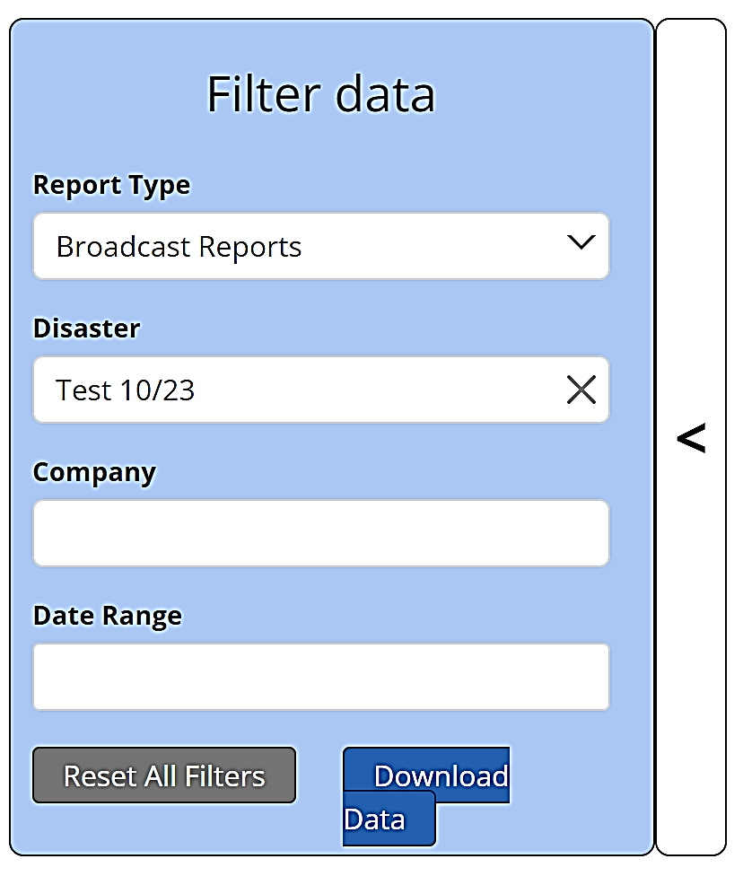
4. Click in the Report Table row to open a Report form for the report you want to update.  
   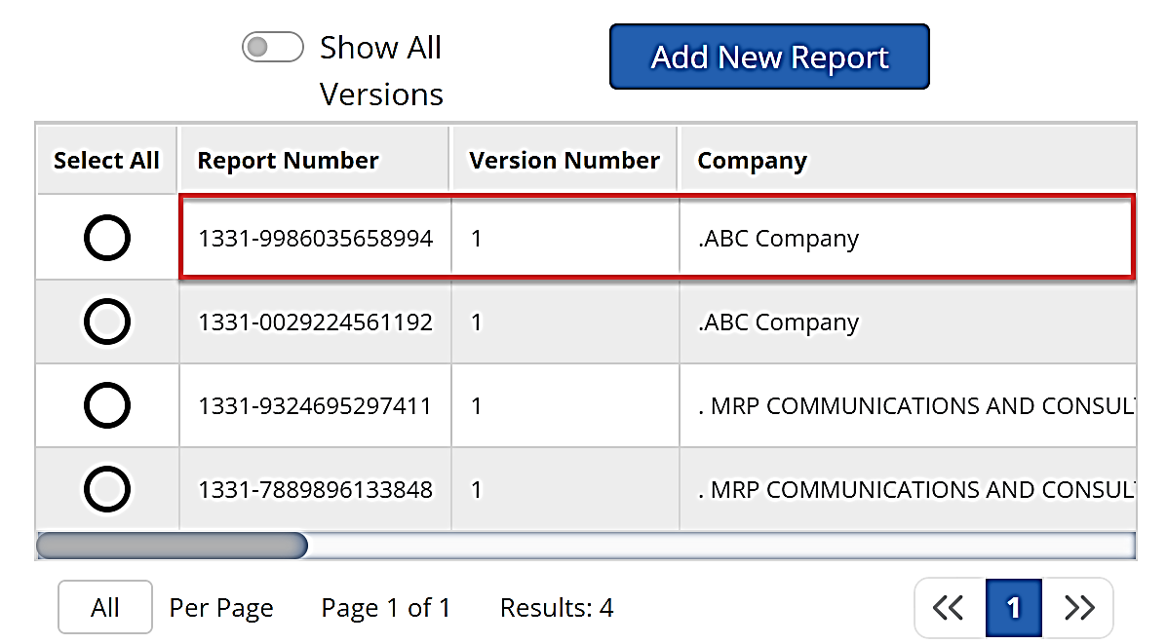

Update your provider disaster data in the Report form fields, then click **Submit**. The required fields have an asterisk. Refer to the Worksheet Field Descriptions tables in guide sections 11.2.1 through 11.2.10 as needed.

### Bulk Updating Provider Disaster Data

|  |
| --- |
| **USER ROLE DETAILS:**   * **Coordinators can bulk update data for their own company(s).** |

You can download your provider report data in an Excel Data Template file, make updates, then upload the template file back to DIRS with your updated provider data.

Use the following steps to bulk upload updated communication provider disaster data in DIRS:

1. Navigate to the DIRS website ([dirs.fcc.gov](https://dirs.fcc.gov/)) and sign in to your DIRS account.
2. Click **View/Add/Update Reports** in the Quick Links section on your Home page, or in you Navigation menu to open the Reports page.  
   Text

   Description automatically generated with medium confidence
3. Click **Download Reports in Excel Template** in the Batch Reports section of the page to open a Download Reports as Uploadable Excel File form. 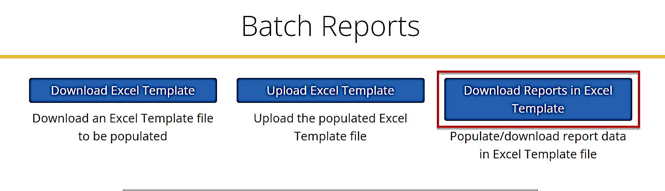
4. Click in the **Disaster** and **Company** fields on the Download Reports as Uploadable Excel File form and select values for the fields.  
   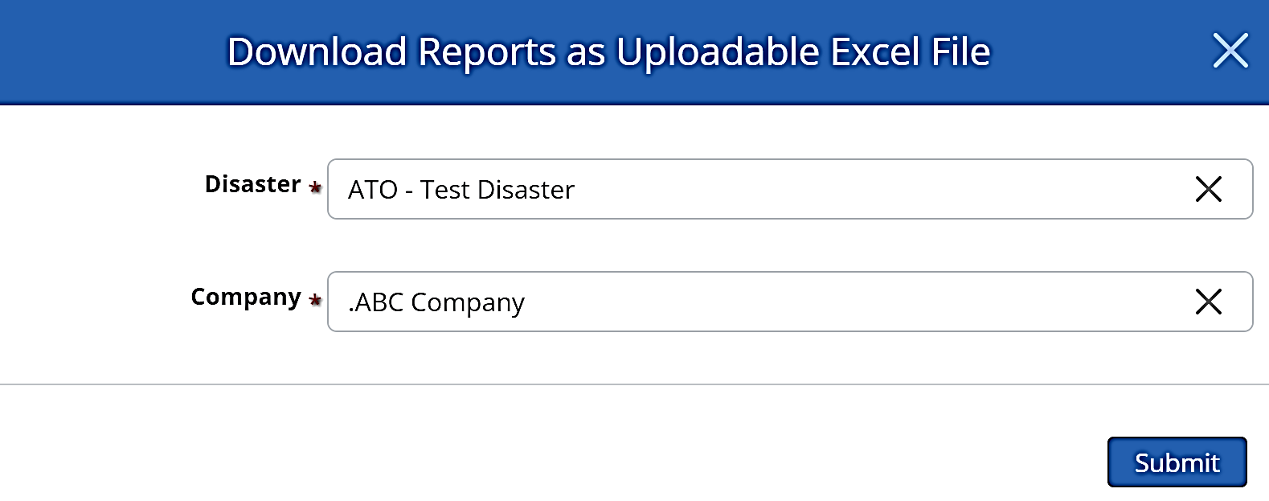
5. Click **Submit** to download the report to your local drive.
6. Enter any updates to your communication provider disaster data in your local copy of the template workbook. Refer to the Worksheet Field Descriptions tables in guide sections 11.2.1 through 11.2.10 as needed.
7. When you have completed your updates, re-open your Reports page in DIRS and click **Upload Excel Template** in the Batch Reports section.  
   
8. Click in the **Choose File** field, attach your updated Excel Data Template, then click **Submit**.

Your updated provider disaster data then uploads into the DIRS system and is available for viewing when the upload is complete. The upload may take several minutes.

## Generating and Downloading Reports and Lists

Reports and lists in DIRS are based primarily on disaster data provided by communication providers. The reports/lists available for your user role to view are listed in the Quick Links section on your Home page, or under Reports on your Navigation Menu. Reports that can be downloaded are .pdf or .xlsx file types.

### Generating and Downloading a Summary Report

|  |
| --- |
| **USER ROLE DETAILS: Only Coordinators can generate and download a Summary Report.** |

A Summary Report provides a summary of disaster data by disaster, company, and date/time.

Use the following steps to generate a Summary Report:

1. Navigate to the [external DIRS website](https://dirs.fcc.gov/) (non-FCC users) and sign in to DIRS.
2. Select **Summary Report** on your DIRS Home page in the Quick Links section, or in your Navigation menu.  
   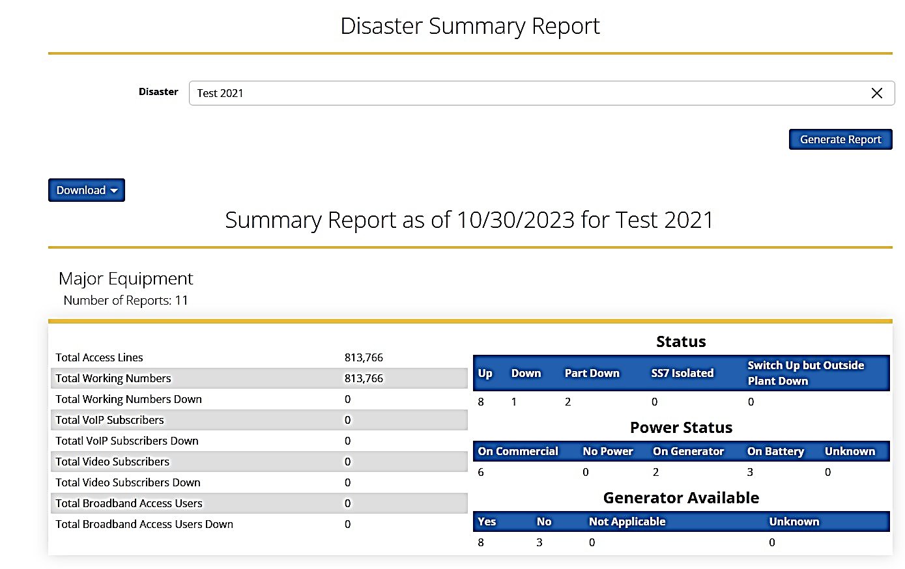
3. Click in the Disaster field to display a drop-down list and select a disaster, then click **Generate Report**. Refer to the Summary Report Request Field Descriptions table provided below.

| **Summary Report Request Field Descriptions** | | |
| --- | --- | --- |
| **Field Name** | **Required** | **Description** |
| **Display Comprehensive Report By** |  | Select how the report will be sorted. |
| **Disaster** | X | Select an existing disaster. |
| **Report Type** | X | Select which report information will be displayed. |

### Generating a Report List

|  |
| --- |
| **USER ROLE DETAILS: All roles can generate and download a Report List. If you are an Inputter, you can only see the reports that you have generated. If you are a Coordinator, you can only see the reports from your company.** |

A Report List provides a list of reports submitted by disaster, company, and report type.   
  
Use the following steps generate a Report List:

1. Navigate to the [external DIRS website](https://dirs.fcc.gov/) (<https://dirs.fcc.gov/>) and sign in to DIRS.
2. Click **View/Add/Update Reports** or **View Reports** in your Home page Quick Links or in your Navigation menu to open the Reports page.  
   Text

   Description automatically generated with medium confidence
3. Click in the **Report Type**, **Disaster**, **Company**, and **Date Range** fields on the Filter data pane to display drop-down lists and a calendar, then choose the criteria for your report list. The report table dynamically updates as you make your selections. Refer to the Filter Data Pane Field Descriptions table provided below.  
   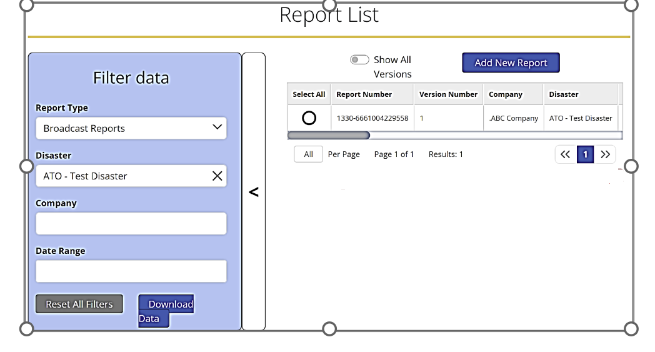

| **Filter Data Pane Field Descriptions** | | |
| --- | --- | --- |
| **Field Name** | **Required** | **Description** |
| **Report Type** |  | Select which report information will be displayed. |
| **Disaster** |  | Select an existing disaster. |
| **Company** |  | Select an existing company. |
| **Date Range** |  | Select a start and end date. |

1. Optionally, click **Download Data** in the Filter data pane to download an Excel report to your local drive.

### Generating and Download a County PSAP List

|  |
| --- |
| **USER ROLE DETAILS:**   * **Coordinators and Inputters can generate and download a County PSAP List for their affiliated disasters.** |

A County PSAP List provides a list of county PSAP’s affected by a disaster.

Use the following steps to generate and download a County PSAP List:

1. Navigate to the [external DIRS website](https://dirs.fcc.gov/) (<https://dirs.fcc.gov/>) and sign in to DIRS.
2. Click **PSAPs for Counties** in your Navigation menu to open the PSAPS For Counties page.
3. Click in the **Disaster** and **County/State** form fields to display drop-down lists and select filter options for your list. Refer to the County PSAP List Request Field Descriptions table provided below.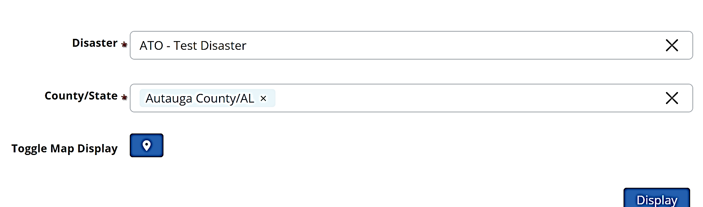

| **County PSAP List Request Field Descriptions** | | |
| --- | --- | --- |
| **Field Name** | **Required** | **Description** |
| **Disaster** | X | Select an existing disaster. |
| **County/State** | X | Enter a county or state name(s) for a disaster. |
| **Toggle Map Display** |  | Display off/on a map of PSAPS for counties. |

1. Optionally, click **Toggle Map Display** to add a map to your list page.
2. Click **Display** to display your list and map.  
   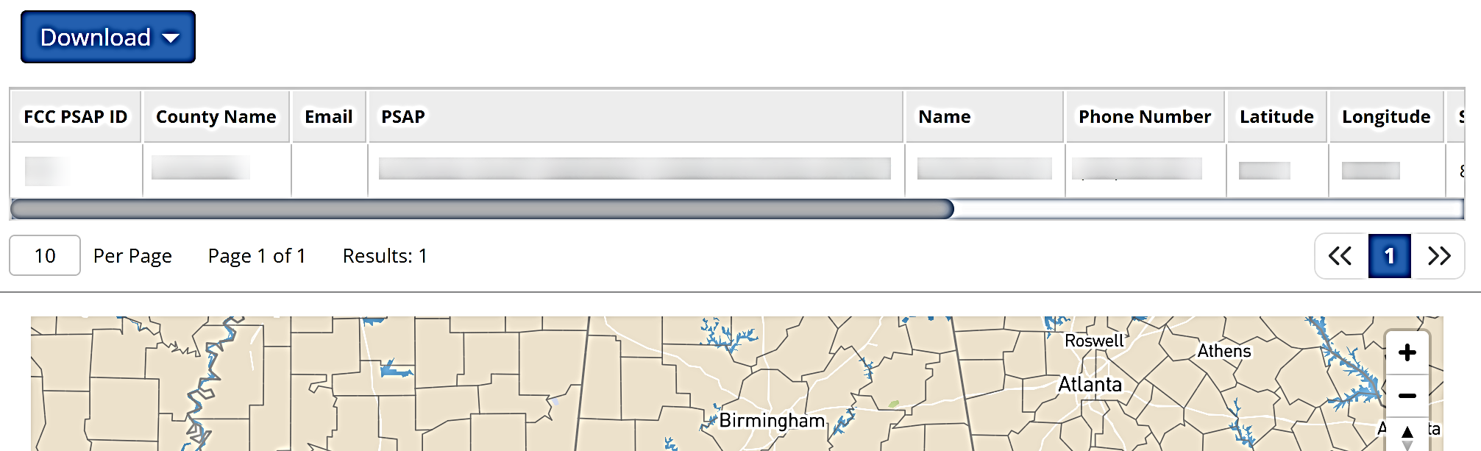
3. Optionally, click **Download** on the list page and select PDF or Excel from the drop-down list to download the list, or list and map.  
   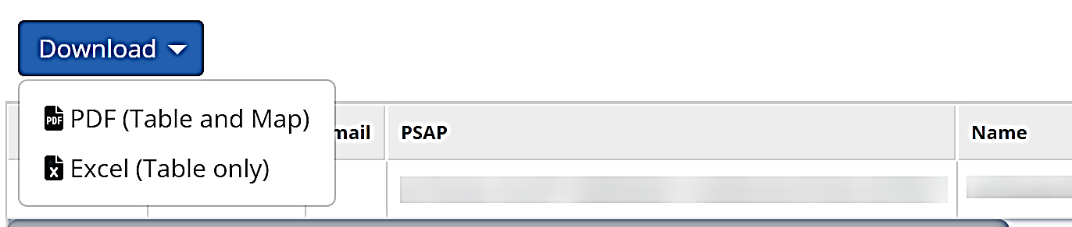

### Generating and Downloading a City List

|  |
| --- |
| **USER ROLE DETAILS:**   * **Coordinators can generate and download a City List for their affiliated disasters.** |

A City List provides a list of cities affected by disaster.

Use the following steps generate and download a City List:

1. Navigate to the [external DIRS website](https://dirs.fcc.gov/) (<https://dirs.fcc.gov/>) and sign in to DIRS.
2. Click **City List** in your Navigation menu to open the City List page.
3. Click in the **Select Disaster** field and select a disaster from the drop-down list to dynamically populate the City List table.  
   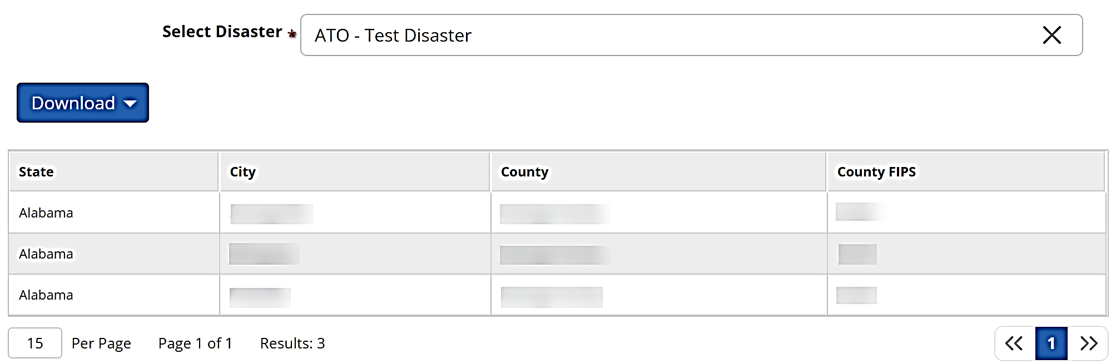
4. Optionally, click **Download** on the list page and select PDF or Excel from the drop-down list to download the list and map.  
     
   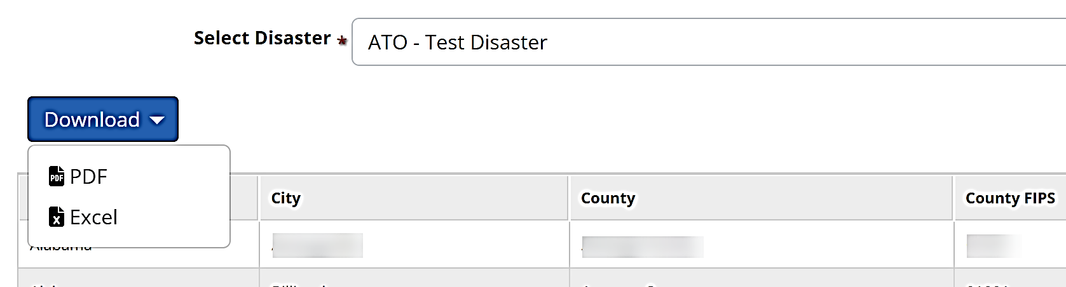

## Generating, Downloading, and Uploading Maps

There are three types of maps available in DIRS to assist with disaster analysis and recover efforts, Disaster maps, Wireless Coverage maps, and Dashboard maps.

### Generating and Downloading a Disaster Map

|  |
| --- |
| **USER ROLE DETAILS:**   * **Participating Agencies Users can generate and download any Disaster map.** * **Coordinators can generate and download Disaster maps affiliated with their company(s)** |

Disaster Maps provide disaster details by equipment type, state/territory, and date in a map format.

Use the following steps to generate and download a disaster map:

1. Navigate to the [external DIRS website](https://dirs.fcc.gov/) (<https://dirs.fcc.gov/>) and sign in to DIRS.
2. Select **Disaster Maps** on your Home page, or in your Navigation menu to open the Disaster Maps page.
3. Click in the map filter fields to display drop-down lists or a calendar and select filter options for your map. The map is dynamically generated as you select your options. Refer to the Disaster Map Request Field Descriptions table provided below.  
   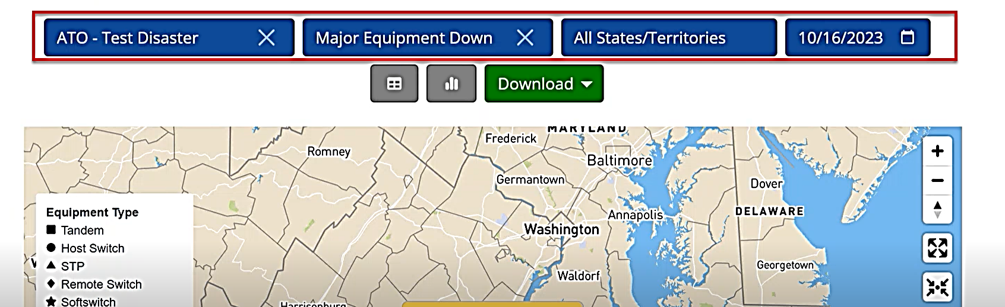

| **Disaster Map Request Field Descriptions** | | |
| --- | --- | --- |
| **Field Name** | **Required** | **Description** |
| **Disaster** |  | Select an existing disaster. |
| **Major Equipment Type** |  | Select type of equipment. |
| **All States / Territories** |  | Select a state or territories. |
| **Date** |  | Select a date. |

1. Optionally, click on the **Table** or **Chart** button to add your map data in table or chart format to the page.  
     
   
2. Optionally, click **Download** to open a file type drop-down list and select a file type for your download. Your file is downloaded when you make the file type selection.  
   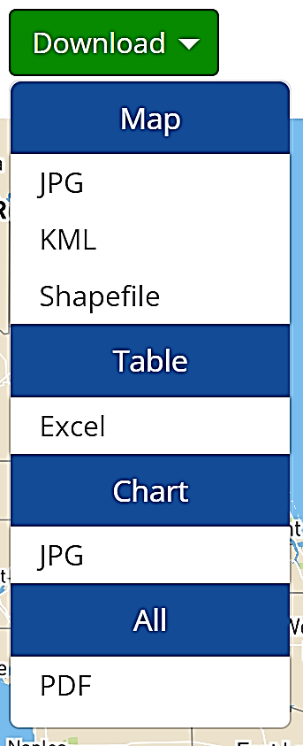

### Uploading and Downloading Wireless Coverage Maps

|  |
| --- |
| **USER ROLE DETAILS:**   * **Coordinators can upload and download Wireless Coverage maps affiliated with their own company(s)** |

#### Uploading a Wireless Coverage Map

Use the following steps to upload a Wireless Coverage Map:

1. Navigate to the [external DIRS website](https://dirs.fcc.gov/) (<https://dirs.fcc.gov/>) and sign in to DIRS.
2. Select **Wireless Coverage Maps** on your Home page, or in your Navigation menu to open the Wireless Coverage Maps page.  
   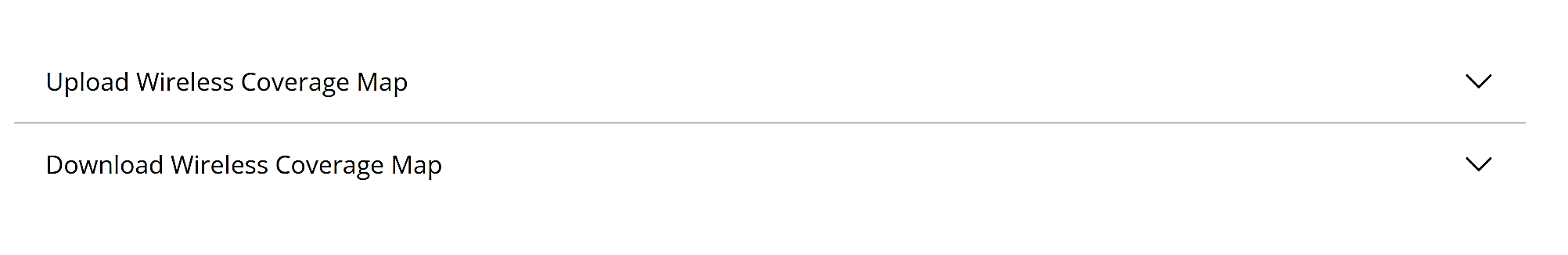
3. Select **Upload Wireless Coverage Map** on the Wireless Coverage Maps page to open the Upload Wireless Coverage Map form.
4. Click on the **Disaster**, **Company**, and **State** fields to display drop-down lists and select criteria for your map. Refer to the Upload Wireless Map Field Descriptions table provided below.  
   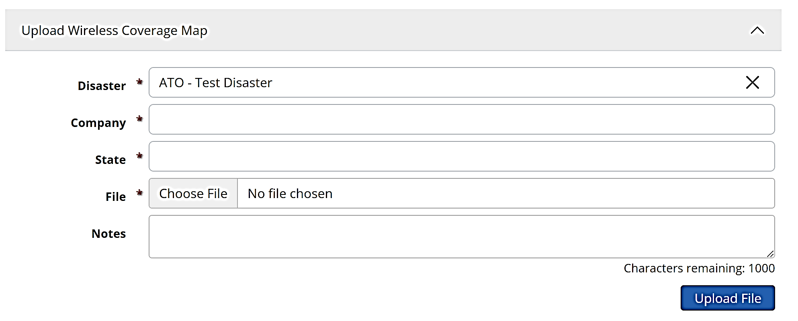
5. Click in the **Choose File** field and attach your map file.
6. Optionally, enter **Notes**.
7. Click **Upload File**. The upload may take several minutes.

| **Upload Wireless Map Field Descriptions** | | |
| --- | --- | --- |
| **Field Name** | **Required** | **Description** |
| **Disaster** | X | Select an existing disaster. |
| **Company** | X | Select an existing company. |
| **State** | X | Select a state or territories. |
| **File** | X | Select a file to upload. **Note**: Acceptable file types for the report file are .png, .jpg, .jpeg, .pdf, .kml, .kmz, .zip, .json, .csv, .xls, or .xlsx. The report file size should be no larger than 50 MB. |
| **Notes** |  | Enter any notes. |

#### Downloading a Wireless Coverage Map

Use the following steps to download a Wireless Coverage Map:

1. Navigate to the [external DIRS website](https://dirs.fcc.gov/) (<https://dirs.fcc.gov/>) and sign in to DIRS.
2. Select **Wireless Coverage Maps** on your Home page, or in your Navigation menu to open the Wireless Coverage Maps page.  
   
3. Select **Download Wireless Coverage Map** on the Wireless Coverage Maps page to open the Upload Wireless Coverage Map form.
4. Click on the **Disaster**, **Company**, and **State(s)** fields to display drop-down lists and select criteria for your map. The available maps dynamically display in the Map table as you make your selections. Refer to the Download Wireless Map Field Descriptions table provided below.   
   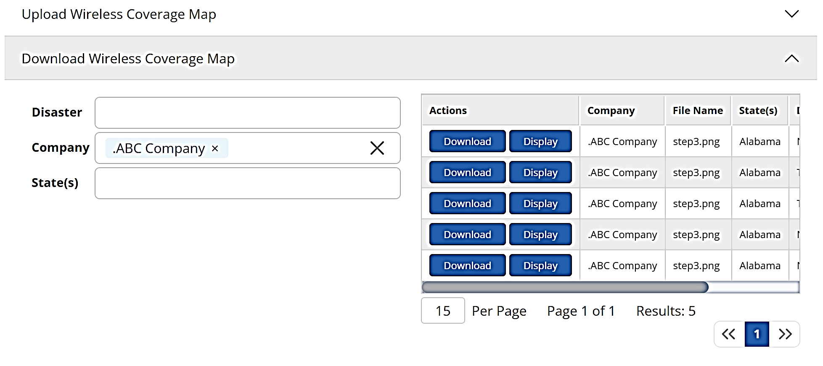
5. Optionally, select **Display** in a map’s table row to preview the map.
6. Select **Download** in a map’s table row to download the map to your local drive.

| **Download Wireless Map Field Descriptions** | | |
| --- | --- | --- |
| **Field Name** | **Required** | **Description** |
| **Disaster** |  | Select an existing disaster. |
| **Company** |  | Select an existing company. |
| **State(s)** |  | Select states. |