FREQUENTLY ASKED QUESTIONS ABOUT THE
EMERGENCY ALERT SYSTEM TEST REPORTING SYSTEM (ETRS)
Last updated August 2, 2023

Below is information to help EAS Participants better understand the ETRS filing process. More information about ETRS and the nationwide Emergency Alert System (EAS) test can be found on the FCC’s ETRS website at https://www.fcc.gov/general/eas-test-reporting-system.

Table of Contents

General Questions 4
How do I access ETRS? 4
How do I complete an ETRS form if I receive a notification/error message that the window for the test cycle is closed? 5
When can I file in ETRS? 11
Información en Español 11
Registration 11
How to I register an ETRS account? 11
Can I use the ETRS-specific account that I created in 2016? 12
Who needs to register and file in ETRS? 12
I want to file for multiple stations. Should I file for them using the same FCC Username? 12
Can I register multiple accounts for the same EAS Participant? 12
When I associate my EAS Participant’s FCC Registration Number (FRN) to an FCC Username, will that Username be limited to filing in ETRS? 12
I need an FCC Registration Number (FRN) to associate with my FCC Username for ETRS. How do I get one? 12
I don’t remember my FCC Registration Number (FRN). 13
I don’t remember my FCC Registration Number (FRN) password. 13
I don’t remember my FCC Username password. 13
Who Must File ETRS Forms? 13
Are low power FM stations (LPFM) and small student radio stations (Class D) required to register and file in ETRS? 13
Are LPFM televisions stations that operate as television broadcast translator stations required to register and file in ETRS? 13
Are FM broadcast booster stations or translator stations that entirely rebroadcast the programming of other local FM broadcast stations required to register and file in ETRS? 13
Are satellite stations or repeaters of a hub station required to register and file in ETRS? 13
I have a broadcast station with multiple HD stations (HD2, HD3, etc.). Do I need to file separately for each HD? 14
Do EAS Participants need to resubmit Form One Yearly? 14
I need to correct an error. How do I update forms that I have previously filed? 14
Filing Form One 14
How do I pre-populate Form One? 14
The pre-populated data for my facility is incorrect. 18
What is my Geographic Zone of Service? 14
My Geographic Zone of Service/operational area does not appear to be in the FCC’s database. 15
Should I submit the latitude/longitude of my studio or my antenna? 15
I’ve typed in latitude/longitude and the map is showing an incorrect location. 15
How do I convert my latitude/longitude to NAD83 and/or decimal format? 15
How do I find my EAS designation? 15
Where can I find my monitoring assignments? 15
My monitoring assignments do not appear to be in the FCC’s database. 15
What is a waiver? Do I need a waiver? 16
How do I find out the make and model of my EAS equipment? 16
How do I find out the software version of my EAS equipment? 16
How do I determine if our equipment is interfacing with FEMA's IPAWS? 16
I returned to an incomplete form after several hours, and I had to start over. 16
How do I add a call sign? My monitored source is not listed as an option in the ETRS dropdown menu. 16
I cannot change other information on Form One (latitude/longitude, for example) because it is grayed out. How do I make changes to these fields? 18
How do I edit the Day of Test Contact (DoTC) fields? 21
State EAS Plans 22
I can’t find my operational area(s) in my state’s EAS plan. 22
I can’t find a copy of my state’s EAS plan. 22
Batch filing 22
How do I submit a batch filing? 22
I received an error message when attempting to upload my spreadsheet. 22
Can I file Form One using the same batch filing spreadsheet that I used last year? 23
My batch filing failed to process. How do I find the list of corrections I need to make? 26
Non-Filing Related Questions 29
How do I print a previously-filed Form? 29
Guide to Filing Form 1 35
Guide to Filing Forms 2 and 3 39
Further Questions 42

General Questions

How do I access ETRS?
ETRS can be found here. Some users have experienced problems when filing with Internet Explorer, so we recommend that filers use Chrome or Firefox.

Users can log in to ETRS, as well as obtain Information on how to access ETRS at https://www.fcc.gov/general/eas-test-reporting-system. Users can log in to ETRS using their Commission Registration System (CORES) account. Users who do not have a CORES account may register for one at https://apps.fcc.gov/cores/userLogin.do. Once on the ETRS webpage, there is an instructional video (see tab at the top of the page) that provides guidance on how to log in (see screenshot of the web page below).

Back to Top

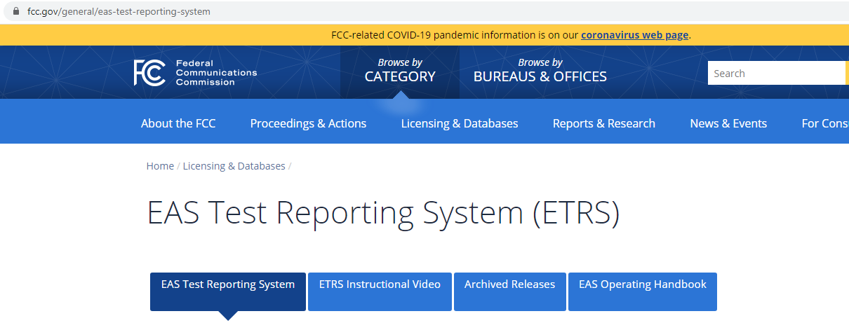

How do I complete an ETRS form if I receive a notification/error message that the window for the test cycle is closed?

There are a few reasons you may be experiencing this issue. It may be because you are attempting to edit an ETRS form from a previous year. We require you to file a new Form One for each year by clicking on the appropriate option from the menu: Submit Form One. Once you enter an FCC Registration Number (FRN), your EAS Participant Type, and Facility ID (or Physical System ID (PSID) for cable operators) on that new form, it will populate with the last available year’s data. After making any necessary updates, you can submit the form.

Step 1: Choose Submit Form One
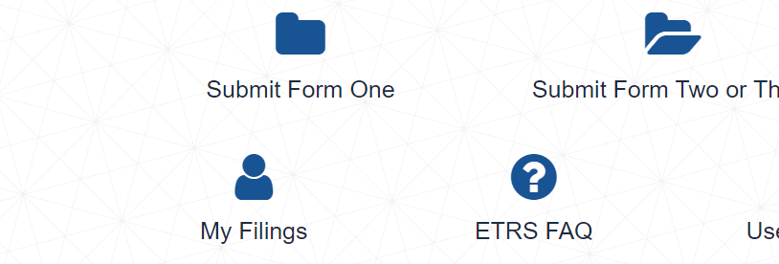

Step Two: Choose a Filing Window from Dropdown Menu

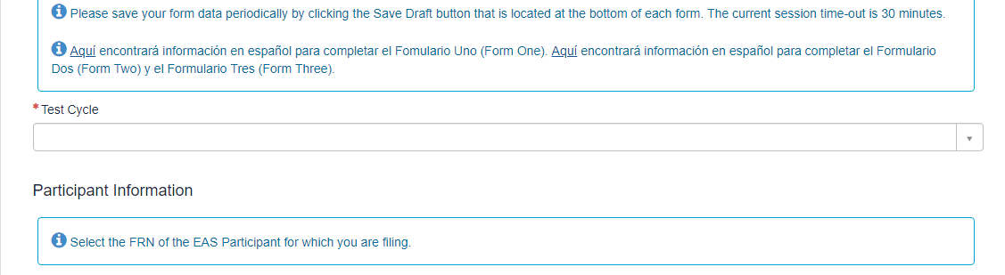

Step Three: Enter FRN/PSID, EAS Participant Type, and Facility ID to Populate Form with the Last Available Year’s Data

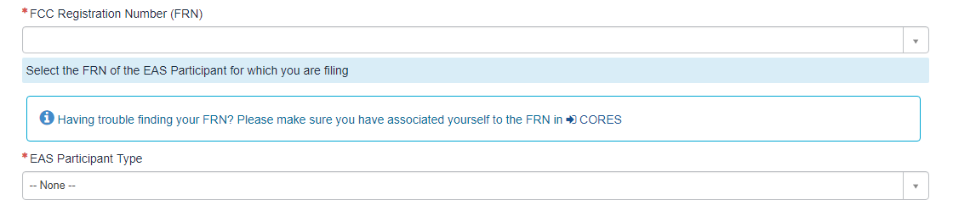

*Once you enter an EAS Participant type, the Facility ID field will appear below the EAS Participant drop down menu.

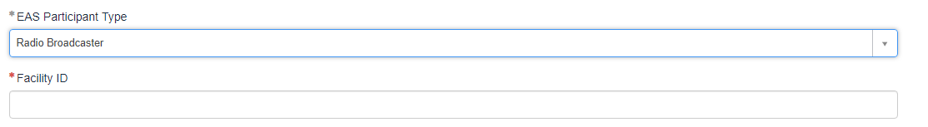

You also may have received this error message because the ETRS filing window has closed for the year. If this is the case, you may not submit, resubmit, or make changes to any ETRS form. Check the filing window dates on the ETRS home screen to verify whether you are attempting to file outside the filing window.
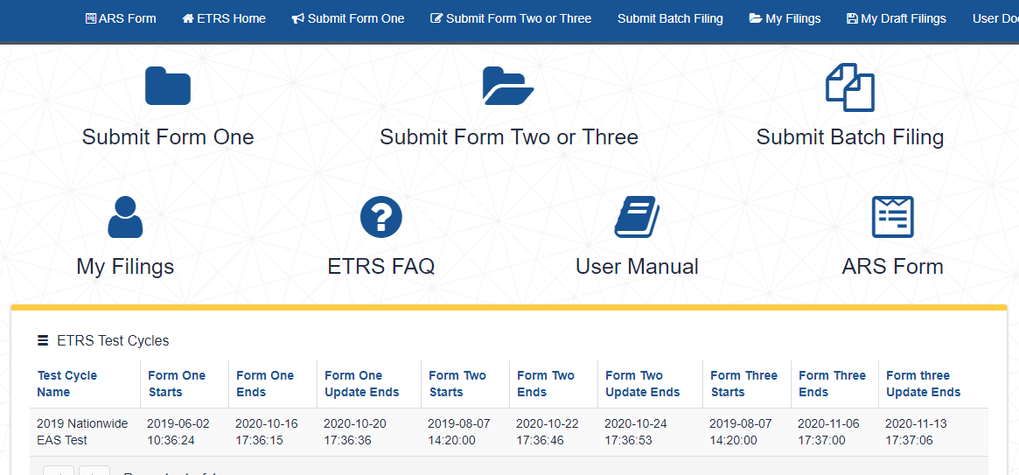

When can I file in ETRS?

Please see the PSHSB website here for the latest details on filing deadlines.

Back to Top

Información en Español

Aquí encontrará información en español para completar el Fomulario Uno (Form One): https://www.fcc.gov/file/20555/download. Aquí encontrará información en español para completar el Formulario Dos (Form Two) y el Formulario Tres (Form Three): https://www.fcc.gov/file/20556/download.

Para obtener más ayuda, por favor póngase en contacto con nuestro equipo de asistencia para licencias (FCC Licensing Support) en línea, ingresando al sitio web https://www.fcc.gov/available-support-services o llamando al teléfono 1-877-480-3201. El horario de atención es de 8 a.m. a 6 p.m. Hora del Este de Estados Unidos (Eastern Time) de lunes a viernes (excepto en feriado federal). Cuando envíe su consulta por Internet, por favor elija “ETRS” en el menú de opciones.

Back to Top

Registration

How to I register an ETRS account?
To access ETRS, you need to register an FCC Username in our Commission Registration System (CORES) and associate your EAS Participant’s FCC Registration Numbers (FRNs) to that Username. Please allow 24-48 hours for your FRNs to be associated with your Username. Filers that have already created a Username for use with another FCC system can use that same Username to access ETRS. You can register a Username at https://apps2.fcc.gov/fccUserReg/pages/createAccount.htm.

Can I use the ETRS-specific account that I created in 2016?
No. You will need to register an FCC Username in CORES.

Who needs to register and file in ETRS?
All EAS Participants are required to register an FCC Username and file Forms One, Two, and Three in ETRS. EAS Participants are radio and television broadcasters, cable systems, satellite radio and television providers, and wireline video providers.

I want to file for multiple stations. Should I file for them using the same FCC Username?
Yes. You can file for multiple FCC Registration Numbers (FRNs) using the same Username. To do so, you will need to associate all FRNs to your FCC Username in CORES. Please allow 24-48 hours for your FRNs to be associated with your Username. For further information, please review the ETRS Registration Public Notice at https://docs.fcc.gov/public/attachments/DA-21-680A1.pdf.

Can I register multiple accounts for the same EAS Participant?
Yes. Each user should register their own FCC Username. That Username will be able to file on behalf of any FCC Registration Number (FRN) that is associated to it. A single FRN can be associated with many FCC Usernames. Please allow 24-48 hours for your FRNs to be associated with your Username.

When I associate my EAS Participant’s FCC Registration Number (FRN) to an FCC Username, will that Username be limited to filing in ETRS?
No. Usernames that have an associated FRN can file on behalf of that FRN in all FCC applications and edit all filings made on behalf of that FRN in ETRS. Please keep this mind when deciding which individuals within your organization should have FRNs associated with their Usernames.

I need an FCC Registration Number (FRN) to associate with my FCC Username for ETRS. How do I get one?
Every EAS Participant should already have an FRN. Please check with others in your organization to obtain your FRN and Password. If you need additional assistance, please contact FCC Licensing Support at 1-877-480-3201 (Mon.-Fri. 8 a.m.-6 p.m. ET) or via the web at https://www.fcc.gov/wireless/available-support-services. If submitting your query online, please select “submit a help request” and then select “ETRS” from the drop-down menu.

I don’t remember my FCC Registration Number (FRN).
Please contact FCC Licensing Support at 1-877-480-3201 (Mon.-Fri. 8 a.m.-6 p.m. ET) or via the web at https://www.fcc.gov/wireless/available-support-services. If submitting your query online, please select “submit a help request” and then select “ETRS” from the drop-down menu.
I don’t remember my FCC Registration Number (FRN) password.
You may reset your FRN password using a link available at https://apps.fcc.gov/coresWeb/publicHome.do.

I don’t remember my FCC Username password.
You may reset your FCC Username password at https://apps2.fcc.gov/fccUserReg/pages/reset-passwd-identify.htm.

Back to Top

Who Must File ETRS Forms?

Are low power FM stations (LPFM) and small student radio stations (Class D) required to register and file in ETRS?
LPFM stations and Class D non-commercial educational FM stations are required to register and file in ETRS.

Are LPFM televisions stations that operate as television broadcast translator stations required to register and file in ETRS?
Analog and digital low power television (LPTV) stations that operate as television broadcast translator stations are NOT required to register and file in ETRS.

Are FM broadcast booster stations or translator stations that entirely rebroadcast the programming of other local FM broadcast stations required to register and file in ETRS?
FM broadcast booster stations and FM translator stations which entirely rebroadcast the programming of other local FM broadcast stations are NOT required to register and file in ETRS.

Are satellite stations or repeaters of a hub station required to register and file in ETRS?
Analog and digital broadcast stations that operate as satellites or repeaters of a hub station (or common studio or control point if there is no hub station) and rebroadcast 100 percent of the programming of the hub station (or common studio or control point) are NOT required to register and file in ETRS. However, the hub station (or common studio or control point) is required to register and file in ETRS.

I have a broadcast station with multiple HD stations (HD2, HD3, etc.). Do I need to file separately for each HD?
Each EAS Participant should file a separate copy of Form One for each of its EAS decoders, EAS encoders, and units combining such decoder and encoder functions. For example, if you are filing for a broadcaster (or cable headend) that uses two units combining decoder and encoder functions, you should file two copies of Form One – one for each unit.

Do EAS Participants need to resubmit Form One Yearly?
Yes, all EAS Participants were required to submit a new Form One for their EAS equipment starting in 2017. Form One data collected in past years will be used to pre-populate next year’s Form Ones. Please confirm the accuracy of your pre-populated Form One before submission.

I need to correct an error. How do I update forms that I have previously filed?
You can update previously filed forms by visiting the record for that facility in ETRS. You can access that record by clicking on the My Filings menu option. All corrections must be submitted within thirty (30) days of the initial deadline.

Back to Top

Filing Form One

How do I pre-populate Form One?
Broadcasters can pre-populate Form One by completing the FRN, EAS Participant Type, and Facility ID fields. Cable systems can pre-populate Form One by completing the FRN, EAS Participant Type, and PSID fields.

What is my Geographic Zone of Service?
Your Geographic Zones of Service are the geographic areas that your facility serves. To find your Geographic Zones of Service, review your state’s EAS plan. Each state EAS plan organizes the state into several operational areas. Each operational area in which the facility provides service should be submitted as a Geographic Zone of Service.

My Geographic Zone of Service/operational area does not appear to be in the FCC’s database.
If the operational area is not already in our database, you can add it to our database by clicking on the “Click here to add new geographic zones to the picker” link, which will let you type it in. Please enter it exactly as it appears in your state’s EAS plan.

Should I submit the latitude/longitude of my studio or my antenna?
You should submit that latitude/longitude of your broadcasting antenna.

I’ve typed in latitude/longitude and the map is showing an incorrect location.
Please ensure that your latitude/longitude is in NAD83 and decimal format.

How do I convert my latitude/longitude to NAD83 and/or decimal format?
The Commission has tools on its website that can assist you. Please visit https://www.fcc.gov/media/radio/dms-decimal.

How do I find my EAS designation?
Your station's EAS designation should be indicated in your state's EAS plan. Most EAS Participants will be Participating Nationals.

Where can I find my monitoring assignments?
Your EAS monitoring assignment can be found in your state’s EAS plan. Typing the monitoring assignment’s call sign into the Form One monitoring assignment fields will help you find the appropriate entry in our database. In addition, please ensure that your EAS equipment is monitoring these EAS sources.

My monitoring assignments do not appear to be in the FCC’s database.
Type the first three characters of the monitoring assignment’s call sign into the Form One monitoring assignment fields. If the correct call sign does not appear, click on the text under the Other Monitored Sources field that states “Is your Monitored Source missing? Click here to add a new Monitored Source.” Please enter the monitoring assignments exactly as it appears in your state’s EAS plan.

What is a waiver? Do I need a waiver?
Some EAS Participants may find that they have difficulty monitoring one or more of the EAS sources assigned by their state EAS plan. If those EAS Participants plan to monitor different EAS sources than those assigned in their state EAS plan, they must seek a waiver of the Commission’s Part 11 rules regarding EAS Participants’ monitoring obligations. EAS Participants that monitor the EAS sources assigned by their state EAS plan do not need a wavier and should choose “no” to answer the Form One question related to waivers. In the event you need to seek a waiver in connection with your monitoring obligations, please allow sufficient time for your waiver request to be considered by Commission staff prior to this year’s nationwide test and plan accordingly.

How do I find out the make and model of my EAS equipment?
For assistance in finding the make and model of your EAS equipment, please contact your EAS equipment vendor.

How do I find out the software version of my EAS equipment?
For assistance in finding the software version of your EAS equipment, please contact your EAS equipment vendor.

How do I determine if our equipment is interfacing with FEMA's IPAWS?
To determine if your EAS equipment is interfacing with FEMA’s IPAWS, contact your EAS equipment vendor.

I returned to an incomplete form after several hours, and I had to start over.
Please save your form data periodically by clicking the Save Draft button that is located at the bottom of each form. The current session time-out is approximately 30 minutes. If you return to complete your data, please return to the draft form rather than starting a new filing.

How do I add a call sign? My monitored source is not listed as an option in the ETRS dropdown menu.
Scroll down the form (just above Transmitter Location) and click on the box immediately below the Other Monitored sources field. Then manually add your call sign to the database.

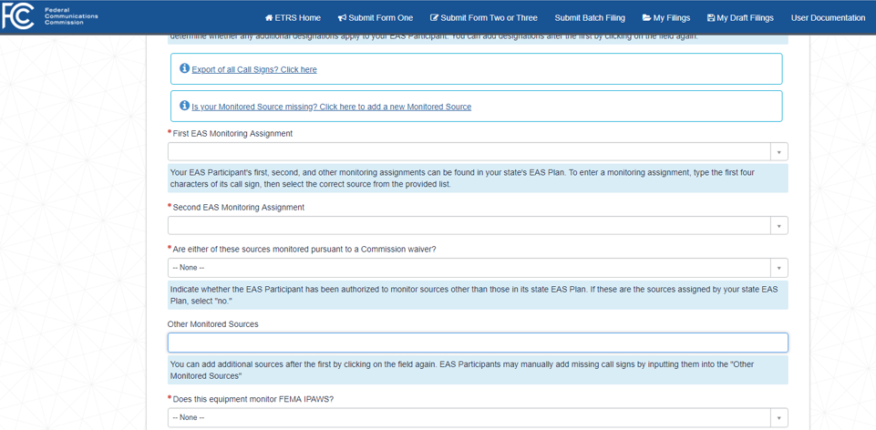

I cannot change other information on Form One (latitude/longitude, for example) because it is grayed out. How do I make changes to these fields? (The pre-populated data for my facility is incorrect.)

EAS Participants that pre-populate Form One using a Facility ID number or a Physical System ID (PSID) number are urged to review their pre-populated data to ensure accuracy. Outdated or inaccurate data fields that cannot be edited in ETRS are populated from the EAS Participant’s filings in the Commission’s Online Public Inspection File (OPIF). Accordingly, EAS Participants must ensure that their OPIF information is correct for it to appear accurately in ETRS. EAS Participants are urged to review Form One as soon as possible to allow sufficient time for possible OPIF corrections. Once information is corrected in OPIF, it will be updated in ETRS within 24 hours. This is the OPIF sign in page. Please find a more detailed answer below.
Step One: Update information in the database that feeds into ETRS.

ETRS is populated from the EAS Participant’s filings in the Commission’s Online Public Inspection File (OPIF), which is, in turn, updated from the Consolidated Database System (CDBS). You must first correct and update that CDBS information in the OPIF for it to accurately appear in ETRS. To do that, go to https://publicfiles.fcc.gov to log in to the OPIF. Use the Sign In button in the upper right-hand corner.

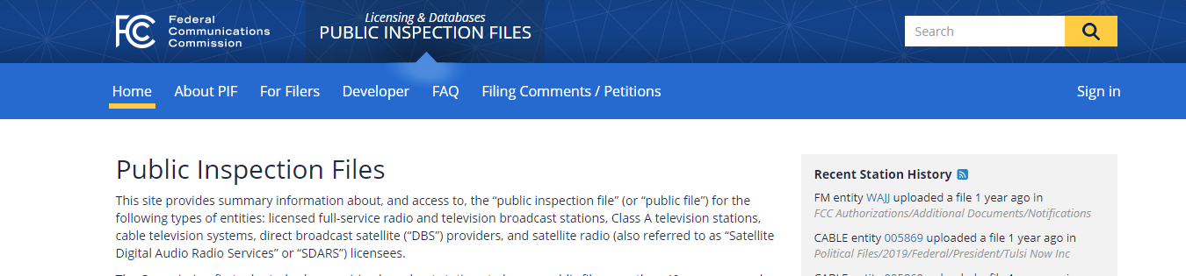
- Use the following website to find answers to Public File FAQs. https://publicfiles.fcc.gov/faq/#broadcasters-login

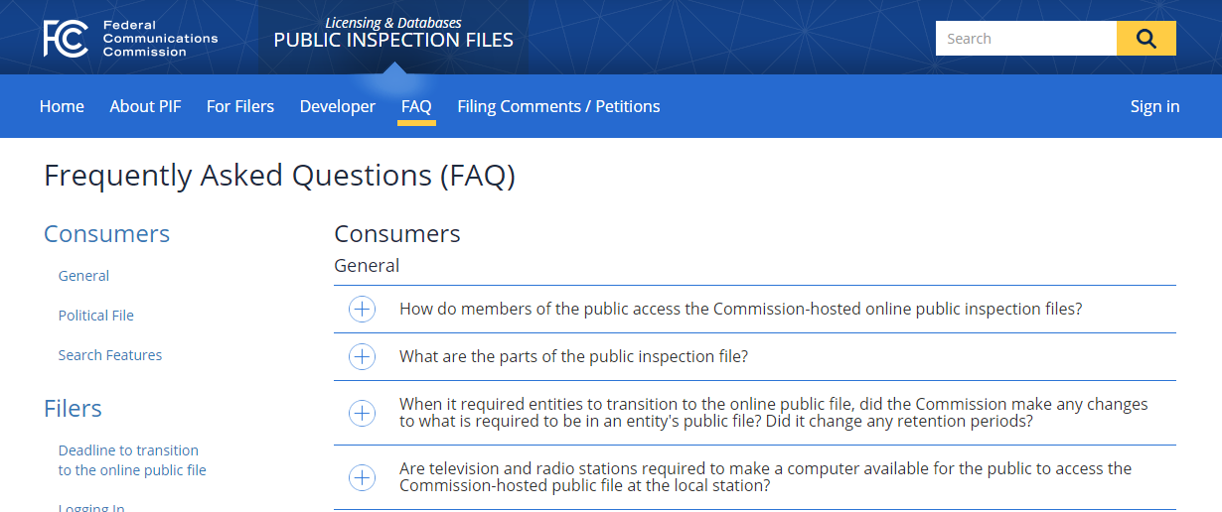

How do I edit the Day of Test Contact (DoTC) fields?
If you cannot edit the day-of-test contact fields directly, this is because you have indicated that the filer and the DoTC are the same. You can edit that field by completing all the Filer Contact Information fields or indicating “No” in the dropdown menu that the person designated in the Filer Contact Information fields is not the EAS Participant’s day of test contact.

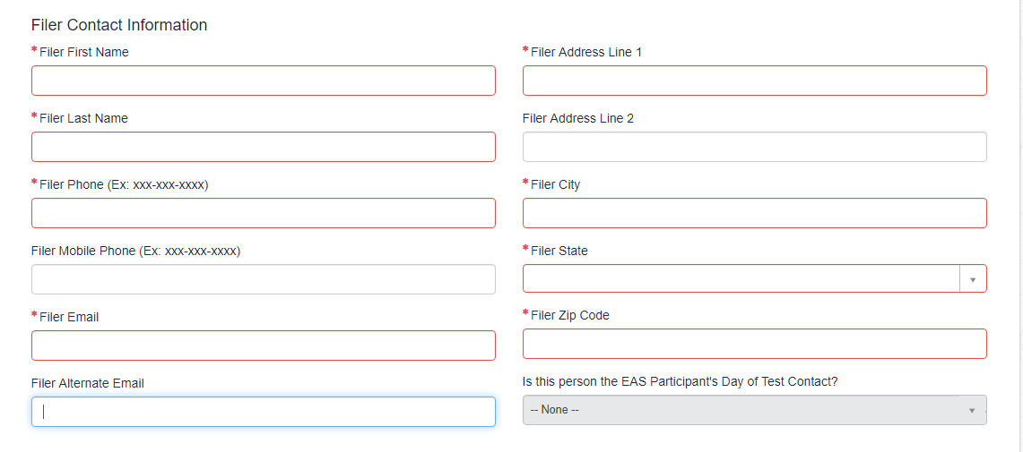
Complete All Required Fields Below

Back to Top

State EAS Plans

I can’t find my operational area(s) in my state’s EAS plan.
If you have any questions about your state's plan, please contact your State Emergency Communications Committee (SECC) chair. If you cannot reach your state’s SECC chair, please contact your state’s broadcasters association.

I can’t find a copy of my state’s EAS plan.
If you have any questions about your state’s plan, please contact your State Emergency Communications Committee (SECC) chair using the contact information available at: https://www.fcc.gov/public-safety-and-homeland-security/policy-and-licensing-division/alerting/general/state-eas-plans.

Back to Top

Batch filing

How do I submit a batch filing?
Click on the “Submit Batch Filing” menu option. Download and complete the spreadsheet template. After you have completed the template, you can choose a test cycle on the batch filing page, upload your file, and submit it. You will receive an e-mail after your batch filing has processed. If corrections to your batch filing are needed, the e-mail will provide you with a link to a page that explains the corrections that you need to make before re-uploading the template. Filers should ensure that all fields are complete before uploading the batch filing.

I received an error message when attempting to upload my spreadsheet.
Spreadsheet templates must be saved in .xlsx format before being uploaded to ETRS. Instructions for saving in the correct format can be found in the User Documentation available in ETRS. We also strongly recommend that spreadsheets be edited and saved in Excel or errors may occur.

Can I file Form One using the same batch filing spreadsheet that I used last year?
When batch filing in ETRS, you can file by filling out and submitting the blank batch filing template spreadsheet that is provided on the Batch Filing page of ETRS. Alternatively, you can file by updating and submitting a batch filing spreadsheet that you filed in a prior year. To ensure that an updated spreadsheet is processed accurately, please take the following steps:
- Review column B of your spreadsheet to ensure that it correctly reflects the Form that you intend to file (e.g. Form One);
- Delete all Filing Numbers in column C of your spreadsheet, as these filing numbers change every year; and
- Delete any responses in columns AM through BM and any notes in Column CK of your spreadsheet that report test results from prior years.

Column B: Column C:

You MUST SELECT a form, from the drop-down, that indicates which form you are filing. | To paste the Filing Number, please use one of the following options:  1 - Double-click on the cell, then Right-click on the cell and select Paste.  2 – Right-click on the cell and select the Paste option for Match Destination Formatting (M).
Required Form One
Required Form Two | Required Form Two
Required Form Three | Required Form Three
Form | Filing Number

Column AM:

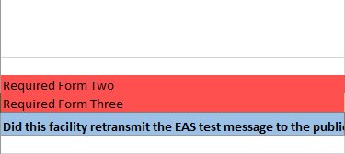

Column BM:
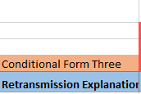

Column CK:

My batch filing failed to process. How do I find the list of corrections I need to make?

Step One: Click on “Submit Batch Filing” menu option
From the main ETRS page, find the Submit Batch Filing thumbnail tile. This will bring up your submitted batch filings. On the filing in question, it should say “Correction to Filing Needed” under “Status.”

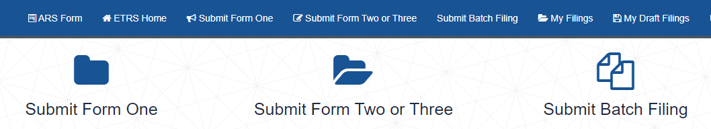

Step two: Click on Section Labeled “Correction to Filing Needed”
The section “Correction to Filing Needed” will bring you to a list of the filings that require correction.
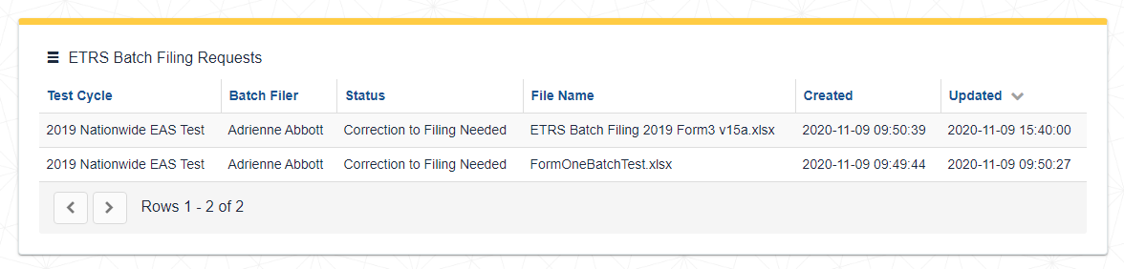

Step three: Click on an individual filing to see the list of corrections needed.
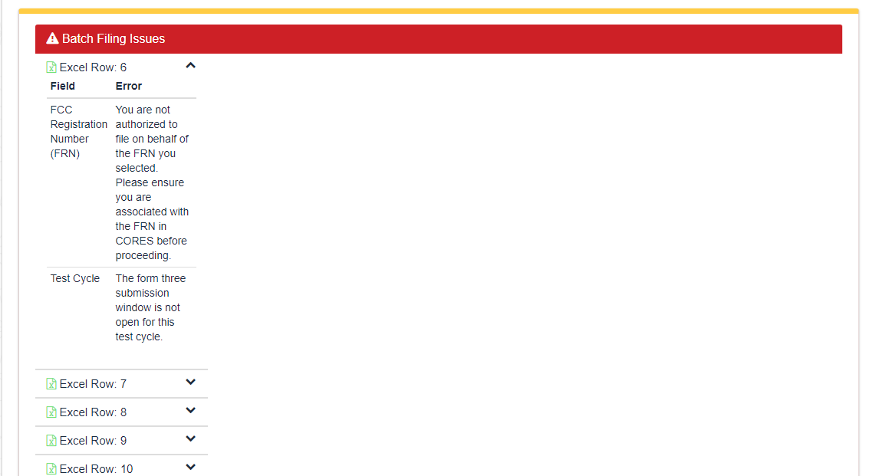

Back to Top

Non-Filing Related Questions

How do I print a previously filed Form?
Step One: Click on My Filings.

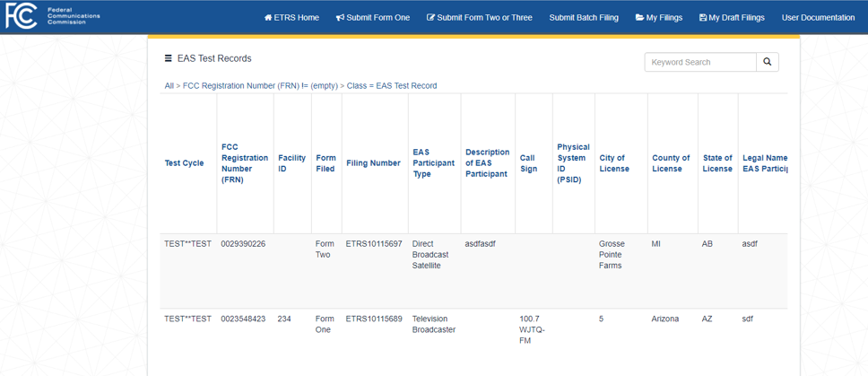

Step Two: Open the record by choosing one record from a row.

You can choose to print all records by clicking on the “Hamburger” menu next to the EAS Test Records heading. If you choose this option, go to Step Four.

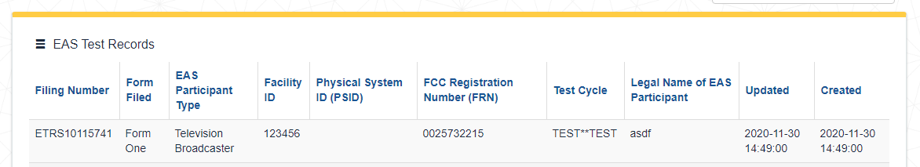

Step Three: Click on “Hamburger” menu (three horizontal lines) next to the Filing Number.
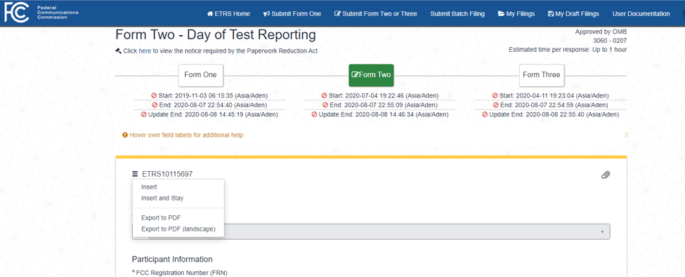
Step Four: Click on desired export -- either Export to PDF or Export to PDF (landscape) (if printing individual files) or PDF, Excel, or CSV* if printing the entire group of filings.

For individual filings, only PDF or PDF (landscape) is an option under the menu.

* CSV stands for comma-separated value. This type of download allows data to be saved in a tabular format. CSV files can be used with many spreadsheet programs, such as Microsoft Excel or Google Spreadsheets.
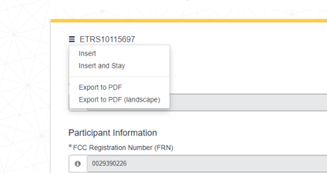

You may export the document as a PDF, Excel, or CSV file and print the group.
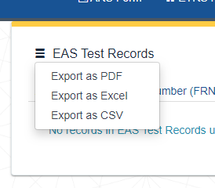

Step Five:

If exported as PDF, choose “print” from the File menu, or click on the printer icon.

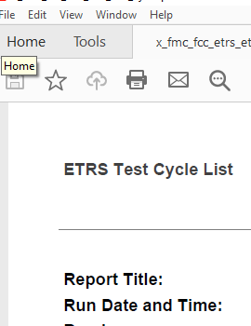

If exported as Excel or CSV, choose “print” from the File menu. You may need to click on “Enable Editing” first.

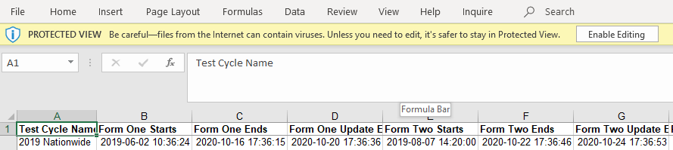

Back to Top

Guide to Filing Form 1
Below is a list of the information you will need to complete Form One. Please use this sheet to help gather the necessary Form One information before you sit down to file the form. If you have filed Form One in previous years, much of this information will be pre-populated once you complete the FRN, Facility ID, and/or Physical System ID fields.

Each EAS Participant should file a separate copy of Form One for each its EAS encoder/decoders. For example, if you are filing for a broadcaster (or cable headend) that uses two EAS encoder/decoders, you should file two copies of Form One. If your EAS Participant shares an EAS encoder/decoder with another EAS Participant, each EAS Participant should file its own copies of Form One for that EAS encoder/decoder.

- FCC Registration Number (FRN)

- EAS Participant Type
Select from Radio Broadcaster, Television Broadcaster, Cable System, Wireless Cable System, Cable Reseller, Direct Broadcast Satellite, Satellite Digital Audio Radio Service, IPTV Provider, Wireline Video System, Other.

- Facility ID
For broadcasters.

- Call Sign
For broadcasters.

- Physical System ID
For cable, IPTV, and wireline video providers.

- City of License

- County of License

- State of License

- Legal Name of EAS Participant
This is typically the name of the licensee for which you are filing.

- Owner of EAS Participant
If this EAS Participant is owned by a larger entity, you may provide the entity's name here.

- EAS Equipment Make and Model
If your EAS Participant uses multiple types of equipment, please provide them all.

- EAS Equipment Software Version
If your EAS Participant uses multiple types of equipment, please provide them all.
- Community Unit IDs served by this equipment
For cable, IPTV, and wireline video providers.
- EAS Designation
Please select all applicable EAS Designations for this facility. Most EAS Participants only serve as Participating Nationals. Please review your state's EAS Plan to determine whether any additional designations apply to your EAS Participant.
- First EAS Monitoring Assignment
Your EAS Participant's first monitoring assignment can be found in your state's EAS Plan.
- Second EAS Monitoring Assignment
Your EAS Participant's second monitoring assignment can be found in your state's EAS Plan.
- Are either of these sources monitored pursuant to a Commission waiver? Indicate whether the EAS Participant has been authorized to monitor sources other than those in its state EAS Plan. If these are the sources assigned by your state EAS Plan, select "no."
- Other Monitored Sources
Your EAS Participant's other monitoring assignments can be found in your state's EAS Plan.
- Does this equipment monitor FEMA IPAWS?
- Primary Language(s) in Service Area Drop down choices or You can add additional languages after the first by clicking on the field again.
- Geographic Zones of Service
In your state EAS Plan, you will find that your state is divided into several operational areas. Please enter the operational area(s) to which your EAS Participant provides service.
- Transmitter Latitude (NAD83)
Please provide the facility's latitude using the North American Datum of 1983 in decimal format.
Enter the latitude and the longitude of your EAS Participant`s antenna that transmits emergency alerts to the public. Latitude and longitude are accepted in Decimal Degrees. If you need to convert your latitude or longitude from Degrees Minutes Seconds or NAD27, click here.

- Transmitter Longitude (NAD83)
Please provide the facility's longitude using the North American Datum of 1983 in decimal format.

- Transmitter City
If your EAS Participant's transmitter is not located within a city or other municipality, enter "N/A."

- Transmitter County

- Transmitter State

- Receiver Address Line 1
Please enter the location of the antenna that your EAS Participant uses to monitor for emergency alerts transmitted by other EAS Participants.

- Receiver Address Line 2 | - Receiver City
- Receiver County | - Receiver State
- Receiver Zip Code

- Filer First Name | - Filer Last Name
- Filer Phone (Ex: xxx-xxx-xxxx) | - Filer Mobile Phone (Ex: xxx-xxx-xxxx)
- Filer Email | - Filer Alternate Email
- Filer Address Line 1 | - Filer Address Line 2
- Filer City | - Filer Zip Code
- Is this person the EAS Participant's Day of Test Contact?

- Day-of-Test Contact (DoTC) First Name | - DoTC Last Name
- DoTC Phone (Ex: xxx-xxx-xxxx) | - DoTC Mobile Phone (Ex: xxx-xxx-xxxx)
- DoTC Email | - DoTC Alternate Email
- DoTC Address Line 1 | - DoTC Address Line 2
- DoTC City | - DoTC State
- DoTC Zip Code

Back to Top

Guide to Filing Forms 2 and 3
Below is a list of the questions and information needed to complete Forms Two and Three. Please use this sheet to help gather necessary Form Two and Three information before you sit down to file the forms. Forms Two and Three will become available at the time of the test. Only those filers who have previously submitted Form One for the current test cycle will be able to submit Forms Two and Three in ETRS.

Form Two
Did this facility receive the EAS test message?
- Yes
- No
Did this facility retransmit the EAS test message to the public?
- Yes
- No

Form Three
From which source(s) did this facility receive the EAS test message?
Identify the source from which this facility first received the EAS test message.
Date and Time of Receipt of First Message
Receipt Time Zone
Language(s) of EAS Message Receipt
Receipt Other Language
Received without complications
- True
- False
Receipt Equipment configuration issues
- True
- False
Receipt Software out-of-date
- True
- False
Receipt Equipment failure
- True
- False
Receipt Audio quality issue
- True
- False
Receipt User error
- True
- False
Receipt Other
Receipt Explanation (open text field)
Date and Time of Retransmission of EAS Test Message
Retransmission Time Zone
Language(s) of EAS Message Retransmission
Retransmission Other Language
Retransmission without complication
- True
- False
Retransmission Equipment configuration issues
- True
- False
Retransmission Software-out-of-date
- True
- False
Retransmission Equipment failure
- True
- False
Retransmission User error
- True
- False
Retransmission Other
Retransmission Explanation (open text field)

Back to Top

Further Questions

If you have a question that is not addressed in this FAQ, please e-mail that question to etrs@fcc.gov. The ETRS Team will respond to your question as quickly as possible. Please include your email and phone number so that the ETRS Team can follow up with you if necessary.

Back to Top

