Incentive Auction Broadcaster Relocation Reimbursement System – FCC Form 2100, Schedule 399

User’s Guide

Table of Contents for Broadcaster’s Form 399 User’s Guide

Using Form 399 4

*Requesting Upgrades* 4

*Providing Justification* 5

Form 399 Sections 5

Section I. – *Application Section* 6

Section I.A. – *Applicant Information* 7

Section I.B. – *Reimbursement Contact Information* 7

Section I.C. – *Preparer Contact Information* 9

Section I.D. – *Broadcaster Information and Transition Plan* 10

Section II. – *Transmitter Information* 12

Section II.A. – *Transmitter Related Expenses* 12

Section II.B. – *Transmitter Changes* 12

Section II.C. – *Add Transmitter* 13

Section II.D. – *New Transmitter Costs* 15

Section II.E. – *Retuning Transmitter Costs* 17

Section II.F. – *Other* *Transmitter Costs* 18

Section III. – *Antenna Related Expenses* 19

Section III.A – Antennas 19

Section III.B. – *Antenna Changes* 20

Section III.C. – *Add Antenna* 22

Section III.D. – *Other Antenna Costs* 24

Section IV. – *Transmission Line Changes* 26

Section IV.A. – *New Transmission Line* 26

Section V. – *Tower Equipment and Rigging Costs* 28

Section V.A. – *Tower Equipment and Rigging Costs* 29

Section V.B. – *Engineering Study/Tower Reinforcements* 32

Section V.C. – *Tower Rigging Costs* 32

Section VI. – *Outside Professional Services Costs* 33

Section VI.A. – *Outside RF Consulting Engineering Services* 33

Section VI.B. – *Attorney and Other Outside Consulting Services* 34

Section VI.C. – *RF Field Engineering Services* 35

Section VI.D. – *Other Professional Expenses Not Listed* 36

Section VI.E. – *Facility Expenses* 37

Section VI.F. – *Permit and Filing Costs* 37

Section VI.G. – *Other Miscellaneous Expenses* 38

Section VII. – *Costs Section* 39

Section VIII. – *Application Summary Section* 40

Section IX. – *Certify Section* 41

APPENDIX - DEFINITIONS 43

The Federal Communications Commission (FCC) Form 2100, Schedule 399 (“Form 399”), is the form broadcasters and Multichannel Video Programming Distributors (MVPDs) will use to claim reimbursement for their reasonably incurred expenses in connection with the post-auction repack. Form 399 is accessible via the FCC Licensing and Management System (LMS).

# Using Form 399

Broadcasters, or users, can log-in to the LMS to access Form 399 using their respective FCC Registration Number (FRN) via the following link: <https://enterpriseefiling.fcc.gov/dataentry/login.html>.

Within Form 399, the button at the bottom of every screen allows users to save information. This information will be stored, but not submitted to, the FCC and can be edited while users work through developing their cost estimate. Cost estimates and expense reimbursement requests are not reviewed by the FCC until broadcasters certify each cost estimate or expense reimbursement request in Form 399. Eligible broadcasters are encouraged to begin the process as soon as possible, using the button to save their work intermittently. Within Form 399, all fields marked with an asterisk “*” are required fields.

## *Requesting Upgrades*

Throughout Form 399 users can indicate a request for reimbursement of upgraded equipment by clicking “Yes” in response to the upgrade question within each equipment category section.  Stations may upgrade their equipment by paying the difference(s) between the cost of the reasonable, comparable equipment necessary to achieve a station’s post-auction reassignment — without the upgrade –and the upgraded equipment. For example, a station has an Inductive Output Tube (IOT) transmitter that can be re-channeled with some Radio Frequency (RF) parts, a new tube, a new tube cart and a new exciter. The price for the entire re-channel, including the labor is $215,000. Their existing transmitter has had some reliability problems, and the station feels that they would rather have a new IOT transmitter than re-channel the one they have. The cost of a new IOT transmitter for the power they need is $400,000. The station submits both the costs to re-channel their existing transmitter and the quote for the new transmitter, understanding that they will pay the $185,000 difference between the new transmitter and the re-channel costs. For upgrades, stations need to submit documentation demonstrating the cost differential for each option. *See* Fig. 1: *Upgrades*.

**Fig. 1: *Upgrades***

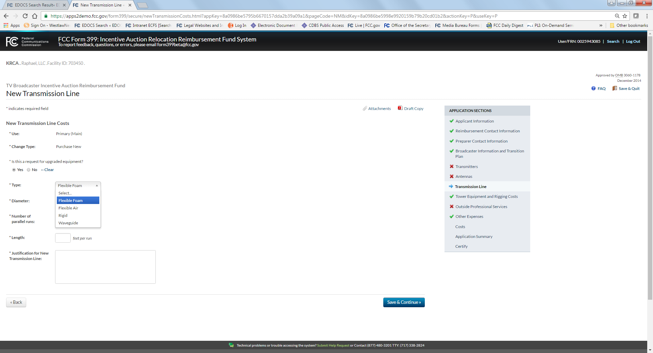

## *Providing Justification*

The predetermined cost estimate is based on the ranges provided in the latest Cost Catalog. You can rely on the Cost Catalog for cost estimates for which you don’t have cost estimates from individual vendors. For your reference and convenience, the latest *Catalog of Potential Expenses and Estimated Costs* is available here: <http://transition.fcc.gov/Daily_Releases/Daily_Business/2017/db0209/DA-17-154A2.pdf>. Stations may rely on the Cost Catalog to submit estimates if they do not have individual estimates from vendors. You are required to provide supporting documentation for any items that are not listed in the Catalog.

# Form 399 Sections

The Form 399 has nine sections: Application Information, Reimbursement Contact Information, Preparer Contact Information, Broadcaster Information and Transition Plan, Broadcaster Estimated and Actual Transition Expenses, Costs, Final Accounting, Application Summary and Certify. Sections that have not been completed will not have a red “X” or a green check mark in front of the section name. When all requirements of a section are completed, a green check mark appears in front of the section name. If a section shows a red “X” in front of the section name, the section has been partially filled out but not all requirements have been completed. The *Final Accounting* section of this document will be added later. *See* Fig. 2: *Application Sections*.

**Fig. 2: *Application Sections***

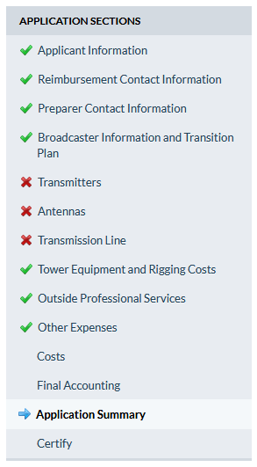

## Section I. – *Application Section*

Form 399 will pre-populate the applicant type field either broadcaster or MVPDs based on the information entered at the LMS log-in screen. The contact information of the individual entering information on behalf of the station will also pre-populate with information currently in the FCC’s database. You should review this contact information for accuracy. If changes or updates are required, you must correct the information in the corresponding FCC database (either LMS or the Commission Registration System (CORES)) prior to submitting Form 399. *See* Fig. 3: Application Section: *Applicant Information*.

## Section I.A. – *Applicant Information*

**Fig. 3: Application Section: *Applicant Information***

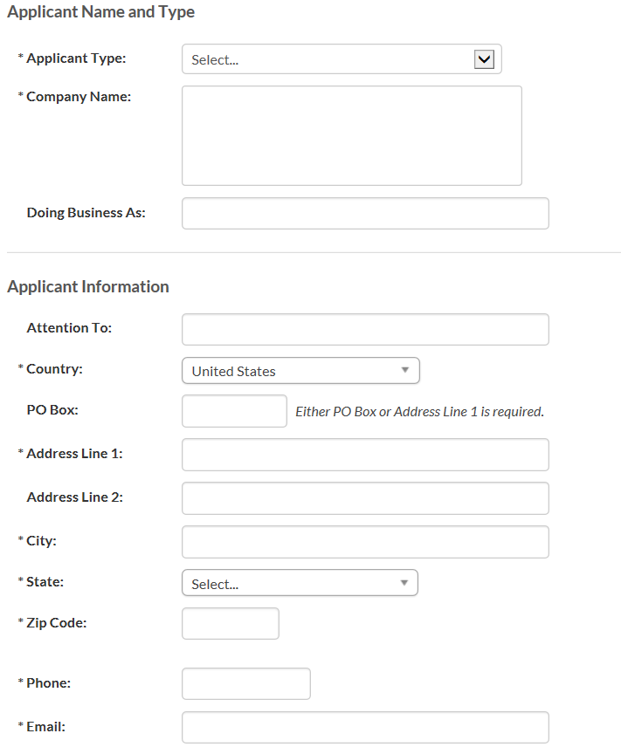

## Section I.B. – *Reimbursement Contact Information*

In the *Reimbursement Contact Information* section, enter the contact information for the individual that the FCC should contact if any questions arise with respect to the information stated in Form 399. *See* Fig. 4: Application Section: *Reimbursement Contact Information*. This contact information may be different than the contact information in Form 1876.

**Fig. 4: Application Section: *Reimbursement Contact Information*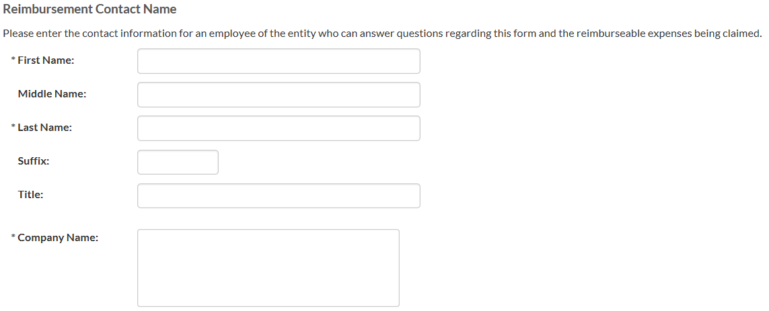**

The information in the *Reimbursement Contact Information* section may be different than information listed in Form 1876.

After completing the *Reimbursement Contact Information* section, click on the  button located in the lower-right corner of the page to save information and continue to the *Preparer Contact Information* section. *See* Fig. 5: Application Section: *Reimbursement Contact Information*.

**Fig. 5: Application Section: *Reimbursement Contact Information***

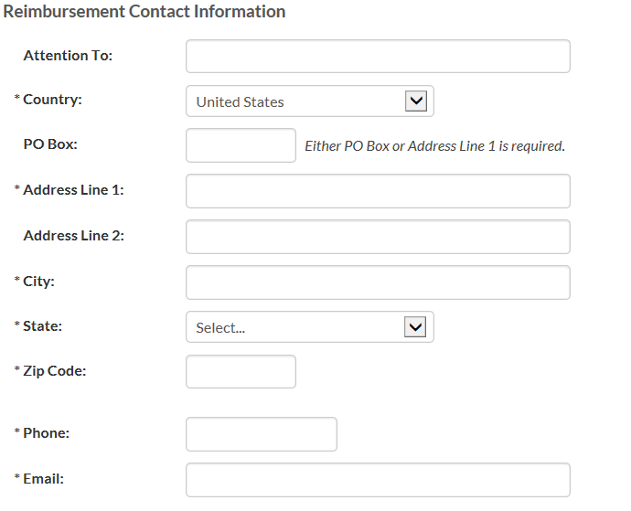

## Section I.C. – *Preparer Contact Information*

In the *Preparer Contact Information* section, provide the contact information for the individual or party responsible for preparing and submitting Form 399. Please indicate whether the preparer is the same individual as the reimbursement contact. If yes, the contact information will pre-populate in the appropriate fields. *See* Fig. 6: Application Section: *Preparer Contact Information* *(Part 1)* and Fig. 7: Application Section:*Preparer Contact Information* *(Part 2).*

**Fig. 6: Application Section: *Preparer Contact Information (Part 1)***

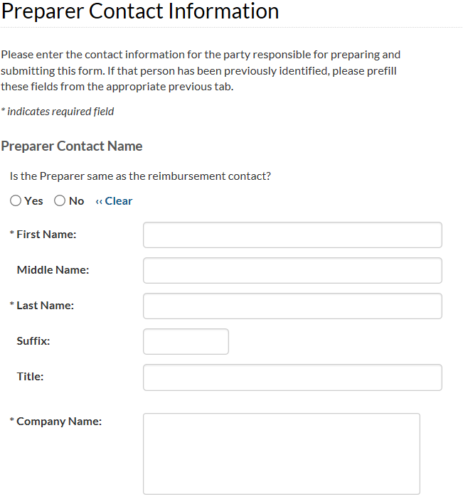

**Fig. 7: Application Section: *Preparer Contact Information* *(Part 2)* 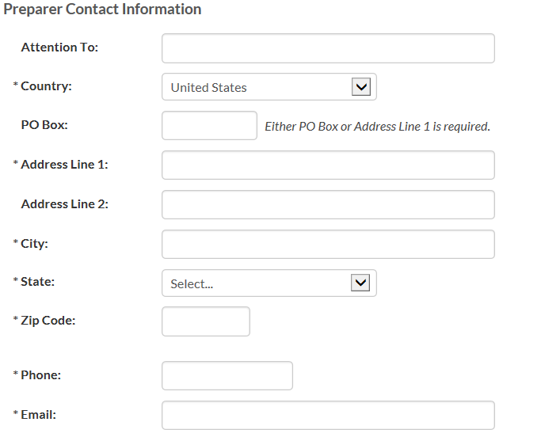**

After completing the *Preparer Contact Information* section, click the  button located in the lower-right corner of the page to save the information and continue to the next section (*Broadcaster Information and Transition Plan*).

## Section I.D. – *Broadcaster Information and Transition Plan*

In the *Broadcaster Information and Transition Plan* section, indicate whether you will be sharing equipment with another broadcast television station or stations (e.g., a shared antenna, co-location on a tower, use of the same transmitter room, multiple transmitters feeding a combiner, etc.) or not.

You must provide a brief description of the transition plan. The following are required for submission: a brief description of the transition plan (not to exceed a 255 character limit) including a short description of the current RF system, and if available, upload an attachment in the form of a drawing, hand sketch, or other descriptive item that will help reviewers to understand your system’s current state and future state. Additional information is not required but will significantly decrease the time required for FCC review. *See* Fig. 8: *Broadcaster Information and Transition Plan (Part 1)*.

**Fig. 8: Application Section: *Broadcaster Information and Transition Plan (Part 1)***

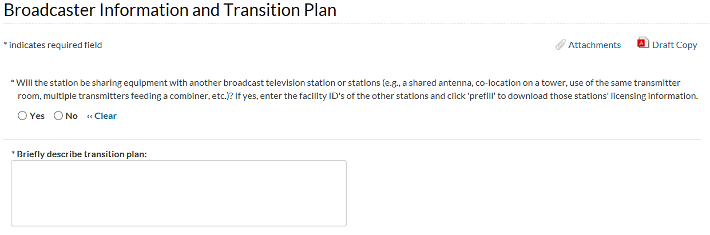

If stations will be sharing equipment with another broadcast television station or stations, it is required to provide the Facility ID for each station(s) sharing the equipment. Details about the sharing station(s) will automatically populate after the appropriate Facility ID is entered. For each station, click the 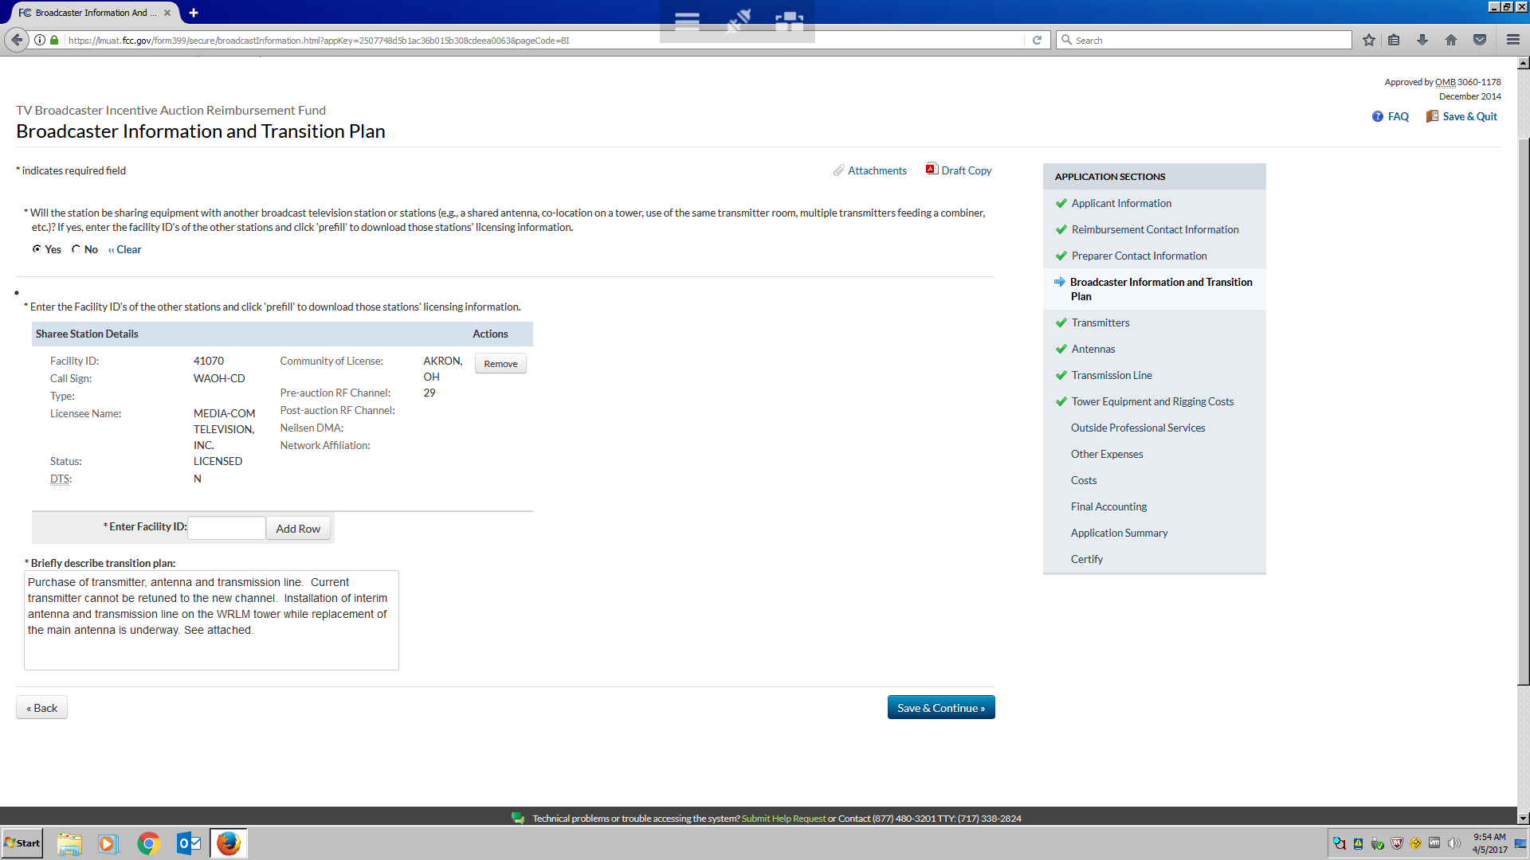 button to enter a Facility ID. *See* Fig. 9: Application Section: *Broadcaster Information and Transition Plan (Part 2).*

**Fig. 9: Application Section: *Broadcaster Information and Transition Plan (Part 2)***



After completing the *Broadcaster Information and Transition Plan* section, click on the  button located in the lower-right corner of the page to save information and continue to the *Transmitter Information* section.

## Section II. – *Transmitter Information*

Depending on your new channel assignment, it may be possible to retune your existing transmitter to transmit on the new channel rather than replace it. If you have transmitter related expenses, whether retuning or purchasing a new transmitter, you can submit requests for reimbursement in the *Transmitter Related Expenses* section.

## Section II.A. – *Transmitter Related Expenses*

If you will have transmitter related expenses, indicate so by choosing “**Yes**” from the dropdown menu. If you do not have or will not have transmitter related expenses, choose “**No**” and proceed to the *Antenna Related Expenses* section. *See* Fig. 10: *Transmitter Related Expenses*.

**Fig. 10: Transmitters Section: *Transmitter Related Expenses***

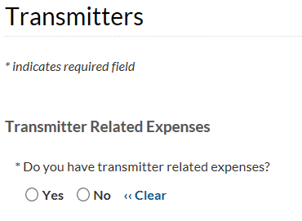

## Section II.B. – *Transmitter Changes*

When requesting reimbursement for transmitters, each licensed transmit site for this Facility ID will be listed. Click the “Edit” button to update information about existing transmitter(s). The station may currently have one or more auxiliary transmitter(s). One or more of these transmitters may be able to be retuned to operate on the new channel, or may require replacement. During transition to the new channel, stations may also need to use a transmitter for interim operations while work is being performed on the primary transmitter (i.e., retuning or replacement). Stations may have an existing auxiliary transmitter that can be used for interim operations, or may have to purchase or lease another transmitter. *See* Fig. 11: Transmitters Section: *Transmitter Changes Summary Screen*.

**Fig. 11: Transmitters Section: *Transmitter Changes Summary* 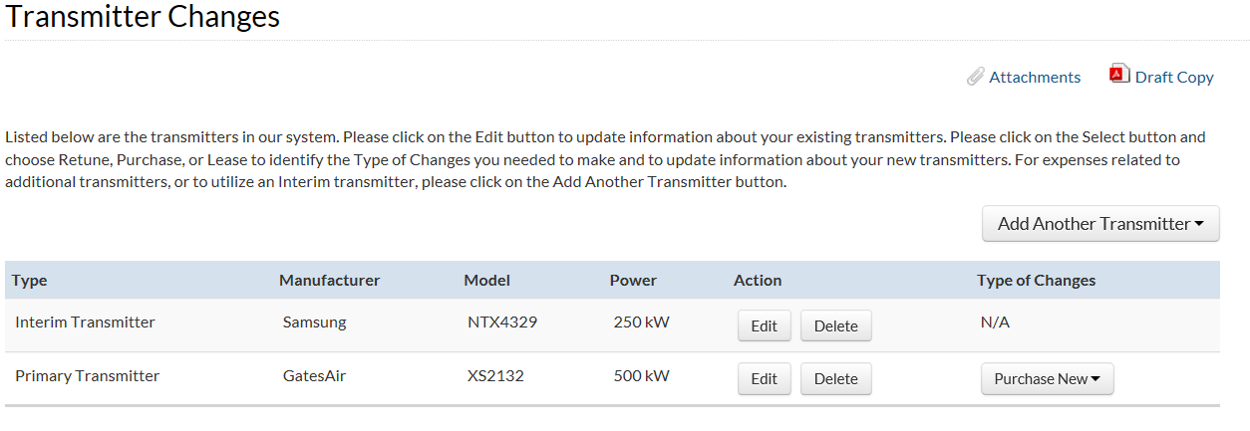**

## Section II.C. – *Add Transmitter*

If the station’s existing transmitters are not listed, add additional transmitters by clicking the ****button. Stations must list the Facility ID and Call Sign of any station on the transmitter. Also indicate the Manufacturer, Model, Year, and Type (**IOT**, **Solid State**, or **Other Type**). List the information outlined above for all transmitters the station currently has. *See* Fig. 12: *Add Transmitter*.

**Fig. 12: Transmitters Section: *Add Transmitter***

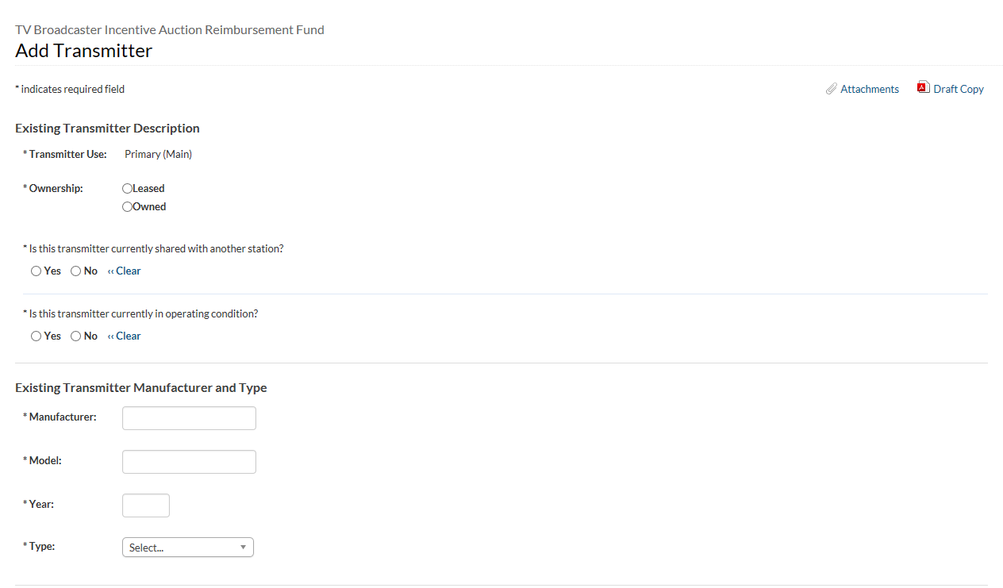

After clicking the ****button, confirm that you have accurately described each transmitter’s function (**primary** or **auxiliary**), indicated if the transmitter is owned by the station or a company affiliated with the station (e.g., a group station owner), and indicated whether the transmitter is rented or leased. If the transmitter is leased, provide the name and contact information for the owner. Indicate whether the transmitter is shared with another station and, if so, provide the Facility ID number of the station(s) with which the transmitter is shared, and whether or not the transmitter is in operating condition. For each transmitter, indicate the manufacturer, model, year manufactured, transmitter type (for IOTs, indicate power type) and power capacity.

To indicate that a new transmitter(s) will be added to the station, use the dropdown menu on the right side of the *Transmitter Changes* screen. (*See* Fig. 13: Transmitter Section: *Transmitter Summary Page*). For each of the transmitters, three options will appear in the dropdown menu: **Retune**, **Purchase New**, or **Lease New**.

**Fig. 13: Transmitter Section: *Transmitter Summary Page***

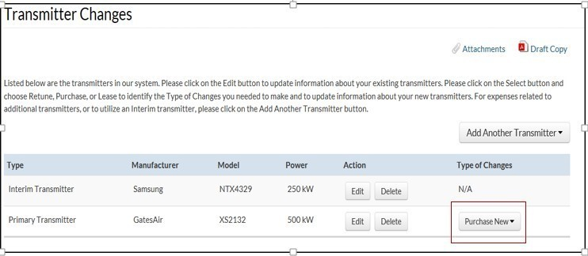

## Section II.D. – *New Transmitter Costs*

To add new transmitter costs, you will need to indicate the following: the change type (**lease new** or **purchase new**), the manufacturer, the model, the transmitter type, and justification for a new transmitter. The transmitter type will detail whether a transmitter is identified as solid state, an IOT, or “Other” transmitter type. For a solid state transmitter, the operator will need to indicate if a solid state cooling system is air or liquid and disclose the solid state power capacity (in kW). If the transmitter is identified as an IOT transmitter, then you will need to provide the IOT power type (**single**, **two**, **three**, or **other**) and the power capacity (in kW) (*see* Fig. 14: Transmitters Section: *New Inductive Output Tube Transmitter Costs*). If the transmitter is identified as an “Other” transmitter type, you will need to provide the transmitter type (*see* Fig. 15: Transmitters Section: *New Other Transmitter Type Costs*).

In the “Justification for a New Transmitter” section, you must provide details about why the current transmitter cannot be used for the reassigned channel. An example of a justification for a new transmitter might be, “The existing transmitter output mask filter is channel-specific and must be replaced to accommodate the channel change.” “The current transmitter cannot be re-channeled to meet new channel assignment. Engineering a spare tube cabinet into the current design is more expensive than purchasing a new transmitter.” Use attachments to further explain and provide supporting documentation and details for justification.

**Fig. 14: Transmitters Section: *New Inductive Output Tube Transmitter Costs***

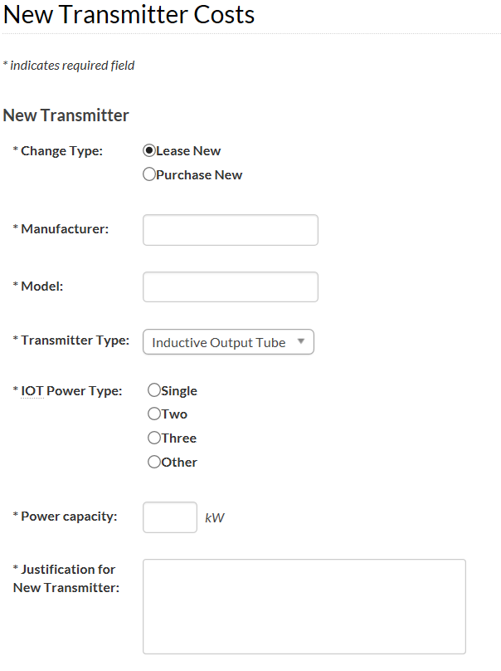

**Fig. 15: Transmitters Section: *New Other Transmitter Types Costs***

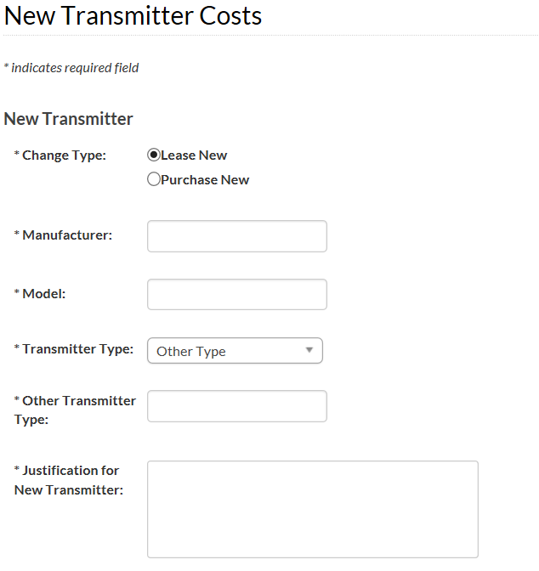

If you indicate that your station operates with a Distributed Transmission System (DTS), you will find each DTS site prefilled in the system. You will then be prompted to provide answers (Transmitters and In-Building Expenses) for each site in the system.

## Section II.E. – *Retuning Transmitter Costs*

Stations may be able to retune existing IOT transmitters to transmit on new channels, rather than replacing it. *See* Fig. 16: Transmitters Section: *Retuning Transmitter Costs*.

**Fig. 16: Transmitters Section: *Retuning Transmitter Costs***

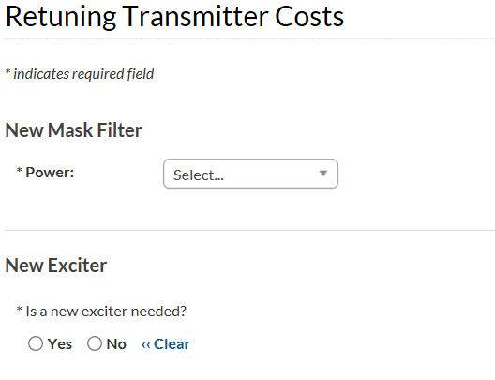

If you indicate that you need a new mask filter, you will be prompted to indicate the power level from a dropdown menu (**1.5kW**, **3 kW**, **7 kW**, **10 kW**, **30 kW**, **60 kW**, **90 kW**, or **other**). If you indicate that a new exciter is needed, you will need to indicate the “Exciter Type” (**single frequency agile** or **dual exciter with changeover**).

## Section II.F. – *Other* *Transmitter Costs*

The next section, *Other Transmitter Costs*, contains a list of possible changes the station might have to make to its transmitter(s) in order to transition to its new channel.

In the *Other Transmitter Costs* section, you will be able to indicate costs associated with Electrical Service, HVAC and Transmitter Building Addition/Modification or Leasehold Improvement. The Electrical Service options include: **Service Entrance** (3 phases 800A 208V), **Switchgear** (industrial 800 amp), **Transformer** (480V), **Rigid Conduit and Wiring**, and **Other Electrical Services**). In addition, there is a section that allows for “Other Transmitter Costs Not Listed” that includes the opportunity to identify the cost and provide a description. (*See* Fig. 17: Transmitters Section: *Other* *Transmitter Costs*).

**Fig. 17: Transmitters Section: *Other* *Transmitter Costs***

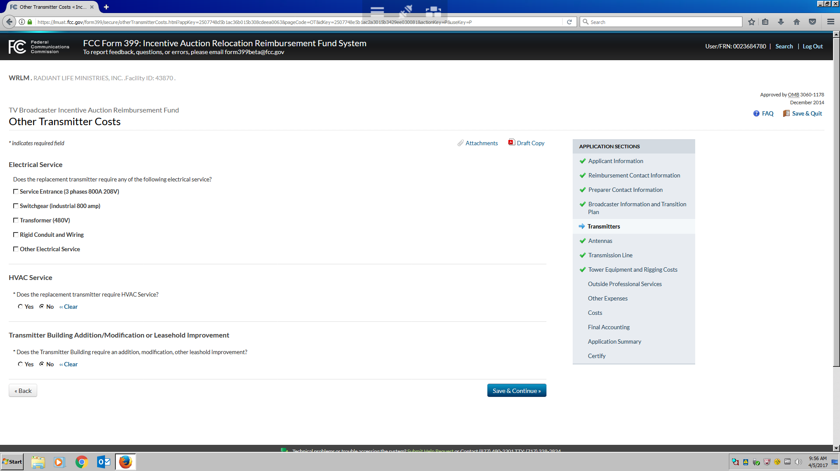

## Section III. – *Antenna Related Expenses*

This section contains a list of possible changes the station might have to make related to its antenna(s) in order to transition to its new channel.

## Section III.A – Antennas

In addition to the station’s existing primary antenna, the station may currently have one or more licensed auxiliary antennas available to use for backup and/or emergency purposes. It may be possible to retune these antennas to operate on the new channel or it may have to be replaced. During its transition to the new channel, the station may also need to use an antenna for interim operations while work is performed on the primary antenna (e.g., retuning, replacement, etc.). If the station has an existing auxiliary or emergency/backup antenna, such an antenna may be used for interim operations. Alternatively, the station may need to rent or purchase another antenna for interim operations.

For antennas currently used by a station that are operational and necessary for operations, stations should answer the question, “Do you have antenna related expenses?” Reimbursement is only available for equipment that is in working order. *See* Fig. 18: Antenna Section: *Antennas*.

**Fig. 18: Antenna Section: *Antennas***

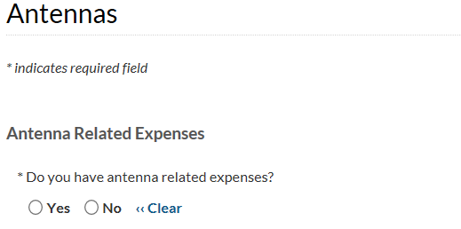

## Section III.B. – *Antenna Changes*

The system will pre-populate information for the existing antenna(s) that have been previously identified in the FCC’s system. You may add other antenna(s) by clicking the 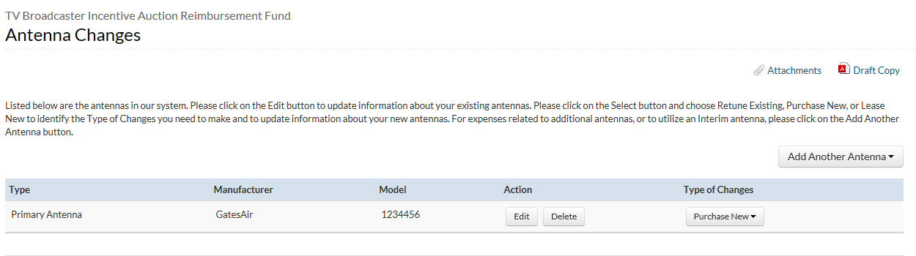button. *See* Fig. 19: Antenna Section: *Antenna Changes*.

**Fig. 19: Antenna Section: *Antenna Changes***



For each antenna the station currently uses, use the dropdown menu to describe the purpose for which the antenna is used (i.e., **primary**, **licensed auxiliary**, **interim**).

Users must provide and/or confirm the following required information for all antenna(s):

|  |  |
| --- | --- |
| **Attribute/Characteristic** | **Example/Options** |
| Antenna Use | **Primary**, **Auxiliary**, **Interim** |
| Change Type | **Primary**, **Auxiliary**, **Interim** (**Lease** **New**, **Rent** **Temporary**, **Purchase New**) |
| Ownership | **Leased**, **Owned** |
| Is the antenna shared? | **Yes**, **No** |
| Will the antenna be located on or in close proximity to an antenna farm? | **Yes**, **No** |
| New Antenna Manufacturer and Type | N/A |
| Class | **Class A**, **Full Power** |
| Mounting | **Top-mount single**, **Top-mount stacked**, **side-mount** |
| Antenna position in stack | **Not in Stack**, **Top, Middle**, **Bottom** |
| Polarization | **Horizontal**, **Elliptical**, **Circular** |
| Type | **Slotted coaxial**, **Broadband Panel**, **Other Type** |
| Effective Radiated Power (ERP) (in Kw) | N/A |
| Manufacturer | N/A |
| Model | N/A |
| Year | N/A |
| Justification for New Antenna | N/A |

## Section III.C. – *Add Antenna*

To add antenna(s), choose the Type of Changes (i.e., **Purchase New**, **Rent Temporary**, **Lease New**) for the appropriate antenna. When you have chosen the type of change, you will be asked the same series of questions listed in the table above. *See* Fig. 20: Antenna Section: *Add Antenna (Part 1)*, and Fig 21: Antenna Section: *Add Antenna* (Part 2) and Fig. 22: Antenna Section: *Add Antenna* (Part 3).

**Fig. 20: Antenna Section: *Add Antenna* (Part 1)**

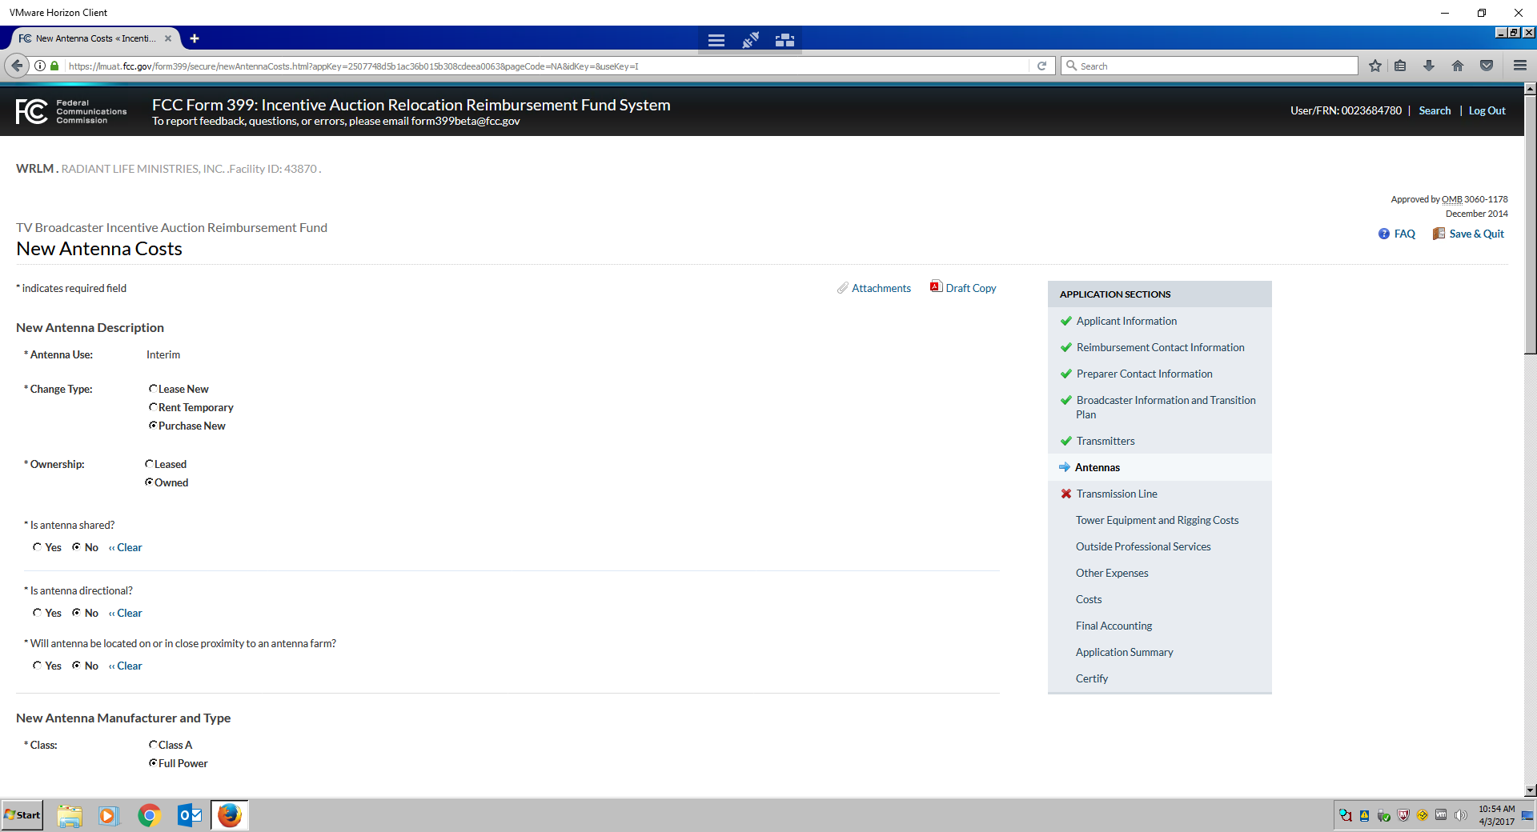

**Fig. 21: Antenna Section: *Add Antenna* (Part 2)**

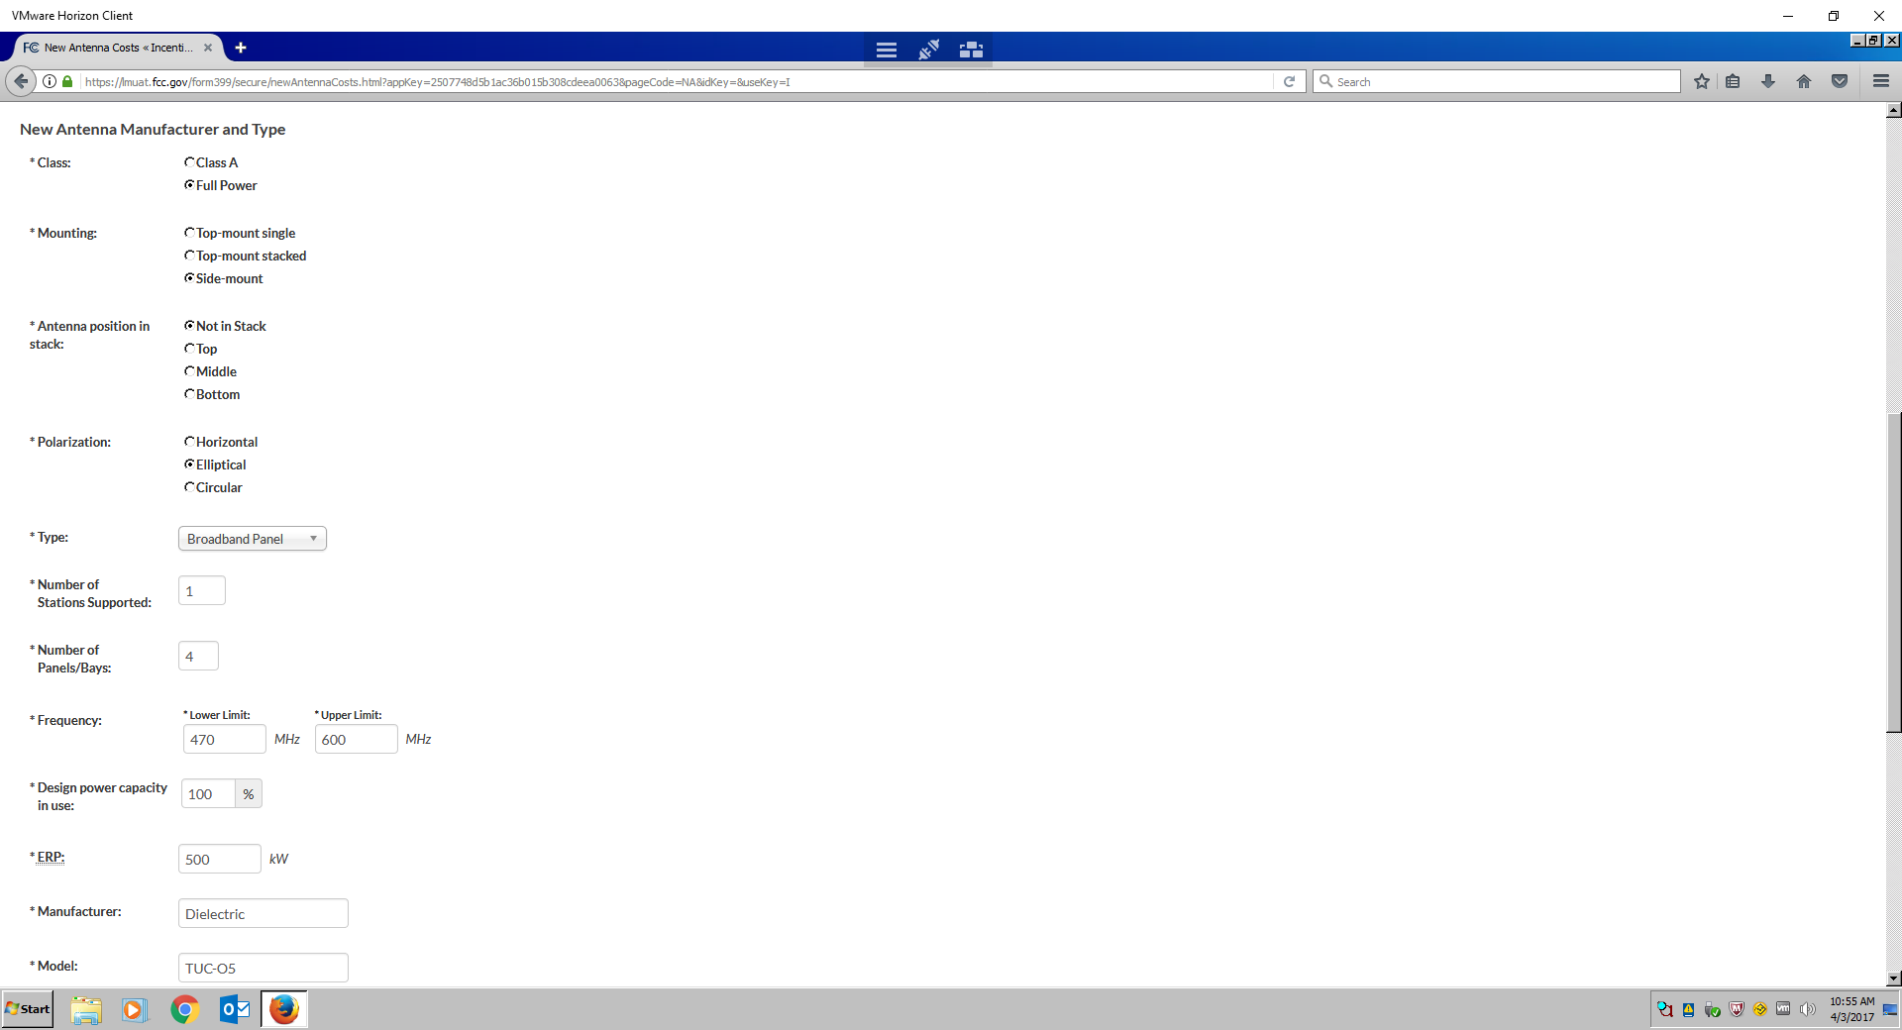

**Fig. 22: Antenna Section: *Add Antenna* (Part 3)**

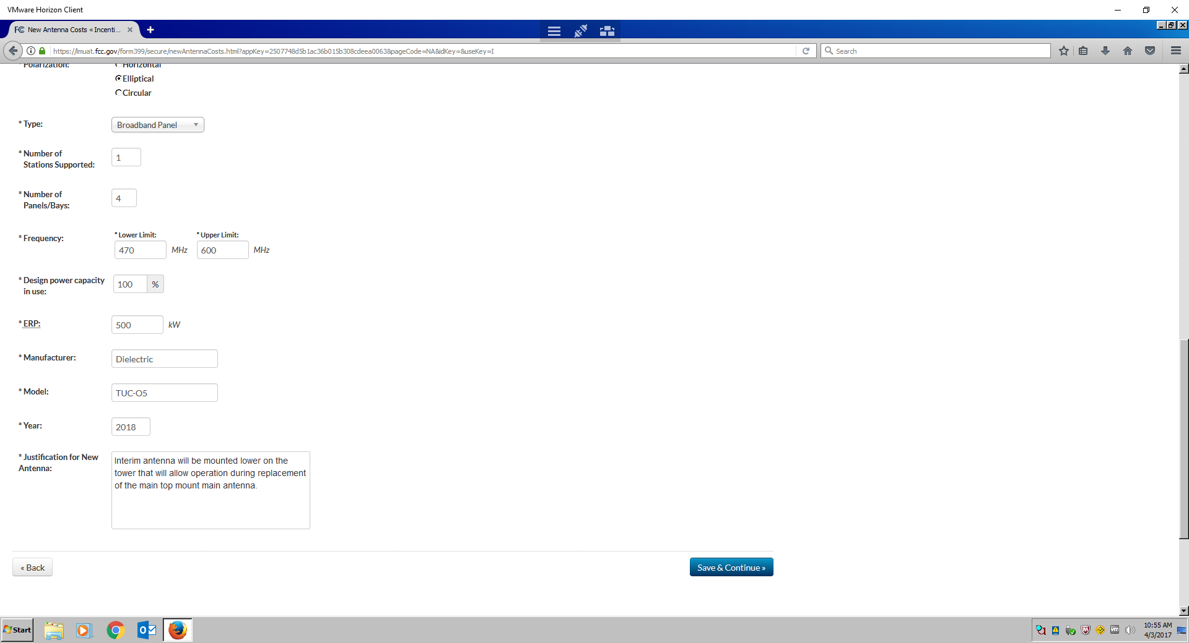

When your antenna is shared, you will need to provide the Facility’s ID and Call Signs of all stations with whom the antenna shared. *See* Fig. 23: Antenna Section: *Shared Antenna.*

**Fig. 23: Antenna Section: *Shared Antenna***

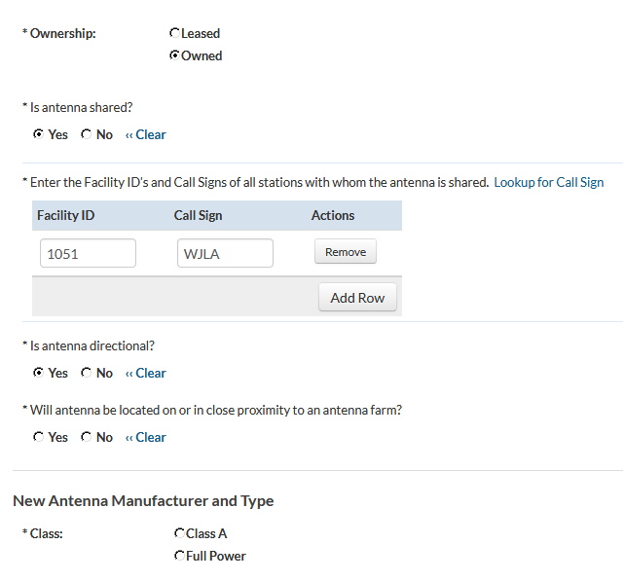

When writing a justification for the new antenna, provide as much information as possible to assist reviewers in making a determination about why the new transmitter is necessary.

## Section III.D. – *Other Antenna Costs*

Other antenna costs may include Retuning of Existing Antenna, Combiner for Shared Antenna, or “Other Expenses Not Listed.”

For antennas being retuned, indicate whether a sweep test is needed. *See* Fig. 24: Antenna Section: *Other Antenna Costs*.

**Fig. 24: Antenna Section: *Other Antenna Costs***

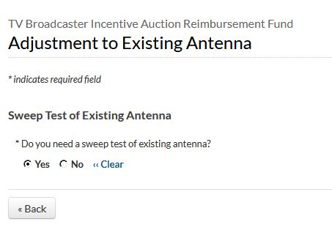

When requesting reimbursement for a combiner for Shared Antenna, indicate whether the station requires a new combiner for a shared broadband antenna or an additional module for an existing combiner. If the station requires a new combiner for shared a shared broadband antenna or an additional module for existing combiner, indicate the number of channels supported by the antenna and the frequency range of the channels capable of using the antenna.

*See* Fig. 25: Antenna Section: *Other Antenna Costs.*

**Fig. 25: Antenna Section: *Other Antenna Costs***

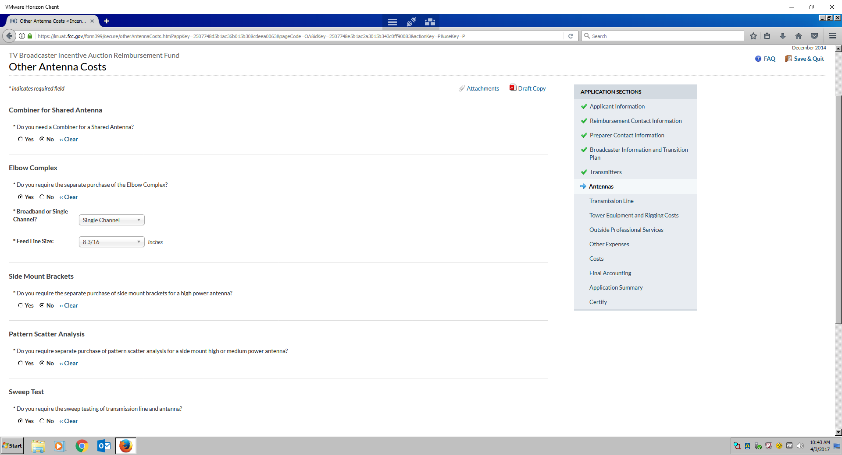

## Section IV. – *Transmission Line Changes*

The Transmission Line Changes questions contain a series of possible changes the station might have to make to its existing transmission line(s) in order to transition to its new channel. You will be prompted to answer these questions with respect to each antenna identified in response to the *Antennas* section, to account for the one or more parallel runs of transmission line for each antenna.

## Section IV.A. – *New Transmission Line*

You should only answer questions about transmission line(s) required for existing antenna to be retuned or for a new antenna. For each transmission line a station currently uses, describe the purpose of the antenna served by the line (e.g., **primary**, **licensed auxiliary**, etc.) and indicate if the line is owned by the station or a company affiliated with the station (e.g., a group owner) or if the line is rented/leased. In addition, for each line, indicate whether it is shared with another television station and, if so, provide the Facility ID number of the other station(s) with which the line is shared. Also, for each line, provide the name of the manufacturer and indicate the type (**Flexible Foam**, **Flexible Air**, **Rigid**, **Waveguide**), number of parallel runs, length of the line and whether it is in operating condition.

For each new transmission line the station intends to purchase, indicate the purpose for which the associated antenna is used (**primary**, **licensed auxiliary**, **interim**). Indicate whether or not this is a request for upgraded equipment. Also indicate the type of transmission line (**flexible foam**, **flexible** **air**, **rigid** or **waveguide**) and the diameter. For rigid line, indicate the segment length. Indicate the number of parallel runs of line required and the length of line in each run. In addition, provide a justification as to why the station thinks it is reasonable under the circumstances to purchase new transmission line rather than reusing its current line. *See* Fig. 26: Transmission Line Section: *New Transmission Line*.

**Fig. 26: Transmission Line Section: *New Transmission Line***

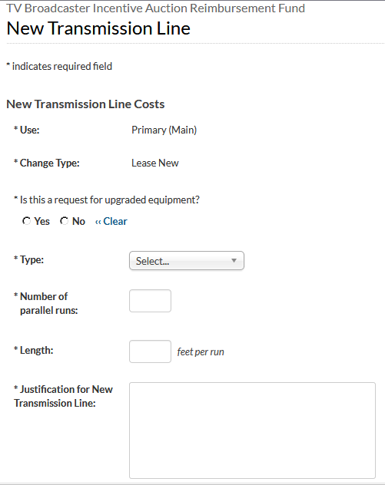

Stations that have costs related to transmission line that are not identified in the Cost Catalog should identify those costs and provide a description of the cost and provide justification as to the necessity and reasonableness of this cost.

## Section V. – *Tower Equipment and Rigging Costs*

This section contains a list of possible changes the station might have to make to its primary or auxiliary tower in order to transition to its new channel.

## Section V.A. – *Tower Equipment and Rigging Costs*

If you have tower equipment costs, you will be able to record them in the Tower Equipment and Rigging Costs section. *See* Fig. 27: Tower Equipment and Rigging Costs Section: *Tower Equipment and Rigging Costs*.

**Fig. 27: Tower Equipment and Rigging Costs Section: *Tower Equipment and Rigging Costs***

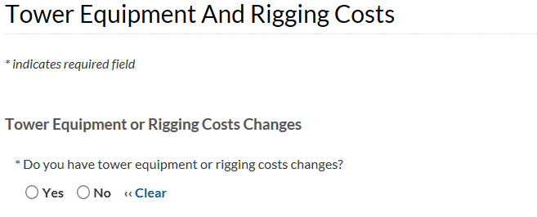

A table will appear that shows the towers associated with a given station in the FCC’s system. You can click the “edit” button to update information about your existing towers. *See* Fig. 28: Tower Equipment and Rigging Costs Section: *Tower Changes.*

**Fig. 28:** **Tower Equipment and Rigging Costs Section: *Tower Changes***

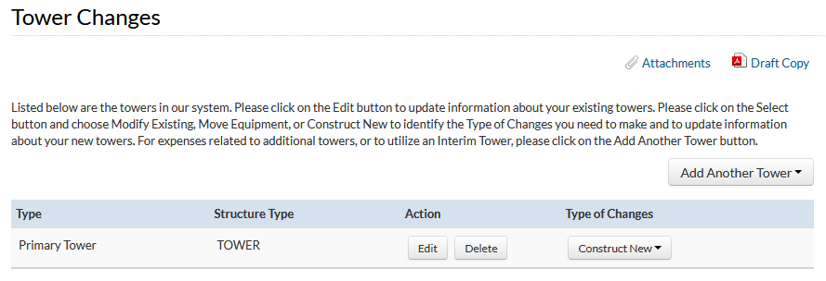

For each tower the station currently uses, indicate whether the tower’s registration number should be provided (if applicable) in addition to the tower’s Antenna Structure Registration (ASR) number. If the tower has an ASR number, the tower height and coordinates, as well as the name of the tower owner and date constructed, will be generated from the Commission’s Antenna Structure Registration System.

If the existing tower does not have an ASR number, provide the tower coordinates (latitude and longitude) and Height Above Ground Level (Height AGL) (in feet or meters). Describe the following information: the purpose for which the station uses the tower [e.g., for its **primary antenna**, **auxiliary antenna**, **distributed transmission system (DTS)]** and indicate if the tower is owned by the station or a company affiliated with the station (e.g., a group owner) or if the tower is rented or leased. If the tower is leased, provide the name and contact information for the tower owner.For towers not owned by the station, you may need to contact the tower owner to obtain some of the information required in this question, as outlined below. See Fig. 29: Tower Equipment and Rigging Costs Section: *Tower Construction Costs.*

**Fig. 29: Tower Equipment and Rigging Costs Section: *Tower Construction Costs***

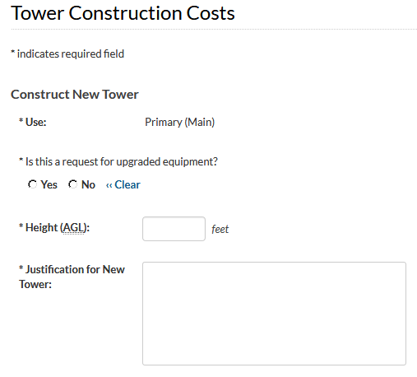

Indicate whether there are other users on the tower and include information related to other facilities and provide the Facility ID number for other broadcasters (AM radio, FM radio, or other television station). Indicate whether the tower is a complex tower. A tower is considered complex for purposes of Form 399 if it has a candelabra, is located on a building, or located in an area that is difficult to access because of weather or other conditions (i.e. constrained by terrain). *See* Fig. 30: Tower Equipment and Rigging Costs Section: *Add* *Tower.*

**Fig. 30: Tower Equipment and Rigging Costs Section: *Add* *Tower***

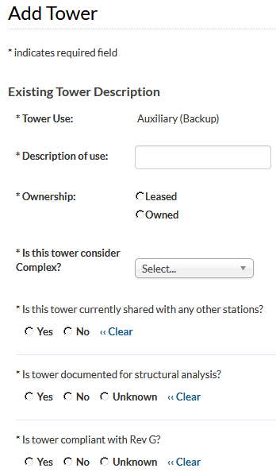

You can choose the “Add Another Tower” button to add a tower not currently in the FCC’s system. You can also do so by choosing from the dropdown menu in the “Type of Changes” column any changes you intend to make to the towers listed. If you intend to build a new tower to replace your primary tower, choose “Purchase New” from the “Type of Changes” dropdown menu in the Primary Tower row. When purchasing a new tower, you will be required to provide supporting documentation.

In the Tower Construction Costs section, you must provide additional information about the tower, and its use (e.g. new tower to support primary facilities or an auxiliary facility). You will also need to indicate whether or not this tower construction will be an upgrade. You will be required to define the height in feet (above ground level (AGL)).

## Section V.B. – *Engineering Study/Tower Reinforcements*

For each tower previously indicated as requiring tower modifications, indicate whether a tower study is necessary and if so, the kind of tower and study needed (**undocumented/poorly documented tower**, **documented tower**, **tower with candelabra**). Also indicate if tower reinforcements are needed and, if so, the degree of reinforcement (**minor**, **major**, or **serious**). The definitions for these tower reinforcement classifications can be found in the Cost Catalog. *See* Fig. 31: Tower Equipment and Rigging Costs Section: *Engineering Study/Tower Reinforcements*.

**Fig. 31: Tower Equipment and Rigging Costs Section: *Engineering Study/Tower Reinforcements***

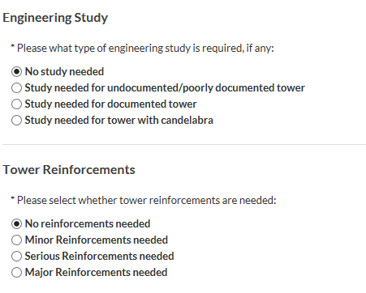

## Section V.C. – *Tower Rigging Costs*

For each new tower you previously indicated as needing construction, indicate the Height AGL (in feet) of the new tower. In addition, provide a justification as to why it is reasonable under the circumstances to build a new tower rather than modifying its existing tower or moving to a different, nearby tower.

For each modified or new tower for which rigging costs will be incurred, indicate the kind of tower. Indicate also if a helicopter lift will be required. *See* Fig. 32: Tower Equipment and Rigging Costs Section: *Tower Rigging Costs*.

**Fig. 32: Tower Equipment and Rigging Costs Section: *Tower Rigging Costs***

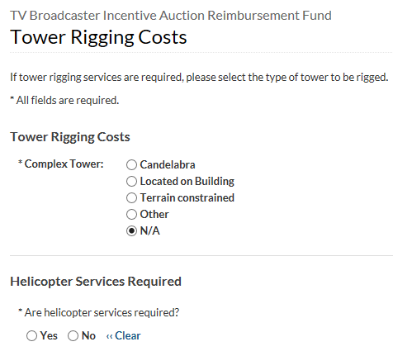

Stations with tower-related costs that are not listed in the Catalog of Costs should identify the anticipated cost and provide a brief description of that cost and an explanation of why costs are reasonable and necessary.

## Section VI. – *Outside Professional Services Costs*

Stations can obtain quotes for professional services from an outside source to complete the station’s channel relocation including Outside RF Consulting Engineering Services, Attorney and Other Outside Expenses and Other Professional Expenses Not Listed.

## Section VI.A. – *Outside RF Consulting Engineering Services*

For Outside RF Consulting Engineering Services, indicate the type of work (e.g., preparing engineering study or completing forms) for which the station will use RF consulting engineer services. With respect to preparation of FCC forms or requests for special temporary authority, indicate the number of such forms and requests the station expects to use outside engineering help to prepare. *See* Fig. 33: Other Expenses Section: *Outside RF Consulting Engineering Services.*

**Fig. 33: Other Expenses Section: *Outside RF Consulting Engineering Services***

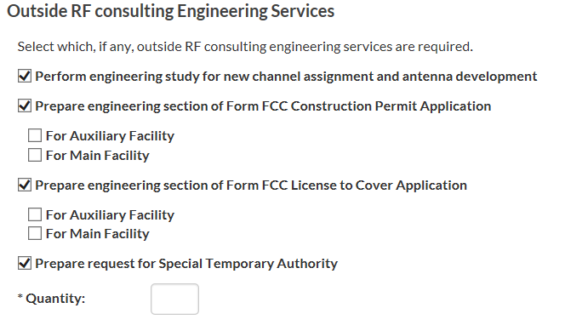

## Section VI.B. – *Attorney and Other Outside Consulting Services*

Indicate outside attorney costs the station may incur. With respect to preparation of FCC forms or requests for special temporary authority, indicate the number of such requests the station expects to need outside attorney help to file. Indicate if the station expects to engage outside professional services in connection with a NEPA Section 106 environmental review, environmental assessment, ASR modification, or FAA consultation. *See* Fig. 34: Other Expenses Section: *Attorney and Other Outside Consulting Services*.

**Fig. 34: Other Expenses Section: *Attorney and Other Outside Consulting Services***

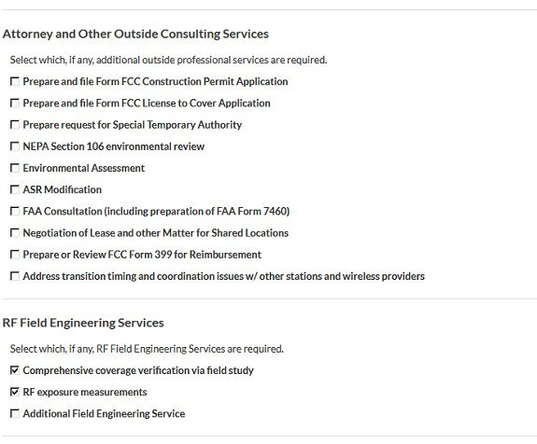

## Section VI.C. – *RF Field Engineering Services*

For RF Field Engineering Services costs, indicate if the station expects to incur fees for a field study for comprehensive coverage verification or for RF exposure measurements. In addition, indicate if the station expects to need additional field engineering services. *See*Fig. 35: Other Expenses Section: *Outside RF Field Engineering Services.*

**Fig. 35: Other Expenses Section: *Outside RF Field Engineering Services***

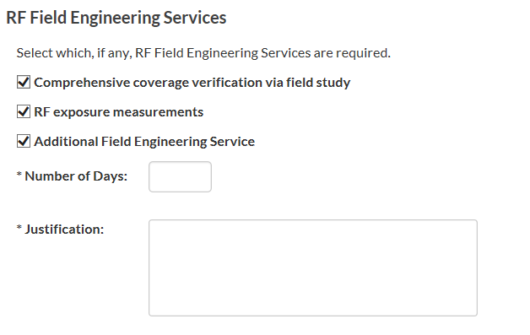

Section VI.D. – *Other Professional Expenses Not Listed*

If your station expects to incur costs related to outside professional services, answer the following questions:

Is an Impact Study needed? And Is Remediation needed? *See* Fig. 36: *Other Professional Expenses Not Listed*.

**Fig. 36: Other Expenses Section: *Other Professional Expenses Not Listed***

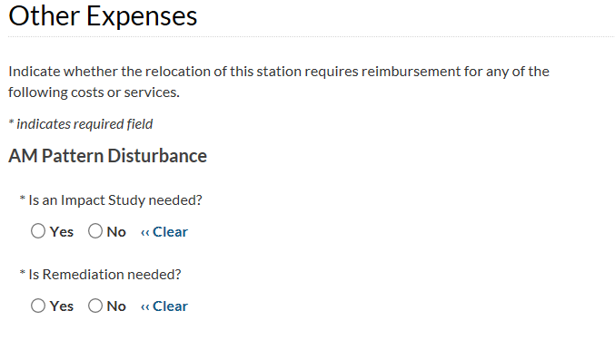

S

Section VI.E*. –* *Facility Expenses* For facility expenses, indicate if the station has other expenses related to interim facilities or operation of DTS station(s). Also indicate if the station will incur expenses related to notification of nearby medical facilities of their channel change. *See* Fig. 37: Other Expenses Section: *Facility Expenses*.

**Fig. 37: Other Expenses Section: *Facility Expenses***

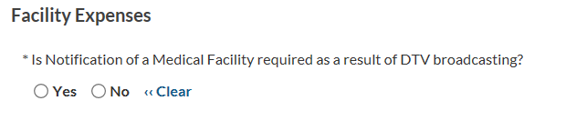

Section VI.F. – *Permit and Filing Costs*

Forpermit and filing costs, indicate if the station expects to have to obtain permits in connection with its channel relocation. *See* Fig. 38: Other Expenses Section: *Permit and Filing Costs*.

**Fig. 38: Other Expenses Section: *Permit and Filing Costs***

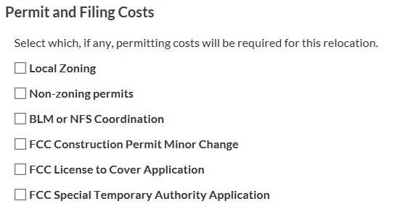

## Section VI.G. – *Other Miscellaneous Expenses*

For other miscellaneous expenses, indicate if the station expects to incur costs identified in this section including Disposal Costs (for equipment and other waste, net of any salvage value), Equipment Delivery or Handling Charges not otherwise included in individual item costs, Equipment Storage, Development and Airing of an Announcement regarding the upcoming channel change, or MVPD notification of the change. *See* Fig. 39: Other Expenses Section: *Other Miscellaneous Expenses*.

**Fig. 39: Other Expenses Section: *Other Miscellaneous Expenses***

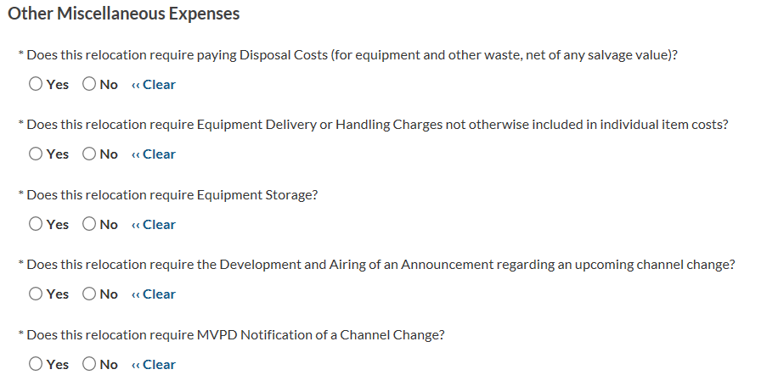

## Section VII. – *Costs Section*

For each section, there will be columns for:

Description

Predetermined Cost Estimate (if available)

Estimate Cost and Actual Cost Information.

The Description describes what the cost is for. The Predetermined Cost Estimate includes the highest possible cost from the Catalog (if it is listed in the Catalog).

When you obtain receipts and/or invoices, you can add them by choosing the word “Add” under Actual Cost Information. This will allow you to upload the actual documents associated with the cost estimate. If the Actual Cost Information is higher than the Estimated Cost, you will need to go back to the cost estimate, change the amount to the actual expense and resubmit for approval (you can attach the invoice as part of the justification). *See* Fig. 40: Costs Section: *Estimate Cost and Actual Cost Information.*

**Fig. 40: Costs Section: *Estimate Cost and Actual Cost Information***

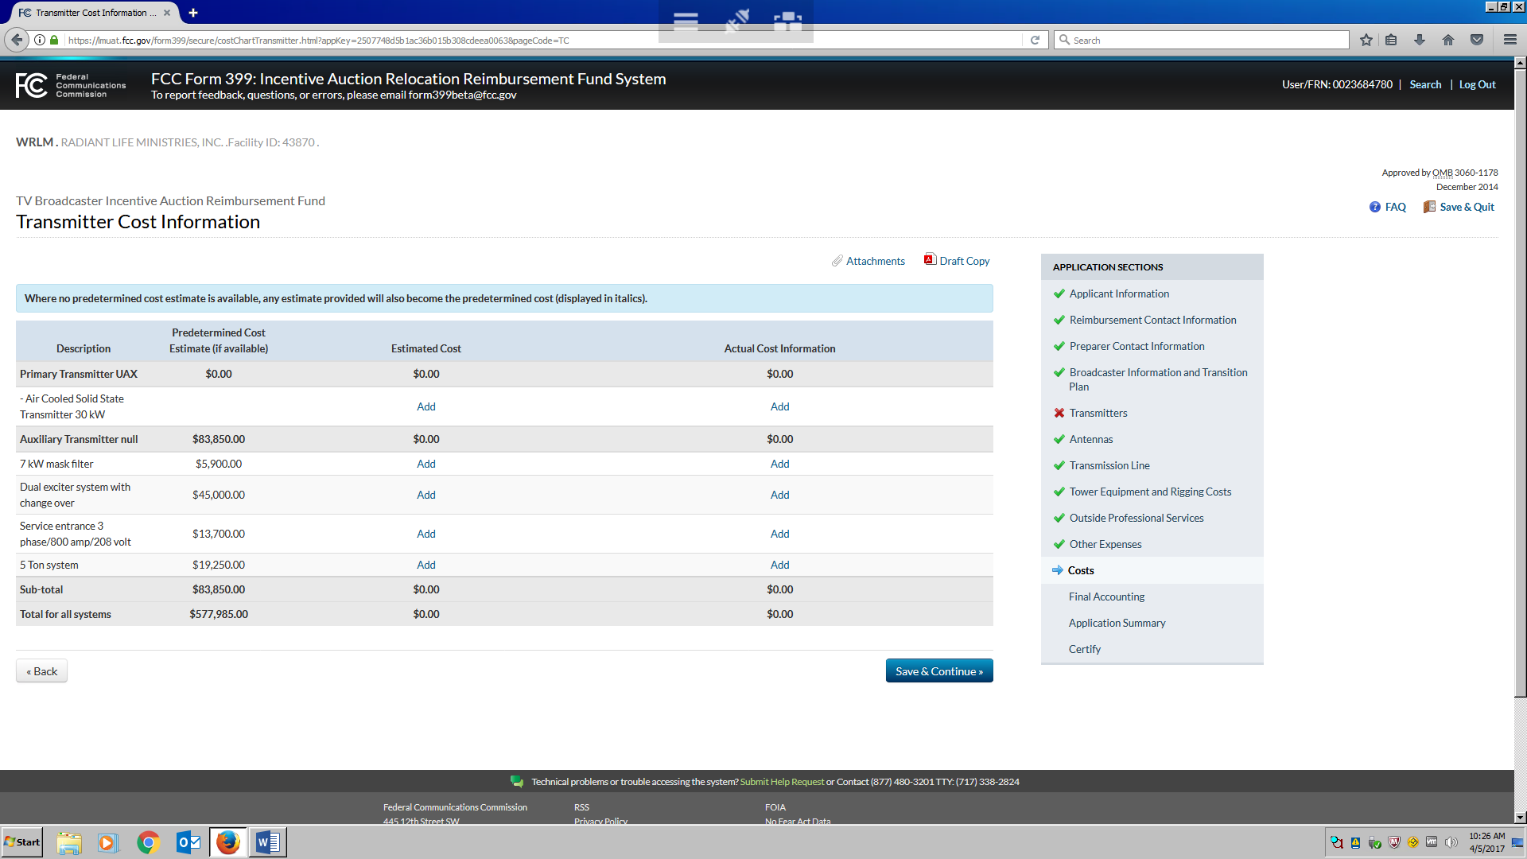

As noted in Fig. 41: Costs Section: *Transmitter* *Estimated Co*st, for each cost for which you see Add in the Estimated Cost column, you must enter a cost. For each of these costs, you will be able to add an attachment to support the cost estimate by clicking the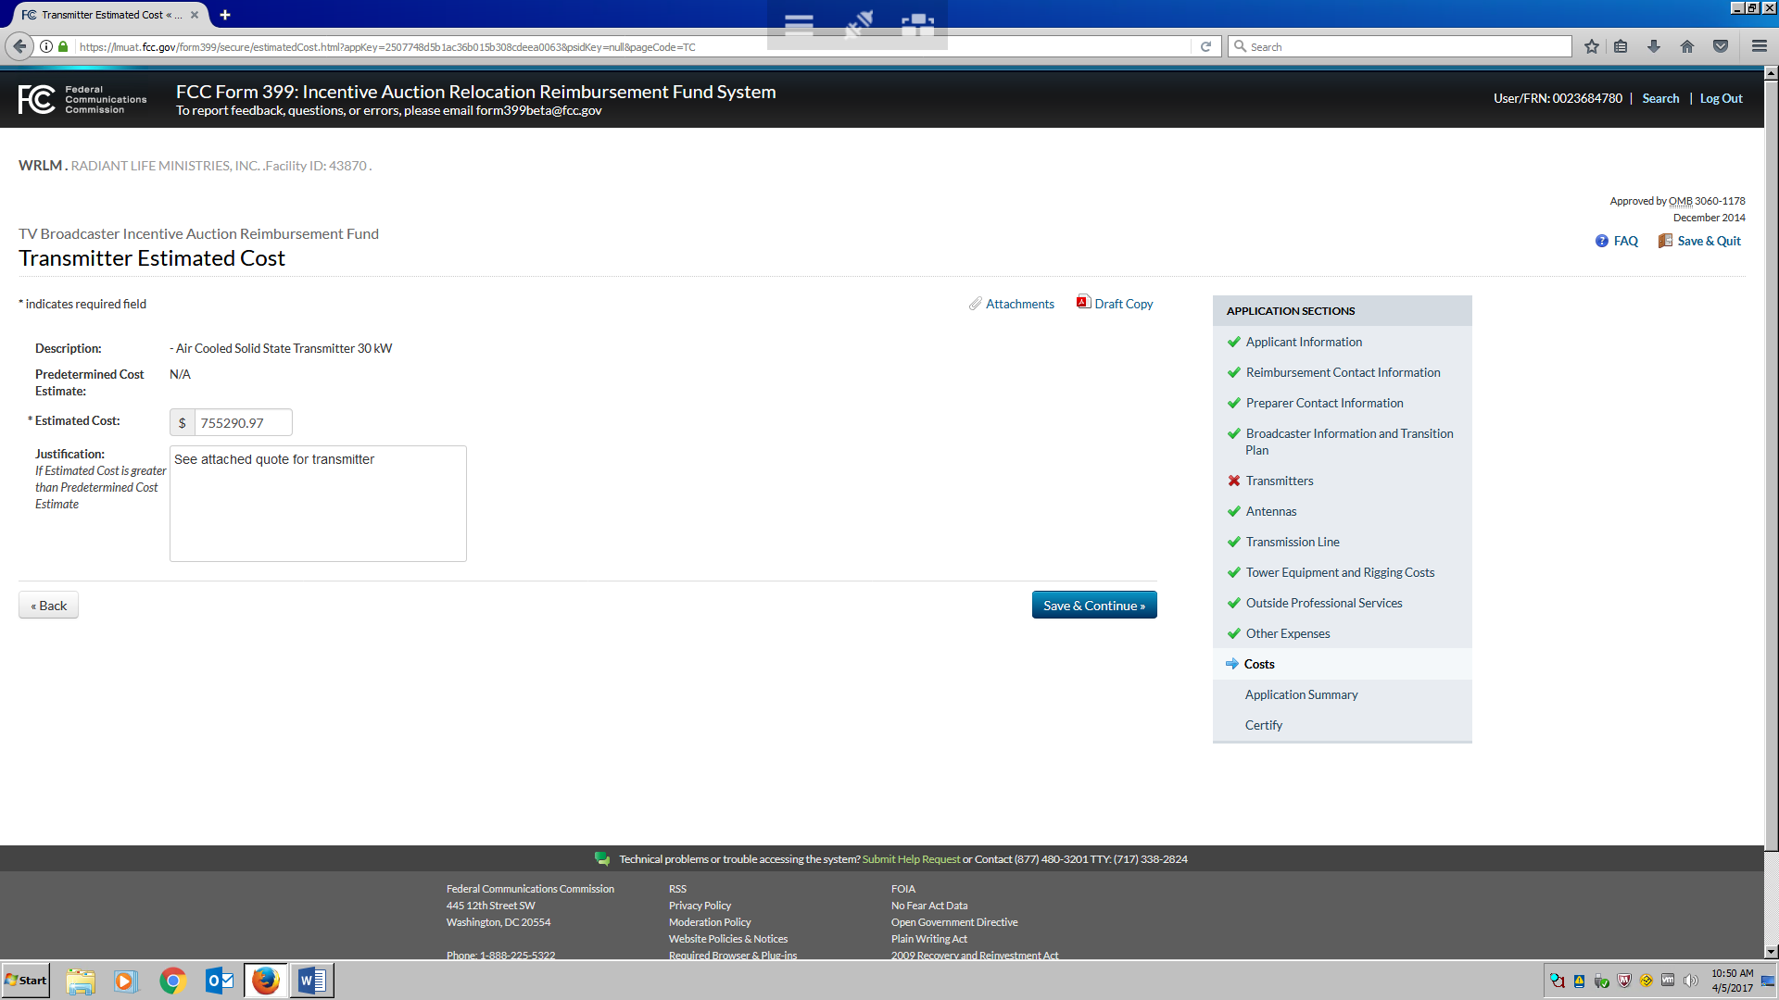icon in the right corner of the screen. For any estimated cost exceeding the predetermined cost estimate amount (which is taken from the Cost Catalog and will be prepopulated in the “Predetermined Cost Estimate” field), you will be required to explain, in the “Justification” field, why the cost is greater than the Predetermined Cost Estimate.

**Fig. 41: Costs Section: *Transmitter* *Estimated Cost***



When you click , you will move to the next section for which you indicated you would incur costs associated with the change. The will allow you to continue working on the estimate without submitting the cost estimate for review. Your cost estimate will only be submitted for review when you certify your estimate and submit the application.

Section VIII. – *Application Summary Section*

The Application Summary Section will allow you to review your application as a whole. This view represents what reviewers will see when reviewing your request for reimbursement. The contact information provided in the first sections will be visible. There will also be a summary of all cost information. You will be able to see the Cost Catalog pricing, your input in the Cost Estimate and when actual expenses when they have been submitted. *See* Fig. 42: Application Summary Section: *Cost Information*.

**Fig. 42: Application Summary Section: *Cost Information***

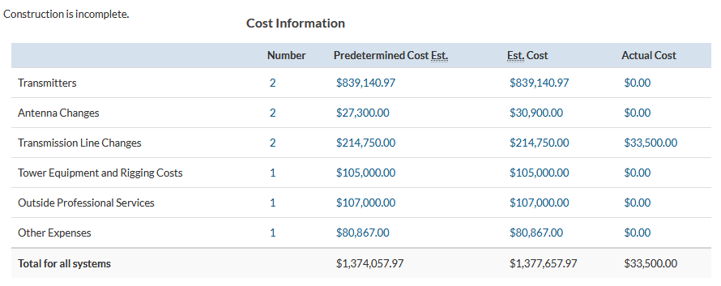

Section IX. – *Certify Section*

The Certify section requires the authorized person identified in the Applicant Information section to certify the submission. Clicking the 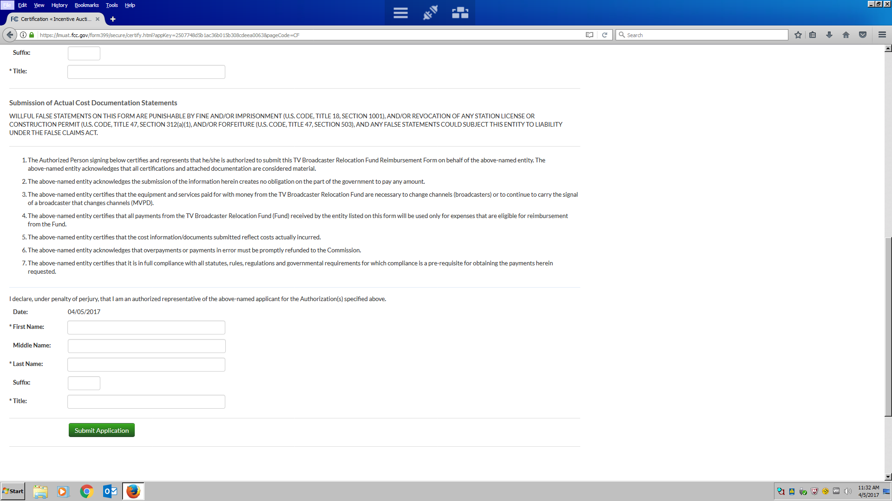 will submit the application for review by the FCC.

This process will be repeated after allocations have been made and funds become available. For each expense submitted for reimbursement, this process will be repeated for all expenses submitted. *See* Fig. 43: Certify Section: *Certification.*

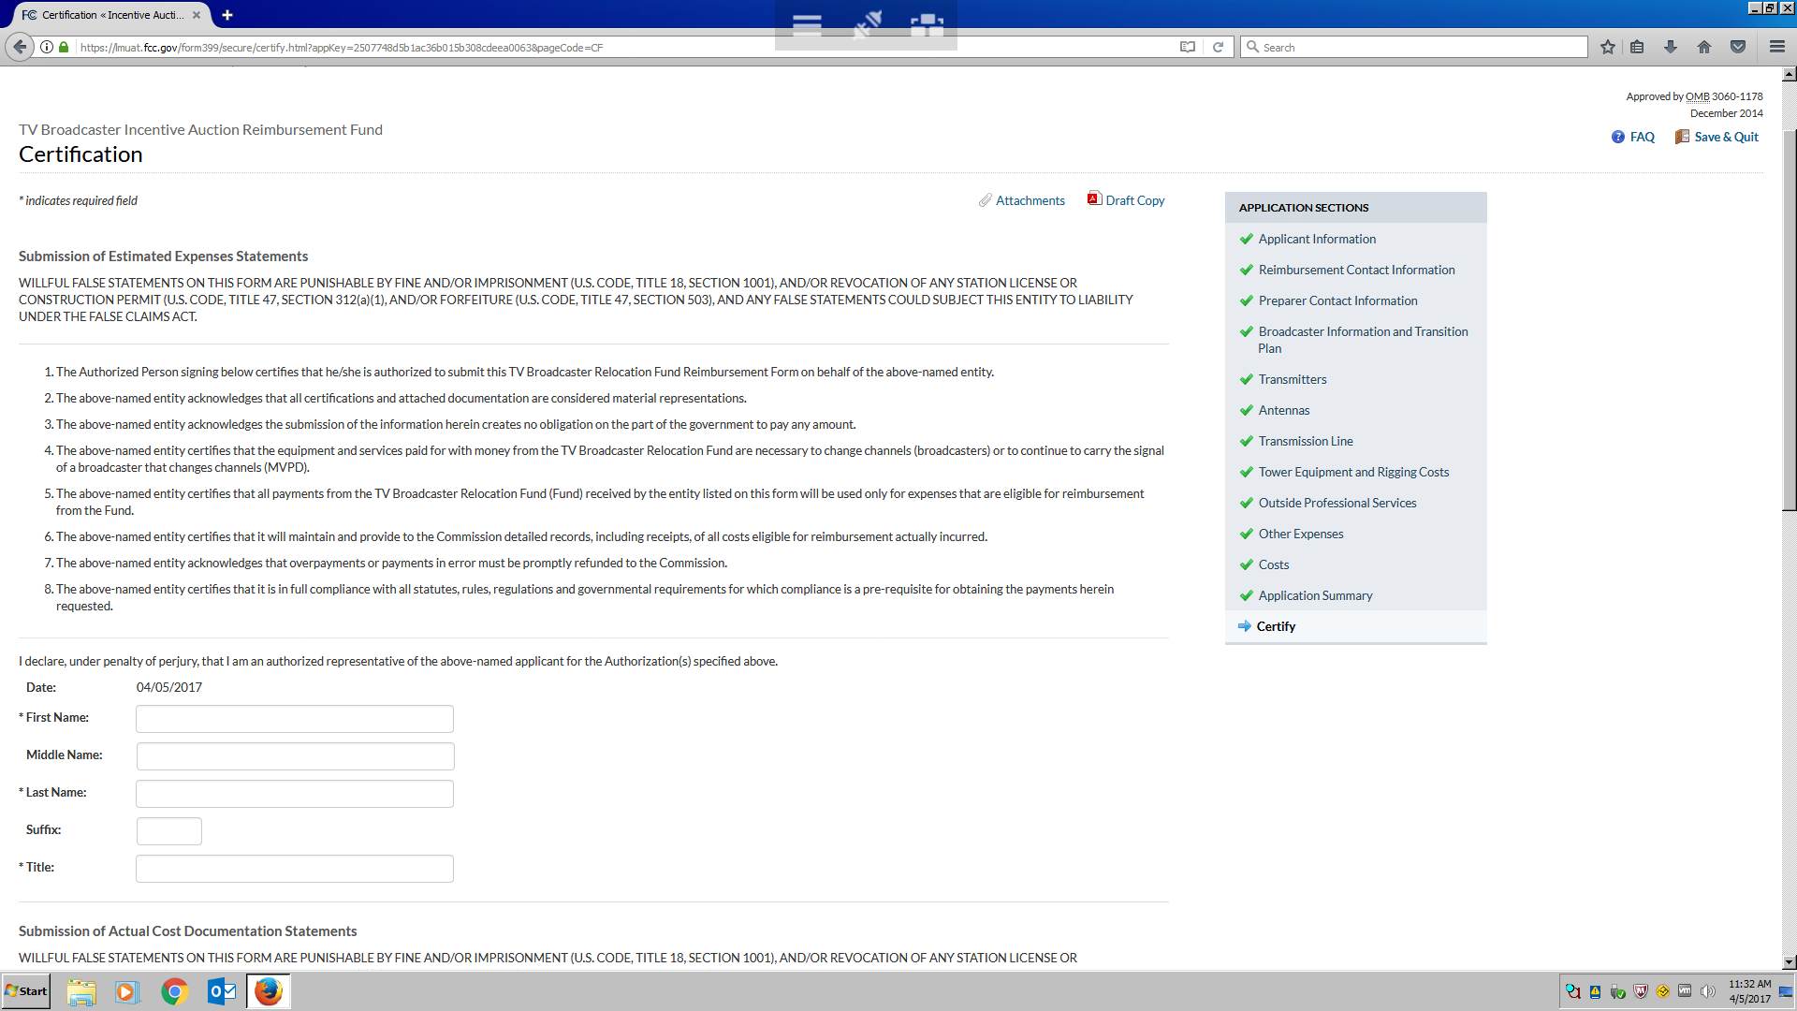**Fig. 43: Certify Section: *Certification***

# APPENDIX - DEFINITIONS

**Actual Cost Form**: Broadcasters that received an initial allocation will use this form to submit invoices, receipts, and other documentation of costs in connection with requests for payment from the TV Broadcaster Relocation Fund.

**Allocations**: After reviewing the cost estimates submitted, the Media Bureau will make an initial reimbursement allocation for each reassigned station and MVPD that filed cost estimates. After reviewing cost estimates, the Media Bureau will make an initial allocation from the Fund across all Eligible Entities.66 The initial allocation for each Eligible Entity will be based on a percentage of its estimated costs, with the initial allocation for commercial stations and MVPDs accounting for up to 80 percent of their estimated costs and the initial allocation for non-commercial stations accounting for up to 90 percent of their estimated costs.67 The Media Bureau will release a public notice announcing the percentage of cost estimates allocated for each of the three categories of reimbursable entities: MVPDs, commercial stations, and non-commercial stations.68 An Eligible Entity will be able to “draw down” against the allocation amount as it incurs reimbursable expenses.69 Each Eligible Entity will be able to see the specific amount allocated to its Facility ID (for reassigned stations) or File Number (for MVPDs) by logging in to the CORES Incentive Auction Financial Module and navigating to the Auction Payments component.

**Catalog of Potential Expenses and Estimated Costs (“Cost Catalog”)**: The Cost Catalog is a list, embedded in Form 399, which contains some of the expenses broadcasters will incur during the repacking process that may be eligible for reimbursement and the estimated cost of each service and piece of equipment.

**Estimated Cost Form**: Broadcasters seeking reimbursement from the Fund will use this form to provide an estimate of relocation costs in advance of transition construction [*see* 47 C.F.R. §73.3700(e)(2)].

**Final Accounting**: After completing all construction or reimbursable changes, broadcast television station licensees that have received money from the TV Broadcaster Relocation Fund will be required to submit final expense documentation containing a list of estimated expenses and actual expenses as of a date to be determined by the Media Bureau. Entities that have finished construction and have submitted all actual expense documentation by the Final Allocation Deadline will not be required to file at the final accounting stage [*see* 47 C.F.R. § 73.3700(e)(4)].

**Final Allocation Deadline**: Upon completing construction or other reimbursable changes, or by a specific deadline prior to the end of the Reimbursement Period to be established by the Media Bureau, whichever is earlier, all broadcast television station licensees that received an initial allocation from the TV Broadcaster Relocation Fund must provide the Commission with information and documentation, including invoices and receipts, regarding their actual expenses incurred as of a date to be determined by the Media Bureau. If a broadcast television station licensee has not yet completed construction or other reimbursable changes by the Final Allocation Deadline, it must provide the Commission with information and documentation regarding any remaining eligible expenses that it expects to reasonably incur. [*See* 47 C.F.R. §73.3700(e)(3)(i)].

**Individualized Cost Estimate**: Cost estimate provided by the entity seeking reimbursement from the Reimbursement Fund that differs from the Cost Catalog, either because the entity believes the catalog cost is not in the range of predetermined costs or because the item or service is not included in the Cost Catalog. In either situation, entities submitting individualized cost estimates must submit supporting evidence and certify that the estimate is made in good faith.

**Initial Allocation**: Broadcasters that submit estimated cost forms will receive an initial allocation of funding of up to 80 percent of their estimated costs. Broadcasters will then be able to draw down against this amount as they incur expenses related to the channel transition.

**Predetermined Cost Estimate**: The estimated cost of an eligible expense as generally determined by the Media Bureau in the Cost Catalog [*see* 47 C.F.R. §73.3700(a)(10)].

**Reimbursement Period**: The period ending three years after the completion of the forward auction pursuant to section 6403(b)(4)(D) of the Spectrum Act [*see* 47 C.F.R. §73.3700(a)(13)].

|  |  |
| --- | --- |
| **List of Acronyms and Abbreviations** | |
| **Acronym/Abbreviation** | **Description** |
| MVPD | Multichannel Video Programming Distributors |
| LMS | Licensing and Management System |
| FRN | FCC Registration Number |
| CORES | COmmission REgistration System |
| PSID | Physical System ID |
| DMA | Designated Market Area |
| RF | Radio Frequency |
| ASR | Antenna Structure Registration |
| Height AGL | Height Above Ground Level |
| DTS | Distributed Transmission System |
| IOT | Inductive Output Tube |