**Implications of Tech-Based Workforce Development on Advancing Economic Mobility and Growth in Disadvantaged Communities[1]**

**Working Paper Developed by Harin Contractor, Member of the**

**Use/Digital Readiness Subgroup of the**

**Digital Empowerment and Inclusion Working Group**

**Of the**

**FCC’s Advisory Committee on Diversity and Digital Empowerment**

**ACDDE Meeting**

**June 24, 2019**

**FCC Headquarters, Washington, DC**

Introduction

The last 20 years has seen a rapid evolution of broadband technology as the foundation upon which greater economic, education and job opportunities can be realized. However, unserved and underserved rural and urban communities continue to grapple with the basic challenge of having access to high-speed broadband infrastructure. In an increasingly digital world, access for a community of students and a changing workforce is critical to prepare for the new skills, tools, and resources to adequately and meaningfully adopt broadband technology

This paper discusses how economically disenfranchised communities can benefit from deliberate and strategic investments in technology-driven programs that enable digital learning, workforce development (up-skilling and re-skilling in the face of increased automation), and economic mobility in disadvantaged communities.

For the last few years the country and the economy has made significant progress since the depths of the Great Recession. Yet a significant amount of people of color and rural communities are not experiencing the recovery or are seeing disparities widening. Many of the disparities are exacerbated in regions like the “Black Belt,” “Rust Belt,” Appalachia, and Native Country where significant portions of the population live under the poverty rate. While many factors contribute to this disconnect and alarming poverty levels. A major concern remains that the changing nature of work, increasing automation and additional skill requirements, will further exacerbate the disparities between communities of color and rural America from the rest of the country. Addressing the challenge of up-skilling and re-skilling to meet the demands of the current and future workplace is not enough for these residents. A holistic approach to address systemic, health, and infrastructure related barriers is required to enable economic mobility.

The opportunity for economic mobility is great for communities of color and rural Americans. Strategic and coordinated investments from governments and business partners can create pathways for prosperity and harness technology as a lever for growth. Foundational tools such as high-speed broadband, a coordinated workforce system, and quality education can create avenues of economic opportunities for communities of color and rural Americans.

Educational Disparities and its Impact on Workforce Development

Over time, America has seen significant improvements in broadband availability at schools and improved educational outcomes as a result. The challenge that schools continue to face is lack of connectivity and computers in some households which creates a barrier for students being able to do homework and teachers being able to incorporate technology-based learning in the curricula. A recent study conducted by the Consortium for School Networking (CoSN)[2] found that less than 10% of school districts reported that all their students have access to non-shared devices at home. This disparity has been termed the “Homework Gap.“ This Homework Gap represents “the inequities between students who have devices and internet connectivity at home, and those who don't and struggle to complete tech-based assignments as a result.”[3]

More specifically, looking at the history of the education of African American students, the judicial order to desegregate schools and a push for school reforms led to a rise in high school graduation rates across the rural south, in particular. However, not all education facilities are created equal. Many students of color and rural students still lag behind significantly in math and reading proficiency based on the 2017 National Assessment of Educational Progress. Not only do these students lag in proficiencies, but the proficiency gap between African Americans and White students actually widens between grades 4 and 8. [4] The marked difference in educational proficiencies from more affluent and/or more urban areas hinder the growth potential of regions like the “Black Belt” or Appalachia.

Further exacerbating the problem, today the Homework Gap adversely affects African American children. According to the Pew Research Center, more than 38% of African Americans with school-age children and incomes under $50,000/year have broadband access at home.[5] With the digital skills divide starting at an early age, it exacerbates the gap of digital skills development that working age adults need to thrive in a digital economy.

The lack of homegrown human capital discourages companies from moving into and limits economic mobility for the residents. In Williamsburg County, South Carolina, where the population is over 65% African American and the poverty rate is 29%; Jim Moore the director of the county’s development board says businesses pass over the county all the time because of concerns on the basic education of the workforce. “We definitely lose projects every year because we never even get a chance,” Moore said. [6] The county graduates 84% of its students from high school, but only about 38% meet the statewide standard for math proficiency. [7] Employers are citing these as concerns. Staying in South Carolina, Michelin employs 8,500 workers across seven facilities in the state but say that “70%-90% of their workers fail the math section on its test for technicians.”[8] Elisabeth Kovacs, who works in the South Carolina State Commerce Department says that employers aren’t looking for specific skills when considering the state, as they do not know what skills they will need a few years from now, but they want a workforce that has the foundation that they can train and retrain when necessary.[9]

The proficiency deficit hinders further educational and skill-based opportunities. Many diverse communities lag significantly behind in students who attend some college or obtain a college degree. One alarming example is in Mississippi, where in 2016, only 1,000 Black men graduated from college from the entire state. [10] This is important as history dictates, education begets innovation, and in turn demands more skills to keep up with the pace of growth. [11] Increased skills not only correlate with additional productivity, but also resilience to endure economic downturns. [12] Obstacles to appropriate skills development are just one of the issues that create an almost untenable situation for the residents in the Black Rural South and leave them unprepared for the changing nature of work.

For all rural communities, schools are a central component for youth and adults alike. They are not only the central place of education for youth and employment for adults but often act as a social and cultural hub for the entire community, providing everything from sports, music, and theater to adult education, town meetings and civic engagement opportunities.[13] Unfortunately, many rural districts face significant obstacles in recruiting and retaining teachers in general, and especially teachers with more advanced degrees and additional skills or specialized training.[14] Resource and staff shortages also limit the ability of rural schools to respond to similar systemic challenges facing their students, such as the high rates of child poverty in rural America. Nearly two thirds (64%) of rural counties have high rates of child poverty, compared to 47% of urban counties.[15] The challenges felt in rural America continue to add to the educational disparities, including for LGBTQ students.

It is important to recognize that for LGBTQ students and adults who work in education in rural areas, the challenges are amplified and often multiplied if an individual is part of a minority and identifies as LGBTQ. With a shortage of resources and teachers in rural areas, LGBTQ students are more likely to lack supportive staff or the ability to find information germane to their specific needs. The 2017 National School Climate Survey, with a sample of over 20,000 LGBTQ youth, found that LGBTQ students in rural areas reported the most hostile school climates, and that they were more likely to have negative and dangerous experiences at school that can make attending school, let alone succeeding at school, more difficult.[16]

**New Manufacturing, Skills, and Education**

Kingstree, South Carolina in Williamsburg County was the prime example of the changing face of globalization. Baxter Healthcare and Bridgestone employed hundreds of workers in downtown Kingstree, only to shut down their factories and send their operations overseas. However, Royal DSM, a global science company, built its factory on the site of the old Baxter plant. The DSM factory is making components of fish oil, without any fish. A job at the factory once involved a lot of manual labor, but now requires more technical and mathematical skills. Brian Lee, head of Human Resources for the plant said, “You’ve got to know math to work here. You have to solve problems and think on the fly. Workers here don’t stay in one place, and they don’t work on one machine. They’re running a massive process that takes weeks, and it could go to waste if someone makes a mistake.”

It’s a microcosm of the changing nature of work. Once factories located here for its cheap labor, cheap land, and low taxes, now according to the President of DSM North America, Hugh Welsh, they want to “have a workforce that can learn, be trained, adapt as quickly as we do.”

<https://data.postandcourier.com/saga/minimally-adequate/page/3>

Workforce Issues and Economic Challenges

Infrastructure is a further major reason for the lack of economic activity in rural communities, or areas with a high concentration of communities of color. The digital divide is a real and serious problem that hinders economic growth, foundational learning, skill development, job creation, and mobility for the region.[17] Lack of access makes it difficult to prepare or participate in the digital economy, the economic activity that happens online by connecting “people, businesses devices, data, and processes.”[18] Of the states with the lowest rate of high-speed subscriptions, the vast majority are located in the American South.[19] Across the country, African Americans have the lowest rates of subscriptions. These two realities combined lead to a major digital divide issue that is particularly acute for communities of color in rural areas. [20] Furthermore, access to broadband internet and reliable mobile phone service are critical for education, job training, employment and economic growth, accessing government services, the ability to receive health care,[21] civic engagement, and more.[22] While internet access is important for all rural residents, especially minority communities, the internet is a critical lifeline for LGBTQ people in rural communities as the internet can help them find anything from LGBTQ-affirming and knowledgeable healthcare providers to counselors to legal assistance and even faith communities.[23]

The lack of access and affordability of high-speed internet is a barrier for further economic activity. Lack of adequate access hinders residents from using ridesharing applications, enabling autonomous farm equipment, and supporting more effective tele-health solutions.[24] Businesses and advanced manufacturing facilities need high-speed internet to connect to global consumers.



Figure 1: Autonomous Tractor by John Deere Credit - SETH PERLMAN/AP PHOTO

Technology-driven Programs Advancing Workforce Development in Disadvantaged Communities

It is important to note, the traditional manufacturing and agricultural jobs that dominated rural areas a few decades ago have greatly dissipated. The ones that are left require additional training and skills to continue to function. The Black Rural South as well as the rest of country was not prepared for the massive upheaval of manufacturing jobs that started in the late 90’s and continued through the Great Recession. The policy responses to address the rapid change in the sector were not implemented fast enough nor did they adequately address the problem.

The Trade Adjustment Assistance (TAA) program, run by the U.S. Department of Labor, is the main program to support workers and regions that were adversely affected by globalization/loss of jobs due to trade. TAA has a number of benefits and services including employment counseling, training assessment and enrollment, job search and relocation reimbursements. However, the program did not address the full number of workers who lost their jobs from the late 90’s, as a significant number did not complete the training program, and if they did only saw about 3/4ths of their earnings replaced with their new jobs.[25]

There are important lessons to learn from the trade upheaval as many of the same concerns arise with the potential workplace disruption from automation and artificial intelligence. Workers, businesses, and governments feel automation will have a similar, if not more drastic effect on jobs and displacement in the coming years. While there are fears for massive displacement, unlike trade, governments, community groups, and businesses know this disruption is coming and can prepare workers, communities, and young people to take advantage of the change.

**Economic Cooperatives**

Economic development is a catch-all phrase governments use to try to attract businesses, create growth, and drive greater economic mobility for its residents. Cities, counties, states, and even the federal government all try to enact policies or incentives for their constituents. Some are successful.

The Golden Triangle region of northern Mississippi, which encompasses Columbus, Starkville and West Point, and its economic development team provide a model for bringing in advanced manufacturers. The Golden Triangle Commission has a strong partnership model of working with community colleges and re-training the workforce from low-wage jobs to high wage jobs to meet the demand of companies moving into this region. The Golden Triangle Regional Commission also pushed for building out infrastructure for potential companies – installing the water and sewer infrastructure and building the roads and the broadband connections to ensure their sites are shovel-ready for potential investors.[26] This region has attracted $5.9 billion in industry and investments over a decade.[27]

There are lessons here for counties, cities, and municipalities to push for greater economic development. Building up regional cooperation models like the Golden Triangle Commission, the Appalachian Regional Commission, the Joint Development Authority of Jasper, Morgan, & Covington can help align resources, expand their economies, and create a larger workforce base to attract businesses. The counties can support each other in attracting companies, building out key infrastructure, creating partnerships with educational institutions, and creating avenues for mobility for their residents and workers.

**Coastal Gateway Economic Alliance**

An economic development alliance that encompasses Choctaw, Clarke, Conecuh, Escambia, and Monroe counties in Alabama. The Alliance won the bid for a software development firm called Provalus to hire 300 people to write code and handle help desk calls. According to the Federal Reserve of Atlanta, while 300 jobs may not be a lot, for Escambia County it is the Atlanta equivalent of bringing in 60,000 jobs. These counties could not have won this bid individually. The Executive Director of the Alliance, Will Ruzic said, “If we’re going to win big, we can only win big together.”

**Utilizing Libraries**

Local libraries are an untapped area for aligning resources. Libraries are often the centers of community activity and some have pilot workforce development efforts already underway. Providing more resources and information in rural communities can lead to more opportunities for its residents. Some ways to strengthen libraries as a workforce development strategy are the following:

1. Train library staff with information on job training/job seeking similar to American Job Center staff.
2. Use libraries (as well as community centers, churches and other houses of worship) for job training and resume workshop events.
3. Take advantage of technology for job training assistance. All libraries have access to Universal Service Fund E-Rate dollars to build out broadband and WiFi in their centers. As previously stated, African Americans in the rural south have far less access to broadband at their homes. Most libraries do not take advantage of E-Rate dollars, but that can change given better coordination.
4. Though more of a Federal-based approach, there is little to no coordination between the Institute of Museum and Libraries Services (IMLS), the Universal Service Administrative Company (USAC), the U.S. Department of Labor, the U.S. Department of Education, and the U.S. Department of Agriculture. Aligning resources through these agencies can create synergies, maximize resources, and increase take-up rates for programs that address the needs of Black Belt communities and other unserved or underserved areas.

All schools have access to Universal Service Fund dollars through USAC to build out broadband and WiFi access for their students. USAC is a non-profit regulated by the Federal Communications Commission that provides up to $10 billion in grants to build out broadband and promote greater telecom access. Unfortunately, due to its complicated application process, many eligible schools and libraries miss out on funding to build out access for residents.[28] Nonprofits like EducationSuperHighway are using USAC data and working with schools and school districts to bridge the digital divide for disconnected students and residents. However, many rural schools are still overpaying or do not apply for the proper equipment to enhance their digital capabilities.[29] If rural schools, particularly those in the Black Belt region utilized these resources, it could set up a platform to enable blended learning at these institutions.

**HBCUs/Minority Serving Institutions & Workforce Development**

Additionally, blended learning holds the potential to increase access to high quality education for students of color. By working with Minority Serving Institutions and Historically Black Colleges and Universities (HBCUs) - students can learn from experts in particular subjects like math and science from distant instructors alongside a classroom facilitator. Blended learning allows students to gain access to tutors/mentors that can provide additional educational support. Blended learning enablement and USAC grant applications are handled by local school districts. Black Belt leaders working alongside their local education peers can support an environment to allow blended learning to thrive for students in these communities.

HCBUs are important institutions in the education and training of African Americans. Many are situated in rural areas and near communities of color. They provide key resources for their regional community and its students. Moreover, HCBUs provide a ladder of opportunity for low-income African Americans as 59% of HBCU students come from families that earn $30,000 or less compared to 33% nationally.[30] Occupational status and earnings are higher for the graduates of HBCUs compared to African American graduates from non-HBCU institutions.[31] Unfortunately, many HBCUs are under-utilized and under-resourced compared to peer institutions.[32] Given that HBCUs historically enroll a larger share of students with lower academic preparation, more resources and services are needed to support these students through the education process.

*STEM PROGRAMS AT HBCUs*

Yet, HBCUs do remarkably well, when given the opportunity to place African American students into STEM occupations. The Louis Stokes Alliances for Minority Participation (LSAMP) program, established in 1991, seeks to promote more minorities into science and engineering. Despite its limited capacity, in the Texas LSAMP initiative, all 242 students (2007-2012) graduated with a STEM B.A. degree and 70 students went on to a M.S./Ph.D. program.[33]

The private sector is seeing the value of HCBUs. Boeing is investing $6 million in the Thurgood Marshall College Fund as support for HBCUs. Google created an HBCU-in-residence program at Howard University engaging with their computer science department to build a pipeline of tech talent. Models such as these should be highlighted and replicated by other tech firms.   
  
Regional partnership models are a potential mode for success. A Minority Serving Institution (MSI), West LA College, is partnering with the South Bay Workforce Investment Board on a pre-apprenticeship engineering program with local employers. Local governments, workforce boards, and regional companies can work with HBCUs to develop pre-apprenticeship initiatives for students in the Black Belt. If given the proper support, HBCUs can develop into regional workforce hubs for community. Given the limited resources and capacities currently at many HBCUs, leveraging partnerships and investment from the private sector are promising avenues to provide a pipeline for Black and minority students in these communities. Investments are needed to attract the quality teaching talent and infrastructure to build and host pre-apprenticeship programs that will lead to student success.

**Innovative Use of Spectrum**

Building out broadband is expensive and cost-prohibitive for companies even with the support of the Universal Service Fund. The FCC should consider how innovative uses of spectrum could bridge the digital divide. For example, promising innovations like Microsoft’s Airband Initiative “is a technology model that uses a combination of fixed wireless technologies—including unassigned broadcast spectrum often referred to as “TV white spaces”—alongside traditional fiber optic and satellite coverage. This approach can reduce initial capital and operating costs by more than 80 percent compared with using fiber optic cable alone and by approximately half compared with current fixed wireless technologies that use other spectrum bands.”[34] Microsoft says that TV white spaces has the potential to reach 80% of those in underserved rural areas. Pilots are starting and communities of color should monitor the efficacy of this effort to see if it is a viable option for their communities. If leaders in rural communities are interested in joining a pilot, ISPs are working with Microsoft on pilot sites and expansion opportunities for rural communities in particular.[35]

In addition, a new FCC order is trying to encourage innovation through the 3.5 GHz spectrum band. Several major internet providers are developing plans to use both licensed and unlicensed spectrum in the 3.5 GHz band to provide fixed wireless cost-effective connectivity and higher speeds to less densely populated areas. Using unlicensed spectrum could provide a cost-effective means of providing connectivity for healthcare monitoring, smart farming, universities, military bases, hospitals and other large institutions, securing financial transactions, and more. Although it is too early to say if this move will substantially change rural access.

**The Homework Network**

In Charlotte and Halifax Counties in southern Virginia, half the students in these rural communities lack broadband access at home leading to this problem called the “Homework Gap” where students who lack connectivity find it hard to keep up with assignments, communicate with teachers and peers, and access online learning material. Microsoft, Atlantic Broadband Company, white space technology company Adaptrum, and local internet provider, B2X, created the Southern Virginia Homework Network in 2017. Using TV white space devices, the Network installed TV white space devices on 18 towers around the schools and enabled low-cost access to over 200 households with plans to reach up to 800 more. Given the rurality and geographic barriers, building out broadband is extremely cost prohibitive, but utilizing white space, facilitated high speed access for this region of Virginia.

<https://blogs.microsoft.com/uploads/prod/sites/5/2018/12/MSFT-Airband_InteractivePDF_Final_12.3.18.pdf>

**Making Workforce Development Work**

Real-time labor market information, workforce analysis, and data on skills mismatches are crucial to help policymakers, educators, and businesses understand how to develop a stronger, more responsive workforce system. According to the Federal Reserve Bank of Atlanta, only three southern states (Florida, Mississippi, and South Carolina) have systems that analyze in-state demand for occupations and how to prepare the workforce to meet current labor market needs. According to the Bank, the workforce development data systems will connect post-secondary institutions and workforce development programs to better inform “students, workers, employers, policymakers, and others about whether people are accessing and completing programs and finding jobs.”[36]

LinkedIn, Indeed, and other job-finding sites can support these initiatives and help bring in real-time labor market information. For instance, LinkedIn is starting regional initiatives in areas like Detroit to help policymakers and educators use their data to make better informed decisions. Better data can support community colleges, workforce systems, and businesses with immediate openings. The goal of building a better educated/more skilled workforce will help attract companies and create economically resilient communities.

There are some examples of how some states are using data to work with educators and employers to build better pipelines. In 2014, Georgia started the High Demand Career Initiative (HDCI). Using $3 million in Workforce Innovation and Opportunity Act (WIOA) funds, the state formed regional sectoral partnerships to bring together the public, educational institutions, and 120 employers to identify current and projected high-demand sectors.[37] The funds allowed these sectoral partnerships to hire local conveners charged with collecting data and work with employers and training centers to meet the demand of growing sectors. While local public officials and employers have hailed this as a solid foundation to bring together data and stakeholders, funds are limited to scale in a meaningful way.

While the government, federal and state, should provide more funds to such efforts, honest and frank conversations need to occur with private sector employers to also contribute to local partnerships to build a skilled pipeline for their interests. According to Census data, employer-based on-the-job training has diminished over the last few decades.[38] This is partly due to the diminishing role of unions but also employers reducing benefits to their employees as the workforce becomes more fissured.

*Apprenticeships*

One way the public and private sector are looking to work together are through apprenticeship programs. This effort allows participants to learn in the classroom and receive on-the-job training while earning a salary. As noted in a survey from The Joint Center for Political and Economic Studies, African Americans identified financial barriers as the top reason why they do not receive additional training even though there is a clear demand.[39] Apprenticeships advance the career opportunities for its participants, offer compensation for trainees rather than taking on student loans. It is well documented that this option works well in other developed countries, particularly in Germany.[40]

The U.S. apprenticeship model is not supported anywhere close to levels of other developed countries. While more money was appropriated in 2017 via Congress, less than 0.2% of the American workforce goes through a registered apprenticeship program. Compare that to 2.2% of the Canadian and 3.7% of the German workforces.[41] Trade unions and employers often work together with states to fund these programs, but as unions diminish states have to look into other options.

States like South Carolina offer a $1,000 annual business tax credit per apprentice and ranked sixth amongst states with the most active apprenticeship programs. The state provides a strong model for starting an apprenticeship initiative. In an interview with Brookings Institution, Brad Neese, Director of Apprenticeship in South Carolina, gave this insight on why they are so successful in getting companies to buy into this model:

*“Each company participating in an apprenticeship has had a personal visit from one of our apprenticeship consultants. Our approach to working with organizations, however, is not a typical sales approach. Our consultants do not cold-call businesses. Instead, we have developed an extensive network of key partners who engage companies regularly: all 16 of our technical colleges, workforce investment boards, economic development organizations, and trade associations (among many others). Our approach has been to educate our partners, deploy them to listen to the needs of employers, and then offer apprenticeships as a viable solution for employers with workforce development and training needs.”[42]*

Alabama, Arkansas, Louisiana, and South Carolina offer tax credits to businesses who hire apprentices, but South Carolina’s model goes above and beyond the small financial incentive. For many states, the corporate tax situation is already favorable, so additional credits for apprentices is not enough of an incentive. For an apprenticeship model to work in the United States, it needs a stronger support system to be successful, as demonstrated in South Carolina. Their model took time and coordination, but included intermediaries/consultants to organize regional partnerships. South Carolina offers wage and tuition subsidies to ensure ease of adoption for businesses and participants. Local governments can take some immediate steps to facilitate apprenticeships.

**12+2, a Model for Post-Secondary Training**

Reducing the financial barriers and developing pathways to technical training will allow diverse residents the ability to gains skills for “good jobs” that do not require a traditional four-year degree. To do this, states and localities must consider new arrangements within the traditional educational model to provide more opportunities to disadvantaged communities.

The United States established itself as an economic leader in the 20th century. While a number of factors led to this, one of the primary ways the U.S distinguished itself was its large investments in secondary education. While other Europeans nations called it “wasteful,” the United States largely provided free primary education to most of its residents. “In the 1950s, American teenagers were three times as likely to be in school full-time compared to European teenagers.” This was key as the first part of the 20th century saw major technological advances which called for a demand of skilled workers in the United States.

The country is again experiencing changes due to technology, rapidly affecting the demand for skilled workers. Although the United States is noted for still having the world’s best higher education system, the rest of the world has caught up if not surpassed America in its investments in primary and secondary education. Europeans have refined the model to invest in vocational training, pathways, and apprenticeships in their secondary education system.

There’s a clear link between education, a productive workforce, and economic growth.[43] As innovation continues, the demand for skilled labor increases. Integrating vocational and career pathways into middle and high school systems, the country can move to providing greater access to post-secondary options. One option is a model that experts are calling 12+2, which is a proposal to move towards universal free community college and/or vocational training. Community colleges serve roughly 45% of all undergraduates and are often more innovative and flexible to meet the demands of local employers.[44]

Tennessee is one of the leaders in implementing a 12+2 model with Tennessee Promise and Tennessee Reconnect. Tennessee became the first state to offer free community college to students and adult learners to up-skill their workforce. This effort was led by Governor Bill Haslam and uses the state’s lottery system to support the initiative. Tennessee Promise focuses on recent high school graduates while Reconnect targets adult learners. Reconnect meets the challenges adult learners may face returning to school by setting up personalized counseling to map resources for each student to succeed in the program.[45] Enrollment in public higher education in the state increased by 13%. That’s approximately 33,000 students who enrolled in this program that offers free community or technical college.[46] Reconnect started earlier in 2018 and saw 3,000 enroll with over 30,000 applying for the scholarship. The 12+2 is a model that leaders from diverse communities should push their states to strongly consider and adopt.

According to one study, the United States ranks near the bottom of developed countries in terms of spending per capita on “active labor market policies.”[47] Workforce development, training, and apprenticeship type programs are included in this definition.[48] As highlighted earlier, some states are using federal funds to build up their infrastructure and investing state funds to focus on local strategies. With the major Workforce Innovation and Opportunity (WIOA) reforms, the American workforce system has streamlined training opportunities, allowed for limited support services (child care, wage subsidies), and in some locations career counseling also. The awareness and funding remain inadequate, even though investments in these policies are proven methods to address employment challenges.[49]

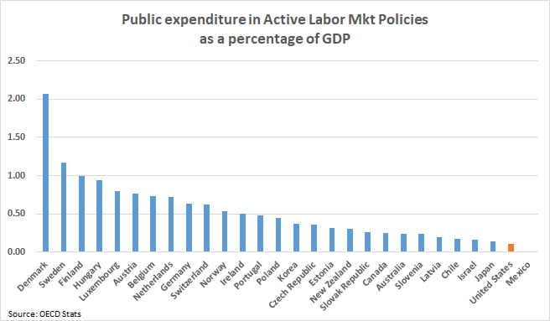

In fact, due to the recession and an era of fiscal austerity at both the state and federal levels, Congress has cut $1 billion from employment and training programs.[50] In a time where training and skills development is needed more than ever, workers have less support to meet the demands of a changing economy. Leaders in urban and rural communities along with state partners should advocate for additional federal support for workforce development initiatives.

**10-20-30**

A congressional funding formula from the 2009 Recovery Act is a targeted approach to coordinate funds to communities in need, particularly in the Black Belt, Rust belt, Appalachia, and Native Country. The 10-20-30 formula funding spearheaded by Congressman Clyburn (D-SC) “directs at least 10 percent of funding from four government agencies (USDA, Commerce, EPA, and Community Development Financial Institutions (CDFI) Fund) to communities where at least 20 percent of the population has lived at or beneath the poverty line for the last 30 or more years.”[51] The program successfully funded 4,000 critical projects such as building wastewater infrastructure, expanding community health centers, and building out broadband.

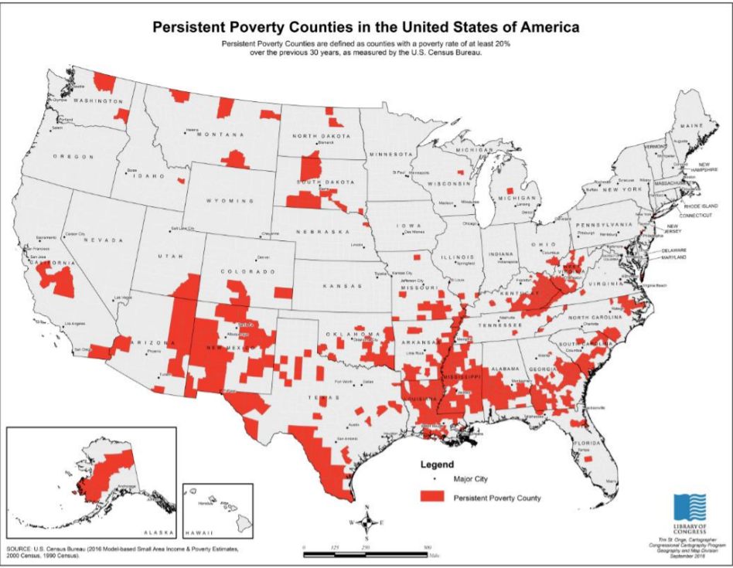

This is a promising proposal that can be expanded to amplify the impact. There is currently legislation from Rep. Clyburn to expand the number of federal agencies that partake to include the Department of Labor (Training grants), the Department of Transportation (Capital Investment grants), Health and Human Services, the Delta Regional Commission, and Department of Justice.[52] Expanding the number of infrastructure investments will create opportunities. As noted earlier there are a number of infrastructure challenges that create barriers for the community.

Putting aside the possibility of a massive infrastructure investment package, expansion of the 10-20-30 initiative can specifically target underserved communities to build out wastewater infrastructure, 5G and/or broadband buildout, new roads, rail, and upgrades to waterways. Infrastructure investments in these communities will create thousands of skilled jobs that will need to be filled and the opportunities created due to additional access will yield benefits for years to come.

**Private Sector Experimentation**

As noted earlier, employer-sponsored training has diminished over the last few decades. Employers may be changing their attitudes towards this recognizing the need for a skilled workforce. Employers and the private sector are beginning to understand that investing in workers leads to higher productivity, lower turnover, increased retention, and resilient communities that will lead to more consumers. Major corporations that employ thousands across the United States can and should look to innovate their hiring and workforce practices. Based on evidence or ideas, companies should run trials on up-skilling and inclusive hiring and measure outcomes for the community as well as the company in specific locales. It is costly for companies to change human resources and training policies immediately only to see the trials not work. However, working with local leaders and community groups to try new practices and procedures can lead to innovative thinking that could provide more evidence to support broader and more effective efforts to up-skill a workforce while supporting resilient communities.

Companies can also work with target communities to support digital skills inclusion. An example is the “Grow with Google” initiative. This is a multi-pronged effort to provide free digital skills trainings. Google allows a user to take free online courses to earn certificates as an IT Support Professional and Applied Digital Skills. Google also does a series of one-week workshops in rural and urban communities to teach fundamental digital skills at a local library for residents. While efforts like this should be applauded, unless there is a consistent in-person presence working with local libraries and centers of education, these efforts will do little to create digital inclusion. Businesses can build off this model to enable public-private partnerships with community colleges, high schools, and libraries to create regionally recognized certifications and/or licenses for new digital learners.

Conclusion

Geography does not have to mean destiny for children and families living in unserved and underserved communities. Technology, automation, and the changing nature of work can adversely affect workers of color and exacerbate disparities, particularly those in the rural and urban communities that have historically faced barriers. Yet, this disruption can also provide a means for greater opportunity. These communities can utilize technology, develop infrastructure, and build pipelines to enhance the region into greater economic productivity and success.

Aligning resources and creating cooperatives similar to the Golden Triangle is a model that could raise the profile of under-served and under-resourced communities. However, just creating economic incentives is not enough to vault these communities forward. The region and its leaders must look to innovation and new technologies to bridge transportation and connectivity divides, create an environment of greater financial inclusion, revamp the education system to allow for greater opportunities, and to develop strategic infrastructure needs through existing programs. For the United States to remain competitive and protect against the next economic downturn, holistic approaches to education and workforce development working with the private sector, community groups, and government are needed. Lawmakers and community leaders in the region can provide more pathways for their residents. These communities do not need to stay in a place of perpetual economic distress. By working with partners and making smart investments, civic, industry and elected leaders can generate greater economic growth not only for the region but for their respective states as well.

**Appendix:**

Residential Fixed Internet Access Service Connections per 1000 Households by Census Tract

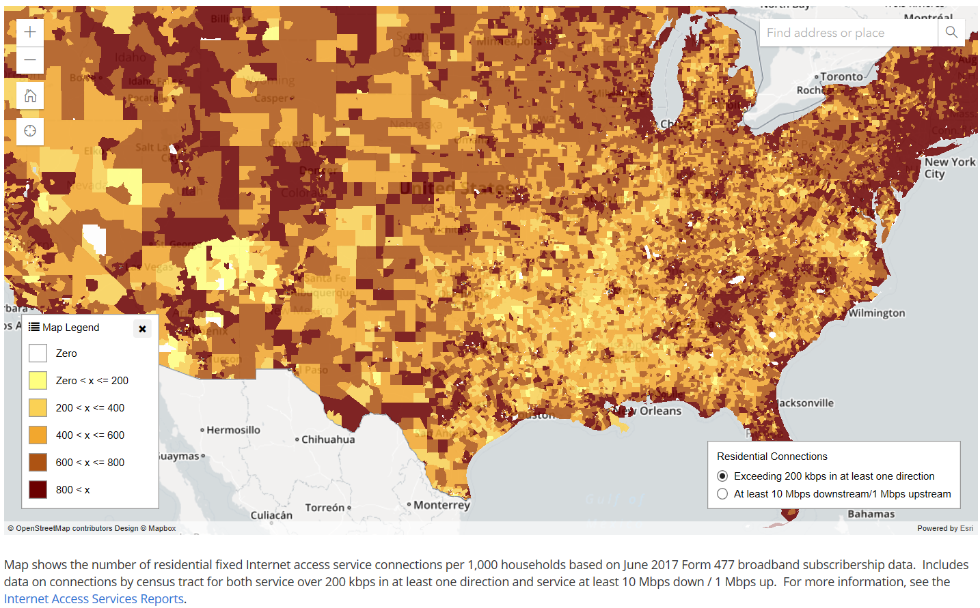

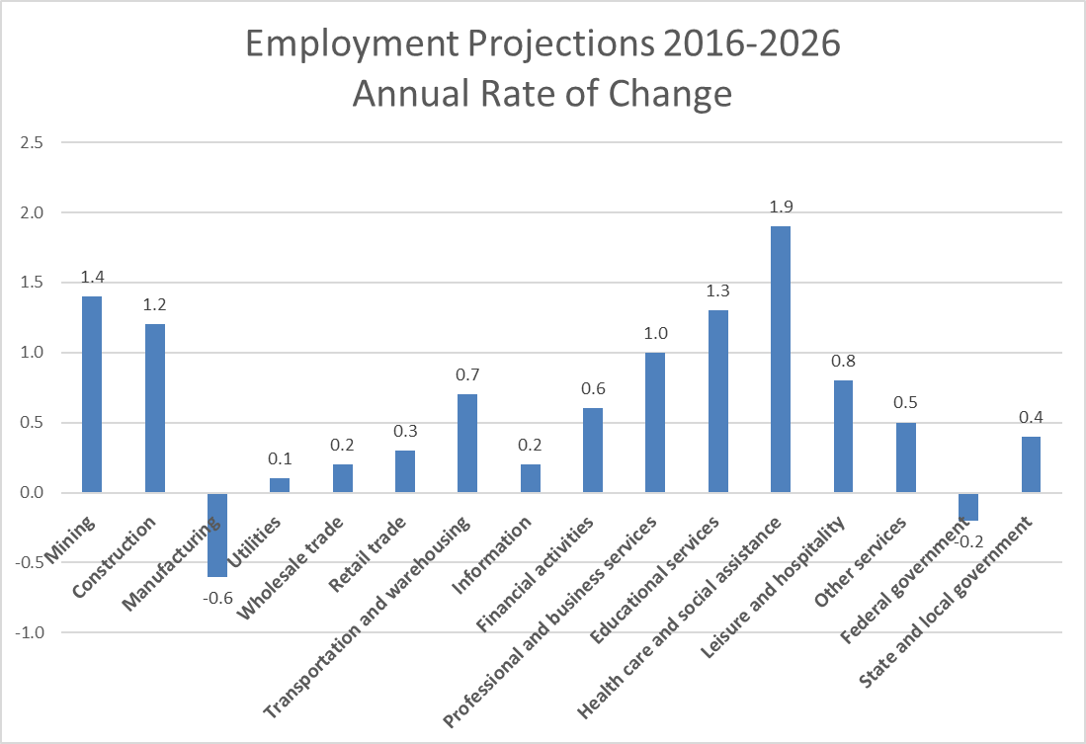

1. The development of this working paper was led by Harin Contractor with contributions from members of the DEI Use/Digital Readiness Subgroup, including Subgroup lead Janice Bryant Howard, Founder and CEO, The ActOne Group, and Heather Gate, Director of Digital Inclusion, Connected Nation. The working paper reflects the preliminary views of its author, Harin Contractor, and contributors, and may, as deemed appropriate by future ACDDE broadband working groups, undergo further review and development. The Use Subgroup explored how broadband and related applications could be used to advance economic growth in disadvantaged communities with persistent poverty, population decline, poor health outcomes, and lack of economic opportunity. The Subgroup priorities include:

   Reviewing the role the digital economy plays in early childhood education, workforce development, economic development, and disaster recovery and response;

   Identifying metrics to monitor and track progress on engagement and readiness in digital preparedness and literacy; and

   Making recommendations to the FCC on “moving the needle” by leveraging and aligning existing resources to advance digital readiness and use of technological resources in historically disadvantaged communities.
2. Sara Friedman, *Homework Gap Persists Despite Broadband Gains, Ed Tech Trends* (Jan. 1, 2019), <https://thejournal.com/articles/2019/01/10/homework-gap-persists-despite-broadband-gains.aspx>.
3. Lauraine Genota, *'Homework Gap' Hits Minority, Impoverished Students Hardest, Survey Finds*, Education Week: BLOG (Sept. 19, 2018), <https://blogs.edweek.org/edweek/DigitalEducation/2018/09/homework_gap_education_equity_ACT_survey.html>.
4. National Center for Education Statistics, <https://nces.ed.gov/nationsreportcard/>.
5. <https://www.newyorkfed.org/medialibrary/media/outreach-and-education/cra/reports/DallasFed-Closing-the-Digital-Divide.pdf>
6. Paul Bowers et al., *Minimally Adequate*, The Post and Courier, Part One, Minimally Adequate, <https://data.postandcourier.com/saga/minimally-adequate/page/1>.

  
7. South Carolina Department of Education, 2017 Report Cards, <https://ed.sc.gov/data/report-cards/historic-school-report-cards/2017/knowledge/act-workkeys/?d=4501&s=000&t=D&y=2017>.
8. Thad Moore et al., *A Pipeline of Failure*, The Post and Courier, Part 3, <https://data.postandcourier.com/saga/minimally-adequate/page/3>.

  
9. *Id.*
10. *Report: Closing the Education Equity Gap for Mississippi’s Black Males*, Hope Policy Institute, (Sept. 2017), <http://hopepolicy.org/reports/report-closing-the-education-equity-gap-for-mississippis-black-males/>.
11. Claudia Goldin and Lawrence F. Katz., *The Race Between Education and Technology,* Journal of American History (2009).
12. Edward L. Glaeserm Giacomo A. M. Ponsetto, Kristina Tobio, *Cities, Skills, ad Regional Change* (Mar. 2011), <https://scholar.harvard.edu/files/glaeser/files/cities_skills_and_regional_change.pdf>.
13. Thomas Lyson, *The Role of Education: Promoting the Economic & Social Vitality of Rural America: The Importance of Schools to Rural Community Viabilit*y*,* Cornell University, <https://files.eric.ed.gov/fulltext/ED493383.pdf>.
14. Douglas Gagnon and Marybeth Mattingly, *Beginning Teachers Are More Common in Rural, High Poverty, and Racially Diverse Schools*, Carsey Institute, Summer 2012, <https://scholars.unh.edu/cgi/viewcontent.cgi?referer=&httpsredir=1&article=1172&context=carsey>.
15. Andrew Schaefer, Marybeth J. Mattingly, Kenneth M. Johnson, *Child poverty higher and more persistent in rural America*, Carsey Institute, Winter 2016, <https://scholars.unh.edu/cgi/viewcontent.cgi?referer=&httpsredir=1&article=1265&context=carsey>.
16. Joseph G. Kosciw, Emily A. Greytak, Adrian D. Zongrone, Caitlin M. Clark, and Nhan L. Truong, *The 2017 National School Climate Survey: The Experiences of Lesbian, Gay, Bisexual, Transgender, and Queer Youth in Our Nation’s* ERIC, <https://eric.ed.gov/?id=ED590243>.
17. *See* Appendix Figure 2 below.
18. Deloitte, *What is Digital Economy*, <https://www2.deloitte.com/mt/en/pages/technology/articles/mt-what-is-digital-economy.html.>
19. Camille Ryan & Jamie M. Lewis, *Computer and Internet Use in the United States: 2015* (Sept. 2027), <https://www.census.gov/content/dam/Census/library/publications/2017/acs/acs-37.pdf>.
20. *Id.*

   
21. Jessie Daniels and Mary L. Gray, *A Vision for Inclusion: An LGBT Broadband Future, June 2014; Daniels, Gray, City, Report, University of New York (Apr. 2014).*
22. Aaron Smith, *Lack of broadband can be a key obstacle, especially for job seekers*, Pew Research Center (Dec. 28, 2015), <http://www.pewresearch.org/facttank/2015/12/28/lack-of-broadband-can-be-a-key-obstacle-especially-for-job-seekers>.
23. Lourdes Ashley Hunter, Ashe McGovern, and Carla Sutherland, *Intersecting Injustice: Addressing LGBTQ Poverty and Economic Justice for All: A National Call to Action*, Social Justice Sexuality Project, Graduate Center, City University of New York (ed. 2018).
24. Rhoda C. Joseph, *Ride-Sharing Services: The Tumultuous Tale*

    *of the Rural Urban Divide*, Twenty-fourth Americas Conference on Information Systems, New Orleans (2018), <https://aisel.aisnet.org/cgi/viewcontent.cgi?article=1128&context=amcis2018>.
25. Ramya M. Vijaya, *Broken Buffer: How Trade Adjustment Assistance Fails American Workers*, Demos (2010), <https://www.demos.org/sites/default/files/publications/Broken_Buffer_FINAL.pdf>.
26. Bill Whitaker, *How an Economic Developer is Bringing Factory Jobs Back to Mississippi*, 60 Minutes, Dec. 4, 2016, <https://www.cbsnews.com/news/60-minutes-mississippi-factory-jobs-joe-max-higgins/>.

   
27. Christian Camerota, *Manufacturing a Renaissance in the Deep South,* Harvard Business School (Mar, 13, 2018), <https://www.hbs.edu/news/articles/Pages/golden-triangle-up-close.aspx?cid=sm-tw-sf85735849&sf85735849=1>
28. Stephen Noono, *Why the FCC’s E-rate Makes Funding High Speed Internet a Slow Crawl*, EdSurge, Aug. 7, 2018, <https://www.edsurge.com/news/2018-08-07-why-the-fcc-s-e-rate-makes-funding-high-speed-internet-a-slow-crawl>.
29. Quentin, Hardy, *A Case for Cheaper Broadband in Schools*, N.Y. Times.: BLOG (Jan. 30, 2014), <https://bits.blogs.nytimes.com/2014/01/30/a-case-for-cheaper-broadband-in-schools/>.
30. Todd Green and Ashley Bozarth, The Critical Role of Historically Black Colleges and Universities in Workforce Development, chapt. 14, <https://www.investinwork.org/-/media/Files/volume-one/The%20Critical%20Role%20of%20Historically%20Black%20Colleges%20and%20Universities%20in%20Workforce%20Development.pdf?la=en>.
31. *Minority Serving Institutions: America’s Underutilized Resource for Strengthening the STEM Workforce*, Report (2019), <https://www.nap.edu/catalog/25257/minority-serving-institutions-americas-underutilized-resource-for-strengthening-the-stem>.
32. *Id.*
33. *Id.*
34. An Update on Connecting Rural America The 2018 Microsoft Airband Initiative.: BLOG (2018), <https://blogs.microsoft.com/uploads/prod/sites/5/2018/12/MSFT-Airband_InteractivePDF_Final_12.3.18.pdf>.
35. Note: No one associate with the contributions of this paper is associated with Microsoft.
36. Stuart Andreason et al., *Building a Skilled Workforce for a Stronger Southern Economy, Report*, 25, <https://www.frbatlanta.org/-/media/documents/community-development/publications/special/180612-building-a-skilled-workforce-for-a-stronger-southern-economy/report.pdf>.
37. *Id.* at 16.

   
38. White House, Economic Report of the President, 3 (Feb. 2015), <https://obamawhitehouse.archives.gov/sites/default/files/docs/cea_2015_erp.pdf>.
39. *Racial Differences on the Future of Work: A Survey of the American Workforce*, (US 2050 Project, Peter G. Peterson Foundation, Working Paper 2019), <https://www.pgpf.org/us-2050/research-projects/Racial-differences-on-the-Future-of-Work-A-Survey-of-the-American-Workforce>.
40. Eric A. Hanushek and Ludger Woessmann, *Apprenticeship programs in a changing economic world*, Brookings, Brown Center Chalkboard (June 28, 2017), <https://www.brookings.edu/blog/brown-center-chalkboard/2017/06/28/apprenticeship-programs-in-a-changing-economic-world/>.
41. Robert Lerman, *Expanding Apprenticeship Opportunities in the United States,* Brookings Report (June 19, 2014),<https://www.brookings.edu/research/expanding-apprenticeship-opportunities-in-the-united-states/>.
42. Joseph Parilla and Alan Berube, *Building One of America’s Fastest-growing Apprenticeship Programs: A Q&A with Brad Neese of Apprenticeship Carolina*, Brookings, The Avenue: BLOG (Apr. 7, 2015), <https://www.brookings.edu/blog/the-avenue/2015/04/07/building-one-of-americas-fastest-growing-apprenticeship-programs-a-qa-with-brad-neese-of-apprenticeship-carolina/>.
43. Claudia Goldin and Lawrence F. Katz, *The Race Between Education and Technology*, Journal American History. (2008).
44. Betsey Stevenson, Why Access to Free Community College Matters, The White House: BLOG (Jan. 9, 2015), <https://obamawhitehouse.archives.gov/blog/2015/01/09/why-access-free-community-college-matters>.
45. Chattanooga State Community College, Tennessee Reconnect FAQ’s, <https://www.chattanoogastate.edu/tennessee-reconnect-faqs>.
46. <https://www.tnecd.com/advantages/workforce-education/>.
47. OECD, *Active Labour Market Policies: Connecting People with Jobs*, <http://www.oecd.org/employment/activation.htm>.
48. *Id.*
49. Jun Nie and Ethan Struby, *Would Active Labor Market Policies Help Combat High U.S. Unemployment?*, <https://www.kansascityfed.org/publicat/econrev/pdf/11q3Nie-Struby.pdf>.
50. National Skills Coalition, Federal Policy: Federal Funding, <https://www.nationalskillscoalition.org/federal-policy/federal-funding>.
51. <https://assistantdemocraticleader.house.gov/index.cfm?a=files.serve&File_id=74955F33-3ED3-4412-859A-61B06B06D852>.
52. <https://assistantdemocraticleader.house.gov/index.cfm?a=files.serve&File_id=C7EE68CD-A0DA-4728-BD32-451A61824701>.