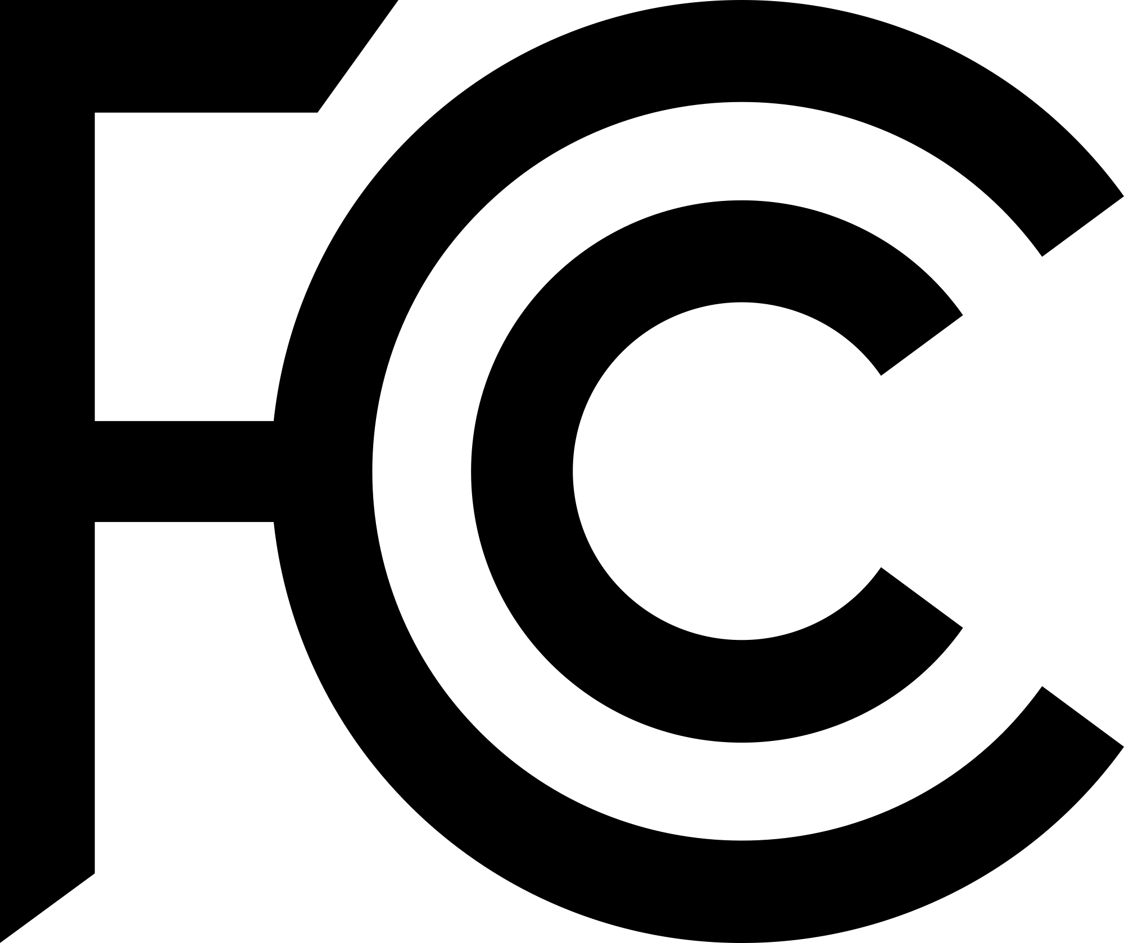

**National Broadband Map**

Partners can tweak these suggested social media posts to fit their voice.

**Sample Tweets**

Note: ***indicates that the proceeding tweet will be tweeted in a series.

Check the new National Broadband Map which launched today. Help @FCC improve the map, search for your address at broadbandmap.fcc.gov to learn more about the services providers reported available. #broadband

******** If you see inaccurate information about your location or the services providers reported as available, file a challenge to dispute the data. Accurate maps = improved internet access!

Need high-speed internet access? The FCC’s new National Broadband Map shows internet availability data nationwide and accepts input from consumers like you! Go to BroadbandMap.gov to see what's available in your area. #broadband

The @FCC wants to make sure all locations are represented on the National Broadband Map. Search for your address at BroadbandMap.gov. If information about your location is wrong or the location is missing, submit a challenge to correct the map! Accurate maps = improved internet access

Check the National Broadband Map to find out who offers internet service at your location. Visit BroadbandMap.gov. If the reported service or speed is not offered, submit a challenge to help improve the map! Accurate maps = improved internet access

The @FCC Speed Test App can challenge the mobile coverage reported by providers. Download the app and share your test results to help improve the National Broadband Map. You can check and compare mobile coverage in your area by visiting BroadbandMap.fcc.gov

**Sample Facebook Posts**

The FCC’s new National Broadband Map shows internet availability data nationwide, and for the first time, accepts input from consumers like you! Go to BroadbandMap.gov, search for your home or small business. If the reported service or speed is not available for purchase, submit a challenge to correct the map. Help Improve the map! More information at FCC.gov/BroadbandData/consumers.

The FCC wants to make sure that all locations are represented on the National Broadband Map. Search for your home or small business at BroadbandMap.gov. If the information about your location is wrong, or the location is missing from the map, submit a challenge to correct it! More information at FCC.gov/BroadbandData/consumers.

Learn more by visiting fcc.gov/broadbanddata/consumers.