ATTACHMENT A
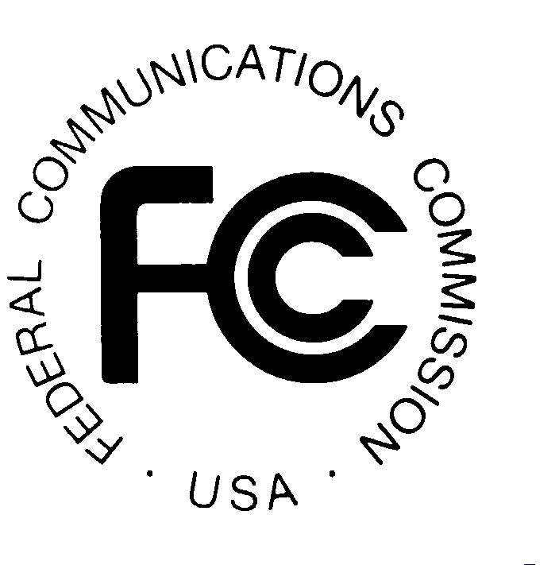

PAYMENT INSTRUCTIONS

METHOD OF PAYMENT

All payments must be made in U.S. dollars, must be in the form of a Wire Transfer. No personal checks, credit cards payments, or other forms of payment will be accepted. All payments must be accompanied by a completed FCC Remittance Advice Form (FCC Form 159).

To submit funds by wire transfer, please supply the following information:

ABA Routing Number: 043000261
Receiving Bank: Mellon Pittsburgh
BNF: FCC/AC--9116106
OBI Field: (Skip one space between each information item)
"AUCTIONPAY"
TAXPAYER IDENTIFICATION NO: (same as FCC Form 159 ,Block 26)
PAYMENT TYPE CODE: (Block # 5);(same as FCC Form 159, Block 20A: "A22D")
FCC CODE 1: (same as FCC Form 159, Block 23A: "18")
PAYOR NAME: (same as FCC Form 159, Block 2)
LockBox No. 358850

Please fax a completed FCC Form 159 to Mellon Bank at (412) 236-5702 at least one hour before placing the order for the wire transfer (but on the same business day).

