PUBLIC NOTICE
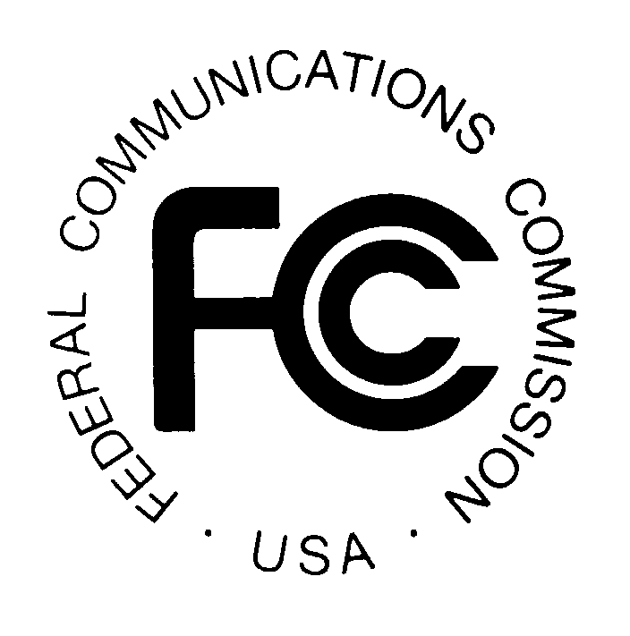

FEDERAL COMMUNICATIONS COMMISSION News Media Information: (202) 418-0500
445 12th STREET, S.W. Fax-On-Demand: (202) 418-2830

WASHINGTON, D.C. 20554 Internet: http://www.fcc.gov

ftp.fcc.gov

DA-00173
February 1, 2000

AUCTION OF 2,499

929 AND 931 MHz Paging Licenses

Status of Applications to Participate in the Auction

Report No. AUC-00-26-C (Auction No. 26)

The Federal Communications Commission ("FCC") has received 87 FCC Form 175 applications to participate in Auction No. 26 scheduled to begin on Thursday, February 24, 2000, for 2,499 - 929 and 931 MHz Paging licenses. The applications have been reviewed for completeness and compliance with the Commission's Rules, and have been classified into the following categories:

ACCEPTED FOR FILING.............................................. 67 Applications

INCOMPLETE.................................................................. 20 Applications

Accepted: Applications classified as accepted for filing are listed in Attachment A. These applicants will become qualified bidders upon receipt of the required upfront payment by 6:00 p.m. ET on Monday, February 7, 2000, as discussed below. With respect to their applications, these applicants need take no further action except as may be necessary to keep their applications up-to-date. Applicants are also advised that Attachment A includes FCC account numbers that are automatically created by the FCC software system for each applicant. FCC account numbers are applicable for bidding only.

Incomplete: Applications classified as incomplete are listed alphabetically in Attachment B. Applicants whose applications have been classified as incomplete will receive overnight correspondence indicating what information is required to make the applications acceptable for filing. These applicants will become qualified bidders only if they: (1) resubmit their applications by 5:30 p.m. ET on Tuesday, February 8, 2000, to correct the minor deficiencies indicated; and (2) make the required upfront payments by 6:00 p.m. ET on Monday, February 7, 2000, as discussed below. They must also keep their applications up-to-date as required. Applicants are also advised that Attachment B includes FCC account numbers that are automatically created by the FCC software system for each applicant. FCC account numbers are applicable for bidding only.

The filing window for resubmitting FCC Form 175 applications is now open. Corrected applications must be electronically filed no later than 5:30 p.m. ET on Tuesday, February 8, 2000. This will be the only opportunity to cure FCC Form 175 defects; late resubmissions will not be accepted. In addition, if an application remains incomplete or otherwise deficient after the resubmission deadline has passed, it will be rejected.

UPFRONT PAYMENT DEADLINE

Upfront payments and accompanying FCC Remittance Advice (FCC Form 159) for this auction are due at Mellon Bank, Pittsburgh, Pennsylvania, by 6:00 p.m. ET on Monday, February 7, 2000. Payments must be made by wire transfer and applicants must include their Taxpayer Identification Numbers (TIN). No other payment method is acceptable for this auction. Applicants are reminded to use their TIN numbers and not their FCC Account Numbers on the FCC Remittance Advice (FCC Form 159).

Applicants that have filed applications classified by this public notice as incomplete must submit timely and sufficient upfront payments before the Commission will review their resubmitted applications. If such an application remains incomplete following its resubmission, it will be dismissed. The upfront payment will be refunded automatically if the applicant has provided its Taxpayer Identification Number (TIN) and wire transfer instructions.

OTHER IMPORTANT INFORMATION

Due Diligence: Previously, the Commission has provided information on due diligence issues to potential bidders in Auction No. 26. Potential bidders should be aware of the following:

Application of County of Sacramento, California, Request for Waiver to Obtain a License for a Frequency Allocated for Exclusive Paging Operations (929.0125 MHz), Order, DA 99-2959 (rel. December 21, 1999), Petition for Reconsideration filed by Sacramento County, CA, January 18, 2000.

Potential bidders are reminded that the Commission makes no representation that the proceedings it has cited include every proceeding pending as of February 1, 2000, relevant to the spectrum included in Auction No. 26. Potential bidders are strongly encouraged to conduct their own research prior to Auction No. 26 in order to determine the existence of pending proceedings that might affect their decisions regarding participation in the auction. Participants in Auction No. 26 are strongly encouraged to continue such research during the auction.

Qualified Bidders: A public notice listing all applicants qualified to bid in the auction will be released approximately one week after upfront payments have been received, resubmitted FCC Form 175 applications have been processed and reviewed, and payments and applications have been correlated. The same public notice will also include instructions on how to monitor the auction on-line, how to access the bid tracking tool software, a bidding schedule for the mock auction, and the bidding schedule for the first two days of the auction.

Prohibition of Collusion: Bidders are reminded that Section 1.2105(c) of the Commission’s Rules prohibits applicants for the same geographic license area from communicating with each other during the auction about bids, bidding strategies, or settlements unless they have identified each other as parties with whom they have entered into agreements under section 1.2105(a)(2)(viii). If parties agreed in principle on all material terms, those parties must be identified on the short-form application under Section 1.2105(c), even if the agreement has not been reduced to writing. If the parties have not agreed in principle by the filing deadline, an applicant would not include the names of those parties on its application, and may not continue negotiations with those parties. For further details regarding collusion, refer to Auction No. 26 Public Notice. For Auction No. 26, this prohibition became effective at the filing deadline for short-form applications on Thursday, January 20, 2000, and will end on the post-auction down payment due date to be announced in a future public notice.

In addition, applicants are reminded that they are subject to the antitrust laws, which are designed to prevent anti-competitive behavior in the marketplace. Winning bidders will be required to disclose in their long-form applications the specific terms, conditions and parties involved in all bidding consortia, joint ventures, partnerships, and other arrangements entered into relating to the competitive bidding process. Bidders found to have violated the anti-collusion rule may be subject to sanctions.

Ex Parte Rule: Applicants should also be aware that the Commission has generally exempted auction proceedings from the strict requirements of the ex parte rule (47 C.F.R. § 1.2108).

Mock Auction: All applicants found to be qualified bidders are eligible to participate in a mock electronic auction on Tuesday, February 22, 2000. The Bureau will issue a public notice announcing when software for the mock auction is posted on the World Wide Web and BBS.

Remote Bidding Software: Applicants are reminded that qualified bidders are eligible to bid either electronically or telephonically. To bid electronically, applicants should complete the software order form included in the Auction No. 26 Public Notice and the Bidder Information Package, or contact the Auctions Hotline at (717) 338-2888. To ensure timely delivery of remote bidding software before the auction begins, the Commission requests receipt of software orders by 5:30 p.m. ET on Tuesday, February 8, 2000. The hardware and software specifications required for the FCC remote bidding system are contained in the Auction No. 26 Public Notice and Tab D of the 929 and 931 MHz Paging Bidder Information Package.

Long-Form Applications: All applicants should be aware that at the long-form application stage, they will be subject to the more extensive reporting requirements contained in the Commission's Part 1 ownership disclosure rule.

Bidder Alerts: All applicants must certify on their FCC Form 175 applications under penalty of perjury that they are legally, technically, financially and otherwise qualified to hold a license, and not in default on any payment for Commission licenses (including down payments) or delinquent on any non-tax debt owed to any Federal agency. Prospective bidders are reminded that submission of a false certification to the Commission is a serious matter that may result in severe penalties, including monetary forfeitures, license revocations, exclusion from participation in future auctions, and/or criminal prosecution.

Information about deceptive telemarketing investment schemes is available from the FTC at (202) 326-2222 and from the SEC at (202) 942-7040. Complaints about specific deceptive telemarketing investment schemes should be directed to the FTC, the SEC, or the National Fraud Information Center at (800) 876-7060. Consumers who have concerns about specific 929 and 931 MHz Paging proposals may also call the FCC National Call Center at (888) CALL-FCC ((888) 225-5322).

* * * * *

For questions about payment or instructions for wiring upfront payments, contact Gail Glasser or Michelle Bennett, Auction Accounting Group, at (202) 418-1995. For specific questions about an applicant's incomplete status, the applicant should contact the designated attorney identified in the correspondence sent to the applicant by overnight mail. For additional information, contact: Rosemary Cabral, Legal Branch at (202) 418-0660 (regarding legal questions); Lisa Hartigan, Auction Operations at (202) 418-0695 (regarding bidding and general filing status); and Bob Reagle, Analyst, Auction Operations at (717) 338-2807 (regarding bidding).

- FCC -

? See 47 C.F.R. §§ 1.65 and 1.2106.
Id.
? See "Auction of 929 and 931 MHz Paging Service Spectrum; Auction Notice and Filing Requirements for 2,499 Paging Upper Band Licenses Scheduled for February 24, 2000; Minimum Opening Bids and Other Procedural Issues," Public Notice, DA 99-1591 (rel. August 12, 1999)(“Auction No. 26 Public Notice”) for detailed remittance and upfront payment information. This and other documents, including the Bidder Information Package, are available on the FCC website at: http://www.fcc.gov/wtb/auctions.
See Auction No. 26 Public Notice; “Auction Notice for 2,499 Paging Upper Band Licenses Scheduled for February 24, 2000, Due Diligence Issues,” Public Notice, DA 99-2988 (rel. December 23, 1999).
“Wireless Telecommunications Bureau clarifies Spectrum Auction Anti-Collusion Rules,” Public Notice, DA 95-2244 (rel. October 26, 1995), 11 FCC Rcd 9645 (1995).
See 47 C.F.R. §§ 1.2105(c), 1.2107(d), and 1.2109(d).
See 47 C.F.R. §1.202(d) note (1); See also “Commission Announces that Mutually Exclusive ‘Short-Form’ Applications (Form 175) to Participate in Competitive Bidding Process (‘Auctions’) Are Treated as Exempt for Ex Parte Purposes,” Public Notice, 9 FCC Rcd 6760 (1994).
? See 47 C.F.R. § 1.2112(b).

