PUBLIC NOTICE
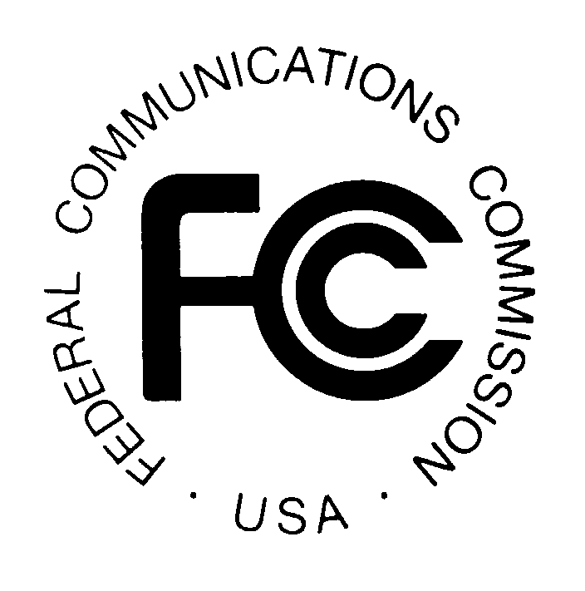

FEDERAL COMMUNICATIONS COMMISSION News Media Information: (202) 418-0500
445 12th STREET, S.W. Fax-On-Demand: (202) 418-2830

WASHINGTON, D.C. 20554 Internet: http://www.fcc.gov

ftp.fcc.gov

DA 00-375
February 25, 2000

39 GHz Band

Pre-Auction Seminar

Thursday, March 2, 2000
The free FCC pre-auction seminar for the 39 GHz Band Auction (Auction No. 30) is scheduled for Thursday, March 2, 2000. Interested parties must pre-register using the attached form or by calling the FCC. Registration will begin at 8:30 a.m. and the program will end by 4 p.m.
The seminar will be held at the Federal Communications Commission, 445 12th Street S.W., Washington, D.C. Potential bidders in the auction are strongly encouraged to attend. This seminar provides an opportunity for hands-on demonstrations of the FCC filing and bidding software and access to the FCC staff responsible for the 39 GHz band licensing and auction conduct procedures.

The following is a timeline of the important events prior to the auction start date:

Deadline to register for Pre-Auction Seminar: February 29, 2000
Seminar Date: March 2, 2000
Short Form Application (FCC Form 175): March 13, 2000 5:30 p.m. ET
Upfront Payments (via wire transfer): March 27, 2000 6:00 p.m. ET
Orders for Remote Bidding Software: March 28, 2000 5:30 p.m. ET
Mock Auction: April 7, 2000
Auction Start Date: April 12, 2000

It is strongly advised that all potential bidders review the public notices released for this auction prior to the seminar. To register for the seminar, please contact the FCC’s Auctions Hotline at (888)-225-5322, Press Option #2, or directly at (717) 338-2888.

For further information, please contact Lisa Stover or Kathy Garland of the Auctions Operations Branch at (717) 338-2888, or for Press Inquiries, Meribeth McCarrick at (202) 418-0654.

FCC AUCTION SEMINAR REGISTRATION FORM
Auction No. 30
The FCC will sponsor a one-day seminar for the 39 GHz Band Auction applicants. The seminar is free of charge and will provide information about pre-auction procedures, service and auction rules, conduct of the auction, and the FCC remote bidding software.

Reservation will be taken on a first-come first-served basis until room capacity is filled.
The seminar will be held:
Thursday, March 2, 2000
Federal Communications Commission
445 12th Street S.W.

Washington, DC 20554
Registration 8:30 a.m. - 9:30 a.m.
Seminar 9:30 a.m. - 4 p.m.
If hotel accommodations are needed
Please contact 1-888-225-5322 (option #2) for a list of hotels in the area
**********************************
To register, complete the form below and
return no later than
Tuesday, February 29, 2000, by mail or fax to:

FCC Auction 30
Auctions Operations Branch
1270 Fairfield Road
Gettysburg, PA 17325-7245

FAX: 717-338-2850
Phone: 717-338-2888

I/We will attend the 39 GHz Band Auction seminar, Thursday, March 2, 2000.

Name of attendee: _____________________________________________________

Name of attendee: _____________________________________________________
Company name: ______________________________________________________
Phone: __________________________ Fax: ______________________________

