PUBLIC NOTICE
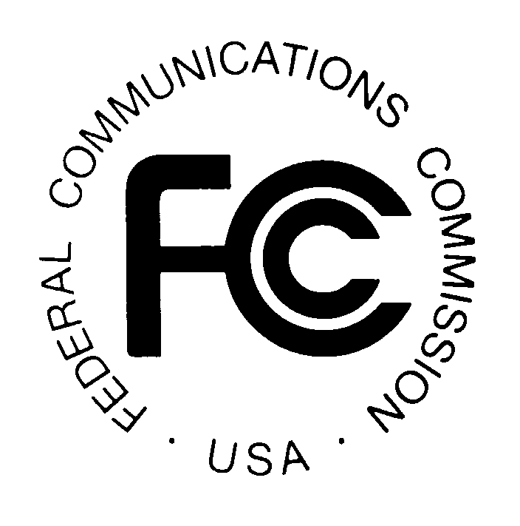

FEDERAL COMMUNICATIONS COMMISSION
1919 M STREET, N.W.
WASHINGTON, D.C. 20554
News Media Information: (202) 418-0500
Fax-On-Demand: (202) 418-2830
Internet: http://www.fcc.gov
ftp.fcc.gov

DA 00-478
March 2, 2000

SUPPLEMENT TO ATTACHMENT B

AUCTION OF LICENSES FOR
FIXED POINT-TO-POINT MICROWAVE SERVICES
IN THE 38.6 to 40.0 GHz (39 GHz) BAND

Auction Notice and Filing Requirements for 2,450 Licenses
in the 39 GHz Band; Auction Scheduled for April 12, 2000;
Minimum Opening Bids and Other Procedural Issues

The following Attachment supplements and updates Attachment B of the Public Notice released January 21, 2000 ("39 GHz Auction Public Notice") announcing the auction and filing requirements for the auction of 2,450 licenses in the 38.6 to 40.0 GHz band scheduled for April 12, 2000 (Auction No. 30). Specifically, the Attachment to this Public Notice supplements and updates Attachment B (entitled "Pending Applications as of January 12, 2000”) of the 39 GHz Auction Public Notice.

Potential bidders are solely responsible for investigating and evaluating the degree to which such pending matters may affect spectrum availability in areas where they seek EA licenses. To aid potential bidders, the Attachment to this Public Notice lists matters pending before the Commission that relate to licenses or applications in the 39 GHz band. The Commission makes no representations or guarantees that the listed matters are the only pending matters that could affect spectrum availability in the 39 GHz band.

In addition, certain decisions reached in these matters are subject to judicial appeal and may be the subject of additional reconsideration or appeal. We note that resolution of these matters could have
an impact on the availability of spectrum for EA licensees in the 39 GHz band. In this regard, potential bidders should note the following proceedings:

Bachow Communications, Inc., et. al. v. Federal Communications Commission, Case No. 99-1346 (and consolidated cases) (D.C. Cir., filed August 30, 1999) (“Bachow et. al.”); see also Commco, L.L.C. v. Federal Communications Commission, Case No. 99-1533 (D.C. Cir., filed December 20, 1999), motion to consolidate with Bachow et. al. filed January 24, 2000.

— FCC —

? See "Auction of Licenses for Fixed Point-to-Point Microwave Services in the in the 38.6 to 40.0 GHz (39 GHz) Band; Auction Notice and Filing Requirements for 2,450 Licenses in the 39 GHz band; Auction Scheduled for April 12, 2000; Minimum Opening Bids and Other Procedural Issues," Public Notice, DA 00-112 (rel. January 21, 2000), 65 Fed. Reg. 9309 (February 24, 2000) (“39 GHz Auction Public Notice”).
We note that the Commission order that is the subject of the judicial appeal involves the dismissal of numerous applications.

