PUBLIC NOTICE
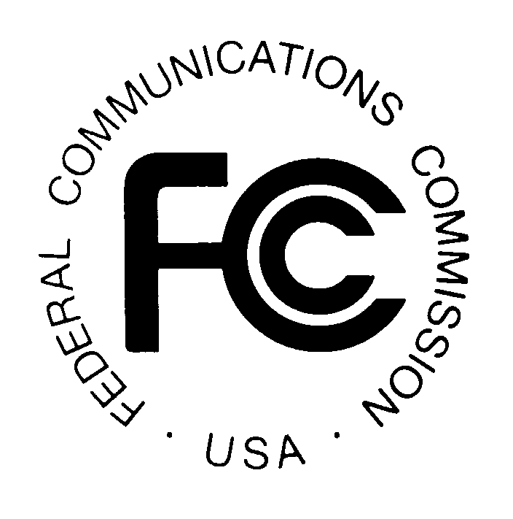

FEDERAL COMMUNICATIONS COMMISSION News Media Information: (202) 418-0500
445 12th STREET, S.W. Fax-On-Demand: (202) 418-2830

WASHINGTON, D.C. 20554 Internet: http://www.fcc.gov

ftp.fcc.gov

DA 00-1246
June 7, 2000

Auction of Licenses for C and F Block Broadband PCS Spectrum POSTPONED UNTIL November 29, 2000

Report No. AUC-00-35-B (Auction No. 35)

The upcoming auction of licenses for the C and F Block Broadband Personal Communications Services spectrum, scheduled to begin on July 26, 2000, is postponed until November 29, 2000, in order to provide additional time for bidder preparation and planning. By public notice the Commission will announce the procedures and terms of this auction. The key dates for this auction are listed below:

Filing Deadline for FCC Form 175 October 16, 2000; 6:00 PM ET

Upfront Payment Deadline November 6, 2000; 6:00 PM ET

Mock Auction November 27, 2000

Auction Start Date November 29, 2000

For further information, contact Audrey Bashkin, Auctions Legal Branch at (202) 418-0660, or Lisa Stover, Auctions Operations at (717) 338-2888.

