PUBLIC NOTICE
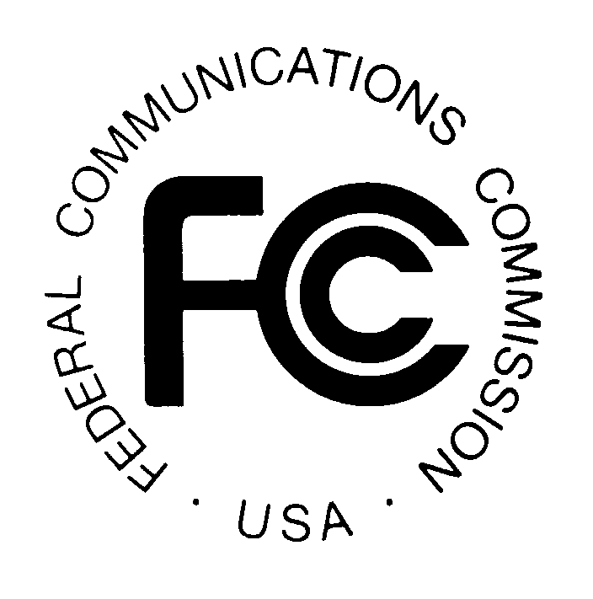
FEDERAL COMMUNICATIONS COMMISSION
445 TWELFTH STREET, S.W.
WASHINGTON, D.C. 20554 DA 01-2045

News media information 202/418-0500 Fax-On-Demand 202/418-2830 Internet: http://www.fcc.gov ftp.fcc.gov

Released: August 31, 2001

WIRELESS TELECOMMUNICATIONS BUREAU ANNOUNCES THE
RETURN TO ACTIVE STATUS OF LICENSES TO NEXTWAVE PERSONAL COMMUNICATIONS INC. AND NEXTWAVE POWER PARTNERS INC.,
SUBJECT TO THE OUTCOME OF ONGOING LITIGATION

On August 30, 2001, the United States Court of Appeals for the District of Columbia Circuit issued the mandate implementing its holding that Section 525 of the Bankruptcy Code prevented the cancellation of licenses held by NextWave Personal Communications Inc. and NextWave Power Partners Inc. (collectively “NextWave”). Accordingly, the Wireless Telecommunications Bureau will update its licensing records to reflect the court’s mandate. A list of NextWave licenses returned to active status is included as Attachment A.

The United States and the Commission have indicated their intention to ask the Supreme Court of the United States to review the D.C. Circuit decision. In addition, related litigation is pending in the Bankruptcy Court for the Southern District of New York, Case No. 98 B 21529 (ASH); and there are potential or ongoing related regulatory proceedings before the Commission. These litigation and/or regulatory matters may affect the status of the involved licenses.

The Wireless Telecommunications Bureau will separately address the status of affected Auction No. 35 license applications and associated payments. A list of affected Auction No. 35 licenses is included as Attachment B.

-FCC-

See NextWave Personal Communications Inc. v. FCC, 254 F.3d 130 (D.C. Cir. 2001).

