PUBLIC NOTICE
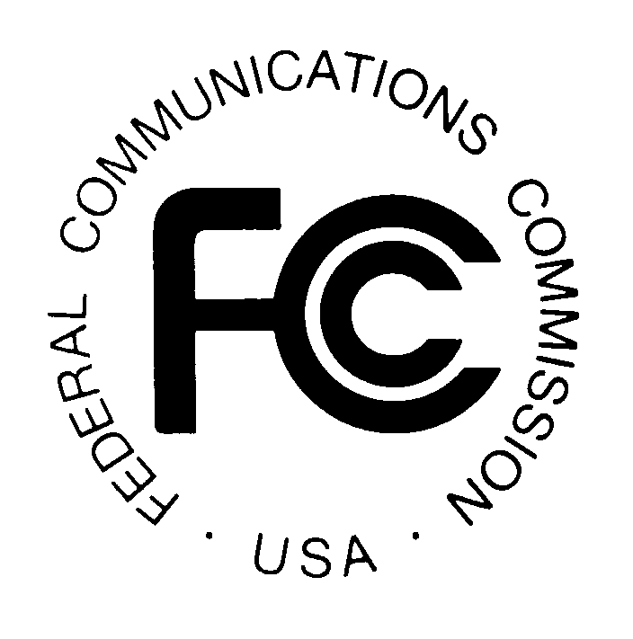

FEDERAL COMMUNICATIONS COMMISSION News Media Information: (202) 418-0500
445 12th STREET, S.W. Fax-On-Demand: (202) 418-2830

WASHINGTON, D.C. 20554 Internet: http://www.fcc.gov

ftp.fcc.gov

DA 00-2849
December 20, 2000

AUCTION OF LICENSES FOR THE 700 MHz GUARD BANDS

SCHEDULED FOR FEBRUARY 13, 2001

Pre-Auction Seminar Reminder

January 4, 2001

A free FCC pre-auction seminar for the 700 MHz Guard Bands Auction (Auction No. 38) is scheduled for Thursday, January 4, 2001. Interested parties must pre-register using the attached form or by calling the FCC. Registration will begin at 9:30 a.m. and the program will end by 2 p.m. The seminar will be held at the Federal Communications Commission, 445 12th Street S.W., Washington, D.C. Potential bidders in the auction are strongly encouraged to attend. This seminar provides an opportunity for hands-on demonstrations of the FCC filing and bidding software and access to the FCC staff responsible for the 700 MHz guard band licensing and
auction conduct procedures.

The following is a timeline of the important events prior to the auction start date:

Deadline to register for Pre-Auction Seminar: January 2, 2001
Seminar Date: January 4, 2001
Short Form Application (FCC Form 175): January 12, 2001 6:00 p.m. EST
Upfront Payments (via wire transfer): January 26, 2001 6:00 p.m. EST
Orders for Remote Bidding Software: January 29, 2001 6:00 p.m. EST
Mock Auction: February 9, 2001
Auction Start Date: February 13, 2001

It is strongly advised that potential bidders review all public notices released for this auction prior to the seminar. To register for the seminar, please contact the FCC’s Auctions Hotline at (888)-225-5322, Press Option #2, or directly at (717) 338-2888.

For further information, please contact Linda Sanderson of the Auctions Operations Branch at (717) 338-2888, or for press inquiries, Mark Rubin at (202) 418-1995.

FCC AUCTION SEMINAR REGISTRATION FORM
Auction No. 38
The FCC will sponsor a one-day seminar for the 700 MHz Guard Band Reauction applicants. The seminar is free of charge and will provide information about pre-auction procedures, radio service and auction rules, conduct of the auction, and the FCC remote bidding software.

Representatives from each company can make reservations to attend the seminar being held:

Thursday, January 4, 2001
Federal Communications Commission
445 12th Street S.W.
Room CY-B511/418
(Courtyard Level Conference Room)

Washington, DC 20554
Registration: 9:30 a.m. – 10:00 a.m.
Seminar: 10:00 a.m. – 2:00 p.m.
If hotel accommodations are needed
Please contact 1-888-225-5322 (option #2) for a list of hotels in the area
**********************************
To register, complete the form below and
return by mail or fax to be received no later than noon
Tuesday, January 2, 2001, to:

FCC Auction No. 38
Auctions Operations Branch
1270 Fairfield Road
Gettysburg, PA 17325-7245

FAX: 717-338-2850
Phone: 717-338-2888

I/We will attend the Auction No. 38 Seminar, scheduled for Thursday, January 4, 2001.

Name of attendee: _____________________________________________________

Name of attendee: _____________________________________________________
Company name: ______________________________________________________
Phone: __________________________ Fax: ______________________________

