PUBLIC NOTICE
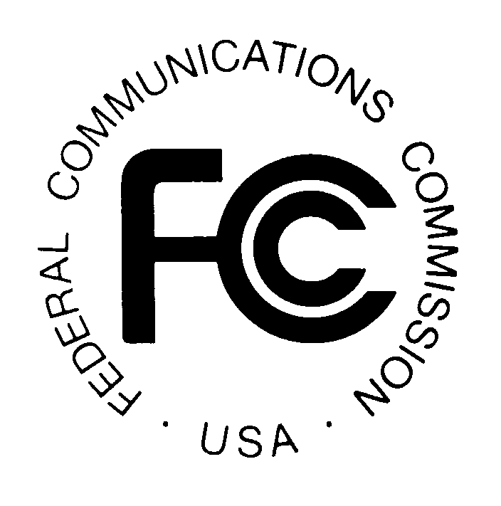

FEDERAL COMMUNICATIONS COMMISSION News Media Information: (202) 418-0500
445 12th STREET, S.W. Fax-On-Demand: (202) 418-2830

WASHINGTON, D.C. 20554 Internet: http://www.fcc.gov

ftp.fcc.gov

DA 01-2075

September 4, 2001

MULTIPLE ADDRESS SYSTEMS SPECTRUM

AUCTION SCHEDULED FOR NOVEMBER 14, 2001

Reminder: Pre-Auction Seminar September 18, 2001

A free FCC pre-auction seminar for the Multiple Address Systems Spectrum Auction (Auction No. 42) is scheduled for Tuesday, September 18, 2001. Interested parties must pre-register using the attached form or by calling the FCC. Registration will begin at 9:30 a.m. and the program will end by 4 p.m. The seminar will be held at the Federal Communications Commission, 445 12th Street S.W., Room 4-B516, Washington, D.C. Potential bidders in the auction are strongly encouraged to attend. This seminar provides an opportunity for hands-on demonstrations of the FCC filing and bidding systems, as well as access to the FCC staff responsible for the Multiple Address Systems licensing and auction conduct procedures.

The following is a timeline of the important events prior to the auction start date:

Deadline to register for Pre-Auction Seminar: September 14, 2001
Seminar Date: September 18, 2001
Short Form Application (FCC Form 175): September 28, 2001 6:00 p.m. EST
Upfront Payments (via wire transfer): October 22, 2001 6:00 p.m. EST
Mock Auction: November 9, 2001
Auction Start Date: November 14, 2001

It is strongly advised that potential bidders review all public notices released for this auction prior to the seminar. To register for the seminar, please contact the FCC’s Auctions Hotline at (888)-225-5322, Press Option #2, or directly at (717) 338-2888.

For further information, please contact Barbara Sibert of the Auctions Operations Branch at (717) 338-2888, or for press inquiries, Meribeth McCarrick at (202) 418-0654.
FCC AUCTION SEMINAR REGISTRATION FORM

Auction No. 42

The FCC will sponsor a one-day seminar for Auction No. 42 applicants. The seminar is free of charge and will provide information about pre-auction procedures, service and auction rules, conduct of the auction, and the Automated Auction System.

A maximum of two representatives from each company may attend on a reservation basis, first-come first-served until room capacity is filled. Additional seating may be available on a stand-by basis the day of the seminar. The seminar will be held:

Tuesday, September 18, 2001
Federal Communications Commission
445 12th Street SW
Room 4-B516
Washington, DC 20554
Registration 9:30 a.m. – 10:00 a.m.
Seminar 10:00 a.m. - 4 p.m.
If hotel accommodations are needed
Please contact 1-888-225-5322 (option #2) for a list of hotels in the area
**********************************
To register, complete the form below and
return no later than
Friday, September 14, 2001, by mail or fax to:

FCC Auction 42
Auctions Operations Branch
1270 Fairfield Road
Gettysburg, PA 17325-7245

FAX: 717-338-2850
Phone: 717-338-2888
_______________________________________________________
I/We will attend the Auction No. 42 Seminar, scheduled for Tuesday, September 18, 2001.

Name of attendee: _____________________________________________________
Name of attendee: _____________________________________________________
Company name: ______________________________________________________
Phone: __________________________ Fax: _____________________________

